Body Fat Estimation

Building regression models (step-wise, ridge and lasso) using a dataset of ~4k individuals for estimating body fat and total mass by using generic body measurements i.e. weight, height and etc.

amhoesk

2023-06-11

Table of Contents

# Data Exploration

As missing or invalid data have been multiply imputed, the DXX_D data release file contained 5 records for each survey participant. Only 1 record was recommended to be used in calculating sample sizes while all 5 records were recommended to be used in analyses in order to obtain more accurate variance estimates. The records for some survey participants, such as pregnant females, were blank as pregnant females were not eligible for the DXA scan. DXA scans were administered to eligible survey participants aged 8-69. Only individuals were all of their data were valid and none were imputed, were selected.

## List of independent and dependent variables

Dependent variables only reported for the left side of body.

List of independent variables

|  | description |
| --- | --- |
| BMXWT | Weight (kg) |
| BMXHT | Standing Height (cm) |
| RIAGENDR | Sex (0 male, 1 female) |
| RIDAGEEX | Exam Age (year) |
| BMXWAIST | Waist Circumference (cm) |
| BMXARMC | Arm Circumference (cm) |
| BMXTHICR | Thigh Circumference (cm) |
| BMXCALF | Maximal Calf Circumference (cm) |
| BMXARML | Upper Arm Length (cm) |
| BMXLEG | Upper Leg Length (cm) |
| BMXTRI | Triceps Skinfold (mm) |
| BMXSUB | Subscapular Skinfold (mm) |

List of dependent variables

|  | description |
| --- | --- |
| DXXHEFAT | Head Fat (kg) |
| DXXLAFAT | Left Arm Fat (kg) |
| DXXLLFAT | Left Leg Fat (kg) |
| DXXTRFAT | Trunk Fat (kg) |
| DXDTOFAT | Total Fat (kg) |
| DXDHETOT | Head Total (kg) |
| DXDLATOT | Left Arm Total (kg) |
| DXDLLTOT | Left Leg Total (kg) |
| DXDTRTOT | Trunk Total (kg) |
| DXDTOBMC | Total Bone Mineral Content (kg) |
| DXDTOBMD | Total Bone Mineral Density (g/cm^2) |
| DXDHEPF | Head Percent Fat |
| DXDLAPF | Left Arm Percent Fat |
| DXDLLPF | Left Leg Percent Fat |
| DXDTRPF | Trunk Percent Fat |
| DXDTOPF | Total Percent Fat |

## Exploring demographics

The number of females are a little bit higher than males. Age distribution does not match the age distribution of USA population. Therefore, estimations based on this sample may predict outcome variables for young people better than old ones.

Summary of demographic variables

|  | vars | n | mean | sd | median | trimmed | mad | min | max | range | skew | kurtosis | se |
| --- | --- | --- | --- | --- | --- | --- | --- | --- | --- | --- | --- | --- | --- |
| RIAGENDR | 1 | 20235 | 0.462 | 0.499 | 0 | 0.452 | 0.000 | 0 | 1 | 1 | 0.153 | -1.977 | 0.004 |
| RIDAGEEX | 2 | 20235 | 27.294 | 17.246 | 19 | 25.115 | 11.614 | 8 | 70 | 62 | 0.899 | -0.479 | 0.121 |

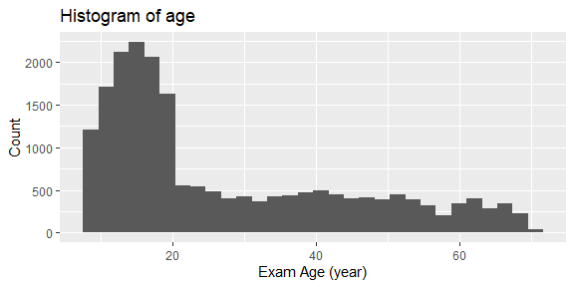

## Exploring body measurements

Some of the variables show strong linear correlations.

Summary of body measurement variables

|  | vars | n | mean | sd | median | trimmed | mad | min | max | range | skew | kurtosis | se |
| --- | --- | --- | --- | --- | --- | --- | --- | --- | --- | --- | --- | --- | --- |
| BMXWT | 1 | 20235 | 64.551 | 19.323 | 63.8 | 64.428 | 19.274 | 20.0 | 131.4 | 111.4 | 0.109 | -0.275 | 0.136 |
| BMXHT | 2 | 20235 | 163.163 | 13.757 | 164.7 | 164.120 | 13.047 | 112.0 | 192.8 | 80.8 | -0.611 | 0.158 | 0.097 |
| BMXARMC | 3 | 20235 | 28.801 | 5.112 | 29.0 | 28.812 | 5.337 | 15.5 | 45.7 | 30.2 | 0.002 | -0.429 | 0.036 |
| BMXARML | 4 | 20235 | 35.666 | 3.663 | 36.0 | 35.872 | 3.410 | 22.1 | 46.3 | 24.2 | -0.492 | 0.199 | 0.026 |
| BMXCALF | 5 | 20235 | 35.759 | 4.533 | 36.0 | 35.864 | 4.448 | 20.2 | 52.8 | 32.6 | -0.166 | 0.075 | 0.032 |
| BMXLEG | 6 | 20235 | 38.908 | 4.259 | 39.2 | 39.016 | 4.151 | 24.2 | 52.0 | 27.8 | -0.229 | -0.054 | 0.030 |
| BMXSUB | 7 | 20235 | 16.239 | 8.050 | 14.8 | 15.559 | 8.599 | 3.6 | 40.4 | 36.8 | 0.638 | -0.399 | 0.057 |
| BMXTHICR | 8 | 20235 | 49.145 | 6.892 | 49.3 | 49.179 | 6.672 | 28.3 | 74.3 | 46.0 | 0.008 | -0.017 | 0.048 |
| BMXTRI | 9 | 20235 | 15.902 | 7.506 | 14.6 | 15.248 | 8.006 | 3.0 | 42.0 | 39.0 | 0.701 | -0.167 | 0.053 |
| BMXWAIST | 10 | 20235 | 83.046 | 14.844 | 82.0 | 82.655 | 15.716 | 48.0 | 138.7 | 90.7 | 0.273 | -0.390 | 0.104 |

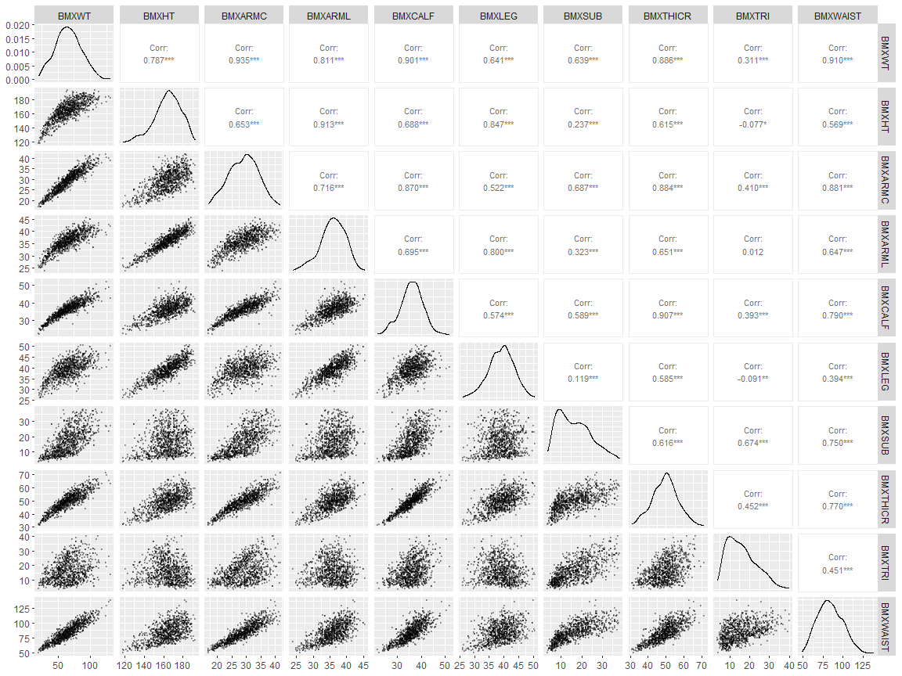

## Exploring DXA - Body parts fat weight

Data was only ploted for the left arm and leg

Summary of body parts fat weights

|  | vars | n | mean | sd | median | trimmed | mad | min | max | range | skew | kurtosis | se |
| --- | --- | --- | --- | --- | --- | --- | --- | --- | --- | --- | --- | --- | --- |
| DXXHEFAT | 1 | 20235 | 1.087 | 0.154 | 1.074 | 1.081 | 0.162 | 0.676 | 1.659 | 0.983 | 0.360 | -0.212 | 0.001 |
| DXXLAFAT | 2 | 20235 | 1.108 | 0.545 | 1.024 | 1.059 | 0.539 | 0.182 | 3.843 | 3.661 | 0.961 | 1.327 | 0.004 |
| DXXLLFAT | 3 | 20235 | 3.688 | 1.581 | 3.485 | 3.558 | 1.514 | 0.705 | 11.072 | 10.367 | 0.865 | 0.991 | 0.011 |
| DXXTRFAT | 4 | 20235 | 8.786 | 4.952 | 7.920 | 8.342 | 5.297 | 1.239 | 31.199 | 29.960 | 0.791 | 0.291 | 0.035 |
| DXDTOFAT | 5 | 20235 | 19.530 | 8.814 | 18.471 | 18.887 | 9.217 | 4.029 | 58.845 | 54.815 | 0.695 | 0.337 | 0.062 |

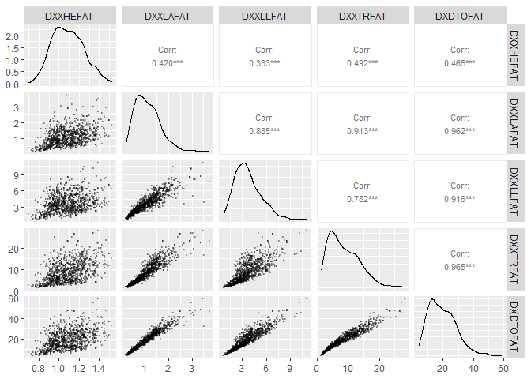

## Exploring DXA - Body parts total weight

Data was only ploted for the left arm and leg

Summary of body parts total weights

|  | vars | n | mean | sd | median | trimmed | mad | min | max | range | skew | kurtosis | se |
| --- | --- | --- | --- | --- | --- | --- | --- | --- | --- | --- | --- | --- | --- |
| DXDHETOT | 1 | 20235 | 4.575 | 0.631 | 4.534 | 4.557 | 0.664 | 2.849 | 6.767 | 3.918 | 0.275 | -0.241 | 0.004 |
| DXDLATOT | 2 | 20235 | 3.689 | 1.289 | 3.583 | 3.645 | 1.350 | 0.968 | 8.288 | 7.320 | 0.328 | -0.333 | 0.009 |
| DXDLLTOT | 3 | 20235 | 11.094 | 3.194 | 11.006 | 11.073 | 3.087 | 3.167 | 23.581 | 20.414 | 0.148 | 0.098 | 0.022 |
| DXDTRTOT | 4 | 20235 | 30.707 | 10.518 | 30.266 | 30.508 | 10.592 | 8.561 | 72.623 | 64.062 | 0.227 | -0.268 | 0.074 |

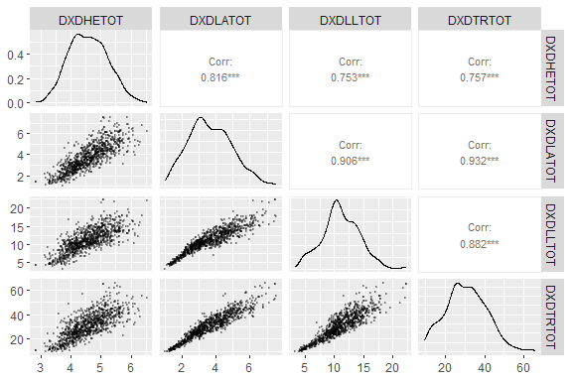

# Building Regression Models

## Using all independent variables

All independent variables were normalized (centered by subtracting the column means from their corresponding columns and divided by the centered columns by their standard deviations) except binary sex variable

### Stepwise regression models

Step-wise regression model based on all independent variables

|  | (Intercept) | BMXWT | BMXHT | RIAGENDR | RIDAGEEX | BMXWAIST | BMXARMC | BMXTHICR | BMXCALF | BMXARML | BMXLEG | BMXTRI | BMXSUB | R2 | RMSE |
| --- | --- | --- | --- | --- | --- | --- | --- | --- | --- | --- | --- | --- | --- | --- | --- |
| DXXHEFAT | 1.121 | 0.114 | 0.007 | -0.073 | -0.019 | -0.004 | 0.013 | -0.006 | NA | -0.006 | NA | -0.018 | 0.019 | 0.739 | 0.079 |
| DXXLAFAT | 1.044 | 0.307 | -0.128 | 0.139 | NA | 0.117 | 0.046 | -0.065 | 0.008 | 0.025 | -0.006 | 0.229 | 0.006 | 0.893 | 0.179 |
| DXXLLFAT | 3.414 | 0.769 | -0.293 | 0.592 | -0.028 | 0.173 | -0.646 | 0.496 | 0.254 | 0.071 | 0.074 | 0.794 | -0.127 | 0.850 | 0.612 |
| DXXTRFAT | 8.217 | 4.412 | -1.157 | 1.234 | 0.202 | 2.283 | -0.854 | -0.653 | -0.530 | -0.158 | -0.236 | 0.934 | 0.326 | 0.935 | 1.263 |
| DXDTOFAT | 18.311 | 6.647 | -1.957 | 2.639 | 0.131 | 2.868 | -2.025 | 0.229 | NA | NA | -0.101 | 2.970 | 0.109 | 0.937 | 2.203 |
| DXDHETOT | 4.689 | 0.441 | 0.095 | -0.247 | -0.038 | -0.107 | 0.078 | 0.017 | NA | -0.026 | -0.014 | -0.087 | 0.078 | 0.736 | 0.324 |
| DXDLATOT | 3.779 | 1.219 | -0.139 | -0.195 | -0.026 | -0.218 | 0.518 | -0.216 | -0.069 | 0.092 | 0.046 | -0.102 | 0.026 | 0.970 | 0.225 |
| DXDLLTOT | 11.094 | 2.911 | -0.038 | NA | -0.156 | -0.628 | -0.613 | 0.736 | 0.499 | 0.116 | 0.211 | 0.320 | -0.102 | 0.966 | 0.586 |
| DXDTRTOT | 30.407 | 10.649 | 0.303 | 0.650 | 0.416 | 1.772 | 0.174 | -1.085 | -0.877 | -0.458 | -0.441 | -0.379 | 0.123 | 0.987 | 1.217 |
| DXDTOBMC | 2.109 | 0.416 | 0.253 | 0.076 | 0.051 | -0.263 | 0.122 | 0.076 | -0.040 | NA | NA | -0.129 | 0.021 | 0.856 | 0.235 |
| DXDTOBMD | 1.073 | 0.030 | 0.069 | 0.047 | 0.022 | -0.066 | 0.055 | 0.046 | -0.010 | NA | -0.002 | -0.044 | 0.018 | 0.667 | 0.090 |
| DXDHEPF | 23.912 | 0.130 | -0.301 | -0.339 | -0.210 | 0.459 | -0.096 | -0.207 | 0.029 | NA | 0.047 | 0.054 | 0.012 | 0.408 | 0.422 |
| DXDLAPF | 27.714 | -5.581 | -1.331 | 5.559 | 0.221 | 5.697 | -0.765 | 0.629 | 0.793 | NA | -0.169 | 6.039 | 0.344 | 0.834 | 4.336 |
| DXDLLPF | 30.551 | -3.226 | -1.893 | 5.636 | NA | 3.958 | -2.603 | 1.869 | 0.528 | 0.191 | 0.158 | 5.455 | -0.623 | 0.778 | 4.451 |
| DXDTRPF | 25.555 | -2.639 | -1.840 | 3.623 | 0.305 | 6.948 | -0.509 | 0.380 | -0.299 | 0.230 | -0.281 | 2.803 | 1.509 | 0.863 | 3.286 |
| DXDTOPF | 27.503 | -2.616 | -1.895 | 4.226 | 0.171 | 5.196 | -1.436 | 0.811 | 0.243 | 0.196 | NA | 3.941 | 0.506 | 0.857 | 3.087 |

### Ridge regression

Ridge regression model based on all independent variables

|  | (Intercept) | BMXWT | BMXHT | RIAGENDR | RIDAGEEX | BMXWAIST | BMXARMC | BMXTHICR | BMXCALF | BMXARML | BMXLEG | BMXTRI | BMXSUB | R2 | RMSE |
| --- | --- | --- | --- | --- | --- | --- | --- | --- | --- | --- | --- | --- | --- | --- | --- |
| DXXHEFAT | 1.122 | 0.107 | 0.003 | -0.076 | -0.015 | 0.000 | 0.008 | 0.000 | 0.000 | 0.000 | 0.000 | -0.015 | 0.015 | 0.738 | 0.079 |
| DXXLAFAT | 1.046 | 0.270 | -0.104 | 0.134 | 0.002 | 0.131 | 0.045 | -0.039 | 0.000 | 0.014 | -0.010 | 0.227 | 0.008 | 0.892 | 0.179 |
| DXXLLFAT | 3.415 | 0.726 | -0.270 | 0.590 | -0.028 | 0.176 | -0.621 | 0.499 | 0.255 | 0.062 | 0.070 | 0.790 | -0.119 | 0.850 | 0.612 |
| DXXTRFAT | 8.217 | 4.371 | -1.138 | 1.232 | 0.202 | 2.291 | -0.837 | -0.642 | -0.528 | -0.162 | -0.242 | 0.932 | 0.325 | 0.935 | 1.263 |
| DXDTOFAT | 18.312 | 6.588 | -1.979 | 2.637 | 0.126 | 2.875 | -2.004 | 0.222 | 0.015 | 0.048 | -0.100 | 2.967 | 0.116 | 0.938 | 2.203 |
| DXDHETOT | 4.689 | 0.423 | 0.085 | -0.247 | -0.037 | -0.089 | 0.075 | 0.017 | 0.000 | -0.016 | -0.006 | -0.085 | 0.072 | 0.736 | 0.324 |
| DXDLATOT | 3.782 | 1.144 | -0.106 | -0.201 | -0.023 | -0.184 | 0.514 | -0.189 | -0.061 | 0.085 | 0.038 | -0.102 | 0.024 | 0.969 | 0.225 |
| DXDLLTOT | 11.093 | 2.839 | -0.011 | 0.002 | -0.159 | -0.602 | -0.587 | 0.742 | 0.503 | 0.107 | 0.210 | 0.313 | -0.096 | 0.966 | 0.586 |
| DXDTRTOT | 30.412 | 10.658 | 0.305 | 0.641 | 0.420 | 1.769 | 0.161 | -1.072 | -0.880 | -0.457 | -0.447 | -0.373 | 0.116 | 0.987 | 1.217 |
| DXDTOBMC | 2.113 | 0.386 | 0.257 | 0.067 | 0.049 | -0.242 | 0.119 | 0.069 | -0.022 | 0.001 | 0.000 | -0.125 | 0.016 | 0.856 | 0.236 |
| DXDTOBMD | 1.077 | 0.004 | 0.072 | 0.039 | 0.020 | -0.045 | 0.053 | 0.043 | 0.000 | 0.000 | 0.000 | -0.040 | 0.013 | 0.665 | 0.090 |
| DXDHEPF | 23.910 | 0.081 | -0.276 | -0.335 | -0.208 | 0.468 | -0.077 | -0.180 | 0.017 | 0.000 | 0.034 | 0.050 | 0.011 | 0.407 | 0.422 |
| DXDLAPF | 27.710 | -5.516 | -1.256 | 5.569 | 0.222 | 5.686 | -0.732 | 0.612 | 0.769 | -0.129 | -0.156 | 6.043 | 0.332 | 0.834 | 4.335 |
| DXDLLPF | 30.557 | -3.219 | -1.858 | 5.625 | 0.012 | 3.941 | -2.610 | 1.896 | 0.508 | 0.171 | 0.139 | 5.457 | -0.620 | 0.778 | 4.451 |
| DXDTRPF | 25.553 | -2.594 | -1.824 | 3.628 | 0.302 | 6.929 | -0.493 | 0.357 | -0.301 | 0.200 | -0.283 | 2.808 | 1.501 | 0.863 | 3.286 |
| DXDTOPF | 27.503 | -2.563 | -1.853 | 4.226 | 0.165 | 5.169 | -1.430 | 0.820 | 0.216 | 0.183 | -0.044 | 3.948 | 0.497 | 0.857 | 3.087 |

### Lasso regression

Lasso regression model based on all independent variables

|  | (Intercept) | BMXWT | BMXHT | RIAGENDR | RIDAGEEX | BMXWAIST | BMXARMC | BMXTHICR | BMXCALF | BMXARML | BMXLEG | BMXTRI | BMXSUB | R2 | RMSE |
| --- | --- | --- | --- | --- | --- | --- | --- | --- | --- | --- | --- | --- | --- | --- | --- |
| DXXHEFAT | 1.122 | 0.107 | 0.003 | -0.076 | -0.015 | 0.000 | 0.008 | 0.000 | 0.000 | 0.000 | 0.000 | -0.015 | 0.015 | 0.738 | 0.079 |
| DXXLAFAT | 1.046 | 0.270 | -0.104 | 0.134 | 0.002 | 0.131 | 0.045 | -0.039 | 0.000 | 0.014 | -0.010 | 0.227 | 0.008 | 0.892 | 0.179 |
| DXXLLFAT | 3.415 | 0.726 | -0.270 | 0.590 | -0.028 | 0.176 | -0.621 | 0.499 | 0.255 | 0.062 | 0.070 | 0.790 | -0.119 | 0.850 | 0.612 |
| DXXTRFAT | 8.217 | 4.371 | -1.138 | 1.232 | 0.202 | 2.291 | -0.837 | -0.642 | -0.528 | -0.162 | -0.242 | 0.932 | 0.325 | 0.935 | 1.263 |
| DXDTOFAT | 18.312 | 6.588 | -1.979 | 2.637 | 0.126 | 2.875 | -2.004 | 0.222 | 0.015 | 0.048 | -0.100 | 2.967 | 0.116 | 0.938 | 2.203 |
| DXDHETOT | 4.689 | 0.423 | 0.085 | -0.247 | -0.037 | -0.089 | 0.075 | 0.017 | 0.000 | -0.016 | -0.006 | -0.085 | 0.072 | 0.736 | 0.324 |
| DXDLATOT | 3.782 | 1.144 | -0.106 | -0.201 | -0.023 | -0.184 | 0.514 | -0.189 | -0.061 | 0.085 | 0.038 | -0.102 | 0.024 | 0.969 | 0.225 |
| DXDLLTOT | 11.093 | 2.839 | -0.011 | 0.002 | -0.159 | -0.602 | -0.587 | 0.742 | 0.503 | 0.107 | 0.210 | 0.313 | -0.096 | 0.966 | 0.586 |
| DXDTRTOT | 30.412 | 10.658 | 0.305 | 0.641 | 0.420 | 1.769 | 0.161 | -1.072 | -0.880 | -0.457 | -0.447 | -0.373 | 0.116 | 0.987 | 1.217 |
| DXDTOBMC | 2.113 | 0.386 | 0.257 | 0.067 | 0.049 | -0.242 | 0.119 | 0.069 | -0.022 | 0.001 | 0.000 | -0.125 | 0.016 | 0.856 | 0.236 |
| DXDTOBMD | 1.077 | 0.004 | 0.072 | 0.039 | 0.020 | -0.045 | 0.053 | 0.043 | 0.000 | 0.000 | 0.000 | -0.040 | 0.013 | 0.665 | 0.090 |
| DXDHEPF | 23.910 | 0.081 | -0.276 | -0.335 | -0.208 | 0.468 | -0.077 | -0.180 | 0.017 | 0.000 | 0.034 | 0.050 | 0.011 | 0.407 | 0.422 |
| DXDLAPF | 27.710 | -5.516 | -1.256 | 5.569 | 0.222 | 5.686 | -0.732 | 0.612 | 0.769 | -0.129 | -0.156 | 6.043 | 0.332 | 0.834 | 4.335 |
| DXDLLPF | 30.557 | -3.234 | -1.859 | 5.624 | 0.013 | 3.950 | -2.613 | 1.902 | 0.510 | 0.174 | 0.140 | 5.457 | -0.622 | 0.778 | 4.451 |
| DXDTRPF | 25.553 | -2.586 | -1.825 | 3.628 | 0.301 | 6.925 | -0.491 | 0.352 | -0.299 | 0.197 | -0.281 | 2.808 | 1.500 | 0.863 | 3.286 |
| DXDTOPF | 27.503 | -2.563 | -1.853 | 4.226 | 0.165 | 5.169 | -1.430 | 0.820 | 0.216 | 0.183 | -0.044 | 3.948 | 0.497 | 0.857 | 3.087 |

## Using only five independent variables

### Stepwise regression models

Step-wise regression model based on only five easily-measurable independent variables

|  | (Intercept) | BMXWT | BMXHT | RIAGENDR | RIDAGEEX | BMXWAIST | R2 | RMSE |
| --- | --- | --- | --- | --- | --- | --- | --- | --- |
| DXXHEFAT | 1.126 | 0.118 | 0.002 | -0.085 | -0.014 | NA | 0.732 | 0.080 |
| DXXLAFAT | 0.948 | 0.406 | -0.216 | 0.346 | -0.013 | 0.227 | 0.823 | 0.230 |
| DXXLLFAT | 2.985 | 1.534 | -0.505 | 1.523 | -0.285 | 0.189 | 0.717 | 0.841 |
| DXXTRFAT | 7.855 | 2.366 | -1.568 | 2.017 | 0.272 | 3.214 | 0.912 | 1.470 |
| DXDTOFAT | 16.895 | 6.400 | -3.011 | 5.704 | -0.342 | 4.047 | 0.892 | 2.893 |
| DXDHETOT | 4.712 | 0.544 | 0.049 | -0.297 | -0.022 | -0.112 | 0.727 | 0.329 |
| DXDLATOT | 3.865 | 1.376 | -0.057 | -0.382 | 0.048 | -0.179 | 0.951 | 0.284 |
| DXDLLTOT | 10.815 | 4.193 | NA | 0.604 | -0.439 | -0.951 | 0.942 | 0.769 |
| DXDTRTOT | 30.777 | 7.681 | 0.105 | -0.151 | 0.820 | 2.354 | 0.981 | 1.467 |
| DXDTOBMC | 2.161 | 0.560 | 0.257 | -0.037 | 0.061 | -0.323 | 0.839 | 0.249 |
| DXDTOBMD | 1.086 | 0.137 | 0.054 | 0.019 | 0.023 | -0.090 | 0.629 | 0.095 |
| DXDHEPF | 23.904 | -0.211 | -0.214 | -0.323 | -0.191 | 0.542 | 0.387 | 0.429 |
| DXDLAPF | 24.764 | -0.903 | -4.458 | 11.947 | -0.706 | 7.757 | 0.694 | 5.882 |
| DXDLLPF | 27.909 | NA | -3.760 | 11.358 | -1.246 | 5.123 | 0.639 | 5.674 |
| DXDTRPF | 23.994 | -0.583 | -3.749 | 7.003 | NA | 8.703 | 0.799 | 3.981 |
| DXDTOPF | 25.494 | NA | -3.720 | 8.576 | -0.519 | 6.520 | 0.750 | 4.074 |

### Ridge regression

Ridge regression model based on only five easily-measurable independent variables

|  | (Intercept) | BMXWT | BMXHT | RIAGENDR | RIDAGEEX | BMXWAIST | R2 | RMSE |
| --- | --- | --- | --- | --- | --- | --- | --- | --- |
| DXXHEFAT | 1.126 | 0.117 | 0.002 | -0.084 | -0.012 | 0.000 | 0.732 | 0.080 |
| DXXLAFAT | 0.949 | 0.395 | -0.211 | 0.344 | -0.012 | 0.231 | 0.823 | 0.230 |
| DXXLLFAT | 2.986 | 1.520 | -0.498 | 1.521 | -0.284 | 0.196 | 0.717 | 0.841 |
| DXXTRFAT | 7.855 | 2.372 | -1.568 | 2.016 | 0.272 | 3.207 | 0.912 | 1.470 |
| DXDTOFAT | 16.896 | 6.420 | -3.017 | 5.703 | -0.337 | 4.028 | 0.892 | 2.893 |
| DXDHETOT | 4.712 | 0.523 | 0.055 | -0.297 | -0.023 | -0.096 | 0.727 | 0.329 |
| DXDLATOT | 3.864 | 1.339 | -0.041 | -0.380 | 0.043 | -0.151 | 0.951 | 0.285 |
| DXDLLTOT | 10.817 | 4.168 | 0.005 | 0.599 | -0.440 | -0.931 | 0.942 | 0.769 |
| DXDTRTOT | 30.776 | 7.718 | 0.092 | -0.148 | 0.823 | 2.325 | 0.981 | 1.467 |
| DXDTOBMC | 2.161 | 0.542 | 0.263 | -0.036 | 0.058 | -0.306 | 0.839 | 0.249 |
| DXDTOBMD | 1.088 | 0.117 | 0.060 | 0.015 | 0.019 | -0.072 | 0.627 | 0.095 |
| DXDHEPF | 23.903 | -0.188 | -0.220 | -0.320 | -0.187 | 0.522 | 0.387 | 0.429 |
| DXDLAPF | 24.764 | -0.848 | -4.477 | 11.947 | -0.698 | 7.712 | 0.694 | 5.882 |
| DXDLLPF | 27.908 | 0.126 | -3.809 | 11.360 | -1.237 | 5.030 | 0.639 | 5.674 |
| DXDTRPF | 23.995 | -0.504 | -3.775 | 7.001 | 0.013 | 8.637 | 0.799 | 3.982 |
| DXDTOPF | 25.496 | -0.075 | -3.687 | 8.572 | -0.521 | 6.569 | 0.750 | 4.074 |

### Lasso regression

Lasso regression model based on only five easily-measurable independent variables

|  | (Intercept) | BMXWT | BMXHT | RIAGENDR | RIDAGEEX | BMXWAIST | R2 | RMSE |
| --- | --- | --- | --- | --- | --- | --- | --- | --- |
| DXXHEFAT | 1.126 | 0.117 | 0.002 | -0.084 | -0.012 | 0.000 | 0.732 | 0.080 |
| DXXLAFAT | 0.949 | 0.395 | -0.211 | 0.344 | -0.012 | 0.231 | 0.823 | 0.230 |
| DXXLLFAT | 2.986 | 1.520 | -0.498 | 1.521 | -0.284 | 0.196 | 0.717 | 0.841 |
| DXXTRFAT | 7.855 | 2.372 | -1.568 | 2.016 | 0.272 | 3.207 | 0.912 | 1.470 |
| DXDTOFAT | 16.896 | 6.420 | -3.017 | 5.703 | -0.337 | 4.028 | 0.892 | 2.893 |
| DXDHETOT | 4.712 | 0.523 | 0.055 | -0.297 | -0.023 | -0.096 | 0.727 | 0.329 |
| DXDLATOT | 3.864 | 1.339 | -0.041 | -0.380 | 0.043 | -0.151 | 0.951 | 0.285 |
| DXDLLTOT | 10.817 | 4.168 | 0.005 | 0.599 | -0.440 | -0.931 | 0.942 | 0.769 |
| DXDTRTOT | 30.776 | 7.718 | 0.092 | -0.148 | 0.823 | 2.325 | 0.981 | 1.467 |
| DXDTOBMC | 2.161 | 0.542 | 0.263 | -0.036 | 0.058 | -0.306 | 0.839 | 0.249 |
| DXDTOBMD | 1.088 | 0.117 | 0.060 | 0.015 | 0.019 | -0.072 | 0.627 | 0.095 |
| DXDHEPF | 23.903 | -0.188 | -0.220 | -0.320 | -0.187 | 0.522 | 0.387 | 0.429 |
| DXDLAPF | 24.764 | -0.848 | -4.477 | 11.947 | -0.698 | 7.712 | 0.694 | 5.882 |
| DXDLLPF | 27.908 | 0.126 | -3.809 | 11.360 | -1.237 | 5.030 | 0.639 | 5.674 |
| DXDTRPF | 23.995 | -0.504 | -3.775 | 7.001 | 0.013 | 8.637 | 0.799 | 3.982 |
| DXDTOPF | 25.499 | -0.001 | -3.710 | 8.565 | -0.505 | 6.501 | 0.750 | 4.074 |

# Simple formulas

The following formulas were generated based on lasso regression analysis and can be used to provide rougher estimation of body parts fat and total mass as well as percentage of mass. Independent variables should be used in original, non-normalized, form.

DXXHEFAT = (0.117) × BMXWT + (0.002) × BMXHT + (-0.084) × RIAGENDR + (-0.012) × RIDAGEEX + (0.000)

DXXLAFAT = (0.395) × BMXWT + (-0.211) × BMXHT + (0.344) × RIAGENDR + (-0.012) × RIDAGEEX + (0.231) × BMXWAIST + (0.231)

DXXLLFAT = (1.520) × BMXWT + (-0.498) × BMXHT + (1.521) × RIAGENDR + (-0.284) × RIDAGEEX + (0.196) × BMXWAIST + (0.196)

DXXTRFAT = (2.372) × BMXWT + (-1.568) × BMXHT + (2.016) × RIAGENDR + (0.272) × RIDAGEEX + (3.207) × BMXWAIST + (3.207)

DXDTOFAT = (6.420) × BMXWT + (-3.017) × BMXHT + (5.703) × RIAGENDR + (-0.337) × RIDAGEEX + (4.028) × BMXWAIST + (4.028)

DXDHETOT = (0.523) × BMXWT + (0.055) × BMXHT + (-0.297) × RIAGENDR + (-0.023) × RIDAGEEX + (-0.096) × BMXWAIST + (-0.096)

DXDLATOT = (1.339) × BMXWT + (-0.041) × BMXHT + (-0.380) × RIAGENDR + (0.043) × RIDAGEEX + (-0.151) × BMXWAIST + (-0.151)

DXDLLTOT = (4.168) × BMXWT + (0.005) × BMXHT + (0.599) × RIAGENDR + (-0.440) × RIDAGEEX + (-0.931) × BMXWAIST + (-0.931)

DXDTRTOT = (7.718) × BMXWT + (0.092) × BMXHT + (-0.148) × RIAGENDR + (0.823) × RIDAGEEX + (2.325) × BMXWAIST + (2.325)

DXDTOBMC = (0.542) × BMXWT + (0.263) × BMXHT + (-0.036) × RIAGENDR + (0.058) × RIDAGEEX + (-0.306) × BMXWAIST + (-0.306)

DXDTOBMD = (0.117) × BMXWT + (0.060) × BMXHT + (0.015) × RIAGENDR + (0.019) × RIDAGEEX + (-0.072) × BMXWAIST + (-0.072)

DXDHEPF = (-0.188) × BMXWT + (-0.220) × BMXHT + (-0.320) × RIAGENDR + (-0.187) × RIDAGEEX + (0.522) × BMXWAIST + (0.522)

DXDLAPF = (-0.848) × BMXWT + (-4.477) × BMXHT + (11.947) × RIAGENDR + (-0.698) × RIDAGEEX + (7.712) × BMXWAIST + (7.712)

DXDLLPF = (0.126) × BMXWT + (-3.809) × BMXHT + (11.360) × RIAGENDR + (-1.237) × RIDAGEEX + (5.030) × BMXWAIST + (5.030)

DXDTRPF = (-0.504) × BMXWT + (-3.775) × BMXHT + (7.001) × RIAGENDR + (0.013) × RIDAGEEX + (8.637) × BMXWAIST + (8.637)

DXDTOPF = (-0.001) × BMXWT + (-3.710) × BMXHT + (8.565) × RIAGENDR + (-0.505) × RIDAGEEX + (6.501) × BMXWAIST + (6.501)

# References

<https://www.datacamp.com/tutorial/tutorial-ridge-lasso-elastic-net>