Walkthrough

1. Open admin.php first and click the button in the upper left hand corner.
2. Then click the link that states “BACK”.
3. This should redirect you to the login page.
4. Going to any other page before logging in will redirect you to the login page.
5. To register, click the Register link and make an account.
6. Then go back to the login page and login.
7. This will take you to the main page.
8. Your session is stored with a PHPSESSID cookie.
9. To logout, click the Logout link where your username is displayed in the right hand corner below the header image on every page.
10. The IRC works perfectly fine except on the school’s Wi-Fi, so here is a screenshot of it functioning: 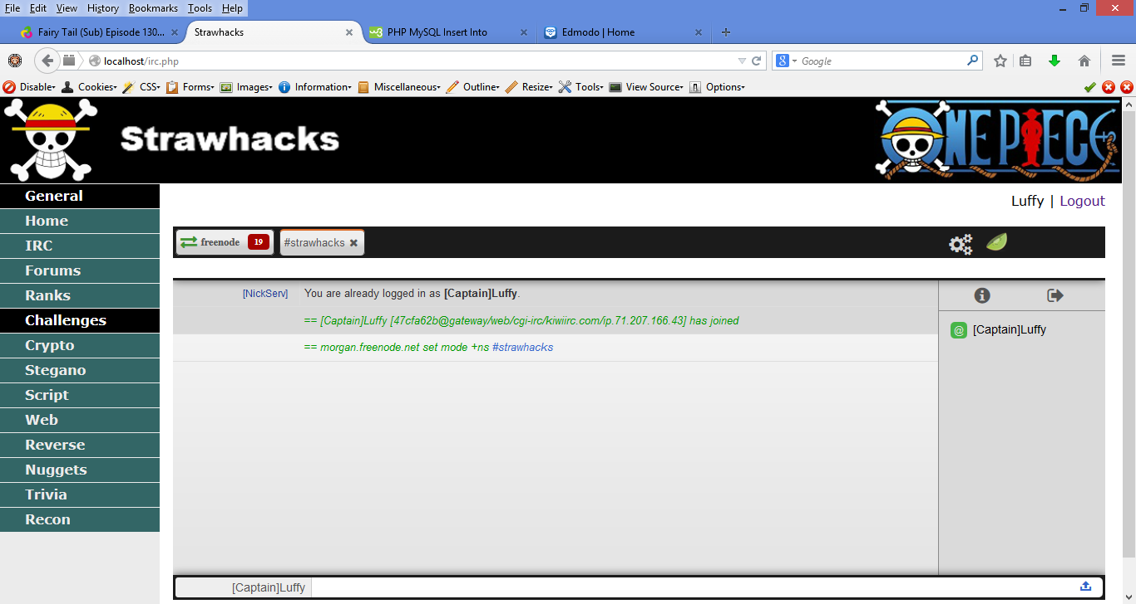
11. Not all the pages have challenges on them quite yet because some of them take extensive amounts of time to create, and I wanted to get all the PHP and MySQL coding done so only a handful of challenges are necessary to prove that I can make more easily and that everything works properly.
12. The site will be fully developed over the summer, so I will send you a link to it once we publish it.
13. The most developed challenge category is the Crypto section if you want to get the best feel for how the site operates and looks.
14. Here are the solutions to the crypto challenges for your testing purposes:

* 1- One Piece
* 2- WE ARE!
* 3- MonkeyDLuffy
* 4- Thousand Sunny
* 5- santoryu
* 6- Strawhats
* 7- marines
* 8- Ohara
* 9- CHoPPEr
* 10- R0r0n04Z0r0
* 11- NicoRobin
* 12- MEAT
* 13- GolDRoger
* 14- Going Merry
* 15- takoyaki

1. Here are the solutions to the rest of the challenges made so far:

* Stegano1- NewWorld
* Stegano2- Mugiwara
* Web1- Franky
* Recon1- Br00k

1. Enjoy!