Slovenia Flood Susceptibility Mapping — Analysis Report
This report summarises the results of Items 3–6 of the FSM analysis: class area statistics, frequency ratio analysis, comparison with national flood hazard zones, and spatial agreement across models.

1. Susceptibility Class Area Statistics (Item 3)
For each of the five models, pixels were counted per susceptibility class (1–5), converted to km², and expressed as a percentage of the total valid Slovenia area. The cross-tabulation column 'Pct_Flooded' shows what percentage of pixels in each class are historically flooded (from the Flooded_NoFlood reference raster).
Table 1: Class area statistics for all models
Model | Class | Class_Label | Pixels | Area_km2 | Pct_Total | Pct_Flooded
RF | 1 | Very Low | 25871433 | 4042.41 | 19.96 | 0.0
RF | 2 | Low | 25932814 | 4052.0 | 20.01 | 0.0
RF | 3 | Moderate | 25959647 | 4056.19 | 20.03 | 0.002
RF | 4 | High | 25952851 | 4055.13 | 20.02 | 0.073
RF | 5 | Very High | 25906069 | 4047.82 | 19.99 | 28.08
XGBoost | 1 | Very Low | 25912509 | 4048.83 | 19.99 | 0.0
XGBoost | 2 | Low | 25929422 | 4051.47 | 20.0 | 0.0
XGBoost | 3 | Moderate | 25951374 | 4054.9 | 20.02 | 0.0
XGBoost | 4 | High | 25896850 | 4046.38 | 19.98 | 0.01
XGBoost | 5 | Very High | 25932659 | 4051.98 | 20.01 | 28.116
CatBoost | 1 | Very Low | 25925520 | 4050.86 | 20.0 | 0.0
CatBoost | 2 | Low | 25904126 | 4047.52 | 19.98 | 0.0
CatBoost | 3 | Moderate | 25929126 | 4051.43 | 20.0 | 0.001
CatBoost | 4 | High | 25944382 | 4053.81 | 20.02 | 0.04
CatBoost | 5 | Very High | 25919660 | 4049.95 | 20.0 | 28.099
Ensemble_mean | 1 | Very Low | 25890777 | 4045.43 | 19.97 | 0.0
Ensemble_mean | 2 | Low | 25910989 | 4048.59 | 19.99 | 0.0
Ensemble_mean | 3 | Moderate | 25993449 | 4061.48 | 20.05 | 0.001
Ensemble_mean | 4 | High | 25897494 | 4046.48 | 19.98 | 0.03
Ensemble_mean | 5 | Very High | 25930105 | 4051.58 | 20.0 | 28.099
DNN | 1 | Very Low | 25923045 | 4050.48 | 20.0 | 0.0
DNN | 2 | Low | 25900062 | 4046.88 | 19.98 | 0.0
DNN | 3 | Moderate | 25945982 | 4054.06 | 20.02 | 0.002
DNN | 4 | High | 25940833 | 4053.26 | 20.01 | 0.08
DNN | 5 | Very High | 25912892 | 4048.89 | 19.99 | 28.066

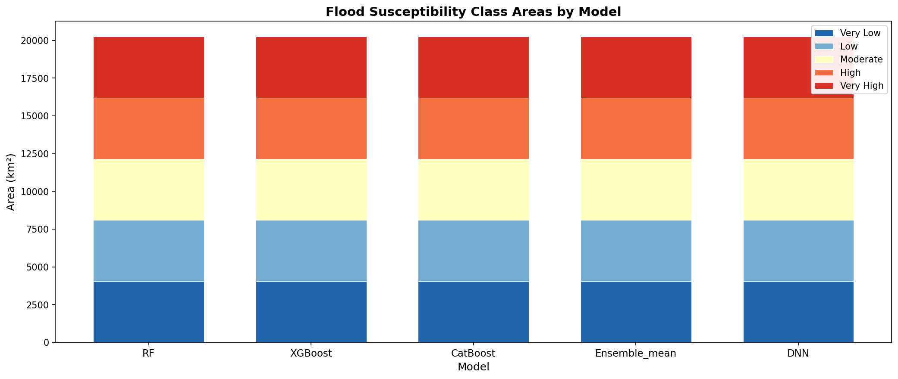

2. Frequency Ratio Analysis (Item 4)
Frequency Ratio (FR) was computed for each conditioning factor at 1/10 spatial scale (~1.3 M pixels). Continuous factors were binned into 10 quantile classes; categorical factors (Hgk_grouped, Pedoloska_grouped, lito_poly_250_d96_grouped) used their natural unique values. FR > 1 indicates flood-prone classes; FR < 1 indicates relatively safe classes.
Table 2: Frequency Ratio values (first 60 rows; full data in frequency_ratio.csv)
Feature | Bin | Bin_Label | Total_Px | Flood_Px | FR
Distance_to_River | 0 | 0.00–77.49 | 129010 | 22439 | 3.0823
Distance_to_River | 1 | 77.49–158.29 | 130012 | 14011 | 1.9098
Distance_to_River | 2 | 158.29–242.95 | 129673 | 9788 | 1.3376
Distance_to_River | 3 | 242.95–330.42 | 129674 | 7547 | 1.0314
Distance_to_River | 4 | 330.42–423.14 | 129637 | 5715 | 0.7812
Distance_to_River | 5 | 423.14–524.41 | 129561 | 4339 | 0.5935
Distance_to_River | 6 | 524.41–639.12 | 129640 | 3188 | 0.4358
Distance_to_River | 7 | 639.12–781.15 | 129608 | 2277 | 0.3113
Distance_to_River | 8 | 781.15–987.39 | 129601 | 1631 | 0.223
Distance_to_River | 9 | 987.39–3317.91 | 129607 | 2211 | 0.3023
Distance_to_Road | 0 | 0.00–18.26 | 128102 | 5726 | 0.7921
Distance_to_Road | 1 | 18.26–36.49 | 128662 | 6220 | 0.8567
Distance_to_Road | 2 | 36.49–59.79 | 131330 | 6569 | 0.8864
Distance_to_Road | 3 | 59.79–87.31 | 129956 | 6870 | 0.9368
Distance_to_Road | 4 | 87.31–118.59 | 129295 | 6688 | 0.9167
Distance_to_Road | 5 | 118.59–156.09 | 129894 | 6833 | 0.9322
Distance_to_Road | 6 | 156.09–203.97 | 129477 | 7010 | 0.9594
Distance_to_Road | 7 | 203.97–271.42 | 129984 | 7492 | 1.0214
Distance_to_Road | 8 | 271.42–392.59 | 129648 | 8304 | 1.135
Distance_to_Road | 9 | 392.59–2269.63 | 129595 | 11183 | 1.5292
Hgk_grouped | 1 | 1 | 42761 | 544 | 0.2254
Hgk_grouped | 2 | 2 | 171500 | 43826 | 4.5286
Hgk_grouped | 3 | 3 | 163792 | 1155 | 0.125
Hgk_grouped | 4 | 4 | 10050 | 212 | 0.3738
Hgk_grouped | 5 | 5 | 65021 | 18019 | 4.911
Hgk_grouped | 6 | 6 | 205836 | 1391 | 0.1198
Hgk_grouped | 7 | 7 | 191460 | 4727 | 0.4375
Hgk_grouped | 8 | 8 | 251553 | 1792 | 0.1262
Hgk_grouped | 9 | 9 | 1604 | 437 | 4.828
Hgk_grouped | 10 | 10 | 192523 | 1010 | 0.093
LULC | 1 | 1 | 114214 | 24533 | 3.8065
LULC | 2 | 2 | 32985 | 1001 | 0.5378
LULC | 3 | 3 | 241868 | 21676 | 1.5882
LULC | 4 | 4 | 810619 | 13626 | 0.2979
LULC | 5 | 5 | 67363 | 5791 | 1.5234
LULC | 6 | 6 | 9296 | 6476 | 12.3454
LULC | 7 | 7 | 19716 | 39 | 0.0351
Pedoloska_grouped | 0 | 0 | 36061 | 4997 | 2.4556
Pedoloska_grouped | 1 | 1 | 2684 | 5 | 0.033
Pedoloska_grouped | 2 | 2 | 374453 | 1288 | 0.061
Pedoloska_grouped | 3 | 3 | 154710 | 812 | 0.093
Pedoloska_grouped | 4 | 4 | 27365 | 46 | 0.0298
Pedoloska_grouped | 5 | 5 | 213014 | 4755 | 0.3956
Pedoloska_grouped | 6 | 6 | 268132 | 1942 | 0.1283
Pedoloska_grouped | 7 | 7 | 30944 | 220 | 0.126
Pedoloska_grouped | 8 | 8 | 2644 | 0 | 0.0
Pedoloska_grouped | 9 | 9 | 65045 | 27497 | 7.4914
Pedoloska_grouped | 10 | 10 | 12390 | 14 | 0.02
Pedoloska_grouped | 11 | 11 | 48555 | 899 | 0.3281
Pedoloska_grouped | 12 | 12 | 60262 | 30669 | 9.0188
River_Density | 0 | 0.03–0.35 | 129603 | 3993 | 0.546
River_Density | 1 | 0.35–0.42 | 129602 | 2332 | 0.3189
River_Density | 2 | 0.42–0.46 | 129601 | 2280 | 0.3118
River_Density | 3 | 0.46–0.50 | 129603 | 2267 | 0.31
River_Density | 4 | 0.50–0.53 | 129602 | 2595 | 0.3548
River_Density | 5 | 0.53–0.57 | 129603 | 3010 | 0.4116
River_Density | 6 | 0.57–0.61 | 129602 | 4035 | 0.5517
River_Density | 7 | 0.61–0.67 | 129602 | 6609 | 0.9037
River_Density | 8 | 0.67–0.77 | 129602 | 14807 | 2.0246
River_Density | 9 | 0.77–1.19 | 129603 | 31218 | 4.2686

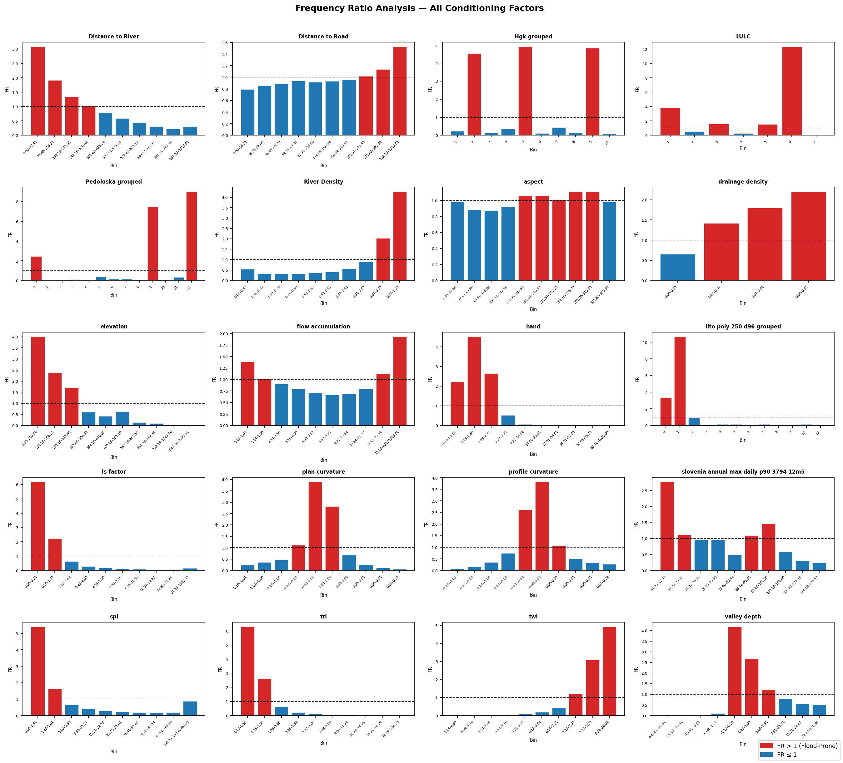

3. National Flood Map Comparison (Item 5)
National flood zones (Frequent, Rare, Extreme Rare) were rasterized to the model grid and overlaid with the Ensemble_mean and XGBoost 5-class maps. Two metrics are reported: (a) % of each national zone that falls in model class 4 or 5, and (b) % of the Very High class (5) that overlaps each national zone.
Table 3: National flood zone comparison
Model | Flood_Zone | Zone_Area_km2 | Overlap_Cls4_5_km2 | Pct_Zone_in_Cls4_5 | VeryHigh_Area_km2 | Pct_VeryHigh_in_Zone
Ensemble_mean | Frequent | 97.09 | 97.09 | 100.0 | 4051.58 | 2.4
Ensemble_mean | Rare | 464.88 | 464.88 | 100.0 | 4051.58 | 11.46
Ensemble_mean | Extreme_Rare | 1038.86 | 1038.84 | 100.0 | 4051.58 | 25.62
XGBoost | Frequent | 97.09 | 97.09 | 100.0 | 4051.98 | 2.4
XGBoost | Rare | 464.88 | 464.88 | 100.0 | 4051.98 | 11.47
XGBoost | Extreme_Rare | 1038.86 | 1038.86 | 100.0 | 4051.98 | 25.63

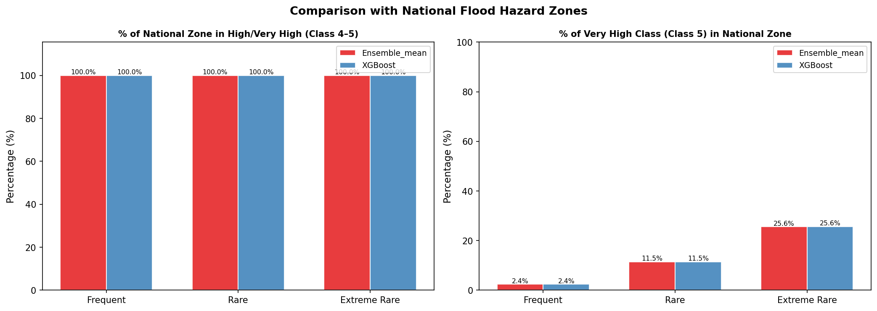

4. Spatial Agreement (Item 6)
The agreement map counts, for each pixel, how many of the five models classify it as Very High susceptibility (class 5). Values range from 0 (no model) to 5 (all models). A consensus map of pixels with ≥4 models agreeing on Very High is discussed below.
Table 4: Spatial agreement statistics
Models_Agree_VeryHigh | Pixels | Area_km2 | Pct_Slovenia
0.0 | 98650083.0 | 15414.08 | 76.1055
1.0 | 3488073.0 | 545.01 | 2.6909
2.0 | 1690320.0 | 264.11 | 1.304
3.0 | 1734075.0 | 270.95 | 1.3378
4.0 | 2770868.0 | 432.95 | 2.1376
5.0 | 21289395.0 | 3326.47 | 16.4241

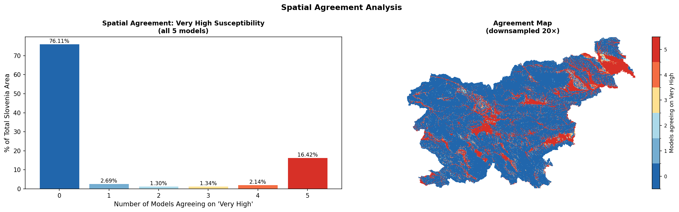
Consensus Very High area (≥4 models agreeing): 18.56% of Slovenia.

