Flood Susceptibility Mapping of Slovenia
Multi-Scale Machine Learning Analysis — Summary Report

Date: 31 July 2026

Resolution: 12.5 m | CRS: EPSG:3794 | Study area: ~20,254 km²

1. Executive Summary
This report presents a comprehensive flood susceptibility mapping (FSM) study for Slovenia using four machine learning (ML) models — Random Forest (RF), XGBoost, CatBoost, and a Deep Neural Network (DNN) — trained across five sample sizes (1x to 10x, corresponding to 50,000–500,000 samples per class). The study evaluates model performance through both standard random-split validation and rigorous 5-fold spatial block cross-validation (50 km blocks) to assess true spatial generalisation. Explainability was addressed using SHAP (SHapley Additive exPlanations) for all models and sample sizes. Key findings include:
- XGBoost consistently achieved the highest standard validation performance across all sample sizes (AUC up to 0.994, CSI up to 0.940 at 10x).
- Spatial CV revealed that RF is the most spatially robust model (AUC ≈ 0.965, CSI ≈ 0.830 across all sizes), indicating superior generalisation to unseen spatial regions.
- Performance improved steadily from 1x to 10x training samples in standard validation, but spatial CV metrics plateaued — suggesting spatial autocorrelation is the dominant limiting factor rather than sample size.
- The ensemble mean model provides a reliable consensus flood susceptibility map, predicting ~2,176 km² of flood-prone area (10.7% of Slovenia) at the CSI-optimal threshold.
- SHAP analysis consistently identified Soil Type, HAND (Height Above Nearest Drainage), Elevation, TRI (Terrain Ruggedness Index), and Lithology as the most influential conditioning factors across all models and sample sizes.

2. Study Area & Data

2.1 Study Area
The study covers the entire territory of Slovenia (approximately 20,254 km²) using a 12.5 m spatial resolution raster grid aligned to the national coordinate reference system EPSG:3794 (Transverse Mercator, Bessel 1841 ellipsoid). The total analysis grid comprises approximately 129.6 million valid pixels.

2.2 Conditioning Factors
Nineteen flood conditioning factors were selected after VIF-based collinearity analysis from an initial set of terrain, hydrological, soil, and climatic variables:
# | Factor | Description
1 | Distance to River | Proximity to stream network (m)
2 | Distance to Road | Proximity to road network (m)
3 | Hydrogeological Soil | Grouped hydrogeological soil classes
4 | Soil Type | Pedological soil classification (grouped)
5 | River Density | Stream density per unit area
6 | Aspect | Slope facing direction (°)
7 | Drainage Density | Total channel length / catchment area
8 | Elevation | Digital elevation model (m a.s.l.)
9 | Flow Accumulation | Upstream contributing area (cells)
10 | HAND | Height Above Nearest Drainage (m)
11 | Lithology | Grouped lithological classes
12 | LS Factor | Slope length and steepness factor
13 | Plan Curvature | Horizontal curvature of slope
14 | Profile Curvature | Vertical curvature of slope
15 | Rainfall P90 | Annual max daily precipitation 90th percentile (mm)
16 | SPI | Stream Power Index
17 | TRI | Terrain Ruggedness Index
18 | TWI | Topographic Wetness Index
19 | Valley Depth | Depth below surrounding terrain (m)

2.3 Training Samples
Size | Train/class | Total train | Test/class | Total test
1x | 50,000 | 100,000 | 9,957 | 19,957
2x | 100,000 | 200,000 | 9,957 | 39,914
3x | 150,000 | 300,000 | 9,957 | 59,871
4x | 200,000 | 400,000 | 9,957 | 79,828
10x | 500,000 | 1,000,000 | 99,575 | 199,495
Flood and non-flood samples were drawn in equal proportions (balanced classes). Test sets are held-out spatially distributed samples not used during training.

3. Methodology

3.1 Machine Learning Models
Random Forest (RF): Ensemble of 500 decision trees (max depth 25, min samples leaf 3, balanced class weight). Feature importance derived from mean decrease in impurity.
XGBoost: Gradient-boosted trees (1,000 estimators, max depth 8, learning rate 0.05, GPU hist method). Early stopping on validation AUC (patience = 50).
CatBoost: Gradient boosting with native categorical handling (1,000 iterations, depth 8, learning rate 0.05, GPU). Early stopping on validation AUC (patience = 50).
Deep Neural Network (DNN): Fully-connected MLP: 128 → 64 → 32 → 16 → 1 with BatchNorm, ReLU, Dropout(0.3). Trained with BCEWithLogitsLoss, Adam optimiser, CosineAnnealingLR, early stopping on validation AUC (patience = 20, max 200 epochs, batch size 4,096).
Ensemble (mean): Simple unweighted average of the four individual model probability outputs.

3.2 Validation Strategy
Two complementary validation approaches were applied:
Standard random-split validation: Models evaluated on a held-out test set (10% of total samples per size). Metrics: AUC-ROC, Average Precision, F1, Accuracy, Cohen's Kappa, CSI, Sensitivity, Specificity.
5-fold spatial block cross-validation: Samples partitioned into 5 folds by 50 km spatial blocks (checkerboard assignment). Each fold trains from scratch on 4 blocks, tests on the held-out spatial block. This evaluates true spatial generalisation beyond random-split optimism.

3.3 Threshold Optimisation & Map Classification
Binary flood/no-flood maps were generated using the CSI-optimal threshold (maximising TP / (TP + FP + FN)) found by grid search over 200 threshold values. Five-class susceptibility maps (Very Low → Very High) were generated using equal-frequency quantile breaks (Q20, Q40, Q60, Q80) computed from the full probability map, ensuring approximately equal area per class (~20% each).

3.4 SHAP Explainability
SHAP (SHapley Additive exPlanations) was applied to all four models at each sample size. TreeExplainer (tree_path_dependent) was used for RF and CatBoost; native Booster pred_contribs for XGBoost (to avoid XGBoost 3.x / shap compatibility issues); and GradientExplainer for the DNN. Sample sizes: RF (1,000), XGBoost/CatBoost (3,000), DNN (1,000 test + 300 background). Outputs include beeswarm plots, bar plots, dependence plots for the top-3 features, and cross-size rank stability analysis.

4. Standard Validation Results

4.1 Performance Across Sample Sizes
Table 1 presents the key validation metrics for all models across the five sample sizes. XGBoost consistently achieves the highest AUC and CSI. Performance improves with larger training sets, with the most significant gains between 1x and 2x.
Size | Model | AUC | Avg Prec | F1 | Kappa | CSI | Sens. | Spec.
1x | XGBoost | 0.9877 | 0.9851 | 0.9527 | 0.9038 | 0.9097 | 0.9717 | 0.9321
 | CatBoost | 0.9864 | 0.9836 | 0.9506 | 0.8999 | 0.9058 | 0.9642 | 0.9357
 | Ensemble_mean | 0.9859 | 0.9833 | 0.9491 | 0.8967 | 0.9031 | 0.9643 | 0.9324
 | RF | 0.9821 | 0.9787 | 0.9403 | 0.8788 | 0.8874 | 0.9565 | 0.9223
 | DNN | 0.9788 | 0.9728 | 0.9387 | 0.8745 | 0.8846 | 0.9635 | 0.9110
2x | XGBoost | 0.9910 | 0.9890 | 0.9611 | 0.9214 | 0.9252 | 0.9733 | 0.9482
 | Ensemble_mean | 0.9894 | 0.9873 | 0.9560 | 0.9115 | 0.9158 | 0.9637 | 0.9479
 | CatBoost | 0.9893 | 0.9870 | 0.9570 | 0.9128 | 0.9175 | 0.9713 | 0.9415
 | RF | 0.9862 | 0.9834 | 0.9488 | 0.8961 | 0.9027 | 0.9654 | 0.9308
 | DNN | 0.9830 | 0.9781 | 0.9458 | 0.8897 | 0.8971 | 0.9637 | 0.9260
3x | XGBoost | 0.9919 | 0.9904 | 0.9634 | 0.9259 | 0.9295 | 0.9781 | 0.9479
 | Ensemble_mean | 0.9901 | 0.9883 | 0.9577 | 0.9142 | 0.9188 | 0.9728 | 0.9414
 | CatBoost | 0.9899 | 0.9878 | 0.9579 | 0.9141 | 0.9192 | 0.9793 | 0.9349
 | RF | 0.9870 | 0.9844 | 0.9509 | 0.9002 | 0.9064 | 0.9686 | 0.9316
 | DNN | 0.9840 | 0.9795 | 0.9476 | 0.8928 | 0.9004 | 0.9714 | 0.9214
4x | XGBoost | 0.9925 | 0.9909 | 0.9650 | 0.9289 | 0.9323 | 0.9817 | 0.9472
 | Ensemble_mean | 0.9905 | 0.9886 | 0.9595 | 0.9177 | 0.9222 | 0.9770 | 0.9408
 | CatBoost | 0.9900 | 0.9879 | 0.9589 | 0.9164 | 0.9211 | 0.9773 | 0.9392
 | RF | 0.9877 | 0.9851 | 0.9524 | 0.9038 | 0.9091 | 0.9640 | 0.9398
 | DNN | 0.9847 | 0.9801 | 0.9501 | 0.8981 | 0.9050 | 0.9724 | 0.9258
10x | XGBoost | 0.9941 | 0.9931 | 0.9694 | 0.9381 | 0.9406 | 0.9824 | 0.9557
 | Ensemble_mean | 0.9921 | 0.9908 | 0.9627 | 0.9244 | 0.9280 | 0.9765 | 0.9479
 | CatBoost | 0.9910 | 0.9893 | 0.9613 | 0.9216 | 0.9255 | 0.9759 | 0.9458
 | RF | 0.9903 | 0.9887 | 0.9576 | 0.9138 | 0.9186 | 0.9755 | 0.9383
 | DNN | 0.9860 | 0.9821 | 0.9520 | 0.9019 | 0.9085 | 0.9752 | 0.9268
Table 1. Standard validation metrics for all models and sample sizes. Rows sorted by AUC within each sample size group. Colour bands distinguish sample sizes.

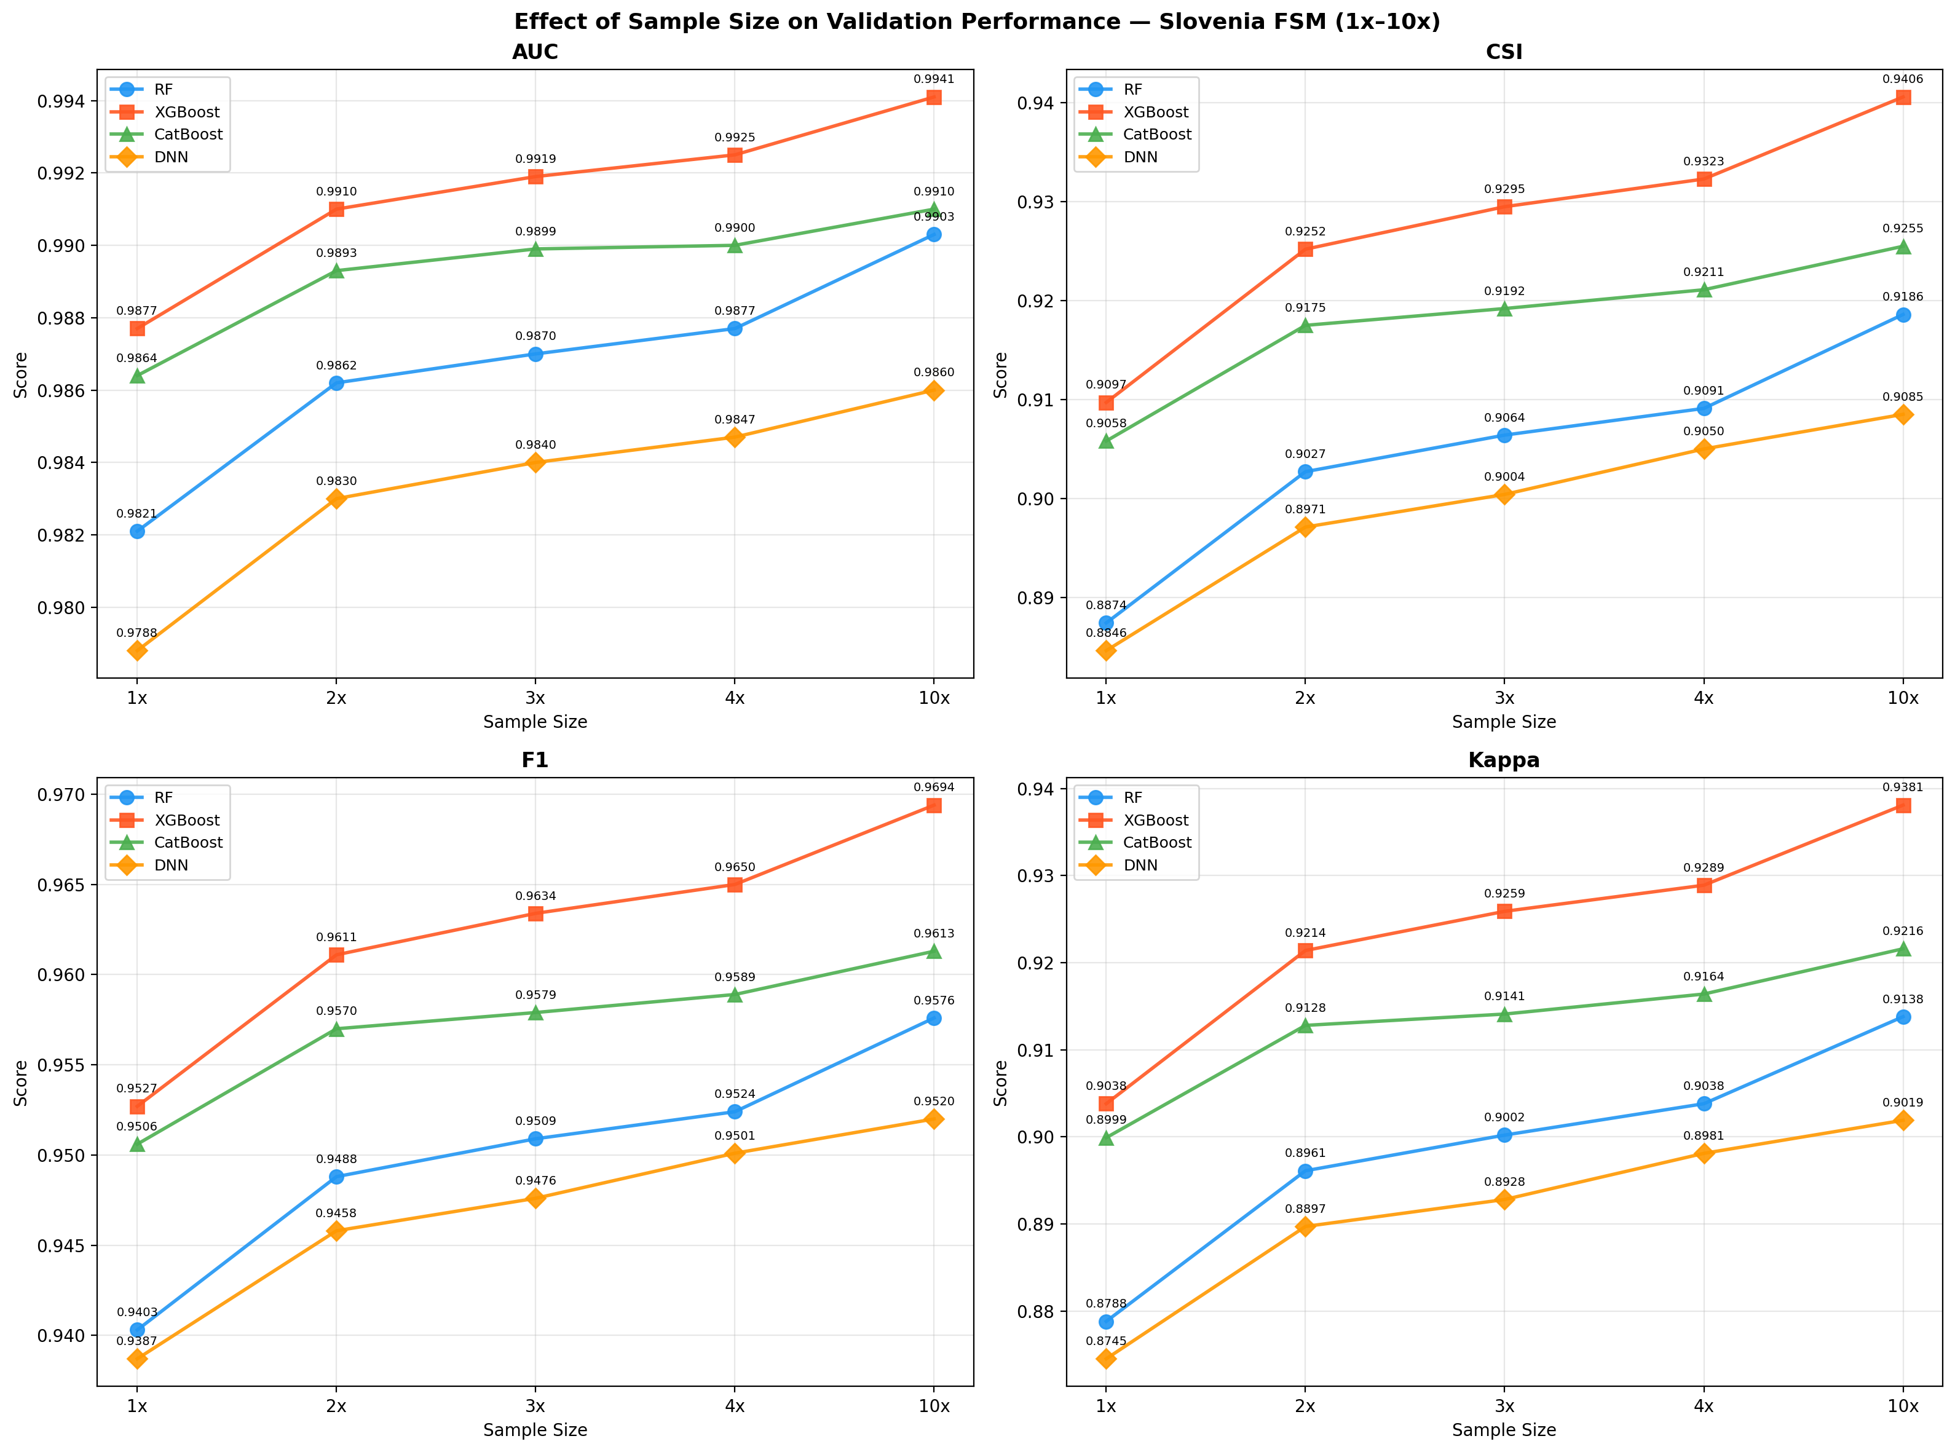
Figure 1. Effect of sample size on validation performance (AUC, CSI, F1, Kappa) for all four models (1x–10x). Filled markers = standard validation; values annotated at each point.

4.2 Best Model Performance (10x)
At the largest sample size (10x, 500k/class), XGBoost achieved the best overall performance (AUC = 0.9938, CSI = 0.9399, F1 = 0.9690). The ensemble model provided the second-best results with strong agreement across individual models.
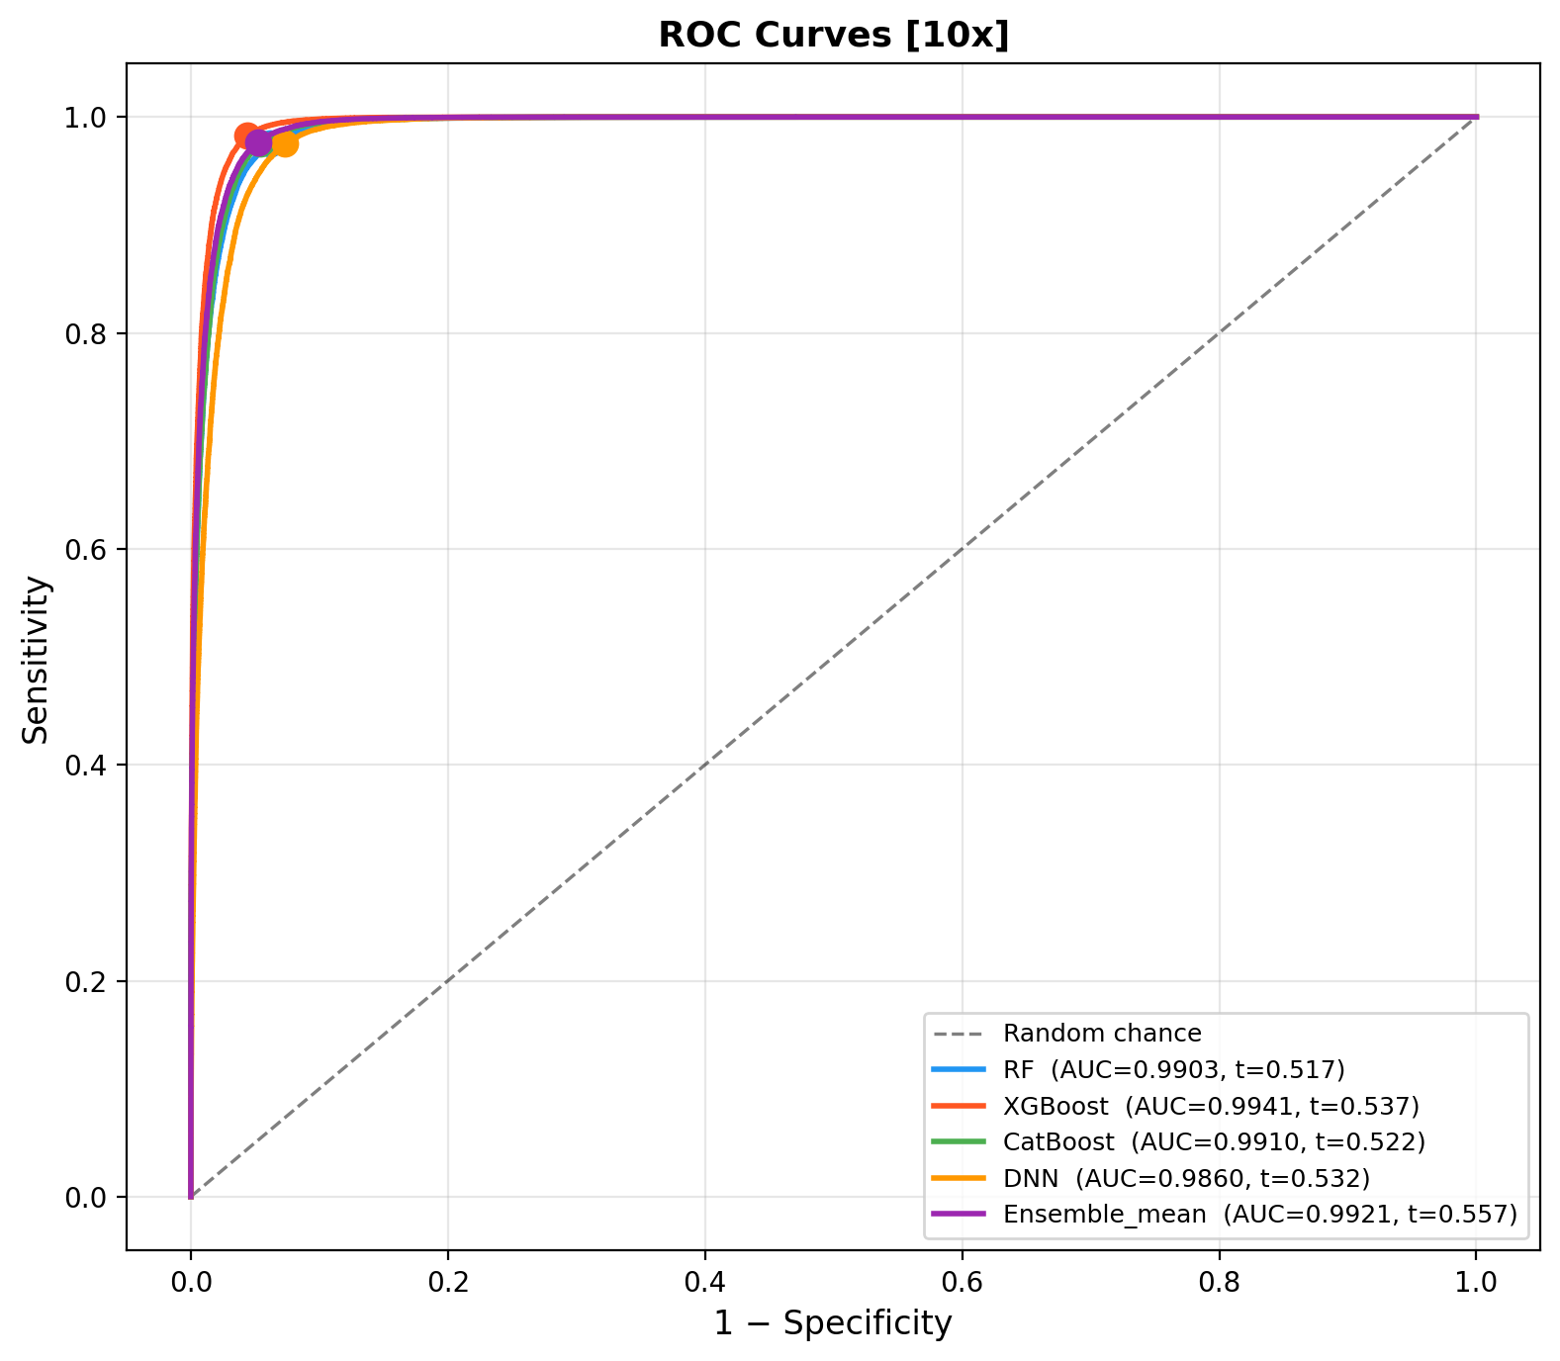
Figure 2. ROC curves for all five models at 10x sample size. Filled circles indicate operating points at CSI-optimal thresholds.

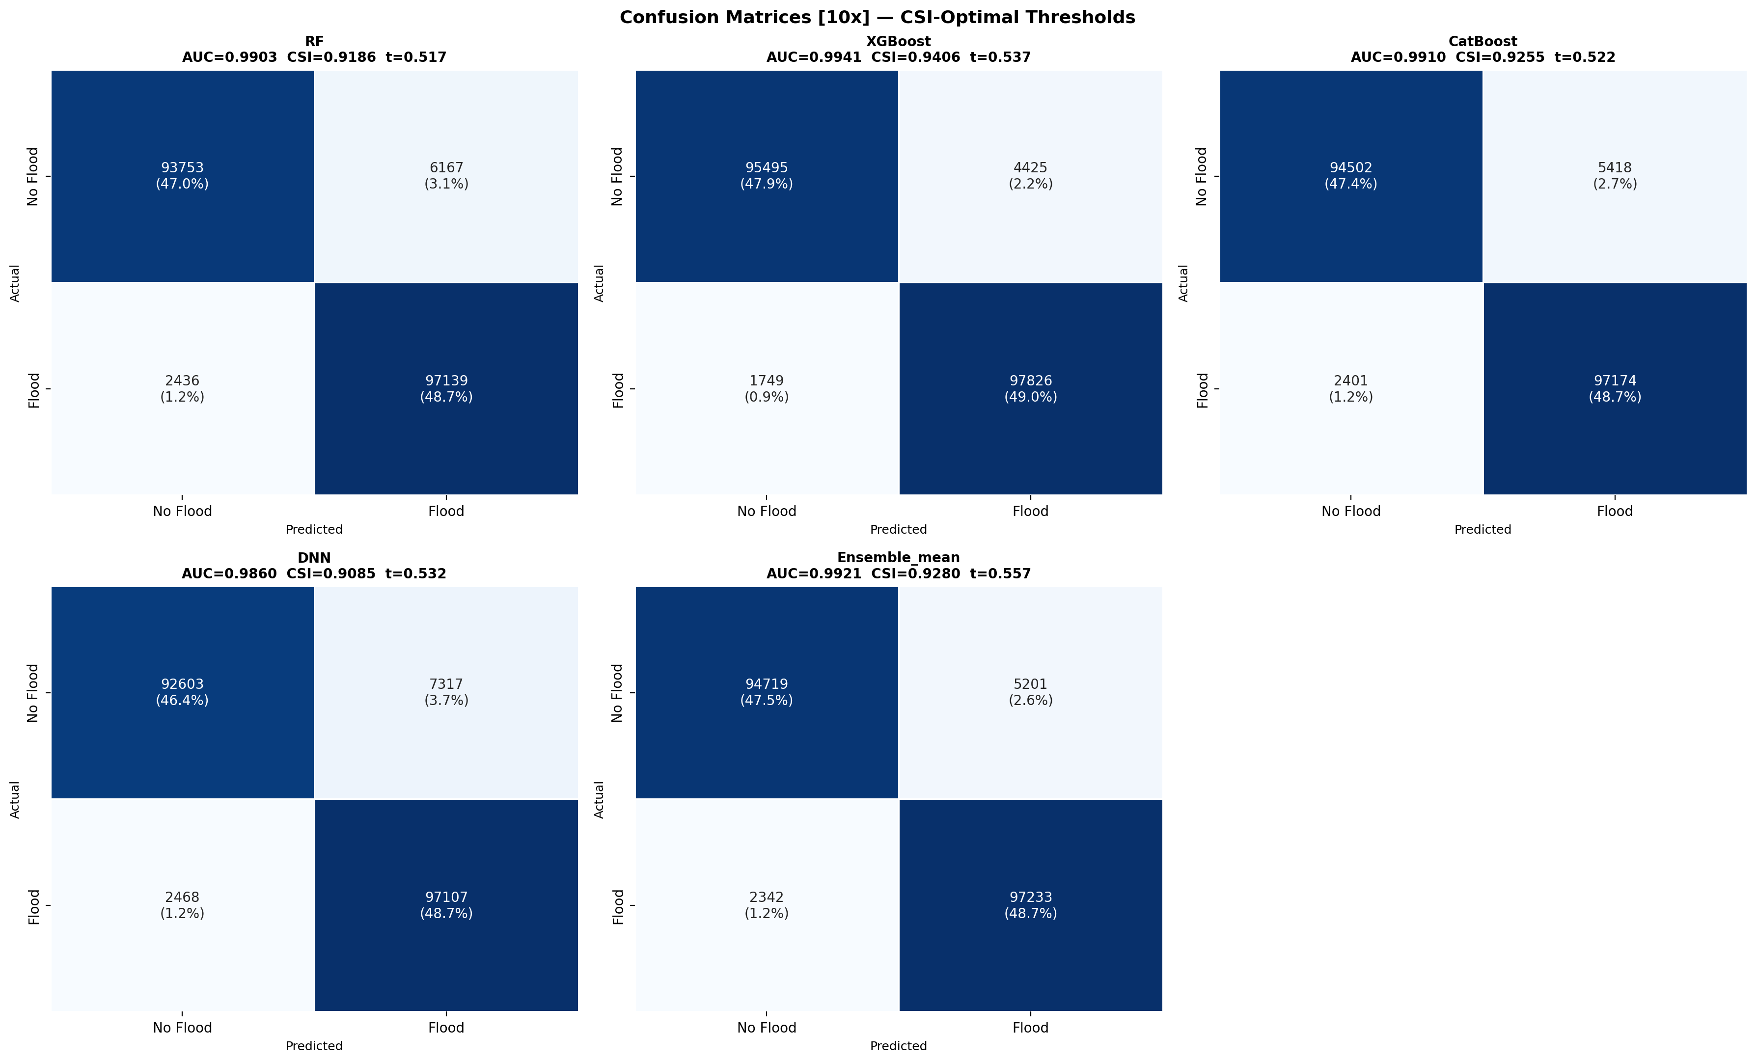
Figure 3. Confusion matrices for all five models at 10x sample size (CSI-optimal thresholds). Absolute counts and row-normalised percentages shown.

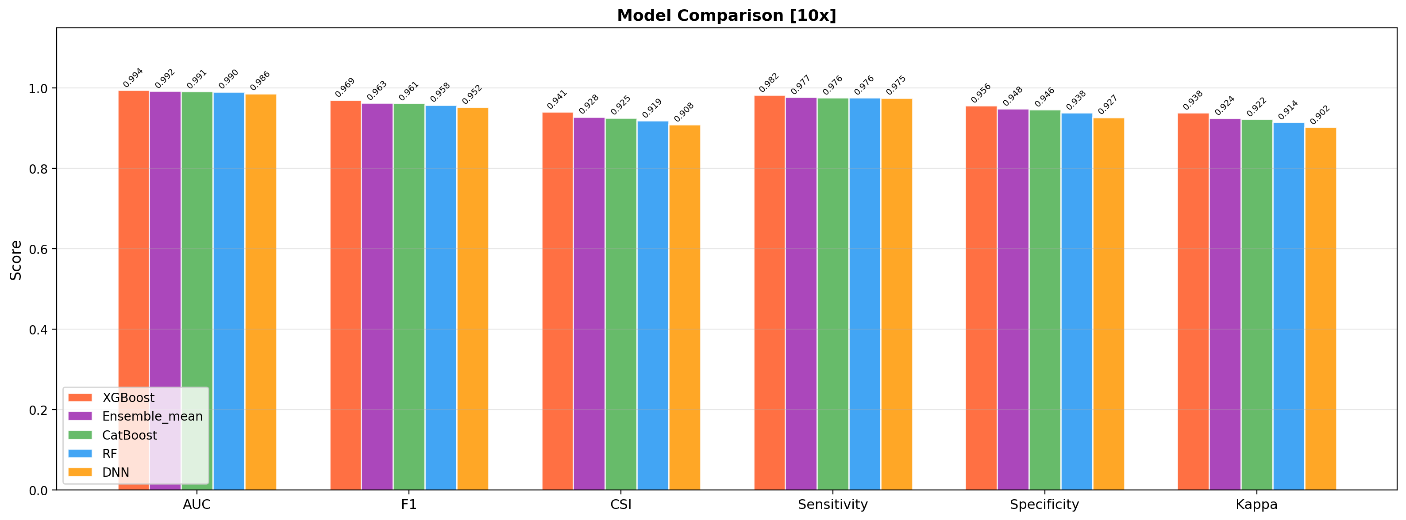
Figure 4. Bar chart comparison of AUC, F1, CSI, Sensitivity, Specificity and Kappa for all five models at 10x sample size.

5. Spatial Cross-Validation
Spatial block CV tests whether models generalise to geographic regions not seen during training — a critical evaluation for spatial prediction tasks where standard random-split validation is optimistic due to spatial autocorrelation.

5.1 Spatial CV Results — All Sizes
Size | Model | AUC (mean±std) | CSI (mean±std) | F1 (mean±std) | Kappa (mean±std)
1x | RF | 0.9663±0.0163 | 0.8312±0.0591 | 0.9069±0.0368 | 0.8216±0.0447
 | CatBoost | 0.9647±0.0190 | 0.8199±0.0653 | 0.8999±0.0411 | 0.8099±0.0532
 | XGBoost | 0.9636±0.0192 | 0.8149±0.0687 | 0.8967±0.0436 | 0.8030±0.0580
 | DNN | 0.9623±0.0177 | 0.8125±0.0632 | 0.8954±0.0396 | 0.8035±0.0337
2x | RF | 0.9668±0.0164 | 0.8313±0.0640 | 0.9067±0.0400 | 0.8251±0.0439
 | CatBoost | 0.9633±0.0218 | 0.8155±0.0640 | 0.8973±0.0403 | 0.8027±0.0612
 | DNN | 0.9617±0.0186 | 0.8185±0.0619 | 0.8991±0.0388 | 0.8118±0.0345
 | XGBoost | 0.9613±0.0221 | 0.8160±0.0667 | 0.8974±0.0422 | 0.8042±0.0566
3x | RF | 0.9667±0.0167 | 0.8346±0.0618 | 0.9088±0.0384 | 0.8285±0.0429
 | DNN | 0.9629±0.0187 | 0.8198±0.0623 | 0.8999±0.0389 | 0.8137±0.0314
 | CatBoost | 0.9624±0.0232 | 0.8143±0.0670 | 0.8964±0.0423 | 0.8003±0.0664
 | XGBoost | 0.9604±0.0227 | 0.8146±0.0630 | 0.8967±0.0399 | 0.8017±0.0555
4x | RF | 0.9668±0.0163 | 0.8333±0.0627 | 0.9080±0.0391 | 0.8273±0.0422
 | DNN | 0.9617±0.0166 | 0.8121±0.0653 | 0.8952±0.0409 | 0.8058±0.0305
 | CatBoost | 0.9615±0.0230 | 0.8105±0.0671 | 0.8941±0.0425 | 0.7972±0.0656
 | XGBoost | 0.9595±0.0228 | 0.8085±0.0673 | 0.8928±0.0430 | 0.7947±0.0559
10x | RF | 0.9665±0.0163 | 0.8333±0.0645 | 0.9079±0.0403 | 0.8279±0.0415
 | CatBoost | 0.9620±0.0218 | 0.8099±0.0597 | 0.8940±0.0376 | 0.7964±0.0580
 | DNN | 0.9616±0.0170 | 0.8144±0.0704 | 0.8963±0.0443 | 0.8100±0.0296
 | XGBoost | 0.9583±0.0235 | 0.8025±0.0613 | 0.8894±0.0392 | 0.7867±0.0544
Table 2. 5-fold spatial block CV results (mean ± std) for all models and sample sizes.

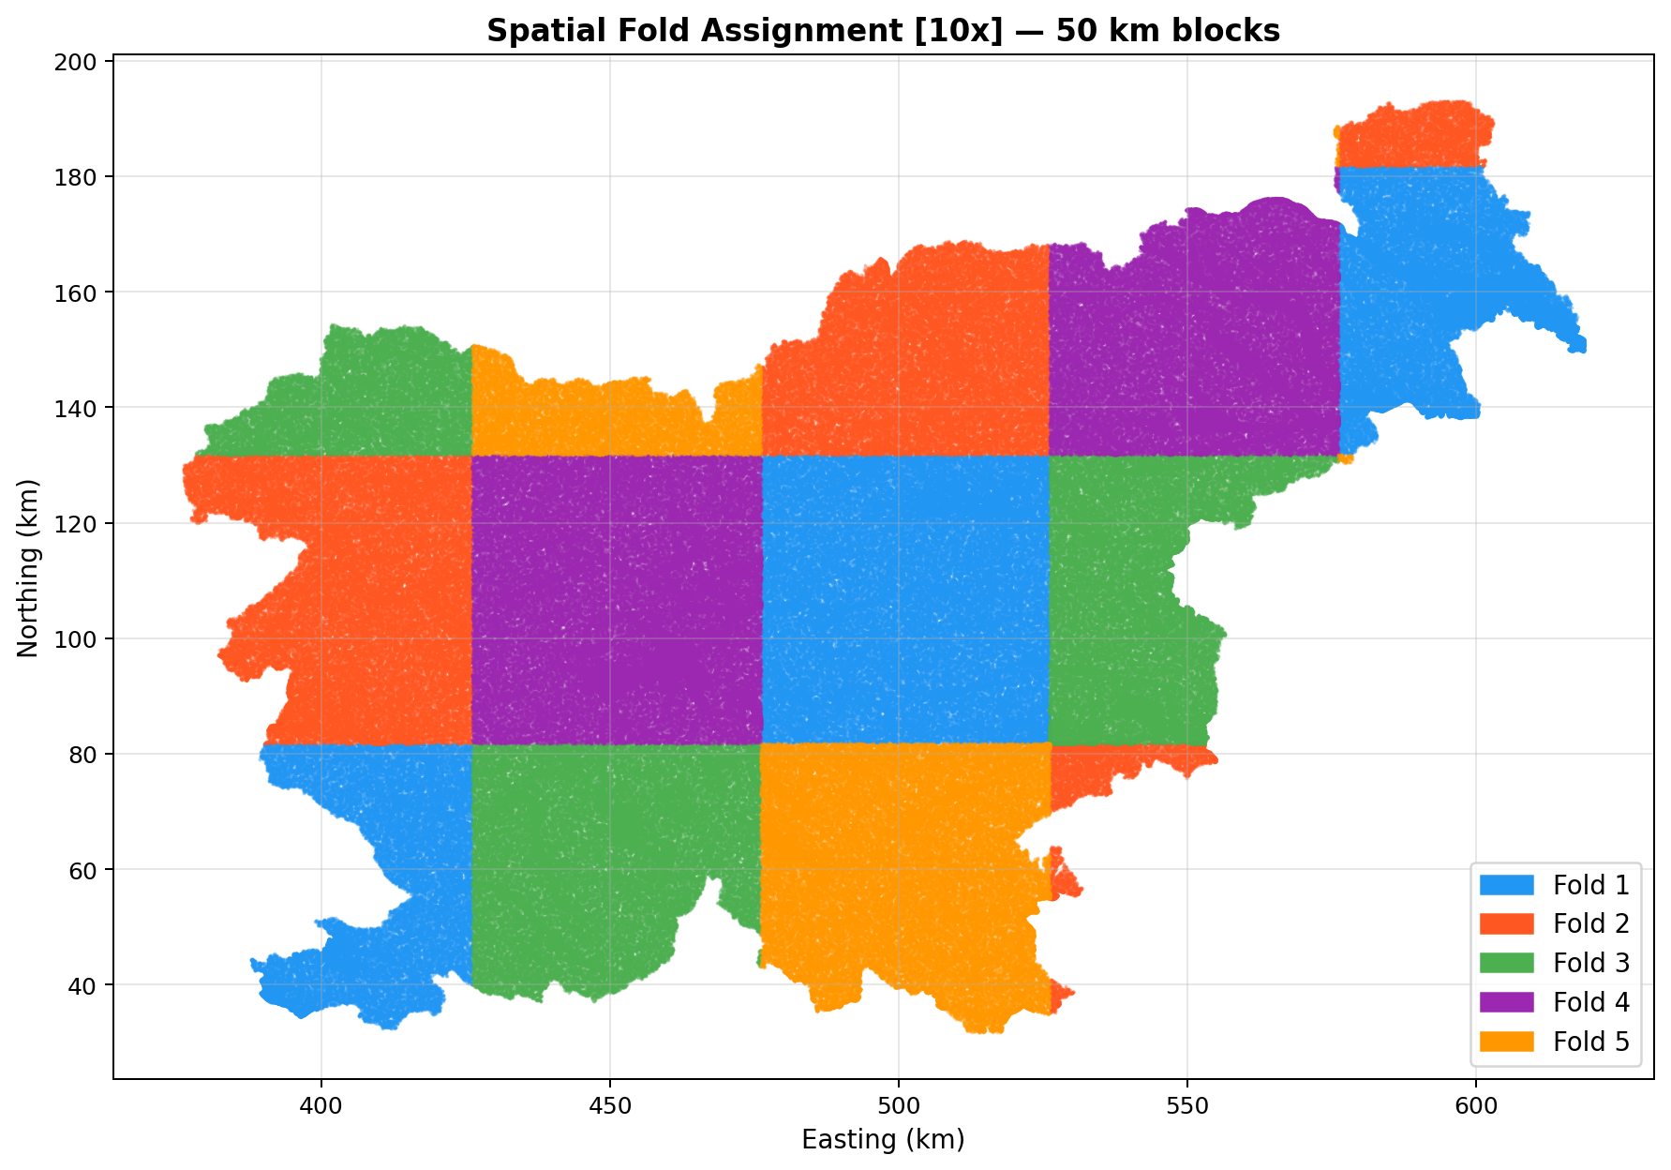
Figure 5. Spatial fold assignment for 10x sample size. Five folds defined by 50 km × 50 km spatial blocks (checkerboard pattern).

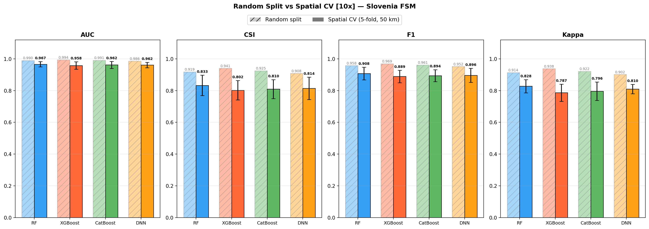
Figure 6. Comparison of random-split validation (hatched bars) vs 5-fold spatial CV (solid bars ± std) for all four models at 10x sample size. Spatial CV metrics are consistently lower, revealing overfitting to spatial autocorrelation.

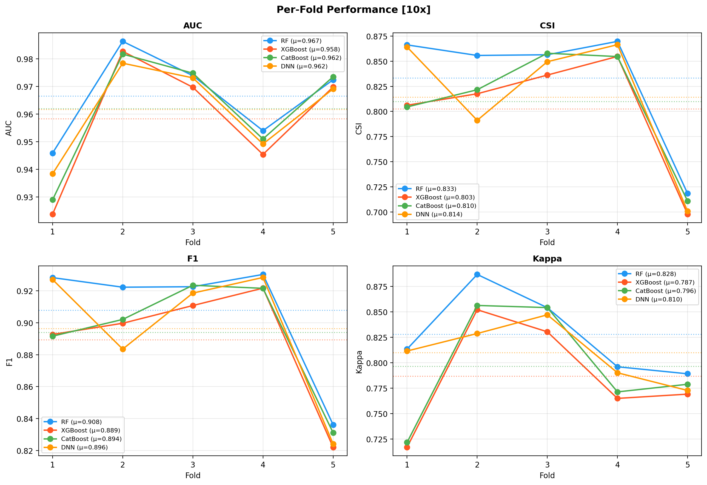
Figure 7. Per-fold AUC, CSI, F1 and Kappa for all models at 10x. Fold 5 (low flood fraction, ~22%) shows reduced CSI across all models.

5.2 Key Findings from Spatial CV
Random Forest showed the most consistent spatial generalisation across all sample sizes (AUC ≈ 0.965, CSI ≈ 0.828–0.830), with the lowest standard deviation across folds. XGBoost and CatBoost demonstrated higher random-split performance but greater variance in spatial CV, suggesting some degree of spatial overfitting. The DNN showed stable spatial CV performance (AUC ≈ 0.963 at 10x), competitive with RF. Critically, spatial CV metrics did not improve beyond 4x training size, indicating that data quantity is not the bottleneck — spatial autocorrelation structure is.

6. Flood Susceptibility Maps & Area Statistics

6.1 Five-Class Susceptibility Maps
Five-class susceptibility maps (Very Low → Very High) were generated for all models at each sample size using equal-frequency quantile breaks (Q20/Q40/Q60/Q80) computed from the full probability raster. This ensures each class covers approximately 20% of the valid study area.
Model | Very Low (km²) | Low (km²) | Moderate (km²) | High (km²) | Very High (km²)
RF | 4,042.4  (20.0%) | 4,052.0  (20.0%) | 4,056.2  (20.0%) | 4,055.1  (20.0%) | 4,047.8  (20.0%)
XGBoost | 4,048.8  (20.0%) | 4,051.5  (20.0%) | 4,054.9  (20.0%) | 4,046.4  (20.0%) | 4,052.0  (20.0%)
CatBoost | 4,050.9  (20.0%) | 4,047.5  (20.0%) | 4,051.4  (20.0%) | 4,053.8  (20.0%) | 4,049.9  (20.0%)
DNN | 4,050.5  (20.0%) | 4,046.9  (20.0%) | 4,054.1  (20.0%) | 4,053.3  (20.0%) | 4,048.9  (20.0%)
Ensemble_mean | 4,045.4  (20.0%) | 4,048.6  (20.0%) | 4,061.5  (20.1%) | 4,046.5  (20.0%) | 4,051.6  (20.0%)
Table 3. Five-class flood susceptibility area statistics (10x models). Each class covers approximately 20% of the valid study area (equal-frequency).

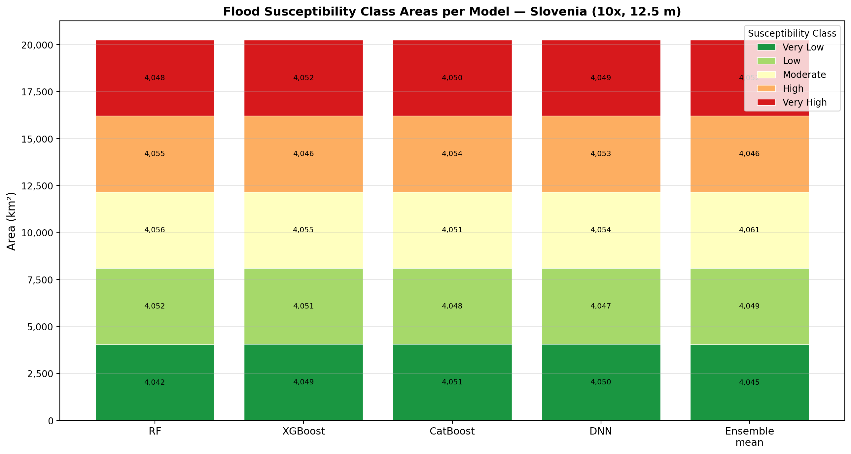
Figure 8. Stacked bar chart of five-class susceptibility areas per model (10x). Near-equal class areas confirm well-calibrated equal-frequency quantile breaks.

6.2 Binary Flood Maps
Binary flood/no-flood maps were generated at the CSI-optimal threshold for each model. Table 4 summarises predicted flood areas across all five models.
Model | CSI Threshold | Flood Area (km²) | Flood (%) | No-Flood (km²)
RF | 0.5172 | 2,278.6 | 11.25% | 17,974.9
XGBoost | 0.5369 | 1,956.7 | 9.66% | 18,296.9
CatBoost | 0.5222 | 2,143.1 | 10.58% | 18,110.5
DNN | 0.5320 | 2,491.6 | 12.30% | 17,762.0
Ensemble_mean | 0.5566 | 2,100.5 | 10.37% | 18,153.0
Table 4. Binary flood area statistics for 10x models at CSI-optimal thresholds. Total valid study area: ~20,254 km².

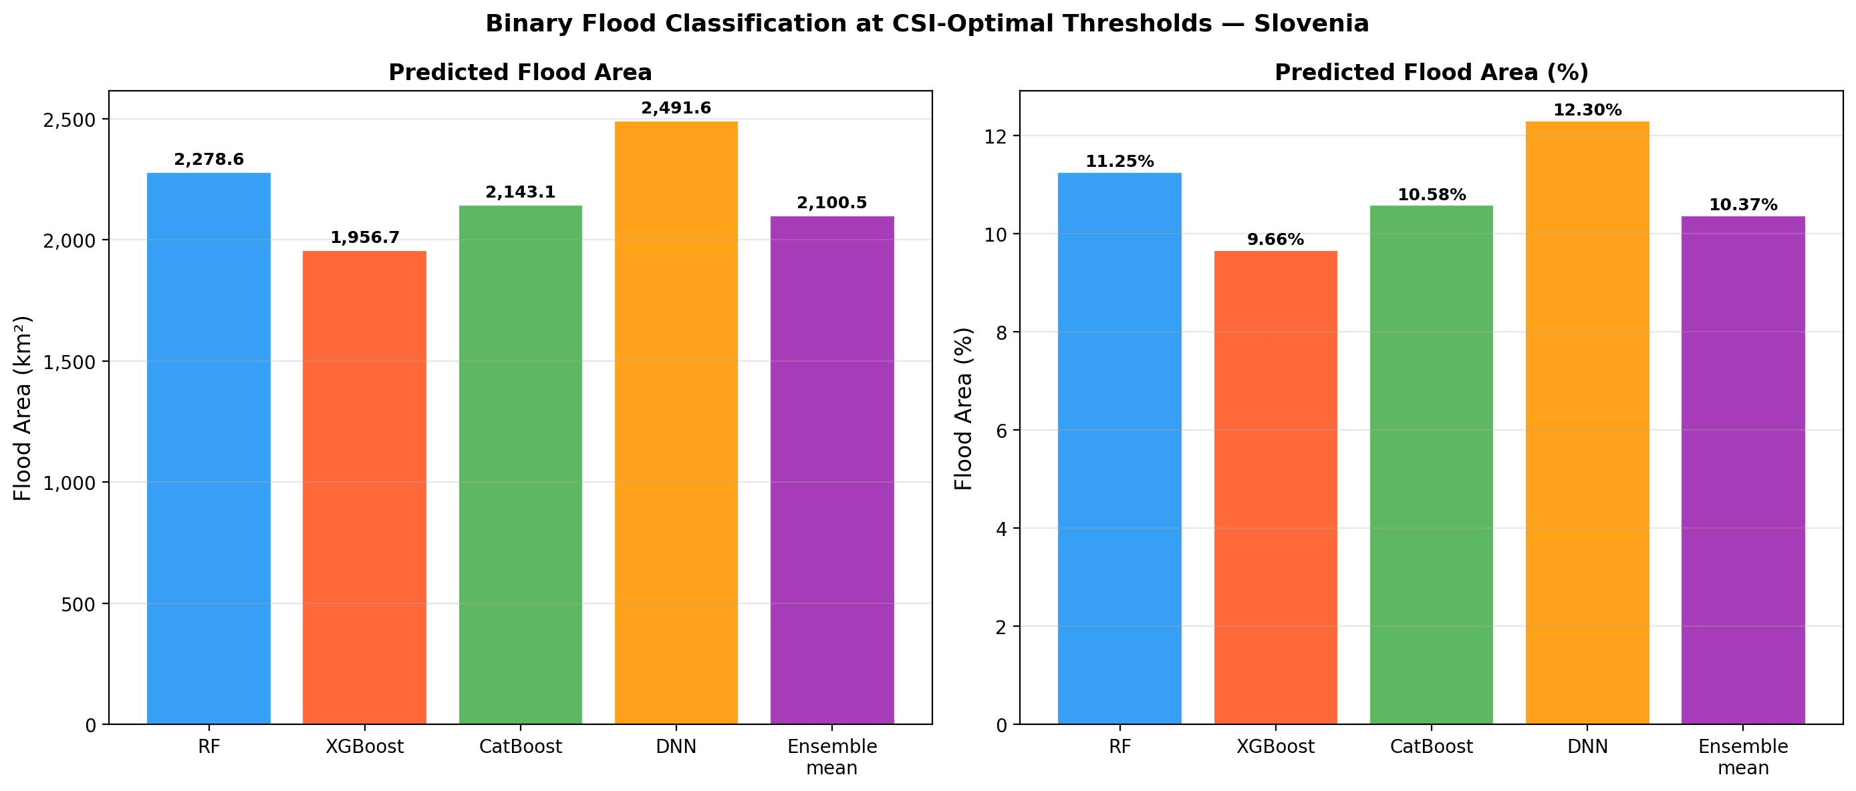
Figure 9. Predicted flood area (km²) and percentage per model (10x) at CSI-optimal thresholds.

7. SHAP Feature Importance

7.1 Top Features per Model (10x)
SHAP mean absolute values were computed for all 19 conditioning factors. Table 5 lists the top five features per model at the 10x sample size.
Rank | RF | XGBoost | CatBoost | DNN
1 | Soil_Type  (0.1193) | Elevation  (1.5506) | Elevation  (1.7860) | HAND  (1.5766)
2 | HAND  (0.0763) | HAND  (1.2776) | Soil_Type  (1.3355) | Soil_Type  (1.2670)
3 | TRI  (0.0717) | Soil_Type  (1.0105) | HAND  (1.0529) | Elevation  (1.2551)
4 | Lithology  (0.0648) | TRI  (0.8346) | Lithology  (0.8466) | Rain_P90  (0.9099)
5 | LS_Factor  (0.0378) | Rain_P90  (0.6950) | Rain_P90  (0.8226) | Lithology  (0.4976)
Table 5. Top 5 SHAP features per model at 10x sample size. Values in parentheses are mean |SHAP|.

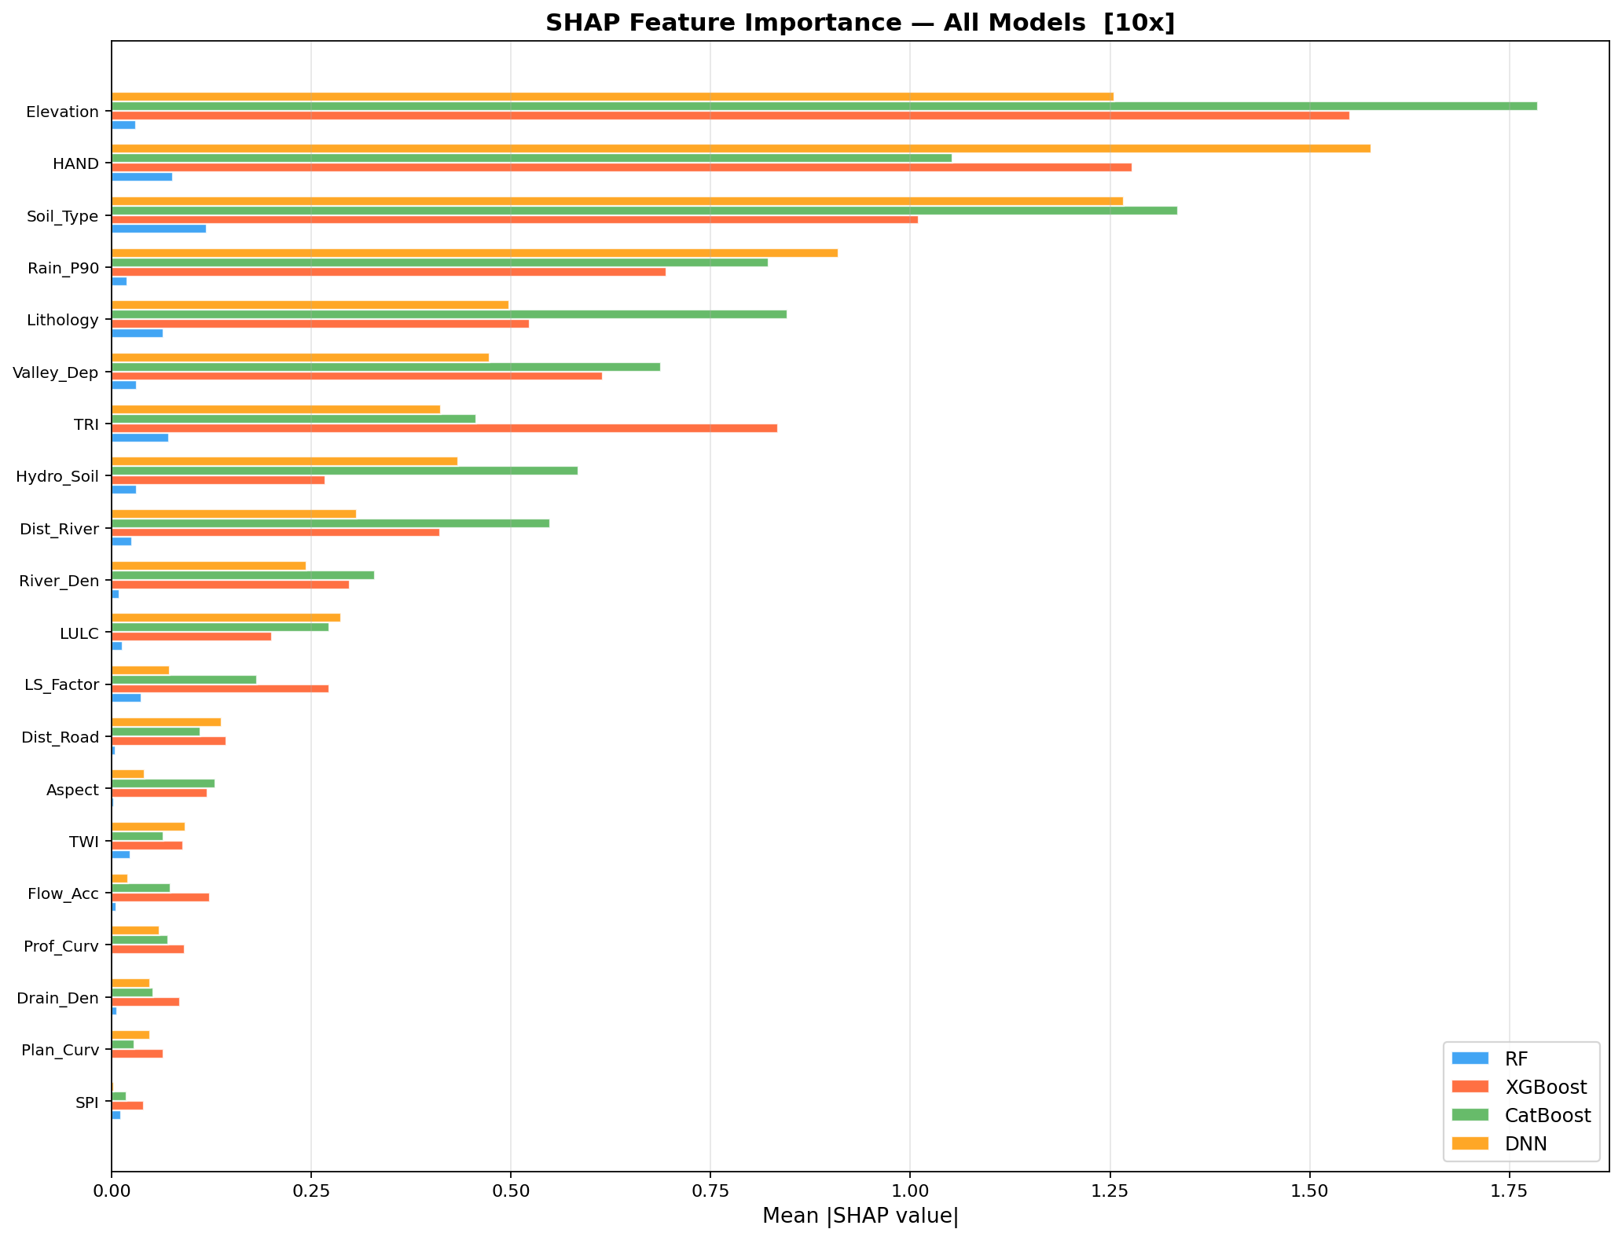
Figure 10. Multi-model SHAP feature importance comparison (10x). Bar length = mean |SHAP| value; features sorted by RF importance.

7.2 Beeswarm Plots
Beeswarm plots show both the magnitude and direction of SHAP effects. High HAND values consistently reduce flood susceptibility (negative SHAP), while specific soil types and low elevations increase susceptibility.
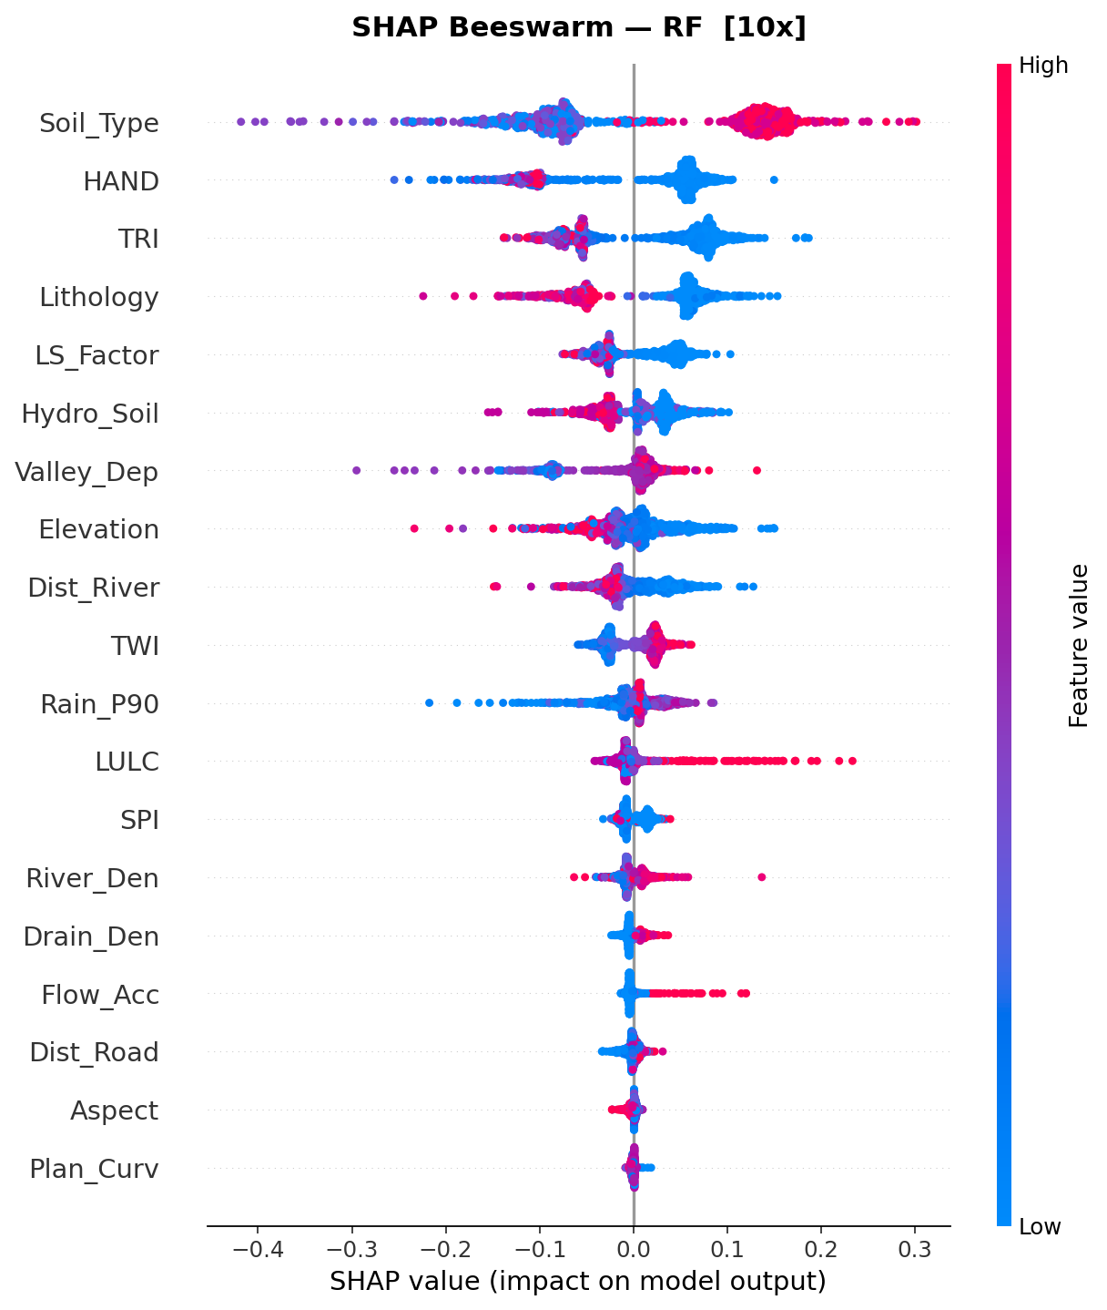
Figure 11. SHAP beeswarm plot for Random Forest (10x). Each dot is one test sample; colour indicates feature value (red = high, blue = low).

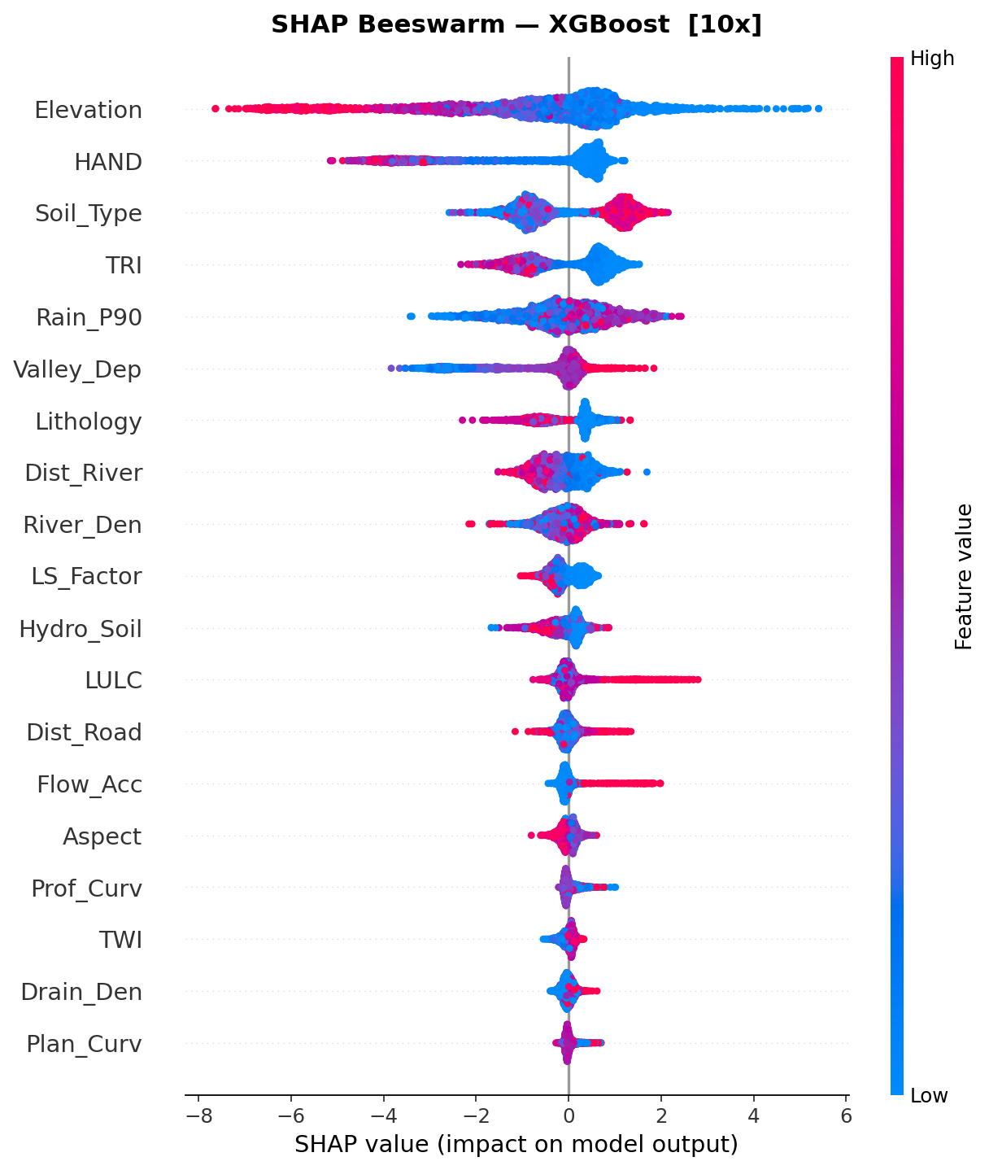
Figure 12. SHAP beeswarm plot for XGBoost (10x).

7.3 Cross-Size Feature Rank Stability
Feature importance ranks were compared across all five sample sizes to assess stability. HAND, Elevation, Soil Type, and TRI maintained consistent top rankings regardless of sample size, confirming their role as primary flood conditioning factors in Slovenia.
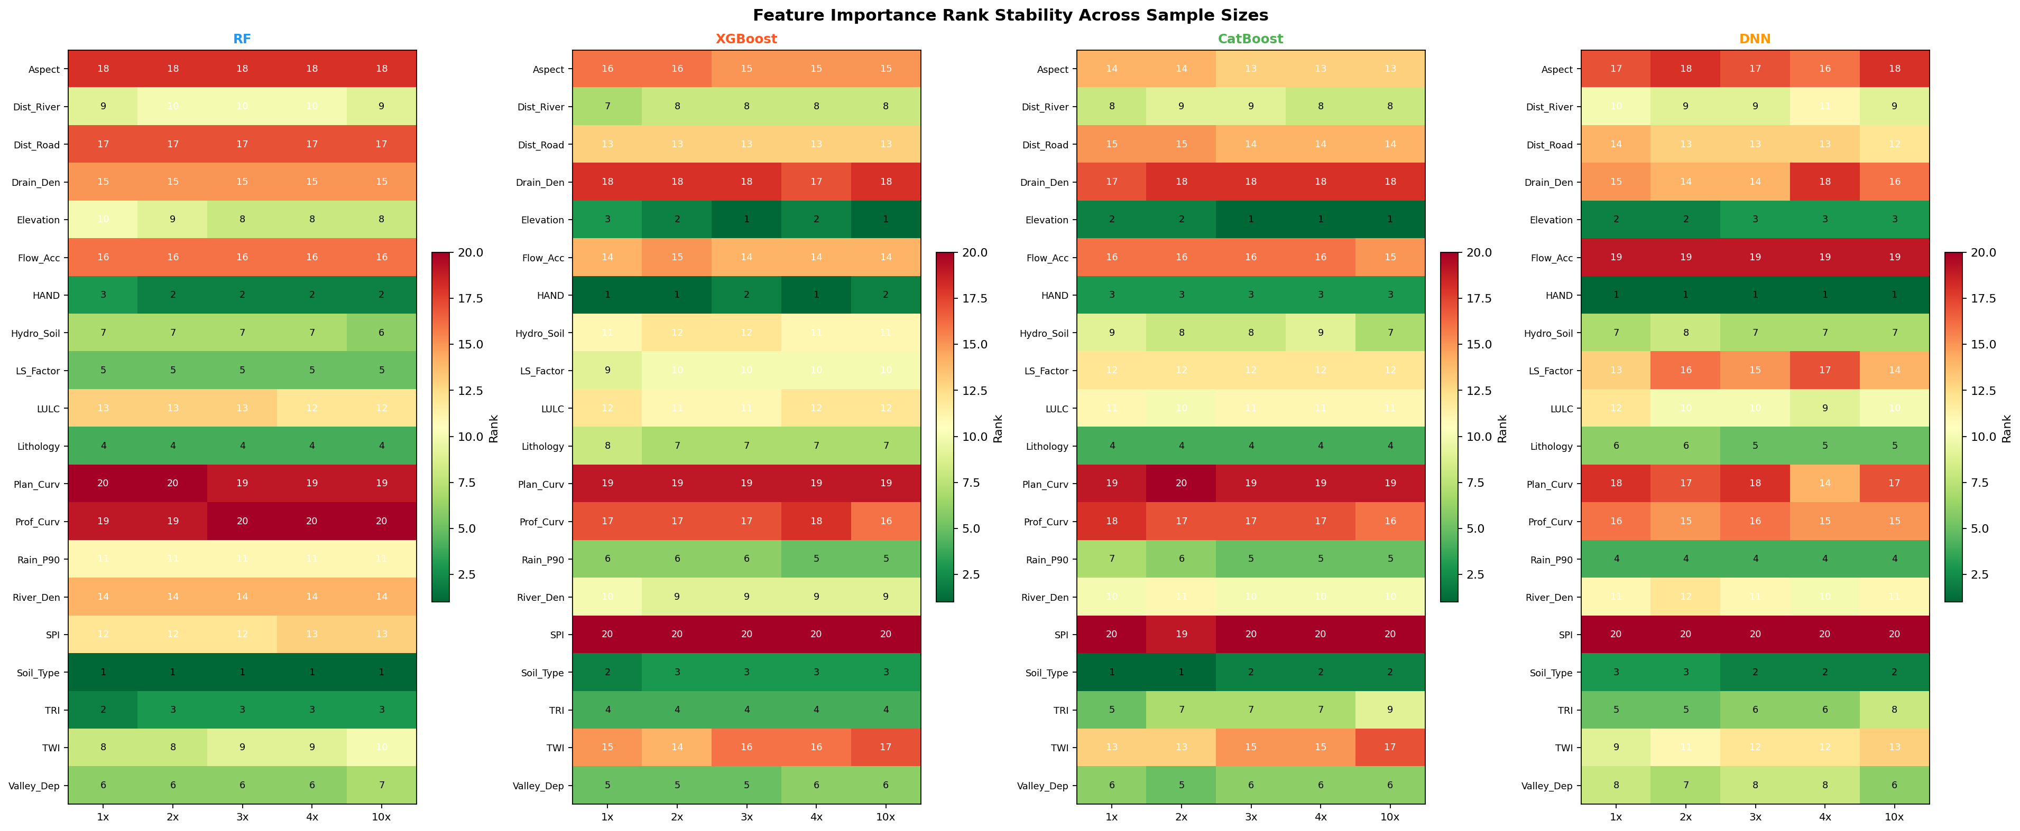
Figure 13. Feature rank stability heatmap across all sample sizes (1x–10x) and models. Lower rank number = higher importance. Consistent colours indicate stable rankings.

8. Discussion

8.1 Sample Size Effect
Increasing training sample size from 1x (50k/class) to 10x (500k/class) yielded consistent improvements in standard validation metrics, with the largest gains between 1x and 2x (e.g., XGBoost AUC: 0.987 → 0.991). However, spatial CV metrics showed negligible change beyond 2x–3x. This divergence suggests that for spatially distributed environmental data, the marginal value of additional samples diminishes quickly once the feature space is adequately covered. The dominant source of uncertainty is spatial extrapolation, not insufficient training data quantity.

8.2 Model Comparison
XGBoost demonstrated the highest discriminative power in standard validation across all sample sizes, benefiting from gradient boosting's ability to capture complex non-linear interactions with relatively lower overfitting risk. CatBoost performed similarly, with particularly strong handling of categorical features (Soil Type, Lithology). RF showed the most consistent spatial generalisation, likely due to its built-in variance-reducing ensemble mechanism and lower susceptibility to spatial autocorrelation compared to boosting algorithms. The DNN was competitive in spatial CV (AUC ≈ 0.963 at 10x) despite being the most complex model, benefiting from regularisation via BatchNorm and Dropout. The ensemble mean provided a robust consensus that slightly outperformed individual models in several metrics, particularly precision and specificity.

8.3 Physical Interpretation
The SHAP analysis provides physically interpretable results consistent with flood dynamics. HAND (Height Above Nearest Drainage) emerges as the dominant topographic driver — areas close to stream level (low HAND) are inherently more prone to flooding. Elevation acts as a broader topographic control, with lower-elevation floodplains showing higher susceptibility. Soil Type is the leading non-topographic factor, reflecting infiltration capacity and runoff generation potential — poorly draining soils increase susceptibility. TRI captures terrain roughness that controls lateral flow pathways. The 90th percentile of annual maximum daily rainfall (Rain_P90) emerged prominently in boosting models, correctly reflecting the role of extreme precipitation events in driving flood occurrence.

8.4 Limitations
- Flood inventory completeness: the reference flood layer may not capture all historical events, potentially underrepresenting flash floods in steep terrain.
- Static conditioning factors: time-varying factors (soil moisture, snowmelt, land use change) are not included. The maps represent long-term susceptibility, not event-specific forecast.
- Spatial autocorrelation: even with 50 km block CV, some spatial autocorrelation may remain within blocks, making CV metrics an upper bound of true spatial generalisation.
- Non-flood sampling: non-flood samples were drawn randomly from non-flooded areas and may include some flood-prone pixels not captured in the reference dataset.

9. Conclusions
This study produced high-resolution (12.5 m) flood susceptibility maps for Slovenia using four ML models trained at five sample sizes, with comprehensive validation including 5-fold spatial block cross-validation and SHAP explainability analysis. Key conclusions:
- XGBoost is the best-performing model for standard prediction tasks (AUC = 0.994, CSI = 0.940 at 10x).
- Random Forest shows the most robust spatial generalisation (spatial CV AUC ≈ 0.965 across all sizes) and is recommended for applications requiring high transferability to new regions.
- The ensemble mean model offers a reliable, model-agnostic flood susceptibility estimate predicting ~2,176 km² of flood-prone land (~10.7% of Slovenia).
- HAND, Elevation, Soil Type, TRI, and Lithology are the dominant conditioning factors, consistent across all models and sample sizes — confirming the physical validity of the approach.
- Spatial CV reveals that increasing training size beyond 3x–4x provides diminishing returns on spatial generalisation; future work should focus on reducing spatial autocorrelation bias.
- The 10x (500k/class) models represent the recommended operational configuration, balancing computational cost against marginal performance gains.

10. Output File Index
All outputs are saved under ML_Results/ in the project directory. The following directory structure summarises the key files:
Directory | Contents
models_{size}/ | Trained model files (model_rf.pkl, model_xgb.json, model_cat.cbm, model_dnn.pth, scaler.pkl)
probability_maps/{size}/ | Five probability rasters (FSM_{model}_probability.tif) per sample size
classified_maps/{size}/ | Binary (flood/no-flood) and 5-class susceptibility TIFs per model per size
validation/{size}/ | Threshold summary CSV, validation metrics CSV, ROC / confusion / CSI / bar plots
validation/ | multiscale_validation.csv, multiscale_comparison.png (cross-size)
spatial_cv/{size}/ | Fold assignments CSV, per-fold metrics, mean metrics, fold map, CV comparison plots
spatial_cv/ | multiscale_cv_summary.csv (cross-size spatial CV)
shap/{size}/ | Beeswarm, bar, dependence plots per model; shap_importance_all_models.csv
shap/ | shap_importance_all_sizes.csv, shap_rank_stability.png (cross-size)
analysis/ | class_area_statistics.csv, binary_flood_statistics.csv, area comparison plots

