Business Template

Social media
Logo / Image

Contents
1 Business Description 3
1.1 Business background 3
1.2 Problems. Current Situation 3
1.3 The benefits of implementing a database. Project Vision 3
2 Model description 3
2.1 Definitions & Acronyms 3
2.2 Logical Scheme 3
2.3 Objects 3

Business Description

Business background
Social media platforms have become essential tools for communication, content sharing, and digital interaction. They allow users to create and share posts, follow others, engage through likes and comments, and join groups with common interests. Managing such a large amount of interconnected user data requires an efficient, scalable, and well-structured database.
The proposed database aims to model the core functionality of a typical social media application while ensuring data consistency, security, and performance.

Problems. Current Situation
Without a centralized and normalized database system, managing user-generated data can lead to multiple issues:
- Data redundancy and inconsistency when storing posts, comments, and likes separately without referential control.
- Inefficient queries when trying to retrieve relationships, such as which users follow each other or which posts belong to a specific group.
- Difficulty ensuring data integrity, such as preventing duplicate accounts or enforcing unique usernames.
- Scalability challenges when user activities grow and data is not properly normalized or indexed.

the Benefits of implementing a database. Project Vision
Implementing a structured relational database allows the platform to:
- Maintain data integrity and consistency through relationships and constraints.
- Support scalable growth of user interactions (likes, comments, messages).
- Provide efficient querying and reporting of user behavior.
- Improve security and enforce access control through clear entity relationships.
Project Vision:
To design a relational database that models all essential aspects of a social media application — users, posts, interactions, and communication — in compliance with the Third Normal Form (3NF). This ensures minimal redundancy and maximum integrity, enabling the future expansion of the system (e.g., analytics or recommendation features).

Model description

Definitions & Acronyms

2.1 DEFINITIONS & ACRONYMS
Term / Acronym | Definition
PK | Primary Key – unique identifier for each record in a table.
FK | Foreign Key – establishes a relationship between tables.
M:N | Many-to-Many relationship.
1:N | One-to-Many relationship.
3NF | Third Normal Form – ensures all non-key attributes depend only on the primary key.
ERD | Entity-Relationship Diagram – visual representation of database structure.

Logical Scheme
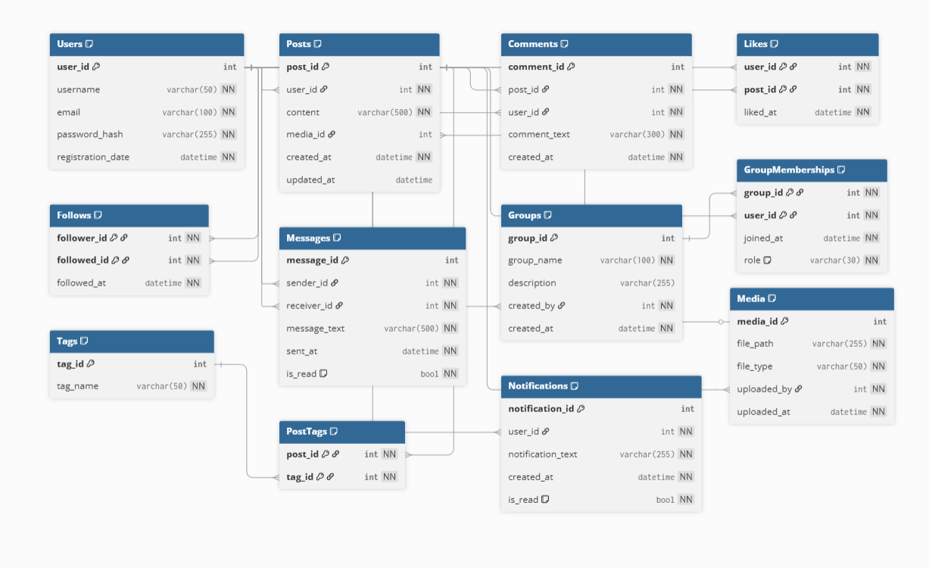

Objects

Table: Users
Field Name | Field Description | Data Type
User_ID | Unique identifier of the user (PK) | INT
Username | User’s chosen display name (UNIQUE) | VARCHAR(50)
Email | User’s email address (UNIQUE) | VARCHAR(100)
PasswordHash | Encrypted password value | VARCHAR(255)
Registration_Date | Date and time when the user registered | DATETIME
Comments:
Each user can create posts, write comments, send messages, and join groups. Relationships: 1:N with Posts, 1:N with Comments, M:N with Groups (via GroupMemberships), and self-referential M:N in Follows.

Table: Posts
Field Name | Field Description | Data Type
Post_ID | Unique identifier for each post (PK) | INT
User_ID | Reference to the user who created the post (FK) | INT
Content | Text content of the post | VARCHAR(500)
Media_ID | Reference to attached media (optional FK) | INT
Created_At | Date and time the post was created | DATETIME
Comments:
Each post belongs to one user but can have multiple comments, likes, and tags.
Relationships: 1:N with Comments, M:N with Tags (via PostTags), M:N with Users (via Likes).

Table: Comments
Field Name | Field Description | Data Type
Comment_ID | Unique identifier for each comment (PK) | INT
Post_ID | Reference to the post being commented (FK) | INT
User_ID | Reference to the user who made the comment (FK) | INT
Comment_Text | Text of the comment | VARCHAR(300)
Created_At | Timestamp when comment was posted | DATETIME
Comments:
Each comment links one user to one post (many comments can exist per post).

Table: Likes
Field Name | Field Description | Data Type
User_ID | Reference to the user who liked a post (PK, FK) | INT
Post_ID | Reference to the liked post (PK, FK) | INT
Liked_At | Timestamp of like action | DATETIME
Comments:
Associative table implementing a many-to-many relationship between Users and Posts.

Table: Follows
Field Name | Field Description | Data Type
Follower_ID | ID of the user who follows another user (PK, FK) | INT
Followed_ID | ID of the user being followed (PK, FK) | INT
Followed_At | Timestamp of follow action | DATETIME
Comments:
Self-referential M:N relationship within the Users table.

Table: Messages
Field Name | Field Description | Data Type
Message_ID | Unique identifier for each message (PK) | INT
Sender_ID | Reference to the user who sent the message (FK) | INT
Receiver_ID | Reference to the user who received the message (FK) | INT
Message_Text | Content of the message | VARCHAR(500)
Sent_At | Timestamp of when the message was sent | DATETIME
Comments:
Each message connects one sender and one receiver (Users). Relationship: 1:N from User to Message.

Table: Groups
Field Name | Field Description | Data Type
Group_ID | Unique identifier of a group (PK) | INT
Group_Name | Name of the group (UNIQUE) | VARCHAR(100)
Description | Description or purpose of the group | VARCHAR(255)
Created_By | ID of the user who created the group (FK) | INT
Created_At | Timestamp when the group was created | DATETIME
Comments:
Each group is created by one user. Many users can belong to a group via GroupMemberships.

Table: GroupMemberships
Field Name | Field Description | Data Type
Group_ID | Reference to the group (PK, FK) | INT
User_ID | Reference to the user (PK, FK) | INT
Joined_At | Date when the user joined the group | DATETIME
Comments:
Associative table implementing M:N relationship between Users and Groups.

Table: Tags
Field Name | Field Description | Data Type
Tag_ID | Unique identifier for the tag (PK) | INT
Tag_Name | Name of the tag (UNIQUE) | VARCHAR(50)
Comments:
Used to categorize posts. Connected to posts through PostTags.

Table: PostTags
Field Name | Field Description | Data Type
Post_ID | Reference to post (PK, FK) | INT
Tag_ID | Reference to tag (PK, FK) | INT
Comments:
Associative table representing M:N relationship between Posts and Tags.

Table: Notifications
Field Name | Field Description | Data Type
Notification_ID | Unique identifier for each notification (PK) | INT
User_ID | User to whom the notification belongs (FK) | INT
Notification_Text | Description of the notification | VARCHAR(255)
Created_At | Timestamp of notification | DATETIME
Is_Read | Status of whether the notification has been seen | BOOLEAN
Comments:
Generated for user activities such as new likes, followers, or messages.

Table: Media
Field Name | Field Description | Data Type
Media_ID | Unique identifier of media (PK) | INT
File_Path | Path or URL of stored file | VARCHAR(255)
File_Type | Type of file (image, video, etc.) | VARCHAR(50)
Uploaded_By | ID of the user who uploaded the file (FK) | INT
Uploaded_At | Timestamp when media was uploaded | DATETIME
Comments:
Media files can be attached to posts or uploaded directly by users.

