**PRACTICAL - 6**

**AIM:** Write a PHP script to:

1. Design the web page to display welcome message when user visit the web page second time using cookie.

2. Design a web application which demonstrates the use of session.

3. Write a PHP script to upload the file from client to server on some folder. Also put the restriction that client can upload only .doc or .pdf files.

**pr6_1.php**

<?php

if(isset($_COOKIE['cnt'])) {

echo "You have visited this page ". $_COOKIE['cnt'] . " times";

$cnt = $_COOKIE['cnt'] + 1;

setcookie('cnt', $cnt);

} else {

echo "Welcome!";

setcookie('cnt', 1);

}

?>

**pr6_2.php**

<?php

session_start();

if(isset($_SESSION['cnt'])) {

$_SESSION['cnt'] += 1;

}else {

$_SESSION['cnt'] = 1;

}

echo "You have visited this page ". $_SESSION['cnt'] . " times";

?>

**pr6_3.php**

<!DOCTYPE html>

<html lang="en">

<head>

<meta charset="UTF-8">

<meta name="viewport" content="width=device-width, initial-scale=1.0">

<meta http-equiv="X-UA-Compatible" content="ie=edge">

<title>Document</title>

</head>

<body>

<form action="" method="post" enctype="multipart/form-data">

<input type="file" name="fu">

<input type="submit" name="Upload">

</form>

</body>

</html>

<?php

if($_POST) {

$file_name = $_FILES['fu']['name'];

$file_size = $_FILES['fu']['size'];

$file_tmp = $_FILES['fu']['tmp_name'];

$file_type = $_FILES['fu']['type'];

$tmp = explode('.', $file_name);

$file_ext = end($tmp);

//echo $file_name . " " . $file_size . " " . $file_tmp . " " . $file_ext;

$ok = 1;

if(!($file_ext == 'pdf' || $file_ext == 'doc')) {

$ok = 0;

}

if($ok == 1) {

move_uploaded_file($file_tmp, 'data/'.$file_name);

echo "File Uploaded Successfully";

} else {

echo "Please upload pdf or doc";

}

}

?>

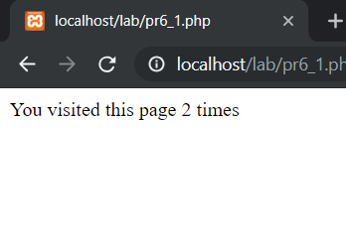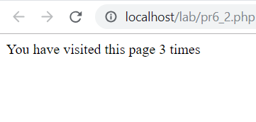**OUTPUT**

