**PRACTICAL - 9**

**AIM:** Write a JavaScript for the following:

1. Assume that a web page has one image placed on it. When mouse is clicked and hold on it then image get changed. Write DHTML code for the same. (Use OnMouseDown and OnMouseUp events).

2. Assume that a web page has one table and one text box. Table has three cells with given colors (red, blue and green). When you mouse over the particular cell in the table then text of textbox will take color same as table’s cell color. (Use OnMouseOver event).

**pr9_1.html**

<!DOCTYPE html>

<html lang="en">

<head>

<meta charset="UTF-8">

<meta name="viewport" content="width=device-width, initial-scale=1.0">

<meta http-equiv="X-UA-Compatible" content="ie=edge">

<title>Document</title>

</head>

<body>

<img src="images.jpg" alt="Notebook" onmousedown="this.src='js.png'" onmouseup="this.src='images.jpg'">

</body>

</html>

**pr9_2.html**

<!DOCTYPE html>

<html>

<style>

div {

width: 100px;

height: 50px;

border: 1px solid black;

}

</style>

<body>

<table>

<tr>

<td onmouseover="fun(this)"><div style="background-color:red"></div></td>

<td onmouseover="fun(this)"><div style="background-color:blue"></div></td>

<td onmouseover="fun(this)"><div style="background-color:green"></div></td>

</tr>

</table>

<input type="text" id="demo" value="Color">

<script>

function fun(x) {

var clr = x.childNodes[0].style.backgroundColor;

document.getElementById('demo').style.color = clr;

}

</script>

</body>

</html>

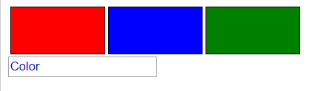**OUTPUT**

