PRACTICAL 1

AIM : Study of class path and java runtime environment. General program to learn java sytax.

1. W.A.P. that reverse a number.

Program:

package lab1;

import java.util.Scanner;

public class Rev

{

int no,r;

public void run(){

Scanner sc=new Scanner(System.in);

System.out.println("Enter a number");

no=sc.nextInt();

int n=0;

while(no!=0)

{

r=no%10;

no=no/10;

n=(n\*10) + (r);

}

System.out.println(n);

}

}

Output:

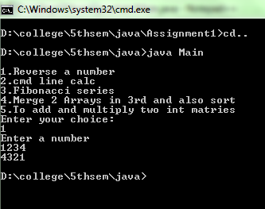

1. W.A.P. that implements a cmd line calc.

Program:

package lab1;

public class Cal{

int x,y;

char c;

public Cal(int a,int b,char c){

x=a;

y=b;

this.c = c;

}

public void run(){

switch(c){

case '+':System.out.println(" = "+(x+y));

break;

case '-':System.out.println(" = "+(x-y));

break;

case '\*':System.out.println(" = "+(x\*y));

break;

case '/':System.out.println(" = "+(x/y));

break;

}

}

}

Output:

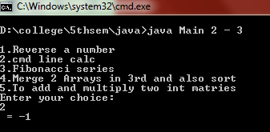

1. W. A. P. to prints Fibonacci series.

Program:

package lab1;

import java.util.Scanner;

public class Fib{

int n1=0,n2=1,n3,i,n;

public void run(){

Scanner sc=new Scanner(System.in);

System.out.println("Enter limit: ");

int n = sc.nextInt();

System.out.print(n1+" "+n2);

for(i=2;i<n;++i)

{

n3=n1+n2;

System.out.print(" "+n3);

n1=n2;

n2=n3;

}

}

}

Output:

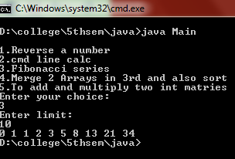

1. W. A. P. to merge two arrays in third array, also sort that array in ascending order.

Program:

package lab1;

import java.util.Scanner;

public class Array{

private int data[],row;

public Array(int row){

data = new int[row];

this.row=row;

}

public Array(int x[]){

data = x;

row = data.length;

}

int getRow(){

return row;

}

public Array Merge(Array ob){

int y[] = new int[getRow()+ob.getRow()];

int i,j,k;

for(j=0;j<row;j++){

y[j]=data[j];

}

for(i=j,k=0;k<ob.getRow();k++,i++){

y[i]=ob.data[k];

}

return (new Array(y));

}

public void read(){

Scanner sc = new Scanner(System.in);

for(int i=0;i<data.length;i++){

data[i]=sc.nextInt();

}

}

public void display(){

for(int i=0;i<data.length;i++){

System.out.println(""+data[i]);

}

}

int Max(int x[]){

int m=x[0];

for(int i=0;i<x.length;i++){

if(m<x[i])

m=x[i];

}

return m;

}

public int [] sort(){

int l=data.length;

int m = Max(data);

int c[] = new int[m+1];

int b[] = new int[l+1];

for(int i=0;i<l;i++){

c[data[i]]=c[data[i]]+1;

}

for(int i=1;i<m;i++){

c[i]=c[i]+c[i-1];

}

for(int i=l-1;i>=0;i--){

b[c[data[i]]]=data[i];

c[data[i]]=c[data[i]]-1;

}

return b;

}

}

Output:

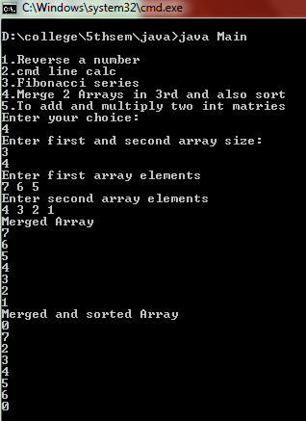

1. W. A. P. to add and to multiply two int matrices.

Program:

package lab1;

import java.util.Scanner;

public class Array2D{

private int data[][];

int i,row,col,j;

public Array2D(int row,int col){

this.row=row;

this.col=col;

data=new int[row][col];

}

Array2D(int x[][]){

data=x;

row = x.length;

col = x[0].length;

}

int [][] getElement(){

return data;

}

public void read(){

Scanner sc = new Scanner(System.in);

for(i=0;i<row;i++){

for(j=0;j<col;j++)

data[i][j]=sc.nextInt();

}

}

public void display(){

for(i=0;i<row;i++){

for(j=0;j<col;j++){

System.out.println(""+data[i][j]);

}

}

}

public Array2D add(Array2D ob){

int y[][]=new int[row][col];

int x[][]=ob.getElement();

for(i=0;i<row;i++){

for(j=0;j<col;j++){

y[i][j]=data[i][j]+x[i][j];

}

}

Array2D j = new Array2D(y);

return (j);

}

public Array2D mul(Array2D ob){

int t[][]=new int[row][ob.col];

for(int i=0;i<row;i++){

for(int j=0;j<ob.col;j++){

for(int k=0;k<col;k++){

t[i][j]+= data[i][k] \* data[k][j];

}

}

}

Array2D K = new Array2D(t);

return (K);

}

}

Output:

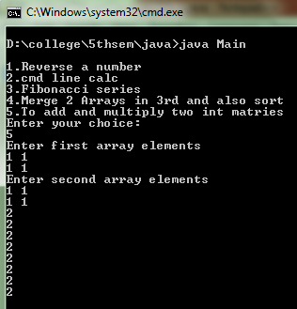

* Common Main function from another package

package main;

import lab1.\*;

import java.util.Scanner;

class Main

{

public static void main(String a[]){

int ch;

Scanner sc=new Scanner(System.in);

System.out.println("\n1.Reverse a number\n2.cmd line calc\n3.Fibonacci series\n4.Merge 2 Arrays in 3rd and also sort\n5.To add and multiply two int matries");

System.out.println("Enter your choice: ");

ch = sc.nextInt();

switch(ch){

case 1: Rev ob1 = new Rev();

ob1.run();

break;

case 2: int x = Integer.parseInt(a[0]);

int y = Integer.parseInt(a[2]);

char c = a[1].charAt(0);

Cal ob2 = new Cal(x,y,c);

ob2.run();

break;

case 3: Fib ob3 = new Fib();

ob3.run();

break;

case 4: System.out.println("Enter first and second array size: ");

int aS = sc.nextInt();

int bS = sc.nextInt();

Array a1 = new Array(aS);

Array b = new Array(bS);

System.out.println("Enter first array elements");

a1.read();

System.out.println("Enter second array elements");

b.read();

System.out.println("Merged Array");

Array c1 = a1.Merge(b);

c1.display();

System.out.println("Merged and sorted Array");

int s[] = c1.sort();

for(int i=0;i<s.length;i++)

System.out.println(""+s[i]);

break;

case 5: Array2D A1=new Array2D(2,2);

Array2D A2=new Array2D(2,2);

System.out.println("Enter first array elements");

A1.read();

System.out.println("Enter second array elements");

A2.read();

Array2D A3=A1.add(A2);

A3=A1.add(A2);

A3.display();

Array2D A4 = A1.mul(A2);

A4.display();

break;

}

}

}