## **PRACTICAL 10:**

**AIM:** Socket Programming

**Program 1:**

Implement multithreaded echo server using TCP.

**Source code:**

**Server Program:**

import java.net.*;

import java.io.*;

import java.util.*;

class Server

{

public static void main(String args[]) throws IOException

{

ServerSocket s=new ServerSocket(3333);

Socket s1=s.accept();

InputStream s1In=s1.getInputStream();

DataInputStream dis=new DataInputStream(s1In);

String strr=new String(dis.readUTF());

System.out.println(strr);

OutputStream s1out=s1.getOutputStream();

DataOutputStream dos=new DataOutputStream(s1out);

String str;

Scanner sc=new Scanner(System.in);

str=sc.nextLine();

dos.writeUTF(str);

dis.close();

dos.close();

s1out.close();

s1.close();

}

}

**Client Program:**

import java.util.*;

import java.io.*;

import java.net.*;

class Client

{

public static void main(String args[])throws IOException

{

Socket client=new Socket("localhost",3333);

OutputStream s1Out=client.getOutputStream();

InputStream s1In=client.getInputStream();

DataOutputStream dos=new DataOutputStream(s1Out);

String str;

Scanner sc=new Scanner(System.in);

str=sc.nextLine();

dos.writeUTF(str);

DataInputStream dis=new DataInputStream(s1In);

String st=new String (dis.readUTF());

System.out.println(st);

dos.close();

s1Out.close();

dis.close();

s1In.close();

client.close();

}

}

**Output:**

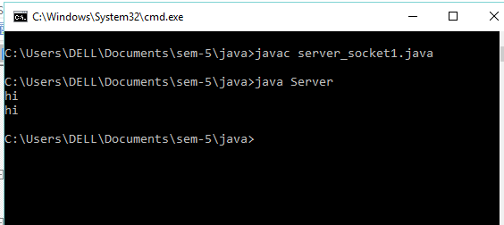

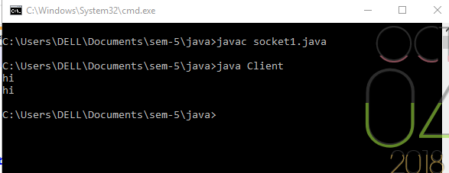

**Program 2:**

Implement a daytime server using datagram socket

**Source Code:**

**Server Program:**

import java.io.IOException;

import java.net.DatagramPacket;

import java.net.DatagramSocket;

import java.net.InetAddress;

import java.net.SocketException;

class UDPServer

{

public static void main(String[] args) throws IOException

{

DatagramSocket ds=new DatagramSocket(1234);

byte[] receive=new byte[65535];

DatagramPacket DpReceive=null;

while(true)

{

DpReceive=new DatagramPacket(receive, receive.length);

ds.receive(DpReceive);

System.out.println("Client:-" + data(receive));

if (data(receive).toString().equals("bye"))

{

System.out.println("Client sent bye ... EXITING");

break;

}

receive = new byte[65535];

}

}

public static StringBuilder data(byte[] a)

{

if (a == null)

return null;

StringBuilder ret = new StringBuilder();

int i = 0;

while (a[i] != 0)

{

ret.append((char) a[i]);

i++;

}

return ret;

}

}

**Client Program:**

import java.io.IOException;

import java.net.DatagramPacket;

import java.net.DatagramSocket;

import java.net.InetAddress;

import java.util.Scanner;

class UDPClient

{

public static void main(String args[]) throws IOException

{

Scanner sc=new Scanner(System.in);

DatagramSocket ds=new DatagramSocket();

InetAddress ip=InetAddress.getLocalHost();

byte buf[]=null;

while(true)

{

String inp=sc.nextLine();

buf=inp.getBytes();

DatagramPacket DpSend=new DatagramPacket(buf, buf.length, ip, 1234);

ds.send(DpSend);

if(inp.equals("bye"))

break;

}

}

}

**Output:**

