**PRACTICAL 14:**

**AIM:** Prepare an activity diagram for computing a restaurant bill, there should be charge for each delivered item. The total amount should be subject to tax and service charge of 18% for group of six and more. For smaller groups there should be a blank entry. Any coupons or gift certificates submitted by the customer should be subtracted**.**

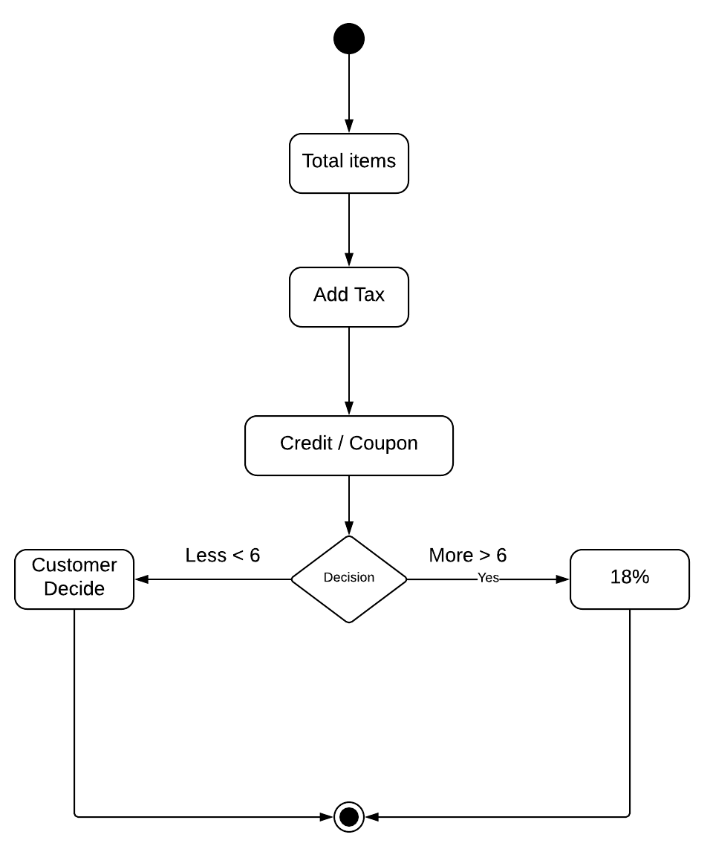

**PRACTICAL 15:**

**AIM:** Prepare a sequence diagram for issuing a book in the library management system.

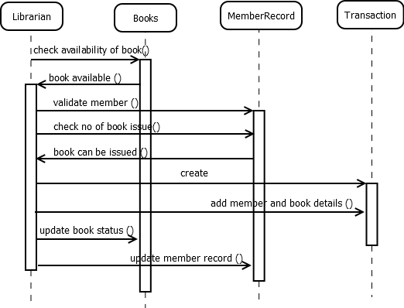

**PRACTICAL 13:**

**AIM:** Prepare a state diagram for an interactive diagram editor for selecting and dragging objects

