## **PRACTICAL 8:**

# **AIM:** Collection framework

**Program 1:**

Define the following collections with some values.

a. Array List  
b. HashSet  
c. HashMap  
d. Hash table

e. LinkedList

**a) Array List**

**Source Code:**

import java.util.*;

class Student

{

int rollno;

String name;

int age;

Student(int rollno,String name,int age)

{

this.rollno=rollno;

this.name=name;

this.age=age;

}

}

class TestStudent

{

public static void main(String args[])

{

Student s1=new Student(10,"mansi",24);

Student s2=new Student(05,"jeel",20);

Student s3=new Student(15,"divya",23);

Student s4=new Student(07,"jil",19);

Student s5=new Student(13,"Tulsi",15);

Student s6=new Student(04,"vaibhavi",20);

ArrayList<Student> al=new ArrayList<Student>();

al.add(s1);

al.add(s2);

al.add(s3);

al.add(s4);

al.add(s5);

al.add(s6);

for(Student st:al)

System.out.println(st.rollno+" "+st.name+" " + st.age);

}

}

**Output:**

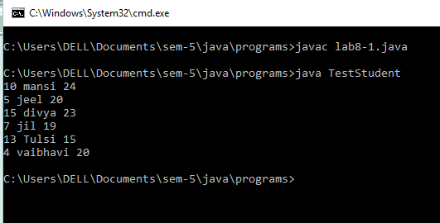

**b)Hashset**

import java.util.*;

class Test

{

public static void main(String[]args)

{

HashSet<String> h = new HashSet<String>();

h.add("India");

h.add("Australia");

h.add("South Africa");

h.add("India");

System.out.println(h);

System.out.println("\nList contains India or not:" +

h.contains("India"));

h.remove("Australia");

System.out.println("\nList after removing Australia:" +h);

System.out.println("\nIterating over list:");

Iterator<String> i = h.iterator();

while (i.hasNext())

System.out.println(i.next());

}

}

**Output:**

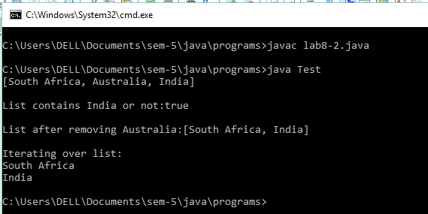

**c)HashMap:**

import java.util.*;

class hmap

{

public static void main(String args[])

{

HashMap<Integer, String> map = new HashMap<Integer, String>();

map.put(101,"Let us C");

map.put(102, "Operating System");

map.put(103, "Data Communication and Networking");

System.out.println("Values before remove: \n"+ map);

map.remove(102);

System.out.println("Values after remove: \n"+ map);

}

}

**Output:**

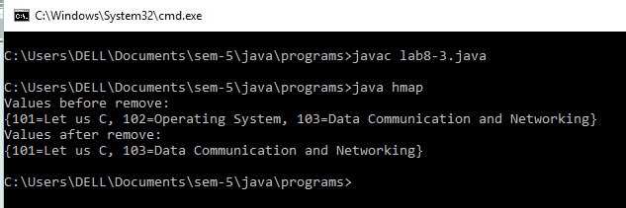

**d)Hashtable:**

import java.util.*;

class Book

{

int id;

String name,author,publisher;

int quantity;

public Book(int id,String name,String author,

String publisher,int quantity)

{

this.id=id;

this.name=name;

this.author=author;

this.publisher=publisher;

this.quantity=quantity;

}

}

class htable

{

public static void main(String a[])

{

Map<Integer,Book> map=new Hashtable<Integer,Book>();

Book b1=new Book(101,"Let us C","Yashwant Kanethar","BPB",8);

Book b2=new Book(102,"Data Communications & Networking","Forouzan","Mc Graw Hill",4);

Book b3=new Book(103,"Operating System", "Galvin","Wiley",6);

map.put(1,b1);

map.put(2,b2);

map.put(3,b3);

for(Map.Entry<Integer,Book> entry:map.entrySet())

{

int key=entry.getKey();

Book b=entry.getValue();

System.out.println("\n"+key+" Details :");

System.out.println("Id :"+b.id);

System.out.println("\nBook name :"+b.name);

System.out.println("\nAuthor name :"+b.author);

System.out.println("\nPublisher :"+ b.publisher);

System.out.println("\nQuantity :"+b.quantity);

}

}

}

**Output:**

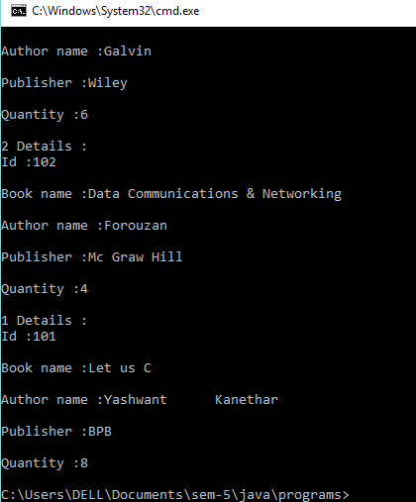

**e)LinkedList:**

import java.util.*;

class TestList

{

public static void main(String a[])

{

LinkedList<String> a1=new LinkedList<String>();

a1.add("Mansi");

a1.add("Mahima");

a1.add("Mahi");

a1.add("Rainal");

a1.add("Shivani");

a1.add("Shiv");

a1.add("Adi");

Iterator<String>itr=a1.iterator();

{

while(itr.hasNext())

{

System.out.println(itr.next());

}

}

}

}

**Output:**

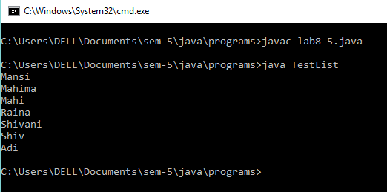

**Program 2:**

Iterate through all elements of collection using Enumeration and Iterator Interface and remove an element of each collection using these Interfaces.

**Source Code:**

import java.util.Vector;

import java.util.Enumeration;

class Test

{

public static void main(String args[])

{

Vector dayNames = new Vector();

dayNames.add("Sunday");

dayNames.add("Monday");

dayNames.add("Tuesday");

dayNames.add("Wednesday");

dayNames.add("Thursday");

dayNames.add("Friday");

dayNames.add("Saturday");

Enumeration days = dayNames.elements();

while (days.hasMoreElements())

System.out.println(days.nextElement());

}

}

**Output:**

