## **PRACTICAL 1:**

## **AIM:** Study of class path and java runtime environment. General program to learn java syntax.

**Program 1:**

W. P. that reverse a number.

Source Code:

package lab1;

public class reverse

{

int temp,n;

public int rev(int x)

{

while((x%10)!=0)

{

temp=x%10;

n=(n*10)+temp;

x=x/10;

}

return n;

}

}

Output:

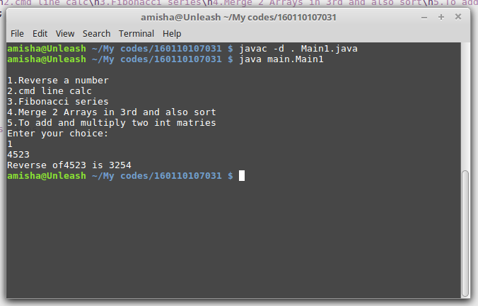

**Program 2:**

W.P. that implements a cmd line calc.

Source Code:

package lab1;

public class Cal{

int x,y;

char c;

public Cal(int a,int b,char c){

x=a;

y=b;

this.c = c;

}

public void run(){

switch(c){

case '+':System.out.println(" = "+(x+y));

break;

case '-':System.out.println(" = "+(x-y));

break;

case '*':System.out.println(" = "+(x*y));

break;

case '/':System.out.println(" = "+(x/y));

break;

}

}

}

Output:

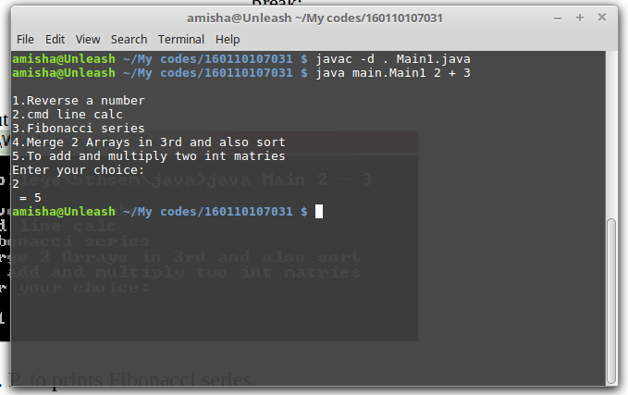

**Program 3:**

W. P. To prints Fibonacci series.

Source code:

package lab1;

import java.util.Scanner;

public class Fib

{

int n1=0,n2=1,n3,i,n;

public void run()

{

Scanner sc=new Scanner(System.in);

System.out.println("Enter limit: ");

int n = sc.nextInt();

System.out.print(n1+" "+n2);

for(i=2;i<n;++i)

{

n3=n1+n2;

System.out.print(" "+n3);

n1=n2;

n2=n3;

}

}

}

Output:

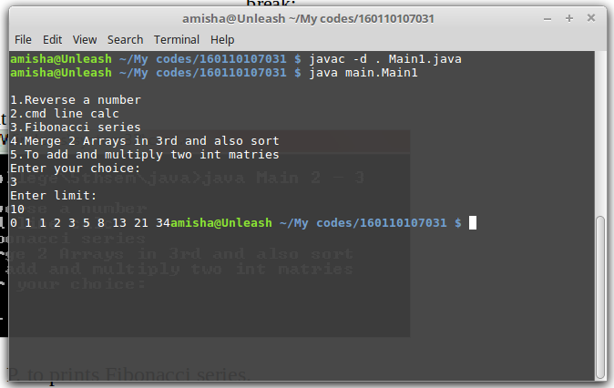

**Program 4:**

W.P. to merge two arrays in third array .also sort that array in ascending order.

Source code:

package lab1;

import java.util.Scanner;

public class Array

{

private int arr[];

public Array()

{

arr=new int[5];

}

public Array(int i)

{

arr=new int[i];

}

public Array(int b[])

{

arr=b;

}

public void read()

{

Scanner ob=new Scanner(System.in);

for(int i=0;i<arr.length;i++)

{

arr[i]=ob.nextInt();

}

}

public int[] getdata()

{

return arr;

}

public void display()

{

System.out.println("\nThe array elements are:");

for(int i=0;i<arr.length;i++)

{

System.out.print(arr[i]+"\t");

}

System.out.print("\n");

}

public Array merging(Array x)

{

int i;

int j;

int c[]=x.getdata();

Array result=new Array(c.length+c.length);

for(i=0;i<arr.length;i++)

{

result.arr[i]=arr[i];

//System.out.println(result.arr[i]);

}

for(j=0;j<c.length;j++)

{

//System.out.println("Hii");

//System.out.println("c[j] :" + c[j]);

result.arr[i++]=c[j];

//System.out.println(i);

}

return result;

}

public void sort(Array a3)

{

int temp;

for(int i=0;i<a3.arr.length;i++)

{

for(int j=i;j<a3.arr.length;j++)

{

if(a3.arr[j]<a3.arr[i])

{

temp=a3.arr[i];

a3.arr[i]=a3.arr[j];

a3.arr[j]=temp;

}

}

}

}

}

Output:

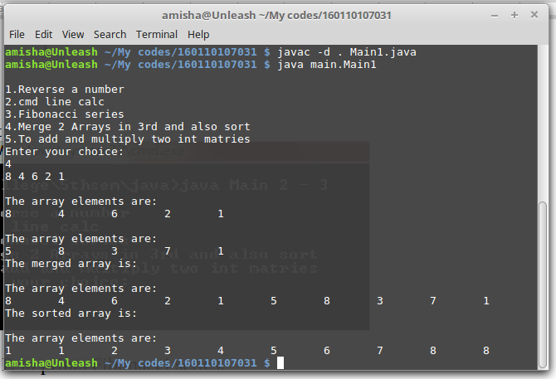

**Program 5:**

W.P to add and to multiply two int matrices.

Source code:

package lab1;

import java.util.Scanner;

public class Matrix

{

int data[][];

int row,col;

public Matrix()

{

data=new int[3][3];

}

public Matrix(int row,int col)

{

data=new int [row][col];

this.row=row;

this.col=col;

}

public Matrix(int arr[][])

{

data=arr;

}

public void read()

{

Scanner ob=new Scanner(System.in);

for(int i=0;i<data.length;i++)

{

for(int j=0;j<data.length;j++)

{

data[i][j]=ob.nextInt();

}

}

}

public void display()

{

for(int i=0;i<3;i++)

{

for(int j=0;j<3;j++)

{

System.out.print(data[i][j]+"\t");

}

System.out.print("\n");

}

}

public Matrix add(Matrix x)

{

Matrix t=new Matrix(row,col);

for(int i=0;i<row;i++)

{

for(int j=0;j<col;j++)

{

t.data[i][j]=data[i][j]+x.data[i][j];

}

}

return t;

}

public Matrix multiply(Matrix x)

{

Matrix temp=new Matrix(3,3);

for(int i=0;i<3;i++)

{

for(int j=0;j<3;j++)

{

temp.data[i][j]=0;

for(int k=0;k<3;k++)

{

temp.data[i][j]=temp.data[i][j]+data[i][k]*x.data[k][j];

}

}

}

return temp;

}

}

Output:

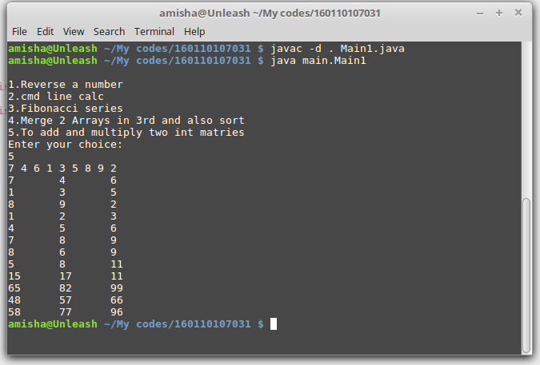

Main class to run all programs according to choice:

package main;

import lab1.*;

import test.*;

import java.util.Scanner;

public class Main1

{

public static void merge()

{

int x[]={5,8,3,7,1};

Array a1=new Array();

Array a2=new Array(x);

Array a3;

a1.read();

a3=a1.merging(a2);

a1.display();

a2.display();

System.out.println("The merged array is:");

a3.display();

System.out.println("The sorted array is:");

a3.sort(a3);

a3.display();

}

public static void matrix()

{

int d[][]={{1,2,3},{4,5,6},{7,8,9}};

Matrix m1=new Matrix(3,3);

Matrix m2=new Matrix(d);

Matrix m3;

Matrix m4;

m1.read();

m3=m1.add(m2);

m4=m1.multiply(m2);

m1.display();

m2.display();

m3.display();

m4.display();

}

public static void main(String a[])

{

int ca;

Scanner sc=new Scanner(System.in);

System.out.println("\n1.Reverse a number\n2.cmd line calc\n3.Fibonacci series\n4.Merge 2 Arrays in 3rd and also sort\n5.To add and multiply two int matries");

System.out.println("Enter your choice: ");

ca= sc.nextInt();

switch(ca)

{

case 1:

{

int ans;

reverse d1=new reverse();

Scanner sca=new Scanner(System.in);

int x= sca.nextInt();

ans=d1.rev(x);

System.out.println("Reverse of"+x+" is "+ans);

break;

}

case 2:

{

int x = Integer.parseInt(a[0]);

int y = Integer.parseInt(a[2]);

char c = a[1].charAt(0);

Cal ob2 = new Cal(x,y,c);

ob2.run();

break;

}

case 3:

{

Fib ob3 = new Fib();

ob3.run();

break;

}

case 4:

merge();

break;

case 5:

matrix();

break;

default:

System.out.println("enter a valid choice");

}

}

}