Design on

RESTAURANT MANAGEMENT SYSTEM

(ONLINE FOOD ORDERING SYSTEM)

AMAN GARU

00162791

COMPUTING PROJECT

Level 5 Diploma in Computing

Softwarica College of IT & E-Commerce

Kathmandu, Nepal

24th, May 2017

Contents

3. Design Specification 3

3.1 Structural Diagram 3

3.1.1 Class Diagram 3

3.2 Behaviour Diagram 4

3.2.1 Sequence Diagram 5

3.2.2 Activity Diagram 12

3.3 Database Design 13

3.3.1 Data Dictionary 14

3.3.2 ER Diagram 16

Conclusion 18

References 18

Table of Figures

Figure 1: Class Diagram 4

Figure 2: Activity Diagram 5

Figure 3: Sequence Diagram for Registration 6

Figure 4: Sequence Diagram for Login 7

Figure 5: Sequence Diagram for Adding New Category 8

Figure 6: Sequence Diagram for Deleting Category 8

Figure 7: Sequence Diagram for Adding new Items 9

Figure 8: Sequence Diagram for Deleting Items 9

Figure 9: Sequence Diagram for Updating Item 10

Figure 10: Sequence Diagram for Updating Customer's Info 10

Figure 11: Sequence Diagram for Ordering Items 11

Figure 12: Sequence Diagram for Delivery and Payment 12

Figure 13: Activity Diagram 13

Figure 14: Data Dictionary for Table cart 14

Figure 15: Data Dictionary for Table category 14

Figure 16: Data Dictionary for Table customer 14

Figure 17: Data Dictionary for Table invoice 15

Figure 18: Data Dictionary for Table item 15

Figure 19: Data Dictionary for Table order 15

Figure 20: Data Dictionary for Table priceCategory 15

Figure 21: Data Dictionary for Table status 16

Figure 22: ER Diagram 16

# 3. Design Specification

Requirement specification is reviewed and the system design is created in this phase. Design is one of the stage in software development that defines architectures and interfaces of a system. It also include the detail properties of project that helps a developer to complete the project making this design a base. It help to define the overall design of system and guides the way in following the design pattern. It provide specification of the system explaining the requirements of the system. In addition, the effective implementation of this design leads in better project management.

Unified Modelling Language (UML) is a standard visual modelling language that help in constructing and documenting the modelling business of the system and it help in analysing, design and implementation of software-based systems. UML is just a standard modelling language, not a software development process. UML specifies how the software should be developed. It provides a guidance in a teamwork and it helps in measuring the progress of the system.

Among different IDE available, Visual Paradigm is the tool, I have used to construct UML Diagrams. It provides essential tools/features required while drawing the UML diagrams. User can enhance the diagram easily and this tool is easier to use. This IDE provide an excellent user-friendly environment.

There are two types of UML Diagram i.e. Structural Diagram and Behaviour Diagram. Along with Entity Relationship diagram, these diagrams are explained below with the clear diagrams.

## 3.1 Structural Diagram

Structural Diagram represent static aspect of system. Static part include the main structure of the system, which tends it to make stable. It show the hierarchy of structurer of the different modules/components of the system showing the interconnection between each other.   
  
Class Diagram, one of the must use structural diagram is described below with the application level diagram.

### 3.1.1 Class Diagram

Class Diagram is the building block of object oriented programming. It specify the classes of the system, its attributes and operations, and the relationship between each classes. It helps to give the overview of the system.

The Class Diagram is shown below.

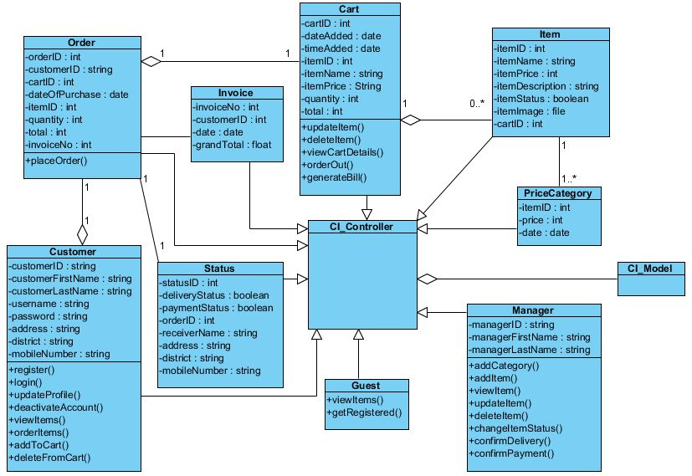

Figure 1: Class Diagram

The above class diagram consist of nine different classes beside CI_Controller and CI_Model. CI_Controller and CI_Model are the built in class of CodeIgniter. All other classes have generalization relationship with CI_Controller class as all this class extend the built in class. Here, Cart and Item classes are related with each other and have an aggregation relationship showing has-a relation as Cart is fully dependent on Item. Similarly, Order and Cart and Customer and Order have aggregation relation. Here Order and Status have Association relation whereas Item and PriceCategory has also Association relationship.

## 3.2 Behaviour Diagram

Behaviour Diagram represent the dynamic aspect of the system. It includes the moving parts of the system. Here the logic is implemented directly. It is used to show the functionality of the system. It show what should happen in a system. It also describe how the object interact each other to make a working framework.

Various behaviour diagram are available in the markers. For e.g., sequence diagram, activity diagram, use case diagram, communication diagram, and timing diagram and so on. Among them mostly used behaviour diagram i.e. Sequence diagram and Activity diagram are described below.

### 3.2.1 Sequence Diagram

As the name sequence diagram, this diagram deals with the sequence of message flowing from one objet to another. It shows how the object interact with each other. It describes the interactions among classes regarding an exchange of message over time. This diagram shows the order in which methods are invoked in the system. It help us to predict how system will work and to distinguish the responsibilities that class must have while demonstrating new system.

The Sequence Diagram for the whole system and the diagram with the small chunks are shown below.

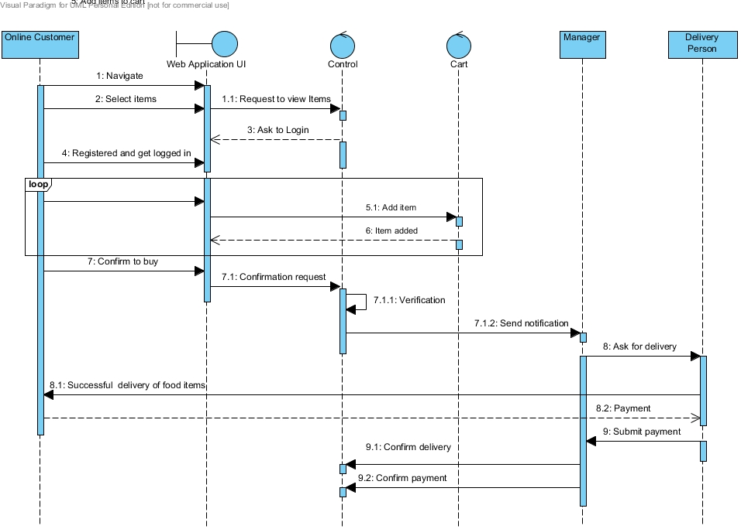

Figure 2: Activity Diagram

Here, first of all user navigate a website. Then Customer select the items, as they want. However, the user need to be logged in before placing order. Therefore, the system ask the user to be logged in and then the customer can add the items as he/she wanted in the cart. After placing, the number of items as he/she wanted in the cart then one must confirm to buy. Only after then actual order is placed to the admin section. After confirming order, system will perform the verification of the user and then then system notify the manager. Then after manager request the delivery person to deliver the goods to the customer and afterwards just after delivery, customer will pay the manager as the amount mentioned during the time of bill generation just after confirming order. After that, delivery person submit the payment to manager and hereby, manager confirm the delivery status and payment status in system.

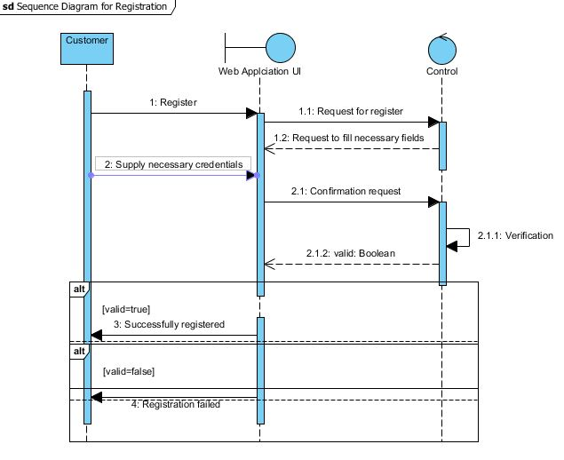

Figure 3: Sequence Diagram for Registration

Here, customer provides all the necessary credentials to be registered. Some level of verification is done in the system. If the system verified customer requesting the confirmation request then, the customer is registered successfully, else there is some error during registration process.

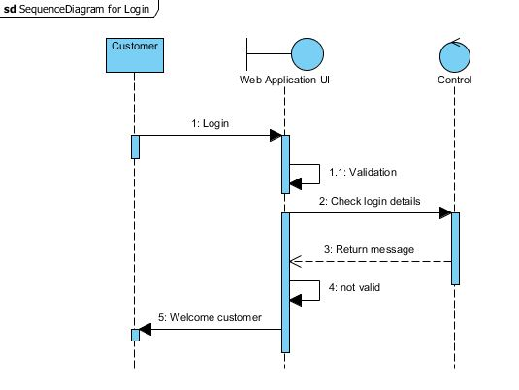

Figure 4: Sequence Diagram for Login

In the above diagram, customer request for login. Then, system check database to check whether the customer is registered or not after having some level of validation through the website. If customer’s username and password matches then the customer is welcomed in the system, else the customer is returned to login page stating the error in username/password.

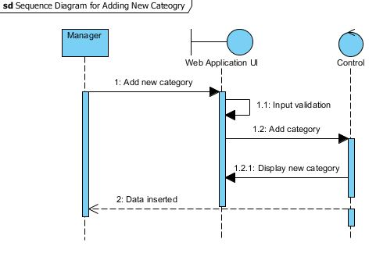

Figure 5: Sequence Diagram for Adding New Category

Here, the new category is inserted in database. First form is filled in website to add new category. Then after checking the input validation, category will be successfully added to the database and the successful data inserted i.e. successful message in adding new category is shown to the manager.

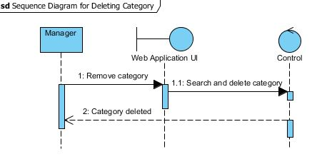

Figure 6: Sequence Diagram for Deleting Category

For deleting the category, manager commands the system to remove category through UI. The UI commands the system to search the category and delete the category if found. After successfully deleted, manager is messaged with Category successfully deleted.

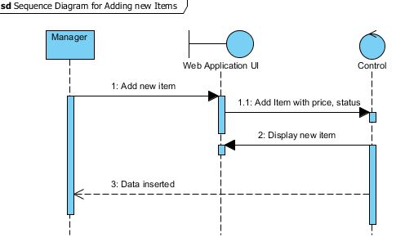

Figure 7: Sequence Diagram for Adding new Items

After adding a new category, items should be added to the specific category with the item name, price and its availability status. Then after giving the command to system to add new items through manager, data inserted message is shown to him.

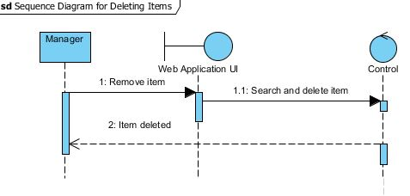

Figure 8: Sequence Diagram for Deleting Items

In the above diagram, manager provide the message to remove the item to the system. Then the item requested by the manager is searched and are deleted after found and later it will be informed to manager.

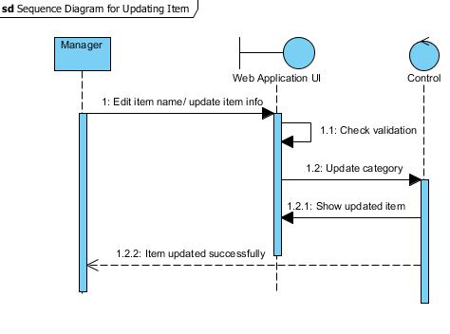

Figure 9: Sequence Diagram for Updating Item

In the above diagram, manager request the system to edit the details of items like as its name and its price, availability etc. Then the site perform some level of validation and if the item requested by the manager found then, the system update the items as user command. Then the updated item is shown in the screen while the update successful message is shown to manager.

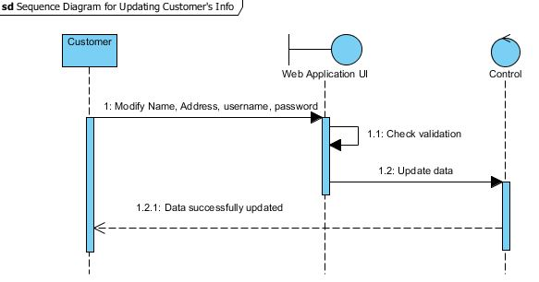

Figure 10: Sequence Diagram for Updating Customer's Info

In the above figure, customer request system to change his/her basic info. Then the system perform the initial validation through web and then after validation, customer information is updated successfully and the successfully message is delivered to the customer.

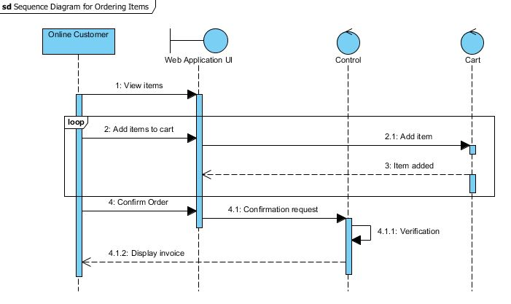

Figure 11: Sequence Diagram for Ordering Items

In the figure mentioned above, customer order the items for delivery. First of all customer view the items in the site. Afterwards, customer add the items in the cart per the need of the customer. After repeating some cycle, customer confirm the order in the webpage. Then, the site checks the confirmation request, which was done through the verification of user in system. At last, invoice is displayed to the customer as per the items selected as per the user request.

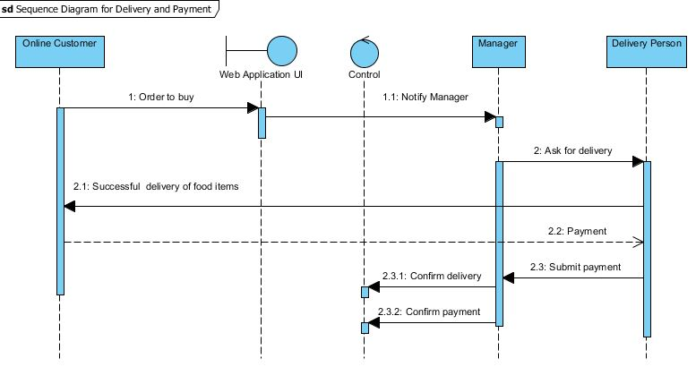

Figure 12: Sequence Diagram for Delivery and Payment

In the above figure, customer order out the cart items for final purchase. Then the system notify the manager. After that manager, request the delivery person to deliver the goods to particular customer. After successful delivery, customer pays the delivery person as the amount mentioned in the invoice. After that delivery person, submit the payment to manager. Then manager confirm the delivery and system, which was recorded in the system.

### 3.2.2 Activity Diagram

Activity Diagram is one of the important behaviours diagram consisting the activities and linkage. In addition, it describe the flow control in a system representing the workflow in a graphical way. They can be utilized to describe business process or operational workflow of any component in a system. Activity diagram is the flow chart representing the flow from one activity to another. It describe the logic of operation shown in class diagram. They are used for outlining the high-level activity of the system and this diagram formally represent algorithm.   
  
The Activity diagram of the system is shown below.

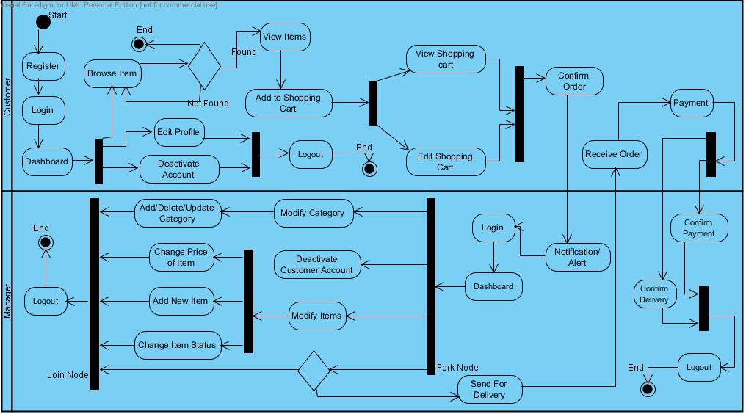

Figure 13: Activity Diagram

The above diagram shows the flow of activity form one activity to another. As in figure first of all customer register to the system then get logged in and then he/she enters dashboard where he/she can edit their profile, deactivate account and browse items. Then the items selected by the customer are stored to the cart, which the user can manipulate in future. Then after checking the cart once again customer confirm order and the order message is reached to manager through notification. Then the manager logged in to the system, view the order details, and ask a delivery person to deliver the items to the particular person. In addition, a manager can modify the category and items. After the delivery, the customer pays the amount to delivery person equals to the amount mention in invoice. After that delivery person submit the amount to manager and the manager confirms the payment and delivery and change the status to YES.

## 3.3 Database Design

Database design determine the data that should be stored in database. It is the process of creating overall database system. It represent the logical design used to store data. Not only the data stored in database, it also deals with the relationship between different data elements, constraints used in table, indexes, triggers, views, procedure, routines etc. A properly designed database help in providing up-to-date and accurate information. In addition, it helps in saving disk spaces and ultimately in eradicates time consuming. During database design, one must tackle with three different model i.e. Conceptual, Logical and Physical. Entities are recognised and the relationship is provided in Conceptual model. Logical mode includes the attributes, keys, normalisation part. In addition, physical design includes the table creation, and it is fully dependent on specific database system. Among different Database system, MySQL is use for this project. Data Dictionary and ER Diagrams considered being the important terms in Database design. These two terms are explained below.

### 3.3.1 Data Dictionary

Data Dictionary is one of the important part in database design, which described the read-only set of table. It is a file that defines the basic organisation of database. It define the structure of database itself and it is used in controlling and maintaining large database. It records what data is stored, description, characteristics of each data element and type of relationships between elements.

The list of database table are shown below.

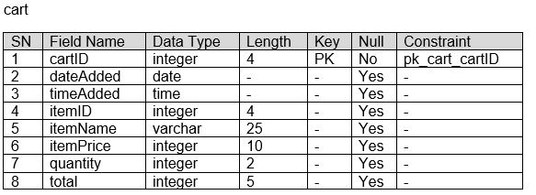

Figure 14: Data Dictionary for Table cart

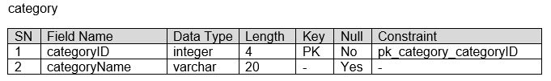

Figure 15: Data Dictionary for Table category

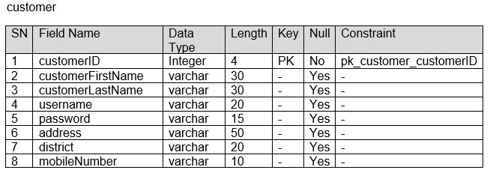

Figure 16: Data Dictionary for Table customer

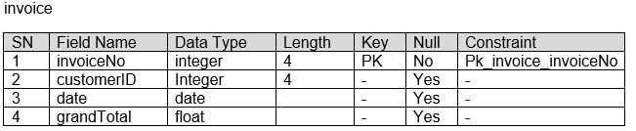

Figure 17: Data Dictionary for Table invoice

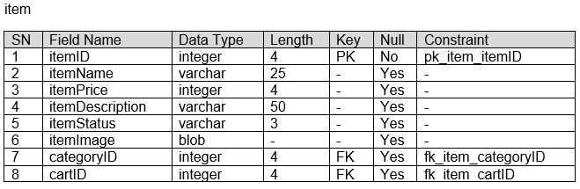

Figure 18: Data Dictionary for Table item

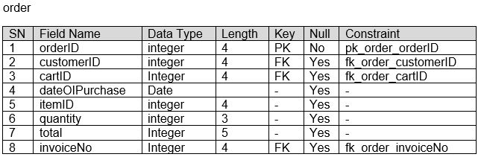

Figure 19: Data Dictionary for Table order

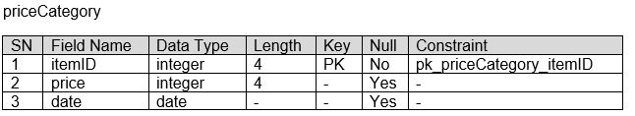

Figure 20: Data Dictionary for Table priceCategory

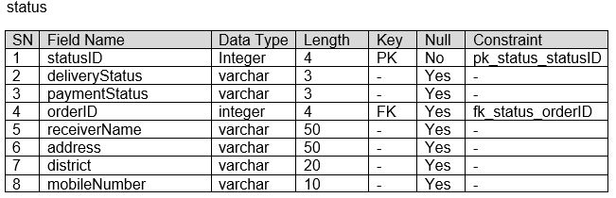

Figure 21: Data Dictionary for Table status

### 3.3.2 ER Diagram

ER Diagram abbreviation of Entity Relationship diagram shows the relationship of entity sets stored in database. There are three main components of ERD that should be well known. First, one is entity; second, one is relationship between entities and lastly cardinality, which describe the relationship in term of numbers. Cardinality relationship is also of three types. One-to-One, One-to-Many and Many-to-Many.

ER diagram of the database of the system is shown below.

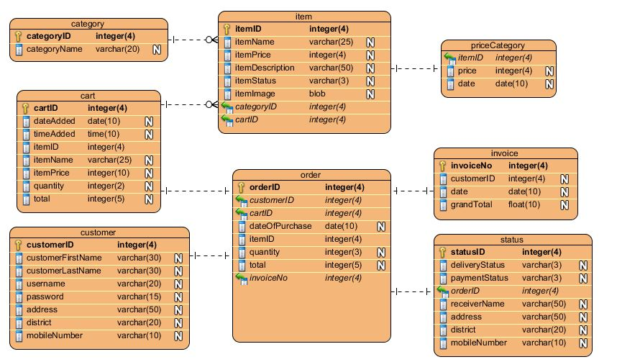

Figure 22: ER Diagram

The above design includes eight different entities i.e. category, item, priceCategory, cart, order, invoice, customer and status. Individual entities consist its own attributes with the appropriate datatypes. Keys i.e. Primary key and foreign key are managed carefully among the diagram. In addition, the relation between the entities are applied carefully. For e.g., one category may have multiple items but an item falls only in one category. Hence, there is one to much relationship between category and customer. Likewise, the priceCategory table is defined to maintain the variable price of the items with change of time. A cart may contain multiple items while a particular order is related only with particular order. Here the invoice is generated with respect to the orderID. In addition, the Status table dwells with the delivery status, payment status and the receiver information. Finally, customer is linked with the order made by him/her.

# Conclusion

Therefore, in this way the architectural and interface part of the system was designed with the help of the different diagrammatic notations. Different types of UML notational diagrams were introduced to incorporate the design phase, which would make the client understandable towards the different parts of the system design and help them to meet their own requirements they would like to need in their system. Here, in the design phase different UML diagrams were associated such as structural design, behavioral design and database design. In context to the structural design, class diagram was associated. In respect to the behavioral design, the message passing diagram or sequence diagram and activity diagram was associated. Whereas in database design, E-R diagram was associated respectively. All of this design are drawn through Visual Paradigm tools.

# References

http://www.uml-diagrams.org/

http://searchcrm.techtarget.com/definition/entity-relationship-diagram