Project Proposal on

RESTAURANT MANAGEMENT SYSTEM

(ONLINE FOOD ORDERING SYSTEM)

AMAN GARU

00162791

COMPUTING PROJECT

Level 5 Diploma in Computing

Softwarica College of IT & E-Commerce

Kathmandu, Nepal

9th, April 2017

Contents

1. Introduction 2

1.1 Aims 3

1.2 Objectives 3

1.3 Main Features 3

1.4 Development Methods 4

2. Project Plan 6

2.1 Work Breakdown Structure (WBS) and Time Estimate 6

2.2 Milestones 7

2.3 Schedule 8

3. Risk Management 10

4. Configuration Management 12

5. Conclusion 13

6. References 14

1. Introduction  
  
Paradise Food Land, one of the popular Restaurant located in Suryavinayak, Bhaktapur is growing is market day by day. Moreover, the head of the Restaurant believes that the growth of the customer will increased by double by this summer. Hence, the director have planned to provide services for customers by providing the facility of Online Food Ordering system and deliver the goods within Kathmandu Valley.

The project, Restaurant Management System (Online Food Ordering Service), suits upon the real problem of the restaurant. Likewise, the productivity of the restaurant will enhanced automatically. Recently the restaurant have been providing services only from the restaurant itself. After the development of this project, the restaurant can have both offline and online services. Offline services work as usual while the online services work with the new feature integrated it in and the different offers to the customer. Customer will also get benefit by the services with the low delivery charge and the customers are able to save their time as well. Nowadays, E-Commerce has become the phenomenon in the today’s changing world. Online Food ordering system is kind of E-Commerce. Being the web-based system, customer can afford is easily without any restriction. Beside All the services for the restaurant, the only one task of the restaurant is to increaser its staff to work as delivery boy and as a cook to handle greater traffic than usual.   
  
Customer are facing various difficulties due the unmanaged system of the restaurant. The visitors are forced to move back to other restaurant/hotels due to the lack of proper placement. Moreover, the busy customer are stressed to spend their precious time visiting the stall. Quality food is the main theme of today’s diet, which the restaurant is being providing. In addition to it, time is the more important factor in today’s worlds. More over the service and the facilities in the company provide extra charm in the human factor. Hence considering these entire factors the restaurant is currently on the way to improve its services to withstand the increasing crowd and to give quality food in the short interval of time for customers. This service not only increase the customer satisfaction but also restaurant can increase their sale due to increase outline outlet.

Online Food Ordering is the process of ordering the foods from restaurant (in this case) on the internet through website. Customer can visit the web-based store from their home as they sit in front of the computer. Customers can order variety of food items from online services. Snacks items, Dinner items, Hard Drinks, Cold Drinks, Alcoholic Beverage, Breakfast Items, Lunch Items and many other products customer can order from the site.

## 1.1 Aims

Aim is defined as a target of achieving something. Every project got its own aim. Likewise, this project also have some of the aims, which are included in the following points below.

* To build the web based system for restaurant for ordering the foods online in that restaurant.
* To increase the overall efficiency of the system.
* To be able to stand out from competitors in the online food service industry.

## 1.2 Objectives

The main objectives of the project is to give a framework, which controls the offering of food items through on the web. Customer will consume less time through online ordering rather than visiting the stall directly. Customer can order the food items from anywhere (within Kathmandu Valley), anytime i.e. (6 am to 9 pm). The transaction will be taken care by the system all the time, which make the data storing easy. It leads in eradication of data miscalculation as well. Some of the objectives for resolving the project aim are shown below.

* To increase human computer interface on the system.
* To perform the automatic billing calculation.
* To increase the security in the transaction.
* To ensure correct placement of orders through self-visual confirmation.
* To increase speed of service, sales volume and customer satisfaction.
* To reduce time wasting by eliminating long queue and visiting the restaurant.

## 1.3 Main Features

Customer of this web-based system are facilitated with different features. Some of the main features integrated in this system are shown below.

* It provide the framework for booking the food items online.
* Customer can sign up and become the member to get extra facilities.
* Customer can login to get various information about food products and purchase the suitable product with price and quality comparison.
* It will provide cart service facility.
* It provide the home delivery facility as well.
* It will perform the automatic price calculation of the foods that a customer order.

## 1.4 Development Methods

Among the different developments methods available and analyzing the project, I have choose Waterfall Model for this project.

The project include the number of sequential task to perform. Similarly, waterfall model helps to meet up the current requirements. Waterfall methods is the classical approach of system development lifecycle in which the process of development are decomposed into several steps and the progress is seen as flowing downwards similar as waterfall. The six stages i.e. Feasibility Study, Analysis and Requirement Specification, Design, Integration, Testing and Maintenance are included in this development method. Feasibility Study helps to determine whether the project is technically, socially and finally feasible. In addition, it focuses on cost-benefit analysis. All the hardware and software aspects are analyzed in Analysis process while the requirements are defined in Requirement Specification process. Design is the place where the system architecture along with UI design and database design are performed. Implementation is the phase where the system is introduced in the organization directly. Testing deals with the system testing and plays with the robustness and reliability. At last, Maintenance helps to ensure that the robustness and reliability continues through the lifetime of that project.

All of these steps are sequentially and strictly followed. Without completing the previous steps next process cannot be followed. It is one of the simple and easiest process to implement in development process. It includes the clearly defined stages, which help in the completion of the phase one at the time and each phase can be progressed. Moreover, the process and results are also well documented in these methods. Discipline is strictly followed in this method. In addition, the documented is compulsory in this method but other design method does not have compulsion in documentation. Hence, waterfall model is used during this system development.

The project look as simple and the requirements of the project implies to be with less requirements. Hence, the waterfall model is preferred for the development of this system. Certainty of the completeness of each phase of the project is clearly described by this model. As the project does not consist of many ambiguous requirement, choosing waterfall model might be the best solutions for this project. Following this methods the development of the system seems to be easy as there is very low chance of overlapping which give the proper result with the well-functioned system. Besides all of the good aspects, cost and time might be the great matter for this project and failure of one-steps forced the user to begin it from the initial stages. Hence analyzing the project, I have decided to implemented waterfall model for this project.

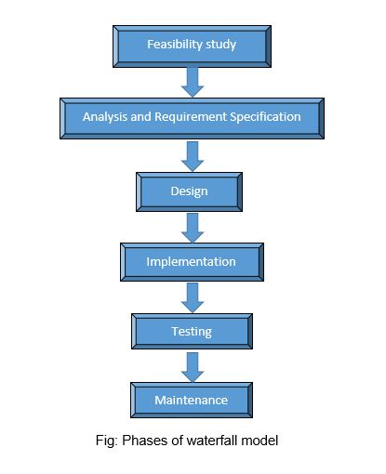

# 2. Project Plan

Plan is the most important term during the development as it deals with the estimation of time of every phase of the system development criteria.

## 2.1 Work Breakdown Structure (WBS) and Time Estimate

Work Breakdown Structure is a chart showing the break down object oriented project into easily manageable components. A work breakdown structure is a model that sorts out the collaboration into reasonable areas. It can also be defined as the hierarchical decomposition of aggregate task of project into subcomponents to accomplish project objectives.

Similarly, I Begin WBS by breaking projects down into its substituent objectives. For this the model showing the time estimation for each phase required for the project are shown in the tabular format below.

|  |  |  |
| --- | --- | --- |
| **WBS** | **Task Name** | **Days** |
| **0** | **Restaurant Management System (Online Food Ordering System)** | **72** |
| **1** | **Feasibility Study** | **6** |
| 1.1 | Brainstorming | 2 |
| 1.2 | Market Feasibility | 1 |
| 1.3 | Planning | 2 |
| 1.4 | Interview | 1 |
| **2** | **Analysis and Requirement Specification** | **8** |
| 2.1 | Software Requirement | 2 |
| 2.2 | Technical Analysis | 2 |
| 2.3 | Key Stakeholder Analysis | 2 |
| 2.4 | Functional and Non-Functional Requirement | 2 |
| **3** | **Design** | **28** |
| 3.1 | **Static Diagram** | 5 |
| 3.1.1 | Use Case Diagram | 2 |
| 3.1.2 | Class Diagram | 3 |
| 3.2 | **Dynamic Diagram** | 9 |
| 3.2.1 | Sequence Diagram | 4 |
| 3.2.2 | Collaboration Diagram | 5 |
| **3.3** | **UI Design** | **8** |
| **3.4** | **Database Design** | **6** |
| **4** | **Implementation** | **22** |
| **5** | **Testing** | **5** |
| 5.1 | White Box Testing | 2 |
| 5.2 | Black Box Testing | 1 |
| 5.3 | Unit Testing | 2 |
| **6** | **Reporting** | **3** |
| **7** | **Maintenance** |  |

Fig: WBS with time estimation

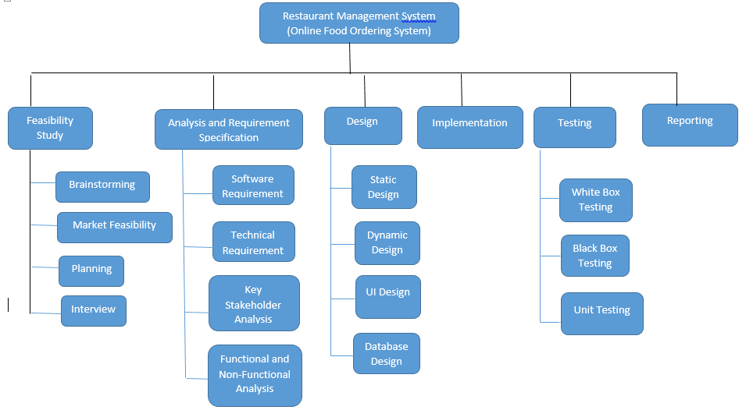

Fig: WBS

## 2.2 Milestones

Milestone are significant point in finalization of project within a specific time span. Referencing the WBS chart mentioned above milestone can be identified. The point used as referencing helps in measuring the project progress.

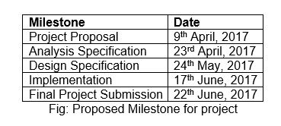

## 2.3 Schedule

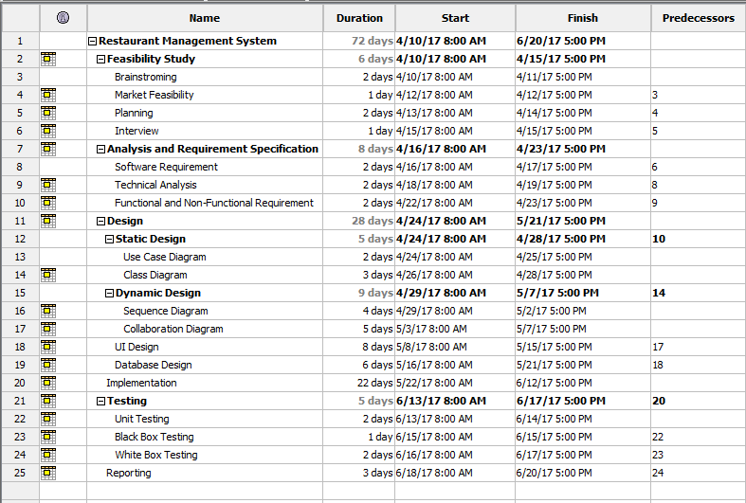

Fig: Gantt chart Table

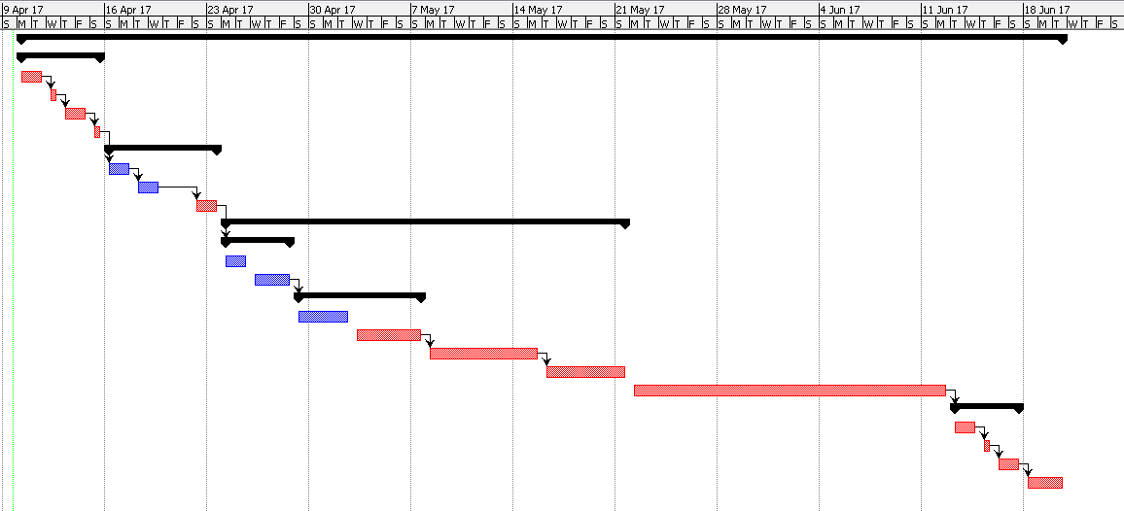

Fig: Gantt chart Detail

# 3. Risk Management

One of the important stages in the development of project is Risk Management. The main aim of the risk management is to deal with the problem arose during project development and mitigate those problems. For the estimation of the risk impacts on project, the following equation is used.  
  
 Impact = Likelihood * Consequences

Likelihood is the state of something is being likely while the consequences is the result of the event occur. The following table shows the index that helps in calculating the impact of risk on project.

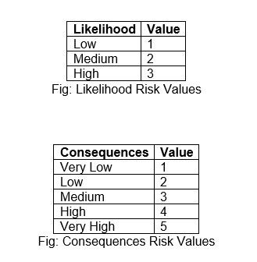

The risk that are to be likely in the project development with its impact (Likelihood and Consequences) and the necessary action are shown in the next page

.

|  |  |  |  |  |  |
| --- | --- | --- | --- | --- | --- |
| **S.No** | **Risk** | **Likelihood** | **Consequences** | **Impact (Likelihood  * Consequences)** | **Action** |
| 1 | Bad Analysis | 2 | 4 | 8 | Analysis should be performed very carefully. |
| 2 | Laptop Crash | 1 | 4 | 4 | Daily Backup should be performed. |
| 3 | Inadequate Design | 2 | 3 | 6 | Allow Sufficient time for design activities and conduct design reviews. |
| 4 | Base Technology not ready for development | 1 | 2 | 2 | Incorporate cost for buying application. |
| 5 | Natural Calamities | 1 | 5 | 5 | Schedule Backup should be maintained. |
| 6 | Illness | 1 | 2 | 2 | Project should be given more emphasis than regular time after recovery. |

Fig: Risk Management Table

# 4. Configuration Management

One of the important task during the development of the project is to record the every steps of the development path that have been carried out. We have to encounter different type of risk during the development of the project, which may cause the great impact on our project. To mitigate this type of risk we have to configure every aspects of the project.

With the help of configuration management, we can protect our documented files along with source code and different software. For configuration management I am using Git where the project are frequently updated and committed. Due to this type of action, any change in the source code of project can be roll back at any time. Version of the program can be controlled at any time. It also help in-group working where a group can work on a project from anywhere.

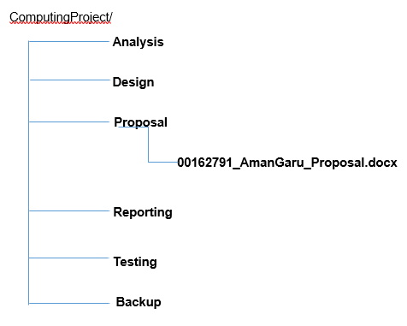

Fig: Configuration Directories

# 5. Conclusion

Stepping into the universe of modernization, majority of the services are being automated and programmed in a particular system to improve and diminish work. It is a wise choice for Paradise Food Land to embrace online food ordering system because of its accommodation and easy to use. In addition, it help to manage the increasing customer and further it handles the burden in the restaurant premises.

“Online Ordering System” application will be produced for client to achieve maximum efficiency in booking the food items on the web and to diminish the time taken for having the foods visiting the stall. It is designed for the public to book the items online rather than visiting the restaurant. Furthermore, after the booking, restaurant provide a home delivery facility as well. The system utilizes HTML, CSS, PHP as front end and MySQL as a back end of database. The framework is sufficiently solid to withstand regressive day-by-day operations under conditions where the database is kept up. The implementation of the system in the restaurant will considerably reduce data entry, time furthermore give promptly computed reports. Also after the implementation of the system, restaurant will able to increase the customer than usual and subsequently its sales and market too.

# 6. References

Business DIctionary, 2016. *Feasibility Study.* [Online]   
Available at: <http://www.businessdictionary.com/definition/feasibility-study.html>  
[Accessed 07 April 2017].

IOWA STATE UNIVERSITY, 2016. *What is.* [Online]   
Available at: <https://www.extension.iastate.edu/agdm/wholefarm/html/c5-65.html>  
[Accessed 8 April 2017].

MindTools, 2016. *Business Requirement analysis.* [Online]   
Available at: <https://www.mindtools.com/pages/article/newPPM_77.htm>  
[Accessed 8 April 2017].