Burning the FPGA image on Board E115

Open Quartus > File > Convert Programming Ffiles
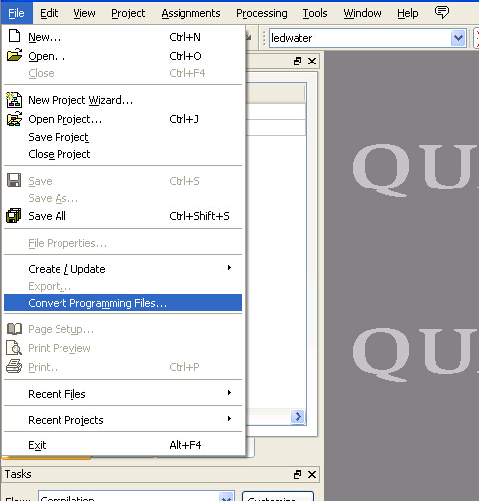

Programing file type > JTAG Indirect configuration file (.jic)
Configuration Device : EPCQ64A
File Name : output_files/fpga_lab.jic
Flash Loader > Device Family – Cyclon IV E , Device name EP4CE115
OK

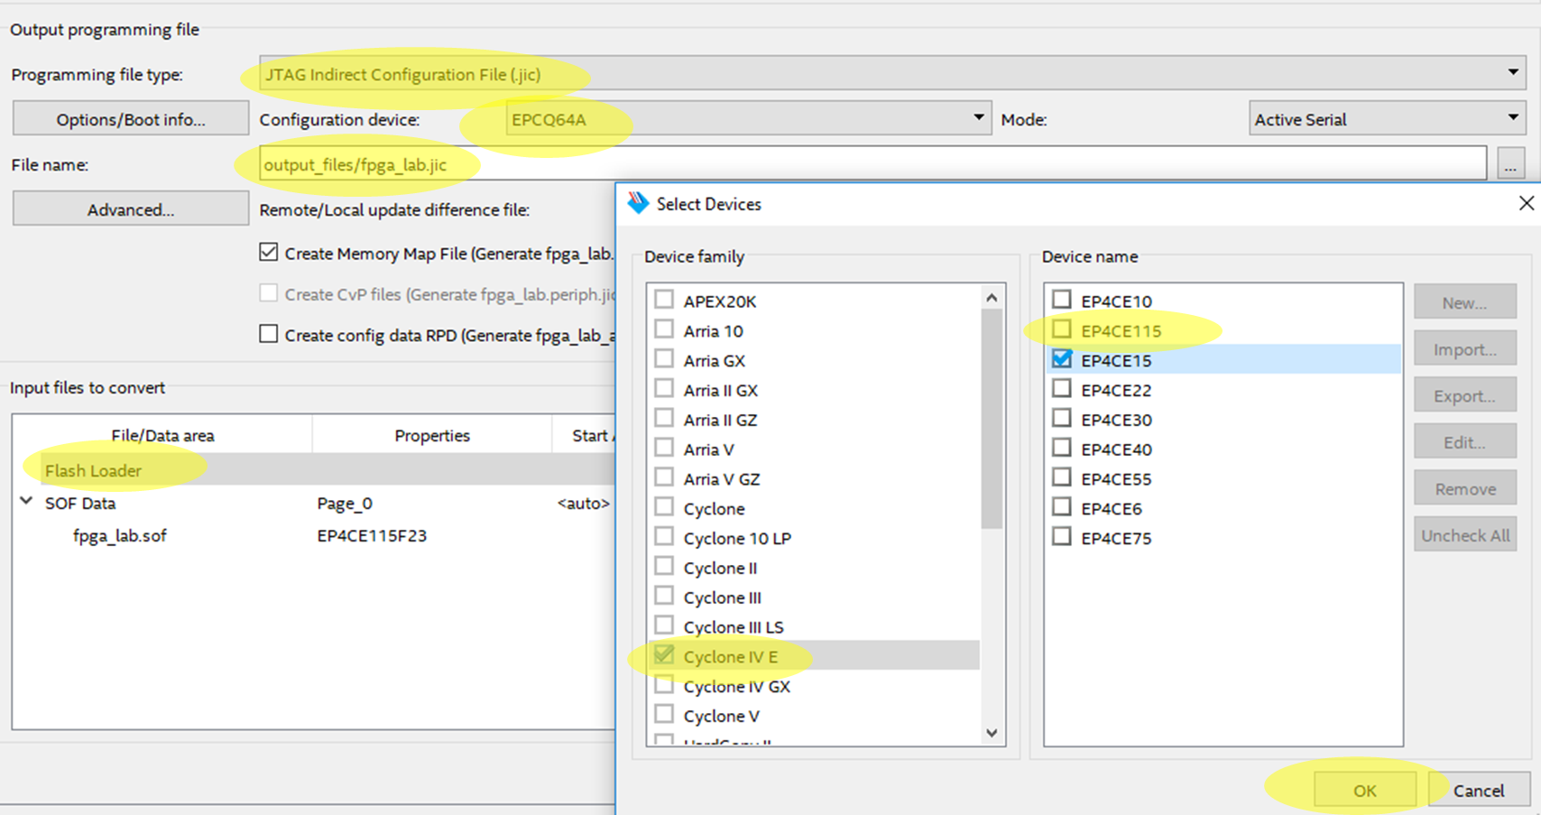

SOF Data -> Add File -> output_files -> open ->
fpga_lab.sof -> open

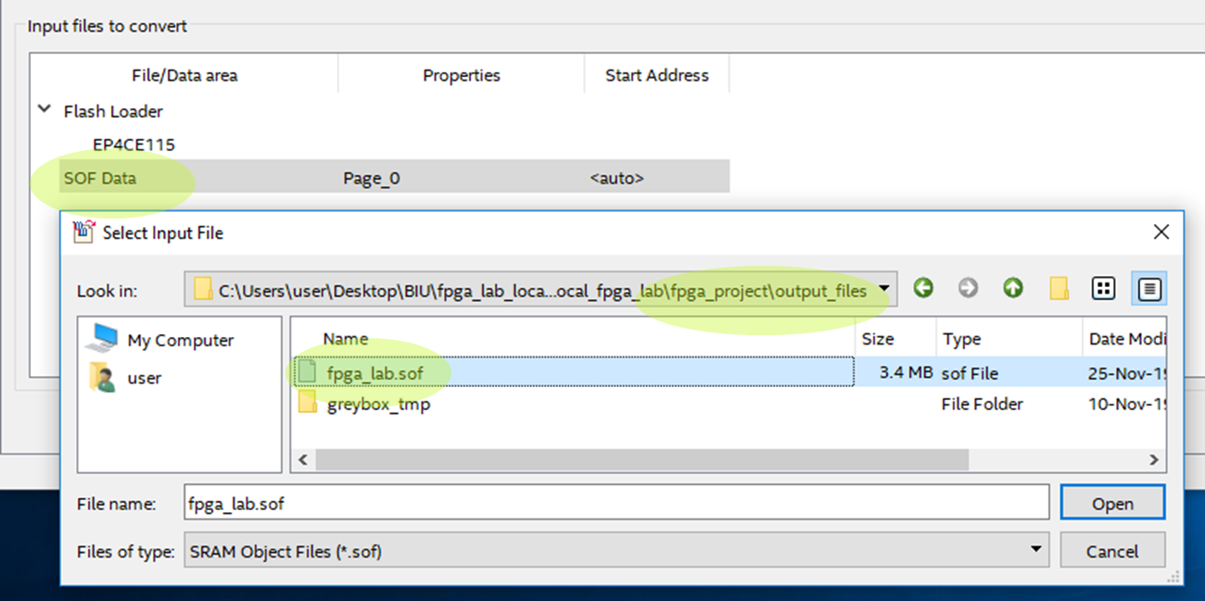

fpga_lab.sof > Properties > Compression -> OK -> Generate
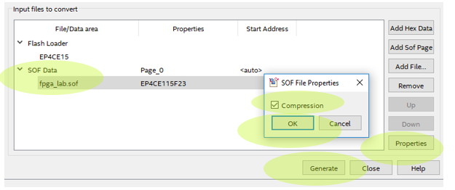
Bitstream image JIC file is now ready, close conversion window and go back to Quartus main window to program the flash memory.

Program Device > Now if a previous image shows up select it and press delete
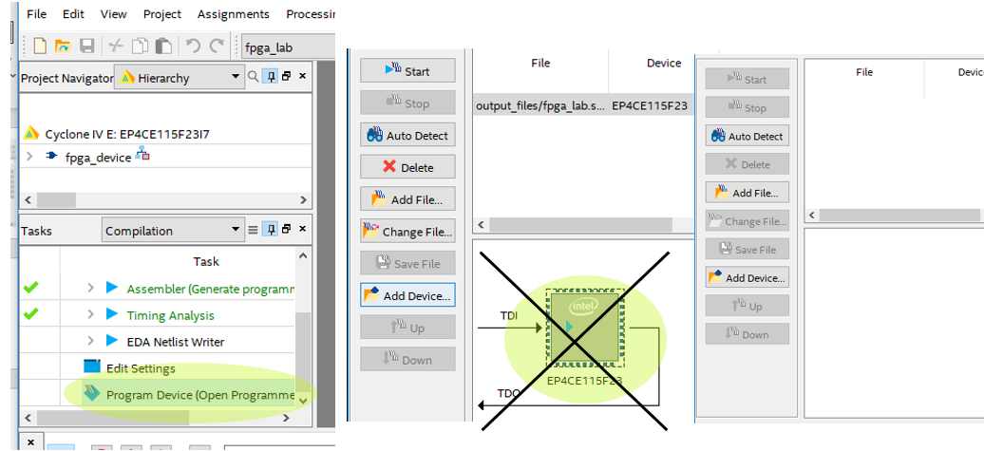

Select the new image to program:
Program Device > Add File > output Files > Open > fpga_lab.jic > open

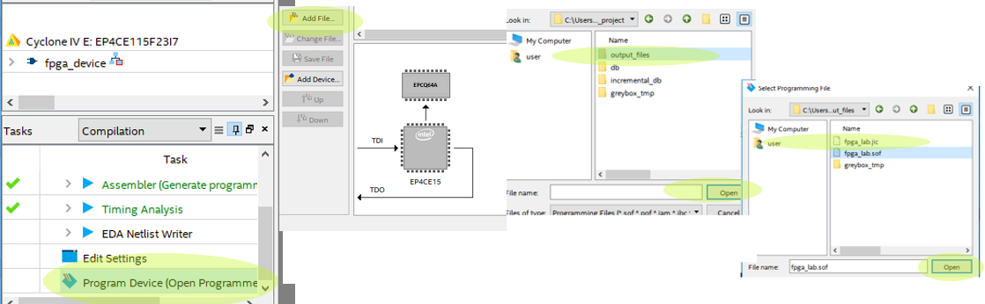

Check both boxes under program Configure and press start, watcj progress bar for good programming.

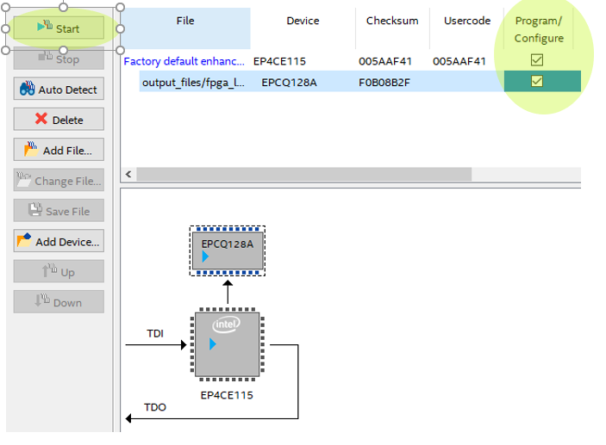

If all is ok you should now be capable of unplugging your USV-Blaster cable and running your design, turn off and on the board to make sure your design is kept.

Ori Fix:

