## Active Bugs

1. You can make a collision with two obstacles if you back one obstacle into another

**How to Cause: What it looks like:**

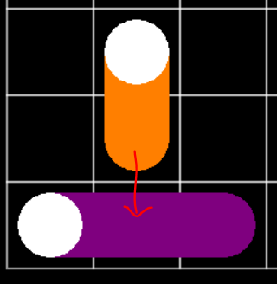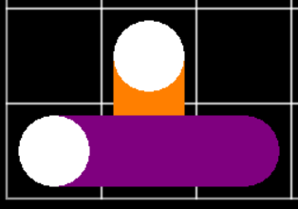

1. If you back an obstacle into the wall, that obstacle will turn into a circle

**How to Cause: What it looks like:**

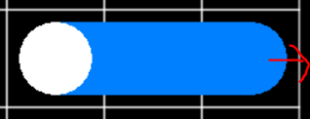

1. If you bump an obstacle into a wall, the game will crash

**How to Cause: What it looks like: *game crashes\***

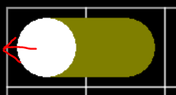

Key:

* Green: I think I fixed it