Dynamic Documents

Aleksandr Michuda

Table of contents

## 1 Before We Begin

* Take-home Exam
* We will start presentation soon!

## 2 Why Dynamic Documents?

Dynamic Documents are a part of the bigger picture of Reproducible Science. Sure, there is a fixed cost; **BUT**, they make my life easier in these ways:

* Short term: Easier to document fresh out of the oven results
* Medium term: Fast, reliable and tractable new results
* Long term: You can see how everything was created

## 3 What are Dynamic Documents?

Based on principles of literate programming, we aim at combining code and paper in one single document

* Best framework to achieve the holy grail of one-click reproducible workflow
* Best implementations: Quarto.

## 4 The State of Things Now

Currently, the code and the narrative components live in separate universes

## 5 Part of Larger Workflow

* Dynamic documents are best used as part of a larger organized workflow
  + Structuring folders: Data, analysis, output
  + Documenting code
  + Combining both into a final document: Pre analysis or final paper
* We have already been using jupyter notebooks, but what if you want to turn that notebook into a publishable format for sharing or even submission?

## 6 Using Markdown

* In terms of writing the “paper”/documentation part of dynamic documents, there are many solutions
  + Latex, HTML, RST (ReStructured Text)
* But most have honed in on using Markdown
  + Markdown is an easy way to write formatted text in a plain text format
  + But without as verbose and difficult of a syntax like latex/HTML
* Although basic markdown has the basics for formatting, creating tables, adding figures
* We will use Pandoc, which is used in both the Stata and R sessions

## 7 What is Pandoc?

* Pandoc is sort of what it says: pan (all), doc (document)
* It’s a way to convert between and across different file formats
  + Word -> HTML
  + Latex -> Markdown
  + HTML -> XML
  + Anything to anything
* See Pandoc’s [website](https://pandoc.org/MANUAL.html#options) for all input and output filetypes

## 8 The Magic of Pandoc

* Pandoc and Markdown allows you to create one file that can then be used in many different places
* Example:
  + You’re writing your CV and want to put it up in various places.
  + Your website needs HTML
  + One job posting allows PDF
  + One job posting only allows Word
* Ordinarily, you would need to have three versions, Word, HTML, PDF
  + This might get unruly as you change one but forget to change the other
  + What if there’s another file format you might need?
* With Pandoc and markdown, you would:
  + write your CV in markdown
  + convert to PDF, Word and PDF with pandoc

## 9 Quarto

* Quarto is the successor or RMarkdown, a very powerful dynamic document software developed for RStudio
* Now it also applies to jupyter notebooks and allows for creating nice documents from the notebooks you create!
* Dynamic documents usually have a yaml header at the top, that defines global options
  + We will talk about three special types of yaml options in Quarto:
    - output type
    - hiding code or output
    - execution options

## 10 What is YAML?

* YAML is a very basic language created by Ansible (I think?) to define options for its software in a way that didn’t require lots of coding.

---  
title: "Toward a Unified Theory of High-Energy Metaphysics: Silly String Theory"  
date: 2008-02-29  
author:  
 - name: Josiah Carberry  
 id: jc  
 orcid: 0000-0002-1825-0097  
 email: josiah@psychoceramics.org  
 affiliation:   
 - name: Brown University  
 city: Providence  
 state: RI  
 url: www.brown.edu  
abstract: >   
 The characteristic theme of the works of Stone is   
 the bridge between culture and society. ...  
keywords:  
 - Metaphysics  
 - String Theory  
license: "CC BY"  
copyright:   
 holder: Josiah Carberry  
 year: 2008  
citation:   
 container-title: Journal of Psychoceramics  
 volume: 1  
 issue: 1  
 doi: 10.5555/12345678  
funding: "The author received no specific funding for this work."  
---

## 11 YAML

* But the basic thing you need in order to get the paper is:

---  
title: My paper  
author: Aleksandr Michuda  
---

## 12 Preview of what we will talk about

* Quarto is VERY expansive, you can write websites, books or dissertations with it
  + All with jupyter notebooks
* Today, we will focus on the basics that you will need if you wanted to write paper using a jupyter notebooks:
  1. Tables
  2. Figures
  3. Cross-references
  4. Citations

## 13 Tables

* You can create tables easily in three ways:
  + Create your own markdown table (Not dynamic)
  + Put in a latex table directly (Not dynamic)
  + Generate a table from code (Dynamic)

Demonstration of pipe table syntax

| Default | Left | Right | Center |
| --- | --- | --- | --- |
| 12 | 12 | 12 | 12 |
| 123 | 123 | 123 | 123 |
| 1 | 1 | 1 | 1 |

Table 1: Demonstration of generated table

|  | A | B | C | D |
| --- | --- | --- | --- | --- |
| 0 | 1.764052 | 0.400157 | 0.978738 | 2.240893 |
| 1 | 1.867558 | -0.977278 | 0.950088 | -0.151357 |
| 2 | -0.103219 | 0.410599 | 0.144044 | 1.454274 |
| 3 | 0.761038 | 0.121675 | 0.443863 | 0.333674 |
| 4 | 1.494079 | -0.205158 | 0.313068 | -0.854096 |
| 5 | -2.552990 | 0.653619 | 0.864436 | -0.742165 |
| 6 | 2.269755 | -1.454366 | 0.045759 | -0.187184 |
| 7 | 1.532779 | 1.469359 | 0.154947 | 0.378163 |
| 8 | -0.887786 | -1.980796 | -0.347912 | 0.156349 |
| 9 | 1.230291 | 1.202380 | -0.387327 | -0.302303 |

## 14 Figures

* You can add figures that are generated or from a folder
* It’s like figures markdown but with more options

|  |
| --- |
| Figure 1: My figure 1, width 300 |

|  |
| --- |
| My figure width 80 |

df.plot.scatter(x='col_1', y='col_2');

|  |
| --- |
| Figure 2: A scatter plot |

import matplotlib.pyplot as plt  
plt.plot([1,23,2,4])  
plt.show()  
  
plt.plot([8,65,23,90])  
plt.show()

|  |  |  |  |  |
| --- | --- | --- | --- | --- |
| |  |  |  |  | | --- | --- | --- | --- | | |  | | --- | | (a) First | | |  | | --- | | (b) Second | |   Figure 3: Charts |

#tbl-something #fig-something

## 15 Cross References

* To reference a figure, table or section, just use its label!
* See Table 1
* See Figure 3
* See Section 15

## 16 Citations and Footnotes

* For citations, You can use a standard bibtex file, just specify it in the YAML

---  
bibliography: references.bib  
---

* See Gupta et al. (2021) [1]
* This is true (Gupta et al. 2021).

## 17 Mermaid

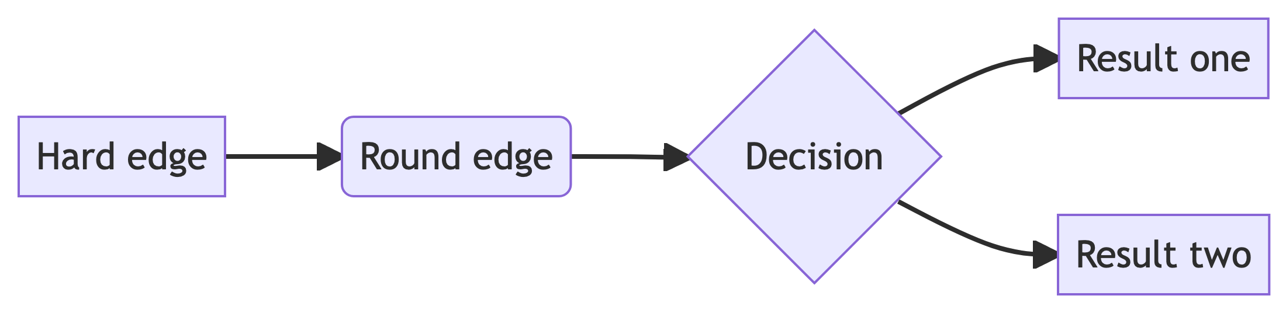

## 18 References

Gupta, Anubhab, Heng Zhu, Miki Khanh Doan, Aleksandr Michuda, and Binoy Majumder. 2021. “Economic Impacts of the COVID- 19 Lockdown in a Remittance-Dependent Region.” *American Journal of Agricultural Economics* 103 (2): 466–85.

1. This is footnote.dkfng