Sr. no | Class | Department | Name of Student | Position | CGPA | Photo
 | B.Sc_IT_6th | Computer Department | Urmila | 1st | 9.4 | 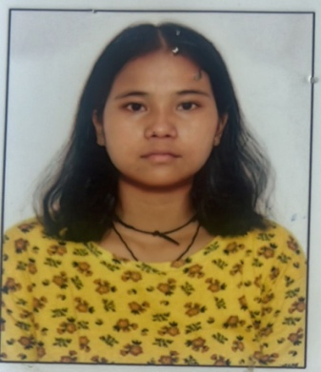
 | B.Sc_IT_6th | Computer Department | Sonam | 2nd | 8.89 | 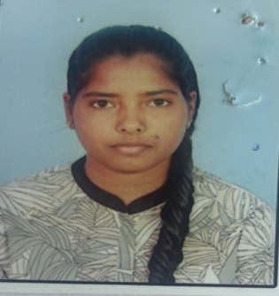
 | B.Sc_IT_6th | Computer Department | Vivek | 3rd | 8.63 | 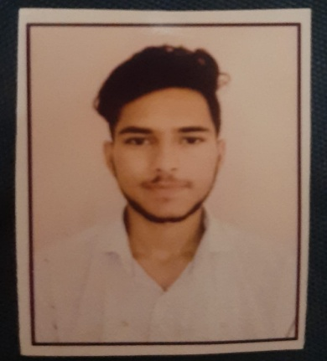
 | B.Sc_MLS-6th | MLS Department | PRITY GUPTA | 1st | 9.00 | 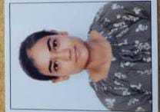
 | B.Sc_MLS-6th | MLS Department | Bharti Devi | 1st | 9.0 | 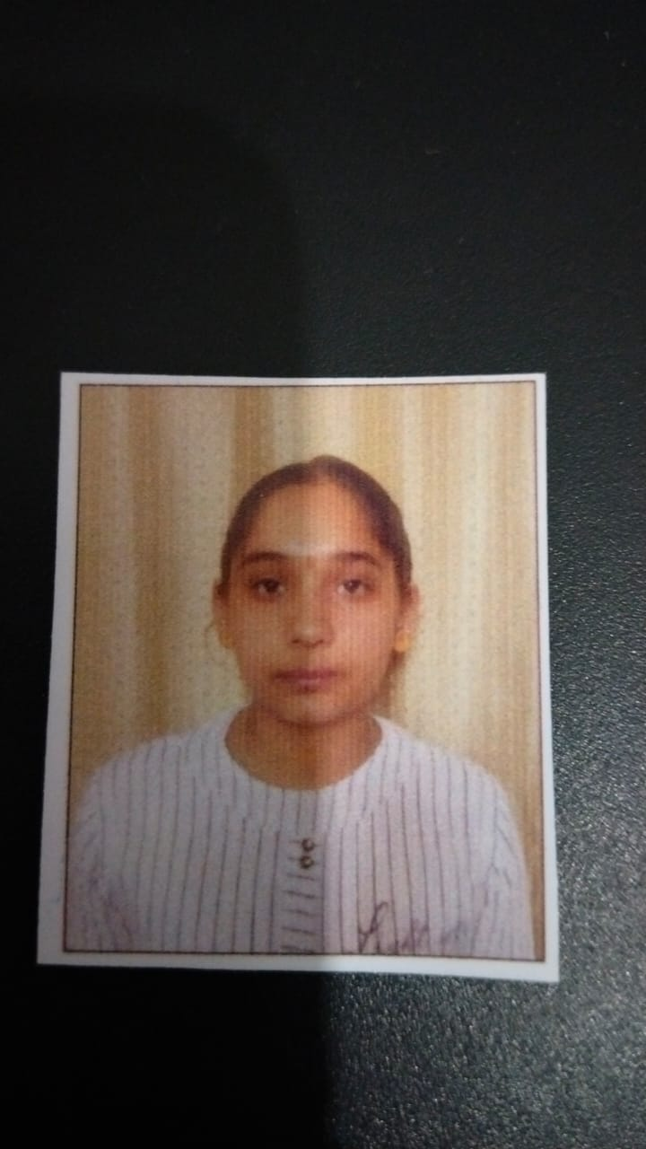
 | B.Sc_MLS-6th | MLS Department | MUSKAN | 2nd | 8.68
 | B.Sc_MLS-6th | MLS Department
 | B.Sc-FD-6th | Fashion Designing | Manisha | 1st | 9.58 | 
 | B.Sc-FD-6th | Fashion Designing | Meena | 2nd | 9.50 | 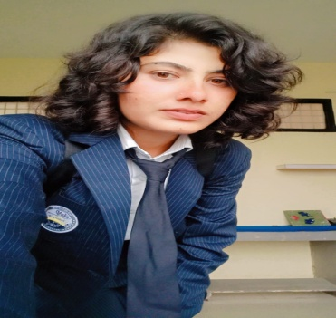
 | B.Sc-FD-6th | Fashion Designing | Nitika | 3rd | 9.30 | 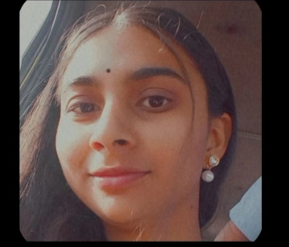

Placed Students
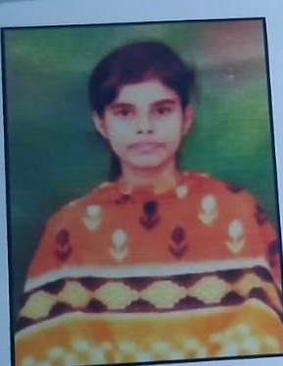 | Muskaan ... Placed in Paytm student of B.sc_it_6th Sem
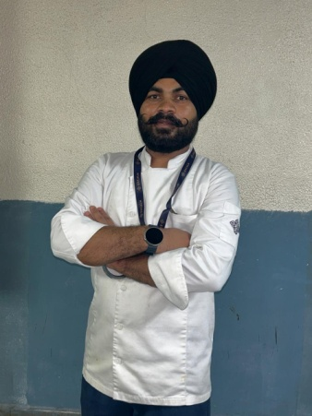 | KapilDeep Singh placed in ENCLAM Hospitality Pvt.Ltd. as a Commie
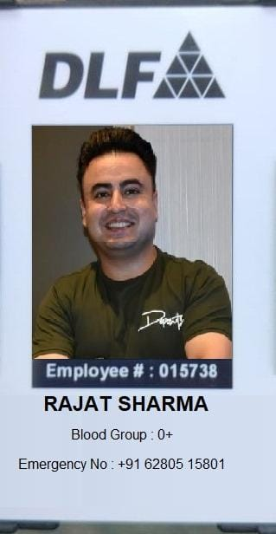 | Rajat Sharma HR at DLF New Delhi
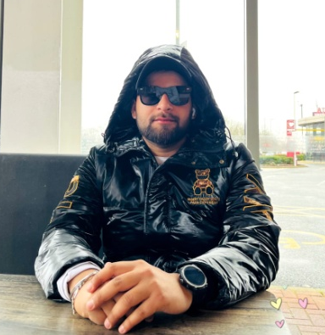 | Keshav Madgotra placed in Hilton Hotel at London
 | Meena at Ludhiana Industries

