**Lab Evaluation 1**

**Fifth Semester**

**Computer Science and Engineering**

**19CSE304 Foundations of Data Science**

Considering the dataset “IoTBotNetDataSet.csv”

1. Import data and save it in your disk space (1)

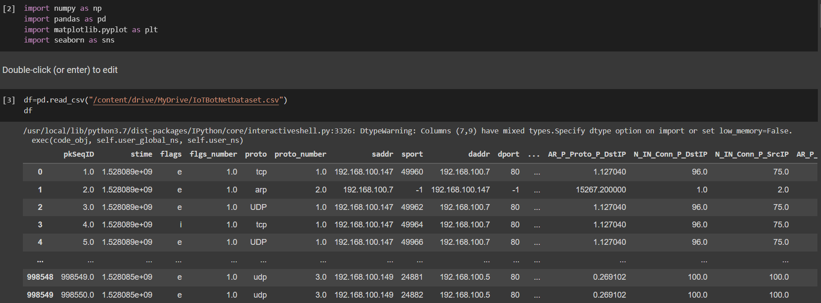

2.   Drop the columns not required for your analysis. (1)

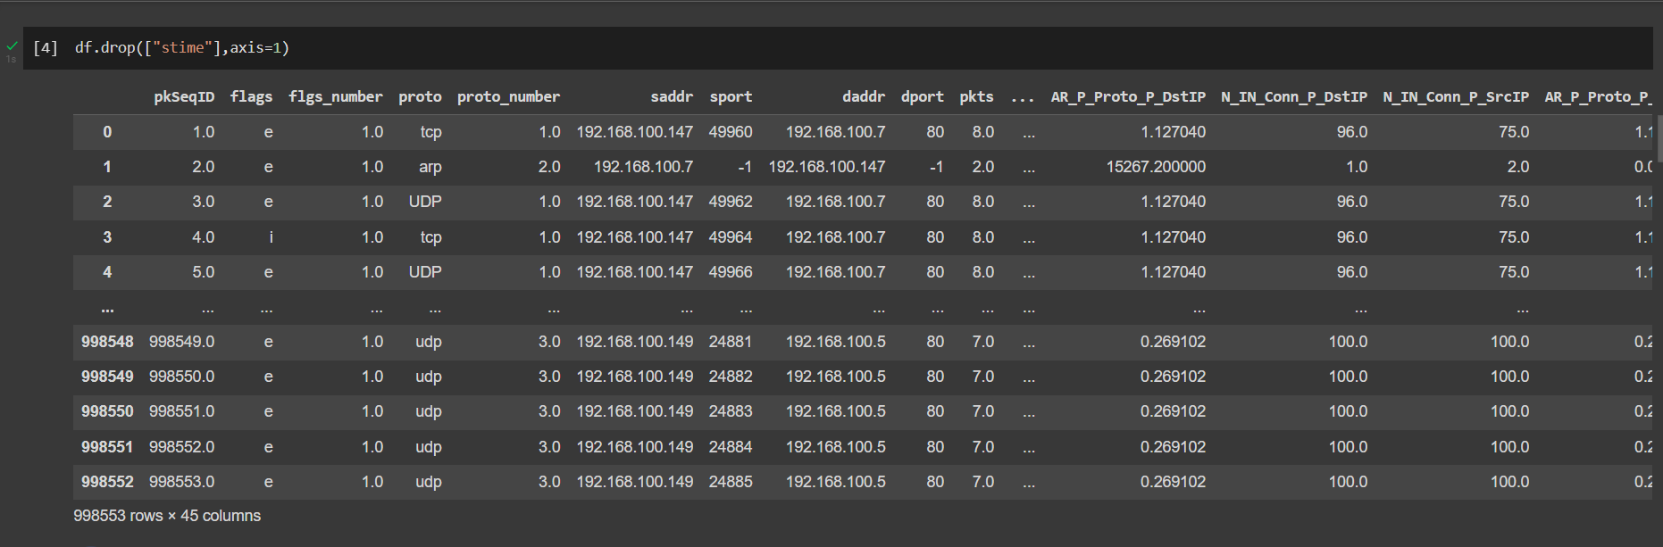

3.   Do a missing value analysis and perform appropriate steps to correct them (2)

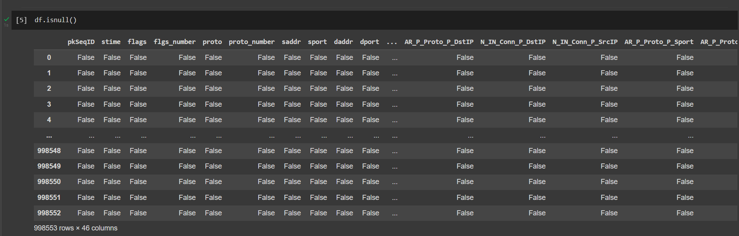

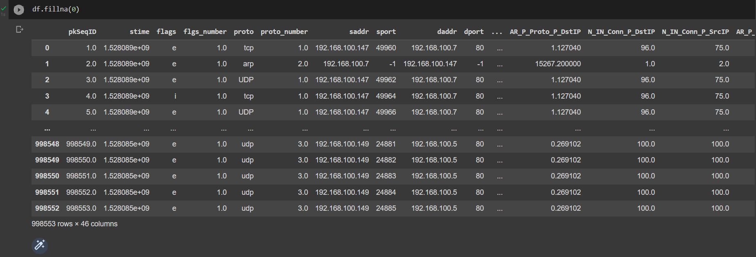

4.  Perform an outlier analysis for any two columns (2)

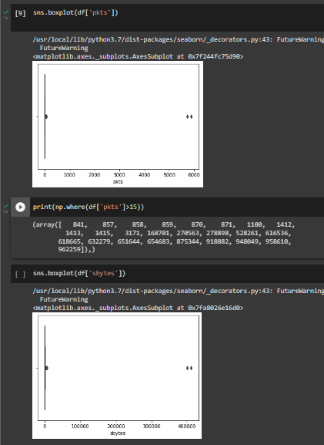

5.  Do a correlation analysis of any two variables. (2)



6.  Describe the data (1).

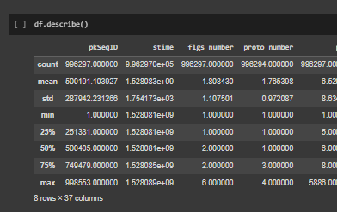

7.  Display the first 3 rows (1).

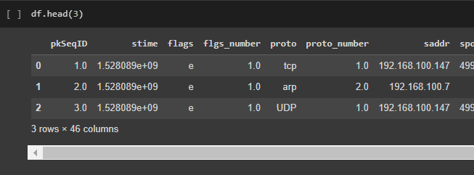

8.  Display the last 4 rows(1)

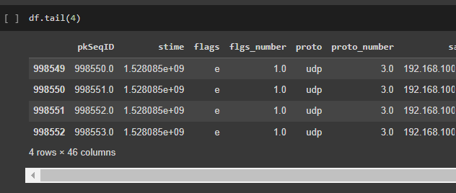

9.  Locate the first row corresponding to the proto as “UDP” (2)

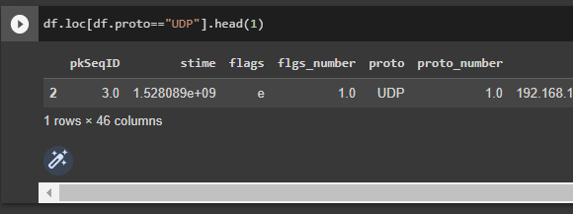

10. How many rows of data do you have? (1)

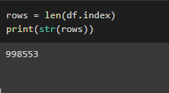

11. Display the first 5 columns of the first row (2)

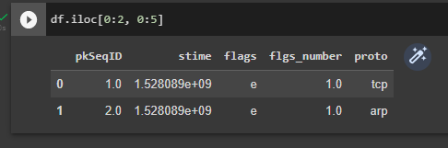

12. Count the number of packets affected  based on flags as “i”(2)

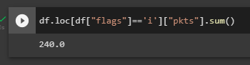

  13.Split the traffic based on traffic into two groups Group 1: pkts<=10 and Group 2:pkts>10 (2)

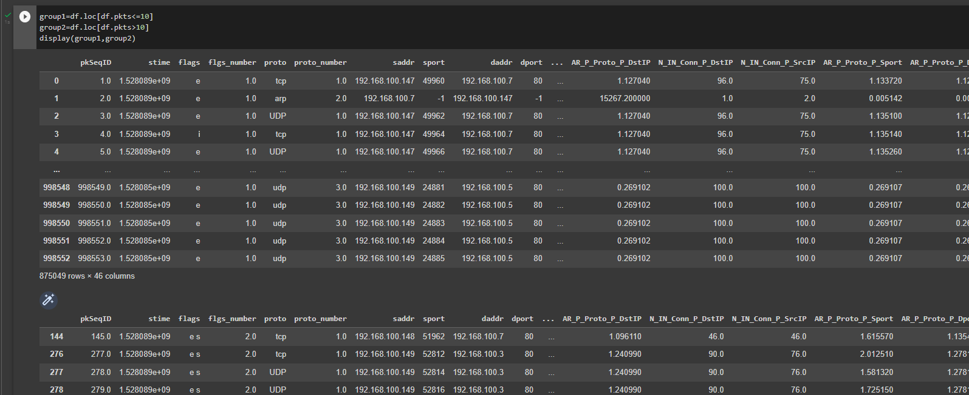

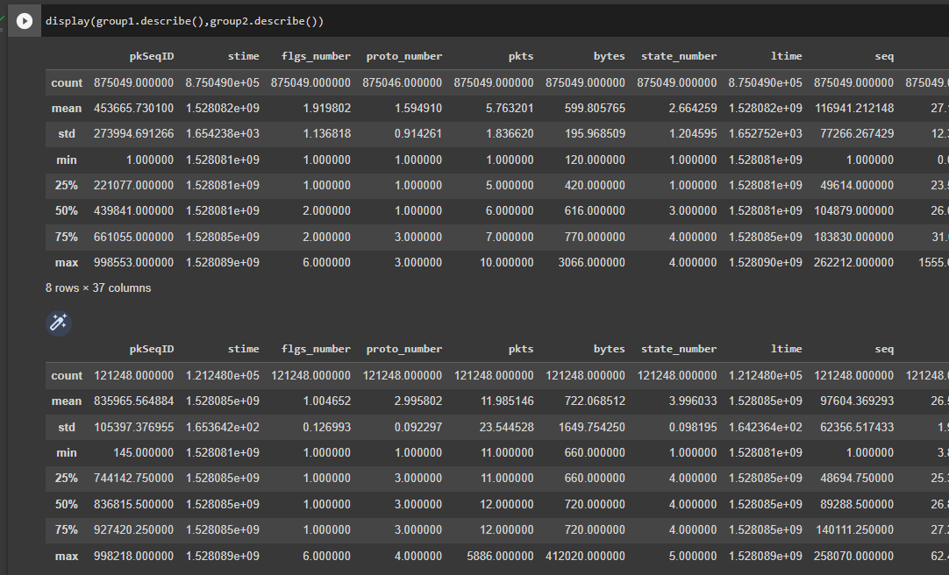

13. Evaluate the characteristics of the packets  distribution with mean and, deviation

(a) Average packets for a given stime

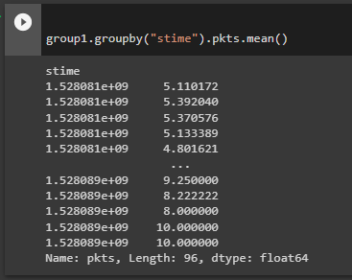

(b) Average sbytes for a given stime

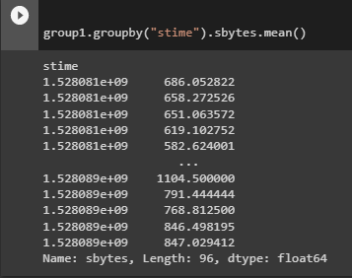

 (c) Average dbytes for a given stime (2)

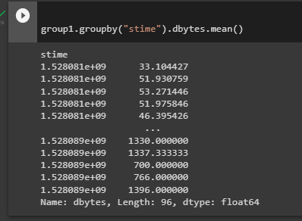

14. Compute the mean and the variance of " Pkts_PState_P_Protocol_P_DestIP” for subcategory as HTTP and TCP  (1).

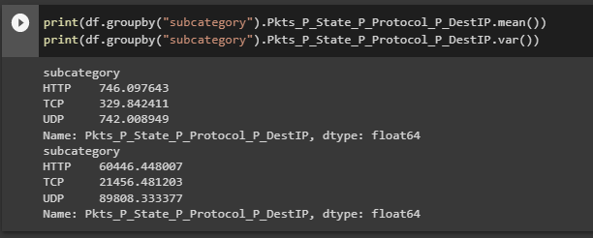

15. Draw a histogram for packets with stime as 1528088521, 1528088522., 1528088523. Histogram should be step-filled with bin of size 20. Find the skew of this distribution, and comment if it is positive or negative (5).

