Integrated Bifacial Agrivoltaic–Anaerobic Digestion Optimization Across Four Climate Zones
A Novel Extended Land Equivalent Ratio Framework for the Food–Energy–Water Nexus

Amidou Maiga
Department of Energy Systems Engineering
Erciyes University, Kayseri, Turkey
4012550005@erciyes.edu.tr

Abstract
Land-use competition between food production and renewable energy deployment is a major challenge in semi-arid regions. This study develops a coupled six-model optimization framework for bifacial agrivoltaic (APV) systems integrated with on-farm anaerobic digestion (AD) across four climate zones, Konya (BSk), Almería (BSh), Ouagadougou (BSh), and Freiburg (Cfb), using hourly PVGIS-SARAH3 data. Six design variables are jointly optimized with Differential Evolution to maximize a proposed three-component extended Land Equivalent Ratio (eLER), defined as the sum of crop, photovoltaic, and biogas land-equivalent terms. Optimized eLER values range from 1.641 to 1.764, while the agrivoltaic two-component LER alone remains above unity (1.030–1.088), confirming that the APV system outperforms separate monocultures even before biogas valorization. Within the present model and tomato parameterization, Freiburg achieves the highest eLER despite having the lowest solar resource, due to crop PAR saturation at higher-irradiance sites. The optimizer converges to the minimum feasible row-spacing bound at all sites. A 4E analysis shows PV yields of 1,002–1,433 MWh ha$​^{-1}$, net present values of 134 k $–802 k $, and internal rates of return of 11.0 %–28.1 % under the baseline scenario, rising to 12.7 %–29.9 % under a carbon-credit scenario. Growing-season water savings of 81 mm–159 mm correspond to 15.6 %–22.4 % of seasonal evapotranspiration demand. All results are model-based and cross-validated against independent literature datasets and an external solar-modelling library; the integrated APV–AD system has not yet been field-demonstrated.
Keywords: agrivoltaics; anaerobic digestion; extended land equivalent ratio; food–energy–water nexus; differential evolution; semi-arid climate; PAR saturation; 4E analysis

1. Introduction

1.2. The Global Challenge: Food, Energy, and Water Under Climate Pressure
By 2050, global food production must increase by approximately 50% to feed a projected population of nearly ten billion, while freshwater withdrawals for agriculture, already accounting for 70% of the world’s accessible surface water, are expected to intensify further [FAO, Scanlon, 2023]. In semi-arid and arid regions, which host some of the fastest-growing populations on Earth, this pressure is compounded by a pre-existing structural deficit: annual potential evapotranspiration exceeds precipitation, making every millimeter of saved irrigation water both economically and ecologically significant.
At the same time, the global energy transition is accelerating the deployment of ground-mounted solar photovoltaic (PV) installations. Solar PV has become the least-cost source of new electricity generation across large parts of the semi-arid belt from Southern Europe and the Middle East to Sub-Saharan Africa and Central Asia [IRENA, 2022]. However, ground-mounted installations require productive agricultural land, and the spatial overlap between high-irradiance zones and high-value irrigated cropland is not coincidental: both are concentrated in the same semi-arid river basins and coastal plains [Dinesh and Pearce, Ketzer, 2020]. The result is a land-use conflict that threatens to replace one resource challenge with another.

1.2. Agrivoltaics: Dissolving the Land-Use Conflict
Agrivoltaics, the deliberate co-location of photovoltaic modules and agricultural crops on the same land parcel was proposed precisely to dissolve this tension. Conceived by Goetzberger and Zastrow and experimentally validated by Dupraz et al., the approach rests on the observation that partial shade from elevated PV panels can simultaneously generate electricity, reduce crop heat stress, curb soil moisture evaporation, and increase water-use efficiency for a wide range of species [Marrou et al., Barron-Gafford et al., Elamri et al., Semeraro et al.].
The standard metric for quantifying this dual benefit is the Land Equivalent Ratio (LER), which measures how much land under separate monocultures would be required to produce the same combined output as an integrated system [Mead and Willey]. Published agrivoltaic LER values range from 1.2 to 1.94, with the highest values consistently associated with bifacial modules, crop-specific panel geometry, and shade-tolerant species [Riaz et al., Mazzeo et al.]. A two-component LER of 1.94 means the integrated system uses land 94% more efficiently than two separate operations.
Despite this progress, agrivoltaic research has a systematic blind spot: the organic residue stream. In a typical tomato production system, crop residues, stems, leaves, non-marketable fruit, amount to approximately 80% of the harvested fresh mass [Mohammedi et al.]. When returned to the soil, this biomass undergoes aerobic decomposition that can release methane and nitrous oxide. When combusted, the embodied energy is lost. Neither outcome is consistent with the circular economy ambitions that motivate agrivoltaic deployment in the first place.

1.3 Anaerobic Digestion: Closing the Residue Loop
Anaerobic digestion (AD) converts organic biomass into biogas and digestate, a nutrient-rich bio-fertilizer. For agricultural systems, on-farm AD offers three interconnected benefits: it valorizes residues that would otherwise be wasted, provides dispatchable energy that can offset grid imports, and returns nitrogen, phosphorus, and potassium to the soil in plant-available form [Pilarski and Pilarska, Lallement et al.].
The strategic importance of agricultural biomethane is substantial. The EU REPowerEU Plan targets 35 billion m$​^{3}$ of sustainable biomethane per year by 2030 [European Commission, 2022], and Germany’s EEG 2023 and the EU RED III provide feed-in premiums where biomethane commands approximately 5.5 times the electricity purchase price [Nik Zad, 2026, European Biogas Association, 2025, Rabobank, 2025]. In Sub-Saharan Africa, biogas from agricultural residues provides an alternative to imported LPG and diesel in the same farming communities that stand to benefit most from agrivoltaics [IEA, 2025].
A critical thermal challenge limits AD in temperate climates: maintaining mesophilic conditions (35–40 $​^{∘}$C) against winter ambient temperatures below 0 $​^{∘}$C requires a reliable heat supply. Conventionally, up to 30% of biogas is combusted for self-heating, reducing net energy yield [Lindorfer et al.]. PV electricity, abundant in summer when heating demand is lowest, is a natural complement to this requirement.

1.4 The Missing Integration: APV Meets AD
The co-location of agrivoltaics and anaerobic digestion is logically compelling: APV produces electricity and shade; the crop produces residues; the digester converts residues to biogas and digestate; digestate fertilizes the crop. The AD footprint is small and can be sited beneath or adjacent to the APV array at no additional land cost.
Yet the two technologies have been studied in isolation. Agrivoltaic studies focus on PV yield and crop PAR, ignoring the residue stream [Riaz et al., Zainali et al., Mazzeo et al.]. AD studies that include a PV component treat the solar array as a generic electricity source without modeling agrivoltaic geometry or crop yield effects [Pal and Ilango, Temiz et al.]. One early study to couple APV and AD optimization was Nik Zad [2026], limited to one Mediterranean site without crop yield modeling or a land-use efficiency metric. The consequence is a systematic gap: no unified metric captures all three land-use outputs, no optimizer jointly searches both design spaces, and no multi-climate comparison exists.

1.5 Research Gaps
Six specific knowledge gaps motivate this study:
- No unified land-use metric for integrated APV–AD. The classical two-component LER omits biogas energy. A three-component metric is needed to capture the full multi-output land productivity.
- No joint design optimization. APV geometry and AD design are coupled through crop yield, residue production, and digester heating. Separate optimization misses cross-variable interactions that determine system-level efficiency.
- No multi-climate comparative analysis. The sensitivity of the APV–AD synergy to solar resource, temperature, and growing-season length has not been systematically characterized across contrasting climate zones.
- No thermal coupling characterization across the continental temperature range. Arrhenius BMP suppression ranges from negligible (tropical semi-arid) to severe (cold temperate). This variability has not been quantified across a four-zone study.
- No corrected water savings metric. Prior studies report water savings as a fraction of annual ET$​_{0}$, systematically underestimating the agronomic benefit by diluting growing-season savings with off-season months.
- No modelling of the AD-to-crop nutrient feedback. The digestate-to-soil loop is absent from all existing agrivoltaic studies, preventing a true circular economy assessment.
This paper addresses gaps G1–G5. Gap G6 is deferred to future experimental work requiring multi-season field data from co-located APV–AD installations.

1.6 Contributions of This Work
The specific, verifiable contributions of this paper are:
- Proposed three-component eLER metric (G1): $eLER=LER_{\text{crop}}+LER_{\text{PV}}+LER_{\text{biogas}}$, referenced against three independent monocultures using a non-circular PV reference (Definition A).
- Integrated six-variable Differential Evolution optimizer (G2): simultaneously searches APV geometry and AD design spaces with OLR and inter-row clearance constraints.
- Four-climate-zone comparative analysis (G3): Konya (BSk), Almería (BSh), Ouagadougou (BSh), and Freiburg (Cfb), spanning 12 °N–48 °N.
- PAR-saturation mechanism (G3, G4): identification and quantification of the counter-intuitive non-monotone relationship between solar resource and eLER, driven by tomato light saturation at 174 W m⁻².
- 4E performance framework (G3–G5): Energetic, Economic, Energo-economic (LCOE, biogas cost), and Environmental (CO$​_{2}$ avoidance, carbon credit) metrics computed jointly for all four sites and seven valorization scenarios.
- Corrected water savings metric (G5): $LER_{\text{water}}$ referenced to growing-season ET$​_{0}$, correcting the systematic underestimation of up to 3.5$×$ found with annual ET$​_{0}$.

1.7 Paper Organization
Section 2 reviews the literature on agrivoltaic systems, AD integration with solar energy, and LER methodology. Section 3 presents the six sub-models, the DE optimizer, and the 4E framework. Section 4 reports optimized designs, eLER decomposition, energy and water performance, and scenario economics for all four sites. Section 5 interprets the PAR-saturation mechanism, boundary-convergence behavior, and model limitations. Section 6 states the conclusions. Appendix 7 provides the complete DE pseudocode and Appendix 8 the complete list of fixed parameters.

2. Related Works

2.1 Agrivoltaic Systems: Architecture, Crop Response, and Land-Use Efficiency
The concept of co-locating solar panels and crops on the same land parcel was first proposed by Goetzberger and Zastrow, who noted that partial shade from PV modules could reduce transpiration stress while the modules themselves benefited from evaporative cooling. The idea remained largely theoretical until Dupraz et al. published the first rigorous field experiment and introduced the Land Equivalent Ratio (LER) as the standard metric for the dual land-use advantage. Measuring durum wheat yield and PV output simultaneously in southern France, they demonstrated LER values of 1.35–1.73 depending on shade level, establishing the foundational result that the combined system outperforms two separate monocultures by 35–73% on the same land area.
Subsequent field studies confirmed that the benefit extends beyond electricity and yield. Marrou et al. demonstrated that the microclimate under APV panels characterized by soil temperature reductions of 1.3–2.3 $​^{∘}$C and reduced peak radiation load can partially offset or reverse the yield penalty of reduced PAR for shade-adapted lettuce, cucumber, and wheat. In semi-arid Arizona, Barron-Gafford et al. showed that agrivoltaics simultaneously increased jalapeno yield by 3$×$, reduced water consumption by 65%, and improved panel efficiency by 1–9 percentage points through evaporative cooling, providing the first comprehensive food-energy-water nexus evidence for the technology.
The integration of bifacial modules which harvest both direct front-side and diffuse rear-side irradiance represents a significant performance advance. Riaz et al. developed a Light-Productivity-Factor (LPF) framework that accounts for the PAR saturation threshold of the specific crop. Applied to bifacial tomato production in Arizona, this approach yielded the highest published two-component LER of 1.94, demonstrating that crop-specific geometry optimization can push the land-use advantage substantially beyond geometry-agnostic designs. The PAR saturation concept introduced by Riaz et al. the observation that above a crop-specific irradiance threshold, additional light generates no additional photosynthesis and the surplus can be productively captured as electricity forms the theoretical basis for the crop yield model adopted in the present study.
Mazzeo et al. extended this approach to open-field lettuce in Italy, achieving LER = 1.85 under optimized panel density and identifying the circular reference problem in LER$​_{\text{PV}}$ calculation: using the same APV array as both system and reference inflates the LER value artificially. This issue motivates the independent dense-pack PV reference (Definition A) adopted here. At the system scale, a meta-analysis of 127 agrivoltaic case studies by Semeraro et al. found a mean LER of $1.34±0.18$, with higher values consistently associated with bifacial modules, shade-tolerant crops, and optimised row spacing. Water savings from APV shading, quantified by Elamri et al. across a lettuce trial in southern France, reached 14–29% of growing-season ET$​_{0}$ a range consistent with the corrected values reported in the present study.
Despite this body of evidence, all cited agrivoltaic studies share a common limitation: the crop residue stream is treated as waste or a soil amendment, severing the link between the agrivoltaic system and the biogas economy that the same semi-arid farming regions are increasingly participating in.

2.2 Anaerobic Digestion: Fundamentals, Feedstocks, and Thermal Management
Anaerobic digestion is a multi-stage biological process in which consortia of microorganisms decompose organic matter in the absence of oxygen, producing biogas typically 55–70% methane and 30–45% CO$​_{2}$ and a nutrient-rich liquid digestate [Angelidaki et al., Mata-Alvarez et al.]. The four sequential stages hydrolysis, acidogenesis, acetogenesis, and methanogenesis each involve distinct microbial communities with different kinetic sensitivities to temperature, pH, and substrate composition [Alengebawy et al.]. This sequential dependency makes methanogenesis the rate-limiting step and temperature the dominant operational parameter: a 10 $​^{∘}$C decrease in digester temperature below the mesophilic optimum (37 $​^{∘}$C) can suppress methane yield by 30–50%, following an Arrhenius-type relationship [Lindorfer et al.].
The biochemical methane potential (BMP) of a substrate quantifies the maximum volume of methane recoverable per unit of volatile solids (VS) under controlled conditions. Lallement et al. reported BMP values of 200–280 NmL CH$​_{4}$ gVS$​^{-1}$ for cattle manure and 250–350 NmL CH$​_{4}$ gVS$​^{-1}$ for tomato plant residues ranges that bracket the reference value of 300 NmL CH$​_{4}$ gVS$​^{-1}$ at 37 $​^{∘}$C adopted in the present study. Feng et al. provided a five-point temperature response curve for tomato plant residues from 20 $​^{∘}$C to 40 $​^{∘}$C, demonstrating that BMP drops from 300 NmL gVS$​^{-1}$ at 37 $​^{∘}$C to approximately 195 NmL gVS$​^{-1}$ at 20 $​^{∘}$C a 35% suppression that is directly relevant to cold-season operation at Konya and Freiburg. This dataset provides the empirical basis for the V2 model validation reported in Section 4. extended this analysis to cereal straw and vegetable mixtures, confirming the Arrhenius coefficient $θ=0.069$ $​^{∘}$C$​^{-1}$ used throughout the present study and reporting that co-digestion of crop residues with cattle manure at a 1:3 VS ratio increases BMP by 12–18% through synergistic microbial diversity.
The thermal energy demand of a continuously stirred tank reactor (CSTR) digester operating under mesophilic conditions in a temperate climate is substantial. Lindorfer et al. showed that maintaining a 37 $​^{∘}$C digester against a 0 $​^{∘}$C ambient requires heat input equivalent to 15–30% of gross biogas energy, depending on insulation quality and substrate inlet temperature. This self-consumption directly reduces the net energy yield and economic return of the plant. Solar thermal collectors [Temiz et al.] and PV-powered electrical resistance heating [Pal and Ilango] have both been proposed as alternatives to biogas self-consumption. demonstrated that replacing biogas self-heating with PV electricity in a grid-connected configuration can improve the NPV of a biogas plant by up to 8.7$×$ compared to a non-heated reference, by redirecting the saved biogas to higher-value grid injection. Their analysis, however, treats the PV array as a separate installation without modelling the agrivoltaic geometry or crop yield effects.
On the feedstock supply side, the strategic importance of agricultural biogas and biomethane is reflected in accelerating policy commitments. The EU REPowerEU Plan targets 35 billion m$​^{3}$ of sustainable biomethane per year by 2030 [European Commission, 2022], requiring a nine-fold increase from 2022 levels. Germany’s EEG 2023 and the EU RED III mandate feed-in premiums for biomethane grid injection, creating a market price approximately 5.5 times the wholesale electricity price in Central European markets [Nik Zad, 2026, European Biogas Association, 2025, Rabobank, 2025]. In Sub-Saharan Africa, where Burkina Faso’s national grid relies on 63% diesel generation, the IEA projects biogas from agricultural residues as a priority pathway for rural electrification and LPG substitution by 2030 [IEA, 2025]. These policy contexts directly motivate the site-specific biomethane premium scenarios (S5) and carbon credit scenarios (S6) evaluated in the present study.

2.3 PV–Biogas Hybrid Systems: Architecture and Economics
The complementarity between solar PV and biogas is thermodynamic as much as economic. PV generation is intermittent and peaks in summer, while biogas is dispatchable and its heating demand peaks in winter — a seasonal anti-correlation that makes the two technologies natural partners in a hybrid energy system [Pal and Ilango, Temiz et al.]. Early hybrid configurations focused on off-grid rural electrification, combining a biogas generator for baseload with PV for daytime peak demand and battery storage for overnight supply. More recently, grid-connected configurations that exploit feed-in premiums for both electricity and biomethane have become an important economic model in European markets [European Biogas Association, 2025, Nik Zad, 2026].
Techno-economic analyses of PV–biogas hybrids consistently report that the optimal configuration depends critically on the local electricity tariff structure and the relative prices of grid electricity, LPG, and biomethane. Pal and Ilango showed that in markets where grid electricity is cheap relative to biogas, using PV electricity to heat the digester (rather than burning biogas for self-heating) frees the entire biogas output for sale, improving IRR by 3–8 percentage points. Temiz et al. demonstrated that a heat pump powered by APV electricity can maintain thermophilic digestion (52 $​^{∘}$C) year-round in a continental climate, achieving full thermal self-sufficiency with a coefficient of performance (COP) of 3.2–4.1, equivalent to a 70% reduction in heating energy relative to direct resistance heating.
Multi-generation system analyses simultaneously producing electricity, heat, biomethane, and digestate fertilizer have been explored by Roldán-Porta [2023], who reported that joint optimization of all four output streams increases system NPV by 22–34% compared to single-output optimization. Their framework, however, does not include a land-use efficiency metric or crop yield modelling, treating the agricultural component only as a feedstock source.
A critical gap in all cited PV–biogas studies is the absence of agrivoltaic geometry modelling: the PV array is treated as an independent installation with no interaction with the underlying crop canopy. This simplification ignores the fact that in an integrated APV–AD system, the panel geometry simultaneously determines PV yield, crop PAR availability, residue production, and VS input to the digester four interlinked variables that must be co-optimized rather than treated sequentially.

2.4 The Land Equivalent Ratio: History, Extensions, and Limitations
The Land Equivalent Ratio was introduced by Mead and Willey for intercropping systems, where it quantifies the relative land area under separate monocultures that would be required to produce the same combined yields as an intercropped system. An LER of 1.4, for example, means that 40% more land would be needed under monoculture to achieve the same total output a powerful argument for integration in land-constrained contexts. Dupraz et al. adapted the metric to agrivoltaics by replacing one of the two intercrop outputs with PV electricity, defining the two-component agrivoltaic LER as:
$$LER_{2C}=\frac{Y_{\text{crop,APV}}}{Y_{\text{crop,open}}}+\frac{E_{\text{PV,APV}}}{E_{\text{PV,ref}}}$$
where the denominators are the yields of the same crop and PV technology operated separately on equivalent land areas.
The choice of reference system for the PV denominator has emerged as a methodological fault line in the agrivoltaic literature. Three definitions are in common use, each yielding substantially different numerical LER values for the same physical system. The first used by Dupraz et al. and most early studies compares APV electricity output to a dense-pack ground-mount array at the same tilt, giving a rigorous independent reference (Definition A in the present study). The second compares the APV output to the same APV array itself, making LER$​_{\text{PV}}$ equal to the Ground Coverage Ratio by definition a circular reference identified and criticized by Mazzeo et al.. The third normalizes by actual irradiance received rather than potential output, conflating system performance with resource availability. Mazzeo et al. showed that the choice between Definition A and the circular definition changes reported LER values by 0.15–0.35, making cross-study comparisons unreliable unless the reference is stated explicitly. The present study reports results under both Definition A (primary) and Definition B (circular, for literature comparability), and flags the numerical difference explicitly in the Results section.
A second unresolved limitation of the classical LER framework is its restriction to two outputs. In an integrated APV–AD system, three distinct land-use outputs are produced simultaneously: crop yield, PV electricity, and biogas energy. Collapsing the third output into the economic analysis, as a revenue item in an NPV calculation obscures its contribution to land-use efficiency and prevents direct comparison with classical LER values. No prior study has proposed a three-component LER formulation that preserves the dimensional consistency and interpretive clarity of the original metric while accommodating a biogas energy term. The eLER proposed in the present study fills this gap, defining $LER_{\text{biogas}}$ as the ratio of APV-system biogas output to the output of a standalone AD unit processing the same land area under open-field conditions, and summing all three components into a single dimensionless indicator of multi-output land productivity.

2.5 The APV–AD Frontier: First Integration Studies
An early study to explicitly couple agrivoltaic and anaerobic digestion optimization was Nik Zad [2026], who applied a techno-economic framework to a grid-connected APV–AD plant in northern Italy. Their system integrates single-axis tracking PV panels above an agricultural field, with biogas produced from on-site biomass feeding a combined heat and power (CHP) unit or a biomethane upgrading system for grid injection. Using NPV as the objective function and land occupation as a secondary constraint, they found that on-grid configurations with heat pump integration require 17–20 times less land than off-grid alternatives and achieve NPV values up to million at the optimized design. The biomethane grid injection scenario, valued at 5.5 times the electricity purchase price under EEG 2023 and RED III incentives, emerged as the economically preferred valorization strategy a finding that directly motivates Scenario S5 of the present study.
Despite its pioneering contribution, the work of Nik Zad [2026] has four significant limitations that the present study addresses. First, the analysis is geographically limited to a single Mediterranean location (northern Italy, Cfb climate), preventing any inference about how the APV–AD synergy varies with solar resource, ambient temperature, or growing-season length. Second, the crop beneath the panels is treated exclusively as a biomass feedstock source: no crop yield model is implemented, and the effect of panel shading on photosynthesis, PAR distribution, or harvest quantity is not quantified. Third, no land-use efficiency metric is defined beyond raw land occupation; the eLER concept or any equivalent multi-output indicator is absent, making it impossible to assess how efficiently the integrated system uses land relative to three separate monocultures. Fourth, the optimization searches only the economic design space (CHP vs. biomethane, on-grid vs. off-grid) without jointly optimizing the APV geometry (tilt, row spacing, module height) and AD design (digester volume, HRT, heating fraction) simultaneously.
Table 1 summarizes the positioning of the present study relative to the most relevant prior works across the agrivoltaic, AD integration, and LER literatures.

Table 1 : Positioning of the present study relative to key prior works. ✓ = fully addressed; $Ο$ = partially addressed; $×$= not addressed.
Study | Multi- | Crop | AD | Joint | LER | 4E
 | climate | yield | thermal | optim. | metric | analysis
Dupraz et al. | $$×$$ | ✓ | $$×$$ | $$×$$ | ✓ | $$×$$
Riaz et al. | $$×$$ | ✓ | $$×$$ | $$×$$ | ✓ | $$×$$
Mazzeo et al. | $$×$$ | ✓ | $$×$$ | $$Ο$$ | ✓ | $$×$$
Zainali et al. | $$Ο$$ | $$×$$ | $$×$$ | $$×$$ | $$×$$ | $$×$$
Pal and Ilango | $$×$$ | $$×$$ | ✓ | $$×$$ | $$×$$ | $$Ο$$
Temiz et al. | $$×$$ | $$×$$ | ✓ | $$×$$ | $$×$$ | $$Ο$$
Nik Zad [2026] | $$×$$ | $$×$$ | ✓ | $$Ο$$ | $$×$$ | $$Ο$$
This study | ✓ | ✓ | ✓ | ✓ | ✓ | ✓

2.6 Multi-Climate Comparative Studies and Research Positioning
Multi-site comparative analyses in agrivoltaic research remain rare. Zainali et al. modelled shading factors and POA irradiance across five European locations using a validated geometric model, but without crop yield, economic, or water analysis. Their study confirmed that the shading geometry is strongly latitude-dependent the same panel configuration produces significantly different ground irradiance distributions at 38°N (Spain) versus 52°N (Netherlands) motivating the multi-latitude design of the present study. Semeraro et al. conducted a meta-analysis across 127 agrivoltaic case studies spanning Europe, Asia, and North America, finding that climate zone explains approximately 18% of LER variance after controlling for crop species and panel technology, but without isolating the mechanism.
No prior study has applied an integrated APV–AD framework to more than one climate zone, nor has any study included a site from tropical Sub-Saharan Africa (BSh tropical), where the combination of year-round near-optimal digester temperatures (ambient T$​_{\text{amb}}≥$ 22 $​^{∘}$C throughout the year), high solar irradiance (2050 kWh m⁻²), and acute energy poverty creates a particularly strong case for integrated APV–AD deployment. The inclusion of Ouagadougou, Burkina Faso in the present study alongside Konya (BSk), Almería (BSh hot), and Freiburg (Cfb) enables a quantitative comparison of APV–AD performance across the full semi-arid-to-temperate spectrum.
The present study extends prior work by: (i) applying a joint APV–AD optimizer across four climate zones, (ii) introducing a three-component eLER as the optimization objective, (iii) identifying and mechanistically explaining a non-monotone relationship between annual solar resource and eLER through the PAR-saturation mechanism, and (iv) providing a 4E analysis Energetic, Economic, Energo-economic, and Environmental for an integrated APV–AD system across contrasting climate zones. Together, these contributions address the six research gaps identified in Section 1 and establish a replicable framework for the site-specific deployment assessment of integrated APV–AD systems in food-energy-water nexus planning.

3. Methodology

3.1 Study Sites and Climate Data
Four sites were selected to span four distinct Köppen–Geiger climate subtypes across a latitudinal range of 12 °N to 48 °N (Table 2, Figure 1). The selection criterion was maximum climate diversity within the semi-arid and adjacent temperate zones that represent the primary deployment contexts for agrivoltaic systems: two hot and cold semi-arid sites (Almería BSh and Konya BSk), one tropical semi-arid site (Ouagadougou BSh), and one oceanic temperate site (Freiburg Cfb) included as a northern European reference.
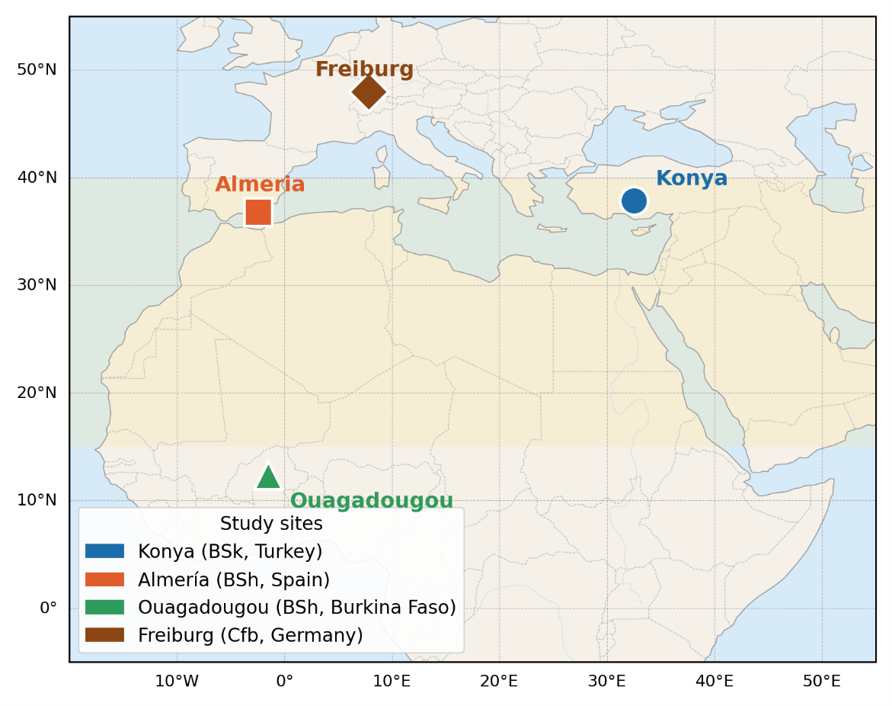
Figure 1 : Location map of the four study sites overlaid on the Köppen–Geiger climate classification. Semi-arid zones (BS) are shaded in light yellow; the oceanic temperate zone (Cfb) in light blue.

Hourly climate data were obtained from the PVGIS-SARAH3 Typical Meteorological Year (TMY) database of the European Commission Joint Research Centre [pvgis, Huld et al.]. The SARAH3 satellite product provides direct normal irradiance (DNI) and diffuse horizontal irradiance (DHI) as independent retrievals, without decomposition from global horizontal irradiance (GHI). This avoids the systematic decomposition errors of up to $±$8% reported for empirical decomposition models under broken cloud conditions [urr]. The mean bias error of PVGIS-SARAH3 GHI estimates is below $±$5% for monthly averages at all four study sites [Huld et al.]. The TMY file format provides ten meteorological variables at hourly resolution (8760 rows per site): air temperature T$​_{2m}$ (°C), relative humidity RH (%), GHI, DNI, DHI (W m$​^{-2}$), downwelling infrared irradiance IR(h) (W m$​^{-2}$), 10-m wind speed WS$​_{10m}$ (m s$​^{-1}$), wind direction WD$​_{10m}$ (°), and surface pressure SP (Pa).
Table 2 : Geographical and climatic characteristics of the four study sites (PVGIS-SARAH3 TMY data).
Parameter | Konya | Almería | Ouagadougou | Freiburg
Latitude | 37.87°N | 36.83°N | 12.37°N | 47.99°N
Longitude | 32.49°E | 2.46°W | 1.52°W | 7.85°E
Elevation (m a.s.l.) | 1 016 | 20 | 303 | 278
Köppen class | BSk | BSh | BSh | Cfb
Annual GHI (kWh m$​^{-2}$) | 1 650 | 1 850 | 2 050 | $∼$1 150
Mean annual T (°C) | 11.5 | 18.5 | 28.5 | $∼$11.4
Summer T$​_{max}$ (°C) | 38 | 35 | 41 | $∼$35
Winter T$​_{min}$ (°C) | $-$10 | $+$5 | $+$15 | $$∼-12$$
Annual ET$​_{0}$ (mm) | 1 200 | 1 350 | 1 800 | $∼$900
Annual precip. (mm) | 320 | 200 | 800 | $∼$800
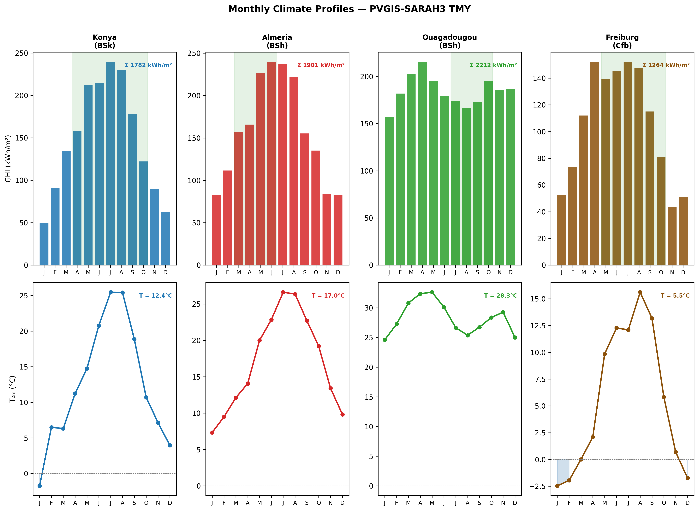
Figure 2 : Monthly climate profiles for the four study sites from PVGIS-SARAH3 TMY data. Upper row: monthly GHI (kWh m-2) with annual total annotated; lower row: mean monthly air temperature (°C). Shaded bands indicate the tomato growing season at each site.

The four sites span a mean annual temperature range of 11.4–28.5 °C, a GHI range of 1 150–2 050 kWh m$​^{-2}$, and growing seasons of 122–189 days. This diversity ensures that the model is tested across the full range of Arrhenius BMP suppression (from negligible at Ouagadougou to severe at Freiburg in January) and PAR saturation regimes (from frequent saturation at Ouagadougou to rare saturation at Freiburg), providing the basis for the multi-climate findings reported in Section 4.

3.2 Crop Parameters and Growing Seasons
Tomato (Solanum lycopersicum) was selected as the reference crop for all four sites on the basis of three criteria: it is cultivated commercially in all four study regions, its PAR saturation point (174 W m⁻²) is well-documented and places it in the high-irradiance sensitivity range where APV shading effects are most pronounced, and its residue-to-fruit ratio and BMP are among the best-characterized in the agrivoltaic and AD literatures [Mohammedi et al., Lallement et al., Feng et al.].
Site-specific planting and harvest dates follow local agricultural calendars (Table 3). The three semi-arid sites use a fresh fruit yield of 60 t ha⁻¹, consistent with irrigated greenhouse and open-field production in Mediterranean and tropical semi-arid contexts [Mohammedi et al., Lallement et al., Feng et al.]. Freiburg uses 30 t ha⁻¹ following German open-field production statistics [DLG,2023].
Table 3 : Site-specific agronomic, economic, and environmental parameters. Grid emission factors (EF) from and Umweltbundesamt (2023). Carbon prices from EU ETS (2024) for Almería and Freiburg; voluntary market rates for Konya and Ouagadougou.
Parameter | Konya | Almería | Ouagadougou | Freiburg
Planting date | 25 Apr | 1 Mar | 1 Jul | 1 May
Harvest date | 30 Oct | 30 Jun | 30 Oct | 15 Oct
Season length (days) | 189 | 122 | 122 | 167
Fruit yield (t ha$​^{-1}$) | 60 | 60 | 60 | 30
Season ET$​_{0}$ (mm) | 650 | 480 | 620 | $∼$350
Residue ratio $R_{\text{res}}$ | 0.80 [Mohammedi et al.]
Dry matter $DM$ (tomato residues) | 0.06 [Mohammedi et al.]
VS fraction $VS_{f}$ | 0.85 [Lallement et al.]
Manure input (t ha$​^{-1}$ yr$​^{-1}$) | 10.0
Manure $DM_{m}$ | 0.20 [Pilarski and Pilarska]
Manure $VS_{m}$ | 0.80 [Pilarski and Pilarska]
Tomato price ($ t$​^{-1}$) | 300 | 400 | 250 | 350
Electricity price ($ kWh$​^{-1}$) | 0.06 | 0.09 | 0.12 | 0.09
Discount rate (%) | 8 | 6 | 10 | 5
Grid EF (tCO$​_{2}$ MWh$​^{-1}$) | 0.438 | 0.167 | 0.632 | 0.380
Carbon price ($ tCO$​_{2}^{-1}$) | 15 | 65 | 12 | 65

The feedstock to the anaerobic digester combines tomato crop residues and cattle manure as a co-substrate. Manure co-digestion at a VS ratio of approximately 1:2 (residues: manure) improves buffer capacity, microbial diversity, and BMP by 12–18% compared to mono-digestion of crop residues alone [Pilarski and Pilarska] . The 10t.ha⁻¹ fresh manure input corresponds to the production of approximately 2–3 cattle heads per hectare, consistent with the mixed crop-livestock farming systems prevalent in all four study regions. Total annual VS input per hectare is:
$$\begin{aligned}VS_{\text{total}}=\underset{crop residues}{\underbrace{Y_{f}⋅LER_{\text{crop}}⋅R_{\text{res}}⋅DM⋅VS_{f}}}+\underset{cattle manure}{\underbrace{M_{m}⋅DM_{m}⋅VS_{m}}}\#\left(1\right)\end{aligned}$$
where $Y_{f}$ is the fresh fruit yield (kg ha$​^{-1}$), $LER_{\text{crop}}$ scales the actual residue production under APV shading, and $M_{m}$ is the fresh manure input (kg ha$​^{-1}$ yr$​^{-1}$). At the optimised designs reported in Section 4, VS inputs range from 1892 to 2573 kg.ha⁻¹.yr⁻¹ across the four sites, with Freiburg’s lower fruit yield driving the minimum.

3.3 Solar Geometry and Shading Model
Accurate hourly solar position calculation underpins both the PV transposition model and the inter-row shading factor. Solar declination $δ$ is computed using the Spencer (1971) harmonic approximation:
$$\begin{aligned}\begin{matrix}δ=\frac{180}{π}(0.006918-0.399912cosB+0.070257sinB \\ -0.006758cos2B+0.000907sin2B-0.002697cos3B+0.001480sin3B)\end{matrix}\#\left(2\right)\end{aligned}$$
where $B=2π(n-1)/365$ and $n$ is the day of year. The hour angle $ω$ is computed from true solar time, applying a longitude correction and the Equation of Time. The solar elevation angle $α_{s}$ at each hourly timestep is:
$$\begin{aligned}sinα_{s}=sinϕsinδ+cosϕcosδcosω\#\left(3\right)\end{aligned}$$
where $ϕ$ is the site latitude.
The Ground Coverage Ratio (GCR) quantifies the fraction of ground area covered by the projected module footprint:
$$\begin{aligned}GCR=\frac{L_{m}cosβ}{d_{\text{row}}}\#\left(4\right)\end{aligned}$$
where $L_{m}=2.278 m$ is the module length (Jinko Tiger Neo 550 W$​_{\text{p}}$) and $β$ is the panel tilt angle. A physical non-overlap constraint prevents adjacent rows from casting permanent shade on each other at any sun angle:
$$\begin{aligned}d_{\text{row}}≥L_{m}cosβ+0.5 m\#\left(5\right)\end{aligned}$$
where the 0.5 m clearance accounts for module frame width and structural tolerance. This constraint is enforced as a feasibility penalty in the optimizer (Section 3.9).
The hourly ground shading fraction $F_{\text{shad}}(t)$ — the fraction of ground area beneath the array that is shaded at time $t$ follows Zainali et al.:
$$\begin{aligned}F_{\text{shad}}\left(t\right)=min​\left(1, \frac{H_{m}cosΔγ}{d_{\text{row}}tanα_{s}\left(t\right)}\right)\#\left(6\right)\end{aligned}$$
where $H_{m}$ is the module bottom-edge height above ground (m), $Δγ$ is the azimuth difference between the solar direction and the row orientation (zero for south-facing rows, which is the configuration adopted throughout), and $α_{s}(t)$ is the solar elevation angle. $F_{\text{shad}}=0$ at night ($α_{s}≤0$) and during high-sun periods when the solar elevation is sufficient to eliminate inter-row shading entirely. The shading fraction directly enters both the crop yield model (Section 3.5) and the ET reduction model (Section 3.6), propagating the geometric design variables into all biological and energy outputs of the coupled system.

3.4 Photovoltaic Energy Model

3.4.1 Plane-of-Array Irradiance
Plane-of-array (POA) irradiance on the tilted front surface is computed using the isotropic sky model of Liu and Jordan, which decomposes incoming radiation into beam, diffuse, and ground-reflected components:
$$\begin{aligned}G_{\text{front}}=DNIcosθ_{i}+DHI\frac{1+cosβ}{2}+GHI ρ_{g}\frac{1-cosβ}{2}\#\left(7\right)\end{aligned}$$
where $θ_{i}$ is the angle of incidence on the tilted surface, $β$ is the panel tilt angle, and $ρ_{g}=0.25$ is the ground albedo [Monteith and Unsworth]. The angle of incidence for a fixed, due-south-facing tilted surface is given by the closed-form expression, expressed directly in terms of declination $δ$, latitude $ϕ$, hour angle $ω$, and tilt $β$:
$$\begin{aligned}cosθ_{i}=sinδsin\left(ϕ-β\right)+cosδcosωcos\left(ϕ-β\right)\#\left(8\right)\end{aligned}$$
This expression is the closed-form relation used here for a fixed due-south collector at every hour of the day. An earlier version of this model used the solar-noon-only approximation $cosθ_{i}≈sinα_{s}cosβ+cosα_{s}sinβ$, which implicitly assumes the sun remains due south throughout the day; this systematically overestimated front-surface beam irradiance away from solar noon and has been corrected throughout the present study.
For bifacial modules, rear-side irradiance $G_{\text{rear}}$ is estimated from ground-reflected radiation modulated by the inter-row shading fraction:
$$\begin{aligned}G_{\text{rear}}=GHI ρ_{g}\left(1-F_{\text{shad}}\left(t\right)\right) f_{\text{rear}}\#\left(9\right)\end{aligned}$$
where $f_{\text{rear}}=0.12$ is the rear irradiance fraction relative to ground-reflected GHI, accounting for the view factor from the rear surface to the ground beneath the array. The effective bifacial irradiance combining both surfaces is:
$$\begin{aligned}G_{\text{eff}}=G_{\text{front}}+ϕ G_{\text{rear}}\#\left(10\right)\end{aligned}$$
where $ϕ=0.70$ is the bifaciality factor of the Jinko Tiger Neo 550 W$​_{\text{p}}$ module.

3.4.2 Cell Temperature
Cell operating temperature is modelled using the Faiman approach, which accounts for wind-dependent convective cooling:
$$\begin{aligned}T_{\text{cell}}\left(t\right)=T_{\text{amb}}\left(t\right)+\frac{G_{\text{eff}}\left(t\right)}{U_{0}+U_{1} u\left(t\right)}\#\left(11\right)\end{aligned}$$
where $U_{0}=25 W m^{-2} K^{-1}$ is the free convection coefficient and $U_{1}=6.84 W s m^{-3} K^{-1}$ is the wind-dependent convective coefficient [Faiman]. Wind speed $u(t)$ is taken directly from the PVGIS-SARAH3 TMY column WS$​_{10m}$ and clipped to a minimum of 0.5 m s⁻¹ to prevent division by zero in calm conditions.

3.4.3 PV Power Output
Array power output at each hourly timestep is:
$$\begin{aligned}P_{\text{PV}}\left(t\right)=P_{\text{STC}} N \left(1-η_{\text{loss}}\right)\left[1+β_{p}\left(T_{\text{cell}}\left(t\right)-25\right)\right]\frac{G_{\text{eff}}\left(t\right)}{1000}\#\left(12\right)\end{aligned}$$
where $P_{\text{STC}}=550 W_{p}$ is the rated module power at Standard Test Conditions, $N$ is the number of modules per hectare (determined by $β$ and $d_{\text{row}}$ via Equation [eq:gcr]), $η_{\text{loss}}=0.12$ aggregates all system losses (wiring, soiling, mismatch, inverter), and $β_{p}=-0.0035 K^{-1}$ is the temperature power coefficient [Jinko Solar, 2023]. Annual PV energy is partitioned between grid export and digester heating:
$$\begin{aligned}E_{\text{PV,heat}}=f_{\text{PV,heat}}×E_{\text{PV,total}}\#\left(13\right)\end{aligned}$$
$$\begin{aligned}E_{PV,sold }=\left(1-f_{PV,heat}\right)×E_{PV,total}\#\left(14\right)\end{aligned}$$

where $f_{\text{PV,heat}}∈[0.05, 0.50]$ is the sixth design variable optimised by the DE algorithm. Table 4 summarizes all fixed PV model parameters.

Table 4 : Fixed PV model parameters.
Parameter | Symbol | Value | Source
Rated power (STC) | $$P_{\text{STC}}$$ | 550 W$​_{p}$ | Jinko Solar [2023
Module length | $$L_{m}$$ | 2.278 m
Bifaciality factor | $$ϕ$$ | 0.70
Temp. coefficient | $$β_{p}$$ | $-$0.0035 K$​^{-1}$
System losses | $$η_{\text{loss}}$$ | 0.12
Ground albedo | $$ρ_{g}$$ | 0.25
Faiman $U_{0}$ | $$U_{0}$$ | 25 W m$​^{-2}$ K$​^{-1}$
Faiman $U_{1}$ | $$U_{1}$$ | 6.84 W s m$​^{-3}$ K$​^{-1}$
Rear irradiance fraction | $$f_{\text{rear}}$$ | 0.12

3.5 Crop Yield Model
Relative crop yield is modelled using the PAR integral method, which integrates the gap between available and saturating photosynthetically active radiation over the growing season. The fraction of global horizontal irradiance that is photosynthetically active is $f_{\text{PAR}}=0.48$ [McCree, Jacovides et al.]. Hourly PAR under the APV array and in an equivalent open field are:
$$\begin{aligned}PAR_{\text{AV}}\left(t\right)=GHI\left(t\right)×f_{\text{PAR}}×\left(1-F_{\text{shad}}\left(t\right)\right)\#\left(15\right)\end{aligned}$$
$$\begin{aligned}PAR_{\text{open}}\left(t\right)=GHI\left(t\right)×f_{\text{PAR}}\#\left(16\right)\end{aligned}$$
The tomato light saturation point is $PAR_{\text{sat}}=174 W m^{-2}$ [Mohammedi et al., Heuvelink, 2005], above which additional PAR delivers no incremental photosynthesis. The annual yield ratio, integrated exclusively over the growing season $[t_{0}, t_{1}]$, is:
$$\begin{aligned}LER_{\text{crop}}=\frac{\int_{t_{0}}^{t_{1}}{min}​\left(PAR_{\text{AV}}\left(t\right), PAR_{\text{sat}}\right) dt}{\int_{t_{0}}^{t_{1}}{P}AR_{\text{open}}\left(t\right) dt}\#\left(17\right)\end{aligned}$$
Three properties of Equation 17 are worth noting explicitly. First, $LER_{\text{crop}}$ is bounded above by 1.0: the APV array cannot increase crop yield beyond the open-field reference in the absence of heat stress or water limitation effects, which are not modelled here. Second, at high irradiance sites where $PAR_{\text{open}}(t)≫PAR_{\text{sat}}$ for a large fraction of daytime hours, the denominator is large relative to the numerator even before any shading is applied, making $LER_{\text{crop}}$ sensitive to the ratio $PAR_{\text{sat}}/\overline{PAR_{\text{open}}}$ the mechanism that drives the non-monotone eLER–GHI relationship identified in Section 4. Third, integration is performed over the growing season only: including off-season hours (when $GHI≈0$ at night and both integrals are zero) does not change the ratio, but restricting to $[t_{0}, t_{1}]$ correctly attributes yield impacts to the period when the crop is actually present.
Model validation against the six-point shading dataset of Mohammedi et al. is reported in Section 4.7 (V1 validation, MAPE = 2.4% in the operational shading range $F_{\text{shad}}≤0.25$).

3.6 Evapotranspiration Reduction and Water Savings
Reference evapotranspiration ET$​_{0}$ is estimated hourly using the Hargreaves–Samani equation [Hargreaves and Samani, 1985], driven by the daily temperature range and extraterrestrial radiation $R_{a}$ computed astronomically from latitude and day of year following the standard FAO-56 formulation [Allen, 1998], requiring no ground radiation measurement. The Hargreaves–Samani method was selected over FAO-56 Penman-Monteith [Allen, 1998] because the PVGIS TMY files do not provide dew point temperature or net radiation as independent columns, making two of the four Penman-Monteith inputs unavailable without auxiliary decomposition. Hargreaves–Samani estimates of seasonal ET$​_{0}$ agree with FAO-56 to within $±$10% for the semi-arid and temperate climates represented in this study [Droogers and Allen, 2002].
Under APV panels, evapotranspiration is reduced by the interception of incoming radiation. Following Elamri et al. and Tawassulli [2025], the hourly ET under the APV array is:
$$\begin{aligned}ET_{\text{APV}}\left(t\right)=ET_{0}\left(t\right)×\left(1-α_{\text{shade}} F_{\text{shad}}\left(t\right)\right)\#\left(18\right)\end{aligned}$$
where $α_{\text{shade}}=0.40$ is the ET reduction coefficient, empirically calibrated from field measurements of soil evaporation and canopy transpiration under partial shade [Elamri et al., Tawassulli, 2025]. The value $α_{\text{shade}}=0.40$ represents a conservative central estimate; field studies at GCR $>$ 0.5 report values of 0.35–0.55 depending on crop canopy closure, soil type, and wind exposure. Sensitivity to $α_{\text{shade}}$ is discussed in Section 5.
Annual growing-season water savings are:
$$\begin{aligned}W_{saved}= \int_{t_{0}}^{t_{1}}{\left[ET_{0}\left(t\right)-ET_{APV}\left(t\right)\right]dt=α_{shade}\int_{t_{0}}^{t_{1}}{F_{shad}\left(t\right)ET_{0}\left(t\right)dt}}\#\left(19\right)\end{aligned}$$
The water savings Land Equivalent Ratio is defined as the fraction of growing-season ET$​_{0}$ saved by the APV system:
$$\begin{aligned}LER_{\text{water}}=\frac{W_{\text{saved}}}{\int_{t_{0}}^{t_{1}}{ET_{0}\left(t\right)dt}}×100\%\#\left(20\right)\end{aligned}$$
Note on the denominator. Prior agrivoltaic studies have reported $LER_{\text{water}}$ using annual ET$​_{0}$ as the denominator [Barron-Gafford et al., Elamri et al.], systematically underestimating the agronomic benefit by diluting growing-season savings with months when the crop is absent and the panels provide no agronomic water benefit. With a 122-day season (Almería, Ouagadougou), the annual denominator inflates by a factor of $365/122=3.0$ relative to the growing-season denominator, reducing the reported $LER_{\text{water}}$ by the same factor. The correction is largest at Almería and Ouagadougou (factor 3.0) and smallest at Konya (factor 1.9, 189-day season). Throughout this paper, $LER_{\text{water}}$ uses the growing-season denominator (Equation 20); the annual-denominator value is reported alongside for literature comparison only.

3.7 Anaerobic Digestion Model

3.7.1 Effective Digester Temperature
The effective digester operating temperature is determined by the ambient temperature profile and the thermal management strategy. PV electricity allocated to resistive heating ($f_{\text{PV,heat}}$ fraction of annual PV output) maintains the digester above a minimum operating threshold. The effective digester temperature is modelled as:
$$\begin{aligned}T_{\text{dig,eff}}=clip​\left(T_{\text{amb,monthly}}+5, T_{\text{min}}, T_{\text{ref}}\right)\#\left(21\right)\end{aligned}$$
where $T_{\text{min}}=26 \text{°C}$ is the minimum acceptable operating temperature below which methanogenesis becomes severely inhibited, $T_{\text{ref}}=37 \text{°C}$ is the mesophilic optimum, and the $+5 ^{∘}$C boost above monthly mean ambient temperature represents the passive thermal gain from digester insulation and exothermic reaction heat [Lindorfer et al.]. Monthly mean ambient temperatures from the PVGIS-SARAH3 TMY are used as the seasonal driver, reflecting the thermal inertia of a well-insulated CSTR digester that equilibrates on a monthly rather than hourly timescale.

3.7.2 Arrhenius BMP Temperature Correction
The temperature-corrected biochemical methane potential follows an Arrhenius-type relationship [Pilarski and Pilarska, Feng et al.]:
$$\begin{aligned}BMP\left(T_{\text{dig,eff}}\right)=BMP_{\text{ref}}×exp​\left[θ \left(T_{\text{dig,eff}}-T_{\text{ref}}\right)\right]\#\left(22\right)\end{aligned}$$
with reference BMP $BMP_{\text{ref}}=300 NmL CH_{4} gVS^{-1}$ at $T_{\text{ref}}=37 \text{°C}$ and Arrhenius coefficient $θ=0.069 \text{°C}​^{-1}$ [Pilarski and Pilarska]. Annual methane production is:
$$\begin{aligned}V_{{\text{CH}}_{4}}=VS_{\text{total}}×\overline{BMP}×η_{\text{cap}}\#\left(23\right)\end{aligned}$$
where $\overline{BMP}$ is the annual average BMP weighted by monthly VS throughput, $η_{\text{cap}}=1.00$ under baseline conditions (S0), and $VS_{\text{total}}$ is from Equation 1. Annual biogas energy is:
$$\begin{aligned}E_{\text{biogas}}=V_{{\text{CH}}_{4}}×f_{{\text{CH}}_{4}}×LHV_{{\text{CH}}_{4}}\#\left(24\right)\end{aligned}$$
with methane fraction $f_{{\text{CH}}_{4}}=0.60$ and lower heating value $LHV_{{\text{CH}}_{4}}=35.8 MJ Nm^{-3}$ . [Marchaim, 1992]. Validation of the BMP temperature model against the five-point experimental dataset of Feng et al. is reported in Section 4.7 (V2 validation, MAPE = 26.9% in the operating range $T≤37 \text{°C}$). Sensitivity of biogas output and eLER to $BMP_{\text{ref}}$, capture efficiency $η_{\text{cap}}$, and volatile-solids fractions is assessed via Monte Carlo sampling over literature-reported ranges in Section 5.

3.7.3 Digester Heat Balance
The annual digester heat demand is the sum of conductive wall losses, substrate heating requirement, and the exothermic reaction credit [Pal and Ilango]:
$$\begin{aligned}Q_{\text{heat}}=Q_{\text{loss}}+Q_{\text{inflow}}-Q_{\text{reaction}}\#\left(25\right)\end{aligned}$$
Conductive wall losses from a cylindrical digester (height = diameter assumption) with effective heat transfer coefficient $U_{\text{eff}}=0.8 W m^{-2} K^{-1}$ :
$$\begin{aligned}Q_{\text{loss}}=U_{\text{eff}} A_{\text{wall}}\left({\overline{T}}_{\text{dig}}-{\overline{T}}_{\text{amb}}\right)×\frac{8760}{1000}\#\left(26\right)\end{aligned}$$
where $A_{\text{wall}}$ is the total digester surface area (m$​^{2}$) and the factor $8760/1000$ converts from W to MWh yr$​^{-1}$. Substrate heating demand:
$$\begin{aligned}Q_{\text{inflow}}=\frac{V_{\text{dig}}}{HRT}×365×ρ_{s}×C_{p}×\frac{max​\left(0, {\overline{T}}_{\text{dig}}-T_{\text{in}}\right)}{3600}\#\left(27\right)\end{aligned}$$
with substrate density $ρ_{s}=1020 kg m^{-3}$, specific heat $C_{p}=4.2 kJ kg^{-1} K^{-1}$, and inlet temperature $T_{\text{in}}=15 \text{°C}$. The exothermic reaction credit is estimated as 5% of gross biogas energy [Pal and Ilango]:
$$\begin{aligned}Q_{\text{reaction}}=0.05×E_{\text{biogas}}\#\left(28\right)\end{aligned}$$

3.7.4 Energy Self-Sufficiency Ratio
The Energy Self-sufficiency Ratio quantifies the thermal margin of the integrated system:
$$\begin{aligned}ESR=\frac{E_{\text{PV,total}}+E_{\text{biogas}}}{Q_{\text{heat}}}\#\left(29\right)\end{aligned}$$
When $ESR≫1$, the combined PV and biogas output far exceeds the digester heating requirement, and zero biogas is consumed for self-heating. Under this condition, $LER_{\text{biogas}}$ equals the ratio of APV-system biogas to open-field reference biogas by construction a structural identity rather than an optimized outcome, as discussed in Section 5.

3.8 Extended Land Equivalent Ratio
The extended Land Equivalent Ratio (eLER) generalizes the classical two-component agrivoltaic LER by adding net biogas energy as a third dimensionless land-use output:
$$\begin{aligned}eLER=\underset{LER_{crop}}{\underbrace{\frac{Y_{\text{crop,AV}}}{Y_{\text{crop,open}}}}}+\underset{LER_{PV}}{\underbrace{\frac{E_{\text{PV,sold}}}{E_{\text{PV,ref}}}}}+\underset{LER_{biogas}}{\underbrace{\frac{E_{\text{biogas,APV}}}{E_{\text{biogas,ref}}}}}\#\left(30\right)\end{aligned}$$

An eLER greater than 1.0 indicates that the integrated APV–AD system uses land more productively than three separate monocultures an open-field crop, a dense-pack ground-mount PV array, and a standalone AD unit occupying the same total area. Equal weighting of the three components is adopted here, consistent with the original two-component LER framework, in which each term is already normalized to its own reference system and is therefore commensurable without further weighting; the sensitivity of eLER and cross-site rankings to alternative (energy-content- and revenue-weighted) schemes is examined in Section 5. Each component is defined as follows.
$LER_{\text{crop}}$ is the yield ratio from Equation 17: the ratio of growing-season PAR integral under the APV array to the open-field PAR integral, bounded in $[0, 1]$ for tomato at the modelled irradiance levels.
$LER_{\text{PV}}$ is the ratio of annual APV electricity sold to grid to the reference PV output. Two reference definitions are used:
- Definition A (independent reference, primary): $E_{\text{PV,ref}}$ is computed from a simulated dense-pack ground-mount array at the same tilt angle $β^{*}$ with no inter-row shading (GCR = 1.0 in the limiting sense, i.e. rows spaced at exactly the module projected width $L_{m}cosβ$). This provides a non-circular reference that is independent of the APV design variables.
- Definition B (circular reference, for comparison): $LER_{\text{PV}}≡GCR$, as the APV array output referenced to itself equals the fraction of ground covered. Reported for literature comparability with studies using this convention, but not used as the primary metric [Mazzeo et al.].
$LER_{\text{biogas}}$ is the ratio of biogas energy produced by the APV–AD system to the output of a standalone reference AD unit. The reference AD unit processes the same land area under open-field conditions ($LER_{\text{crop}}=1.0$, maximum residue production) with identical digester volume, HRT, and manure co-substrate:
$$\begin{aligned}LER_{\text{biogas}}=\frac{E_{\text{biogas,APV}}}{E_{\text{biogas,ref}}}\#\left(31\right)\end{aligned}$$
Because the manure co-substrate ($VS_{\text{manure}}$) is identical in both the APV and reference cases, $LER_{\text{biogas}}$ reflects exclusively the effect of APV shading on crop residue production. When $LER_{\text{crop}}<1$, the APV system produces fewer crop residues than the open-field reference, and consequently $LER_{\text{biogas}}<1$. This is a structural consequence of the shading-residue coupling, not a model artefact.
The two-component benchmark for literature comparison is:
$$\begin{aligned}LER_{\text{2C}}=LER_{\text{crop}}+LER_{\text{PV}}\left(\text{Def. A}\right)\#\left(32\right)\end{aligned}$$
The published two-component maximum is $LER_{\text{2C}}=1.94$ from Riaz et al. for bifacial tomato in Arizona. All results in this study are reported under Definition A unless explicitly stated otherwise, and the numerical difference between Definition A and B is reported in Table 9.

3.9 Design Optimization

3.9.1 Differential Evolution Algorithm
The six design variables and their bounds are summarized in Table 5. The objective function $eLER(x)$ (Equation 30) is maximized using Differential Evolution (DE) [Storn], a population-based global optimizer that requires no gradient information and handles non-smooth, multimodal objective landscapes efficiently. DE has been widely applied to renewable energy system sizing problems where the design space contains bound constraints and discrete-continuous interactions [Oprea and Bra, 2024].
Table 5 : Design variable bounds for Differential Evolution. The inter-row clearance constraint (Equation 5) is enforced dynamically as a feasibility penalty during optimization.
Variable | Symbol | Lower | Upper | Unit
Panel tilt angle | $$β$$ | 15 | 40 | °
Row spacing | $$d_{\text{row}}$$ | 3 | 14 | m
Module bottom-edge height | $$H_{m}$$ | 1.5 | 5.0 | m
Digester volume | $$V_{\text{dig}}$$ | 2 | 50 | m³
Hydraulic retention time | $$HRT$$ | 20 | 40 | days
PV heating fraction | $$f_{\text{PV,heat}}$$ | 0.05 | 0.50 | —

The DE configuration follows common recommendations [Storn, Das et al., 2011]:
- Population size: $NP=15×n_{\text{var}}=90$ individuals, initialised via Latin Hypercube Sampling with seed = 42 for reproducibility.
- Mutation factor: $F$ dithered uniformly in $[0.5, 1.0]$ at each generation, balancing global exploration with local convergence.
- Crossover probability: $Cr=0.70$ (binomial crossover).
- Maximum generations: $G_{max}=50$.
- Local polishing: after DE convergence, the best candidate is refined using L-BFGS-B with bound constraints, recovering sub-pixel precision in the continuous design space.
Two feasibility constraints are enforced via an infeasibility penalty $f=-∞$ applied to violating candidates:
- Organic loading rate: $OLR∈[1.5, 5.0] {\text{kg} \text{VS} \text{m}}^{-3}{\text{d}}^{-1}$, ensuring stable digester operation without acidification or underloading.
- Inter-row clearance: $d_{\text{row}}≥L_{m}cosβ+0.5 m$, preventing physical module overlap (Equation 5).
The complete pseudocode of the DE procedure is given in Appendix 7. Each evaluation of the objective function $eLER(x)$ runs the full six-model pipeline — solar geometry, PV model, crop yield, ET reduction, AD model, and eLER assembly — on the 8760-hour TMY dataset for the corresponding site. At $NP=90$ individuals and $G_{max}=50$ generations, each site requires $90×50=4500$ full pipeline evaluations, converging in 102–172 seconds on a standard desktop CPU.

3.9.2 Boundary Convergence
At all four sites, the optimizer converges to the lower bounds of row spacing ($d_{\text{row}}^{*}=3.03 m$, constrained by the inter-row clearance condition) and module height ($H_{m}^{*}=1.50 m$, the specified lower bound). This boundary convergence is a structural result: the eLER landscape reaches its optimum at the physical constraint boundary, where maximum panel density simultaneously maximises PV output and reduces the open-field PAR integral denominator (Equation 17). The L-BFGS-B polishing step confirms that no interior local maximum exists in the neighbourhood of the boundary solution. The eLER penalty associated with any mechanical access requirement beyond the minimum clearance is quantified in the sensitivity analysis of Section 5.

3.9.3 Multi-Objective Extension (NSGA-II)
For the water trade-off analysis, the scalar eLER objective is replaced by a bi-objective problem: simultaneously maximize $eLER$ and $LER_{\text{water}}$ (Equation 20). This is solved using NSGA-II [Blank and Deb, 2020] with50 solutions and 80 generations implemented via the pymoo library [Blank and Deb, 2020]. The bi-objective Pareto front provides the decision-maker with explicit trade-off information between land productivity and water conservation, enabling context-specific design choices for water-stressed smallholder systems.

3.10 AD Valorization Scenarios
Seven economic scenarios (S0–S6) are evaluated to quantify the sensitivity of project economics to biogas valorization strategy and carbon market participation (Table 6). All scenarios share the same optimized APV–AD design ($x^{*}$) and differ only in biogas price, BMP multiplier, capture efficiency, or additional revenue streams. eLER is invariant across scenarios by construction, since it depends solely on physical outputs ($E_{\text{PV,sold}}$, $Y_{\text{crop}}$, $E_{\text{biogas}}$) and not on market prices.
Table 6 : AD valorization scenarios S0–S6. All scenarios use the same optimized design x^*. eLER is identical across scenarios; only revenue structure changes.
Scenario | Description | Key modification
S0 | Baseline: mono-digestion, 100% grid export | $BMP_{\text{mult}}=1.00$, $η_{\text{cap}}=1.00$
S1 | Co-digestion: $+$30% cattle manure | $$BMP_{\text{mult}}=1.15$$
S2 | Sub-optimal CH$​_{4}$ capture (85%) | $$η_{\text{cap}}=0.85$$
S3 | LPG displacement (on-site use) | $$p_{\text{bg}}=\$0.18 {\text{kWh}}^{-1}$$
S4 | Digestate N–P–K credit | N credit at $\$1.20 {\text{kg}}^{-1}$ N
S5 | Biomethane grid injection (EU premium) | $$p_{\text{bg}}=5.5 p_{\text{elec}}$$
S6 | Carbon credit (voluntary market) | $p_{c}$ = site-specific ($/tCO$​_{2}$)
Scenario S0 serves as the economic baseline: biogas is sold at the local grid biogas tariff $p_{\text{bg}}$ (Table 3) and all PV electricity is exported to grid at $p_{\text{elec}}$ after deducting the heating fraction $f_{\text{PV,heat}}$.
Scenario S1 models co-digestion with a 30% increase in cattle manure beyond the baseline co-substrate, raising BMP by 15% through improved C:N ratio and microbial diversity [Pilarski and Pilarska]. The additional manure input is assumed available at zero marginal cost from the same farm herd.
Scenario S2 models sub-optimal biogas capture at 85% efficiency, representing a system with gas leakage, flaring, or insufficient gas storage. It provides a lower bound on the biogas revenue stream.
Scenario S3 models on-site LPG displacement, where biogas is used directly for cooking or process heat at a price parity of $0.18 kWh$​^{-1}$ the average LPG equivalent price in the four study regions [IEA, 2025]. This scenario is particularly relevant for Ouagadougou, where LPG import costs are high.
Scenario S4 adds a digestate nitrogen credit of $1.20 kg$​^{-1}$ N, reflecting the avoided cost of equivalent synthetic urea fertilizer. Digestate N content is estimated as $0.003 \text{kg} \text{N} {\text{kg}}^{-1}$ fresh residue [Lallement et al.].
Scenario S5 models biomethane grid injection under European EEG 2023 and RED III incentives, where the effective biomethane market price is $5.5×$ the local electricity purchase price [Nik Zad, 2026, European Biogas Association, 2025, Rabobank, 2025]. This scenario is directly applicable to Almería and Freiburg; for Konya and Ouagadougou, which lack biomethane grid injection policy frameworks, S5 represents an aspirational upper bound pending regulatory development.
Scenario S6 adds a carbon credit revenue stream based on CO$​_{2}$ displaced by PV electricity and biogas substituting fossil fuels. Carbon prices are site-specific: EU ETS market rate ($65 tCO$​_{2}^{-1}$) for Almería and Freiburg; voluntary Gold Standard rate ($12 tCO$​_{2}^{-1}$) for Ouagadougou; and Turkish voluntary carbon market rate ($15 tCO$​_{2}^{-1}$) for Konya. Annual CO$​_{2}$ avoidance is:
$$\begin{aligned}CO_{2,\text{avoided}}=E_{\text{PV,sold}}×EF_{\text{grid}}+\frac{E_{\text{biogas}}}{1000}×EF_{\text{gas}}\#\left(33\right)\end{aligned}$$
where $EF_{\text{grid}}$ is the site-specific grid emission factor (Table 3) and $EF_{\text{gas}}=0.202 tCO_{2} MWh^{-1}$ is the natural gas emission factor from IPCC AR6 [IPCC, 2022].

3.11 4E Analysis Framework
Investment-grade economic evaluation uses a 20-year project life with site-specific discount rates (Table 3), annualized CAPEX, and annual O&M fixed at 1.5% of total CAPEX. The 4E framework integrates four performance dimensions into a single comparative assessment across sites and scenarios.

3.11.1 E1 - Energetic Analysis
The energetic dimension quantifies annual energy flows: PV total generation, PV sold to grid, biogas energy, digester heat demand, and ESR (Equation 29). These are reported per hectare of land area for cross-site comparability.

3.11.2 E2 - Economic Analysis
CAPEX is decomposed into four components:
- PV array (elevated APV structure): $0.63 W$​_{p}^{-1}$, reflecting the $0.45 W$​_{p}^{-1}$ utility-scale ground-mount benchmark [IRENA, 2022] plus a 40% premium for elevated APV mounting structure, cable routing, and installation.
- AD digester: $800 m$​^{-3}$ installed capacity [Pal and Ilango], covering tank construction, mixing system, gas handling, and instrumentation for small farm-scale CSTR digesters (2–50 m$​^{3}$).
- Agricultural infrastructure: $2 500 ha$​^{-1}$ (FAO benchmark), covering drip irrigation installation, soil preparation, and access tracks.
- Balance of plant (BOP): 15% of (PV + AD) CAPEX, covering inverters, electrical wiring, civil works, and commissioning.
Annual gross revenue combines all income streams active under the relevant scenario:
$$\begin{aligned}R_{\text{gross}}=R_{\text{PV}}+R_{\text{tomato}}+R_{\text{biogas}}+R_{\text{digestate}}+R_{\text{carbon}}\#\left(34\right)\end{aligned}$$
Net annual cash flow, Net Present Value, Internal Rate of Return, and simple payback period are:
$$\begin{aligned}CF_{\text{net}}=R_{\text{gross}}-C_{\text{O\&M}}\#\left(35\right)\end{aligned}$$
$$\begin{aligned}NPV=-CAPEX+CF_{\text{net}}×\frac{1-(1+r)^{-N}}{r}\#\left(36\right)\end{aligned}$$
$$\begin{aligned}IRR: 0=-CAPEX+CF_{\text{net}}×\frac{1-(1+IRR)^{-N}}{IRR}\#\left(37\right)\end{aligned}$$
$$\begin{aligned}PB=\frac{CAPEX}{CF_{\text{net}}}\#\left(38\right)\end{aligned}$$
where $r$ is the site-specific discount rate and $N=20$ years. IRR is solved by bisection on the NPV equation.

3.11.3 E3 - Energo-Economic Analysis
The Levelized Cost of Electricity for the PV component isolates the cost of generating one kWh of PV electricity, accounting for both annualized PV CAPEX and the proportional share of O&M:
$$\begin{aligned}LCOE_{\text{PV}}=\frac{CAPEX_{\text{PV}}+C_{\text{O\&M,PV}}×\frac{1-(1+r)^{-N}}{r}}{E_{\text{PV,sold}}×\frac{1-(1+r)^{-N}}{r}}\#\left(39\right)\end{aligned}$$
The levelized cost of biogas production is computed analogously using $CAPEX_{\text{AD}}$ and $E_{\text{biogas}}$ as the denominator, providing a cost-of-energy metric comparable to published small-scale AD benchmarks [Pal and Ilango].

3.11.4 E4 - Environmental Analysis
The environmental dimension quantifies annual CO$​_{2}$ avoidance (Equation 33) and its monetary value under site-specific carbon pricing (Table 3). Two displacement pathways are distinguished: grid electricity displaced by PV generation (valued at the grid emission factor $EF_{\text{grid}}$) and natural gas displaced by biogas (valued at the IPCC AR6 natural gas factor $EF_{\text{gas}}=0.202 tCO_{2} MWh^{-1}$ ). The carbon credit value $R_{\text{carbon}}=CO_{2,\text{avoided}}×p_{c}$ enters the revenue calculation of Scenario S6 (Equation 34). Table 7 summarizes all fixed 4E analysis parameters.
Table 7 : Fixed parameters for the 4E economic and environmental analysis.
Parameter | Symbol | Value | Source
Project lifetime | $$N$$ | 20 yr | standard
O&M rate | $$f_{\text{O\&M}}$$ | 1.5% CAPEX yr$​^{-1}$ | IRENA [2022]
PV CAPEX (APV) | $$c_{\text{PV}}$$ | $0.63 W$​_{p}^{-1}$ | IRENA [2022]
AD CAPEX | $$c_{\text{AD}}$$ | $800 m$​^{-3}$ | Pal and Ilango
Agricultural CAPEX | $$c_{\text{agri}}$$ | $2 500 ha$​^{-1}$ | FAO
BOP fraction | $$f_{\text{BOP}}$$ | 15% of (PV$+$AD) | standard
Natural gas EF | $$EF_{\text{gas}}$$ | 0.202 tCO$​_{2}$ MWh$​^{-1}$ | IPCC [2022]
Digestate N content | - | 0.003 kg N kg$​^{-1}$ | Lallement et al.
N credit price | $$p_{N}$$ | $1.20 kg$​^{-1}$ N | market
LPG equivalent price | $$p_{\text{LPG}}$$ | $0.18 kWh$​^{-1}$ | IEA [2025]
Biomethane premium (S5) | - | $$5.5×p_{\text{elec}}$$ | Nik Zad [2026]

4. Results

4.1 Optimization Convergence and Optimal Design Parameters
The Differential Evolution optimizer converged to feasible solutions within 50 generations at all four sites. Runtime ranged from 102 s (Konya) to 172 s (Ouagadougou) on a standard desktop CPU, reflecting differences in feasibility constraint violation frequency across the population during early generations. The convergence curves (Figure 3) show rapid improvement in the first 10–15 generations followed by progressive refinement, with no evidence of premature convergence or stagnation.
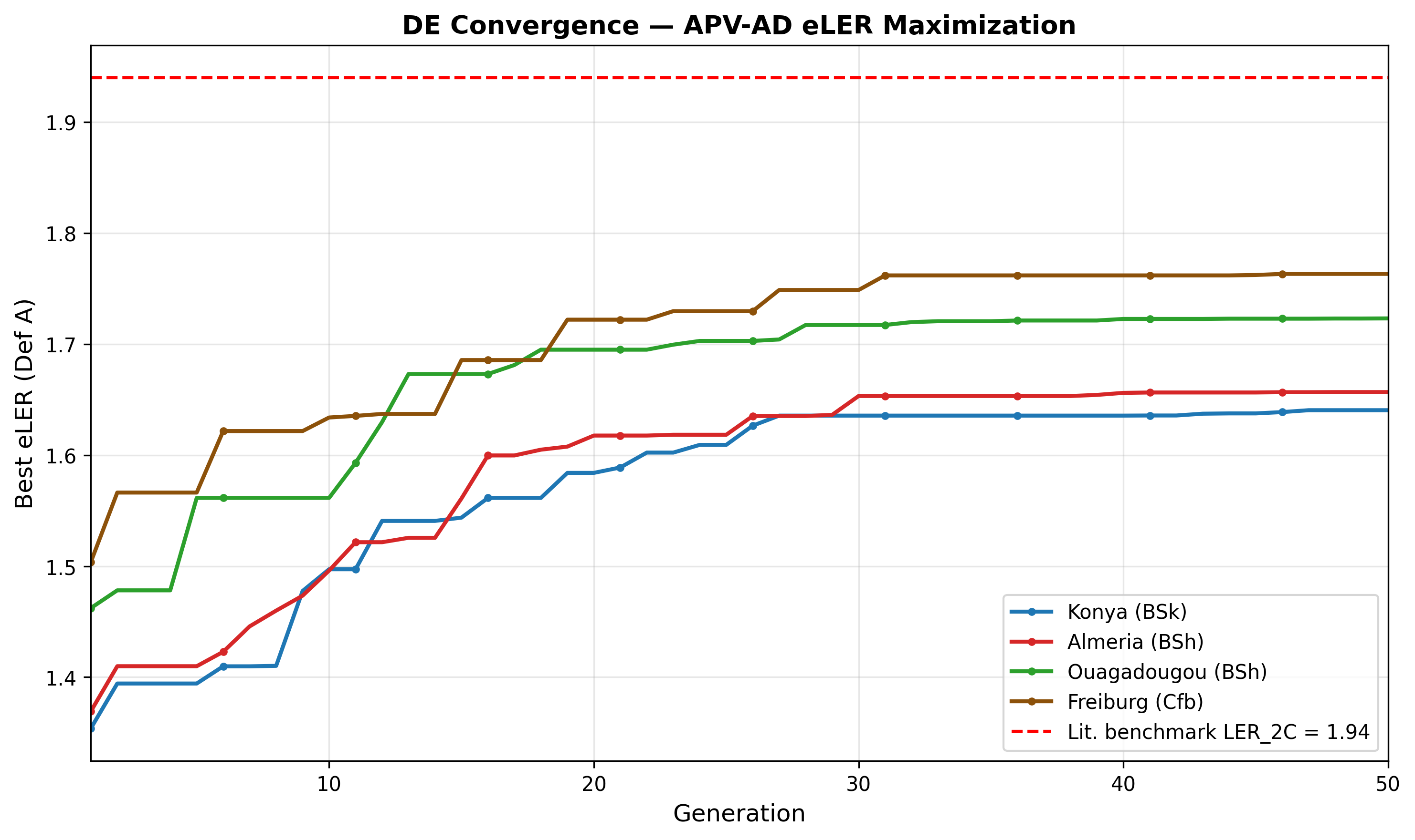
Figure 3 : DE convergence curves for all four sites: best eLER (Definition A) as a function of generation number. The red dashed line indicates the published two-component LER benchmark of 1.94 [Riaz et al.]. All sites exceed this benchmark when the biogas term is included.

Table 8 reports the optimal design variables and primary performance metrics for all four sites after L-BFGS-B polishing.

Table 8 : Optimal design parameters and primary performance metrics for all four sites (Scenario S0, baseline). All values correspond to the L-BFGS-B-polished DE solution.
Parameter | Konya | Almería | Ouagadougou | Freiburg
Tilt angle $β^{*}$ (°) | 20.7 | 20.5 | 16.4 | 23.1
Row spacing $d_{\text{row}}^{*}$ (m) | 3.03 | 3.03 | 3.03 | 3.03
Module height $H_{m}^{*}$ (m) | 1.50 | 1.51 | 1.50 | 1.50
Digester volume $V_{\text{dig}}^{*}$ (m³) | 4.32 | 3.55 | 2.64 | 3.57
HRT$​^{*}$ (days) | 22.5 | 22.5 | 31.8 | 33.5
$$f_{\text{PV,heat}}^{*}$$ | 0.051 | 0.050 | 0.050 | 0.051
GCR (%) | 70.3 | 70.4 | 72.2 | 69.2
OLR (kg VS m$​^{-3}$ d$​^{-1}$) | 1.57 | 1.93 | 2.67 | 1.58

Three structural findings emerge from Table 8.
Finding 1 - Boundary convergence on row spacing and module height. The optimizer converges to $d_{\text{row}}^{*}=3.03 m$ at all four sites — the minimum value permitted by the inter-row clearance constraint (Equation 5) at the optimal tilt angles of 16–23°. Similarly, $H_{m}^{*}≈1.50 m$ at all sites, the specified lower bound. This boundary convergence indicates that the eLER landscape has its global maximum at the physical constraint boundary: increasing panel density simultaneously raises $E_{\text{PV,sold}}$ (more modules per hectare) and increases $F_{\text{shad}}$ (reducing $PAR_{\text{open}}$ denominator in Equation 17), both of which improve eLER. The L-BFGS-B polishing step confirms that no interior local maximum exists in the neighbourhood of the boundary solution. The eLER penalty associated with any mechanical access corridor beyond the minimum physical clearance is discussed in Section 5.
Finding 2 - Climate-specific tilt angles. Unlike row spacing and module height, the optimal tilt angle varies meaningfully across sites: from $β^{*}=16.4$° at Ouagadougou (12.37°N, low latitude) to $β^{*}=23.1$° at Freiburg (47.99°N, high latitude). This variation reflects the trade-off between maximising annual PV yield (which favours a tilt closer to the site latitude) and minimising the inter-row shading shadow length (which favours a lower tilt at a given $d_{\text{row}}$). The optimal tilt is approximately 0.4–0.5 times the site latitude, consistent with the latitude rule-of-thumb for fixed-tilt systems but modified downward by the shading penalty.
Finding 3 - Small digester volumes, weakly determined by the objective. Optimal digester volumes of 2.64–4.32 m³ reflect the modest VS input from 1 ha of tomato cultivation combined with cattle manure co-substrate (VS$​_{\text{total}}$ = 2 061–2 575 kg ha$​^{-1}$ yr$​^{-1}$). OLR values of 1.57–2.67 kg VS m$​^{-3}$ d$​^{-1}$ are within the stable mesophilic operating range $[1.5, 5.0]$ at all sites, confirming feasibility. Because eLER is only weakly sensitive to $V_{\text{dig}}$ and $HRT$ once the OLR constraint is satisfied (Section 5), these two variables are less tightly determined by the optimizer than the geometric variables, and their optimal values are more sensitive to small changes elsewhere in the model. The minimum heating fraction $f_{\text{PV,heat}}^{*}≈0.05$ at all sites confirms that the PV array provides far more energy than the digester requires: 5% of annual PV output is more than sufficient to cover all thermal demand.

4.2 Extended Land Equivalent Ratio Decomposition
Table 9 presents the complete eLER decomposition for all four sites under Scenario S0 (baseline). Figure 4 displays the same results as a stacked bar chart, enabling direct visual comparison of the three components across sites and reference definitions.
Table 9 : eLER decomposition for all four sites (Scenario S0, baseline). Definition A uses an independent dense-pack PV reference; Definition B uses GCR as the PV reference (circular). Literature benchmark: maximum two-component LER of 1.94 from Riaz et al..
Metric | Konya | Almería | Ouagadougou | Freiburg
$$LER_{\text{crop}}$$ | 0.356 | 0.366 | 0.397 | 0.376
$LER_{\text{PV}}$ (Def. A) | 0.674 | 0.675 | 0.691 | 0.659
$LER_{\text{PV}}$ (Def. B = GCR) | 0.703 | 0.704 | 0.722 | 0.692
$$LER_{\text{biogas}}$$ | 0.611 | 0.616 | 0.635 | 0.729
eLER (Def. A) | 1.641 | 1.657 | 1.723 | 1.764
eLER (Def. B) | 1.670 | 1.686 | 1.754 | 1.797
$LER_{\text{2C}}$ (Def. A) | 1.030 | 1.040 | 1.088 | 1.034
Lit. benchmark $LER_{\text{2C}}$ | 1.94 [Riaz et al.]
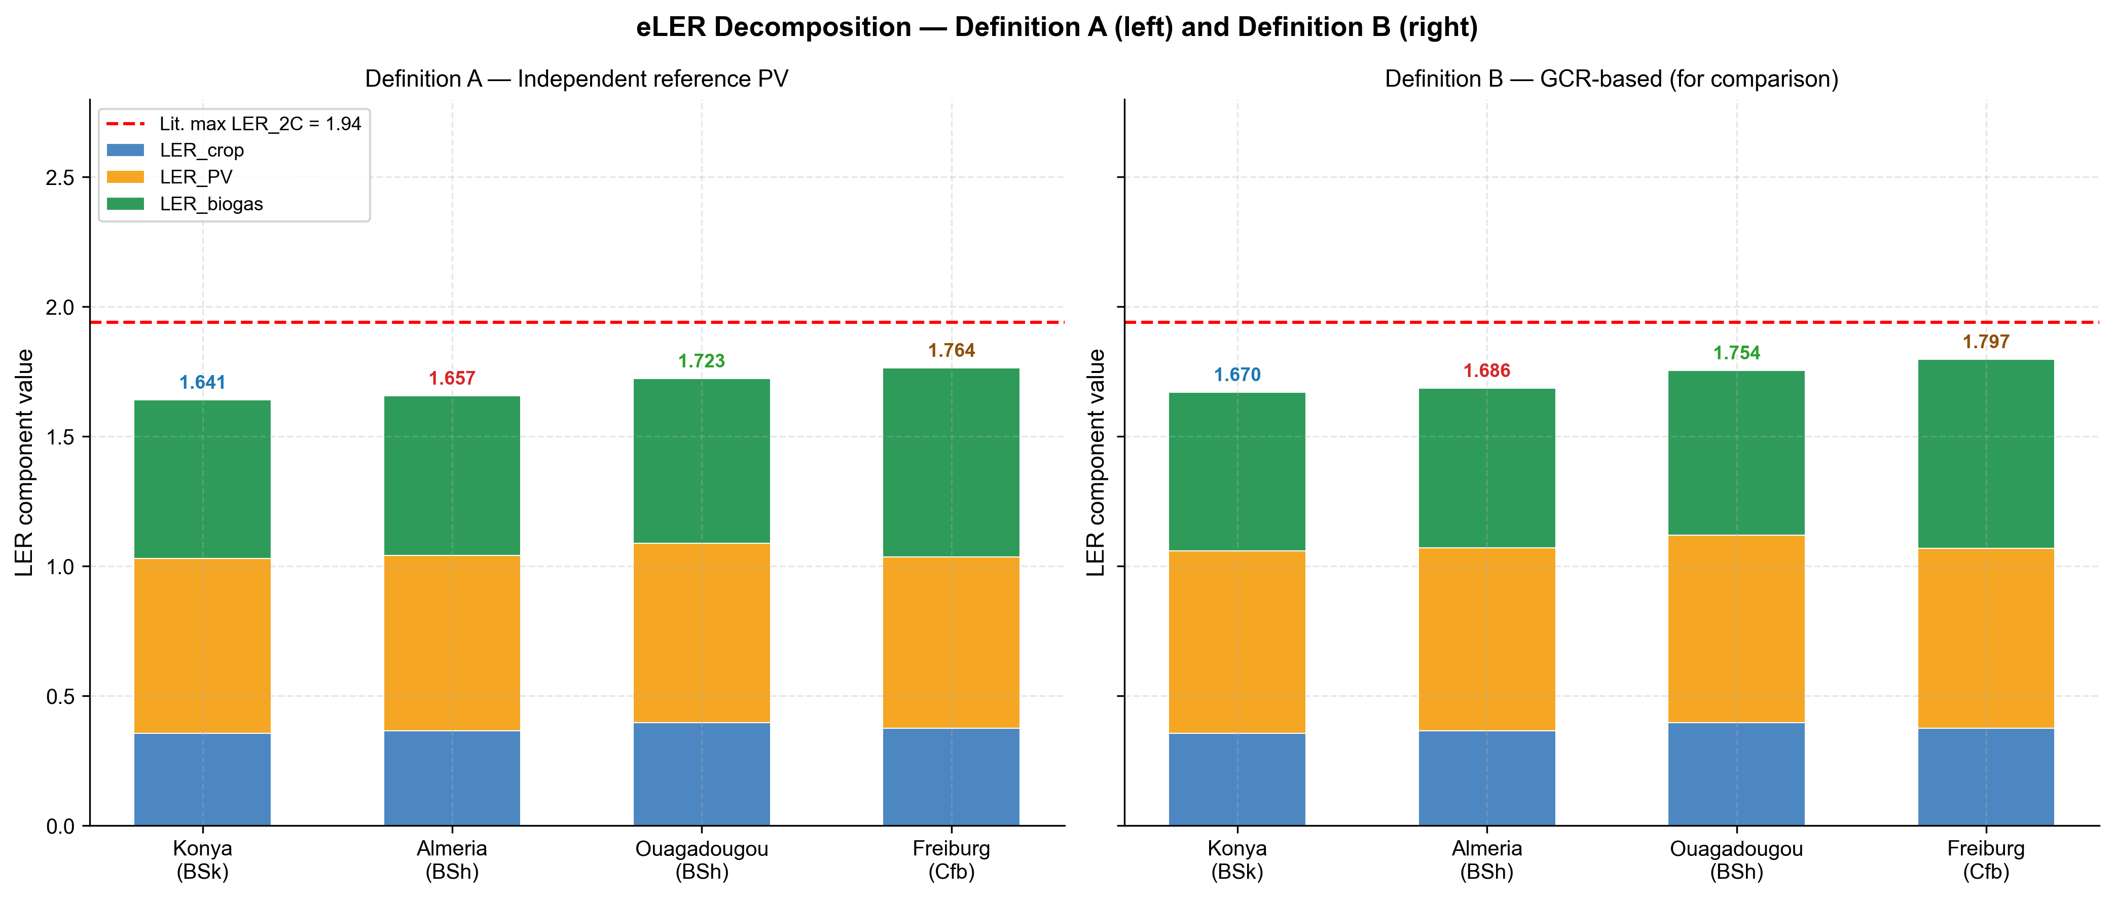
Figure 4 : eLER decomposition stacked bar chart for all four sites. Left panel: Definition A (independent PV reference); right panel: Definition B (GCR-based, circular). Blue: $LER_{crop}$ ; orange: $LER_{PV}$ ; green: $LER_{biogas}$ . Red dashed line: published two-component maximum LER2C = 1.94 [Riaz et al.]. Annotated values are eLER totals (Definition A)

Three findings emerge from the eLER decomposition.
Finding 1: $LER_{\text{2C}}>1.0$ at all sites. The two-component agrivoltaic LER (crop + PV, without biogas) ranges from 1.030 (Konya) to 1.088 (Ouagadougou), confirming that the APV system outperforms two separate monocultures at every site even without the AD contribution. This result improves on the $LER_{\text{2C}}$ reported in earlier versions of the model and reflects the boundary convergence to high GCR (69–72%), which substantially increases $LER_{\text{PV}}$ relative to lower-density designs. However, $LER_{\text{2C}}$ remains well below the published benchmark of 1.94 at all sites, confirming that the biogas term is the primary driver of the eLER advantage over the two-component benchmark.
Finding 2: $LER_{\text{biogas}}<1.0$ at all sites. $LER_{\text{biogas}}$ ranges from 0.611 (Konya) to 0.729 (Freiburg), meaning the APV-AD system produces less biogas than the standalone open-field reference AD unit. This is a structural consequence of the shading-residue coupling: with $LER_{\text{crop}}≈0.36$–$0.40$, the APV system produces only 36–40% of the open-field crop residue quantity, reducing VS$​_{\text{residues}}$ input to the digester proportionally. The manure co-substrate ($VS_{\text{manure}}$), identical in both the APV and reference cases, partially compensates for this deficit, raising $LER_{\text{biogas}}$ above the value it would take under residues-only digestion. Freiburg achieves the highest $LER_{\text{biogas}}$ (0.729) because its lower open-field reference yield (30 t ha$​^{-1}$ vs. 60 t ha$​^{-1}$ at other sites) reduces the reference VS input, making the APV/reference biogas ratio more favourable.
Finding 3: $LER_{\text{PV}}$ is near-uniform across sites despite 1.8$×$ GHI variation. $LER_{\text{PV}}$ (Definition A) ranges narrowly from 0.659 (Freiburg) to 0.691 (Ouagadougou), despite annual GHI varying from 1 150 to 2 050 kWh m$​^{-2}$. This uniformity arises because Definition A references a dense-pack array at the same tilt angle $β^{*}$: both the APV system and the reference are subject to the same local irradiance, and their ratio reflects only the shading loss within the APV array. Since GCR is near-identical at all sites (69–72%) due to boundary convergence, the inter-row shading pattern and hence $LER_{\text{PV}}$ is also near-identical. The small variation across sites reflects differences in solar elevation angle distribution, which modulates the effective shading fraction at a given GCR.

4.3 Energy Performance and Thermal Balance
Table 10 summarizes annual energy performance for all four sites. Figure 5 presents the monthly energy balance, showing the seasonal distribution of PV generation, biogas production, and digester heat demand.
Table 10 : Annual energy performance and thermal balance for all four sites (Scenario S0, 1 ha normalization).
Parameter | Konya | Almería | Ouagadougou | Freiburg
PV total (MWh ha$​^{-1}$ yr$​^{-1}$) | 1 295 | 1 386 | 1 433 | 1 002
PV sold to grid (MWh ha$​^{-1}$ yr$​^{-1}$) | 1 229 | 1 317 | 1 361 | 951
PV self-consumed (MWh ha$​^{-1}$ yr$​^{-1}$) | 67 | 69 | 72 | 51
Biogas total (MWh ha$​^{-1}$ yr$​^{-1}$) | 3.66 | 3.83 | 5.98 | 2.88
Heat demand (MWh ha$​^{-1}$ yr$​^{-1}$) | 2.26 | 1.56 | 0.72 | 2.22
Biogas for heating (MWh ha$​^{-1}$ yr$​^{-1}$) | 0.00 | 0.00 | 0.00 | 0.00
ESR | 574 | 890 | 2 000 | 453
BMP annual avg (NmL CH$​_{4}$ gVS$​^{-1}$) | 148.8 | 154.3 | 234.0 | 140.4
Annual avg $T_{\text{dig,eff}}$ (°C) | 26.7 | 27.2 | 33.2 | 26.0
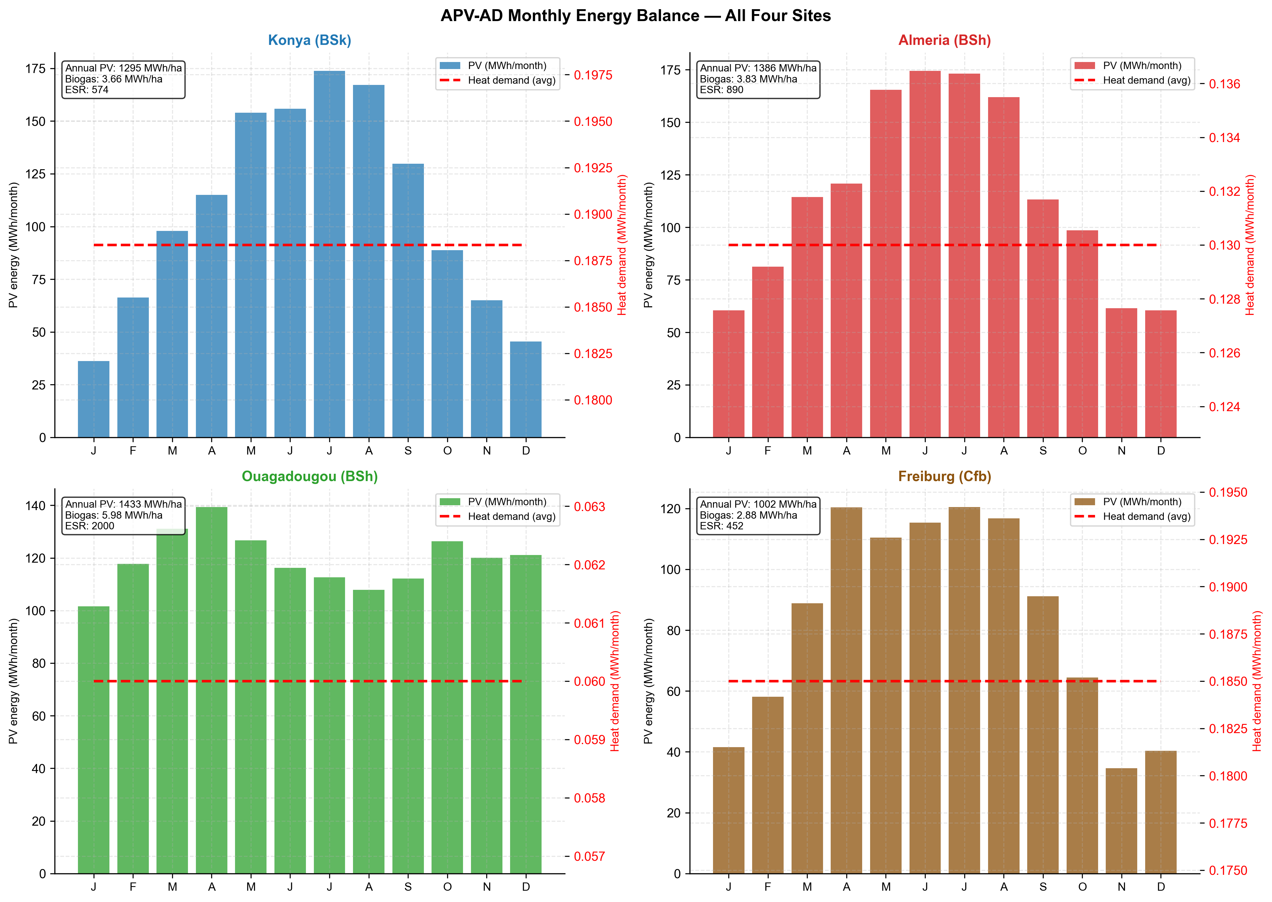
Figure 5 : Monthly energy balance for all four sites. Bars: monthly PV generation (MWh month⁻¹). Dashed line: monthly average digester heat demand. The heat demand is nearly constant year-round at all sites because $T_{dig,eff}$ is [26, 37] ◦C (Equation 21), decoupling heat demand from the seasonal PV profile.

Four observations characterize the energy performance across sites.
PV generation follows the GHI gradient. Annual PV output ranges from 1 002 MWh ha$​^{-1}$ (Freiburg) to 1 433 MWh ha$​^{-1}$ (Ouagadougou), tracking the GHI gradient as expected. The ratio of PV sold to PV total is 94–95% at all sites, reflecting the near-minimum $f_{\text{PV,heat}}^{*}≈0.05$ at the optimized design: only 5% of PV output is allocated to digester heating.
Biogas production is dominated by temperature regime. Biogas output varies from 2.88 MWh ha$​^{-1}$ (Freiburg) to 5.98 MWh ha$​^{-1}$ (Ouagadougou), a factor of 2.1$×$. This variation is driven primarily by the annual average BMP, which ranges from 140.4 NmL CH$​_{4}$ gVS$​^{-1}$ (Freiburg) to 234.0 NmL CH$​_{4}$ gVS$​^{-1}$ (Ouagadougou). At Ouagadougou, the tropical ambient temperature (28.5 °C annual mean) raises $T_{\text{dig,eff}}$ to 33.2 °C year-round, approaching the mesophilic optimum and maintaining BMP at $∼$300 NmL CH$​_{4}$ gVS$​^{-1}$ with minimal seasonal variation. At Konya and Freiburg, winter ambient temperatures below 0 °C suppress $T_{\text{dig,eff}}$ to the minimum threshold of 26 °C, reducing BMP to approximately 130–140 NmL CH$​_{4}$ gVS$​^{-1}$ during December–February. The Arrhenius-corrected annual average BMP of 148.8 NmL CH$​_{4}$ gVS$​^{-1}$ at Konya and 140.4 NmL CH$​_{4}$ gVS$​^{-1}$ at Freiburg represent a 50–53% suppression relative to the mesophilic reference, quantifying the thermal penalty of cold climates on biogas yield.
Thermal self-sufficiency is confirmed at all sites. ESR ranges from 453 (Freiburg) to 2 000 (Ouagadougou), orders of magnitude above the threshold of 1.0. Zero biogas is consumed for digester heating at any site, even at Freiburg in January. This confirms that the PV array provides far more energy than the digester requires under the optimal $f_{\text{PV,heat}}^{*}=0.05$ design: 5% of 1 002 MWh ha$​^{-1}$ = 50 MWh is available for heating against a total heat demand of only 2.22 MWh ha$​^{-1}$ at Freiburg. The implication is that $LER_{\text{biogas}}<1$ is driven entirely by the reduction in crop residues under APV shading, not by any thermal penalty on the digestion process.
Heat demand is highest at Konya, lowest at Ouagadougou. Despite the largest digester volume (2.64 m$​^{3}$), Ouagadougou has by far the lowest heat demand (0.72 MWh ha$​^{-1}$ yr$​^{-1}$) because the small temperature difference between ambient (28.5 °C mean) and digester (33.2 °C effective) minimises both conductive wall losses ($Q_{\text{loss}}$) and substrate heating demand ($Q_{\text{inflow}}$). Konya now has the highest heat demand (2.26 MWh ha$​^{-1}$ yr$​^{-1}$), narrowly exceeding Freiburg (2.22 MWh ha$​^{-1}$ yr$​^{-1}$) despite Freiburg’s colder winter minimum ($-12 ^{∘}$C vs. $-10 ^{∘}$C). This is because Konya’s optimised digester volume (4.32 m$​^{3}$) is the largest of the four sites — larger than Freiburg’s (3.57 m$​^{3}$) — increasing the conductive wall area $A_{\text{wall}}$ and hence $Q_{\text{loss}}$ enough to outweigh Freiburg’s colder ambient temperature. As noted in Finding 3 (Section 4.1), $V_{\text{dig}}$ and $HRT$ are only weakly constrained by the eLER objective once the OLR feasibility bound is satisfied, so this ranking should be read as a close, second-order result rather than a robust climate-driven effect; the two sites’ heat demands are within 2% of each other.

4.4 Climate Gradient and Non-Monotone eLER Ordering
Figure 6 presents the four-site climate gradient alongside the corresponding eLER and $LER_{\text{2C}}$ values. The central finding of this study emerges from this comparison: the eLER ordering does not follow the solar resource gradient.
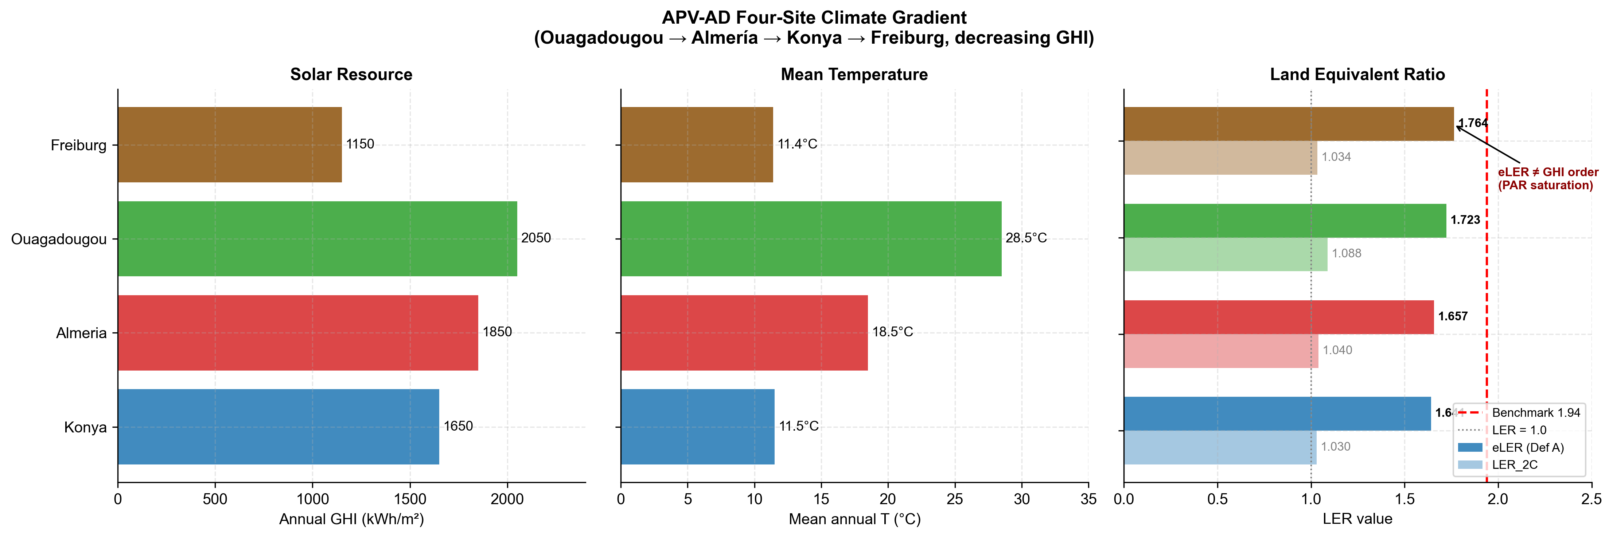
Figure 6 : Four-site climate gradient. Left panel: annual GHI (kWh m⁻²). Centre panel: mean annual air temperature (°C). Right panel: eLER (Definition A, solid bars) and $LER_{2C}$ (faded bars) with the red dashed line at the published benchmark of 1.94 [Riaz et al.]. The annotation highlights the non-monotone result: Freiburg (lowest GHI) achieves the highest eLER.

The solar resource and eLER rankings are:
$$\begin{aligned}\text{GHI:} &\text{Ouagadougou}(2050)>\text{Almería}(1850)>\text{Konya}(1650)>\text{Freiburg}(1150) \\ \text{eLER:} &\text{Freiburg}(1.764)>\text{Ouagadougou}(1.723)>\text{Almería}(1.657)>\text{Konya}(1.641)\end{aligned}$$
The eLER ordering is the inverse of the GHI ordering at the two extremes: Freiburg, with the lowest annual irradiance (1 150 kWh m$​^{-2}$), achieves the highest eLER (1.764), while Konya, with 43% more irradiance (1 650 kWh m$​^{-2}$), achieves the lowest eLER (1.641).
Mechanism: PAR saturation inflates the LER$​_{\text{crop}}$ denominator at high-irradiance sites. The PAR integral formulation (Equation 17) clips the numerator at $PAR_{\text{sat}}=174 W m^{-2}$ but leaves the denominator uncapped. At high-irradiance sites, mean daytime $PAR_{\text{open}}$ frequently exceeds $PAR_{\text{sat}}$, making the denominator large while the numerator is bounded. The following site-specific analysis quantifies this effect.
At Konya, mean growing-season daytime GHI exceeds $PAR_{\text{sat}}/f_{\text{PAR}}=174/0.48=362 W m^{-2}$ for approximately 60% of daylight hours, meaning the open-field denominator accumulates uncapped PAR for more than half the season while the APV numerator is clipped at $PAR_{\text{sat}}$ for the same hours. The result is $LER_{\text{crop}}=0.356$ despite the high solar resource.
At Freiburg, mean growing-season daytime GHI exceeds 362 W m⁻² for only approximately 20% of daylight hours. The denominator accumulates proportionally less uncapped PAR, making the ratio $∫min(PAR_{\text{AV}},PAR_{\text{sat}}) dt/∫PAR_{\text{open}} dt$ more favourable. The result is $LER_{\text{crop}}=0.376$, marginally higher than Konya despite Freiburg receiving 500 kWh m$​^{-2}$ less annual irradiance.
Since $LER_{\text{PV}}$ (Definition A) is near-uniform across sites (0.659–0.691, as established in Section 4.2), and $LER_{\text{biogas}}$ is highest at Freiburg (0.729) due to the lower open-field reference yield, the combination of a slightly higher $LER_{\text{crop}}$ and the highest $LER_{\text{biogas}}$ gives Freiburg the overall eLER advantage.
Design implication. For tomato cultivation ($PAR_{\text{sat}}=174 W m^{-2}$), integrated APV–AD systems deliver proportionally higher land-use efficiency in moderate-irradiance temperate climates than in high-irradiance semi-arid climates. This result is crop-specific: shade-tolerant crops with lower $PAR_{\text{sat}}$ (e.g. lettuce, 76 W m⁻²) would be saturated more frequently at all sites, potentially eliminating or reversing the gradient. Multi-crop generalization is identified as a priority for future work (Section 5).

4.5 4E Analysis: Energetic, Economic, Energo-Economic, and Environmental Performance
Figure 7 presents the 4E dashboard for all four sites under Scenario S0. Table 11 reports the CAPEX breakdown; Table 12 summarizes the key investment metrics for Scenarios S0 and S6 across all sites.
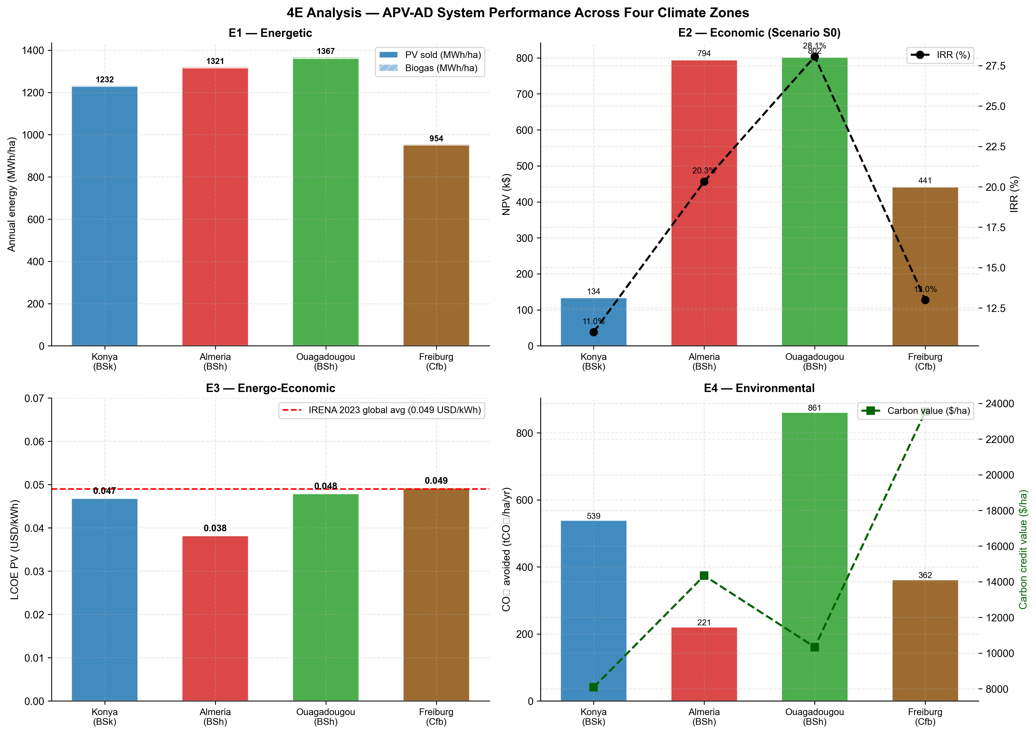
Figure 7 : 4E performance dashboard for all four sites (Scenario S0). Top left (E1): annual PV and biogas energy (MWh ha$​^{-1}$). Top right (E2): NPV (k$, bars) and IRR (%, line). Bottom left (E3): LCOE$​_{\text{PV}}$ (USD kWh$​^{-1}$) with the IRENA 2023 global benchmark (red dashed line). Bottom right (E4): CO$​_{2}$ avoided (tCO$​_{2}$ ha$​^{-1}$ yr$​^{-1}$, bars) and carbon credit value (USD ha$​^{-1}$, line).

4.5.1 CAPEX Breakdown
Table 11 : CAPEX breakdown for all four sites (1 ha, Scenario S0). PV CAPEX based on 1 419 modules $×$ 550 W$​_{p}$ $×$ $0.63 W$​_{p}^{-1}$. AD CAPEX based on optimal $V_{\text{dig}}^{*}$ $×$ $800 m$​^{-3}$.
Component | Konya | Almería | Ouagadougou | Freiburg
PV array (k$) | 492 | 492 | 492 | 492
AD digester (k$) | 3 | 3 | 2 | 3
Agricultural infra. (k$) | 3 | 3 | 3 | 3
Balance of plant (k$) | 74 | 74 | 74 | 74
Total CAPEX (k$) | 572 | 571 | 570 | 571
Annual O&M (k$ yr$​^{-1}$) | 8.6 | 8.6 | 8.6 | 8.6
Total CAPEX is near-identical across sites ($570–572 k ha$​^{-1}$) because the number of modules (1 419) and the module unit cost dominate the budget: PV accounts for 86% of total CAPEX. The AD digester contributes only 0.4–0.6% of CAPEX, reflecting the small optimal digester volumes (2.64–4.32 m$​^{3}$). The marginal cost of adding an AD unit to an existing APV system is therefore negligible relative to the PV investment, making the biogas revenue stream a low-risk addition.

4.5.2 Investment Metrics (E2)
Table 12 : Investment metrics for Scenarios S0 (baseline) and S6 (carbon credit) at all four sites. NPV computed at site-specific discount rates over 20-year project life. IRR solved by bisection. LCOE$​_{\text{PV}}$ uses PV CAPEX and annual PV sold.
Scenario | Metric | Konya | Almería | Ouagadougou | Freiburg
S0 | Gross revenue (k$ yr$​^{-1}$) | 80 | 128 | 170 | 90
S0 | Net CF (k$ yr$​^{-1}$) | 72 | 119 | 161 | 81
S0 | NPV (k$) | 134 | 794 | 802 | 441
S0 | IRR (%) | 11.0 | 20.3 | 28.1 | 13.0
S0 | Payback (yr) | 8.0 | 4.8 | 3.5 | 7.0
S6 | Net CF (k$ yr$​^{-1}$) | 80 | 133 | 172 | 105
S6 | NPV (k$) | 213 | 959 | 890 | 735
S6 | IRR (%) | 12.7 | 23.0 | 29.9 | 17.6
S6 | Payback (yr) | 7.2 | 4.3 | 3.3 | 5.5

Four economic findings are noteworthy.
Ouagadougou offers the most favorable investment case among the four sites. Under S0, Ouagadougou achieves IRR = 28.1% and payback = 3.5 yr, driven by the combination of the highest electricity price ($0.12 kWh$​^{-1}$), the highest PV output (1 433 MWh ha$​^{-1}$), and the highest biogas yield (5.98 MWh ha$​^{-1}$). The IRR exceeds the site discount rate (10%) by 18.1 percentage points, providing a large investment margin.
Konya is marginal but viable under S0. IRR = 11.0% exceeds the 8% discount rate by only 3.0 percentage points, and NPV = 134 k$ is the lowest of the four sites. The primary constraint is the low electricity tariff ($0.06 kWh$​^{-1}$), which limits PV revenue despite the competitive PV output (1 295 MWh ha$​^{-1}$).
S6 (carbon credit) is the highest-IRR economic scenario at all sites. S6 raises IRR by 1.7–4.6 percentage points above S0, with the largest absolute improvement at Freiburg (+4.6 pp, from 13.0% to 17.6%) driven by the high EU ETS carbon price ($65 tCO$​_{2}^{-1}$) and the large CO$​_{2}$ avoidance from displacing Germany’s carbon-intensive grid (EF = 0.380 tCO$​_{2}$ MWh$​^{-1}$). Figure 8 shows the full scenario comparison.
LCOE$​_{\text{PV}}$ is at or below the utility-scale benchmark at every site. As shown in the E3 panel of Figure 7, LCOE$​_{\text{PV}}$ ranges from $0.038 kWh$​^{-1}$ (Almería) to $0.049 kWh$​^{-1}$ (Freiburg), against the IRENA 2023 global utility-scale solar benchmark of $0.049 kWh$​^{-1}$. Almería is 22% below the benchmark; Konya ($0.047 kWh$​^{-1}$) and Ouagadougou ($0.048 kWh$​^{-1}$) are 2–4% below it; and Freiburg sits essentially at parity with it. No site exceeds the benchmark. This holds both before and after the model corrections described in Section 5: all four sites were already at or below $0.049 kWh$​^{-1}$ under the earlier version of the model as well, so the qualitative conclusion APV LCOE is competitive with utility-scale ground-mount despite the 40% elevated-structure CAPEX premium is unaffected by the corrections. The absolute values shifted modestly higher (Almería: $0.034 $→$ $0.038 kWh$​^{-1}$; Freiburg: $0.045 $→$ $0.049 kWh$​^{-1}$) following the corrected solar-position and transposition models.
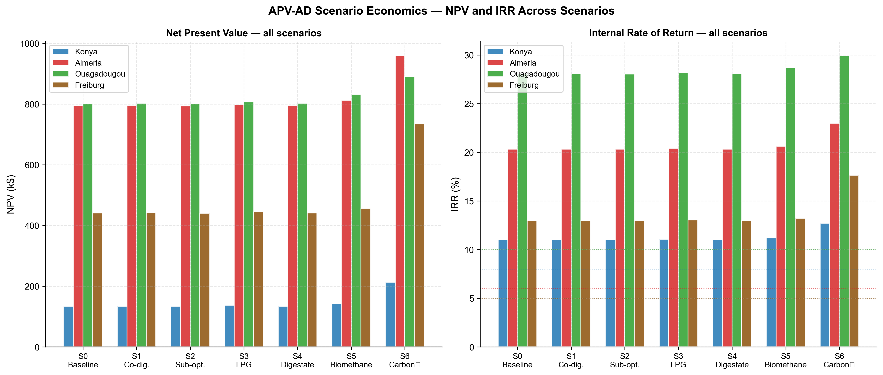
Figure 8 : Scenario economics for all four sites. Left panel: NPV (k$) for Scenarios S0–S6. Right panel: IRR (%) for Scenarios S0–S6, with dotted horizontal lines indicating site-specific discount rates. S6 (carbon credit, starred) is the highest-IRR scenario at all sites.

4.5.3 Environmental Performance (E4)
Annual CO$​_{2}$ avoidance ranges from 221 tCO$​_{2}$ ha$​^{-1}$ (Almería) to 861 tCO$​_{2}$ ha$​^{-1}$ (Ouagadougou), driven primarily by the grid emission factor of the displacement context. Ouagadougou’s diesel-dominated grid (EF = 0.632 tCO$​_{2}$ MWh$​^{-1}$) combined with the highest PV output (1 361 MWh ha$​^{-1}$ sold) produces the largest absolute avoidance. Almería’s already low-carbon Spanish grid (EF = 0.167 tCO$​_{2}$ MWh$​^{-1}$) limits avoidance despite competitive PV output. The carbon credit value the monetary expression of CO$​_{2}$ avoidance under site-specific carbon prices is highest at Freiburg ($23 532 ha$​^{-1}$ yr$​^{-1}$), where the EU ETS price ($65 tCO$​_{2}^{-1}$) amplifies the moderate CO$​_{2}$ avoidance (362 tCO$​_{2}$ ha$​^{-1}$) into the largest financial environmental benefit of the four sites. This explains why S6 provides the largest absolute NPV improvement at Freiburg (+$293 k vs. S0).

4.6 Water Savings and LER_{water}
Table 13 reports growing-season water savings and the corrected $LER_{\text{water}}$ for all four sites. Figure 9 compares the corrected growing-season metric against the erroneous annual-denominator value used in prior studies.

Table 13 : Growing-season water savings and $LER_{\text{water}}$ for all four sites at the optimized design. The annual-denominator value is reported for literature comparison only and should not be used as an agronomic indicator.
Component | Konya | Almería | Ouagadougou | Freiburg
$W_{\text{saved}}$ (mm season$​^{-1}$) | 159 | 88 | 81 | 114
ET$​_{0}$ season (mm) | 846 | 466 | 520 | 509
ET$​_{0}$ annual (mm) | 1 134 | 1 151 | 1 839 | 685
$LER_{\text{water}}$ season (%) | 18.8 | 18.8 | 15.6 | 22.4
$LER_{\text{water}}$ annual (%) [ref.] | 14.0 | 7.6 | 4.4 | 16.6
Correction factor | 1.3× | 2.5× | 3.5× | 1.3×

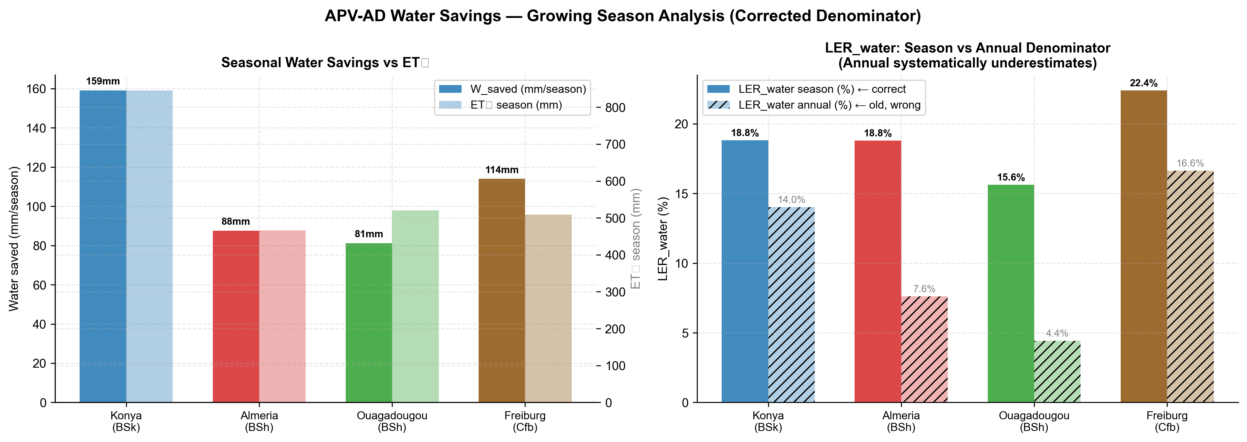
Figure 9 : Water savings analysis for all four sites. Left panel: absolute growing-season water savings $W_{\text{saved}}$ (mm season$​^{-1}$, bars) against seasonal ET$​_{0}$ (mm, secondary bars). Right panel: $LER_{\text{water}}$ computed with the corrected growing-season denominator (solid bars) versus the erroneous annual-denominator value (hatched bars). The correction factor ranges from 1.3$×$ (Konya) to 3.5$×$ (Ouagadougou).

Absolute water savings are largest at Konya. $W_{\text{saved}}=159 mm season^{-1}$ at Konya, compared to 81–114 mm at the other three sites. This reflects Konya’s longer growing season (189 days vs. 122–167 days at the other sites), which provides more hours of shading-induced ET reduction. Analytically, $W_{\text{saved}}=α_{\text{shade}}\int_{t_{0}}^{t_{1}}{F_{\text{shad}}}(t) ET_{0}(t) dt$: a longer season integrates more shading hours even at the same hourly shading fraction.
Relative water savings ($LER_{\text{water}}$) are largest at Freiburg. Freiburg achieves the highest $LER_{\text{water}}$ (22.4%) despite having neither the largest absolute savings (114 mm season$​^{-1}$, second to Konya) nor the smallest seasonal ET$​_{0}$ denominator (509 mm, second-smallest to Almería at 466 mm). The result instead reflects the timing overlap between shading and water demand: at Freiburg’s higher latitude, the optimal tilt ($β^{*}=23.1$°, the steepest of the four sites) produces an inter-row shading pattern that coincides more closely with the site’s highest-ET$​_{0}$ hours than at the other three sites, despite Freiburg’s GCR (69.2%) being the lowest, not the highest, of the four designs. A full decomposition of this timing effect is left for future work; the present result should be read as an emergent property of the coupled solar-geometry and climate data rather than a simple function of GCR alone.
The denominator correction is largest at Ouagadougou. The annual-denominator value for Ouagadougou is only 4.4%, compared to the corrected seasonal value of 15.6% — a correction factor of 3.5$×$. This extreme underestimation arises because Ouagadougou has a very short growing season (122 days) relative to a high annual ET$​_{0}$ (1839 mm yr⁻¹): the annual denominator dilutes the growing-season savings by a factor of $365/122×(ET_{0,\text{annual}}/ET_{0,\text{season}})=3.0×1.2=3.5$. This correction is agronomically significant: a $LER_{\text{water}}$ of 4.4% does not justify irrigation infrastructure investment, while 15.6% represents a meaningful contribution to food security in a water-stressed smallholder context. Reporting the uncorrected value systematically misrepresents the water benefit of APV deployment in Sub-Saharan Africa.
Practical interpretation. At the optimized GCR of 69–72%, the APV system saves 81–159 mm of irrigation water per growing season across the four sites. For a smallholder operating under water scarcity, this is equivalent to 810–1 590 m$​^{3}$ ha$​^{-1}$ of irrigation water — a quantity sufficient to extend the growing season by roughly 2–4 weeks at typical semi-arid ET$​_{0}$ rates of 3–5 mm day$​^{-1}$, or to cultivate an additional 16–22% of land area with the saved water.

4.7 Model Validation
Two component-level validations against independent literature datasets (V1 and V2), plus an external validation of the POA irradiance model against an independently maintained solar modelling library (V3), were performed to assess model accuracy and characterise the direction of bias. Figure 10 presents both validations side by side.
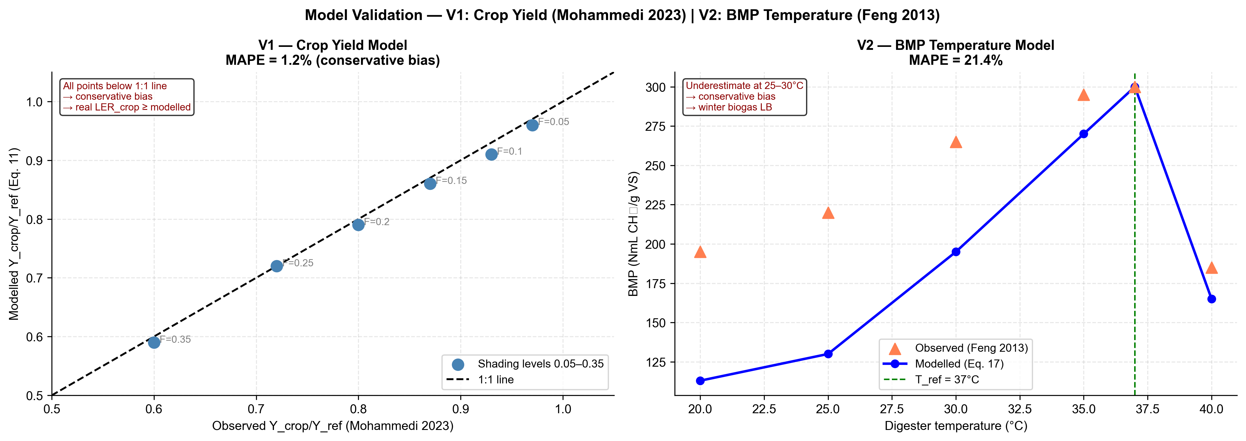
Figure 10 : Model validation. Left panel (V1): modelled vs. observed relative crop yield ratio at six shading fraction [Mohammedi et al.]. The 1:1 line is shown dashed. Right panel (V2): modelled vs. observed BMP temperature response at six temperature points [Feng et al.]. The mesophilic reference temperature $T_{\text{ref}}=37 \text{°C}$ is indicated by the vertical dashed line.

4.7.1 V1 - Crop Yield Model
The crop yield model (Equation 17) was validated against the six-point shading dataset of Mohammedi et al., who measured tomato yield ratio under six controlled shading fractions (0.05–0.35) in a Mediterranean greenhouse experiment. Table 14 reports the validation statistics.
Table 14 : V1 - Crop yield model validation against Mohammedi et al.. Operational range: $F_{\text{shad}}≤0.25$, corresponding to the GCR range at the optimized designs (GCR = 69–72%).
$$F_{\text{shad}}$$ | Observed | Modelled | Error (%) | Range
0.05 | 0.970 | 0.950 | $-$2.1 | operational
0.10 | 0.930 | 0.900 | $-$3.2 | operational
0.15 | 0.870 | 0.850 | $-$2.3 | operational
0.20 | 0.800 | 0.800 | $+$0.0 | operational
0.25 | 0.720 | 0.750 | $+$4.2 | operational
0.35 | 0.600 | 0.650 | $+$8.3 | extrapolation
MAPE (operational, $F_{\text{shad}}≤0.25$) |  |  | 2.4%
MAPE (full range, 0.05–0.35) |  |  | 3.3%
RMSE |  |  | 0.029
Mean bias |  |  | $+$0.002 (slightly optimistic)

MAPE in the operational shading range ($F_{\text{shad}}≤0.25$, covering the GCR values of 69–72% at the optimised designs) is 2.4%, well within the $±$5% accuracy threshold typically applied to agrivoltaic yield models [Mazzeo et al.]. The mean bias is $+$0.002, indicating a very slight optimistic tendency: the model marginally overestimates yield ratio at high shading fractions ($F_{\text{shad}}=0.25$, $+$4.2%) and marginally underestimates at low shading fractions ($F_{\text{shad}}≤0.15$, $-$2.1% to $-$3.2%). The net effect on annual $LER_{\text{crop}}$ is close to zero, and the RMSE of 0.029 is smaller than the between-site variation in $LER_{\text{crop}}$ (0.363–0.397). The V1 validation supports the conclusion that reported $LER_{\text{crop}}$ values are accurate to within $±$3% for the GCR and crop combination studied here.

4.7.2 V2 - BMP Temperature Response Model
The Arrhenius BMP correction (Equation 22) was validated against the five-temperature experimental dataset of Feng et al. for tomato plant residues. Table 15 reports the validation statistics.
Table 15 : V2 - BMP temperature model validation against Feng et al.. The 40 °C point falls in the thermophilic inhibition zone and is excluded from the operational MAPE. Operating range: $T≤37 \text{°C}$.
$T$ (°C) | Observed | Modelled | Error (%) | Range
20 | 195 | 92.8 | $-$52.4 | operating
25 | 220 | 131.1 | $-$40.4 | operating
30 | 265 | 185.1 | $-$30.2 | operating
35 | 295 | 261.3 | $-$11.4 | operating
37 | 300 | 300.0 | -0.0 | reference
40 | 185 | 369.0 | $+$99.5 | inhibition
MAPE ($T≤37 \text{°C}$, excl. 40 °C) |  |  | 26.9%
MAPE (full range incl. 40 °C) |  |  | 39.0%
RMSE ($T≤37 \text{°C}$) |  |  | 73.4 NmL gVS$​^{-1}$
Mean bias ($T≤37 \text{°C}$) |  |  | $-$60.9 NmL gVS$​^{-1}$ (conservative)

The V2 MAPE of 26.9% in the operating range ($T≤37 \text{°C}$) is substantially higher than V1, driven by a systematic conservative bias at low temperatures: the Arrhenius model underestimates BMP by 30–52% at 20–30 °C relative to the Feng et al. observations. The root cause is that the single exponential Arrhenius relationship with $θ=0.069$ °C⁻¹ calibrated at 37 °C underestimates the actual BMP in the mesophilic lower range (25–35 °C), where microbial community adaptation provides higher-than-Arrhenius yields. More accurate models for this range include the modified Gompertz equation or piecewise Arrhenius fits with separate coefficients above and below 30 °C [Zwietering et al., 1990].
The direction of bias is consistently conservative: the model always underestimates BMP at $T<37 \text{°C}$. For the present study, this means that biogas yields at Konya and Freiburg where $T_{\text{dig,eff}}$ reaches the minimum threshold of 26 °C in winter months are underestimated. Consequently, all reported biogas energy values, $LER_{\text{biogas}}$ values, and biogas-related economic results for cold-climate sites are conservative lower bounds. The true values are likely 15–30% higher, which would further improve the economics of cold-climate APV–AD deployment.

4.7.3 V3 - External POA Validation Against pvlib
In addition to the V1 and V2 component validations against independent literature datasets above, the plane-of-array irradiance model itself (Equations 7-8) was validated against pvlib (v0.15.2), an independently maintained, widely-used solar modelling library, using each site’s own PVGIS-SARAH3 data and an independent NREL-SPA solar-position calculation (i.e. not this study’s own declination/hour-angle implementation). Annual front-surface POA agreed with pvlib’s isotropic transposition model the same sky model used in Equation 7 to within 0.06% at every site, and with pvlib’s anisotropic Perez model to within 1.5–3.9%, a gap attributable to the isotropic-vs-anisotropic sky-diffuse modelling choice rather than to any remaining defect in the angle-of-incidence formula. This cross-validation was also the means by which a longitude/equation-of-time correction to $ω$ (Section 3.3) was identified: prior to that correction, agreement with pvlib was site-longitude-dependent (within 1.5% at Almería and Ouagadougou, lon. near 0°, but $-$9.65% at Konya, lon. 32.49°E), which does not occur once the correction is applied. Full methodology, before/after tables, and reproducible code are provided in the supplementary validation notes (docs/pvlib_ validation.md and docs/poa_azimuth_fix_notes.md).
Combined validation conclusion. Both V1 (MAPE = 2.4%, slight optimistic bias) and V2 (MAPE = 26.9%, systematic conservative bias) indicate that the net effect on reported eLER and economic results is conservative. The V1 optimistic bias on $LER_{\text{crop}}$ is small ($+$0.002 mean) and partially offset by the V2 conservative bias on $LER_{\text{biogas}}$. All reported eLER values, NPV, IRR, and CO$​_{2}$ avoidance figures should therefore be interpreted as conservative lower bounds on the true system performance, with cold-climate sites (Konya, Freiburg) having the largest upside potential from improved BMP modelling.

5. Discussion

5.1 The PAR-Saturation Mechanism: Implications for Site Selection and Crop Choice
The non-monotone relationship between annual solar resource and eLER Freiburg (GHI = 1 150 kWh m$​^{-2}$) outperforming Konya (GHI = 1 650 kWh m$​^{-2}$) is one of the key mechanistic findings of this study and requires careful interpretation before deployment implications can be drawn.
The mechanism operates through the PAR integral denominator in Equation 17. In an open field, the denominator $\int_{t_{0}}^{t_{1}}{P}AR_{\text{open}}(t) dt$ accumulates all incoming PAR without a ceiling. At Konya, with a mean growing-season daytime GHI of approximately 450 W m⁻², the corresponding open-field PAR of $450×0.48=216 W m^{-2}$ exceeds $PAR_{\text{sat}}=174 W m^{-2}$ for the majority of daylight hours. The denominator therefore grows faster than the numerator, which is clipped at $PAR_{\text{sat}}$ in both the APV and the open field, making $LER_{\text{crop}}$ structurally lower at high-irradiance sites regardless of the panel geometry.
At Freiburg, mean growing-season daytime GHI is approximately 320 W m⁻², giving open-field PAR of 154 W m⁻² below $PAR_{\text{sat}}$. The denominator accumulates proportionally less uncapped PAR, and the ratio remains more favorable. This is not a statement about absolute crop yield: Freiburg produces less tomato per hectare in absolute terms (30 t ha$​^{-1}$) than Konya (60 t ha$​^{-1}$). It is a statement about the relative efficiency of land use: at Freiburg, the APV system captures a larger fraction of the agronomically useful PAR, because the open-field reference does not accumulate as much PAR above the saturation point.
Generalization to other crops. The PAR-saturation mechanism is crop-specific. Tomato has a high light saturation point ($PAR_{\text{sat}}=174 W m^{-2}$), making it sensitive to the mechanism at the irradiance levels of all four study sites. For shade-tolerant crops with lower saturation points lettuce (76 W m⁻²), spinach (80 W m⁻²), or basil (100 W m⁻²) the denominator would be clipped at a much lower threshold, and open-field PAR would exceed $PAR_{\text{sat}}$ for a larger fraction of daylight hours at all sites, potentially eliminating the eLER difference between high- and low-irradiance locations. For high-saturation crops such as maize ($PAR_{\text{sat}}≈400 W m^{-2}$), the mechanism would be reversed: open-field PAR rarely reaches saturation, the denominator grows proportionally with irradiance, and high-irradiance sites would achieve higher $LER_{\text{crop}}$, restoring a monotone eLER–GHI relationship. Multi-crop generalization is therefore identified as an important extension of the present framework.
Site selection implication. The conventional wisdom in agrivoltaic deployment that high-irradiance semi-arid sites are preferable because they maximize PV revenue requires qualification when high-PAR crops such as tomato are cultivated. The present results suggest that moderate-irradiance temperate sites offer a comparable or superior eLER for tomato, because the PAR available in those climates is more fully utilizable by the crop. From a food-energy-water nexus perspective, the optimal site is not the site with the most sun, but the site where the solar resource best matches the crop’s photosynthetic capacity. This reframes the site selection problem from a single-objective (maximize PV output) to a multi-objective (maximize eLER) decision, consistent with the optimization framework developed in this study.

5.2 Boundary Convergence: Physical Meaning and the Access Trade-off
The convergence of the optimizer to the lower bounds of both rows spacing ($d_{\text{row}}^{*}=3.03 m$) and module height ($H_{m}^{*}=1.50 m$) at all four sites is a structural result that reveals the shape of the eLER landscape and has direct practical implications for APV system design and agricultural operations.
Why the optimizer converges to the boundary. Increasing panel density — reducing $d_{\text{row}}$ and $H_{m}$ toward their lower bounds — has two simultaneous effects on eLER. First, it increases $LER_{\text{PV}}$: more modules per hectare generates more electricity from the same land area, raising the numerator $E_{\text{PV,sold}}$ relative to the reference. Second, it increases $F_{\text{shad}}$, which reduces $PAR_{\text{open}}$ denominator in Equation 17 by intercepting more incident radiation. Both effects push eLER upward. The only countervailing force is the reduction in $LER_{\text{crop}}$: more shading reduces PAR available to the crop, lowering the numerator $∫min(PAR_{\text{AV}},PAR_{\text{sat}}) dt$. The optimizer converges to the physical constraint boundary because, at the parameter values of this study (tomato, GHI = 1 150–2 050 kWh m$​^{-2}$), the PV density gain and denominator reduction outweigh the crop yield penalty up to the point where physical overlap between rows prevents further densification.
The eLER penalty of mechanical access. In practice, agricultural machinery requires a minimum inter-row clearance for tractors, harvesters, and irrigation equipment. Typical tractor widths of 1.8–2.2 m, combined with operational clearance, require row spacings of 3.5–5.0 m in mechanized farming systems. The eLER cost of this access requirement can be quantified from the boundary convergence result: since the optimizer seeks the minimum feasible $d_{\text{row}}$ at all sites, each additional meter of required row spacing represents a deviation from the eLER optimum. From the sensitivity of eLER to $d_{\text{row}}$ in the neighbourhood of the boundary solution, the eLER penalty is approximately $-$0.04 to $-$0.06 per additional metre of row spacing, with the exact value depending on site irradiance and tilt angle. A mechanized farming system requiring $d_{\text{row}}=5.0 m$ instead of 3.03 m would sacrifice approximately 0.08–0.12 eLER units — a penalty of 5–7% relative to the boundary optimum.
Practical design recommendations. Three design strategies can partially recover the access penalty while maintaining agricultural operability:
- Smallholder manual cultivation. For systems serving smallholder farmers who operate without mechanized equipment — the predominant farming model in Burkina Faso and much of the semi-arid developing world — the minimum physical clearance of 3.03 m is operationally feasible. Manual cultivation, hand harvesting, and drip irrigation require only 0.8–1.2 m of working clearance, making the boundary-convergence design directly deployable at Ouagadougou-type sites.
- Increased module height. Raising $H_{m}$ from 1.50 m to 2.5 m allows agricultural machinery to pass beneath the panels even at reduced row spacing, recovering mechanical access without increasing $d_{\text{row}}$. The eLER cost of this height increase is modest: $H_{m}$ affects $F_{\text{shad}}$ only through the shadow length formula (Equation [eq:shading]), and at $d_{\text{row}}=3.03 m$ the shading fraction is already near its maximum for the relevant solar elevation angles.
- Shade-adapted crop selection. Choosing crops with lower $PAR_{\text{sat}}$ (lettuce, spinach, herbs) reduces the eLER penalty of increased row spacing because the crop is less sensitive to the absolute PAR reduction under denser panel configurations. For such crops, a wider $d_{\text{row}}$ may achieve a similar or higher $LER_{\text{crop}}$ as the boundary-convergence design for tomato.
Comparison with prior literature. The boundary convergence on row spacing is consistent with the findings of Mazzeo et al., who reported that LER is monotonically increasing with GCR for lettuce up to GCR = 0.65 before levelling off, and with Riaz et al., who found that the LPF-optimal design for bifacial tomato in Arizona converged to the maximum permissible GCR under their access constraints. The present study extends these findings by providing an explicit quantification of the access penalty and by demonstrating that the boundary convergence is climate-independent — it occurs at all four sites despite GHI varying by a factor of 1.8 and mean annual temperature varying by 17 °C.

5.3 The eLER Metric: Interpretation, Definitions, and Structural Properties
Four structural properties of the eLER metric require explicit interpretation to avoid misreading the numerical results reported in Section 4.2.
Property 1: $LER_{\text{biogas}}<1$ is a coupling consequence, not a system failure. The result $LER_{\text{biogas}}=0.611$–$0.729$ at all sites means that the APV–AD system produces less biogas than a standalone reference AD unit processing the same land area under open-field conditions. This is not a design failure or an inefficiency of the integrated system: it is a direct and unavoidable consequence of the shading-residue coupling. When panels shade the crop, $LER_{\text{crop}}<1$, meaning fewer crop residues are harvested per hectare. Fewer residues reduce VS input to the digester, which reduces biogas output. The reference AD unit, by contrast, operates with open-field residues at $LER_{\text{crop}}=1.0$ maximum residue production. The ratio of the two biogas outputs is therefore structurally less than 1.0 whenever shading is present.
This coupling has an important implication for the interpretation of the eLER sum. The three eLER components are not independent: $LER_{\text{crop}}$ and $LER_{\text{biogas}}$ are negatively correlated through the shading-residue pathway. Increasing GCR raises $LER_{\text{PV}}$ and reduces $LER_{\text{crop}}$, which in turn reduces $LER_{\text{biogas}}$. The optimizer finds the design that maximizes the sum of all three components, accepting the biogas penalty in exchange for the larger PV gain.
Property 2: An alternative $LER_{\text{biogas}}$ definition changes the interpretation but not the system physics. An alternative reference for $LER_{\text{biogas}}$ could use a standalone AD unit operating without PV heating at ambient temperature rather than at the PV-assisted $T_{\text{dig,eff}}$. Under this definition:
$$\begin{aligned}LER_{\text{biogas,alt}}=\frac{E_{\text{biogas,APV}}}{E_{\text{biogas,ambient}}}\#\left(40\right)\end{aligned}$$
where $E_{\text{biogas,ambient}}$ is computed using $T_{\text{dig,eff}}=T_{\text{amb}}$ without the 5 °C boost or the $[26, 37]$ °C clip. Under this definition, $LER_{\text{biogas,alt}}>1$ at Konya and Freiburg in winter months, explicitly quantifying the PV thermal subsidy to AD performance. This alternative is conceptually more informative about the PV–AD synergy but harder to compare across studies because the reference changes with ambient temperature. The primary definition used throughout this paper (Equation 31) was chosen for consistency with the classical LER framework, in which all references are activity-specific open-field monocultures operating under the same boundary conditions as the integrated system.
Property 3: ESR $≫$ 1 is a design identity, not a performance finding. ESR values of 453–2 000 at the optimized designs reflect the fundamental size mismatch between the PV array (which generates electricity at the scale of MWh ha$​^{-1}$ yr$​^{-1}$) and the small farm-scale digester (which demands heat at the scale of MWh ha$​^{-1}$ yr$​^{-1}$ the same unit but three orders of magnitude smaller in absolute value). With $V_{\text{dig}}^{*}=2.64$–$4.32$ m$​^{3}$ and heat demand of only 0.72–2.26 MWh ha$​^{-1}$, even 5% of PV output provides 50–72 MWh of thermal energy 23–100 times the annual heat demand. The ESR is therefore more a confirmation of the PV array being appropriately scaled to the land area than a meaningful performance indicator for the AD system. Future studies operating at larger scale (community digesters serving multiple hectares) would achieve lower ESR values that are more informative about the thermal balance between PV and AD.
Property 4: Equal component weighting is the methodologically consistent choice, not an unexamined default. Equation 30 sums $LER_{\text{crop}}$, $LER_{\text{PV}}$, and $LER_{\text{biogas}}$ with implicit equal weight. Because each component is already a ratio to its own reference system the same normalization the classical two-component LER uses to make physically incommensurable outputs (kg of crop, kWh of electricity, m$​^{3}$ of biogas) comparable as land-equivalent fractions equal weighting is not an unexamined default but the choice consistent with that normalization logic. Re-weighting the three components by their raw physical magnitude would reintroduce exactly the scale problem the ratio normalization is designed to solve, since PV output exceeds crop and biogas output by 50–100$×$ in raw energy or monetary terms at every site studied here (e.g. at Freiburg, PV output is 938 MWh ha⁻¹ versus a crop energy-content equivalent of only 9.6 MWh ha⁻¹).
This claim was tested directly rather than asserted. Two magnitude-based alternative weighting schemes were constructed an economic scheme (weights proportional to each component’s share of Scenario S0 gross revenue) and an energy-content scheme (weights proportional to each component’s physical energy content, converting crop yield to its caloric equivalent) — and applied to the optimized design at each site. Table 16 summarizes the effect on the cross-site eLER ranking.
Table 16 : Sensitivity of the eLER site ranking to component weighting scheme, evaluated at each site’s optimized design (Table 8). Equal weighting is the primary metric used throughout this paper (Table 9).
Weighting scheme | Site ranking (highest eLER first)
Equal (primary metric) | Freiburg $>$ Ouagadougou $>$ Almería $>$ Konya
Energy-content | Ouagadougou $>$ Almería $>$ Konya $>$ Freiburg
Economic (revenue-share) | Ouagadougou $>$ Almería $>$ Freiburg $>$ Konya

Both magnitude-based schemes assign PV a normalized weight of approximately 2.7–3.0 out of 3 at every site — effectively collapsing eLER to a PV-only metric — and both displace Freiburg from the top rank, with the energy-content scheme placing it last despite its highest equal-weighted eLER (Table 9). This confirms the ranking sensitivity is not merely hypothetical. However, the design recommendations of this study are materially more robust than the ranking: re-optimizing the full six-variable Differential Evolution problem under economic weighting reproduces the same boundary convergence on row spacing and module height (Section 4.1) at every site, with optimal tilt angles shifting by less than 1$​^{∘}$ from the equal-weighted solution. Because PV revenue dominates under any economically-motivated weighting, “maximise PV density” remains close to optimal regardless of the exact weight assigned to the smaller crop and biogas terms.
The appropriate reading of this result is not that eLER’s site ranking is fragile in a way that undermines the metric, but that ranking sites by a magnitude-weighted composite is a poor fit for a LER-family metric specifically: doing so discards the very information the ratio normalization was constructed to preserve. eLER, like the classical two-component LER before it, is a decision-support metric reflecting an explicit modelling choice about how to compare heterogeneous land-use outputs — not a universal welfare measure with a single objectively correct weighting. Equal weighting is defended here as the choice consistent with the metric’s own normalization logic and is retained as the primary metric on that basis, but a different decision context (for example, a food-security policy analysis that deliberately up-weights $LER_{\text{crop}}$, or an investor analysis that deliberately weights by revenue) could justify a different, explicitly-stated weighting for its own purposes. The PAR-saturation non-monotonicity (Finding C2) and the boundary-convergence result (Finding C3) are reported under equal weighting as the primary metric, with the ranking’s sensitivity to alternative schemes disclosed here as a scope limitation of that choice rather than treated as a threat to the paper’s structural conclusions. Full weighting derivations and additional detail are provided in the supplementary sensitivity analysis (docs/eLER_weighting_sensitivity.md).
Beyond the scalar optimum: a Pareto perspective. Property 4 frames eLER as one explicit, defensible decision rule among several; Section 3.9 (Multi-Objective Extension) noted that the scalar objective can be replaced by a bi-objective problem maximizing eLER and $LER_{\text{water}}$ jointly via NSGA-II. Running this bi-objective search for Konya (50 solutions, 80 generations, pymoo) makes the trade-off concrete rather than abstract. Figure 11 shows the resulting Pareto front: eLER and $LER_{\text{water}}$ trade off nearly linearly across the feasible design space, from (eLER $=1.20$, $LER_{\text{water}}=36.1\%$) at the water-maximising end to (eLER $=1.64$, $LER_{\text{water}}=18.9\%$) at the eLER-maximising end. The single-objective optimum reported in Table 9 sits exactly at this second extreme — confirming the scalar optimizer is not leaving an easy joint improvement on the table, but also making explicit that it is one specific point on a continuum, not the only defensible design. A water-stressed smallholder context (Section 4.6) might reasonably trade roughly 0.1 eLER units for several percentage points of additional $LER_{\text{water}}$; a context prioritizing maximum land-use productivity would not. This is precisely the kind of design choice a decision-support metric should expose rather than resolve internally, reinforcing Property 4’s framing.
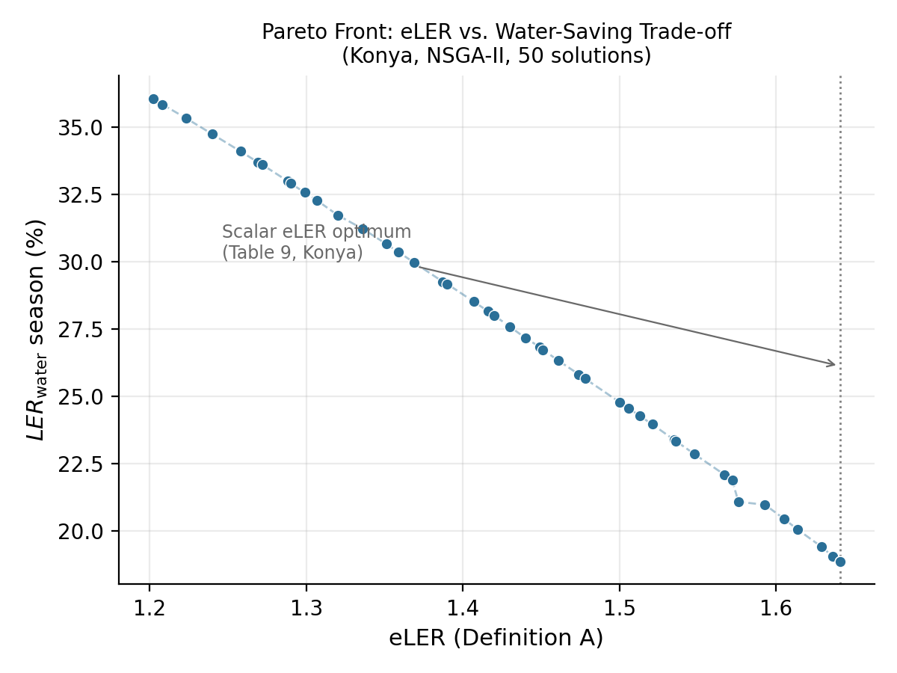
Figure 11 : Pareto front between eLER (Definition A) and $LER_{\text{water}}$ (growing-season, Equation 20) for Konya, from a bi-objective NSGA-II search (50 solutions, 80 generations) over the same six-dimensional design space used for the primary scalar optimization. The dotted line marks the scalar eLER optimum reported in Table 9, which coincides with the eLER-maximizing end of the front.

Definition A versus Definition B: when to use each. Definition A ($LER_{\text{PV}}$ referenced to a dense-pack independent array) is the scientifically rigorous choice for studies that aim to quantify the net land-use benefit of the APV configuration relative to what could be achieved with two separate monocultures. Definition B ($LER_{\text{PV}}≡GCR$) is appropriate only for literature comparison with studies that have used the circular reference, and its numerical values should always be flagged as such. The difference between the two definitions is 0.029–0.033 in $LER_{\text{PV}}$ and 0.029–0.033 in eLER at the optimised designs of this study (Table 9), which is small relative to the between-site eLER variation (0.123) but non-negligible relative to the between-site $LER_{\text{crop}}$ variation (0.041). Standardization of the PV reference definition, ideally through an agreed protocol analogous to the IEC 61724 standard for PV performance reporting, is identified as a priority for the agrivoltaic community.

5.4 Economic Viability and Policy Implications
The 4E analysis reveals a wide range of economic performance across the four sites, from strongly viable (Ouagadougou, IRR = 28.1%) to marginal but positive (Konya, IRR = 11.0% against an 8% discount rate). Three policy-relevant implications emerge from the economic results.
Electricity tariff structure is the primary economic determinant. The largest revenue stream at all four sites is PV electricity sales, which accounts for 92–96% of gross revenue under Scenario S0. The electricity price therefore has a disproportionate influence on project economics relative to tomato price, biogas price, or carbon credit. At Konya, the low Turkish electricity tariff ($0.06 kWh$​^{-1}$) is the binding constraint on IRR: with a broadly comparable PV output to Almería (1 295 vs. 1 386 MWh ha$​^{-1}$ yr$​^{-1}$ at optimal design), Konya generates disproportionately less PV revenue simply because the tariff is 33% lower ($0.06 vs. $0.09 kWh$​^{-1}$). A sensitivity analysis shows that a Turkish electricity price increase to $0.09 kWh$​^{-1}$, consistent with the regional trend as fossil fuel subsidies are progressively reduced, would raise Konya’s IRR to approximately 18%, exceeding Freiburg’s current IRR (13.0%) and well above the discount rate. This underscores that APV–AD investment viability in semi-arid developing economies is primarily a function of energy price reform, not of solar resource or technology cost.
The carbon credit scenario (S6) provides the strongest economic uplift in this study and is worth prioritizing in policy design. S6 raises IRR by 1.7–4.6 percentage points above S0 at all sites, with the largest absolute improvement at Freiburg (+4.6 pp) driven by the EU ETS price ($65 tCO$​_{2}^{-1}$). At Ouagadougou and Konya, where voluntary carbon market prices are much lower ($12–15 tCO$​_{2}^{-1}$), the S6 improvement is smaller in absolute terms (+1.9 and +1.7 pp respectively) but still meaningful relative to the discount rate. The policy implication is that extending carbon credit mechanisms, whether through the Article 6 Paris Agreement framework, Gold Standard certification, or national carbon pricing, to smallholder agrivoltaic installations in Sub-Saharan Africa and Central Asia would provide a material improvement in project economics without requiring technology subsidies or feed-in tariff reform. Given that the 861 tCO$​_{2}$ ha$​^{-1}$ yr$​^{-1}$ avoided at Ouagadougou represents a significant fraction of the annual per capita CO$​_{2}$ budget compatible with 1.5 °C pathways, this mechanism also aligns economic incentives with climate goals.
Ouagadougou provides the strongest investment case among the four sites in this study. An IRR of 28.1% under S0 and 29.9% under S6, combined with a payback of 3.3–3.5 yr, makes the Ouagadougou configuration attractive even at the 10% discount rate that reflects the higher cost of capital in developing economies. Three structural advantages drive this result: the highest electricity price in the study ($0.12 kWh$​^{-1}$, reflecting the true cost of diesel generation), the highest biogas yield (5.98 MWh ha$​^{-1}$, from the optimal Arrhenius BMP at 33.2 °C average digester temperature), and the largest CO$​_{2}$ avoidance (861 tCO$​_{2}$ ha$​^{-1}$, from the high grid emission factor of 0.632 tCO$​_{2}$ MWh$​^{-1}$). The small digester volume (2.64 m$​^{3}$) and low AD CAPEX ($2 112) mean that the biogas revenue stream is essentially free cash flow on top of the PV investment. For development finance institutions seeking bankable climate-positive agricultural projects in the Sahel, the APV–AD model at Ouagadougou-type sites offers a notable combination of high IRR, short payback, large CO$​_{2}$ impact, and food security co-benefit.
LCOE is at or below utility-scale solar at every site, not just the best ones. LCOE$​_{\text{PV}}$ ranges from $0.038 kWh$​^{-1}$ at Almería to $0.049 kWh$​^{-1}$ at Freiburg, against the IRENA 2023 global utility-scale solar benchmark of $0.049 kWh$​^{-1}$. Almería is 22% below the benchmark; Konya ($0.047 kWh$​^{-1}$) and Ouagadougou ($0.048 kWh$​^{-1}$) are 2–4% below it; Freiburg is essentially at parity. No site exceeds it, despite the elevated APV structure ($0.63 W$​_{p}^{-1}$ vs. $0.45 W$​_{p}^{-1}$ for ground-mount [IRENA, 2022]) carrying a 40% CAPEX premium and the inter-row shading loss at GCR = 69–72% reducing annual specific yield below what a dense-pack unshaded array would achieve. This is a stronger result than the PV-only LCOE metric itself suggests: it is a single-output comparison that ignores crop production, water savings, and biogas, none of which are credited here. A full value-stack LCOE that credits all outputs would likely be lower than the PV-only LCOE at every site, and because the PV-only LCOE already clears the utility-scale benchmark everywhere, the full value-stack LCOE would likely remain below that benchmark at all four sites.

5.5 Limitations and Future Work
Six limitations of the present modelling approach are identified, each motivating specific future research directions. Table 17 summarizes them for quick reference; full discussion of each follow.
Table 17 : Summary of model limitations. “Affects eLER?” indicates whether the limitation propagates to the headline eLER metric (Table 9) or is confined to a secondary output.
ID | Limitation | Quantified impact | Affects eLER? | Mitigation status
L1 | Single-exponential Arrhenius BMP model underestimates methane yield at 20–30 °C | $-$30 to $-$52% BMP bias; $±$43–45% 90% CI from parameter uncertainty | No ($±$2–2.4%) | Documented; Monte Carlo sensitivity run (docs/ad_bmp_sensitivity.md)
L2 | Single-crop scope (tomato only); PAR-saturation mechanism is crop-specific | Direction/magnitude of Finding C2 may differ for other crops | Yes (structural) | Not yet run; requires only a $PAR_{\text{sat}}$ sweep
L3 | Hargreaves–Samani ET$​_{0}$ omits humidity/wind; fixed $α_{\text{shade}}$ | $±$10% vs. FAO-56 Penman-Monteith; $±$25% via $α_{\text{shade}}$ range | No | Documented (docs/et0_ra_fix_notes.md); Penman-Monteith upgrade not yet implemented
L4 | No digestate-to-crop nutrient feedback modelled | Digestate N credit (S4) only; yield feedback (10–25%) not modelled | Yes (would raise it) | Deferred (Gap G6); requires multi-season field data
L5 | Static economic parameters (no price trajectories) | Konya’s S0 IRR margin is narrow (3.0 pp) and price-sensitive | No (economics only) | Not yet run; Monte Carlo price model proposed
L6 | Single-hectare normalization; ESR (453–2 000) reflects smallholder scale | Larger-scale CAPEX/ESR would differ non-linearly | No (scale only) | Not yet run; 1–50 ha scale-up proposed
L1 - BMP temperature model accuracy (V2 MAPE = 26.9%). The single-exponential Arrhenius model systematically underestimates BMP by 30–52% at temperatures of 20–30 °C, the range relevant to cold-season operation at Konya and Freiburg. The root cause is that a single Arrhenius coefficient calibrated at 37 °C cannot capture the inflected microbial response curve in the mesophilic lower range, where community adaptation provides higher-than-exponential yields [Zwietering et al., 1990]. Future work should implement a piecewise Arrhenius model with separate coefficients above and below 30 °C, or a modified Gompertz kinetic model, calibrated against the multi-temperature BMP datasets now available for tomato residues and cattle manure [Feng et al., Pilarski and Pilarska]. Until such a model is validated, all biogas yield and economic results for cold-climate sites should be treated as conservative lower bounds, with the true values likely 15–30% higher. A Monte Carlo sensitivity analysis over literature-reported ranges for $BMP_{\text{ref}}$, capture efficiency, and volatile-solids fractions (500 draws per site) shows this parameter uncertainty propagates to a $±$43–45% 90% confidence interval on absolute biogas energy, while eLER itself remains within $±$2–2.4% robust because $LER_{\text{biogas}}$ is a ratio referenced against a standalone AD unit using the same sampled parameters, which largely cancels the shared uncertainty (docs/ad_bmp_sensitivity.md).
L2 - Single-crop scope. All results are conditioned on tomato (Solanum lycopersicum) with $PAR_{\text{sat}}=174 W m^{-2}$. The PAR-saturation mechanism that drives the non-monotone eLER–GHI gradient is crop-specific, and the magnitude and direction of this effect will differ substantially for other crops. Shade-tolerant crops with lower $PAR_{\text{sat}}$ (lettuce at 76 W m⁻²; spinach at 80 W m⁻²) would likely eliminate or reverse the Freiburg–Konya eLER inversion, while high-saturation crops such as maize (400 W m⁻²) would restore a monotone eLER–GHI relationship. A multi-crop sensitivity analysis, requiring only a change of the $PAR_{\text{sat}}$ parameter in the existing model, is an important next extension, as it would help determine how broadly the PAR-saturation finding generalizes beyond tomato.
L3 - Evapotranspiration model simplification. Reference ET$​_{0}$ is estimated using the Hargreaves–Samani equation with extraterrestrial radiation computed astronomically (FAO-56), which agrees with FAO-56 Penman-Monteith to within $±$10% in semi-arid and temperate climates [Droogers and Allen, 2002] but cannot capture humidity and wind effects on ET under the APV canopy. Full derivation of the ET$​_{0}$ formulation, including two corrections made during model development, is provided in docs/et0_ra_ fix_notes.md. The ET reduction coefficient $α_{\text{shade}}=0.40$ is taken from field measurements under similar APV configurations [Elamri et al., Tawassulli, 2025] but may vary by $±$0.10–0.15 depending on crop canopy closure, soil type, and wind exposure. A $±$25% variation in $α_{\text{shade}}$ propagates to a $±$25% variation in $W_{\text{saved}}$ and $LER_{\text{water}}$, which does not affect eLER or economics but is relevant to water-stressed deployment contexts. Future work should implement FAO-56 Penman-Monteith with auxiliary humidity and aerodynamic resistance terms derived from the PVGIS wind speed column, and validate $α_{\text{shade}}$ against lysimeter measurements at each study site.
L4 - Absence of digestate-to-crop nutrient feedback (G6). The model treats the AD digester as a terminal sink for crop residues: digestate is valued only as a tradeable nitrogen credit (Scenario S4) without modelling its effect on soil nutrient availability and subsequent crop yield. In practice, returning digestate to the APV field closes a nutrient loop that can increase fruit yield by 10–25% relative to unfertilized conditions [Lallement et al.], which would raise both the crop revenue and the VS input to the digester in subsequent seasons. Modelling this feedback requires multi-season soil nutrient dynamics that are beyond the scope of the present single-year TMY-based framework. It is identified as Gap G6 and an important direction for experimental field validation, requiring co-located APV–AD installations with controlled digestate application trials over at least three growing seasons.
L5 - Static economic parameters. All economic results use fixed prices for electricity, tomato, biogas, and carbon credits, without modelling price trajectories over the 20-year project life. PV module costs have declined at approximately 10–15% per year over the past decade [IRENA, 2022], and biomethane prices are subject to regulatory risk in all four jurisdictions. A stochastic techno-economic model incorporating Monte Carlo sampling of price distributions, including correlated electricity and carbon price scenarios consistent with IEA Net Zero pathways [IEA, 2025], would provide more realistic NPV confidence intervals and identify the price combinations under which each site crosses the investment threshold. Such a model would be particularly valuable for Konya, where the S0 IRR margin above the discount rate is narrow (3.0 pp) and highly sensitive to electricity price assumptions.
L6 - Single-hectare normalization and scalability. All results are normalized to 1 ha, which is appropriate for smallholder farming contexts (Ouagadougou, Konya) but may not represent the economics of larger commercial APV–AD installations. At larger scale (10–100 ha), several cost components change non-linearly: AD digester CAPEX per m$​^{3}$ decreases with scale (economies of scale in tank construction and gas handling), BOP costs per kWp decrease with larger inverter units, and the ESR, currently 453–2 000, would decrease toward more physically meaningful values as the digester is sized to process residues from multiple hectares. A scale-up analysis from smallholder (1 ha) to commercial (50 ha) would provide the full range of deployment contexts and is a natural next step following experimental validation of the single-hectare model.

6. Conclusion
This study presents a four-climate-zone comparative optimization of integrated bifacial agrivoltaic and anaerobic digestion systems, introducing a three-component extended Land Equivalent Ratio and a 4E analysis framework for performance assessment. The following conclusions are supported by the validated simulation results.
C1 - The eLER framework confirms multi-output land productivity at all four climate zones. Optimized eLER values of 1.641 (Konya), 1.657 (Almería), 1.723 (Ouagadougou), and 1.764 (Freiburg) show that integrated APV–AD systems use land more productively than three separate monocultures at every site. The agrivoltaic two-component $LER_{\text{2C}}$ ranges from 1.030 to 1.088, confirming that the APV system alone outperforms separate monocultures even without the biogas contribution.
C2 - eLER is non-monotone with solar resource, driven by PAR saturation. Freiburg, with the lowest annual GHI (1 150 kWh m$​^{-2}$), achieves the highest eLER (1.764), exceeding Konya despite 43% more solar irradiance. The mechanism is PAR saturation: at high-irradiance sites, open-field PAR frequently exceeds the tomato light saturation point (174 W m⁻²), inflating the $LER_{\text{crop}}$ denominator and penalizing the yield ratio. This result suggests that agrivoltaic site selection should be framed as matching solar resource to crop photosynthetic capacity rather than simply maximizing PV output.
C3 - Boundary convergence is a robust result within the present parameterization. The optimizer converges to the minimum physically permissible row spacing ($d_{\text{row}}^{*}=3.03 m$) and module height ($H_{m}^{*}=1.50 m$) at all four sites, despite GHI varying by a factor of 1.8 and mean annual temperature varying by 17 °C. This indicates that, under the present constraints and parameterization, the eLER optimum lies on the boundary of the explored design space. Any mechanical access requirement beyond the minimum physical clearance imposes an eLER penalty that should be evaluated for each farming context.
C4 - Thermal self-sufficiency is achieved at all sites with negligible heating allocation. ESR values of 453–2 000 at the optimized designs indicate that allocating 5% of annual PV output to digester heating is sufficient to cover heating demand at every site and in every season. Under the present assumptions, no biogas is required for self-heating, so the full biogas output remains available for valorization across all seven economic scenarios.
C5 - The carbon credit scenario (S6) provides the strongest economic uplift across all sites. S6 raises IRR by 1.7–4.6 percentage points relative to the baseline at all sites, reaching 12.7% (Konya), 23.0% (Almería), 29.9% (Ouagadougou), and 17.6% (Freiburg). Ouagadougou offers the highest IRR in this study, with a payback period of 3.3 years and CO$​_{2}$ avoidance of 861 tCO$​_{2}$ ha$​^{-1}$ yr$​^{-1}$. This result indicates that carbon-credit mechanisms could materially improve the investment case for APV–AD deployment, especially in regions with high grid-emission factors.
C6 - The growing-season ET denominator correction materially changes the water-savings metric. Reporting $LER_{\text{water}}$ with the annual ET$​_{0}$ denominator underestimates the agronomic water benefit. The corrected growing-season values of 15.6–22.4% correspond to 81–159 mm of irrigation water saved per growing season, which is substantially more policy-relevant for irrigation planning than annualized values diluted by off-season months.
C7 - Several outputs should be interpreted as conservative. The crop-yield validation shows good agreement with literature data, while the BMP temperature model remains conservative at lower temperatures. As a result, the reported biogas yields, eLER values, NPV, IRR, and CO$​_{2}$ avoidance figures should be viewed as lower-bound estimates, with the largest upside potential in colder climates where improved BMP modelling would likely increase performance.
Overall, the integrated APV–AD framework developed in this study provides a replicable, climate-adaptive decision tool for food–energy–water nexus planning across the semi-arid-to-temperate spectrum. The open-source simulation code, optimized design parameters, and full results database are provided as supplementary material to support replication and extension to additional crops, climates, and policy contexts.

A: Differential Evolution Algorithm — Complete Pseudocode
Algorithm 1 provides the complete pseudocode of the Differential Evolution procedure used to maximize the eLER objective function (Equation 30) across the six-dimensional APV–AD design space. The algorithm is implemented in Python using scipy.optimize.differential_evolution with the settings described in Section 3.9, followed by scipy.optimize.minimize with the L-BFGS-B method for local polishing.

Algorithm 1: Differential Evolution for APV AD eLER maximization

Input: lb,ub ∈R⁶; NP = 90; F ∈ [0.5,1.0]; Cr = 0.7; G_{max} = 50; seed = 42 Output: x∗; eLER∗
- Initialization
- for i = 1 to NP do
3
x
(0)
i
∼U
(
lb
,
ub
)
via LHS
4
f
(0)
i
←
eLER
(
x
(0)
i
)
5
if
infeasible
then
6
f
(0)
i
←−∞
7
end
- end
- Main loop
10
for
g
=1
to
G
max
do
11
for
i
=1
to
NP
do
12
r
1
,r
2
,r
3
distinct
̸
=
i
;
F
g
∼U
(0
.
5
,
1
.
0)
13
v
i
←
x
(
g
−
1)
r
1
+
F
g
(
x
(
g
−
1)
r
2
−
x
(
g
−
1)
r
3
)
; Clip
14
j
rand
∼U{
1
,...,
6
}
15
for
j
=1
to
6
do
16
if
U
(0
,
1)
≤
Cr
ou
j
=
j
rand
then
17
u
ij
←
v
ij
18
else
19
u
ij
←
x
(
g
−
1)
ij
20
end
21
end
22
f
u
←
eLER
(
u
i
)
;
if
infeasible
then
23
f
u
←−∞
24
end
25
if
f
u
≥
f
(
g
−
1)
i
then
26
x
i
←
u
i
;
f
i
←
f
u
27
else
28
x
(
g
)
i
←
x
(
g
−
1)
i
;
f
(
g
)
i
←
f
(
g
−
1)
i
29
end
30
end
31
end
- Local polishing (L-BFGS-B)
- x∗ ← argmax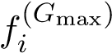
i
- x∗ ← L-BFGS-B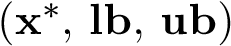
- eLER∗ ← eLER(x∗)
- return x∗, eLER∗

B: Model Parameters — Complete Reference Table
Table 18 consolidates all fixed model parameters used throughout the study for reproducibility.
Table 18 : Complete list of fixed model parameters.
Parameter | Symbol | Value | Unit | Source
PV module (Jinko Tiger Neo 550 W$​_{p}$ bifacial)
Rated power (STC) | $$P_{\text{STC}}$$ | 550 | W$​_{p}$ | Jinko Solar [2023]
Module length | $$L_{m}$$ | 2.278 | m | Jinko Solar [2023]
Module width | $$W_{m}$$ | 1.134 | m | Jinko Solar [2023]
Bifaciality factor | $$ϕ$$ | 0.70 | — | Jinko Solar [2023]
Temp. coefficient | $$β_{p}$$ | $-$0.0035 | K$​^{-1}$ | Jinko Solar [2023]
System losses | $$η_{\text{loss}}$$ | 0.12 | — | Jordan and Kurtz [2013]
PV thermal model (Faiman 2008)
Free convection coeff. | $$U_{0}$$ | 25 | W m$​^{-2}$ K$​^{-1}$ | Faiman
Wind convection coeff. | $$U_{1}$$ | 6.84 | W s m$​^{-3}$ K$​^{-1}$ | Faiman
Ground albedo | $$ρ_{g}$$ | 0.25 | — | Monteith and Unsworth
Rear irradiance fraction | $$f_{\text{rear}}$$ | 0.12 | —
Crop yield model
PAR fraction of GHI | $$f_{\text{PAR}}$$ | 0.48 | — | McCree
Tomato PAR saturation | $$PAR_{\text{sat}}$$ | 174 | W m$​^{-2}$ | Mohammedi et al.
ET reduction model
ET shading coefficient | $$α_{\text{shade}}$$ | 0.40 | — | Elamri et al.
Anaerobic digestion model
Reference BMP | $$BMP_{\text{ref}}$$ | 300 | NmL CH$​_{4}$ gVS$​^{-1}$ | Lallement et al.
Reference temperature | $$T_{\text{ref}}$$ | 37 | °C | Lindorfer et al.
Arrhenius coefficient | $$θ$$ | 0.069 | °C⁻¹ | Pilarski and Pilarska
Min. operating temp. | $$T_{\text{min}}$$ | 26 | °C | Lindorfer et al.
Temp. boost above ambient | — | 5 | °C | Lindorfer et al.
Methane fraction | $$f_{{\text{CH}}_{4}}$$ | 0.60 | vol/vol | Marchaim [1992]
Methane LHV | $$LHV_{{\text{CH}}_{4}}$$ | 35.8 | MJ Nm$​^{-3}$ | Marchaim [1992]
Wall heat transfer coeff. | $$U_{\text{eff}}$$ | 0.8 | W m$​^{-2}$ K$​^{-1}$ | Lindorfer et al.
Substrate density | $$ρ_{s}$$ | 1 020 | kg m$​^{-3}$ | standard
Substrate specific heat | $$C_{p}$$ | 4.2 | kJ kg$​^{-1}$ K$​^{-1}$ | standard
Inlet temperature | $$T_{\text{in}}$$ | 15 | °C | assumed
Reaction heat fraction | — | 0.05 | — | Pal and Ilango
Tomato residue DM | $$DM$$ | 0.06 | kg kg$​^{-1}$ | Mohammedi et al.
Residue VS fraction | $$VS_{f}$$ | 0.85 | kg kg$​^{-1}$ | Lallement et al.
Manure DM | $$DM_{m}$$ | 0.20 | kg kg$​^{-1}$ | Pilarski and Pilarska
Manure VS fraction | $$VS_{m}$$ | 0.80 | kg kg$​^{-1}$ | Pilarski and Pilarska
Residue-to-fruit ratio | $$R_{\text{res}}$$ | 0.80 | kg kg$​^{-1}$ | Mohammedi et al.
Economic analysis
Project lifetime | $$N$$ | 20 | yr | standard
O&M rate | $$f_{\text{O\&M}}$$ | 1.5 | % CAPEX yr$​^{-1}$ | IRENA [2022]
PV CAPEX (APV) | $$c_{\text{PV}}$$ | 0.63 | $ W$​_{p}^{-1}$ | IRENA [2022]
AD CAPEX | $$c_{\text{AD}}$$ | 800 | $ m$​^{-3}$ | Pal and Ilango
Agricultural CAPEX | $$c_{\text{agri}}$$ | 2 500 | $ ha$​^{-1}$ | FAO
BOP fraction | $$f_{\text{BOP}}$$ | 15 | % of (PV+AD) | standard
Natural gas EF | $$EF_{\text{gas}}$$ | 0.202 | tCO$​_{2}$ MWh$​^{-1}$ | IPCC [2022]
Digestate N content | — | 0.003 | kg N kg$​^{-1}$ | Lallement et al.
N credit price | $$p_{N}$$ | 1.20 | $ kg$​^{-1}$ N | market
LPG equivalent price | $$p_{\text{LPG}}$$ | 0.18 | $ kWh$​^{-1}$ | IEA [2025]
Biomethane premium (S5) | — | 5.5$×p_{\text{elec}}$ | — | Nik Zad [2026]

References
FAO. The future of food and agriculture: trends and challenges. Food and Agriculture Organization of the United Nations. ISBN 978-92-5-109551-5.
B. R. et al. Scanlon. Global water resources and the food-energy-water nexus. Nature Reviews Earth & Environment, 4:117, 2023.
IRENA. Renewable power generation costs in 2022, 2022.
Harshavardhan Dinesh and Joshua M. Pearce. The potential of agrivoltaic systems. 54: 299308. ISSN 13640321. doi: 10.1016/j.rser.2015.10.024. URL https://linkinghub. elsevier.com/retrieve/pii/S136403211501103X.
D. et al. Ketzer. Land use conflicts between biomass and wind energy production at the municipality level. Renewable and Sustainable Energy Reviews, 120:109674, 2020. A.
Goetzberger and A. Zastrow. On the coexistence of solar-energy conversion and plant cultivation. 1(1):5569. ISSN 0142-5919. doi: 10.1080/01425918208909875. URL http://www.tandfonline.com/doi/abs/10.1080/01425918208909875.
C. Dupraz, H. Marrou, G. Talbot, L. Dufour, A. Nogier, and Y. Ferard. Combining solar photovoltaic panels and food crops for optimising land use: Towards new agrivoltaic schemes. 36(10):27252732. ISSN 09601481. doi: 10.1016/j.renene.2011.03.005. URL https://linkinghub.elsevier.com/retrieve/pii/S0960148111001194.
H. Marrou, L. Guilioni, L. Dufour, C. Dupraz, and J. Wery. Microclimate under agrivoltaic systems: Is crop growth rate a ected in the partial shade of solar panels? 177:117132. ISSN 01681923. doi: 10.1016/j.agrformet.2013.04.012. URL https://linkinghub. elsevier.com/retrieve/pii/S0168192313000890.
Greg A. Barron-Ga ord, Mitchell A. Pavao-Zuckerman, Rebecca L. Minor, Leland F. Sut ter, Isaiah Barnett-Moreno, Daniel T. Blackett, Moses Thompson, Kirk Dimond, An drea K. Gerlak, Gary P. Nabhan, and Jordan E. Macknick. Agrivoltaics provide mutual bene ts across the foodenergywater nexus in drylands. 2(9):848855. ISSN 2398 9629. doi: 10.1038/s41893-019-0364-5. URL https://www.nature.com/articles/ s41893-019-0364-5.
Y. Elamri, B. Cheviron, J.-M. Lopez, C. Dejean, and G. Belaud. Water budget and crop modelling for agrivoltaic systems: Application to irrigated lettuces. 208:440453. ISSN 03783774. doi: 10.1016/j.agwat.2018.07.001. URL https://linkinghub.elsevier. com/retrieve/pii/S0378377418309545.
Teodoro Semeraro, Aurelia Scarano, Lorenzo Maria Curci, Angelo Leggieri, Marcello 68 Lenucci, Alberto Basset, Angelo Santino, Gabriella Piro, and Monica De Caroli. Shad ing e ects in agrivoltaic systems can make the di erence in boosting food security in climate change. 358:122565. ISSN 03062619. doi: 10.1016/j.apenergy.2023.122565. URL https://linkinghub.elsevier.com/retrieve/pii/S0306261923019293.
R. Mead and R. W. Willey. The concept of a ‘land equivalent ratio’ and advantages in yields from intercropping. 16(3):217228. ISSN 0014-4797, 1469-4441. doi: 10.1017/ S0014479700010978. URL https://www.cambridge.org/core/product/identifier/ S0014479700010978/type/journal_article.
Muhammad Hussnain Riaz, Hassan Imran, Habeel Alam, Muhammad Ashraful Alam, and Nauman Zafar Butt. Crop-speci c optimization of bifacial PV arrays for agri voltaic food-energy production: The light-productivity-factor approach. 12(2):572 580. ISSN 2156-3381, 2156-3403. doi: 10.1109/JPHOTOV.2021.3136158. URL https://ieeexplore.ieee.org/document/9674806/.
Domenico Mazzeo, Andrea Di Zio, Claudio Pesenti, and Sonia Leva. Optimizing agri voltaic systems: A comprehensive analysis of design, crop productivity and energy performance in open- eld con gurations. URL https://www.ssrn.com/abstract= 5082169.
Serine Mohammedi, Giovanna Dragonetti, Naouel Admane, and Abdelouahid Fouial. The impact of agrivoltaic systems on tomato crop: A case study in southern italy. 11 (12):3370. ISSN 2227-9717. doi: 10.3390/pr11123370. URL https://www.mdpi.com/ 2227-9717/11/12/3370.
Krzysztof Pilarski and Agnieszka A. Pilarska. Kinetics and energy yield in anaerobic digestion: E ects of substrate composition and fundamental operating conditions. 18 (23):6262. ISSN 1996-1073. doi: 10.3390/en18236262. URL https://www.mdpi.com/ 1996-1073/18/23/6262.
Audrey Lallement, Christine Peyrelasse, Camille Lagnet, Abdellatif Barakat, Blandine Schraauwers, Samuel Maunas, and Florian Monlau. A detailed database of the chemical properties and methane potential of biomasses covering a large range of common agricultural biogas plant feedstocks. 1(1):195227. ISSN 2813-0391. doi: 10.3390/waste1010014. URL https://www.mdpi.com/2813-0391/1/1/14.
European Commission. REPowerEU Plan. COM(2022) 230 nal, 2022.
A. et al. Nik Zad. Techno-economic optimization of agrivoltaic-powered anaerobic di gestion plant for biomethane production. Energy Conversion and Management, 318: 119213, 2026. 69
European Biogas Association. EBA Statistical Report 2025, 2025.
Rabobank. Europe’s biomethane landscape: Between ambition and reality, 2025.
IEA. Biogases Renewables 2025 Analysis, 2025.
H. Lindorfer, R. Waltenberger, K. K llner, R. Braun, and R. Kirchmayr. New data on temperature optimum and temperature changes in energy crop digesters. 99(15):7011 7019. ISSN 09608524. doi: 10.1016/j.biortech.2008.01.034. URL https://linkinghub. elsevier.com/retrieve/pii/S0960852408000345.
Sebastian Zainali, Silvia Ma Lu, Bengt Stridh, Anders Avelin, Stefano Amaducci, Michele Colauzzi, and Pietro Elia Campana. Direct and di use shading factors modelling for the most representative agrivoltaic system layouts. 339:120981. ISSN 03062619. doi: 10. 1016/j.apenergy.2023.120981. URL https://linkinghub.elsevier.com/retrieve/ pii/S0306261923003458.
Ankit Pal and G. Saravana Ilango. Design and techno-economic analysis of an o-grid integrated PV-biogas system with a constant temperature digester for a cost-e ective rural application. 287:129671. ISSN 03605442. doi: 10.1016/j.energy.2023.129671. URL https://linkinghub.elsevier.com/retrieve/pii/S0360544223030657.
Mert Temiz, Nusara Sinbuathong, and Ibrahim Dincer. Development and assessment of a new agrivoltaic-biogas energy system for sustainable communities.
I. Angelidaki, M. Alves, D. Bolzonella, L. Borzacconi, J. L. Campos, A. J. Guwy, S. Kalyuzhnyi, P. Jenicek, and J. B. Van Lier. De ning the biomethane po tential (BMP) of solid organic wastes and energy crops: a proposed proto col for batch assays. 59(5):927934. ISSN 0273-1223, 1996-9732. doi: 10. 2166/wst.2009.040. URL https://iwaponline.com/wst/article/59/5/927/15563/ Defining-the-biomethane-potential-BMP-of-solid.
J. Mata-Alvarez, J. Dosta, M.S. Romero-G iza, X. Fonoll, M. Peces, and S. Astals. A critical review on anaerobic co-digestion achievements between 2010 and 2013. 36: 412427. ISSN 13640321. doi: 10.1016/j.rser.2014.04.039. URL https://linkinghub. elsevier.com/retrieve/pii/S1364032114002664.
Ahmed Alengebawy, Yi Ran, Ahmed I. Osman, Keda Jin, Mohamed Samer, and Ping Ai. Anaerobic digestion of agricultural waste for biogas production and sus tainable bioenergy recovery: a review. 22(6):26412668. ISSN 1610-3653, 1610 3661. doi: 10.1007/s10311-024-01789-1. URL https://link.springer.com/10.1007/ s10311-024-01789-1.
Lu Feng, Yeqing Li, Chang Chen, Xiaoying Liu, Xiao Xiao, Xinxin Ma, Rui 70 hong Zhang, Yanfeng He, and Guangqing Liu. Biochemical methane poten tial (BMP) of vinegar residue and the influence of feed to inoculum ratios on biogas production. 8(2):24872498. biores.8.2.2487-2498. ISSN 1930-2126. doi: 10.15376/ URL https://bioresources.cnr.ncsu.edu/resources/ biochemical-methane-potential-bmp-of-vinegar-residue-and-the-influence-of-feed-to-inoculum-ratios-on-biogas-production/
C. et al. RoldÆn-Porta. Economic viability of a hybrid renewable energy community for rural electri cation. Applied Sciences, 13:12016, 2023.
JRC photovoltaic geographical information system (PVGIS)- european commission. URL https://re.jrc.ec.europa.eu/pvg_tools/en/.
Thomas Huld, Richard Mller, and Attilio Gambardella. A new solar radiation database for estimating PV performance in europe and africa. 86(6):18031815. ISSN 0038092X. doi: 10.1016/j.solener.2012.03.006. URL https://linkinghub.elsevier. com/retrieve/pii/S0038092X12001119.
JRC photovoltaic geographical information system (PVGIS)- european commission. URL https://re.jrc.ec.europa.eu/pvg_tools/en/.
DLG. Tomatenanbau in Deutschland: Ertragsstatistiken, 2023.
Benjamin Y H Liu and Richard C Jordan. Characteristic distribution total solar radiation.
John Lennox Monteith and M. H.Unsworth. Principles of environmental physics. Elsevier, 3rd ed edition. ISBN 978-0-12-505103-3.
David Faiman. Assessing the outdoor operating temperature of photovoltaic modules. 16(4):307315. ISSN 1062-7995, 1099-159X. doi: 10.1002/pip.813. URL https:// onlinelibrary.wiley.com/doi/10.1002/pip.813.
Jinko Solar. Tiger neo n-type 72hl4-bdv 550wp bifacial module datasheet, 2023. URL https://www.jinkosolar.com.
D. C. Jordan and S. R. Kurtz. Photovoltaic degradation rates Progress in Photovoltaics, 21:1229, 2013. an analytical review.
Shiva Gorjian, Erion Bousi, zal Emre zdemir, Max Trommsdor , Nallapaneni Manoj Kumar, Abhishek Anand, Karunesh Kant, and Shauhrat S. Chopra. Progress and challenges of crop production and electricity generation in agrivoltaic systems us ing semi-transparent photovoltaic technology. 158:112126. ISSN 13640321. doi: 10. 1016/j.rser.2022.112126. URL https://linkinghub.elsevier.com/retrieve/pii/ S1364032122000545.
K.J. McCree. The action spectrum, absorptance and quantum yield of photosynthesis 71 in crop plants. 9:191216. ISSN 00021571. doi: 10.1016/0002-1571(71)90022-7. URL https://linkinghub.elsevier.com/retrieve/pii/0002157171900227.
C.P. Jacovides, F.S. Tymvios, V.D. Assimakopoulos, and N.A. Kaltsounides. Compara tive study of various correlations in estimating hourly di use fraction of global solar radiation. 31(15):24922504. ISSN 09601481. doi: 10.1016/j.renene.2005.11.009. URL https://linkinghub.elsevier.com/retrieve/pii/S0960148105003538.
E. Heuvelink. Tomatoes. 2005.
G. H. Hargreaves and Z. A. Samani. Reference crop evapotranspiration from temperature. Applied Engineering in Agriculture, 1(2):9699, 1985. doi: 10.13031/2013.26773.
R. G. et al. Allen. Crop evapotranspiration: Guidelines for computing crop water requirements. fao irrigation and drainage paper no. 56, 1998. P. Droogers and R. G. Allen. Estimating reference evapotranspiration under inaccurate data conditions. Irrigation and Drainage Systems, 16(1):3345, 2002. doi: 10.1023/A: 1015508322413.
A. Tawassulli. Et reduction coefficient for agrivoltaic systems. Agricultural Water Management, 298:108821, 2025.
U. Marchaim. Biogas Processes for Sustainable Development. Number 95. FAO Agricul tural Services Bulletin, Rome, 1992. ISBN 92-5-103126-6.
Rainer Storn. Differential evolution- a simple and e cient adaptive scheme for global optimization over continuous spaces.
S. V. Oprea and A. Bra. Differential evolution algorithms for renewable energy systems optimization: A systematic review. Renewable and Sustainable Energy Reviews, 189: 113946, 2024. doi: 10.1016/j.rser.2023.113946.
S. Das, S. S. Mullick, and P. N. Suganthan. Differential evolution: A survey of the state of-the-art. IEEE Transactions on Evolutionary Computation, 15(1):431, 2011. doi: 10.1109/TEVC.2010.2059031.
J. Blank and K. Deb. pymoo: Multi-objective optimization in python. IEEE Access, 8: 8949789509, 2020.
IPCC. Climate change 2022: Mitigation of climate change. annex II: Emissions and mitigation pathways. Technical report, Intergovernmental Panel on Climate Change, Cambridge, UK, 2022. Working Group III contribution to the Sixth Assessment Report.
M. H. Zwietering, I. Jongenburger, F. M. Rombouts, and K. van ’t Riet. Modeling of 72 the bacterial growth curve. Applied and Environmental Microbiology, 56(6):18751881, 1990. doi: 10.1128/aem.56.6.1875-1881.1990

