Methodology

Study Sites and Climate Data
Four sites were selected to span four distinct Köppen–Geiger climate subtypes across a latitudinal range of 12 °N to 48 °N (Table 1, Figure 1). The selection criterion was maximum climate diversity within the semi-arid and adjacent temperate zones that represent the primary deployment contexts for agrivoltaic systems: two hot and cold semi-arid sites (Almería BSh and Konya BSk), one tropical semi-arid site (Ouagadougou BSh), and one oceanic temperate site (Freiburg Cfb) included as a northern European reference.
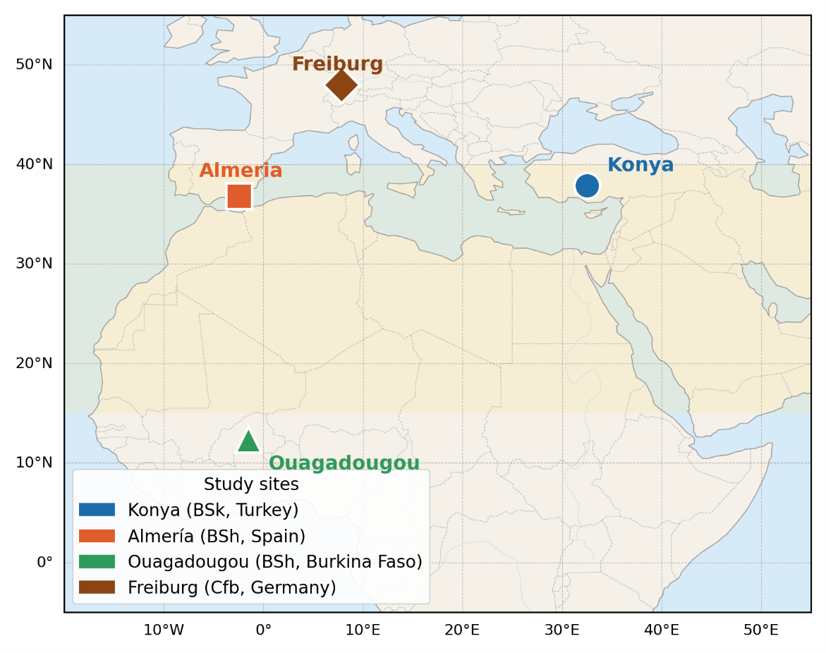
Location map of the four study sites overlaid on the Köppen–Geiger climate classification. Semi-arid zones (BS) are shaded in light yellow; the oceanic temperate zone (Cfb) in light blue.
Hourly climate data were obtained from the PVGIS-SARAH3 Typical Meteorological Year (TMY) database of the European Commission Joint Research Centre . The SARAH3 satellite product provides direct normal irradiance (DNI) and diffuse horizontal irradiance (DHI) as independent retrievals, without decomposition from global horizontal irradiance (GHI). This avoids the systematic decomposition errors of up to $±$8% reported for empirical decomposition models under broken cloud conditions . The mean bias error of PVGIS-SARAH3 GHI estimates is below $±$5% for monthly averages at all four study sites . The TMY file format provides ten meteorological variables at hourly resolution (8760 rows per site): air temperature T$​_{2m}$ (°C), relative humidity RH (%), GHI, DNI, DHI (W m$​^{−2}$), downwelling infrared irradiance IR(h) (W m$​^{−2}$), 10-m wind speed WS$​_{10m}$ (m s$​^{−1}$), wind direction WD$​_{10m}$ (°), and surface pressure SP (Pa).
Geographical and climatic characteristics of the four study sites (PVGIS-SARAH3 TMY data).
Parameter | Konya | Almería | Ouagadougou | Freiburg
Latitude | 37.87°N | 36.83°N | 12.37°N | 47.99°N
Longitude | 32.49°E | 2.46°W | 1.52°W | 7.85°E
Elevation (m a.s.l.) | 1 016 | 20 | 303 | 278
Köppen class | BSk | BSh | BSh | Cfb
Annual GHI (kWh m$​^{−2}$) | 1 650 | 1 850 | 2 050 | $∼$1 150
Mean annual T (°C) | 11.5 | 18.5 | 28.5 | $∼$11.4
Summer T$​_{max}$ (°C) | 38 | 35 | 41 | $∼$35
Winter T$​_{min}$ (°C) | $−$10 | $+$5 | $+$15 | $∼−12$
Annual ET$​_{0}$ (mm) | 1 200 | 1 350 | 1 800 | $∼$900
Annual precip. (mm) | 320 | 200 | 800 | $∼$800
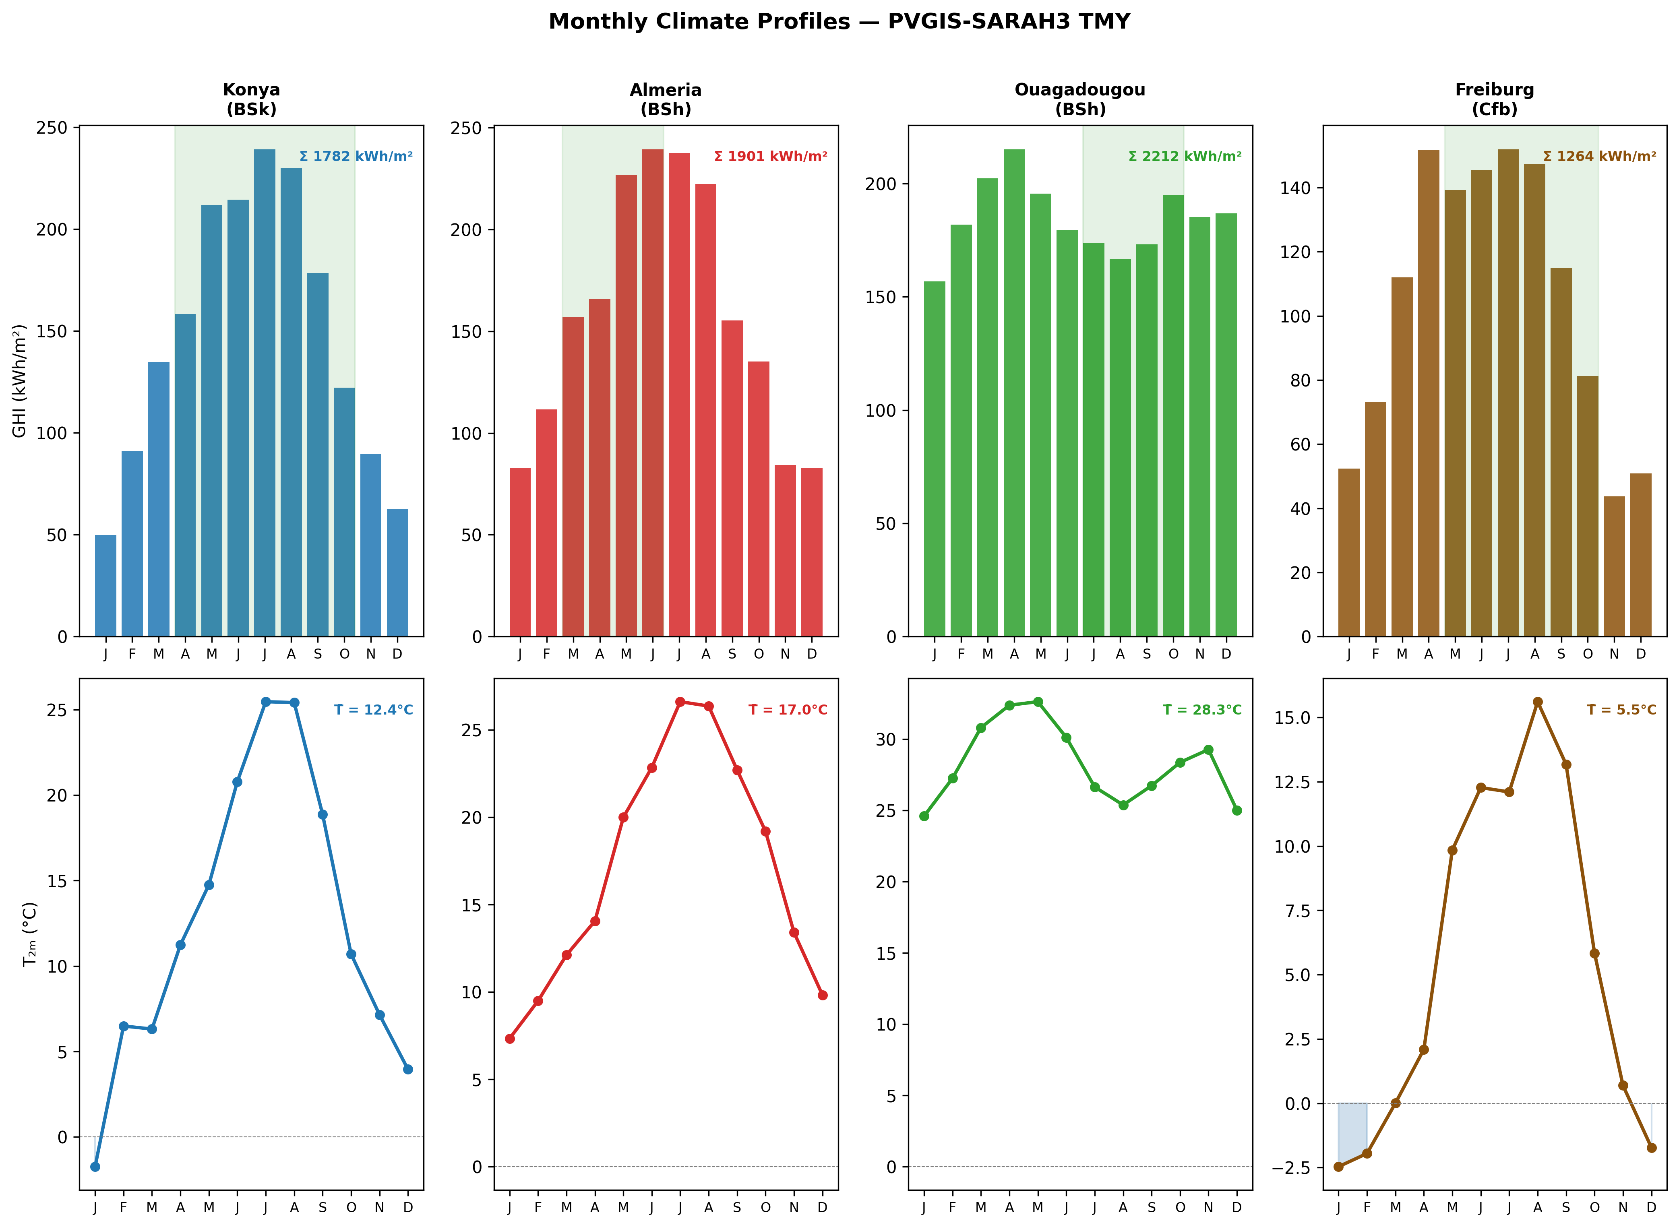
Monthly climate profiles for the four study sites from PVGIS-SARAH3 TMY data. Upper row: monthly GHI (kWh m$​^{−2}$) with annual total annotated; lower row: mean monthly air temperature (°C). Shaded bands indicate the tomato growing season at each site.
The four sites span a mean annual temperature range of 11.4–28.5 °C, a GHI range of 1 150–2 050 kWh m$​^{−2}$, and growing seasons of 122–189 days. This diversity ensures that the model is tested across the full range of Arrhenius BMP suppression (from negligible at Ouagadougou to severe at Freiburg in January) and PAR saturation regimes (from frequent saturation at Ouagadougou to rare saturation at Freiburg), providing the basis for the multi-climate findings reported in Section [sec:results].

Crop Parameters and Growing Seasons
Tomato (Solanum lycopersicum) was selected as the reference crop for all four sites on the basis of three criteria: it is cultivated commercially in all four study regions, its PAR saturation point (174 W m⁻²) is well-documented and places it in the high-irradiance sensitivity range where APV shading effects are most pronounced, and its residue-to-fruit ratio and BMP are among the best-characterised in the agrivoltaic and AD literatures .
Site-specific planting and harvest dates follow local agricultural calendars (Table 2). The three semi-arid sites use a fresh fruit yield of 60 t ha⁻¹, consistent with irrigated greenhouse and open-field production in Mediterranean and tropical semi-arid contexts . Freiburg uses 30 t ha⁻¹ following German open-field production statistics .
Site-specific agronomic, economic, and environmental parameters. Grid emission factors (EF) from and Umweltbundesamt (2023). Carbon prices from EU ETS (2024) for Almería and Freiburg; voluntary market rates for Konya and Ouagadougou.
Parameter | Konya | Almería | Ouagadougou | Freiburg
Planting date | 25 Apr | 1 Mar | 1 Jul | 1 May
Harvest date | 30 Oct | 30 Jun | 30 Oct | 15 Oct
Season length (days) | 189 | 122 | 122 | 167
Fruit yield (t ha$​^{−1}$) | 60 | 60 | 60 | 30
Season ET$​_{0}$ (mm) | 650 | 480 | 620 | $∼$350
Residue ratio $R_{\text{res}}$ | 0.80
Dry matter $DM$ (tomato residues) | 0.06
VS fraction $VS_{f}$ | 0.85
Manure input (t ha$​^{−1}$ yr$​^{−1}$) | 10.0
Manure $DM_{m}$ | 0.20
Manure $VS_{m}$ | 0.80
Tomato price ($ t$​^{−1}$) | 300 | 400 | 250 | 350
Electricity price ($ kWh$​^{−1}$) | 0.06 | 0.09 | 0.12 | 0.09
Discount rate (%) | 8 | 6 | 10 | 5
Grid EF (tCO$​_{2}$ MWh$​^{−1}$) | 0.438 | 0.167 | 0.632 | 0.380
Carbon price ($ tCO$​_{2}^{−1}$) | 15 | 65 | 12 | 65
The feedstock to the anaerobic digester combines tomato crop residues and cattle manure as a co-substrate. Manure co-digestion at a VS ratio of approximately 1:2 (residues:manure) improves buffer capacity, microbial diversity, and BMP by 12–18% compared to mono-digestion of crop residues alone . The 10 t ha⁻¹ fresh manure input corresponds to the production of approximately 2–3 cattle heads per hectare, consistent with the mixed crop-livestock farming systems prevalent in all four study regions. Total annual VS input per hectare is:
$$VS_{\text{total}}=\underset{\text{crop residues}}{\underset{⏟}{Y_{f}⋅LER_{\text{crop}}⋅R_{\text{res}}⋅DM⋅VS_{f}}}+ \underset{\text{cattle manure}}{\underset{⏟}{M_{m}⋅DM_{m}⋅VS_{m}}}$$
where $Y_{f}$ is the fresh fruit yield (kg ha$​^{−1}$), $LER_{\text{crop}}$ scales the actual residue production under APV shading, and $M_{m}$ is the fresh manure input (kg ha$​^{−1}$ yr$​^{−1}$). At the optimised designs reported in Section [sec:results], VS inputs range from 1892 to 2573 kg ha⁻¹ yr⁻¹ across the four sites, with Freiburg’s lower fruit yield driving the minimum.

Solar Geometry and Shading Model
Accurate hourly solar position calculation underpins both the PV transposition model and the inter-row shading factor. Solar declination $δ$ is computed using the Spencer (1971) harmonic approximation:
$$\begin{matrix}δ=\frac{180}{π}(0.006918−0.399912cosB+0.070257sinB \\ −0.006758cos2B+0.000907sin2B−0.002697cos3B+0.001480sin3B)\end{matrix}$$
where $B=2π(n−1)/365$ and $n$ is the day of year. The hour angle $ω$ is computed from true solar time, applying a longitude correction and the Equation of Time. The solar elevation angle $α_{s}$ at each hourly timestep is:
$$sinα_{s}=sinϕsinδ+cosϕcosδcosω$$
where $ϕ$ is the site latitude.
The Ground Coverage Ratio (GCR) quantifies the fraction of ground area covered by the projected module footprint:
$$GCR=\frac{L_{m}cosβ}{d_{\text{row}}}$$
where $L_{m}=2.278 m$ is the module length (Jinko Tiger Neo 550 W$​_{\text{p}}$) and $β$ is the panel tilt angle. A physical non-overlap constraint prevents adjacent rows from casting permanent shade on each other at any sun angle:
$$d_{\text{row}}≥L_{m}cosβ+0.5 m$$
where the 0.5 m clearance accounts for module frame width and structural tolerance. This constraint is enforced as a feasibility penalty in the optimizer (Section 1.9).
The hourly ground shading fraction $F_{\text{shad}}(t)$ — the fraction of ground area beneath the array that is shaded at time $t$ — follows :
$$F_{\text{shad}}(t)=min​\left(1, \frac{H_{m}cosΔγ}{d_{\text{row}}tanα_{s}(t)}\right)$$
where $H_{m}$ is the module bottom-edge height above ground (m), $Δγ$ is the azimuth difference between the solar direction and the row orientation (zero for south-facing rows, which is the configuration adopted throughout), and $α_{s}(t)$ is the solar elevation angle. $F_{\text{shad}}=0$ at night ($α_{s}≤0$) and during high-sun periods when the solar elevation is sufficient to eliminate inter-row shading entirely. The shading fraction directly enters both the crop yield model (Section 1.5) and the ET reduction model (Section 1.6), propagating the geometric design variables into all biological and energy outputs of the coupled system.

Photovoltaic Energy Model

Plane-of-Array Irradiance
Plane-of-array (POA) irradiance on the tilted front surface is computed using the isotropic sky model of , which decomposes incoming radiation into beam, diffuse, and ground-reflected components:
$$G_{\text{front}}=DNIcosθ_{i}+DHI\frac{1+cosβ}{2}+GHI ρ_{g}\frac{1−cosβ}{2}$$
where $θ_{i}$ is the angle of incidence on the tilted surface, $β$ is the panel tilt angle, and $ρ_{g}=0.25$ is the ground albedo . The angle of incidence for a fixed, due-south-facing tilted surface is given by the closed-form expression of , expressed directly in terms of declination $δ$, latitude $ϕ$, hour angle $ω$, and tilt $β$:
$$cosθ_{i}=sinδsin(ϕ−β)+cosδcosωcos(ϕ−β)$$
This expression is the closed-form relation used here for a fixed due-south collector at every hour of the day. An earlier version of this model used the solar-noon-only approximation $cosθ_{i}≈sinα_{s}cosβ+cosα_{s}sinβ$, which implicitly assumes the sun remains due south throughout the day; this systematically overestimated front-surface beam irradiance away from solar noon and has been corrected throughout the present study.
For bifacial modules, rear-side irradiance $G_{\text{rear}}$ is estimated from ground-reflected radiation modulated by the inter-row shading fraction:
$$G_{\text{rear}}=GHI ρ_{g}\left(1−F_{\text{shad}}(t)\right) f_{\text{rear}}$$
where $f_{\text{rear}}=0.12$ is the rear irradiance fraction relative to ground-reflected GHI, accounting for the view factor from the rear surface to the ground beneath the array . The effective bifacial irradiance combining both surfaces is:
$$G_{\text{eff}}=G_{\text{front}}+ϕ G_{\text{rear}}$$
where $ϕ=0.70$ is the bifaciality factor of the Jinko Tiger Neo 550 W$​_{\text{p}}$ module.

Cell Temperature
Cell operating temperature is modelled using the Faiman approach, which accounts for wind-dependent convective cooling:
$$T_{\text{cell}}(t)=T_{\text{amb}}(t)+\frac{G_{\text{eff}}(t)}{U_{0}+U_{1} u(t)}$$
where $U_{0}=25 W m^{−2} K^{−1}$ is the free convection coefficient and $U_{1}=6.84 W s m^{−3} K^{−1}$ is the wind-dependent convective coefficient . Wind speed $u(t)$ is taken directly from the PVGIS-SARAH3 TMY column WS$​_{10m}$ and clipped to a minimum of 0.5 m s⁻¹ to prevent division by zero in calm conditions.

PV Power Output
Array power output at each hourly timestep is:
$$P_{\text{PV}}(t)=P_{\text{STC}} N (1−η_{\text{loss}})\left[1+β_{p}\left(T_{\text{cell}}(t)−25\right)\right]\frac{G_{\text{eff}}(t)}{1000}$$
where $P_{\text{STC}}=550 W_{p}$ is the rated module power at Standard Test Conditions, $N$ is the number of modules per hectare (determined by $β$ and $d_{\text{row}}$ via Equation [eq:gcr]), $η_{\text{loss}}=0.12$ aggregates all system losses (wiring, soiling, mismatch, inverter), and $β_{p}=−0.0035 K^{−1}$ is the temperature power coefficient . Annual PV energy is partitioned between grid export and digester heating:
$$\begin{aligned}E_{\text{PV,heat}}&=f_{\text{PV,heat}}×E_{\text{PV,total}} \\ E_{\text{PV,sold}}&=(1−f_{\text{PV,heat}})×E_{\text{PV,total}}\end{aligned}$$
where $f_{\text{PV,heat}}∈[0.05, 0.50]$ is the sixth design variable optimised by the DE algorithm. Table 3 summarises all fixed PV model parameters.
Fixed PV model parameters.
Parameter | Symbol | Value | Source
Rated power (STC) | $P_{\text{STC}}$ | 550 W$​_{p}$
Module length | $L_{m}$ | 2.278 m
Bifaciality factor | $ϕ$ | 0.70
Temp. coefficient | $β_{p}$ | $−$0.0035 K$​^{−1}$
System losses | $η_{\text{loss}}$ | 0.12
Ground albedo | $ρ_{g}$ | 0.25
Faiman $U_{0}$ | $U_{0}$ | 25 W m$​^{−2}$ K$​^{−1}$
Faiman $U_{1}$ | $U_{1}$ | 6.84 W s m$​^{−3}$ K$​^{−1}$
Rear irradiance fraction | $f_{\text{rear}}$ | 0.12

Crop Yield Model
Relative crop yield is modelled using the PAR integral method, which integrates the gap between available and saturating photosynthetically active radiation over the growing season. The fraction of global horizontal irradiance that is photosynthetically active is $f_{\text{PAR}}=0.48$ . Hourly PAR under the APV array and in an equivalent open field are:
$$\begin{aligned}PAR_{\text{AV}}(t)&=GHI(t)×f_{\text{PAR}}×\left(1−F_{\text{shad}}(t)\right) \\ PAR_{\text{open}}(t)&=GHI(t)×f_{\text{PAR}}\end{aligned}$$
The tomato light saturation point is $PAR_{\text{sat}}=174 W m^{−2}$ , above which additional PAR delivers no incremental photosynthesis. The annual yield ratio, integrated exclusively over the growing season $[t_{0}, t_{1}]$, is:
$$LER_{\text{crop}}=\frac{\int_{t_{0}}^{t_{1}}{min}​\left(PAR_{\text{AV}}(t), PAR_{\text{sat}}\right) dt}{\int_{t_{0}}^{t_{1}}{P}AR_{\text{open}}(t) dt}$$
Three properties of Equation [eq:lercrop] are worth noting explicitly. First, $LER_{\text{crop}}$ is bounded above by 1.0: the APV array cannot increase crop yield beyond the open-field reference in the absence of heat stress or water limitation effects, which are not modelled here. Second, at high irradiance sites where $PAR_{\text{open}}(t)≫PAR_{\text{sat}}$ for a large fraction of daytime hours, the denominator is large relative to the numerator even before any shading is applied, making $LER_{\text{crop}}$ sensitive to the ratio $PAR_{\text{sat}}/\overline{PAR_{\text{open}}}$ — the mechanism that drives the non-monotone eLER–GHI relationship identified in Section [sec:results]. Third, integration is performed over the growing season only: including off-season hours (when $GHI≈0$ at night and both integrals are zero) does not change the ratio, but restricting to $[t_{0}, t_{1}]$ correctly attributes yield impacts to the period when the crop is actually present.
Model validation against the six-point shading dataset of is reported in Section [sec:validation] (V1 validation, MAPE = 2.4% in the operational shading range $F_{\text{shad}}≤0.25$).

Evapotranspiration Reduction and Water Savings
Reference evapotranspiration ET$​_{0}$ is estimated hourly using the Hargreaves–Samani equation , driven by the daily temperature range and extraterrestrial radiation $R_{a}$ computed astronomically from latitude and day of year following the standard FAO-56 formulation , requiring no ground radiation measurement. The Hargreaves–Samani method was selected over FAO-56 Penman-Monteith because the PVGIS TMY files do not provide dew point temperature or net radiation as independent columns, making two of the four Penman-Monteith inputs unavailable without auxiliary decomposition. Hargreaves–Samani estimates of seasonal ET$​_{0}$ agree with FAO-56 to within $±$10% for the semi-arid and temperate climates represented in this study .
Under APV panels, evapotranspiration is reduced by the interception of incoming radiation. Following and , the hourly ET under the APV array is:
$$ET_{\text{APV}}(t)=ET_{0}(t)×\left(1−α_{\text{shade}} F_{\text{shad}}(t)\right)$$
where $α_{\text{shade}}=0.40$ is the ET reduction coefficient, empirically calibrated from field measurements of soil evaporation and canopy transpiration under partial shade . The value $α_{\text{shade}}=0.40$ represents a conservative central estimate; field studies at GCR $>$ 0.5 report values of 0.35–0.55 depending on crop canopy closure, soil type, and wind exposure. Sensitivity to $α_{\text{shade}}$ is discussed in Section [sec:discussion].
Annual growing-season water savings are:
$$\begin{equation}
W_{\text{saved}} = \int_{t_0}^{t_1}
\bigl[ET_0(t) - ET_{\text{APV}}(t)\bigr]\,dt
= \alpha_{\text{shade}}\int_{t_0}^{t_1}
F_{\text{shad}}(t)\,ET_0(t)\,dt
\label{eq:wsaved}
\end{equation}$$
The water savings Land Equivalent Ratio is defined as the fraction of growing-season ET$​_{0}$ saved by the APV system:
$$LER_{\text{water}}=\frac{W_{\text{saved}}}{\int_{t_{0}}^{t_{1}}{E}T_{0}(t) dt}×100\%$$
Note on the denominator. Prior agrivoltaic studies have reported $LER_{\text{water}}$ using annual ET$​_{0}$ as the denominator , systematically underestimating the agronomic benefit by diluting growing-season savings with months when the crop is absent and the panels provide no agronomic water benefit. With a 122-day season (Almería, Ouagadougou), the annual denominator inflates by a factor of $365/122=3.0$ relative to the growing-season denominator, reducing the reported $LER_{\text{water}}$ by the same factor. The correction is largest at Almería and Ouagadougou (factor 3.0) and smallest at Konya (factor 1.9, 189-day season). Throughout this paper, $LER_{\text{water}}$ uses the growing-season denominator (Equation [eq:lerwater]); the annual-denominator value is reported alongside for literature comparison only.

Anaerobic Digestion Model

Effective Digester Temperature
The effective digester operating temperature is determined by the ambient temperature profile and the thermal management strategy. PV electricity allocated to resistive heating ($f_{\text{PV,heat}}$ fraction of annual PV output) maintains the digester above a minimum operating threshold. The effective digester temperature is modelled as:
$$T_{\text{dig,eff}}=clip​\left(T_{\text{amb,monthly}}+5, T_{\text{min}}, T_{\text{ref}}\right)$$
where $T_{\text{min}}=26 \text{°C}$ is the minimum acceptable operating temperature below which methanogenesis becomes severely inhibited, $T_{\text{ref}}=37 \text{°C}$ is the mesophilic optimum, and the $+5 ^{∘}$C boost above monthly mean ambient temperature represents the passive thermal gain from digester insulation and exothermic reaction heat . Monthly mean ambient temperatures from the PVGIS-SARAH3 TMY are used as the seasonal driver, reflecting the thermal inertia of a well-insulated CSTR digester that equilibrates on a monthly rather than hourly timescale.

Arrhenius BMP Temperature Correction
The temperature-corrected biochemical methane potential follows an Arrhenius-type relationship :
$$BMP(T_{\text{dig,eff}})=BMP_{\text{ref}}×exp​\left[θ (T_{\text{dig,eff}}−T_{\text{ref}})\right]$$
with reference BMP $BMP_{\text{ref}}=300 NmL CH_{4} gVS^{−1}$ at $T_{\text{ref}}=37 \text{°C}$ and Arrhenius coefficient $θ=0.069 \text{°C}​^{−1}$ . Annual methane production is:
$$V_{{\text{CH}}_{4}}=VS_{\text{total}}×\overline{BMP}×η_{\text{cap}}$$
where $\overline{BMP}$ is the annual average BMP weighted by monthly VS throughput, $η_{\text{cap}}=1.00$ under baseline conditions (S0), and $VS_{\text{total}}$ is from Equation [eq:vs]. Annual biogas energy is:
$$E_{\text{biogas}}=V_{{\text{CH}}_{4}}×f_{{\text{CH}}_{4}}×LHV_{{\text{CH}}_{4}}$$
with methane fraction $f_{{\text{CH}}_{4}}=0.60$ and lower heating value $LHV_{{\text{CH}}_{4}}=35.8 MJ Nm^{−3}$ . Validation of the BMP temperature model against the five-point experimental dataset of is reported in Section [sec:validation] (V2 validation, MAPE = 26.9% in the operating range $T≤37 \text{°C}$). Sensitivity of biogas output and eLER to $BMP_{\text{ref}}$, capture efficiency $η_{\text{cap}}$, and volatile-solids fractions is assessed via Monte Carlo sampling over literature-reported ranges in Section [sec:discussion].

Digester Heat Balance
The annual digester heat demand is the sum of conductive wall losses, substrate heating requirement, and the exothermic reaction credit :
$$Q_{\text{heat}}=Q_{\text{loss}}+Q_{\text{inflow}}−Q_{\text{reaction}}$$
Conductive wall losses from a cylindrical digester (height = diameter assumption) with effective heat transfer coefficient $U_{\text{eff}}=0.8 W m^{−2} K^{−1}$ :
$$Q_{\text{loss}}=U_{\text{eff}} A_{\text{wall}}\left({\overline{T}}_{\text{dig}}−{\overline{T}}_{\text{amb}}\right)×\frac{8760}{1000}$$
where $A_{\text{wall}}$ is the total digester surface area (m$​^{2}$) and the factor $8760/1000$ converts from W to MWh yr$​^{−1}$. Substrate heating demand:
$$Q_{\text{inflow}}=\frac{V_{\text{dig}}}{HRT}×365×ρ_{s}×C_{p}×max​\left(0, {\overline{T}}_{\text{dig}}−T_{\text{in}}\right)/3600$$
with substrate density $ρ_{s}=1020 kg m^{−3}$, specific heat $C_{p}=4.2 kJ kg^{−1} K^{−1}$, and inlet temperature $T_{\text{in}}=15 \text{°C}$. The exothermic reaction credit is estimated as 5% of gross biogas energy :
$$Q_{\text{reaction}}=0.05×E_{\text{biogas}}$$

Energy Self-Sufficiency Ratio
The Energy Self-sufficiency Ratio quantifies the thermal margin of the integrated system:
$$ESR=\frac{E_{\text{PV,total}}+E_{\text{biogas}}}{Q_{\text{heat}}}$$
When $ESR≫1$, the combined PV and biogas output far exceeds the digester heating requirement, and zero biogas is consumed for self-heating. Under this condition, $LER_{\text{biogas}}$ equals the ratio of APV-system biogas to open-field reference biogas by construction — a structural identity rather than an optimised outcome, as discussed in Section [sec:discussion].

Extended Land Equivalent Ratio
The extended Land Equivalent Ratio (eLER) generalises the classical two-component agrivoltaic LER by adding net biogas energy as a third dimensionless land-use output:
$$eLER=\underset{LER_{\text{crop}}}{\underset{⏟}{\frac{Y_{\text{crop,AV}}}{Y_{\text{crop,open}}}}}+\underset{LER_{\text{PV}}}{\underset{⏟}{\frac{E_{\text{PV,sold}}}{E_{\text{PV,ref}}}}}+\underset{LER_{\text{biogas}}}{\underset{⏟}{\frac{E_{\text{biogas,APV}}}{E_{\text{biogas,ref}}}}}$$
An eLER greater than 1.0 indicates that the integrated APV–AD system uses land more productively than three separate monocultures — an open-field crop, a dense-pack ground-mount PV array, and a standalone AD unit — occupying the same total area. Equal weighting of the three components is adopted here, consistent with the original two-component LER framework, in which each term is already normalised to its own reference system and is therefore commensurable without further weighting; the sensitivity of eLER and cross-site rankings to alternative (energy-content- and revenue-weighted) schemes is examined in Section [sec:discussion]. Each component is defined as follows.
$LER_{\text{crop}}$ is the yield ratio from Equation [eq:lercrop]: the ratio of growing-season PAR integral under the APV array to the open-field PAR integral, bounded in $[0, 1]$ for tomato at the modelled irradiance levels.
$LER_{\text{PV}}$ is the ratio of annual APV electricity sold to grid to the reference PV output. Two reference definitions are used:
- Definition A (independent reference, primary): $E_{\text{PV,ref}}$ is computed from a simulated dense-pack ground-mount array at the same tilt angle $β^{*}$ with no inter-row shading (GCR = 1.0 in the limiting sense, i.e. rows spaced at exactly the module projected width $L_{m}cosβ$). This provides a non-circular reference that is independent of the APV design variables.
- Definition B (circular reference, for comparison): $LER_{\text{PV}}≡GCR$, as the APV array output referenced to itself equals the fraction of ground covered. Reported for literature comparability with studies using this convention, but not used as the primary metric .
$LER_{\text{biogas}}$ is the ratio of biogas energy produced by the APV–AD system to the output of a standalone reference AD unit. The reference AD unit processes the same land area under open-field conditions ($LER_{\text{crop}}=1.0$, maximum residue production) with identical digester volume, HRT, and manure co-substrate:
$$LER_{\text{biogas}}=\frac{E_{\text{biogas,APV}}}{E_{\text{biogas,ref}}}$$
Because the manure co-substrate ($VS_{\text{manure}}$) is identical in both the APV and reference cases, $LER_{\text{biogas}}$ reflects exclusively the effect of APV shading on crop residue production. When $LER_{\text{crop}}<1$, the APV system produces fewer crop residues than the open-field reference, and consequently $LER_{\text{biogas}}<1$. This is a structural consequence of the shading-residue coupling, not a model artefact.
The two-component benchmark for literature comparison is:
$$LER_{\text{2C}}=LER_{\text{crop}}+LER_{\text{PV}}(\text{Def. A})$$
The published two-component maximum is $LER_{\text{2C}}=1.94$ from for bifacial tomato in Arizona. All results in this study are reported under Definition A unless explicitly stated otherwise, and the numerical difference between Definition A and B is reported in Table [tab:eLER].

Design Optimization

Differential Evolution Algorithm
The six design variables and their bounds are summarised in Table 4. The objective function $eLER(x)$ (Equation [eq:eler]) is maximised using Differential Evolution (DE) , a population-based global optimizer that requires no gradient information and handles non-smooth, multimodal objective landscapes efficiently. DE has been widely applied to renewable energy system sizing problems where the design space contains bound constraints and discrete-continuous interactions .
Design variable bounds for Differential Evolution. The inter-row clearance constraint (Equation [eq:overlap]) is enforced dynamically as a feasibility penalty during optimization.
Variable | Symbol | Lower | Upper | Unit
Panel tilt angle | $β$ | 15 | 40 | °
Row spacing | $d_{\text{row}}$ | 3 | 14 | m
Module bottom-edge height | $H_{m}$ | 1.5 | 5.0 | m
Digester volume | $V_{\text{dig}}$ | 2 | 50 | m³
Hydraulic retention time | $HRT$ | 20 | 40 | days
PV heating fraction | $f_{\text{PV,heat}}$ | 0.05 | 0.50 | —
The DE configuration follows common recommendations :
- Population size: $NP=15×n_{\text{var}}=90$ individuals, initialised via Latin Hypercube Sampling with seed = 42 for reproducibility.
- Mutation factor: $F$ dithered uniformly in $[0.5, 1.0]$ at each generation, balancing global exploration with local convergence.
- Crossover probability: $Cr=0.70$ (binomial crossover).
- Maximum generations: $G_{max}=50$.
- Local polishing: after DE convergence, the best candidate is refined using L-BFGS-B with bound constraints, recovering sub-pixel precision in the continuous design space.
Two feasibility constraints are enforced via an infeasibility penalty $f=−∞$ applied to violating candidates:
- Organic loading rate: $OLR∈[1.5, 5.0] {\text{kg} \text{VS} \text{m}}^{−3}{\text{d}}^{−1}$, ensuring stable digester operation without acidification or underloading.
- Inter-row clearance: $d_{\text{row}}≥L_{m}cosβ+0.5 m$, preventing physical module overlap (Equation [eq:overlap]).
The complete pseudocode of the DE procedure is given in Appendix [app:de]. Each evaluation of the objective function $eLER(x)$ runs the full six-model pipeline — solar geometry, PV model, crop yield, ET reduction, AD model, and eLER assembly — on the 8760-hour TMY dataset for the corresponding site. At $NP=90$ individuals and $G_{max}=50$ generations, each site requires $90×50=4500$ full pipeline evaluations, converging in 102–172 seconds on a standard desktop CPU.

Boundary Convergence
At all four sites, the optimizer converges to the lower bounds of row spacing ($d_{\text{row}}^{*}=3.03 m$, constrained by the inter-row clearance condition) and module height ($H_{m}^{*}=1.50 m$, the specified lower bound). This boundary convergence is a structural result: the eLER landscape reaches its optimum at the physical constraint boundary, where maximum panel density simultaneously maximises PV output and reduces the open-field PAR integral denominator (Equation [eq:lercrop]). The L-BFGS-B polishing step confirms that no interior local maximum exists in the neighbourhood of the boundary solution. The eLER penalty associated with any mechanical access requirement beyond the minimum clearance is quantified in the sensitivity analysis of Section [sec:discussion].

Multi-Objective Extension (NSGA-II)
For the water trade-off analysis, the scalar eLER objective is replaced by a bi-objective problem: simultaneously maximise $eLER$ and $LER_{\text{water}}$ (Equation [eq:lerwater]). This is solved using NSGA-II with 50 solutions and 80 generations implemented via the pymoo library . The bi-objective Pareto front provides the decision-maker with explicit trade-off information between land productivity and water conservation, enabling context-specific design choices for water-stressed smallholder systems.

AD Valorization Scenarios
Seven economic scenarios (S0–S6) are evaluated to quantify the sensitivity of project economics to biogas valorization strategy and carbon market participation (Table 5). All scenarios share the same optimized APV–AD design ($x^{*}$) and differ only in biogas price, BMP multiplier, capture efficiency, or additional revenue streams. eLER is invariant across scenarios by construction, since it depends solely on physical outputs ($E_{\text{PV,sold}}$, $Y_{\text{crop}}$, $E_{\text{biogas}}$) and not on market prices.
AD valorization scenarios S0–S6. All scenarios use the same optimized design $x^{*}$. eLER is identical across scenarios; only revenue structure changes.
Scenario | Description | Key modification
S0 | Baseline: mono-digestion, 100% grid export | $BMP_{\text{mult}}=1.00$, $η_{\text{cap}}=1.00$
S1 | Co-digestion: $+$30% cattle manure | $BMP_{\text{mult}}=1.15$
S2 | Sub-optimal CH$​_{4}$ capture (85%) | $η_{\text{cap}}=0.85$
S3 | LPG displacement (on-site use) | $p_{\text{bg}}=\$0.18 {\text{kWh}}^{−1}$
S4 | Digestate N–P–K credit | N credit at $\$1.20 {\text{kg}}^{−1}$ N
S5 | Biomethane grid injection (EU premium) | $p_{\text{bg}}=5.5 p_{\text{elec}}$
S6 | Carbon credit (voluntary market) | $p_{c}$ = site-specific ($/tCO$​_{2}$)
Scenario S0 serves as the economic baseline: biogas is sold at the local grid biogas tariff $p_{\text{bg}}$ (Table 2) and all PV electricity is exported to grid at $p_{\text{elec}}$ after deducting the heating fraction $f_{\text{PV,heat}}$.
Scenario S1 models co-digestion with a 30% increase in cattle manure beyond the baseline co-substrate, raising BMP by 15% through improved C:N ratio and microbial diversity . The additional manure input is assumed available at zero marginal cost from the same farm herd.
Scenario S2 models sub-optimal biogas capture at 85% efficiency, representing a system with gas leakage, flaring, or insufficient gas storage. It provides a lower bound on the biogas revenue stream.
Scenario S3 models on-site LPG displacement, where biogas is used directly for cooking or process heat at a price parity of $0.18 kWh$​^{−1}$ — the average LPG equivalent price in the four study regions . This scenario is particularly relevant for Ouagadougou, where LPG import costs are high.
Scenario S4 adds a digestate nitrogen credit of $1.20 kg$​^{−1}$ N, reflecting the avoided cost of equivalent synthetic urea fertilizer. Digestate N content is estimated as $0.003 \text{kg} \text{N} {\text{kg}}^{−1}$ fresh residue .
Scenario S5 models biomethane grid injection under European EEG 2023 and RED III incentives, where the effective biomethane market price is $5.5×$ the local electricity purchase price . This scenario is directly applicable to Almería and Freiburg; for Konya and Ouagadougou, which lack biomethane grid injection policy frameworks, S5 represents an aspirational upper bound pending regulatory development.
Scenario S6 adds a carbon credit revenue stream based on CO$​_{2}$ displaced by PV electricity and biogas substituting fossil fuels. Carbon prices are site-specific: EU ETS market rate ($65 tCO$​_{2}^{−1}$) for Almería and Freiburg; voluntary Gold Standard rate ($12 tCO$​_{2}^{−1}$) for Ouagadougou; and Turkish voluntary carbon market rate ($15 tCO$​_{2}^{−1}$) for Konya. Annual CO$​_{2}$ avoidance is:
$$CO_{2,\text{avoided}}=E_{\text{PV,sold}}×EF_{\text{grid}}+\frac{E_{\text{biogas}}}{1000}×EF_{\text{gas}}$$
where $EF_{\text{grid}}$ is the site-specific grid emission factor (Table 2) and $EF_{\text{gas}}=0.202 tCO_{2} MWh^{−1}$ is the natural gas emission factor from IPCC AR6 .

4E Analysis Framework
Investment-grade economic evaluation uses a 20-year project life with site-specific discount rates (Table 2), annualized CAPEX, and annual O&M fixed at 1.5% of total CAPEX. The 4E framework integrates four performance dimensions into a single comparative assessment across sites and scenarios.

E1 — Energetic Analysis
The energetic dimension quantifies annual energy flows: PV total generation, PV sold to grid, biogas energy, digester heat demand, and ESR (Equation [eq:esr]). These are reported per hectare of land area for cross-site comparability.

E2 — Economic Analysis
CAPEX is decomposed into four components:
- PV array (elevated APV structure): $0.63 W$​_{p}^{−1}$, reflecting the $0.45 W$​_{p}^{−1}$ utility-scale ground-mount benchmark plus a 40% premium for elevated APV mounting structure, cable routing, and installation.
- AD digester: $800 m$​^{−3}$ installed capacity , covering tank construction, mixing system, gas handling, and instrumentation for small farm-scale CSTR digesters (2–50 m$​^{3}$).
- Agricultural infrastructure: $2 500 ha$​^{−1}$ (FAO benchmark), covering drip irrigation installation, soil preparation, and access tracks.
- Balance of plant (BOP): 15% of (PV + AD) CAPEX, covering inverters, electrical wiring, civil works, and commissioning.
Annual gross revenue combines all income streams active under the relevant scenario:
$$R_{\text{gross}}=R_{\text{PV}}+R_{\text{tomato}}+R_{\text{biogas}}+R_{\text{digestate}}+R_{\text{carbon}}$$
Net annual cash flow, Net Present Value, Internal Rate of Return, and simple payback period are:
$$\begin{aligned}CF_{\text{net}}&=R_{\text{gross}}−C_{\text{O\&M}} \\ NPV&=−CAPEX+CF_{\text{net}}×\frac{1−(1+r)^{−N}}{r} \\ IRR&: 0=−CAPEX+CF_{\text{net}}×\frac{1−(1+IRR)^{−N}}{IRR} \\ PB&=\frac{CAPEX}{CF_{\text{net}}}\end{aligned}$$
where $r$ is the site-specific discount rate and $N=20$ years. IRR is solved by bisection on the NPV equation.

E3 — Energo-Economic Analysis
The Levelised Cost of Electricity for the PV component isolates the cost of generating one kWh of PV electricity, accounting for both annualized PV CAPEX and the proportional share of O&M:
$$LCOE_{\text{PV}}=\frac{CAPEX_{\text{PV}}+C_{\text{O\&M,PV}}×\frac{1−(1+r)^{−N}}{r}}{E_{\text{PV,sold}}×\frac{1−(1+r)^{−N}}{r}}$$
The levelised cost of biogas production is computed analogously using $CAPEX_{\text{AD}}$ and $E_{\text{biogas}}$ as the denominator, providing a cost-of-energy metric comparable to published small-scale AD benchmarks .

E4 — Environmental Analysis
The environmental dimension quantifies annual CO$​_{2}$ avoidance (Equation [eq:co2]) and its monetary value under site-specific carbon pricing (Table 2). Two displacement pathways are distinguished: grid electricity displaced by PV generation (valued at the grid emission factor $EF_{\text{grid}}$) and natural gas displaced by biogas (valued at the IPCC AR6 natural gas factor $EF_{\text{gas}}=0.202 tCO_{2} MWh^{−1}$ ). The carbon credit value $R_{\text{carbon}}=CO_{2,\text{avoided}}×p_{c}$ enters the revenue calculation of Scenario S6 (Equation [eq:revenue]). Table 6 summarises all fixed 4E analysis parameters.
Fixed parameters for the 4E economic and environmental analysis.
Parameter | Symbol | Value | Source
Project lifetime | $N$ | 20 yr | standard
O&M rate | $f_{\text{O\&M}}$ | 1.5% CAPEX yr$​^{−1}$
PV CAPEX (APV) | $c_{\text{PV}}$ | $0.63 W$​_{p}^{−1}$
AD CAPEX | $c_{\text{AD}}$ | $800 m$​^{−3}$
Agricultural CAPEX | $c_{\text{agri}}$ | $2 500 ha$​^{−1}$ | FAO
BOP fraction | $f_{\text{BOP}}$ | 15% of (PV$+$AD) | standard
Natural gas EF | $EF_{\text{gas}}$ | 0.202 tCO$​_{2}$ MWh$​^{−1}$
Digestate N content | — | 0.003 kg N kg$​^{−1}$
N credit price | $p_{N}$ | $1.20 kg$​^{−1}$ N | market
LPG equivalent price | $p_{\text{LPG}}$ | $0.18 kWh$​^{−1}$
Biomethane premium (S5) | — | $5.5×p_{\text{elec}}$

