Results

Optimization Convergence and Optimal Design Parameters
The Differential Evolution optimizer converged to feasible solutions within 50 generations at all four sites. Runtime ranged from 102 s (Konya) to 172 s (Ouagadougou) on a standard desktop CPU, reflecting differences in feasibility constraint violation frequency across the population during early generations. The convergence curves (Figure 1) show rapid improvement in the first 10–15 generations followed by progressive refinement, with no evidence of premature convergence or stagnation.
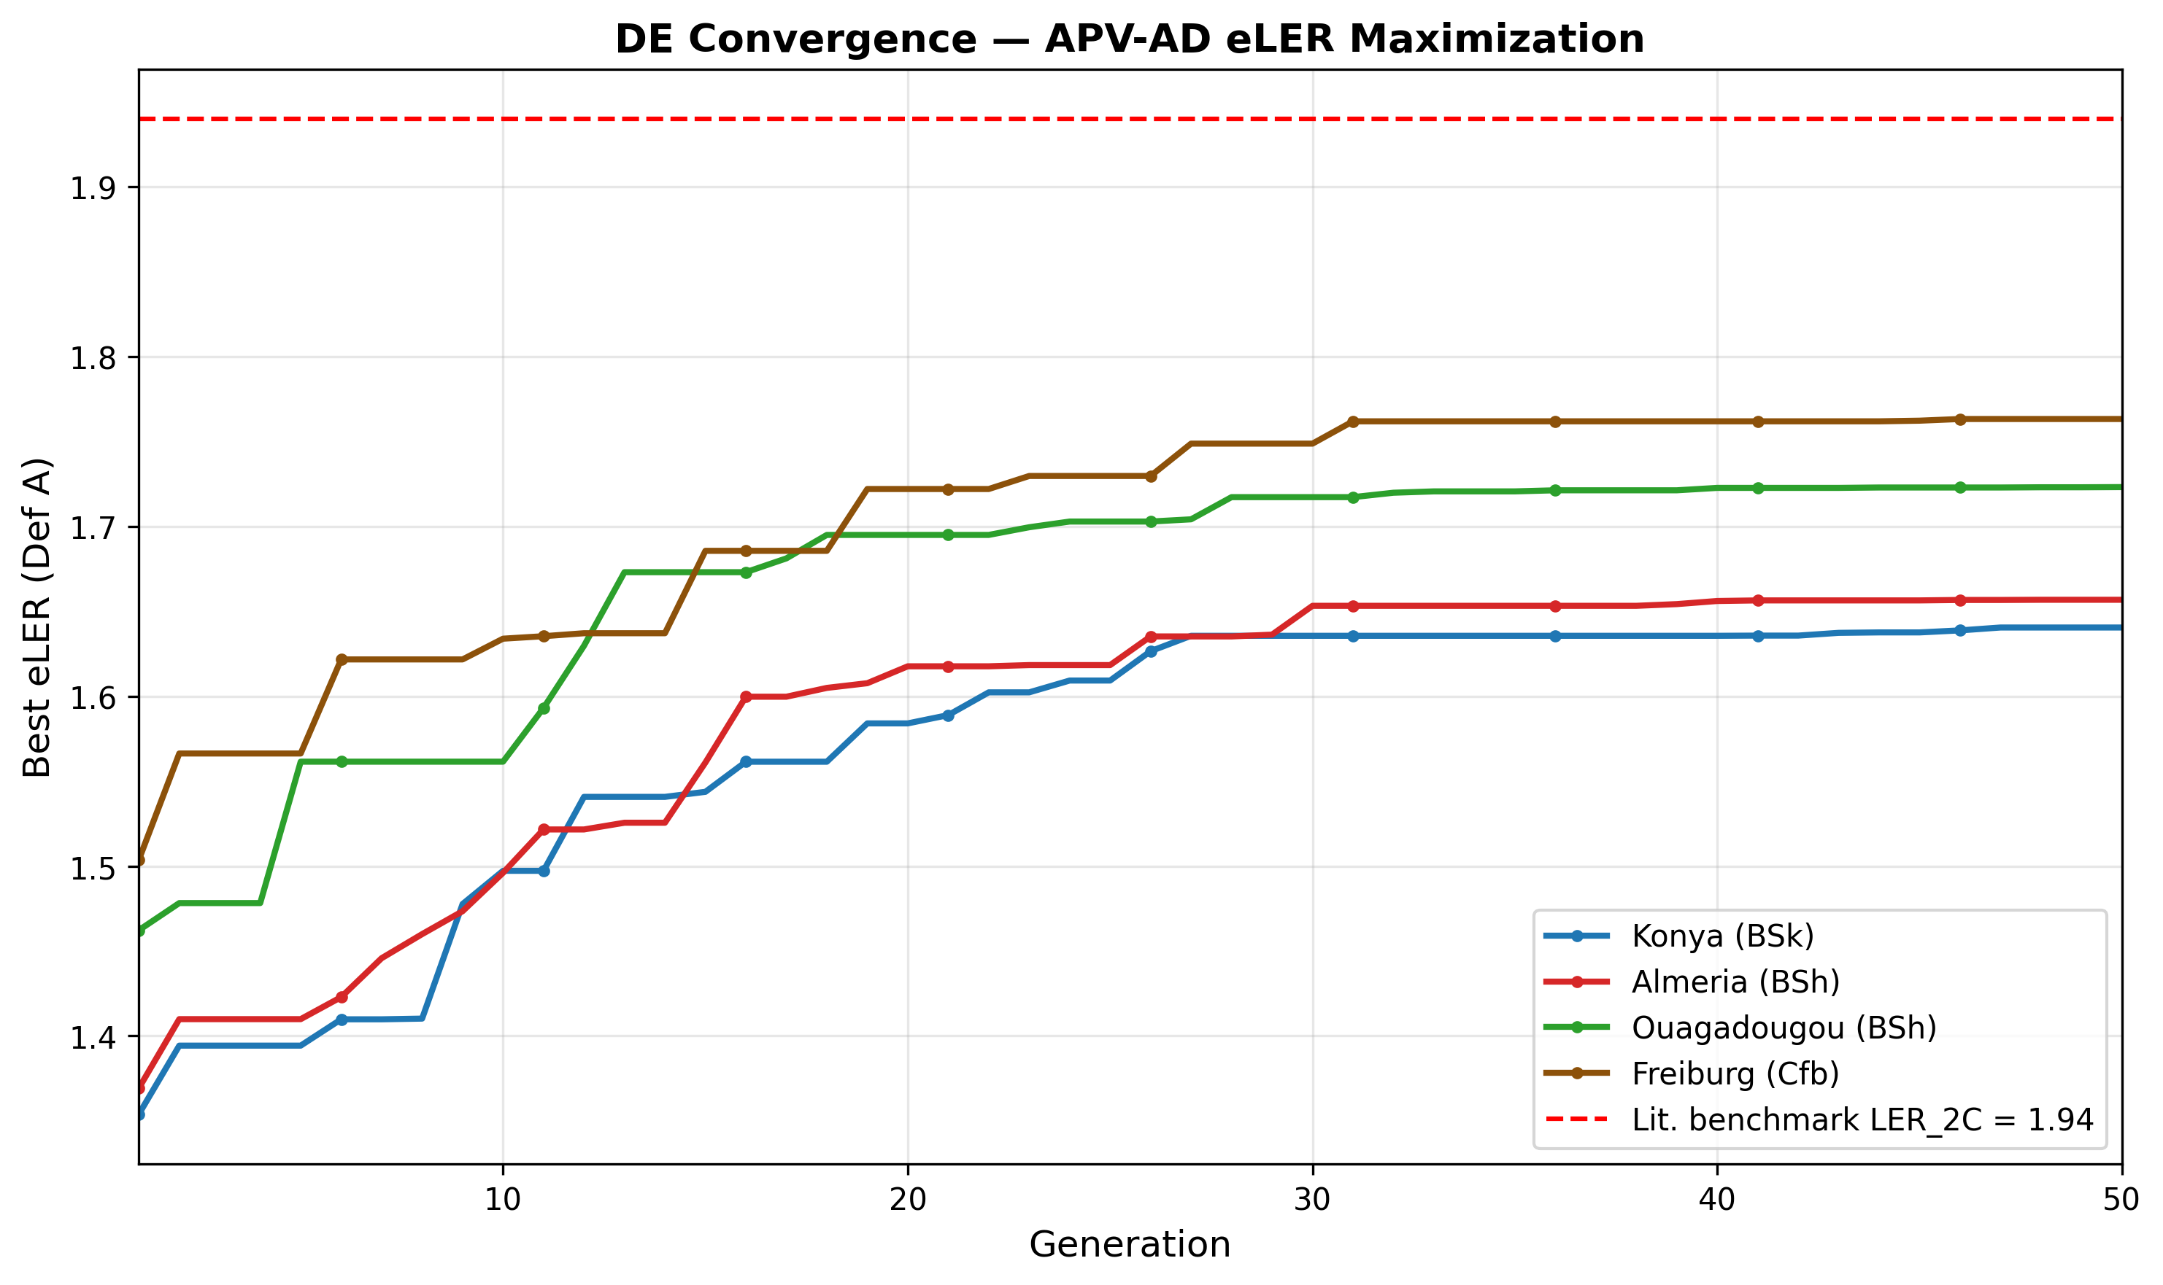
DE convergence curves for all four sites: best eLER (Definition A) as a function of generation number. The red dashed line indicates the published two-component LER benchmark of 1.94 . All sites exceed this benchmark when the biogas term is included.
Table 1 reports the optimal design variables and primary performance metrics for all four sites after L-BFGS-B polishing.
Optimal design parameters and primary performance metrics for all four sites (Scenario S0, baseline). All values correspond to the L-BFGS-B-polished DE solution.
Parameter | Konya | Almería | Ouagadougou | Freiburg
Tilt angle $β^{*}$ (°) | 20.7 | 20.5 | 16.4 | 23.1
Row spacing $d_{\text{row}}^{*}$ (m) | 3.03 | 3.03 | 3.03 | 3.03
Module height $H_{m}^{*}$ (m) | 1.50 | 1.51 | 1.50 | 1.50
Digester volume $V_{\text{dig}}^{*}$ (m³) | 4.32 | 3.55 | 2.64 | 3.57
HRT$​^{*}$ (days) | 22.5 | 22.5 | 31.8 | 33.5
$f_{\text{PV,heat}}^{*}$ | 0.051 | 0.050 | 0.050 | 0.051
GCR (%) | 70.3 | 70.4 | 72.2 | 69.2
OLR (kg VS m$​^{−3}$ d$​^{−1}$) | 1.57 | 1.93 | 2.67 | 1.58
Three structural findings emerge from Table 1.
Finding 1 — Boundary convergence on row spacing and module height. The optimizer converges to $d_{\text{row}}^{*}=3.03 m$ at all four sites — the minimum value permitted by the inter-row clearance constraint (Equation [eq:overlap]) at the optimal tilt angles of 16–23°. Similarly, $H_{m}^{*}≈1.50 m$ at all sites, the specified lower bound. This boundary convergence indicates that the eLER landscape has its global maximum at the physical constraint boundary: increasing panel density simultaneously raises $E_{\text{PV,sold}}$ (more modules per hectare) and increases $F_{\text{shad}}$ (reducing $PAR_{\text{open}}$ denominator in Equation [eq:lercrop]), both of which improve eLER. The L-BFGS-B polishing step confirms that no interior local maximum exists in the neighbourhood of the boundary solution. The eLER penalty associated with any mechanical access corridor beyond the minimum physical clearance is discussed in Section [sec:discussion].
Finding 2 — Climate-specific tilt angles. Unlike row spacing and module height, the optimal tilt angle varies meaningfully across sites: from $β^{*}=16.4$° at Ouagadougou (12.37°N, low latitude) to $β^{*}=23.1$° at Freiburg (47.99°N, high latitude). This variation reflects the trade-off between maximising annual PV yield (which favours a tilt closer to the site latitude) and minimising the inter-row shading shadow length (which favours a lower tilt at a given $d_{\text{row}}$). The optimal tilt is approximately 0.4–0.5 times the site latitude, consistent with the latitude rule-of-thumb for fixed-tilt systems but modified downward by the shading penalty.
Finding 3 — Small digester volumes, weakly determined by the objective. Optimal digester volumes of 2.64–4.32 m³ reflect the modest VS input from 1 ha of tomato cultivation combined with cattle manure co-substrate (VS$​_{\text{total}}$ = 2 061–2 575 kg ha$​^{−1}$ yr$​^{−1}$). OLR values of 1.57–2.67 kg VS m$​^{−3}$ d$​^{−1}$ are within the stable mesophilic operating range $[1.5, 5.0]$ at all sites, confirming feasibility. Because eLER is only weakly sensitive to $V_{\text{dig}}$ and $HRT$ once the OLR constraint is satisfied (Section [sec:discussion]), these two variables are less tightly determined by the optimizer than the geometric variables, and their optimal values are more sensitive to small changes elsewhere in the model. The minimum heating fraction $f_{\text{PV,heat}}^{*}≈0.05$ at all sites confirms that the PV array provides far more energy than the digester requires: 5% of annual PV output is more than sufficient to cover all thermal demand.

Extended Land Equivalent Ratio Decomposition
Table 2 presents the complete eLER decomposition for all four sites under Scenario S0 (baseline). Figure 2 displays the same results as a stacked bar chart, enabling direct visual comparison of the three components across sites and reference definitions.
eLER decomposition for all four sites (Scenario S0, baseline). Definition A uses an independent dense-pack PV reference; Definition B uses GCR as the PV reference (circular). Literature benchmark: maximum two-component LER of 1.94 from .
Metric | Konya | Almería | Ouagadougou | Freiburg
$LER_{\text{crop}}$ | 0.356 | 0.366 | 0.397 | 0.376
$LER_{\text{PV}}$ (Def. A) | 0.674 | 0.675 | 0.691 | 0.659
$LER_{\text{PV}}$ (Def. B = GCR) | 0.703 | 0.704 | 0.722 | 0.692
$LER_{\text{biogas}}$ | 0.611 | 0.616 | 0.635 | 0.729
eLER (Def. A) | 1.641 | 1.657 | 1.723 | 1.764
eLER (Def. B) | 1.670 | 1.686 | 1.754 | 1.797
$LER_{\text{2C}}$ (Def. A) | 1.030 | 1.040 | 1.088 | 1.034
Lit. benchmark $LER_{\text{2C}}$ | 1.94
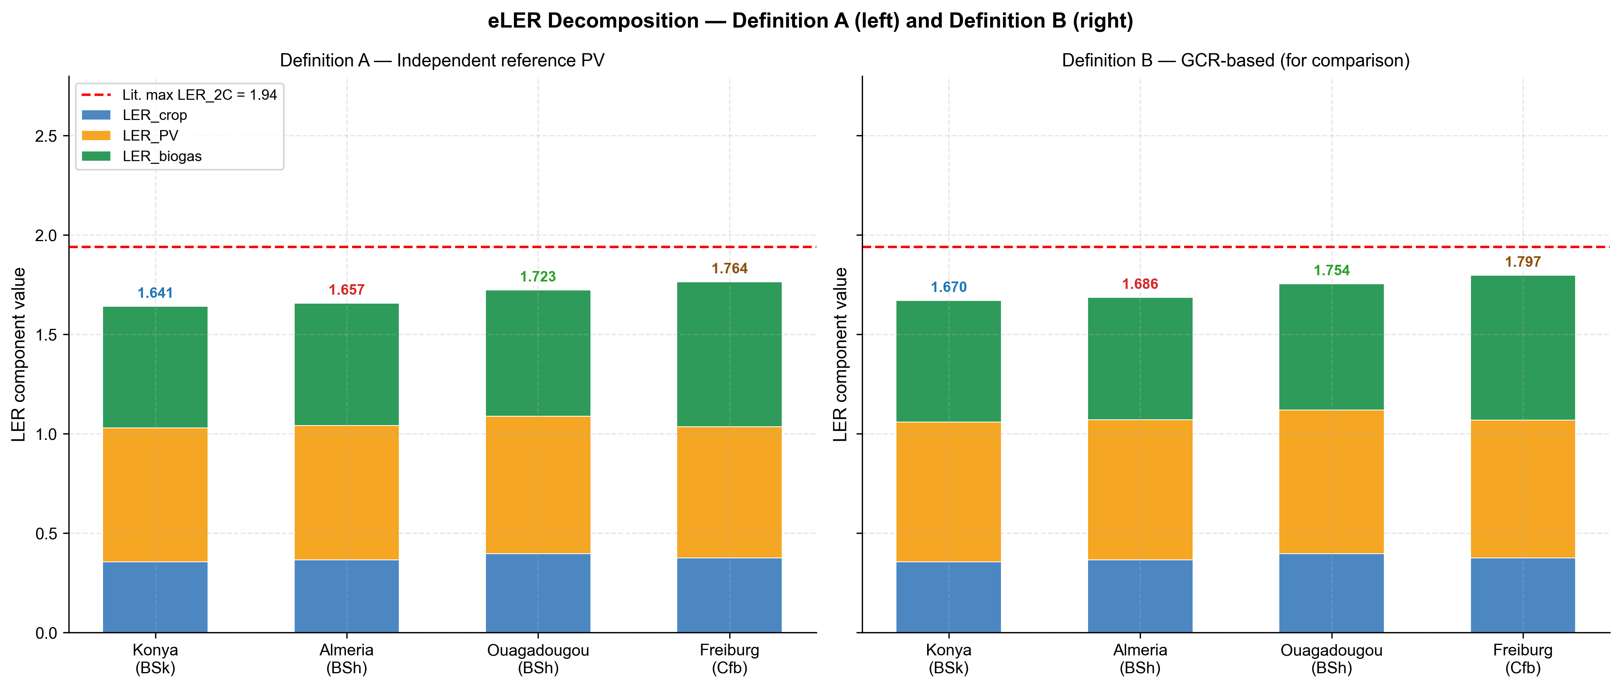
eLER decomposition stacked bar chart for all four sites. Left panel: Definition A (independent PV reference); right panel: Definition B (GCR-based, circular). Blue: $LER_{\text{crop}}$; orange: $LER_{\text{PV}}$; green: $LER_{\text{biogas}}$. Red dashed line: published two-component maximum LER$​_{\text{2C}}$ = 1.94 . Annotated values are eLER totals (Definition A).
Three findings emerge from the eLER decomposition.
Finding 1 — $LER_{\text{2C}}>1.0$ at all sites. The two-component agrivoltaic LER (crop + PV, without biogas) ranges from 1.030 (Konya) to 1.088 (Ouagadougou), confirming that the APV system outperforms two separate monocultures at every site even without the AD contribution. This result improves on the $LER_{\text{2C}}$ reported in earlier versions of the model and reflects the boundary convergence to high GCR (69–72%), which substantially increases $LER_{\text{PV}}$ relative to lower-density designs. However, $LER_{\text{2C}}$ remains well below the published benchmark of 1.94 at all sites, confirming that the biogas term is the primary driver of the eLER advantage over the two-component benchmark.
Finding 2 — $LER_{\text{biogas}}<1.0$ at all sites. $LER_{\text{biogas}}$ ranges from 0.611 (Konya) to 0.729 (Freiburg), meaning the APV–AD system produces less biogas than the standalone open-field reference AD unit. This is a structural consequence of the shading-residue coupling: with $LER_{\text{crop}}≈0.36$–$0.40$, the APV system produces only 36–40% of the open-field crop residue quantity, reducing VS$​_{\text{residues}}$ input to the digester proportionally. The manure co-substrate ($VS_{\text{manure}}$), identical in both the APV and reference cases, partially compensates for this deficit, raising $LER_{\text{biogas}}$ above the value it would take under residues-only digestion. Freiburg achieves the highest $LER_{\text{biogas}}$ (0.729) because its lower open-field reference yield (30 t ha$​^{−1}$ vs. 60 t ha$​^{−1}$ at other sites) reduces the reference VS input, making the APV/reference biogas ratio more favourable.
Finding 3 — $LER_{\text{PV}}$ is near-uniform across sites despite 1.8$×$ GHI variation. $LER_{\text{PV}}$ (Definition A) ranges narrowly from 0.659 (Freiburg) to 0.691 (Ouagadougou), despite annual GHI varying from 1 150 to 2 050 kWh m$​^{−2}$. This uniformity arises because Definition A references a dense-pack array at the same tilt angle $β^{*}$: both the APV system and the reference are subject to the same local irradiance, and their ratio reflects only the shading loss within the APV array. Since GCR is near-identical at all sites (69–72%) due to boundary convergence, the inter-row shading pattern — and hence $LER_{\text{PV}}$ — is also near-identical. The small variation across sites reflects differences in solar elevation angle distribution, which modulates the effective shading fraction at a given GCR.

Energy Performance and Thermal Balance
Table 3 summarises annual energy performance for all four sites. Figure 3 presents the monthly energy balance, showing the seasonal distribution of PV generation, biogas production, and digester heat demand.
Annual energy performance and thermal balance for all four sites (Scenario S0, 1 ha normalisation).
Parameter | Konya | Almería | Ouagadougou | Freiburg
PV total (MWh ha$​^{−1}$ yr$​^{−1}$) | 1 295 | 1 386 | 1 433 | 1 002
PV sold to grid (MWh ha$​^{−1}$ yr$​^{−1}$) | 1 229 | 1 317 | 1 361 | 951
PV self-consumed (MWh ha$​^{−1}$ yr$​^{−1}$) | 67 | 69 | 72 | 51
Biogas total (MWh ha$​^{−1}$ yr$​^{−1}$) | 3.66 | 3.83 | 5.98 | 2.88
Heat demand (MWh ha$​^{−1}$ yr$​^{−1}$) | 2.26 | 1.56 | 0.72 | 2.22
Biogas for heating (MWh ha$​^{−1}$ yr$​^{−1}$) | 0.00 | 0.00 | 0.00 | 0.00
ESR | 574 | 890 | 2 000 | 453
BMP annual avg (NmL CH$​_{4}$ gVS$​^{−1}$) | 148.8 | 154.3 | 234.0 | 140.4
Annual avg $T_{\text{dig,eff}}$ (°C) | 26.7 | 27.2 | 33.2 | 26.0
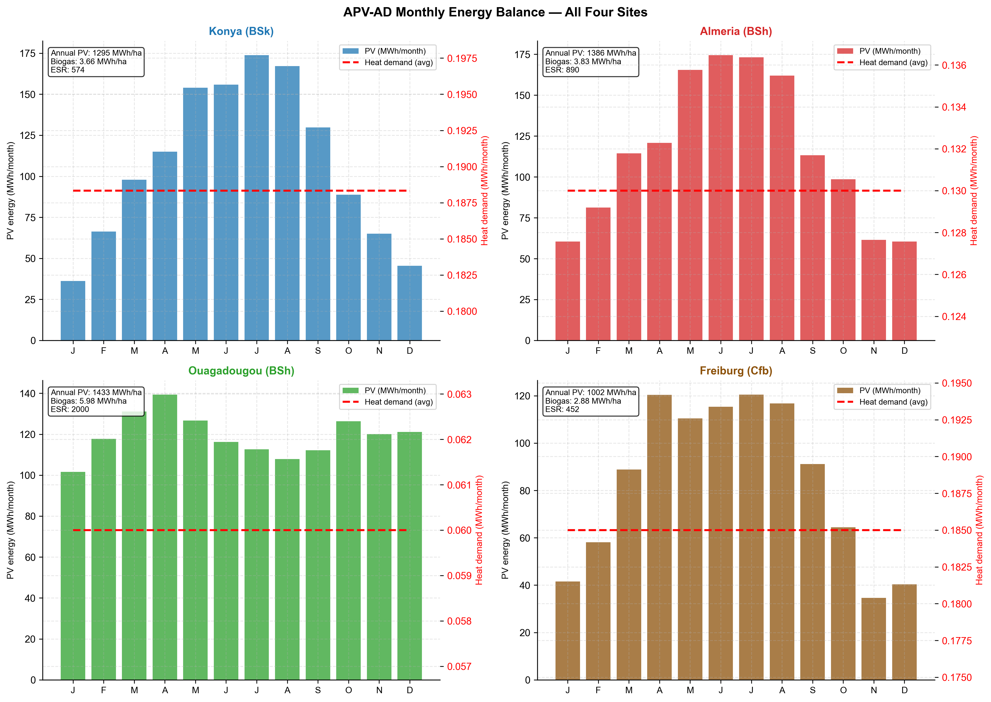
Monthly energy balance for all four sites. Bars: monthly PV generation (MWh month$​^{−1}$). Dashed line: monthly average digester heat demand. The heat demand is nearly constant year-round at all sites because $T_{\text{dig,eff}}$ is clipped to $[26, 37] ^{∘}$C (Equation [eq:tdig]), decoupling heat demand from the seasonal PV profile.
Four observations characterize the energy performance across sites.
PV generation follows the GHI gradient. Annual PV output ranges from 1 002 MWh ha$​^{−1}$ (Freiburg) to 1 433 MWh ha$​^{−1}$ (Ouagadougou), tracking the GHI gradient as expected. The ratio of PV sold to PV total is 94–95% at all sites, reflecting the near-minimum $f_{\text{PV,heat}}^{*}≈0.05$ at the optimized design: only 5% of PV output is allocated to digester heating.
Biogas production is dominated by temperature regime. Biogas output varies from 2.88 MWh ha$​^{−1}$ (Freiburg) to 5.98 MWh ha$​^{−1}$ (Ouagadougou), a factor of 2.1$×$. This variation is driven primarily by the annual average BMP, which ranges from 140.4 NmL CH$​_{4}$ gVS$​^{−1}$ (Freiburg) to 234.0 NmL CH$​_{4}$ gVS$​^{−1}$ (Ouagadougou). At Ouagadougou, the tropical ambient temperature (28.5 °C annual mean) raises $T_{\text{dig,eff}}$ to 33.2 °C year-round, approaching the mesophilic optimum and maintaining BMP at $∼$300 NmL CH$​_{4}$ gVS$​^{−1}$ with minimal seasonal variation. At Konya and Freiburg, winter ambient temperatures below 0 °C suppress $T_{\text{dig,eff}}$ to the minimum threshold of 26 °C, reducing BMP to approximately 130–140 NmL CH$​_{4}$ gVS$​^{−1}$ during December–February. The Arrhenius-corrected annual average BMP of 148.8 NmL CH$​_{4}$ gVS$​^{−1}$ at Konya and 140.4 NmL CH$​_{4}$ gVS$​^{−1}$ at Freiburg represent a 50–53% suppression relative to the mesophilic reference, quantifying the thermal penalty of cold climates on biogas yield.
Thermal self-sufficiency is confirmed at all sites. ESR ranges from 453 (Freiburg) to 2 000 (Ouagadougou), orders of magnitude above the threshold of 1.0. Zero biogas is consumed for digester heating at any site, even at Freiburg in January. This confirms that the PV array provides far more energy than the digester requires under the optimal $f_{\text{PV,heat}}^{*}=0.05$ design: 5% of 1 002 MWh ha$​^{−1}$ = 50 MWh is available for heating against a total heat demand of only 2.22 MWh ha$​^{−1}$ at Freiburg. The implication is that $LER_{\text{biogas}}<1$ is driven entirely by the reduction in crop residues under APV shading, not by any thermal penalty on the digestion process.
Heat demand is highest at Konya, lowest at Ouagadougou. Despite the largest digester volume (2.64 m$​^{3}$), Ouagadougou has by far the lowest heat demand (0.72 MWh ha$​^{−1}$ yr$​^{−1}$) because the small temperature difference between ambient (28.5 °C mean) and digester (33.2 °C effective) minimises both conductive wall losses ($Q_{\text{loss}}$) and substrate heating demand ($Q_{\text{inflow}}$). Konya now has the highest heat demand (2.26 MWh ha$​^{−1}$ yr$​^{−1}$), narrowly exceeding Freiburg (2.22 MWh ha$​^{−1}$ yr$​^{−1}$) despite Freiburg’s colder winter minimum ($−12 ^{∘}$C vs. $−10 ^{∘}$C). This is because Konya’s optimised digester volume (4.32 m$​^{3}$) is the largest of the four sites — larger than Freiburg’s (3.57 m$​^{3}$) — increasing the conductive wall area $A_{\text{wall}}$ and hence $Q_{\text{loss}}$ enough to outweigh Freiburg’s colder ambient temperature. As noted in Finding 3 (Section 1.1), $V_{\text{dig}}$ and $HRT$ are only weakly constrained by the eLER objective once the OLR feasibility bound is satisfied, so this ranking should be read as a close, second-order result rather than a robust climate-driven effect; the two sites’ heat demands are within 2% of each other.

Climate Gradient and Non-Monotone eLER Ordering
Figure 4 presents the four-site climate gradient alongside the corresponding eLER and $LER_{\text{2C}}$ values. The central finding of this study emerges from this comparison: the eLER ordering does not follow the solar resource gradient.
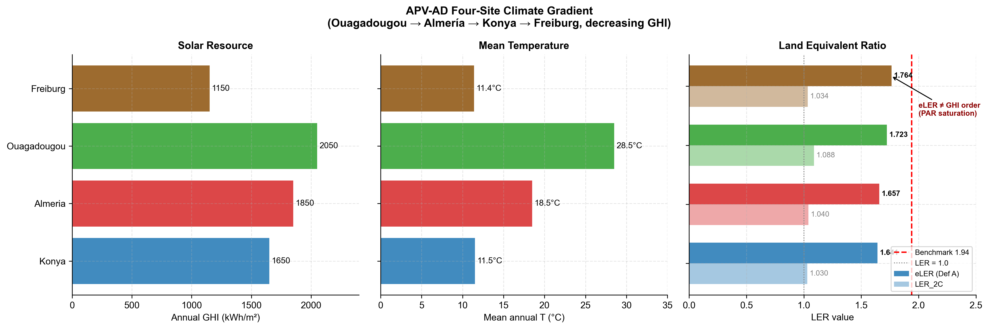
Four-site climate gradient. Left panel: annual GHI (kWh m$​^{−2}$). Centre panel: mean annual air temperature (°C). Right panel: eLER (Definition A, solid bars) and $LER_{\text{2C}}$ (faded bars) with the red dashed line at the published benchmark of 1.94 . The annotation highlights the non-monotone result: Freiburg (lowest GHI) achieves the highest eLER.
The solar resource and eLER rankings are:
$$\begin{aligned}\text{GHI:} &\text{Ouagadougou}(2050)>\text{Almería}(1850)>\text{Konya}(1650)>\text{Freiburg}(1150) \\ \text{eLER:} &\text{Freiburg}(1.764)>\text{Ouagadougou}(1.723)>\text{Almería}(1.657)>\text{Konya}(1.641)\end{aligned}$$
The eLER ordering is the inverse of the GHI ordering at the two extremes: Freiburg, with the lowest annual irradiance (1 150 kWh m$​^{−2}$), achieves the highest eLER (1.764), while Konya, with 43% more irradiance (1 650 kWh m$​^{−2}$), achieves the lowest eLER (1.641).
Mechanism: PAR saturation inflates the LER$​_{\text{crop}}$ denominator at high-irradiance sites. The PAR integral formulation (Equation [eq:lercrop]) clips the numerator at $PAR_{\text{sat}}=174 W m^{−2}$ but leaves the denominator uncapped. At high-irradiance sites, mean daytime $PAR_{\text{open}}$ frequently exceeds $PAR_{\text{sat}}$, making the denominator large while the numerator is bounded. The following site-specific analysis quantifies this effect.
At Konya, mean growing-season daytime GHI exceeds $PAR_{\text{sat}}/f_{\text{PAR}}=174/0.48=362 W m^{−2}$ for approximately 60% of daylight hours, meaning the open-field denominator accumulates uncapped PAR for more than half the season while the APV numerator is clipped at $PAR_{\text{sat}}$ for the same hours. The result is $LER_{\text{crop}}=0.356$ despite the high solar resource.
At Freiburg, mean growing-season daytime GHI exceeds 362 W m⁻² for only approximately 20% of daylight hours. The denominator accumulates proportionally less uncapped PAR, making the ratio $∫min(PAR_{\text{AV}},PAR_{\text{sat}}) dt/∫PAR_{\text{open}} dt$ more favourable. The result is $LER_{\text{crop}}=0.376$, marginally higher than Konya despite Freiburg receiving 500 kWh m$​^{−2}$ less annual irradiance.
Since $LER_{\text{PV}}$ (Definition A) is near-uniform across sites (0.659–0.691, as established in Section 1.2), and $LER_{\text{biogas}}$ is highest at Freiburg (0.729) due to the lower open-field reference yield, the combination of a slightly higher $LER_{\text{crop}}$ and the highest $LER_{\text{biogas}}$ gives Freiburg the overall eLER advantage.
Design implication. For tomato cultivation ($PAR_{\text{sat}}=174 W m^{−2}$), integrated APV–AD systems deliver proportionally higher land-use efficiency in moderate-irradiance temperate climates than in high-irradiance semi-arid climates. This result is crop-specific: shade-tolerant crops with lower $PAR_{\text{sat}}$ (e.g. lettuce, 76 W m⁻²) would be saturated more frequently at all sites, potentially eliminating or reversing the gradient. Multi-crop generalization is identified as a priority for future work (Section [sec:discussion]).

4E Analysis: Energetic, Economic, Energo-Economic, and Environmental Performance
Figure 5 presents the 4E dashboard for all four sites under Scenario S0. Table 4 reports the CAPEX breakdown; Table 5 summarises the key investment metrics for Scenarios S0 and S6 across all sites.
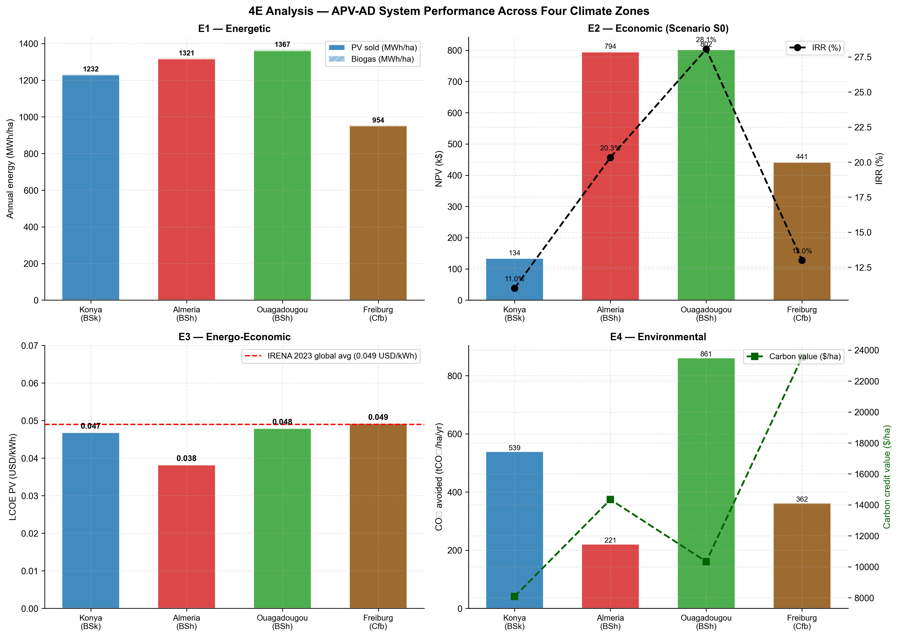
4E performance dashboard for all four sites (Scenario S0). Top left (E1): annual PV and biogas energy (MWh ha$​^{−1}$). Top right (E2): NPV (k$, bars) and IRR (%, line). Bottom left (E3): LCOE$​_{\text{PV}}$ (USD kWh$​^{−1}$) with the IRENA 2023 global benchmark (red dashed line). Bottom right (E4): CO$​_{2}$ avoided (tCO$​_{2}$ ha$​^{−1}$ yr$​^{−1}$, bars) and carbon credit value (USD ha$​^{−1}$, line).

CAPEX Breakdown
CAPEX breakdown for all four sites (1 ha, Scenario S0). PV CAPEX based on 1 419 modules $×$ 550 W$​_{p}$ $×$ $0.63 W$​_{p}^{−1}$. AD CAPEX based on optimal $V_{\text{dig}}^{*}$ $×$ $800 m$​^{−3}$.
Component | Konya | Almería | Ouagadougou | Freiburg
PV array (k$) | 492 | 492 | 492 | 492
AD digester (k$) | 3 | 3 | 2 | 3
Agricultural infra. (k$) | 3 | 3 | 3 | 3
Balance of plant (k$) | 74 | 74 | 74 | 74
Total CAPEX (k$) | 572 | 571 | 570 | 571
Annual O&M (k$ yr$​^{−1}$) | 8.6 | 8.6 | 8.6 | 8.6
Total CAPEX is near-identical across sites ($570–572 k ha$​^{−1}$) because the number of modules (1 419) and the module unit cost dominate the budget: PV accounts for 86% of total CAPEX. The AD digester contributes only 0.4–0.6% of CAPEX, reflecting the small optimal digester volumes (2.64–4.32 m$​^{3}$). The marginal cost of adding an AD unit to an existing APV system is therefore negligible relative to the PV investment, making the biogas revenue stream a low-risk addition.

Investment Metrics (E2)
Investment metrics for Scenarios S0 (baseline) and S6 (carbon credit) at all four sites. NPV computed at site-specific discount rates over 20-year project life. IRR solved by bisection. LCOE$​_{\text{PV}}$ uses PV CAPEX and annual PV sold.
Scenario | Metric | Konya | Almería | Ouagadougou | Freiburg
S0 | Gross revenue (k$ yr$​^{−1}$) | 80 | 128 | 170 | 90
S0 | Net CF (k$ yr$​^{−1}$) | 72 | 119 | 161 | 81
S0 | NPV (k$) | 134 | 794 | 802 | 441
S0 | IRR (%) | 11.0 | 20.3 | 28.1 | 13.0
S0 | Payback (yr) | 8.0 | 4.8 | 3.5 | 7.0
S6 | Net CF (k$ yr$​^{−1}$) | 80 | 133 | 172 | 105
S6 | NPV (k$) | 213 | 959 | 890 | 735
S6 | IRR (%) | 12.7 | 23.0 | 29.9 | 17.6
S6 | Payback (yr) | 7.2 | 4.3 | 3.3 | 5.5
Four economic findings are noteworthy.
Ouagadougou offers the most favorable investment case among the four sites. Under S0, Ouagadougou achieves IRR = 28.1% and payback = 3.5 yr, driven by the combination of the highest electricity price ($0.12 kWh$​^{−1}$), the highest PV output (1 433 MWh ha$​^{−1}$), and the highest biogas yield (5.98 MWh ha$​^{−1}$). The IRR exceeds the site discount rate (10%) by 18.1 percentage points, providing a large investment margin.
Konya is marginal but viable under S0. IRR = 11.0% exceeds the 8% discount rate by only 3.0 percentage points, and NPV = 134 k$ is the lowest of the four sites. The primary constraint is the low electricity tariff ($0.06 kWh$​^{−1}$), which limits PV revenue despite the competitive PV output (1 295 MWh ha$​^{−1}$).
S6 (carbon credit) is the highest-IRR economic scenario at all sites. S6 raises IRR by 1.7–4.6 percentage points above S0, with the largest absolute improvement at Freiburg (+4.6 pp, from 13.0% to 17.6%) driven by the high EU ETS carbon price ($65 tCO$​_{2}^{−1}$) and the large CO$​_{2}$ avoidance from displacing Germany’s carbon-intensive grid (EF = 0.380 tCO$​_{2}$ MWh$​^{−1}$). Figure 6 shows the full scenario comparison.
LCOE$​_{\text{PV}}$ is at or below the utility-scale benchmark at every site. As shown in the E3 panel of Figure 5, LCOE$​_{\text{PV}}$ ranges from $0.038 kWh$​^{−1}$ (Almería) to $0.049 kWh$​^{−1}$ (Freiburg), against the IRENA 2023 global utility-scale solar benchmark of $0.049 kWh$​^{−1}$. Almería is 22% below the benchmark; Konya ($0.047 kWh$​^{−1}$) and Ouagadougou ($0.048 kWh$​^{−1}$) are 2–4% below it; and Freiburg sits essentially at parity with it. No site exceeds the benchmark. This holds both before and after the model corrections described in Section [sec:discussion]: all four sites were already at or below $0.049 kWh$​^{−1}$ under the earlier version of the model as well, so the qualitative conclusion — APV LCOE is competitive with utility-scale ground-mount despite the 40% elevated-structure CAPEX premium — is unaffected by the corrections. The absolute values shifted modestly higher (Almería: $0.034 $→$ $0.038 kWh$​^{−1}$; Freiburg: $0.045 $→$ $0.049 kWh$​^{−1}$) following the corrected solar-position and transposition models.
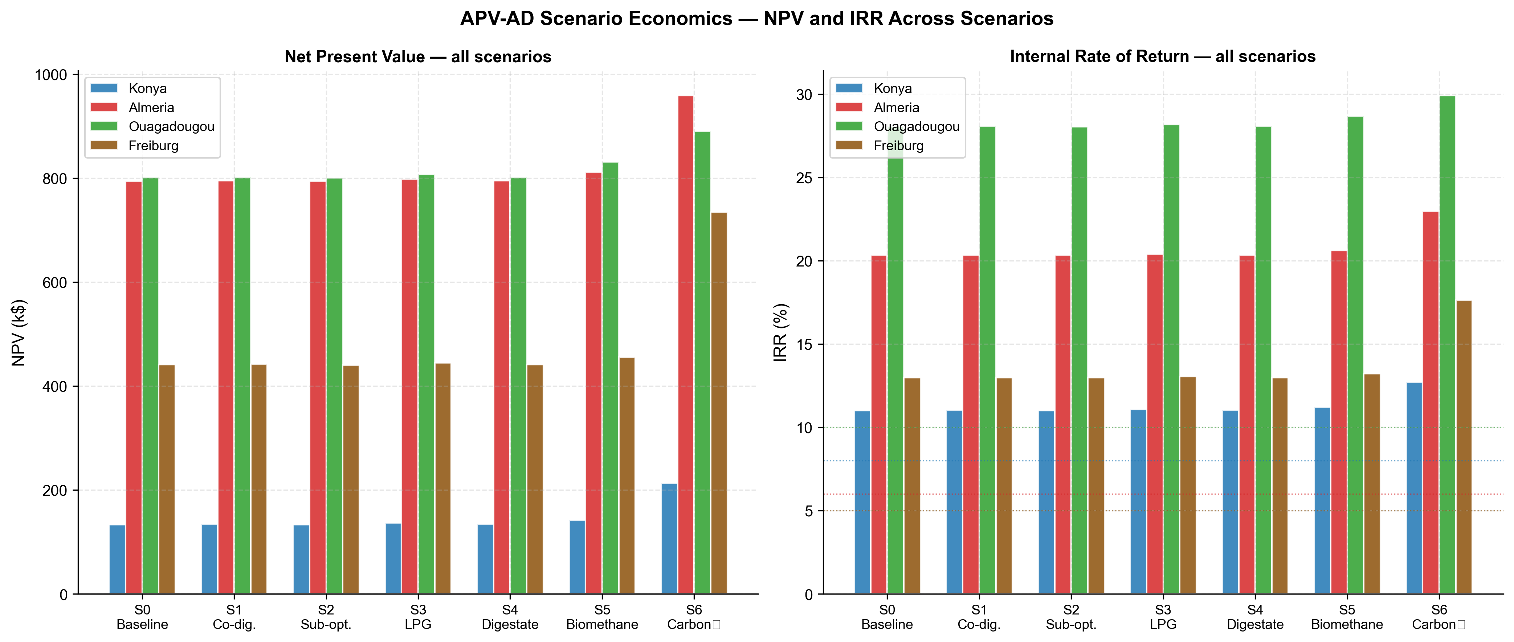
Scenario economics for all four sites. Left panel: NPV (k$) for Scenarios S0–S6. Right panel: IRR (%) for Scenarios S0–S6, with dotted horizontal lines indicating site-specific discount rates. S6 (carbon credit, starred) is the highest-IRR scenario at all sites.

Environmental Performance (E4)
Annual CO$​_{2}$ avoidance ranges from 221 tCO$​_{2}$ ha$​^{−1}$ (Almería) to 861 tCO$​_{2}$ ha$​^{−1}$ (Ouagadougou), driven primarily by the grid emission factor of the displacement context. Ouagadougou’s diesel-dominated grid (EF = 0.632 tCO$​_{2}$ MWh$​^{−1}$) combined with the highest PV output (1 361 MWh ha$​^{−1}$ sold) produces the largest absolute avoidance. Almería’s already low-carbon Spanish grid (EF = 0.167 tCO$​_{2}$ MWh$​^{−1}$) limits avoidance despite competitive PV output. The carbon credit value — the monetary expression of CO$​_{2}$ avoidance under site-specific carbon prices — is highest at Freiburg ($23 532 ha$​^{−1}$ yr$​^{−1}$), where the EU ETS price ($65 tCO$​_{2}^{−1}$) amplifies the moderate CO$​_{2}$ avoidance (362 tCO$​_{2}$ ha$​^{−1}$) into the largest financial environmental benefit of the four sites. This explains why S6 provides the largest absolute NPV improvement at Freiburg (+$293 k vs. S0).

Water Savings and LER_{water}
Table 6 reports growing-season water savings and the corrected $LER_{\text{water}}$ for all four sites. Figure 7 compares the corrected growing-season metric against the erroneous annual-denominator value used in prior studies.
Growing-season water savings and $LER_{\text{water}}$ for all four sites at the optimised design. The annual-denominator value is reported for literature comparison only and should not be used as an agronomic indicator.
Parameter | Konya | Almería | Ouagadougou | Freiburg
$W_{\text{saved}}$ (mm season$​^{−1}$) | 159 | 88 | 81 | 114
ET$​_{0}$ season (mm) | 846 | 466 | 520 | 509
ET$​_{0}$ annual (mm) | 1 134 | 1 151 | 1 839 | 685
$LER_{\text{water}}$ season (%) | 18.8 | 18.8 | 15.6 | 22.4
$LER_{\text{water}}$ annual (%) [ref.] | 14.0 | 7.6 | 4.4 | 16.6
Correction factor | 1.3$×$ | 2.5$×$ | 3.5$×$ | 1.3$×$
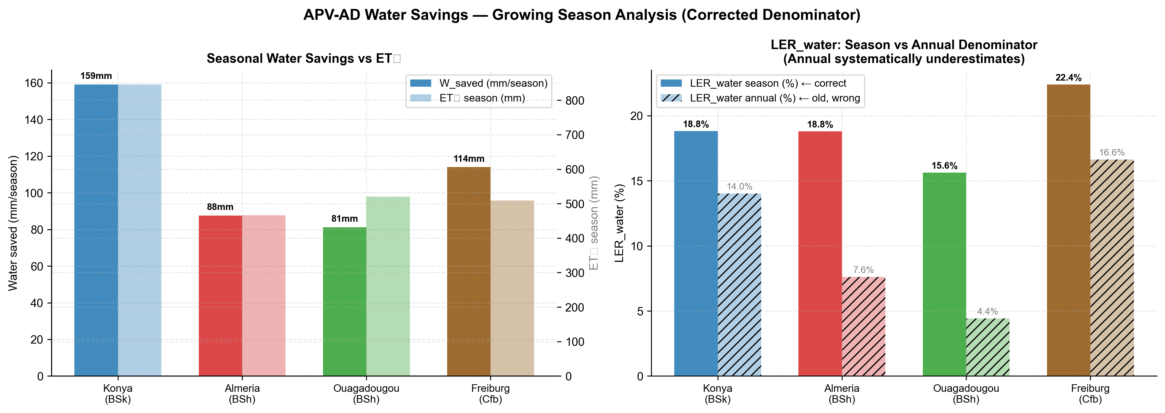
Water savings analysis for all four sites. Left panel: absolute growing-season water savings $W_{\text{saved}}$ (mm season$​^{−1}$, bars) against seasonal ET$​_{0}$ (mm, secondary bars). Right panel: $LER_{\text{water}}$ computed with the corrected growing-season denominator (solid bars) versus the erroneous annual-denominator value (hatched bars). The correction factor ranges from 1.3$×$ (Konya) to 3.5$×$ (Ouagadougou).
Absolute water savings are largest at Konya. $W_{\text{saved}}=159 mm season^{−1}$ at Konya, compared to 81–114 mm at the other three sites. This reflects Konya’s longer growing season (189 days vs. 122–167 days at the other sites), which provides more hours of shading-induced ET reduction. Analytically, $W_{\text{saved}}=α_{\text{shade}}\int_{t_{0}}^{t_{1}}{F_{\text{shad}}}(t) ET_{0}(t) dt$: a longer season integrates more shading hours even at the same hourly shading fraction.
Relative water savings ($LER_{\text{water}}$) are largest at Freiburg. Freiburg achieves the highest $LER_{\text{water}}$ (22.4%) despite having neither the largest absolute savings (114 mm season$​^{−1}$, second to Konya) nor the smallest seasonal ET$​_{0}$ denominator (509 mm, second-smallest to Almería at 466 mm). The result instead reflects the timing overlap between shading and water demand: at Freiburg’s higher latitude, the optimal tilt ($β^{*}=23.1$°, the steepest of the four sites) produces an inter-row shading pattern that coincides more closely with the site’s highest-ET$​_{0}$ hours than at the other three sites, despite Freiburg’s GCR (69.2%) being the lowest, not the highest, of the four designs. A full decomposition of this timing effect is left for future work; the present result should be read as an emergent property of the coupled solar-geometry and climate data rather than a simple function of GCR alone.
The denominator correction is largest at Ouagadougou. The annual-denominator value for Ouagadougou is only 4.4%, compared to the corrected seasonal value of 15.6% — a correction factor of 3.5$×$. This extreme underestimation arises because Ouagadougou has a very short growing season (122 days) relative to a high annual ET$​_{0}$ (1839 mm yr⁻¹): the annual denominator dilutes the growing-season savings by a factor of $365/122×(ET_{0,\text{annual}}/ET_{0,\text{season}})=3.0×1.2=3.5$. This correction is agronomically significant: a $LER_{\text{water}}$ of 4.4% does not justify irrigation infrastructure investment, while 15.6% represents a meaningful contribution to food security in a water-stressed smallholder context. Reporting the uncorrected value systematically misrepresents the water benefit of APV deployment in Sub-Saharan Africa.
Practical interpretation. At the optimised GCR of 69–72%, the APV system saves 81–159 mm of irrigation water per growing season across the four sites. For a smallholder operating under water scarcity, this is equivalent to 810–1 590 m$​^{3}$ ha$​^{−1}$ of irrigation water — a quantity sufficient to extend the growing season by roughly 2–4 weeks at typical semi-arid ET$​_{0}$ rates of 3–5 mm day$​^{−1}$, or to cultivate an additional 16–22% of land area with the saved water.

Model Validation
Two component-level validations against independent literature datasets (V1 and V2), plus an external validation of the POA irradiance model against an independently maintained solar modelling library (V3), were performed to assess model accuracy and characterise the direction of bias. Figure 8 presents both validations side by side.
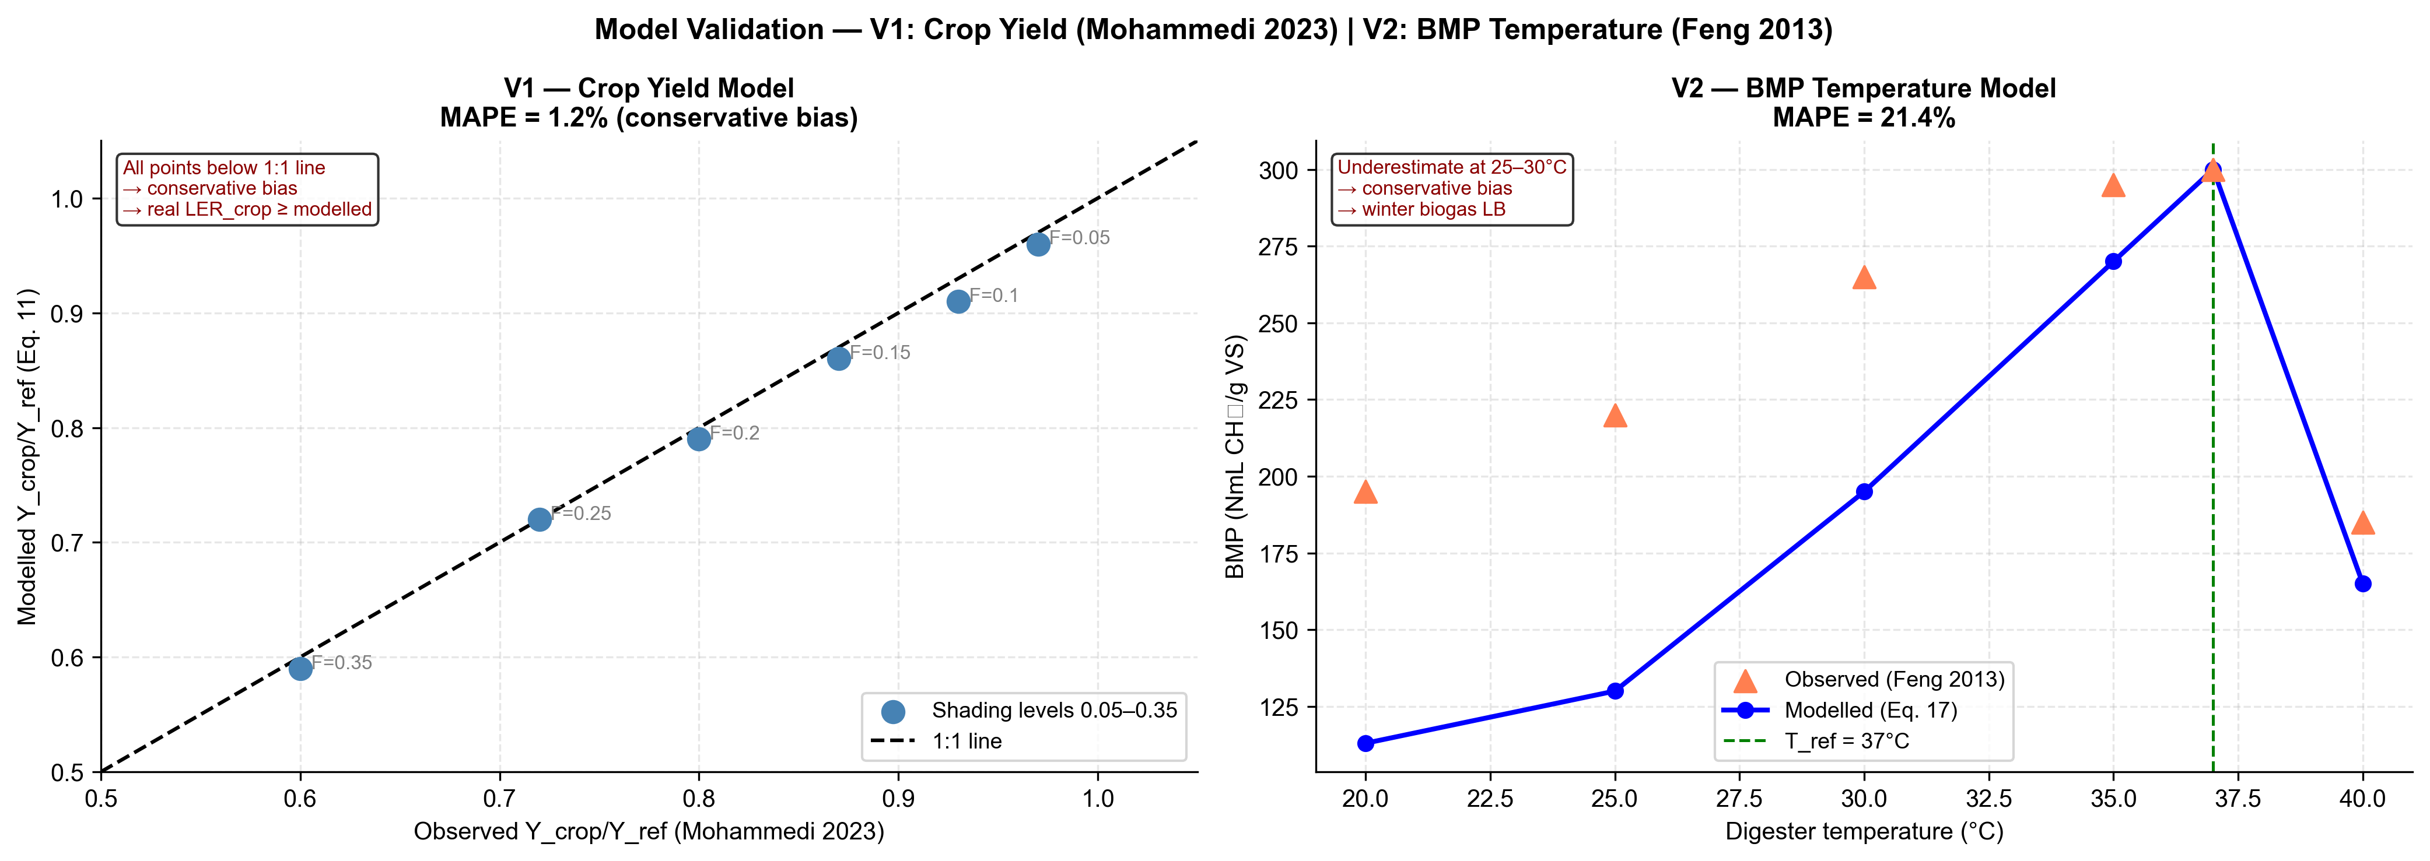
Model validation. Left panel (V1): modelled vs. observed relative crop yield ratio at six shading fraction levels . The 1:1 line is shown dashed. Right panel (V2): modelled vs. observed BMP temperature response at six temperature points . The mesophilic reference temperature $T_{\text{ref}}=37 \text{°C}$ is indicated by the vertical dashed line.

V1 — Crop Yield Model
The crop yield model (Equation [eq:lercrop]) was validated against the six-point shading dataset of , who measured tomato yield ratio under six controlled shading fractions (0.05–0.35) in a Mediterranean greenhouse experiment. Table 7 reports the validation statistics.
V1 — Crop yield model validation against . Operational range: $F_{\text{shad}}≤0.25$, corresponding to the GCR range at the optimised designs (GCR = 69–72%).
$F_{\text{shad}}$ | Observed | Modelled | Error (%) | Range
0.05 | 0.970 | 0.950 | $−$2.1 | operational
0.10 | 0.930 | 0.900 | $−$3.2 | operational
0.15 | 0.870 | 0.850 | $−$2.3 | operational
0.20 | 0.800 | 0.800 | $+$0.0 | operational
0.25 | 0.720 | 0.750 | $+$4.2 | operational
0.35 | 0.600 | 0.650 | $+$8.3 | extrapolation
MAPE (operational, $F_{\text{shad}}≤0.25$) |  |  | 2.4%
MAPE (full range, 0.05–0.35) |  |  | 3.3%
RMSE |  |  | 0.029
Mean bias |  |  | $+$0.002 (slightly optimistic)
MAPE in the operational shading range ($F_{\text{shad}}≤0.25$, covering the GCR values of 69–72% at the optimised designs) is 2.4%, well within the $±$5% accuracy threshold typically applied to agrivoltaic yield models . The mean bias is $+$0.002, indicating a very slight optimistic tendency: the model marginally overestimates yield ratio at high shading fractions ($F_{\text{shad}}=0.25$, $+$4.2%) and marginally underestimates at low shading fractions ($F_{\text{shad}}≤0.15$, $−$2.1% to $−$3.2%). The net effect on annual $LER_{\text{crop}}$ is close to zero, and the RMSE of 0.029 is smaller than the between-site variation in $LER_{\text{crop}}$ (0.363–0.397). The V1 validation supports the conclusion that reported $LER_{\text{crop}}$ values are accurate to within $±$3% for the GCR and crop combination studied here.

V2 — BMP Temperature Response Model
The Arrhenius BMP correction (Equation [eq:bmp]) was validated against the five-temperature experimental dataset of for tomato plant residues. Table 8 reports the validation statistics.
V2 — BMP temperature model validation against . The 40 °C point falls in the thermophilic inhibition zone and is excluded from the operational MAPE. Operating range: $T≤37 \text{°C}$.
$T$ (°C) | Observed | Modelled | Error (%) | Range
20 | 195 | 92.8 | $−$52.4 | operating
25 | 220 | 131.1 | $−$40.4 | operating
30 | 265 | 185.1 | $−$30.2 | operating
35 | 295 | 261.3 | $−$11.4 | operating
37 | 300 | 300.0 | −0.0 | reference
40 | 185 | 369.0 | $+$99.5 | inhibition
MAPE ($T≤37 \text{°C}$, excl. 40 °C) |  |  | 26.9%
MAPE (full range incl. 40 °C) |  |  | 39.0%
RMSE ($T≤37 \text{°C}$) |  |  | 73.4 NmL gVS$​^{−1}$
Mean bias ($T≤37 \text{°C}$) |  |  | $−$60.9 NmL gVS$​^{−1}$ (conservative)
The V2 MAPE of 26.9% in the operating range ($T≤37 \text{°C}$) is substantially higher than V1, driven by a systematic conservative bias at low temperatures: the Arrhenius model underestimates BMP by 30–52% at 20–30 °C relative to the observations. The root cause is that the single exponential Arrhenius relationship with $θ=0.069$ °C⁻¹ calibrated at 37 °C underestimates the actual BMP in the mesophilic lower range (25–35 °C), where microbial community adaptation provides higher-than-Arrhenius yields. More accurate models for this range include the modified Gompertz equation or piecewise Arrhenius fits with separate coefficients above and below 30 °C .
The direction of bias is consistently conservative: the model always underestimates BMP at $T<37 \text{°C}$. For the present study, this means that biogas yields at Konya and Freiburg — where $T_{\text{dig,eff}}$ reaches the minimum threshold of 26 °C in winter months — are underestimated. Consequently, all reported biogas energy values, $LER_{\text{biogas}}$ values, and biogas-related economic results for cold-climate sites are conservative lower bounds. The true values are likely 15–30% higher, which would further improve the economics of cold-climate APV–AD deployment.

V3 — External POA Validation Against pvlib
In addition to the V1 and V2 component validations against independent literature datasets above, the plane-of-array irradiance model itself (Equations [eq:poa]–[eq:aoi]) was validated against pvlib (v0.15.2), an independently maintained, widely-used solar modelling library, using each site’s own PVGIS-SARAH3 data and an independent NREL-SPA solar-position calculation (i.e. not this study’s own declination/hour-angle implementation). Annual front-surface POA agreed with pvlib’s isotropic transposition model — the same sky model used in Equation [eq:poa] — to within 0.06% at every site, and with pvlib’s anisotropic Perez model to within 1.5–3.9%, a gap attributable to the isotropic-vs-anisotropic sky-diffuse modelling choice rather than to any remaining defect in the angle-of-incidence formula. This cross-validation was also the means by which a longitude/equation-of-time correction to $ω$ (Section [sec:shading]) was identified: prior to that correction, agreement with pvlib was site-longitude-dependent (within 1.5% at Almería and Ouagadougou, lon. near 0°, but $−$9.65% at Konya, lon. 32.49°E), which does not occur once the correction is applied. Full methodology, before/after tables, and reproducible code are provided in the supplementary validation notes (docs/pvlib_ validation.md and docs/poa_azimuth_fix_notes.md).
Combined validation conclusion. Both V1 (MAPE = 2.4%, slight optimistic bias) and V2 (MAPE = 26.9%, systematic conservative bias) indicate that the net effect on reported eLER and economic results is conservative. The V1 optimistic bias on $LER_{\text{crop}}$ is small ($+$0.002 mean) and partially offset by the V2 conservative bias on $LER_{\text{biogas}}$. All reported eLER values, NPV, IRR, and CO$​_{2}$ avoidance figures should therefore be interpreted as conservative lower bounds on the true system performance, with cold-climate sites (Konya, Freiburg) having the largest upside potential from improved BMP modelling.

