SEMINAR DOCUMENT

Renewable Energy Integrated
Biogas Production

A Literature Review on Anaerobic Digestion, Hybrid Renewable Systems,
Agricultural Synergies, and the APV+AD Frontier

Submitted by: Amidou MAIGA
401255005@erciyes.edu.tr
Student ID: 4012550005

Submitted to: Prof. Dr. Gamze GENÇ
Energy Systems Engineering
Erciyes University

2025 – 2026 Academic Year
Seminar in Renewable Energy Engineering

Table of Contents

Abstract 3
1. Introduction 4
2. Global Policy Context and Market Dynamics 4
2.1 The International Policy Landscape 4
2.2 Regional Market Dynamics 6
2.3 Upgrading from Biogas to Biomethane: The Policy Case 8
3. Anaerobic Digestion: Fundamentals, Feedstocks, and Upgrading 8
3.1 Process Fundamentals 8
3.2 Feedstock Diversity and Co-Digestion 10
3.3 Biogas Upgrading Technologies 11
4. Hybrid Renewable Systems: PV-Biogas Integration 12
4.1 Rationale and System Architecture 12
4.2 Economic Performance and Sensitivity Analysis 13
4.3 Thermal Integration and the Digester Heat Demand 14
5. Agrivoltaics and Anaerobic Digestion: The APV+AD Frontier 14
5.1 Definition and Motivation 14
5.2 The First Optimization Framework for APV+AD 15
5.3 The eLER Metric: Quantifying Dual-Use Land Efficiency 15
5.4 Agricultural Synergies and Farm Decarbonization 16
6. Multi-Generation Integration and Circular Economy Opportunities 17
6.1 Polygeneration System Architectures 17
6.2 Circular Bioeconomy and Waste Valorization 18
6.3 Power-to-X and Green Hydrogen Pathways 19
6.4 Research Gaps in Multi-Generation Integration 20
7. Synthesis, Research Gaps, and Future Directions 20
7.1 Synthesis of Literature Findings 20
7.2 Identified Research Gaps 21
7.3 Future Research Directions 22
8. Conclusion 23
References 25

Abstract
Biogas produced through anaerobic digestion (AD) has emerged as one of the most versatile and dispatchable renewable energy vectors of the twenty-first century (Alengebawy et al., 2024; Sher et al., 2024). Unlike intermittent solar or wind power, biogas can be stored, dispatched on demand, and upgraded to pipeline-quality biomethane, positioning it as a cornerstone of emerging net-zero energy strategies (IEA, 2025; Gas for Climate Consortium, 2022). This seminar document presents a structured literature review covering the global policy landscape, fundamental AD science, hybrid photovoltaic-biogas system design, the nascent field of agrivoltaic-powered AD plants, multi-generation integration frameworks, and circular-economy opportunities. Drawing on peer-reviewed literature and technical reports published between 2020 and 2026, it synthesizes key findings from the IEA Renewables 2025 outlook (IEA, 2025), the European Biogas Association (EBA, 2025), and frontier research on the first optimization framework coupling bifacial agrivoltaic (APV) systems with AD for biomethane production (Nik Zad et al., 2026). A particular emphasis is placed on the eLER (energy Land Equivalent Ratio) metric as a novel tool for evaluating the dual-use efficiency of APV+AD systems (Nik Zad et al., 2026). The document identifies critical research gaps and proposes future directions at the intersection of renewable energy engineering, agricultural systems science, and circular economy design.
Key works: Biogas, Biomethane, Anaerobic digestion, Renewable energy integration, Hybrid renewable systems

1. Introduction
The global energy system is undergoing a structural transformation driven by climate commitments, energy-security imperatives, and rapidly falling costs for renewable technologies (IEA, 2025). Within this transition, biogas occupies a unique strategic niche: it is simultaneously a waste-management solution, a dispatchable energy carrier, a source of renewable heat, and a feedstock for green chemicals (IEA Bioenergy Task 37, 2020). The International Energy Agency's Renewables 2025 analysis projects combined global biogas and biomethane production to grow by 23% between 2025 and 2030, reflecting accelerating policy support across the European Union, the United States, China, and India (IEA, 2025).
Despite this momentum, the technical challenge of integrating biogas production with other renewable energy streams — particularly solar photovoltaics — remains an active area of research. The complementarity between solar and biogas is intuitive: PV supplies daytime electricity while biogas covers night-time and cloudy periods, but fully exploiting this complementarity requires sophisticated system architectures, control strategies, and economic models (Alhijazi et al., 2024; Roldán-Porta et al., 2023). A further frontier concerns the spatial co-location of solar panels with the agricultural feedstock base needed for AD, giving rise to the concept of agrivoltaic-integrated AD systems (Nik Zad et al., 2026).
This seminar document is organized into seven substantive sections following this introduction. Section 2 maps the global policy context and market dynamics. Section 3 reviews AD fundamentals, feedstock diversity, and biogas upgrading technologies. Section 4 surveys hybrid PV-biogas system design and performance. Section 5 focuses on the rapidly evolving APV+AD paradigm. Section 6 addresses multi-generation integration and circular economy frameworks. Section 7 synthesizes literature and identifies research gaps.

2. Global Policy Context and Market Dynamics

2.1 The International Policy Landscape
The policy environment for biogas and biomethane has intensified dramatically since 2020. The IEA's Renewables 2025 report documents more than 50 new or revised national biogas policy instruments enacted since 2020, spanning feed-in premiums, blending mandates, tax incentives, and direct capital grants (IEA, 2025). In the European Union, the legislative cornerstone is the revised Renewable Energy Directive (RED III), which entered into force in November 2023 and establishes a binding target of 42.5% renewable energy in the EU's final energy mix by 2030 (European Commission – DG Energy, 2025; EBA, 2025). Specifically for gaseous renewables, the REPowerEU Plan of May 2022 set an ambitious non-binding target of 35 billion cubic meters (bcm) of sustainable biomethane per year by 2030, accompanied by an estimated investment need of €37 billion (European Commission – DG Energy, 2025).
The Biomethane Industrial Partnership (BIP), launched in September 2022, was created explicitly to support this target and to coordinate industry, governments, and research actors (European Commission – DG Energy, 2025). France's new blending mandate for biomethane grid injection is set to enter into force in 2026, while the Netherlands is in advanced development of a similar mechanism (IEA, 2025). Ireland has enacted a national blending mandate for the heating sector, and Denmark has set the most ambitious national goal: 100% biomethane content in its gas grid by 2030 (Rabobank, 2025). Despite this policy momentum, a Rabobank analysis warns that national commitments under the 2024 National Energy and Climate Plans leave a gap of approximately 20.2 bcm relative to the REPowerEU target, underscoring the scale of acceleration needed (Rabobank, 2025).

Table 1 : Key regional biogas and biomethane market data. Sources: IEA (2025); REN21 (2025); Research and Markets (2024); European Commission – DG Energy (2025).
Region/Country | Current Status | Target / Outlook
EU (Germany) | 329 PJ combined biogas & biomethane (2024) [IEA, 2025] | 35 bcm biomethane target by 2030 (REPowerEU) [European Commission, 2025]
United States | ~136 PJ biomethane; 400+ farm digesters [IEA, 2025] | Strong IRA incentives; RNG market ~$15.6B (2023) [Research and Markets, 2024]
China | Dominant power generation (69% of biogas) [IEA, 2025] | 23% production growth forecast 2025–2030 [IEA, 2025]
India | Government incentives for on-farm digesters [REN21, 2025] | Phase-out of diesel in farming by 2030 [REN21, 2025]
Global Market | $4.67B solar-biogas hybrid market (2024) [Research and Markets, 2024] | $7.23B forecast by 2030 at 7.39% CAGR [Research and Markets, 2024]

2.2 Regional Market Dynamics
Germany remains the world's largest biogas and biomethane market with a combined production of 329 PJ in 2024, though growth has been relatively stable since 2017 (IEA, 2025). France, Italy, and Denmark are experiencing stronger growth trajectories (IEA, 2025). In France, anaerobic digesters using agricultural feedstocks form the fastest-growing segment, with nearly 1,300 facilities as of 2023, of which more than 1,100 were on-farm (REN21, 2025). In the United States, the sector is shifting from landfill gas toward agricultural waste. From 2018 to 2023, policy incentives — including the Inflation Reduction Act — propelled a quadrupling of plant numbers, and as of June 2024 more than 400 manure-based digesters were operating at livestock farms with over 70 additional units under construction (REN21, 2025).
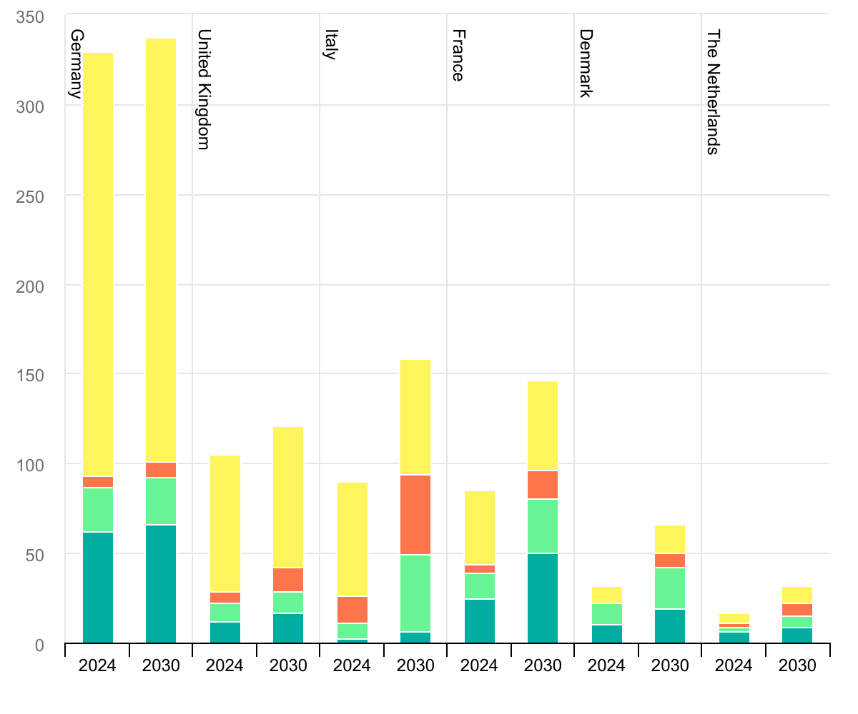
Figure 1 : Biogas production by country and end use for selected European countries, 2024 and 2030. Source: IEA
China continued expanding in 2024, with state-owned energy companies commissioning bio-natural gas (BNG) plants and the first biomethane purchase agreements being signed, signaling the emergence of a commercial biomethane market (IEA, 2025).
The global solar-biogas hybrid power system market reflects these trends. Valued at USD 4.67 billion in 2024, it is projected to reach USD 7.23 billion by 2030, growing at a compound annual rate of 7.39% (Research and Markets, 2024). This trajectory is driven by growing environmental awareness, tightening renewable fuel standards, and declining costs for both solar modules and AD technology (Research and Markets, 2024; Sher et al., 2024).
Regarding renewable energy in agriculture more broadly, REN21's Global Status Report 2025 found that 23 countries had explicit policies targeting renewables in agriculture as of 2024 (REN21, 2025).
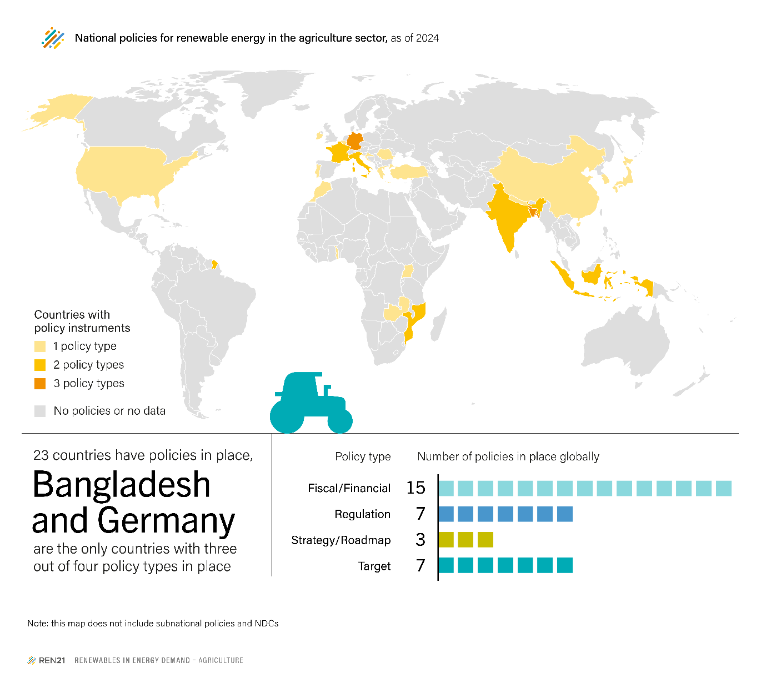
Figure 2 : National policies for renewable energy in the agriculture sector, as of 2024. Source: REN21

In Germany, nearly 8,000 agricultural plants produced approximately 80% of the country's biogas in 2021 (REN21, 2025). The report highlights that agrivoltaics — the co-location of solar PV with agricultural activity — is transitioning from pilot-scale demonstration into a productive economic activity in multiple markets (REN21, 2025).

2.3 Upgrading from Biogas to Biomethane: The Policy Case
A key policy and commercial trend are the shift from on-site biogas combustion (for heat and power) toward upgrading to biomethane for grid injection or transport use. The EU's Waste Framework Directive (2008/98/EC) mandates a separate collection of organic waste by 2024, creating a new feedstock stream for upgraded biomethane (European Commission – DG Energy, 2025). As shown in an analysis of Italian markets, biomethane commands a market value approximately 5.5 times the electricity purchase price, creating a strong economic incentive to preserve biogas for upgrading rather than combusting it in CHP units (Nik Zad et al., 2026). The revised RED III facilitates cross-border trading of biomethane through the extension of Guarantees of Origin to the gas sector and the introduction of a mass-balancing system (EBA, 2025).

3. Anaerobic Digestion: Fundamentals, Feedstocks, and Upgrading

3.1 Process Fundamentals
Anaerobic digestion is a multi-stage biological process in which microorganisms decompose organic matter in the absence of oxygen, yielding biogas (typically 55–70% CH₄ and 30–45% CO₂ by volume) and a nutrient-rich digestate (Alengebawy et al., 2024; Sher et al., 2024) . The process proceeds through four sequential stages: hydrolysis, acidogenesis, acetogenesis, and methanogenesis (Sher et al., 2024).

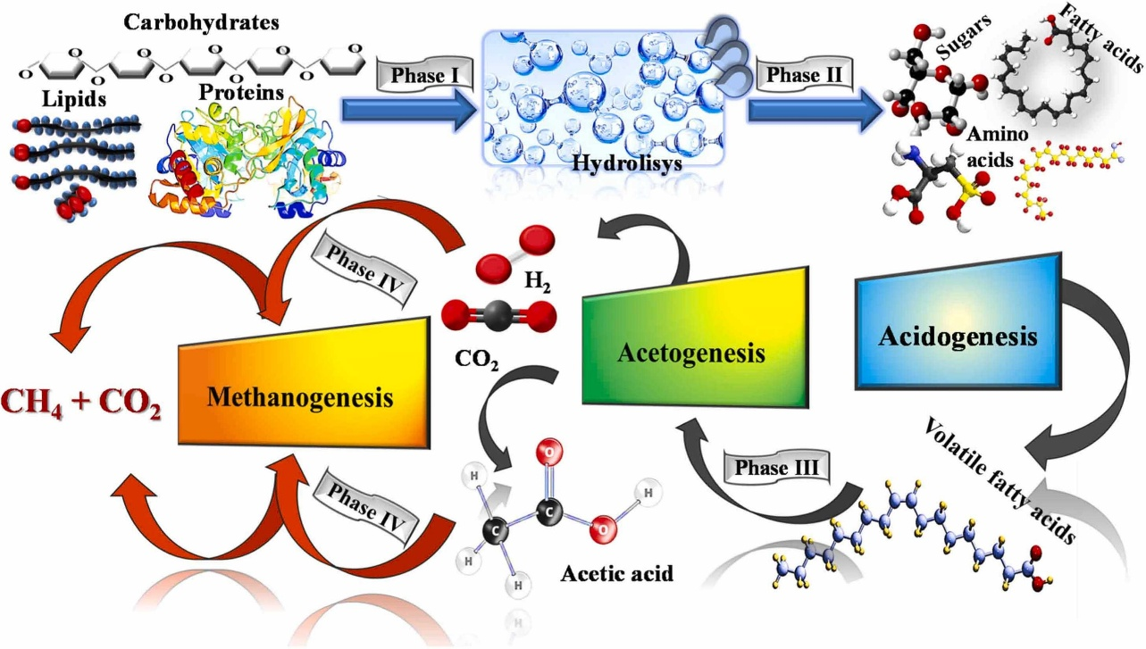
Figure 3 : Anaerobic digestion (AD) stages (hydrolysis, acidogenesis, acetogenesis and methanogenesis) for the process of biogas production from biomass (Sher et al., 2024).

The survival and activity of methanogenic archaea depend critically on several operational parameters: pH (optimal range 6.8–7.2), temperature (mesophilic 35°C or thermophilic 55°C), organic loading rate, C/N ratio, and hydraulic retention time (Alengebawy et al., 2024; Qayyum et al., 2025). A review published in the Journal of Ecological Engineering highlights that advancements in microbial engineering — including genetically modified microbial consortia — are improving the breakdown of recalcitrant lignocellulosic materials, thus enhancing biogas yields and process stability (Alamia et al., 2024, as cited in Journal of Ecological Engineering, 2025).
Raw biogases are not directly interchangeable with natural gas. It contains, alongside methane and CO₂, trace quantities of hydrogen sulphide (H₂S), water vapour, siloxanes, and ammonia, all of which must be removed before the gas can be used in sensitive applications or injected into the gas grid (Mohammadpour et al., 2025; Swinbourn et al., 2024). The upgrading step — typically achieving >97% CH₄ purity — transforms biogas into biomethane, which is chemically and energetically comparable to fossil natural gas (Mohammadpour et al., 2025).

3.2 Feedstock Diversity and Co-Digestion
One of the defining strengths of AD technology is its feedstock flexibility. Primary feedstocks include agricultural residues and manure, food waste, municipal solid waste, sewage sludge, and purpose-grown energy crops (Alengebawy et al., 2024; Sher et al., 2024).

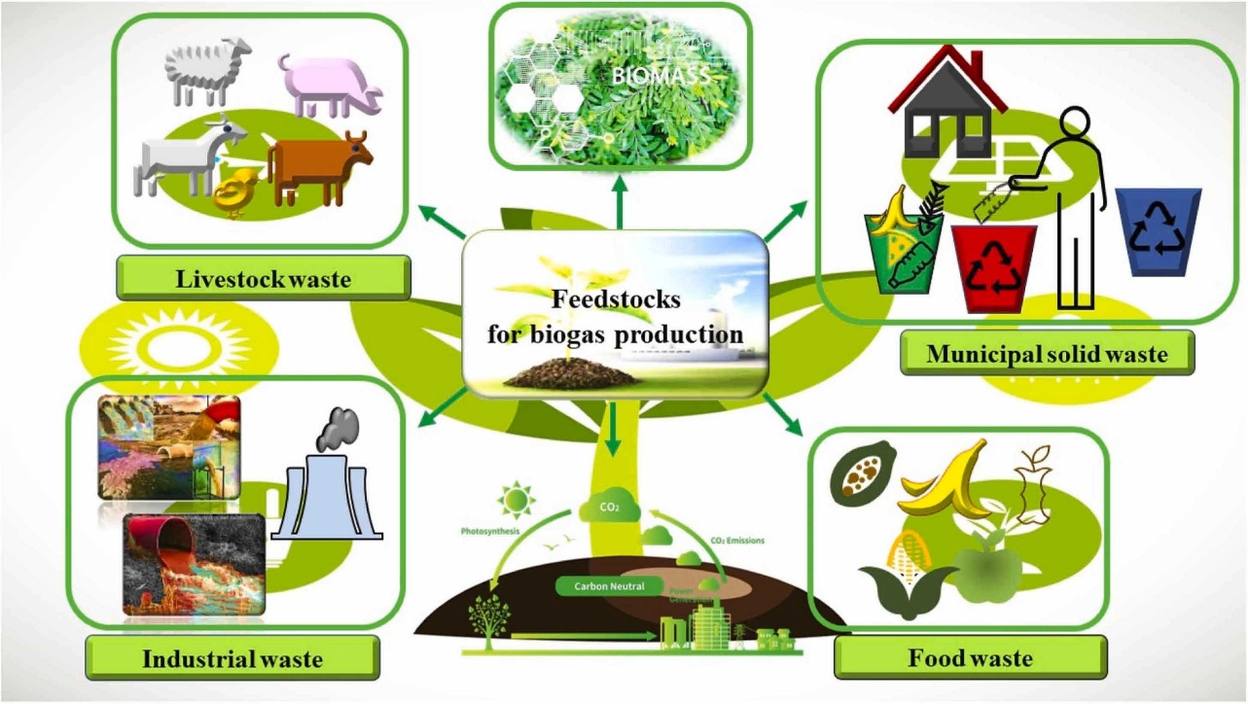
Figure 4 : Different feedstocks that could be used for the production of biogas as a renewable energy source (Sher et al., 2024).

A review in Biomass Conversion and Biorefinery demonstrated that co-digestion of cattle dung with food waste yielded cumulative biogas outputs of up to 1,732 ml, substantially outperforming mono-digestion at 1,035 ml (Qayyum et al., 2025). The synergy arises from complementary nutrient profiles: agricultural residues provide structural carbon while food waste contributes readily digestible carbohydrates and a favorable pH buffer (Qayyum et al., 2025). A 2025 study in the Journal of Ecological Engineering further confirms that multi-feedstock approaches exploiting agricultural residues, food waste, and municipal solid waste produce higher biogas yields than single-feedstock approaches (Pilarski et al., 2025).
Digestate, the solid-liquid effluent from the AD process, is rich in nitrogen, phosphorus, and potassium, making it a valuable organic fertilizer that can reduce chemical fertilizer requirements by as much as 50% (Agriculture Dive, 2024; (Chojnacka & Moustakas, 2024). This nutrient recycling loop is a core element of circular bioeconomy thinking and will be discussed further in Section 7.

3.3 Biogas Upgrading Technologies
Four commercially mature upgrading technologies dominate the market: pressure swing adsorption (PSA), membrane permeation (MP), chemical absorption by amines (chemical scrubbing), and high-pressure water scrubbing (HPWS) (Swinbourn, 2024; Mohammadpour et al., 2025).

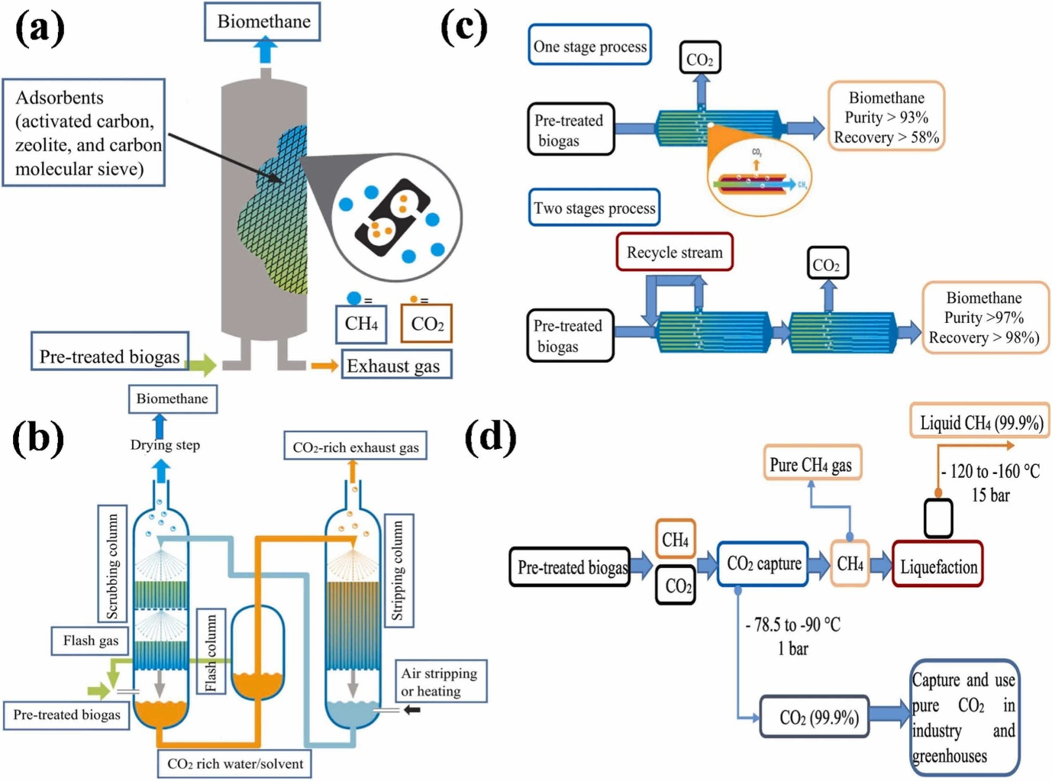
Figure 5 : Biogas upgrading technologies; (a) Pressure swing adsorption, (b) Scrubbing technology for the separation of CH4 and CO2, (c) Membrane separation and (d) Cryogenic technology (Sher et al., 2024).

A comprehensive techno-economic review concludes that biogas-to-biomethane systems generally exhibit superior environmental performance compared to biogas-to-power pathways, though cogeneration can yield higher combined-energy benefits in specific contexts (Swinbourn et al., 2024). Economic feasibility is extremely sensitive to the assumed electricity price and the value assigned to avoided greenhouse gas emissions (Nik Zad et al., 2026; Swinbourn et al., 2024).
An emerging upgrading pathway is electrochemically driven CO₂ capture, which achieves a net energy requirement of only 0.25 kWh/kg CO₂ — the lowest among current upgrading technologies (Mohammadpour et al., 2025). Despite the maturity of conventional methods, only up to 35% of globally produced raw biogas is currently upgraded, indicating a large latent economic and environmental opportunity (Mohammadpour et al., 2025). The integration of biogas systems with Power-to-X (PtX) technology — where surplus renewable electricity is used to produce green hydrogen for methane enrichment — represents a further frontier documented in a 2025 review of emerging upgrading technologies (Foret et al., 2025).

Key Insight: The Upgrading Value Proposition
In Italian markets, biomethane commands approximately 5.5 times the electricity purchase price (Nik Zad et al., 2026). This premium fundamentally changes the economics of AD system design: rather than combusting biogas in a CHP unit, preserving it for upgrading and grid injection yields dramatically higher net present values. This finding has significant implications for the financial modelling of any integrated biogas project.

4. Hybrid Renewable Systems: PV-Biogas Integration

4.1 Rationale and System Architecture
The complementarity between solar PV and biogas is a well-recognized motivation for hybrid system design (Alhijazi et al., 2024; Roldán-Porta et al., 2023). Solar generates electricity during daylight hours, but its output is inherently intermittent and weather-dependent. Biogas, once produced and stored, is fully dispatchable and can be called upon during periods of low solar irradiance, after dark, and during grid stress events (IEA Bioenergy Task 37, 2020). Roldán-Porta et al., (2023) formalize this logic in a study published in Applied Sciences, proposing a methodology for evaluating optimal hybrid PV-biogas-grid configurations for rural energy communities in Spain using internal rate of return (IRR) as the primary optimization aim.
A canonical hybrid system architecture integrates: (1) a PV array, (2) an anaerobic digestion unit producing biogas, (3) a combined heat and power (CHP) unit or biogas engine, (4) an energy management system, and (5) a grid connection or battery storage buffer (Alhijazi et al., 2024; Roldán-Porta et al., 2023). The CHP unit generates electricity from biogas while recovering waste heat for digestate heating (a particularly important thermal load in northern climates), space heating, or cooling via an adsorption chiller (Figaj, 2024). A 2024 study in Energies by Figaj, investigated a small-scale hybrid polygeneration system in Italy combining AD-based biogas, PV, and a wind turbine serving a zootechnical farm and residential buildings. It found that neglecting thermal inertia of the digester in energy modelling leads to an overestimation of total biogas production by approximately 20%, highlighting the importance of dynamic thermal simulation (Figaj, 2024).
A hybrid building-integrated solar-anaerobic digestion system evaluated for the Moroccan residential sector showed a return on investment of 106.1% and an internal rate of return of 15.27%, with a payback period of 7.7 years, while avoiding 215.59 kg/year of CO₂ emissions per building (Mahir et al., 2024). These results reinforce that small-scale urban integration of AD and PV is technically and economically feasible under right policy conditions.

4.2 Economic Performance and Sensitivity Analysis
Economic performance is highly context-specific and sensitive to electricity prices, incentive structures, and local feedstock availability. A peer-reviewed analysis of biogas and PV systems in agro-industrial contexts found that a 1.5 MW biogas power plant can produce approximately 13,140 MWh per year with an annual ROI of 37.13%, a payback period of 31 months, and a GHG reduction of approximately 77,826 tons CO₂-eq/year (Nahwani et al., 2024). The potential value of carbon trading from such a plant was estimated at USD 3.11 million per year (Nahwani et al., 2024).
For off-grid rural electrification in developing countries, a HOMER-modelled analysis of a solar PV/biogas hybrid system in Ghana showed that biomass price has a relatively minor impact on the levelized cost of energy (LCOE): even a 75% increase in feedstock cost raised LCOE by only 5%, demonstrating the economic resilience of such hybrid systems when biomass is locally sourced (Odoi-Yorke et al., 2022). Conversely, sensitivity to electricity prices is high: tariff structures supporting grid feed-in substantially improve NPV (Odoi-Yorke et al., 2022; Roldán-Porta et al., 2023).
A concentrating solar power (CSP)–biogas hybrid study showed that properly sizing the biogas storage section compared to the solar field significantly improves plant capacity factors and efficiency (Petrollese & Cocco, 2020). Two operating strategies — prioritizing dispatchability versus prioritizing efficiency — were compared, with findings that the optimal strategy depends on whether the market reward is for peak-period electricity or for annual energy yield (Petrollese & Cocco, 2020). This trade-off stays live research questions in the context of increasingly granular time-of-use tariffs.

4.3 Thermal Integration and the Digester Heat Demand
The thermal energy demand of the digester is an often overlooked but economically significant system component. Maintaining mesophilic conditions (35°C) in cold climates requires substantial continuous heat input, which can be supplied by the CHP unit's waste heat, by solar thermal collectors, or — increasingly — by heat pumps powered by renewable electricity (Figaj, 2024; Nik Zad et al., 2026). The trade-off between higher biogas yield at elevated temperature and the additional thermal energy cost defines an optimal operating point that varies by climate zone and feedstock composition (Figaj, 2024).

5. Agrivoltaics and Anaerobic Digestion: The APV+AD Frontier

5.1 Definition and Motivation
Agrivoltaics (APV) refers to the simultaneous use of agricultural land for both crop production (or feedstock cultivation) and solar electricity generation, with the solar panels mounted above or between crops in a manner that allows concurrent agricultural activity. The concept has been developing since the seminal work of Dupraz et al. (2011), but the 2020s have seen it transition from experimental pilots to commercially practical systems (REN21, 2025). The REN21 Global Status Report 2025 notes that agrivoltaics is now shifting from the stage of pilot projects to a productive economic activity in multiple markets (REN21, 2025).
Pairing APV systems with on-site AD plants creates an APV+AD configuration that simultaneously: (i) generates solar electricity to power the AD plant and processing equipment; (ii) produces biomethane from the organic feedstock grown or collected on the same land; (iii) reduces the land-use footprint of the overall renewable energy system; and (iv) creates multiple revenue streams — electricity sales, biomethane sales, and potentially digestate-fertilizer value (Nik Zad et al., 2026). This configuration addresses one of the most persistent criticisms of bioenergy: land competition with food production (Nik Zad et al., 2026; Rekleitis et al., 2020).

5.2 The First Optimization Framework for APV+AD
A landmark study published in Energy Conversion and Management from Italy's Catholic University of the Sacred Heart and Sweden's Mälardalen University presents what the authors describe as the first optimization framework integrating bifacial agrivoltaic systems with AD plants specifically designed for biomethane production (Nik Zad et al., 2026). The study employed a multi-objective genetic algorithm (MOGA) coupled with the Technique for Order Preference by Similarity to Ideal Solution (TOPSIS) ranking methodology to simultaneously optimize economic performance and land utilization across eight scenarios, including fixed vertical panels, 1-axis tracking, and 2-axis tracking configurations (Nik Zad et al., 2026).
The findings are striking in several respects. First, heat pump electrification strategies consistently outperformed biogas combustion strategies (CHP or boiler) in net present value, achieving up to 8.7 times higher NPV by preserving biogas for upgrading rather than burning it on-site (Nik Zad et al., 2026). Second, the optimized on-grid configuration using 1-axis APV tracking with a groundwater heat pump achieved an NPV of €2.88 million, compared to a conventional CHP baseline (Nik Zad et al., 2026). Third, optimized on-grid systems require 17–20 times less land than off-grid alternatives, a finding with profound implications for land-use planning and environmental assessment (Nik Zad et al., 2026). Fourth, comparative analysis confirmed that 1-axis APV systems paired with heat pumps represent the most robust configuration across a wide range of sensitivity scenarios (Nik Zad et al., 2026).

APV+AD System Performance Summary (Nik Zad et al., 2026)
• Optimized on-grid APV (1-axis + GWHP): NPV = €2.88 M (4.1× over CHP baseline)
• Heat pump configurations: up to 8.7× higher NPV vs. biogas combustion
• On-grid systems: 17–20× lower land occupation vs. off-grid alternatives
• Biomethane price premium in Italy: ~5.5× electricity purchase price
• This study stands for the first MOGA-TOPSIS framework applied to the APV+AD design problem

5.3 The eLER Metric: Quantifying Dual-Use Land Efficiency
A critical innovation associated with APV+AD research is the energy Land Equivalent Ratio (eLER), a metric adapted from the agricultural LER concept (which measures yield advantage of intercropping over monoculture) (Nik Zad et al., 2026). The eLER quantifies how much more efficiently an APV+AD system uses land compared to separate, single-purpose installations of solar energy and biogas production. An eLER greater than 1.0 shows that the integrated system produces more combined energy output per unit land area than the sum of the two systems working independently on separate parcels (Nik Zad et al., 2026).
The eLER is particularly valuable because it captures the spatial efficiency advantage that is invisible in conventional NPV or LCOE analyses. For example, an APV system may reduce crop yield slightly (the shading penalty) but compensate for this with additional electricity generation and improved microclimate for certain crops; the eLER integrates these trade-offs into a single dimensionless indicator (Nik Zad et al., 2026). As a novel metric, standardized protocols for eLER calculation — covering boundary conditions, system lifetime assumptions, and multi-output weighting — remain an active area of methodological development and constitute a significant contribution of APV+AD research to the broader renewable energy literature (Nik Zad et al., 2026).

5.4 Agricultural Synergies and Farm Decarbonization
The agricultural sector represents 2.5% of global total final energy consumption and is a significant source of methane emissions from both enteric fermentation and manure management (REN21, 2025). On-farm AD systems directly address the latter: by capturing methane from manure that would otherwise volatilize, they simultaneously generate energy and reduce direct GHG emissions. Livestock accounts for approximately 33% of national methane emissions in the United States, and on-site digesters process waste into nutrient-dense digestate that reduces chemical fertilizer requirements by up to 50% (Agriculture Dive, 2024).
The REN21 2025 agriculture-sector review documents the diversity of national approaches. In Denmark, 52% of biogas facilities are on-farm and produce over 90% of the country's biogas (REN21, 2025). In France, nearly 1,300 agricultural AD facilities exist, of which over 1,100 are on-farm (REN21, 2025). India provides incentives for on-farm digesters as part of a broader plan to phase out diesel-powered agricultural machinery (REN21, 2025). These country-level pathways illustrate the importance of policy design in matching technical solutions to local agricultural structures and feedstock logistic constraints.
An important practical finding concerns logistics: when transportation distances for biomass feedstock exceed approximately 50 km, additional operational costs erode profitability significantly, particularly in rural regions with dispersed farms (Vetroni Barros et al., 2025). APV+AD configurations inherently minimize this distance by producing feedstock and energy on the same parcel, representing a structural logistical advantage (Nik Zad et al., 2026).

6. Multi-Generation Integration and Circular Economy Opportunities

6.1 Polygeneration System Architectures
Polygeneration refers to energy systems that simultaneously produce multiple useful outputs — electricity, heat, cooling, transport fuel, and/or chemical feedstocks — from a single integrated process chain (Anvari et al., 2025). Biogas is an ideal polygeneration vector because its chemical energy can be converted to any of these forms (IEA Bioenergy Task 37, 2020). An architectural framework for biogas-based multi-generation systems has been elaborated around three pillars: technology integration, advanced control, and sustainability assessment (Anvari et al., 2025).
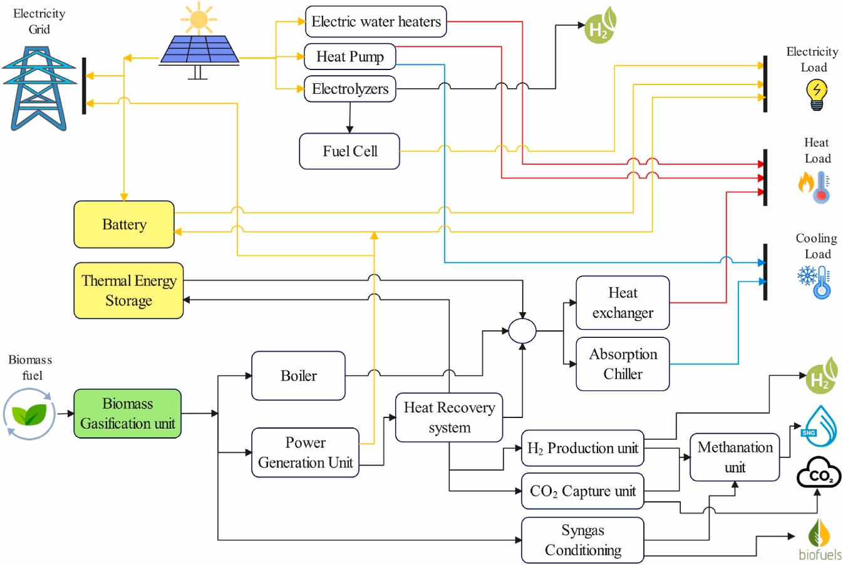
Figure 6 : Outline of general schematic configurations for integrating hybrid PV, BG, and ES technologies into CHP, CCHP, or multigeneration systems for main products and byproducts. Source: (Anvari et al., 2025)

Technology integration encompasses the physical coupling of AD units with CHP engines, organic Rankine cycles, adsorption chillers, membrane upgrading modules, and heat pumps (Anvari et al., 2025). Control integration involves model-predictive and real-time optimization algorithms that schedule biogas production and dispatch to match time-varying energy prices and load profiles (Anvari et al., 2025; Yang et al., 2025). Sustainability assessment closes the loop by quantifying CO₂ emissions, land use, water consumption, and biodiversity impacts across the system boundary (Anvari et al., 2025).
A particularly promising polygeneration configuration is the combined cooling, heating, and power (CCHP) system, in which the thermal output of a biogas CHP unit drives an adsorption chiller for space cooling. A novel CCHP design based on chemical reinjection demonstrated improved thermal efficiency by recycling a fraction of CO₂-rich exhaust gas back into the digester, enhancing methane yield through the hydrogenotrophic methanogenesis pathway (Huang et al., 2024). This circular internal loop illustrates how system integration can overcome individual component limitations.

6.2 Circular Bioeconomy and Waste Valorization
Circular economy thinking reframes from organic waste streams — which represent a disposal cost in a linear model — as resources with positive value. Anaerobic digestion is a central technology in this reframing: it valorizes agricultural residues, food waste, sewage sludge, and municipal organic waste into energy and fertilizer simultaneously (IEA Bioenergy Task 37, 2020; Rekleitis et al., 2020). A review in Environmental Chemistry Letters situates AD within the circular bioeconomy, noting that biogas systems address SDG 7 (affordable and clean energy) and SDG 12 (responsible consumption and production) in an integrated manner, while also contributing to carbon neutrality commitments now in place across approximately 150 national governments (Alengebawy et al., 2024).
Digestate management is emerging as a second-order value stream. Beyond its role as fertilizer, digestate can be further processed to separate a liquid fraction (rich in soluble nutrients for fertigation) and a solid fraction (suitable for composting or as a soil amendment) (Chojnacka & Moustakas, 2024). Digestate processing for carbon neutrality and fertilizer use has been identified as a high-priority research area, particularly given tightening EU regulations on nitrogen emissions from agriculture (Chojnacka & Moustakas, 2024).

6.3 Power-to-X and Green Hydrogen Pathways
The integration of biogas with Power-to-X (PtX) technology creates opportunities for renewable gas production beyond the direct AD pathway.
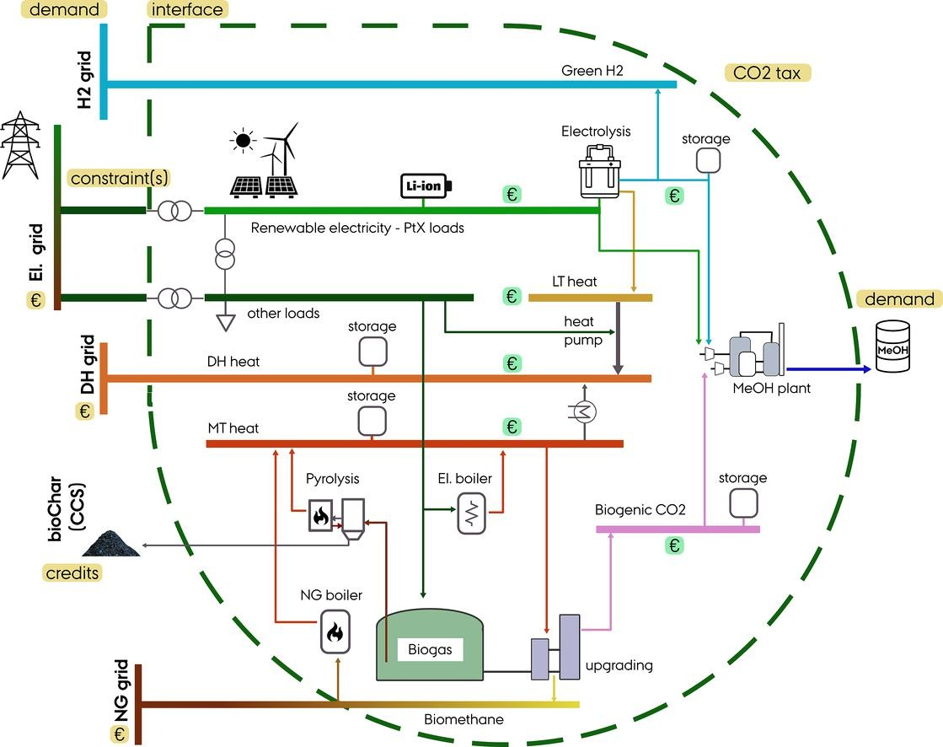
Figure 7 : Overview of the PtX hub, with the indication of the optimization boundaries and an example of the technology options (existing and potential) (Alamia et al., 2024).
In periods of surplus renewable electricity (which are becoming increasingly common as solar and wind capacity expands), surplus power can be converted to green hydrogen via electrolysis. This hydrogen can then be injected into the biogas stream and converted to additional methane via hydrogenotrophic methanogenesis (biological methanation) or catalytic methanation, a process known as Power-to-Methane (PtM) (Alamia et al., 2024; Foret et al., 2025). The IEA notes that the first biomethane purchase agreements involving PtX components in China were signed in 2024 (IEA, 2025). The EU's 2050 long-term climate strategy projects that the share of natural gas in the gaseous fuel mix will fall below 20%, with the remainder being renewable gases including biomethane, hydrogen, and synthetic methane (Gas for Climate Consortium, 2022).
Furthermore, the integration of biogas plants with carbon capture and storage (CCS) creates potential for net-negative emissions. When the biogenic CO₂ captured during biomethane upgrading is stored geologically, the overall system lifecycle emissions become negative, contributing to atmospheric drawdown (Alamia et al., 2024; Francisco López et al., 2024). This bioenergy with carbon capture and storage (BECCS) pathway is included in multiple IPCC mitigation scenarios as a key technology for achieving net-zero by 2050 (Gas for Climate Consortium, 2022).

6.4 Research Gaps in Multi-Generation Integration
Several critical research gaps have been identified in the multi-generation literature. First, standardized sustainability metrics that span technology, control, and environmental dimensions simultaneously are lacking, making cross-study comparison difficult (Anvari et al., 2025). Second, real-time control algorithms that can optimally dispatch biogas across competing end-uses (electricity, heat, transport, or upgrading) in response to dynamic energy market signals remain at an early stage of development (Anvari et al., 2025; Yang et al., 2025). Third, the interaction between biogas systems and emerging flexible electricity markets — including virtual power plants, demand response, and peer-to-peer energy trading — is largely unexplored (Anvari et al., 2025). Fourth, long-term feedstock security and land-use modelling for large-scale biogas deployment require integrated agricultural-energy system models that do not yet exist in standardized form (Anvari et al., 2025; Vetroni Barros et al., 2025).

7. Synthesis, Research Gaps, and Future Directions

7.1 Synthesis of Literature Findings
The literature reviewed in this document converges on several key propositions. First, biogas and biomethane are indispensable components of net-zero energy systems: they provide the dispatchability that purely variable renewables lack, they recycle organic waste, and they decarbonize sectors where direct electrification is difficult or costly (IEA, 2025; IEA Bioenergy Task 37, 2020). Second, the economics of biogas systems are highly sensitive to the choice between on-site combustion and upgrading to biomethane: the substantial market premium for biomethane in liberalized gas markets (documented at ~5.5× electricity price in Italy) shifts the optimal strategy decisively toward upgrading in most contexts where grid injection is technically available (Nik Zad et al., 2026; Swinbourn et al., 2024). Third, the integration of PV — particularly agrivoltaic configurations — with AD plants resolves the land-use tension between bioenergy and solar energy and can dramatically improve system economics through heat pump electrification of thermal demands (Nik Zad et al., 2026).
The APV+AD framework introduced by Nik Zad et al., (2026) represents a methodological advance that directly addresses these three propositions: it optimizes jointly across economic and land-use objectives, it captures the value of the biomethane premium, and it quantifies the contribution of different APV tracking configurations. The eLER metric extends this by providing a land-efficiency indicator that is independent of market price assumptions, making it suitable for policy evaluation and spatial planning contexts (Nik Zad et al., 2026).

7.2 Identified Research Gaps
Several important research gaps appear in this review. In the domain of APV+AD, the existing optimization framework was developed and validated for Italian conditions; generalization to different climates, regulatory environments, and agricultural systems requires systematic validation studies (Nik Zad et al., 2026). The interaction between agrivoltaic shading and the quantity and quality of biomass feedstock grown beneath the panels is not yet well-characterized across crop species and climate zones (Nik Zad et al., 2026). Secondly, the eLER metric requires a standardized calculation protocol — including agreed boundary conditions, system lifetimes, and methods for handling multi-output weighting — before it can be adopted as a reporting standard (Nik Zad et al., 2026).
In the domain of upgrading and PtX integration, the direct biological methanation of CO₂-rich biogas (bypassing the CO₂ separation step) is promising but not yet economically viable at scale; improvements in catalyst design and reactor configuration are needed (Foret et al., 2025). Electrochemical CO₂ separation, while showing the lowest energy requirement among upgrading pathways (0.25 kWh/kg CO₂), has not yet been demonstrated at industrial scale (Mohammadpour et al., 2025). In the control and market domain, real-time dispatch optimization algorithms that respond to granular time-of-use electricity tariffs — which are proliferating as smart metering expands — are not yet standard in commercial plant control systems (Anvari et al., 2025; Yang et al., 2025).
Finally, at the policy and sustainability boundary, the environmental assessment methodology for biomethane under RED III has been criticized for underestimating fugitive methane leakage during AD and upgrading operations (Changing Markets Foundation, 2025). Improved methane leakage monitoring and reporting protocols, integrated into lifecycle assessment frameworks, are needed to ensure that policy support for biomethane delivers genuine climate benefits rather than unintended methane emissions (Changing Markets Foundation, 2025; EBA, 2025).

7.3 Future Research Directions
Based on the synthesis above, the following future research directions are proposed. First, multi-climate validation of the APV+AD optimization framework across Mediterranean, temperate, and semi-arid zones, with particular attention to the interaction between shading, microclimate, and feedstock yield (Nik Zad et al., 2026). Second, development and international standardization of the eLER calculation protocol, including comparison with existing LER methodologies from the intercropping literature (Nik Zad et al., 2026). Third, experimental and modelling studies on direct biological methanation of biogas at pilot scale, targeting techno-economic parity with conventional upgrading by 2030 (Foret et al., 2025). Fourth, integration of biogas plant control systems with real-time electricity market APIs, enabling automated dispatch optimization based on spot prices (Anvari et al., 2025; Yang et al., 2025). Fifth, development of district-scale circular bioeconomy models that co-optimizes AD plant siting, feedstock logistics, nutrient recycling, and grid injection across agricultural regions (Alengebawy et al., 2024; Vetroni Barros et al., 2025).
At a broader level, the intersection of agrivoltaics, anaerobic digestion, and circular bioeconomy thinking represents one of the most promising frontiers in applied renewable energy research. The spatial co-location of solar energy generation with the biological processes that underpin the food and feed system creates opportunities for synergies that are only beginning to be quantified (Nik Zad et al., 2026; REN21, 2025). The seminar document has sought to map this frontier and to provide a structured foundation for deeper investigation.

8. Conclusion

The literature reviewed in this seminar document establishes that renewable energy integrated biogas production—particularly through the coupling of anaerobic digestion with photovoltaic systems—represents a technically mature, economically viable, and policy-supported pathway for sustainable energy transition.
Three principal conclusions emerge from this synthesis.
First, biogas and biomethane are indispensable components of net-zero energy systems. Unlike intermittent solar and wind power, biogas is dispatchable, storable, and upgradable to pipeline-quality biomethane. The IEA (2025) projects 23% global production growth between 2025 and 2030, driven by more than 50 new policy instruments enacted since 2020 across the European Union, United States, China, and India. The REPowerEU target of 35 billion cubic metres of biomethane by 2030, supported by an estimated €37 billion investment need, exemplifies the scale of political commitment.
Second, the economics of biogas systems decisively favour upgrading to biomethane over on-site combustion. In liberalized gas markets, biomethane commands a price premium of approximately 5.5 times the electricity purchase price (Nik Zad et al., 2026). This premium fundamentally changes system design: preserving biogas for grid injection or transport use yields net present values up to 8.7 times higher than combustion in combined heat and power units. Emerging upgrading technologies—particularly electrochemical CO₂ capture with 0.25 kWh/kg CO₂—promise further efficiency gains.
Third, the integration of agrivoltaics with anaerobic digestion (APV+AD) resolves the long-standing land-use tension between solar energy and bioenergy. The first optimization framework for APV+AD, developed by Nik Zad et al. (2026), demonstrates that on-grid configurations using single-axis tracking with heat pumps require 17–20 times less land than off-grid alternatives while achieving net present values of €2.88 million. The energy Land Equivalent Ratio (eLER) metric provides a standardized tool for quantifying dual-use land efficiency, capturing spatial advantages invisible in conventional economic analyses.
Several critical research gaps require attention. The APV+AD optimization framework requires multi-climate validation beyond Italian conditions. The eLER metric lacks an internationally standardized calculation protocol. Direct biological methanation of CO₂-rich biogas remains economically unproven at scale. Real-time dispatch algorithms responding to granular electricity tariffs are not yet standard in commercial plant control systems. Improved methane leakage monitoring under RED III is needed to ensure genuine climate benefits.
The broader implication is clear. Biogas is not merely an energy source—it is a systems technology that simultaneously addresses waste management, energy dispatchability, renewable heat, and green chemicals production. When integrated with agrivoltaics and guided by circular economy principles, it offers a pathway to decarbonize agriculture while enhancing land-use efficiency. The intersection of anaerobic digestion, hybrid renewable systems, and circular bioeconomy thinking represents one of the most promising frontiers in applied energy. research. This seminar document has mapped that frontier and provided a structured foundation for deeper investigation.

References
Agriculture Dive. (2024, January 25). Bio-fueling the future: How farms are shaping the renewable energy transition in 2024. https://www.agriculturedive.com/news/agriculture-renewable-energy-outlook-solar-biofuels/705602/
Changing Markets Foundation. (2025). Biogas in the EU: A policy and financial analysis. https://changingmarkets.org/report/biogas-in-the-eu-a-policy-and-financial-analysis/
European Biogas Association (EBA). (2025). Renewable Energy Directive and the biogas sector. https://www.europeanbiogas.eu/policies/renewable-energy/
European Commission – DG Energy. (2025). Biomethane: EU policy framework and 35 bcm target by 2030. Brussels: European Commission. https://energy.ec.europa.eu/topics/renewable-energy/bioenergy/biomethane_en
International Energy Agency (IEA). (2025). Biogases – Renewables 2025 Analysis. Paris: IEA. https://www.iea.org/reports/renewables-2025/biogases
IEA Bioenergy Task 40. (2025). Implementation of bioenergy in the European Union – Country Report 2024. IEA Bioenergy.
Rabobank. (2025). Europe's biomethane landscape: Between ambition and reality. RaboResearch. https://www.rabobank.com/knowledge/d011498995-europes-biomethane-landscape-between-ambition-and-reality
REN21. (2025). Global Status Report 2025 – Renewables in Agriculture. Paris: REN21. https://www.ren21.net/gsr-2025/sectors/agriculture/
Research and Markets. (2024). Solar Biogas Hybrid Power System Market – Global Industry Size, Share, Trends, Opportunity, and Forecast 2020–2031. Dublin: Research and Markets. https://www.researchandmarkets.com/reports/6115021/solar-biogas-hybrid-power-system-market-global
Gas for Climate Consortium. (2022). Facilitating biomethane scale-up toward 35 bcm by 2030. https://gasforclimate2050.eu
Alamia, A., Partoon, B., Rattigan, E., & Bruun Andresen, G. (2024). Optimizing hydrogen and e-methanol production through Power-to-X integration in biogas plants. Energy Conversion and Management, 322, 119175. https://doi.org/10.1016/j.enconman.2024.119175
Alengebawy, A., Ran, Y., Osman, A. I., Jin, K., Samer, M., & Ai, P. (2024). Anaerobic digestion of agricultural waste for biogas production and sustainable bioenergy recovery: A review. Environmental Chemistry Letters, 22(6), 2641–2668. https://doi.org/10.1007/s10311-024-01789-1
Alhijazi, A. A. K., Alloush, A. F., & Almasri, R. A. (2024). Evaluating a Solar–Biogas Hybrid Renewable Power Plant by Heating the Anaerobic Digester Using the Rejected Heat of Rankine Cycle in Idlib, Syria. Applied Sciences, 14(24), 12027. https://doi.org/10.3390/app142412027
Anvari, S., Medina, A., Merchán, R. P., & Hernández, A. C. (2025). Sustainable solar/biomass/energy storage hybridization for enhanced renewable energy integration in multi-generation systems: A comprehensive review. Renewable and Sustainable Energy Reviews, 223, 115997. https://doi.org/10.1016/j.rser.2025.115997
Chojnacka, K., & Moustakas, K. (2024). Anaerobic digestate management for carbon neutrality and fertilizer use: A review of current practices and future opportunities. Biomass and Bioenergy, 180, 106991. https://doi.org/10.1016/j.biombioe.2023.106991
Dupraz, C., Marrou, H., Talbot, G., Dufour, L., Nogier, A., & Ferard, Y. (2011). Combining solar photovoltaic panels and food crops for optimising land use: Towards new agrivoltaic schemes. Renewable Energy, 36(10), 2725–2732. https://doi.org/10.1016/j.renene.2011.03.005
Figaj, R. (2024). Energy and Economic Sustainability of a Small-Scale Hybrid Renewable Energy System Powered by Biogas, Solar Energy, and Wind. Energies, 17(3), 706. https://doi.org/10.3390/en17030706
Foret, B., Laines Canepa, J. R., Núñez-Nogueira, G., Dufreche, S., Hernandez, R., Gang, D., Sharp, W., Revellame, E., Fortela, D. L. B., Simoneaux, S., Hulin, H., Holmes, W. E., & Zappi, M. E. (2025). Biogas Upgrading into Renewable Natural Gas: Part II—An Assessment of Emerging Technologies. Energies, 18(21), 5760. https://doi.org/10.3390/en18215760
Francisco López, A., Lago Rodríguez, T., Faraji Abdolmaleki, S., Galera Martínez, M., & Bello Bugallo, P. M. (2024). From Biogas to Biomethane: An In-Depth Review of Upgrading Technologies That Enhance Sustainability and Reduce Greenhouse Gas Emissions. Applied Sciences, 14(6), 2342. https://doi.org/10.3390/app14062342
Huang, Z., Su, B., Wang, Y., Yuan, S., Huang, Y., Li, L., Cai, J., & Chen, Z. (2024). A novel biogas-driven CCHP system based on chemical reinjection. Energy, 297, 131238. https://doi.org/10.1016/j.energy.2024.131238
Mahir, M., El Maakoul, A., Khay, I., & Bakhouya, M. (2024). A hybrid building-integrated solar-powered anaerobic digestion system: Energy, economic, and environmental analysis in Morocco. Journal of Building Engineering, 95, 110280. https://doi.org/10.1016/j.jobe.2024.110280
Mohammadpour, H., Cheng, K. Y., Pivrikas, A., & Ho, G. (2025). A review of biogas upgrading technologies: Key emphasis on electrochemical systems. Water Science & Technology, 91(2), 93–116. https://doi.org/10.2166/wst.2024.394
Nahwani, A., Soeprijanto, S., & Widodo, E. (2024). Strategic model for integrating biogas a framework for sustainable energy integration in agro-industries. Scientific Reports, 14(1), 31515. https://doi.org/10.1038/s41598-024-83181-1
Nik Zad, A., Zainali, S., Croci, M., Guezgouz, M., Impollonia, G., Elia Campana, P., & Amaducci, S. (2026). Techno-economic optimization of agrivoltaic-powered anaerobic digestion plant for biomethane production. Energy Conversion and Management, 348, 120791. https://doi.org/10.1016/j.enconman.2025.120791
Odoi-Yorke, F., Abaase, S., Zebilila, M., & Atepor, L. (2022). Feasibility analysis of solar PV/biogas hybrid energy system for rural electrification in Ghana. Cogent Engineering, 9(1), 2034376. https://doi.org/10.1080/23311916.2022.2034376
Petrollese, M., & Cocco, D. (2020). Techno-economic assessment of hybrid CSP-biogas power plants. Renewable Energy, 155, 420–431. https://doi.org/10.1016/j.renene.2020.03.106
Pilarski, K., Pilarska, A. A., & Dach, J. (2025). Biogas as renewable energy source: A brief overview. Journal of Ecological Engineering, 26(7), 408–416. https://doi.org/10.12911/22998993/203376
Qayyum, S., Tahir, A., Mian, A. H., Zeb, S., Siddiqui, M. F., & Rehman, B. (2025). Optimizing biogas production through anaerobic digestion: Transforming food waste and agricultural residues into renewable energy within a circular economy paradigm. Biomass Conversion and Biorefinery, 15(19), 26027–26043. https://doi.org/10.1007/s13399-024-05651-w
Rekleitis, G., Haralambous, K.-J., Loizidou, M., & Aravossis, K. (2020). Utilization of Agricultural and Livestock Waste in Anaerobic Digestion (A.D): Applying the Biorefinery Concept in a Circular Economy. Energies, 13(17), 4428. https://doi.org/10.3390/en13174428
Roldán-Porta, C., Roldán-Blay, C., Dasí-Crespo, D., & Escrivá-Escrivá, G. (2023). Optimising a Biogas and Photovoltaic Hybrid System for Sustainable Power Supply in Rural Areas. Applied Sciences, 13(4), 2155. https://doi.org/10.3390/app13042155
Sher, F., Smječanin, N., Hrnjić, H., Karadža, A., Omanović, R., Šehović, E., & Sulejmanović, J. (2024). Emerging technologies for biogas production: A critical review on recent progress, challenges and future perspectives. Process Safety and Environmental Protection, 188, 834–859. https://doi.org/10.1016/j.psep.2024.05.138
Swinbourn, R., Li, C., & Wang, F. (2024). A Comprehensive Review on Biomethane Production from Biogas Separation and its Techno‐Economic Assessments. ChemSusChem, 17(19), e202400779. https://doi.org/10.1002/cssc.202400779
Vetroni Barros, M., Alves Dourado, R., Cristina Ostwal, M., Salvador, R., Henrique Lermen, F., & Moro Piekarski, C. (2025). Towards Sustainable Energy: Economic and Environmental Factors Influencing Feasibility of Agricultural Waste Derived Biogas for Electricity Systems. Journal of Circular Economy, 3(3). https://doi.org/10.55845/BCMU9175
Yang, J., Wang, J., Ma, K., Zheng, Q., Ji, W., & Guo, S. (2025). A bi-level optimization model of integrated energy system considering waste treatment under uncertainty. Energy, 332, 136810. https://doi.org/10.1016/j.energy.2025.136810

