**Ay2021/2022 Semester 1 Paper**

3

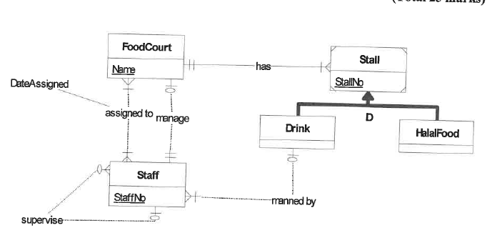

Q4

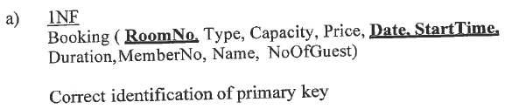

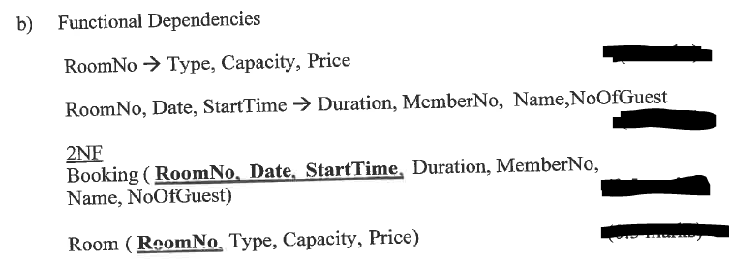

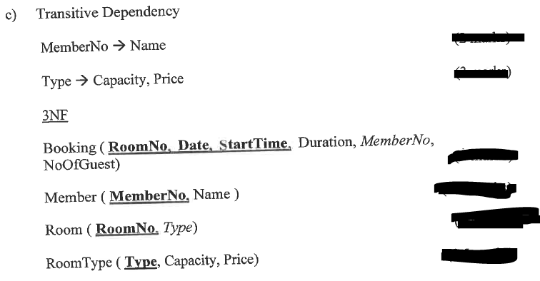

**Ay2021/2022 Semester 1**

1 (a) 3 rows

1 (b) DELETE from member

where substring(NRIC, 8, 1) IN (‘A’, ‘B’, ‘C’)

1 (c) Select name,

YEAR(GetDate()) – YEAR(DateOfBirth) ‘Age’

FROM member

Order By ‘Age’ desc

1(d) Select * from member

Where Sex = ‘F’ and

DateOfBirth between ’01 Jan 1975’ and ’31 Dec 1984’

(speAcc is Null or MedAcc > 5000)

1(e)

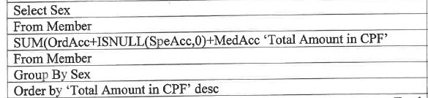

Q2

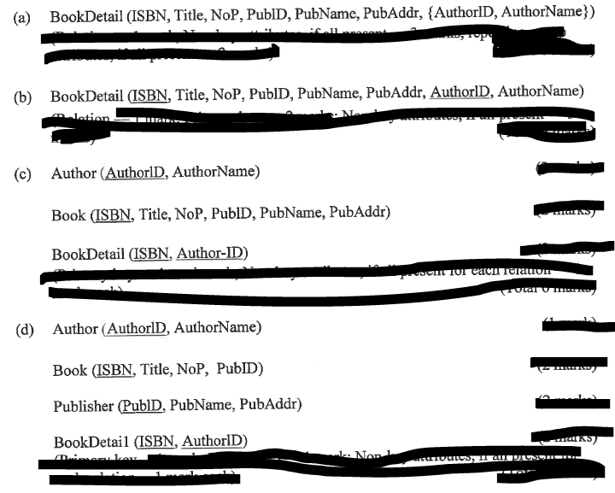

Q3

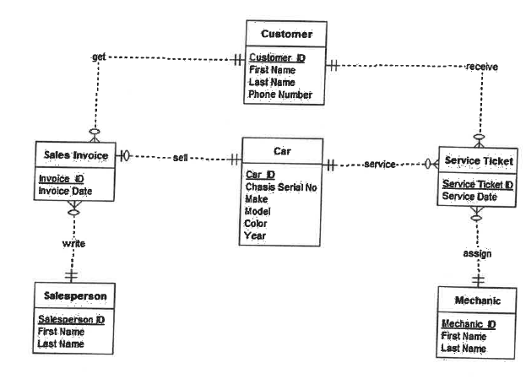

4(a)

