## SALONBEAU – AN ANDROID-BASED APPOINTMENT SYSTEM FOR SALONS IN BATANGAS CITY

A Capstone Project

Presented to the Faculty of

College of Informatics and Computing Sciences

BATANGAS STATE UNIVERSITY

The National Engineering University

Batangas City

In Partial Fulfillment

of the Requirements for the Degree

**Bachelor of Science in Information Technology**

**Major in Business Analytics**

John Gilbert R. Alcazar

Jerevhel B. Lota

Rachel T. Quizon

Jeleen M. Mangubat

Adviser

December 2022

## APPROVAL SHEET

This capstone project entitled **SALONBEAU – AN ANDROID-BASED APPOINTMENT SYSTEM FOR SALONS IN BATANGAS CITY** prepared and submitted by **JOHN GILBERT R. ALCAZAR, JEREVHEL B. LOTA and RACHEL T. QUIZON** in partial fulfillment of the requirements for the degree **Bachelor of Science in Information Technology Major in Business Analytics**, has been examined and is recommended for acceptance and approval for oral examination.

JELEEN M. MANGUBAT

Adviser

Approved by the Committee on Oral Examination with a grade of _______. **PANEL OF EXAMINERS**

**Alex I. Magboo, MEng**

Chairperson

**Lloyd H. Macatangay, MSCS Ms. Fatima Marie Agdon**

Member Member

Accepted and approved in partial fulfillment of the requirements for the degree Bachelor of Science in Information Technology major in Business Analytics.

_______________ **PRINCESS MARIE B. MELO, DIT**

Date Dean, CICS

### ABSTRACT

**Title:** SALONBEAU – AN ANDROID-BASED APPOINTMENT SYSTEM FOR SALONS IN BATANGAS CITY

**Researchers:** John Gilbert R. Alcazar

Jerevhel B. Lota

Rachel T. Quizon

**Degree:** Bachelor of Science in Information Technology

Major in Business Analytics

**Year:** 2022

**Adviser:** JELEEN M. MANGUBAT

__________________________________________________________________

Beauty salon is a service-oriented establishment in which customers receive treatment to increase their beauty. Skin care, facial makeup, hair nourishment and model hair cutting are the most important nourishing activities of a salon. Deciding on a salon appointment system is an important step in making a salon as successful and as recognizable as possible. Upon creating this Android-based Application, the recognition and branding of some salons increases. The system is designed to take the inputs from the customer regarding the services they are availing and their basic information like name, age, address, contact number and the services that they want to avail. With this project is set out to create an Android-based Application for Salons in Batangas City. In addition to this, the owner of the salon were able to view the appointment details of the customer and modify the listed services in the Android-based Application. Nevertheless, people can freely book an appointment with the salon of their choice and the customers can also share their insights about a certain salon with the help of feedback and rating posting. In conclusion, an appointment system like SalonBeau, aids in managing appointments and smoothly registering people for pampering themselves when they arrive. As a result, employees can concentrate on helping customers and meeting their needs to provide a better overall experience. The system assists in managing a hair salon business by monitoring available days, storing customer data, overseeing the operation, hours, and schedules of the salon, as well as organizing marketing campaigns.

# ACKNOWLEDGEMENT

The researchers wish to extend their sincere gratitude to several individuals who, in one way or another, contributed and extended their valuable assistance in the preparation and completion of this study.

Ms. Jeleen M. Mangubat, their capstone project adviser, for the continuous support, patience, motivation and knowledge shared during the preparation and completion of this study;

Dr. Princess Marie B. Melo, Dean of the College of Informatics and Computing Sciences, for her constant encouragement to complete this study;

Mrs. Lanie Palad, their capstone instructor, for all the knowledge, wisdom and advice on creating their capstone topic;

To their parents who always remind them the importance of education in one’s life and giving their undying love and never-ending support;

To their interviewees, for giving their insights pertaining to the topic;

And above all, to our God Almighty, for guidance, blessings, strength, and knowledge that made this capstone project possible.

**John Gilbert R. Alcazar**

**Jerevhel B. Lota**

**Rachel T. Quizon**

# DEDICATION

This piece of work is wholeheartedly dedicated to

Our LORD ALMIGHTY GOD,

the FATHER,

SON and HOLY SPIRIT,

To Dr. Princess Marie B. Melo

To Ms. Jeleen M. Mangubat

To Mrs. Lanie Palad

To their parents, relatives and friends.

J.G.R.A.

J.B.L

R.T.Q

# Table of Contents

i

APPROVAL SHEET ii

ABSTRACT iii

ACKNOWLEDGEMENT v

DEDICATION vi

Table of Contents vii

Chapter I 1

INTRODUCTION 1

Purpose and Description 2

Objectives of the Study 3

Scope and Limitations of the Study 3

Definition of Terms 4

Chapter II 6

REVIEW OF RELATED SYSTEMS/STUDIES 6

Technical Background 6

Synthesis (Foreign) 22

Related Studies (Local) 23

Synthesis (Local) 34

Related Systems 34

Synthesis (System) 42

Conceptual Framework 42

Chapter III 43

DESIGN AND METHODOLOGY 44

Development Model 44

Requirement Analysis 45

Fish Bone Analysis 46

System Boundary 47

Hardware Requirements 48

Functional requirements 48

Non-functional requirements 50

Multiple Design 51

Constraints 53

System Design and Architecture 54

Use Case Diagram 54

Data Flow Diagram 56

Database Design 57

Software 58

Operating System 59

Database 59

Subscription 59

Hardware for development 60

Functional Suitability 61

Usability 62

Compatibility 62

Reliability 62

Maintainability 63

Portability 63

Testing Procedure 63

Data Gathering 65

Chapter IV 70

RESULTS AND DISCUSSIONS 70

Chapter V 75

SUMMARY, CONCLUSIONS AND RECOMMENDATIONS 75

Summary 75

Conclusions 76

Recommendation 76

BIBLIOGRAPHY 78

**List of Figures**

Figure 1. Conceptual Frameworks 43

Figure 2. Agile Development Model 45

Figure 3. Fish Bone Analysis 46

Figure 4. System Boundary 47

Figure 5. Use Case Diagram 55

Figure 6. Data Flow Diagram 56

Figure 7. Sequence Diagram 57

Figure 8. Database Design 57

Figure 9. . ISO/IEC 9126 61

Figure 10. Creating an account 71

Figure 11. Home Page 72

Figure 12. Salon list **Error! Bookmark not defined.**

Figure 13. Salon Dashboard 73

Figure 14. Salon Partners 73

Figure 15. User List 74

**List of Tables**

Table 1. Hardware Requirements 48

Table 2. Software Requirements 48

Table 3. Considered Design and Technology Stack 52

Table 4 Assessment of Designs According to Constraints 53

Table 5. Software Development Requirements Specification 58

Table 6. Hardware Development Requirements Specification 60

Table 7. Testing Procedure 63

Table 8. Testing Procedure (cont.) 64

Table 9. Hardware Matrix for the System Development 66

Table 10. Software Matrix for the System Development: Operating System 66

Table 11. Risk Consequences, and Response Plan 67

Table 12. Risk Analysis and Rankings 67

Table 13. Risk Category 68

Table 14. Risk Assessment Matrix 68

Table 15. Mitigation Grading Matrix 69

# Chapter I

# INTRODUCTION

**Project Context**

Appointment scheduling has been a challenging undertaking, particularly for some salons in Batangas City. They do not have enough knowledge about improving the system they have in this day and age. Technology has evolved as a replacement for manual scheduling. The old method is almost gone when you have to call or text a salon business to make an appointment. Technology has been an essential tool in resolving this kind of transaction.

Apparently, there are 70 registered salons in Batangas City as per the Office of the Mayor and yet the customers are struggling to find salons that can accommodate their needs and date that fit their schedules. It is advisable in all types of business enterprises ranging from large corporations to small service firms, to have an appointment system. Because a few salons in Batangas City lack technology or software, many customers walk-in just to find a salon that can accommodate them.

Most of the customers did not know the importance of an appointment system nowadays. Appointment systems offer convenience and provide orderliness when it comes to booking services in salons. The project results in having an Android-based application specifically for the customers of different salons in Batangas City who want to go to a salon hassle-free. They can find and book appointments at their own convenience.

The Android-based application has an appointment system that helps them make an online appointment in a particular salon at a specific time, date, and service that the particular salon offers. Furthermore, the customer can rate the salon based on how well they perform a specific service.

This project developed an Android-based application with an appointment system, along with features for the salon showcasing the customer feedback and ratings of the service of the other party. Additionally, the knowledge that this research can contribute to the field of ICT and Salons in Batangas City can be of greater use for future researchers and studies.

## Purpose and Description

The purpose of the project is to help customers in Batangas City manage to schedule an appointment in an orderly manner. Because salons are usually full for the day, some customers choose to leave or find another salon. Improve the manual process of the salon and develop an Android-based application to properly establish the goal of this endeavor. The project assist customers by organizing salon ratings so that they may choose the best salon for them. After the customer chose the best salon, the Android-based application let the customer create an appointment and leave a rating after visiting the corresponding salon.

## Objectives of the Study

The general objective of the project is to develop an Android-based application for the salons in Batangas City that helped the customer schedule an appointment, select service, and see the salon that registers in the system and its rating within the application.

1. To provide an efficient way of scheduling and booking of services in a salon.
2. To design and develop the system with the following features:
   1. Appointment confirmation via email.
   2. Salons review the appointment before confirmation.
3. To help customers in finding the top rated salon with the use of analytics.

## Scope and Limitations of the Study

The researchers developed an Android-based Application for the customers and salon owners in Batangas City only. It is an appointment system application aimed at assisting customers with their appointments to a particular salon and preferred services. In addition, the Android-based application helped the customers to choose what was the best salon in Batangas City. The Android-based application only focused on the salons here in Batangas City. Furthermore, the android-based application only covered and focused on the appointment system and generating a rating from customers feedback and system does not cover the billing method or any transaction involving online payment.

## Definition of Terms

The following terms are conceptually and operationally defined for better understanding of the study:

**Android-Based Application.** This pertains to software applications that run on the android platform are built for mobile devices. In this study, An Android-based application is a platform that supports the appointment system for salons in Batangas City.

**Appointment-Scheduling.** This pertains to time, date and place agreed by the parties as a confirmed appointment. In this project, it is an activity that allows the customer to secure the day for the particular salon, to appoint and schedule a specific service.

**ICT.** The technology that is used to handle communications processes such as telecommunications, broadcast media, and intelligent building management system. As used in the study, it allows the salons to merge their services with ICT which makes it convenient for them to reach out to many customers.

**Ratings/Feedback.** This pertains to closed-ended survey question used to represent respondent feedback in a comparative form for specific particular features/products/services. As used in the project, Ratings/Feedback is used to serve as the data visualization that is aiming to help the salon to improve their services and promote better customer relationships.

**Salon Service**.  This is an act carried out in a salon. In this project, we used the Android-based application to promote salon service since the Android-based application showed the different services and had promos offered by the salon.

# 

# Chapter II

# REVIEW OF RELATED SYSTEMS/STUDIES

This chapter provided an overview of the literature that informed the research and that has implications for the findings. It was divided into four main sections where the technical background, related studies, synthesis and conceptual framework were considered.

## Technical Background

Salons in Batangas City did not have enough knowledge on how to improve their services. The Android-based application named “SalonBeau” centralized the salons in Batangas City; the customer gave feedback and rating to a particular salon, based on their performance. This chapter covered all the software and hardware resources for the whole system and the development process.

The majority of customers were unaware of the value of an appointment system today, especially in salons. The Android-based application named “SalonBeau” centralized the salons in Batangas City; the customer gave feedback and rating to a particular salon, based on their performance. This chapter covered all the software and hardware resources for the whole system and the development process.

The researcher used different software languages as part of the development of the android-based application. The front-end development of the SalonBeau was made out by the researchers using Ionic and the React framework. Javascript library is also React that used to create quick and easy user interfaces. Instead of using templates, its component logic is written in javascript. This made it simple for them to develop a web-based, mobile-responsive version of the system. Firebase and Ionic used in the development of the android-based application. Firebase was the database platform for android because it was a lightweight and real-time database and firebase was a cloud-hosted NoSQL database. In addition, firebase is used for the back-end development of the system. Real-time databases shipped with mobile and web SDKs, provided authentication to provide simple and intuitive authentication for the researchers. Used the declarative security model that allowed access based on the identity or with pattern matching on the data. Besides just being a database, firebase could be the server and API of the Android-Based Application.

Ionic was a cross platform mobile development framework written in Typescript, and could be used in both operating systems Android and iOS. Ionic was a framework for building mobile apps using web technologies and Angular was a framework for building web apps. Ionic was built on top of angular and provides a set of tools and services for building mobile apps.

Furthermore, the interface design was smooth and adaptable, responded to screen size, and it allowed the systems to function properly and respond to user input, platform, and orientation influence behavior and environment.

**Related Studies (Foreign)**

The goal of this project was to create an Android-based application that helped customers find and book different services offered by the salons based on their needs. It made it simple for individuals to book a stylist of their choice. It used to book stylists for a variety of occasions, including weddings, birthdays, engagements, get-togethers, and parties. Beauty Community: Android Application for Booking Makeup and Mehendi Artist (2021).

Finding the best production schedule has been a difficult and active subject of research for decades due to it enticing combinatorial logic and application in real-world sociotechnical systems. Production scheduling (PS) problems have been solved utilizing heuristics or numerical optimization methods in the past and present. Both have benefits and drawbacks: heuristics, such as Earliest Due Date First, can be useful and understandable recommendations for decision-making, but they may not be appropriate for all jobs (Mart et al., 2018). Numerical optimization approaches are more difficult to implement since the production environment and goals must be mathematically specified in considerable detail and then solved analytically, but they produce probably more optimal results (Pinedo, 2016). Waubert de Puiseau, C., Meyes, R. & Meisen, T. On reliability of reinforcement learning based production scheduling systems: a comparative survey. J Intell Manuf 33, 911–927 (2022).

Almost everyone requires the services of a beauty salon or a barbershop. They still largely use traditional approaches in their business activities nowadays. Customers with a lot of activities face challenges as a result of the system; for example, they must arrive directly to the beauty salon or barber shop to join the wait. Furthermore, without E-CRM media, it is difficult to market, communicate, and assess. Because there is no guide symbol on Google Maps, finding the place is also challenging. Geographic Information System for Booking Beauty Salon and Barber Shop with an Android-Based ECRM Approach (2020).

Online appointment scheduling systems were created to address the limitations of traditional ones. Because most outpatient clinics and our study population in Iran do not use an online appointment scheduling system, they have a high patient no-show rate and extended wait times. The impact of an online appointment scheduling system was explored in this study by comparing appointment scheduling assessment metrics before and after the intervention. This before-and-after pilot study involved ten outpatient clinics with various specialties. The intervention group consisted of five clinics, while the control group consisted of five clinics. To evaluate appointment scheduling metrics, a checklist was created. Effect of an Online Appointment Scheduling System on Evaluation Metrics of Outpatient Scheduling System: a before-after MulticenterStudy (2019).

# In this paper, researchers look at a joint scheduling and sequencing problem in multi-stage service systems with unpredictable service times and no-shows. Over various stages, the goal is to reduce the total projected weighted costs of the waiting time of the customer and idle hours of the internet provider. They first frame the problem as a stochastic program, then use the sample average approximation approach to further reformulate it as a mixed-integer program. The stochastic program is then transformed into a two-stage optimization task, and a typical Benders decomposition algorithm is developed. They simplify the master issue in the method and present a Benders decomposition-based approach to discover a near-optimal solution to overcome the long running time of Benders decomposition.

# This research performed a series of numerical experiments to demonstrate the efficacy of our algorithm, investigate the impact of the number of stages, stochastic service times, and no-shows on the optimal job allowances and performance metrics (i.e. waiting times and idle times), and investigate two simple sequence rules. The findings suggest that our Benders decomposition-based algorithm and simple-to-implement sequence rules work effectively together. Tarun Kumar Agrawal, Jannis Angelis, Wajid Ali Khilji, Ravi Kalaiarasan, Magnus Wiktorsson. (2022)

# Containers are placed vertically and horizontally in the terminal yard of many container ports, limited mostly by the dimensions of the yard crane. Containers for import and export are usually stacked separately. Only after scheduling an appointment and reserving a pickup time may an external truck enter the terminal to pick up an import container. Container pickup appointments are usually booked on a time window basis to reduce truck waiting time inside the terminal. When a truck arrives at the terminal yard on schedule, the target container is frequently not at the top of its stack, resulting in inefficient relocations to remove all the containers piled above the target container, lengthening the waiting time of the truck.

# The Block Relocation Problem (BRP) is typically solved separately, without regard for appointment scheduling, in order to reduce the number of relocations. To overcome both concerns, they present a novel optimization problem called the Block Relocation Problem with Appointment Scheduling (BRPAS) in this study. Two binary IP models are used to tackle the problem, and examples from the literature are solved to verify the performance of the two models. The formulations are expanded to include numerous operational characteristics of container pickup procedures that are linked to flexibility. The method can improve container transfer operations at terminal yards by coordinating with appointment scheduling, according to the findings. Ahmed Azab, Hiroshi Morita, The block relocation problem with appointment scheduling, European Journal of Operational Research, Volume 297, Issue 2, (2022)

# The Smart Scheduling (SMASCH) system is a web-based solution created for longitudinal clinical studies that require participants to return for recurrent follow-up sessions. Longitudinal clinical research studies are frequently conducted using a one-stop shop model, in which participants only need to visit the clinical research center a few times to complete all essential examinations with various specialists in one location. Participants in such research typically have a series of follow-up meetings with a lower frequency of clinical visits (eg, yearly). SMASCH aids clinical teams with sensitive information management, essential items for conducting assessments, and participant appointment scheduling. Although it does not fully automate individual appointment scheduling, it does create follow-up visits for participants once the prior visit is completed. To avoid misalignment or time lag, such visits should be spread out consistently. Smart Scheduling (SMASCH): multi-appointment scheduling system for longitudinal clinical research studies. JAMIA Open, Volume 5, Issue 2, (2022).

Appointment scheduling systems could be beneficial in improving patient satisfaction. The purpose of this study was to look at the demands of patients and their satisfaction with the existing state of appointment scheduling systems in outpatient clinics. This cross-sectional investigation took place in ten outpatient clinics with various specialties. The stratified randomization method was used to choose the outpatient clinics. From December 2016 to March 2017, data was collected using a questionnaire. The test-retest approach was used to assess questionnaire reliability with the participation of 15 patients. Evaluation of patient satisfaction of the status of appointment scheduling systems in outpatient clinics: Identifying patients’ needs (2018).

# Technology has now spread throughout the globe. People are drawn to a simple life. Technology makes life much easier. Everyone, especially women, wants simple and quick service in real life. Thousands of apps have been developed in our country to make life easier and faster. There are numerous apps that benefit us and save us time and money. The concept was to save the time and money of the customers in the parlor. Because most ladies visit the parlor at least once a week. This program assists women in saving time when looking for the best beauty salon in their area. Ansary, T. (2018). An Android Based Online Plarlour Management System.

# Multi-appointment scheduling issues (MASPs), which are common in longitudinal clinical research investigations, should be made easier. Reducing management time, maximizing clinical resources, and safeguarding personally identifiable information are among the other objectives. In Luxembourg, the Smart Scheduling (SMASCH) system aids clinical research and integrated care programs by providing capabilities to better manage MASPs and streamline administrative chores. Smart Scheduling (SMASCH): multi-appointment scheduling system for longitudinal clinical research studies. JAMIA Open, Volume 5, Issue 2, (2022).

# The demand for outpatient services in the United States is likely to rise, but the supply of physicians to deliver the treatment is expected to fall. Furthermore, inefficiencies in the appointment system (AS) and patient no-shows (patients who fail to show up for planned appointments) lower provider productivity and delay care, costing the US healthcare system more than $150 billion each year. Outpatient clinics frequently overbook appointments to cope with rising demand and compensate for patient no-shows. The majority of scheduling guidelines presented in the literature and current practice at most clinics presume that all patients are equally likely to skip an appointment. Furthermore, while scheduling patients, most scheduling rules in the literature do not leverage available data, such as electronic health records. This paper provides a prescriptive analytics methodology for improving patient satisfaction of the appointment system (as measured by average patient waiting time and the number of patients unable to get an appointment for the day in question) and resource usage (measured using average resource idle time, overflow time and overtime).

# Patient-related data from multiple sources is used to construct prediction models that indicate the risk of a patient no-show in the framework. Sharan Srinivas, A. Ravi Ravindran, optimizing outpatient appointment system using machine learning algorithms and scheduling rules: A prescriptive analytics framework, Expert Systems with Applications, Volume 102, (2018).

# The nation's beauty culture sector has advanced to follow international trends. As the industry's representatives, initiatives have arisen. Many people are employed in the beauty industry.By demonstrating that it is one of the most lucrative sectors in the nation, of workers nationally. Making ourselves appear good is a crucial aspect of being human. There's plenty more to come. The idea of attractiveness rather than flawless face features. Maintaining one's health, cleanliness, and hygiene is essential. As well as being crucial in fostering social bonds, competence, likeability, and reliability. The premise of the modern world's standards of beauty, as well as the consumer's requirements and wishes, have additionally been modified to create a niche market rapidly. Salon Management System for Salon Chami. (2018).

# According to a recent study, their aim is to better understand the feelings of senior people who participated in an internet forum activity with university students, as well as how they feel about these encounters. Following five such sessions, 11 elderly villagers were polled. The findings reveal that the older people loved the sessions and were satisfied as a result of them. It is also obvious that they became acquainted with the pupils and felt that they had effectively interacted with and connected with them. This points to the potential utility of ICT for the elderly. Possibility of Using Information and Communications Technology for Senior Citizens in Online Salons. (2021).

# The purpose of this study is to evaluate and create an online system for barbershop and salon reservations that satisfies the requirements of its users, owners, and clients. However, this technique can shorten lines at each barbershop and salon. In order to examine system requirements, a set of questions is compiled, distributed via online Google Docs, and then analyzed using partial correlation. After processing the data, a general understanding of the necessity for this system's development is established. This study has shown that the Online Reservation System can be used to shorten client wait times. According to our research, young persons between the ages of 21 and 30 (52%) or between the ages of 17 and 20 (43%) who work as students account for the majority of respondents who visit salons or barber shops. They developed a Web-based system for online reservations at barbershops and salons. Prototype Development for Online Reservation System in Barbershop and Salon Industry. (2019).

# A smartphone application called Hair Technique Salon Management System offers a mobile platform that allows customers to schedule appointments for hair services and employers and staff to manage client and salon information. The Hair Technique Salon now uses paper-based and computerized document management to manually handle the salon and customer information. Additionally, due to poor appointment administration, consumers can only call in to schedule an appointment. To address these issues, a mobile-based Hair Technique Salon Management System is created. This project employs the straightforward Software Development Life Cycle (SDLC) methodology. As more than just a mobile-based scripting language, Dart utilize this project, and the application was created using Flutter, Android Studio, and the Firebase database. Customers can access salon information, schedule appointments, and get notifications using this Hair Technique Salon Management System. Both the employer and the employees can simply manage the appointment, the salon's details, and notification at the same time. The created system raised the hair salon's competitiveness among its competitors, extend the consumer segments, and enhance the systematic work management efficiency of the hair salon. Hair Technique Salon Management System Using Mobile Application. (2021).

# For practically everyone, barbershops and beauty parlors are necessities. Currently, the business most of their processes continue to be traditional. The approach has challenges. Customers with several activities, for instance, must visit the beauty parlor right away. To join the line, go to a salon or barbershop. Additionally, it is challenging to advertise, interact, and sans E-CRM media, evaluate. Due to the lack of signage, it is also challenging to find the location. Google Maps' directional marker Geographic Information System for BeautyReservations. Solutions are offered by Salon and Barber Shop for arranging transactions and booking by applying promotional features using the e-CRM technique to draw customers. The application offers several functions, like chat capabilities for the ability to communicate, rate and review the services received, and the ability to route as a way to display the location of particular vendors. The execution procedure calls for a PC device running Android Studio and an Android smartphone, XAMPP, Visual Studio Code, and SQLYog. The outcomes of putting the system into practice. According to the survey, 25.8% of respondents selected "excellent," while 45.7% selected "good," 28.3% of respondents said "enough," while 0.2% said "terrible." Geographic Information System for Booking Beauty Salon and Barber Shop with an Android-Based ECRM Approach. (2020).

# The need for a system that monitors elderly people's activities while continuing to let them live independent, healthy lives is growing as the world's aging populations, mostly in affluent nations, continue to expand. As a result, it's necessary to create activity of daily living (ADL) sensing systems based on advanced information and sensor technologies. However, the majority of the systems that have been put out up to now have only been researched and/or tested in lab settings. There is a growing need for a system that can monitor senior people's activities while still enabling them to live independent, healthy lives. This demand is primarily driven by the aging populations that are growing in developed nations. Thus, the development of activity of daily living (ADL) sensing systems based on high-performance sensors and information technologies is necessary. Most of the systems that have been put out up to this point, though, have only been researched and/or tested in lab settings. They set up our suggested approach in 10 typical houses with older residents and gathered the ADL information over a two-month period to assess its viability. Using a long short-term memory (LSTM) model, we then visualized the data that had been gathered and carried out activity recognition. With the help of the results, they were able to confirm that the low-cost, non-invasive technology they have developed can gather resident ADL data accurately and can identify activities with an average recall rate of 72.3%. This result demonstrates our system's strong potential for use in providing services for the elderly. SALON: Simplified Sensing System for Activity of Daily Living in Ordinary Home. (2020).

# According to this research, queuing is a problem in Ghana, particularly in hospitals and other public-sector workplaces. Most Ghanaians are discouraged from participating in health-promoting activities such as vaccines because of long lines. Again, some Ghanaians pay bribes to public sector officials in order to avoid long lines and frequent visits to public sector agencies. This is one of several variables that contribute to Ghana's high bribery and corruption rate. In this sense, the goal of this project was to create "zer0Clock," a general online appointment booking system that allows for pre-booking prior to an appointment. Prospective users provided feedback on the application's requirements. Zer0Clock: An online appointment booking system (2018).

# Small business owners who fail to deploy automated accounting systems may have a detrimental influence on their company's sustainability and financial performance. Small firms employ the majority of the workers in the United States, but half of them fail within five years, with only 30% surviving long term. The beauty salon owners were successful in their selection.

# To tackle the issues of financial loss, a computerized accounting system was established. The goal of this qualitative multiple case research, based on Davis's technology adoption theory, was to analyze techniques employed by small business beauty salon owners in Baltimore to implement computerized accounting systems in order to continue their operations beyond five years. Strategies Used to Transition from Manual to Computerized Accounting in Small Businesses. (2021).

# Salon NadeeLalani is a well-known beauty care center in a populated village area. Salon NadeeLalani offers a wide range of ladies beauty care services, including all types of ladies beauty care, Bridle care, and ladies/gents haircuts. Every day, a large number of consumers attend Salon Nadeelalani for their beauty and cultural demands. Salon NadeeLalani uses a manual paper-based data management method to keep track of their records. Salon NadeLalani is concerned about employing a web-based Data Management System as a solution because the present data management system takes too long to store/retrieve data and is occasionally inaccurate.

# Customer data management, staff data management, salon master data management, inventory management, schedule handling, message handling, promotional reminder, and report creation are all included in this Salon Data Management System. Web Based Data Management System for Salon NadeeLalani. (2017).

# Every day, people all throughout the world attempt to make their lives more comfortable through technical improvements. Nobody expects to waste time, effort, or money by waiting in line at a counter, especially during medical appointments. This report then advocated web development as a way for patients to arrange medical appointments online, with doctors authorizing them based on their availability. The created system intends to control patient knowledge based on doctor accessibility, hospital and specialized schedules, and patient appointments. The suggested system was created within the ASP to automate day-to-day tasks in a hospital such as room activities, admission of the most recent patient, and doctor visits. The suggested distributed resource allocation system look for available appointments at adjacent hospitals. Online Appointment Management System in Hospitals Using Distributed Resource Allocation Algorithm. (2021).

# Synthesis (Foreign)

The related studies show the importance of having a different system that provides an appointment system to both the customers and the salon owners. When it comes to offering services to customers, each system and application has its own techniques or methods. However, they all share the same goal to have a better appointment system for the customers and salon owners.

According to the related studies, having a system that delivers immediate assistance to customers and owners is critical so that they do not have scheduling difficulties. Their customers receive excellent service from them. Every system has its own set of procedures and processes. Its purpose is to improve appointment scheduling in various industries, such as the salon industry. Similar features to the system were identified by relevant researchers, as well as its development in a format and the collecting of customer’s information such as personal information and scheduling. Customers might view a list of the salons based on the information gathered. Furthermore, customer request processes were observed.

## Related Studies (Local)

Currently, online appointment systems are widely used, either online or through traditional queueing methods. Several businesses, such as hospitals, use various online appointment systems for their patients, which streamline the appointment procedure, reducing patient wait times and increasing the overall number of patients served. The prototype was evaluated using the ISO 9126 during the entire enumeration of the respondents. The data was compiled and categorized to show the methods used to determine the system's performance and acceptability. With the verbal interpretation of "Agree," the total weighted mean for User Acceptance Test (UAT) is 4.10. The clinic is pleased and eager to embrace the designed system's installation. International Conference on Humanoid, Nanotechnology, Information Technology, Communication and Control, Environment, and Management (HNICEM), 1-4, (2021).

Every hospital prioritizes the satisfaction and comfort of its patients. Patients have become dissatisfied with the old appointment system because of the excessive wait times. This study created the "InstaSked," a new web-based appointment scheduling system that could help patients spend less time waiting. It is intended for patients (appointment scheduling), medical secretaries (patient list administration), doctors, and management (monitoring patients). The Six Sigma technique, DMADV (define, measure, analyze, design, and verify), and BPM were all used in the system (business process management). A Web-Based “InstaSked” Appointment Scheduling System at Perpetual Help Medical Center Outpatient Department, (2019).

A reservation system is a service application. We give our assistance because the parlor uses a manual process. A computerized reservation management system can take the role of a "paperless" transaction. Customers can utilize this system to make reservations, making the job of employees easier. The login form, which is solely available to employees, is the initial subsystem of our system. The second subsystem information form collects information from the consumer before they reserve the system. The mainframe is the third subsystem. Following the acquisition of information, the consumer selects the timetable and service they require. The fourth step is to use this form to administer the reservation form. On that particular day, the researcher is in charge of all consumer reservations. The life cycle of systems development was employed by the proponents. Proposed Reservation Management System for Daisy Salon (2020).

This related study focused on building Sweet Aphrodite Salon and Spa, which is located at 3023 Muzon Caltex City of San Jose Del Monte Bulacan and provides various salon and spa services as well as an entertainment room for children. Sweet Aphrodite has been presented as a business to assist women, particularly mothers, in relaxing and pampering themselves. The concept is to provide all women, especially mothers, with the necessary relaxation.

To get more ideas and notions about the study, the researchers explored secondary sources of research such as the Internet and books. Following that, in-depth research was conducted on key components of the study, such as the process of preparing services, marketing, and the financial side. The researchers utilized a chart to show what they performed over the course of five months, and the amount they invested was thoroughly studied. As a result, the researchers arrived at the conclusion and recommendation that the firm be established. According to the poll, 98 percent of respondents are familiar with salons and spas, and 91 percent want these companies to include a children's playground. Feasibility Study on Establishment of Sweet Aphrodite Salon and Spa in Caltex Muzon SJDM, Bulacan (2020).

In accordance with that, The BeautyFull salon was built to meet the demands and desires of the customers. Everyone wants to appear attractive; yet, attractiveness necessitates upkeep and care, which is best supplied by a professional. Going to BeautyFull Salon, on the other hand, can provide several benefits that you won't find at a regular salon, like meals. As a result, you should not delay in taking care of your looks. BeautyFull Salon can make you feel better. With today's hectic lifestyles with work, children, school, and household responsibilities, opportunities for leisure and pleasure should not be overlooked. A descriptive research strategy was adopted in this study. The researchers wanted to determine if the BeautyFull Salon is accessible and if the products and services offered are reasonably priced. Feasibility Study on Establishment of BeautyFull Salon in #24 Shorthorn St. Project 8 Quezon City (2020).

Aphrodite Home Salon is a beauty salon that provides both men and women with a variety of cosmetic treatments and services. This salon provides services at clients' homes. The goal is to reach out to busy people who don't have time to visit the salon. The researchers employed a variety of techniques, including location site analysis and financial analysis. A survey questionnaire was randomly distributed to 100 people between the ages of 18 and 50 in the area for qualitative investigation. Non-working mothers, professionals, students, and partygoers in Fairview, Quezon City are the company's target markets. The researchers interpreted and analyzed the survey results. According to the findings, most individuals visit the salon once a week, and no salon offers a home service with skilled personnel. Only "fly by night" or non-certified hairstylists and manicurists who conduct home services as a sideline are allowed. A Feasibility Study on the Establishment of Aphrodite Home Salon at Rolex Street, Brgy. Greater Fairview, Quezon City (2019).

Famdom salon's importance is to deliver a gratifying service to customers and to provide relaxation to reduce stress after a busy day while their children play in our indoor playground. Even with today's hectic lifestyles, which include work, children, school, and domestic responsibilities, moments for rest and pleasure should not be overlooked. It's a unique opportunity to relax and enjoy being looked after. You can enjoy the massage, water, heat, and soft pressure applied to your skin whether you are getting your hair styled or getting a facial, manicure, or pedicure. Feasibility Study on Establishment of Famdom Salon in Quirino Highway, Novaliches, Quezon City (2020).

Today, transportation is one of our most basic needs. Along with the rise in the number of automobiles. The increased demand for driving licenses is creating new roads. With so many options for ground transportation, few offices provide new driver's licenses, thus they must serve a large number of applicants who put in a lot of effort and time to complete the application procedure, which takes on average more than four hours. This study is concerned with time, which is a critical aspect in our daily decisions. This research attempts to reduce the total time to complete the procedure, as well as the minimum waiting time of 46%, by establishing an efficient process. Simulation and system enhancement were used to create and test the appointment system. Simulation Driven Appointment System Model for a License Processing Office in the Philippines, (2020).

Online Bus Seat Reservation is a web-based application that allows bus passengers to book their seats. It is designed to be user-friendly for both bus trip operators and passengers. It keeps track of all customer information, including bus routes, bus seats, bus trip arrival times, bus journey destination times, and bus fares. The researchers utilize Google Forms to collect data because they are unable to collect data physically due to a pandemic that prevents them from stepping outside. The application developed may check a specific person's bookings, including their personal information and bus seat reservation information. The 6th International Conference on Industrial and Business Engineering, 14-19, (2020).

The number of cars in the Philippines has increased in recent years. As a result, the need for service appointments is increasing, posing a problem for service centers in terms of meeting the increased demand for car servicing. As a result, the customer's total happiness with after-sales care is jeopardized. To solve this, numerous appointment systems have been developed that allow customers to contact their service providers and schedule appointments at any time. These systems, however, are not cross-platform. Such systems also lack complete flexibility in terms of appointment scheduling and access, as well as service requests. More mobile subscribers utilized android-based applications than surfed the web on their smartphones, according to a comScore study: 51.1 percent vs. 49.8%, respectively. This study recommended the creation of a multi-platform online reservation system to respond to both users' needs and the limitations of the existing car services appointment system. Asian Journal of Multidisciplinary Studies 2 (1), 165-173, (2019).

Blood donation services are extremely important since they can save lives. Lack of a platform to schedule appointments for blood donations and blood requests causes issues including confusion of the blood donation and blood request processes. This study offers a development framework for an Android mobile app that can streamline blood services for blood banks, blood donors, and blood requesters. Blood banks can coordinate blood drives to increase the number of donors, read up-to-date reports of the present state of blood services, and manage both blood demands and blood donations thanks to the system. Blood donors were able to simply arrange appointments for blood donations or take part in blood drives thanks to the mobile application. Through the suggested mobile application, individuals in need of blood can make an inquiry to the closest blood bank that has blood on hand. BloodBank PH: A Framework for an Android-based Application for the Facilitation of Blood Services in the Philippines. (2018).

As a result of the digitalization of several industries, new systems that deliver correct information and prompt effective services have emerged. Decision-making and, on a broader scale, policies, especially in the health sector, depend heavily on this information. In the Philippines, several healthcare organizations have not responded to this digital revolution. The goal of this project is to create an improved model of healthcare management system that can digitize data, perform predictive health analytics, and analyze sales trends. These three features were chosen as the system's primary focus by the researchers because they enhance data quality, accessibility, reliability, and autonomy. The system is built on prescriptive analytics, a sort of analytics that processes historical and predictive data using machine learning. In order to improve its services to the public, the artificially intelligent management system meets the needs of the healthcare industry in this digital age. Healthcare Management System with Sales Analytics using Autoregressive Integrated Moving Average and Google Vision. (2020).

Health is critical in human life. Good health keeps us safe from diseases and other medical disorders. It is difficult for residents in some rural parts of the Philippines to acquire basic healthcare services as well as disseminate health information or announcements through local barangay health centers, making it harder for them to receive the aid they require. This could cause health problems, and even worse, it could increase the mortality rate among individuals in distant places. The researcher suggests a project to create a mobile and online application for remote barangay health centers. The B-Health app can track a patient's medical history and ailments. Users can also receive health announcements via Short Message Service. B-Health - A Framework for Mobile and Web Application for Barangay Health Center in the Municipality of Laguna. (2021).

Blood services are critical since they can save a person's life. The lack of a platform for scheduling blood donation appointments and requesting blood caused issues such as a lack of understanding about the procedure of blood donation and requesting blood. This study proposes a framework for the creation of an Android mobile application that can help blood banks, blood donors, and blood requesters communicate more effectively. The system enables blood banks to run blood drives to encourage more people to donate, read up-to-date data on the current condition of blood services, and manage both blood demand and blood donations.

The mobile application can make it easier for blood donors to book appointments or participate in blood drives. People in need of blood can use the suggested mobile application to make a request to the nearest blood bank with an available supply of blood. BloodBank PH: A Framework for an Android-based Application for the Facilitation of Blood Services in the Philippines (2018).

People's lives are greatly influenced by modern technologies. We utilize technology in a variety of ways, and sometimes our choices end up damaging us and the society we live in. There is mounting evidence that cell phone use while driving is dangerous. This research proposes a technique to encourage undivided concentration while driving. The undivided program runs on a variety of Android-based devices with GPS and connectivity capabilities. The anti-distracted driving mobile software not only blocks incoming calls and texts, but users can also add groups that may be mapped to handle capabilities such as set auto reply message, respond SMS using speech to text, and scans incoming messages from identified contacts. unDivided: An android application for anti-distracted driving (2017).

Commuters and tourists in the Philippines rely extensively on buses as transit linkages in cities and provinces, but one issue that has yet to be addressed is the lack of real-time bus information readily available for both passengers and operators. Victory Liner, Inc. is one of the major provincial bus operators in the United States. However, their bus schedules are still severely impacted by unpredictable weather, leaving customers in the dark about when their buses arrives. As a result, this article investigates the development of a real-time bus-tracking Android application called "BusTap" to overcome the knowledge gap in the Victory Liner Baguio public bus transit service utilizing Global Positioning System (GPS) technology. BusTap: A Real-Time Bus Tracking Android Application (2021).

Online appointment systems are widely used nowadays, either online or through traditional queue systems. Several businesses, such as hospitals, employ various online appointment systems for their patients, which make the appointment procedure more effective, reducing patient wait time and increasing the total number of patients served. This paper describes an online patient appointment system that allows patients, staff, and physicians to have access to the system simply by connecting to the internet. The ISO 9126 was used to evaluate the prototype after an exhaustive enumeration of the responders. The data were compiled and classed to demonstrate the method used to determine the system's performance and acceptability. EC Health Medical Clinic and Diagnostic Center Appointment System (2021).

Transportation is a need in our modern lives. The demand for driver's licenses is increasing in tandem with the increase in the number of cars and roads being built. With so many modes of land mobility available, few offices provide new driver's licenses, so it has to serve many applicants who put in a lot of time and effort to finish the application procedure, which generally takes more than four hours.

This study is concerned with time, which is a very significant aspect in our daily decisions. To improve the study's findings, more research on the variables influencing and degree of punctuality of license applicants, as well as changes in employee utilization after the application, can be conducted. Simulation Driven Appointment System Model for a License Processing Office in the Philippines. (2020).

# Synthesis (Local)

According to the studies mentioned above, the whole concept of the local studies is that the satisfaction of the customers are important in terms of pampering themselves. According to this sources, the importance of salon is to provide customers with a satisfying service.

According to all of the studies, the most important factor is the services provided to customers.Appointmentsystems make an important contribution to society. The BloodBank scheduling is an example of a problem that exists not only in salons but also in other fields such as health.

Bus Tracking Android Application, this study concludes that an android application can benefit society because commuters and tourists rely heavily on transportation.

## Related Systems

As everyone understands the relevance of growing technology in many industries, there is a rapid need for automation to decrease human efforts and boost job efficiency. Because early hair salon management systems are time demanding and ineffective, they are most likely overlooked. Because the overall salary of the salon's employees and customer information are not correctly recorded, additional human effort is required. As a result, a system known as the "smart hair salon management system" has been used to help address these disadvantages. The system assists both the consumer and the salon owner in keeping salon records in a specific manner. Based on the customer's admittance and registration, the worker gives service to the customer in accordance with their needs. The procedure proceeds in the same way, and a queue is generated. The kind of queue that forms is based on the "First in First Out" (FIFO) technique.

Every day, countless salon visitors have this experience. Because traditional hair salon processes are inefficient, the solution, dubbed "smart hair salon management system," is taken into consideration. The system is an embedded system. In this technique, the consumer sends a message or makes a phone call to the salon, which is subsequently accepted by a salon worker. The worker determines how many clients are waiting as well as the predetermined time for a specific activity to respond to a message. When a consumer arrives at a specific moment, workers provide service in accordance with their needs.

The traditional hair salon system was manual and not secure because there was no method for counting consumers that came into the salon, which caused severe problems at times. The problems affect both the customer and the owner. For billing purposes, these early systems rely on paper-pencil systems, which means that records of consumer invoices and personnel in their salon are kept in written form. Anyone's mistake could cause the records to be incorrect. Maintaining manual records of all of these chores is tough. As a conclusion, the system is the best way to prevent all of these issues. Salon managers are frequently in charge of scheduling staff and training new front-desk employees. Smart Hair Salon Management System (2017).

One of the related systems is that the Wan Muslimah Salon lacked a solution to help them manage their customer information and appointment scheduling. Wan Muslimah Salon uses only the WhatsApp application to take customer bookings and manually record their information in a logbook. As a result, all of the information was recorded in a logbook. Aside from that, the manual salon booking system only deliver services during business hours, limiting the amount of time customers have to complete transactions or make reservations. Previously, customers were unaware of the price of services in the salon and had to first WhatsApp the staff to inquire about the price of each service. Customers who want to make a reservation should use the Wan Muslimah Salon's WhatsApp application to contact the staff. After the consumer has selected their service and date, the staff can confirm the booking agreement. When the staff confirms the reservation, they can enter their customer information into a logbook. As a result, employees must manage a large amount of data in their records, and they may encounter redundancy in client information. “Salon Management System” Project Proposal APPENDIX, ( April 2020).

In connection with this, the capstone project “Salon Appointment System with SMS Notification” is a digital website for setting salon appointments conveniently. The Salon Appointment System allows clients to schedule appointments whenever and wherever it is convenient for them.

Salons without internet bookings had trouble managing clients who wanted the same services at the same time. Clients frequently walk into their preferred salons without making an appointment, which wastes their time if other clients are waiting. SALON APPOINTMENT SYSTEM WITH SMS NOTIFICATION (2021).

A beauty parlour is a service-oriented establishment where customers are treated in order to improve their appearance. The most significant nourishing activities of a beauty parlor are skin care, facial make-up, hair nourishment, and model hair trimming. Choosing a salon scheduling system is a vital step in ensuring the success of your business. The suggested system is set up to accept the customer's inputs on the services they desire, run a scheduling algorithm to discover an expert employee in that field who is available at that time, and inform the client of the approximate time they can expect to be served along with the employee's identity. The researchers construct an online appointment page for a saloon with this project. Scheduling Clients for Appointment in Beauty Parlour (2017).

According to a Study Case of SWCU’s students (2017), People are driven to design systems that make things faster and more instantaneously available as mobile devices, smart technology, and modern lifestyles evolve. SWCU students from other cities are looking for rooms, and room owners are looking for renters. Based on this phenomenon, the authors developed an application that uses Location Based Service to help those (LBS). This project makes use of the Object-Oriented Business Application Development Method and the Codeigniter Framework. An android-based prototype is created to demonstrate that the application meets all of the requirements.

With the widespread proliferation of beauty clinics, it can be stated that beauty and women are two intertwined concepts. Almeera Skin Care is a beauty center that specializes in providing medically developed cosmetic treatments and medicines. The inability of clinic managers to manage patient data, drug data, and treatment data has an influence on clinic services. The issue is that not all regular clients are subject to systematic regulation. Another issue is that all cosmetic products are not recorded in a computerized database, which makes it difficult to look for product information. A Development of Web-based Customer Relationship Management (CRM) system for Beauty Clinic (2020).

Bookazor is a web-based appointment booking and scheduling solution for booking appointments in the parlor, hospital, and architect fields within a given geographic area. This application is built on an ionic foundation. It's an open source SDK for developing hybrid mobile apps. BOOKAZOR - an Online Appointment Booking System (2019).

Beauty salon administration system is a web-based program with appointment scheduling capabilities. It brings clients, salons, and stylists together in an online community, allowing users to browse salons and stylists, make appointments, and cancel them. In addition, users can post and read salon and stylist evaluations. Salons can select which lists and services are available at their locations. Customers can arrange appointments at the salon, and schedules can be viewed and printed in a variety of formats. Users can also leave feedback about the salon or stylist. Both the consumer and the salon benefit from this system. Customers may quickly choose the best salon in their area and read reviews from other salon customers online. Beauty Parlour Management System (2021).

The Spa and Salon application project aids "Rose Spa and Hair Saloon" in managing their spa and saloon operations. The project has three goals, the first of which is to design an android-based Spa and Saloon application. Second, utilizing a prototype model, create an android-based Spa and Saloon app. Finally, to ensure that the Android-based Spa and Saloon app works properly. Customers, staff, and administrators are the users for this program. Spa and salon apps are developed using Android Studios and Firebase applications. Customers of "Rose Spa and Hair Saloon" can use this application to access all of the features available. Aplikasi Spa dan Salun (2021).

The goal of this study is to create an information system that aid services at Almeera Skin Care by determining the impact of service quality, product, kind of care, and registration on customer satisfaction and consumer loyalty. The results of Almeera Skin Care's development of the beauty clinic service system make it easier for admins to record customer data, products, types of care, registration, examinations, and patient medical records, as well as reduce errors in recapitulating income report data, simplifying admin tasks. A Development of Web-based Customer Relationship Management (CRM) system for Beauty Clinic (2020).  This platform allows users to see all of the salons that have joined our salon management system as well as their services. Our solution connects clients and salons online, similar to how Zomato.com does in the food industry. When consumers search for a salon, the system displays all available salons on their locations, as well as the next vacant slots on our system that are registered with our platform on that location if the time you have searched is not available. Salon Management System (2021).

This study focuses on a hospital transaction difficulty such as manually registering and reading a record, which resulted in the loss of patient information and the inability to connect with other modules through integration in every department operation. The proponent's solution focuses on developing a computerized, integrated, real-time, user-friendly, and cost-effective system that can assist personnel in easily managing and maintaining all hospital transactions. Agile Scrum is a process that is extensively used in product development, particularly software development. The Product Owner is the project's primary figure who represents users and consumers. The Scrum Master is in charge of keeping the team busy and assisting the team in using the scrum process. The product backlog is a list of desired features for the product.

Sprint Planning Meetings are held when the product owner represents the greatest number of items on the product backlog. The findings of the proponent are critical in tackling a different difficulty in this study. Hospitals now maintain crucial information using a manual system. There are multiple copies of the same patient information at the hospital, which may cause discrepancy in various data storage. The supporters devised a highly effective method to meet the needs of a hospital transaction as well as the personnel who manage it. The most common issue with patient registration and doctor's appointments is a lack of doctor's appointment scheduling and manually recording patient information, where employees struggle to standardize data. Hospital Management System: Core Transaction 1 (Patient Registration, Doctors Appointment, Inpatient Management, Outpatient Management and Bed in Linen Management) (2019).

A hospital's outpatient department (OPD) provides diagnostics for non-urgent patients who do not need to be admitted for extended periods of time. The department has a variety of physical facilities and medical technology, as well as various doctors and consulting rooms, each of which is a specialist in their own field. The goal of this research is to develop an online scheduling system for a hospital's outpatient department. It is an online solution that aids the appointment system of a hospital's outpatient department. Not only this benefits the hospital, but it also helps patients schedule appointments by allowing them to verify the doctor's availability.

The patient's waiting time was reduced because they travels to the hospital for their booked appointment. The doctor can also browse the list of appointments to see how many patients are currently planned for the day. Online Scheduling System for Doctors and Patients in a Hospital. (2021).

# Synthesis (System)

The study focuses on developing a computerized, integrated, real-time, user-friendly, and cost-effective system that can assist personnel in easily managing and maintaining all hospital transactions. The related study examines the impact of service quality, product, kind of care, and registration on customer satisfaction and consumer loyalty. Development of a web-based customer relationship management system for Beauty Clinic. Web-based booking and scheduling solution for booking appointments in the parlor, hospital, and architect fields within a given geographic area.

## Conceptual Framework

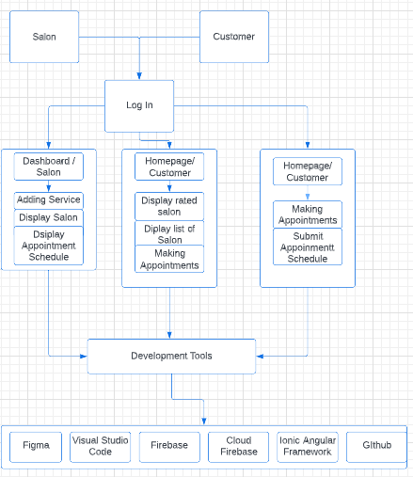Figure 1 shows the conceptual framework of the system and how the Salon and customer would be satisfied with the system performance, accurate system service quality and security as well as the design, convenience and the accessibility of the system.

Figure 1. Conceptual Frameworks

# Chapter III

# DESIGN AND METHODOLOGY

In order to design and develop the SalonBeau - An Android-based Appointment Systems; the researchers applied the Agile Development Methodology that helped teams deliver value to their customers faster and with fewer headaches.

## Development Model

The Agile Development Methodology, which was a project management methodology that distinguished by the partition of activities into brief work phases and constant reevaluation and adaptation of plan; was known for ability to move quickly and effortlessly. The technique adopted the approach of determining the significant user developed a project deliverable and fulfilled the performing the customer rating to a salon. Using the agile methodology process resulted in improved user satisfaction, fewer failure and faster development timelines.

The Agile Development model resulted in the best quality, provided a more limited variety of features, and gave researchers more time to refine before releasing them. The outcomes for each iteration improved, leading to a much-improved quality output, toward the iteration attribute and flexibility it offered in the construction of the system.

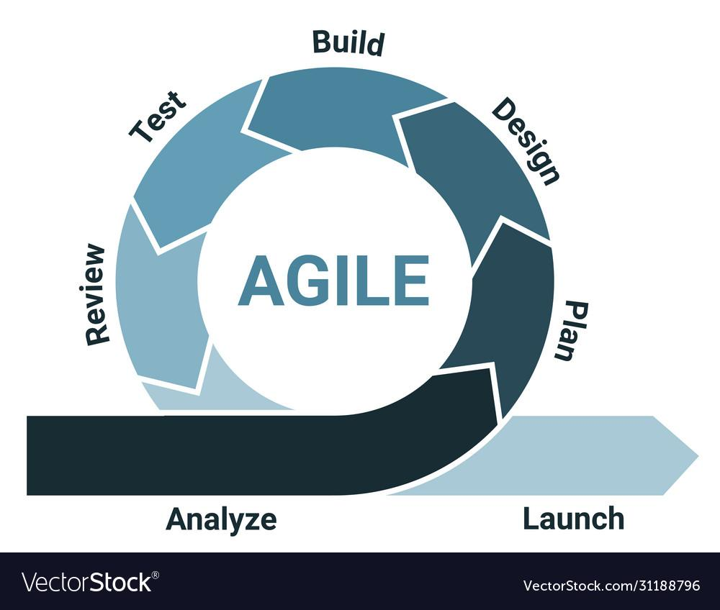

Figure 2. Agile Development Model

## Requirement Analysis

The requirements specified and analyzed the development of the application. The hardware, software and tools were used in creating the android-based application. The hardware requirements for the Android Based application was a Laptop that specified 64-bit Intel core i5 with 8GB RAM, 240 Solid Sata Drive, and version Windows 10 Lenovo laptop. The tools needed were Visual studio code firebase and Ionic-Angular programming language as the frameworks, firebase for the database, and for the logo it was Adobe Express.

## Fish Bone Analysis

Figure 3 showed the project fishbone analysis diagram which identifies the sources of the problem and organizes them by categorizing each aspect such as equipment, environment, procedures, and people in order to explain the consequences of the problem.

Figure 3. Fish Bone Analysis

From the illustration, the major problem that the Android-based Application might encounter was the unorganized salon businesses and dissatisfaction of the customers. The equipment was just not enough for the number of customers and was done manually. Untrained workers affected the whole business and lost a lot of regular customers. The procedure of the salons was being delayed because of the lack of technical help that was being provided by this Android-based Application.

## System Boundary

Figure 4 illustrates the system boundary of the Android-based Application. The Android-based Application was only designed for the salons in Batangas City. The system was intended to help the salons with their appointments.

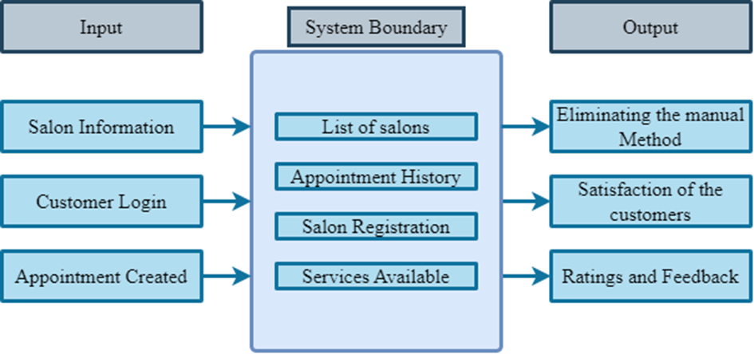

Figure 4. System Boundary

The system boundary of the Android-based Application showed what would be the inputs encoded to the Android-based Application such as salon information, customer login, and appointment created. The contents of the Android-based application were able to show the list of salons, appointment history, salon registration, and services available. For the output that the Android-based Application was expected to present are the elimination of manual methods, satisfaction of the customers, and as well as the ratings and feedback of the customers.

## Hardware Requirements

The hardware requirements of the system were determined by the researchers. The table below lists the needed specifications for each piece of hardware that the user used as well as the minimum and recommended versions.

Table 1. Hardware Requirements

|  |  |  |
| --- | --- | --- |
| **Android OS Requirements** | | |
| **Hardware** | **Minimum Requirement** | **Suggested Requirement** |
| **Android Phone** | Version 11 | Version 11 or Higher |
| **Storage** | 4GB RAM | 4GB RAM or Higher |

**Software Requirements**

These were the software prerequisites for using the Android-based Application. The Android-based Application required Android OS for android devices.

Table 2. Software Requirements

|  |  |
| --- | --- |
| **Software** | **Specification** |
| Android OS | Android 11 or latest |

## Functional requirements

The functional requirements presented the behavior of the Android-based Application, specifically the functionalities of the Android-based Application. The researchers created an Android-based Application and the following features to be implemented.

* **Cover page**
  + The android-based application displays the interface of the application
  + The android-based application displays the information
* **Sign in /Sign up Page**
  + The android-based application displays buttons for the users
  + The android-based application displays login form and sign up form
  + The android-based application displays and detect the wrong username and password
  + The android-based application determined the user login and salon login
  + The android-based application detects an existing username
  + The android-based application displays forgot password
* **Salon Registration**
  + The android-based application displays a button to register the salon
  + The Android-based application displays a registration form
* **Salon Page**
  + The android-based application displays the scheduled from the client
* **Appointment Setting Page**
  + The android-based application displays calendar that contains the schedule if available or not
  + The android-based applications displays the appointment form
  + The android-based applications displays the billing settlement

## Non-functional requirements

The criteria that the software met were non-functional requirements. The researchers created an android-based application to gratify all the customers at different salons in Batangas City.

**● Performance**

The Android-Based Application works as an expected, with no service errors

**● Reliability**

The Android-Based Application should supposedly manage errors and avoid data failure and long periods of downtime

**● Maintainability**

The Android-Based Application provides some updates to help with maintenance general reliability and consistency.

**● Availability**

As lengthy, because the person has a connection, the android-based application changes to be accessible each time they want it.

**● Usability**

The Android-Based Application can be usable, adaptable, and easy to use.

**● Security**

The administrator of the back-end android-based application has power over the users and passwords. Error reporting was accomplished by retaining error logs for the purpose of addressing difficulties.

**Constraints and Multiple Design**

This section discussed the various sets of software tools that were included in the development and the constraint of the entire project at hand for the design and implementation of the system. Constraints were restricting factors that affect the whole project at hand. In a way, these limitations aided researchers in restricting their options for software resources that can be used in device construction.

## Multiple Design

Table 3 showed the Android-based Application design and technology stack options. The researchers considered various frameworks that could be used in the development of the android-based application.

Table 3. Considered Design and Technology Stack

|  |  |  |  |
| --- | --- | --- | --- |
| **Design** | **Technology Stack** | | |
| **Design A** | Node.js  Ionic-angular  CSS | Visual Studio Code | Firebase – Database and App Hosting  Google Play Store – uploading the application |
| **Design B** | HTML and CSS | Visual Studio  Code | Google Play store |

In design A, visual studio code and firebase were the software that were being used in creating the Android-based Application. Node.js is used to install the ionic and uses it as the front-end and back-end development that use a typescript library to build cross platform applications. It was used to develop applications for android and another operating system. Firebase was a real-time database and collaborative application by allowing secured access to the database directly from client-side, even while offline data was persisted locally and gave the end user a responsive experience. Also, firebase was hosted for both android, iOS and web applications and offered an awesome speed at a lower cost.

In design B, Html and CSS were the following software. CSS or cascading style sheet and HTML or hypertext markup language was to build the user interface of android-based applications. Visual studio code was used for editing code and google play store to host the android application.

## Constraints

Table 4 showed the two sets of designs that were evaluated based on the cost, security, memory, speed and features of the stated set of software tools and constraints.

Table 4 Assessment of Designs According to Constraints

|  |  |  |
| --- | --- | --- |
| **Design** | **Design A** | **Design B** |
| **Cost** | Cost $25 | Cost $25 |
| **Security** | Safe in creating websites | CSS and HTML do not have functionality to make hacker destroy or steal |
| **Components** | High UI components | Low UI Components |
| **Memory** | React Native has built-in support for most of the popular databases | CSS supports various databases |
| **Speed** | Performs well | Performs well |

**Trade-offs**

With the constraints discussed, the design with the corresponding technology that evaluates depending on the needs of the system. The evaluation was based on the learnability and familiarity of the user on those technologies.

To begin with, Design A has a set of software development tools in creating applications. In terms of speed, this software gave better results. Ionic was one of the top programming languages for creating an android application and suitable for data storing using Firebase and used as hosting for the android application. However, while the database systems can provide data storage security, researchers know very little about the software to use.

In Design B, there were sets that brought about rapid development in android-based applications. It was a basic HTML job and cannot proceed to develop an android-based application due to limited language that was used in design B.

**Design**

The design phase of the agile development model deals with the design and architecture of the Android-Based Application. It contains diagrams that aim to demonstrate system processes and explain how the user interacts with the Android-based Application.

## System Design and Architecture

## Use Case Diagram

Figure 5 showed a use case diagram where it displayed all the functionalities of the SalonBeau-An Android-Based Appointment System for Batangas City.

Figure 5. Use Case Diagram

The simplest interaction of the user interaction with the system. Customers were able to login and navigate the menu to explore the android-based application. Booking an appointment was also allowed with regards to the service given by the salon. While the salon was able to update, validate, and receive customer’s appointments. They were also allowed to confirm the appointment given by the customer.

## Data Flow Diagram

Figure 6 illustrated the system functionality and flow of the android-based application. It illustrated the systematic process of performing the objectives step-by-step.

Figure 6. Data Flow Diagram

The Data Flow Diagram showed the flow on how the customer data flows throughout the android-based application. The customer needed to create an account first before accessing the android-based application. After creating an account, the customer was able to create an appointment to their corresponding salon of choice. In the salon section, the front-desk personnel assigned to every salon can view appointments and confirm the appointments.

**Sequence Diagram**

Figure 7 showed the sequence diagram of the android-based application. The system diagram showed the various interactions between users and android-based application components.

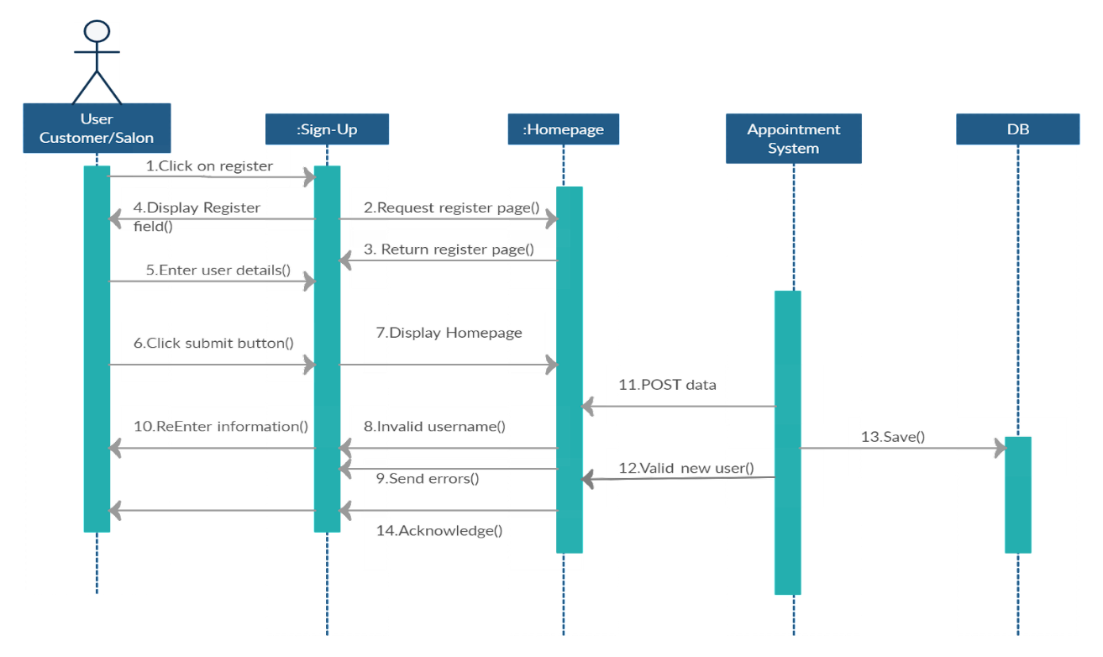

Figure 7. Sequence Diagram

## Database Design

Figure 8 showed the database design diagram of the Android-based application. The database diagram showed the relationships between each component of the Android-based application.

Figure 8. Database Design

We used Star Schema in this diagram, there was the Appointment as the main component of the diagram connected to the customer and salon attributes. In the salon attributes there was the Salon ID and as well as the Service ID for the service attribute under the salon.

**Development**

This stage is the part where the researchers begin to build the android-based application. It begins with the creation of the intended format and coding based on the original functionalities and efficiency of the android-based application.

## Software

This section shows the software requirements of the development of the android-based application. Ionic-Angular was the main programming language to be used in developing the android-based application. HTML and CSS also helps in the Mobile-page structure and style, that can support the programming language mentioned. It also supports frontend and backend development.

Table 5. Software Development Requirements Specification

|  |  |
| --- | --- |
| **Operating System** | Windows 10 |
| **Database** | Firebase |
| **Programming Language** | Typescript |
| **Framework** | Ionic |
| **Development Tool** | Ionic-Angular, Node.js and Visual Studio code |
| **Display Design** | CSS |
| **Internet Browser** | Google Chrome and Microsoft edge |
| **Web Platform** | W3schools, Ionic Documentation and YouTube |

## Operating System

The android-based application was developed using the Windows 10 operating system by the researcher. The operating system manages all of the applications of the computer. These computer programs was used in the coding and development of the project.

## Database

The framework to use in developing the system in Ionic-Angular. Firebase was used for databases, using the framework of Ionic-Angular is the easiest choice for the researchers as it was connected to android-based applications.

## Subscription

Firebase provides all the basics for the hosting android. The platform was used to deploy and manage android-based applications, the researchers chooses a reliable hosting platform and easy to use, fast configuration and development that allows the administrator to track all the changes via web system. Firebase is free and handles service efficiently.

## Hardware for development

Table 6 shows the minimum hardware requirements for android-based application development that the researchers used.

Table 6. Hardware Development Requirements Specification

|  |  |
| --- | --- |
| **Hardware** | **Specification** |
| **System Type** | 64-bit operating system, x64 based processor |
| **Processor** | Intel ™ Core ™ i5  CPU @ 2.50GHz  (4CPUs), ~2.7GHz |
| **Size of Installed RAM** | 8GB |
| **Size of Hard Drive** | 240 GB Solid State Drive |
| **Others** | Mouse and Keyboard |

**Testing**

Testing phase covered the testing of the android-based application to identify the errors and bugs. This also determined the quality of the system. It was conducted to make sure that every part of the android-based application was functioning. It was the stage of identifying holes in the android-based application as well if the product meets the expected outcome. The system was tested using ISO/IEC 9126.Diagram

Figure 9. . ISO/IEC 9126

The used of ISO/IEC 9126 (or the revised version – ***ISO/****IEC 25010:2011*) as shown in figure 9 and used to evaluate the android-based application. The following criteria were portability, maintainability, efficiency, usability, relatability and functionality.

## Functional Suitability

To what extent the android-based application provides functionality that meets specified and implicit requirements when used under certain conditions. This phase helps researchers monitor, judge and evaluate the accuracy and validity of system modules function.

## Usability

This shows how the users can use the android-based application to achieve a particular goal. Effectiveness, efficiency, and satisfaction in a particular usage situation. The researchers evaluate android-based application performance based on user testing.

## Compatibility

To the extent that an android-based application or component can exchange information with others while sharing the required functionality with the system or component hardware and software. This helps researchers monitor and evaluate coexistence of an android-based application with other systems.

## Reliability

This refers to the range in which an android-based application, product, or component runs at a specified level. It works for a certain period of time under certain conditions. This phase is for researchers to ensure system performance consistency.

## Maintainability

This phase is going to determine researchers’ capabilities of the android-based application. Especially adapts to changing requirements and environment.

## Portability

This phase is related to testing the reliability and effectiveness of what has to develop. The system when transferred from hardware, software, or other environments.

## Testing Procedure

The researchers used detail in this phase, testing period basis is on an incremental testing approach specified by the agile development approach development approach. The testing procedure repeats until the results are acceptable.

Table 7. Testing Procedure

|  |  |
| --- | --- |
| **User Type** | **Testing Procedure** |
| **User’s side** | |
| **Homepage** | * Test if every button is functioning and visible * Test if the desired layout is shown |
| **Sign In/Sign Up** | * Test if the customer can register * Test if the salon can register * Test if every button related to sign in and sign up are functioning * Test if the customer can use his email account upon registration * Test if the forgot password is functioning * Test if the customer can retrieve their account * Test if an email was received upon clicking the forget password |
| **Appointment** | * Test if the customer can access the services * Test if the customer can book an appointment |
| **Feedbacks** | * Test if the customers can put ratings and comments |
| **Salon Dashboard** | * Test if the salon can view the schedule * Test if the salon can confirm the customer appointment |
|  | * Test if the Salon can edit the services |

Table 8. Testing Procedure (cont.)

|  |  |
| --- | --- |
| **Developer Side** | |
| **Homepage** | * Test if every button is functioning and visible * Test if the desired layout is shown |
| **Sign In/Sign Up** | * Test if the researchers can register * Test if every button related to sign in and sign up are functioning * Test if the researchers can access customer accounts * Test if the forgot password is functioning * Test if an email was received upon clicking the forget password |
| **Developer verification** | * Test if the researcher can receive the requisition * Test if the confirmation works prompt on the computer screen |
| **Availability** | * Test if the android-based application is accessible * Test whether android-based application is updating automatically |

## Data Gathering

Gathering data for the android-based application of salons in Batangas City, the researchers used Google forms to gather insights and feedback from the respondents and potential customers particularly with the efficiency, functionality, security and usability of the system.

**Deployment**

In this phase, this showed the different activities that needed to be done for the customer to publish the project and make it available to the residents of Batangas City and the researchers are the owner of this application as they begin their technopreneurship. In this case, the system was fully developed, bug-free, and ready for deployment.

The development plan for the android-based application was to create an apk file that could be installed on an android device. This android-based application was advertised to social media most especially in Facebook Meta to attract users in Batangas City and also download and install the application.

The following tables are the provided hardware and software matrix to consider by the customer for the successful deployment.

Table 9. Hardware Matrix for the System Development

|  |  |  |
| --- | --- | --- |
| **Hardware** | **Requirements** | **Applicable System** |
| **Disk space** | 2 or higher | Android 5.0 or higher |
| **Memory** | Minimum of 2GB RAM  Or higher | Android 5.0 or higher |
| **Processor** | Quad Core CPU | Android 5.0 or higher |
| **Display** | 1080 × 1920 screen resolution  or more | Android 5.0 or higher |

Table 10. Software Matrix for the System Development: Operating System

|  |  |  |
| --- | --- | --- |
| **Operating System** | **Minimum Operating System** | **Bitness** |
| Android | Base | 64 bits |

**Risk Management Plan**

In this phase the possible risk and consequences upon using and conducting testing to the android-based application as well as the response plan in relation to it. This also represent guidelines for the users dealing with unexpected events.

Table 11. Risk Consequences, and Response Plan

|  |  |  |
| --- | --- | --- |
| **RISK** | **CONSEQUENCES** | **RESPONSE PLAN** |
| Loss of Internet connection | System cannot be accessed | Ensure the connectivity |
| System Downtime | Loss of  Access | Contact the server  provider |
| Expiration of Web Host Subscription | Loss of access | Pay subscription fee on  time |
| Human Error | Inaccurate data | Check data manually |
| Poor Cellular Signal | Misunderstandings | Look for a spot where  signal is good |

Table 12. Risk Analysis and Rankings

|  |  |  |  |  |  |
| --- | --- | --- | --- | --- | --- |
| **Risk** | **Likelihood** | **Consequence** | **Vulnerability** | **Speed** | **Rank** |
| Loss of Internet  connection | 5 | 5 | 4 | 2 | 1st |
| System Downtime | 2 | 4 | 2 | 2 | 2nd |
| Expiration of  Web Host  Subscription | 2 | 4 | 2 | 2 | 2nd |
| Human Error | 2 | 2 | 3 | 2 | 3rd |
| Poor Cellular Signal | 2 | 3 | 3 | 2 | 2nd |

Table 13. Risk Category

|  |  |  |  |
| --- | --- | --- | --- |
| **Risk** | **Risk Likelihood** | **Risk Severity** | **Risk Category** |
| Loss of Internet  connection | Probable | Undesirable | High |
| System Downtime | Probable | Undesirable | High |
| Expiration of Web  Host Subscription | Possible | Undesirable | High |
| Human Error | Possible | Tolerable | Medium |
| Poor Cellular Signal | Possible | Tolerable | Medium |

Table 14. Risk Assessment Matrix

|  |  |  |  |  |  |  |
| --- | --- | --- | --- | --- | --- | --- |
|  | | | Impact | | | |
| 0  Acceptable | 1  Tolerable | 2  Unacceptable | 3  Intolerable |
| Little or No Effect | Effects are Felt but not Critical | Serious Impact to Course of Action and Outcome | Could Result in Disasters |
| Likelihood | Improbable | Risk Unlikely to Occur |  |  |  |  |
| Possible | Risk Will Likely Occur |  |  |  |  |
| Probable | Risk Will Occur |  |  |  |  |

Table 15. Mitigation Grading Matrix

|  |  |  |  |  |  |
| --- | --- | --- | --- | --- | --- |
| **RISK MATRIX** | | | | | |
|  |  | **SECTIONS IMPACTED** | | | |
| **LIKELIHOOD** |  | LOW | MEDIUM | HIGH | EXTREME |
| LOW | N | D | C | A |
| MEDIUM | D | C | B | A |
| HIGH | C | B | A | A |

|  |  |  |
| --- | --- | --- |
| **RISK MITIGATION BASED UPON GRADE** | |  |
| **GRADE** | **POSSIBLE ACTION** |  |

|  |  |  |
| --- | --- | --- |
| **A** | As a priority, mitigation actions reducing both likelihood and seriousness are to be identified and implemented at the start of the project. |  |
| **B** | Mitigation actions reducing both likelihood and seriousness are to be identified and implemented throughout the course of the project. |  |
| **C** | Mitigation actions reducing both likelihood and seriousness are to be identified and cost for possible action should funds permit execution. |  |
| **D** | Risk to be noted: No action is required unless grading increases over time. |  |
| **N** | Risk to be noted: No action is required unless grading increases over time. |  |

# Chapter IV

# RESULTS AND DISCUSSIONS

This chapter presented the result and discussion, final layout and system features of the project. The development of SalonBeau- An Android-based Appointment system for Salon in Batangas City and the interpretation of data gathered. Results of the objectives presented were considered and listened to accordingly.

1. To provide an efficient way of scheduling and booking of services in a salon.

The developed android-based application manage to lessen the manual method of the salons in terms of booking appointments. The customers can conveniently book an appointment without the need to go physically into the salons in Batangas City just to secure a slot.

1. To design and develop the system with the following features:
2. Appointment confirmation via email.

This feature sends a confirmation email to the provided email address of the customer.

1. Salons review the appointment before confirmation.

In this feature, the appointment that the customer booked sends as a request that the salon owners can either accept or reject based on their schedule.

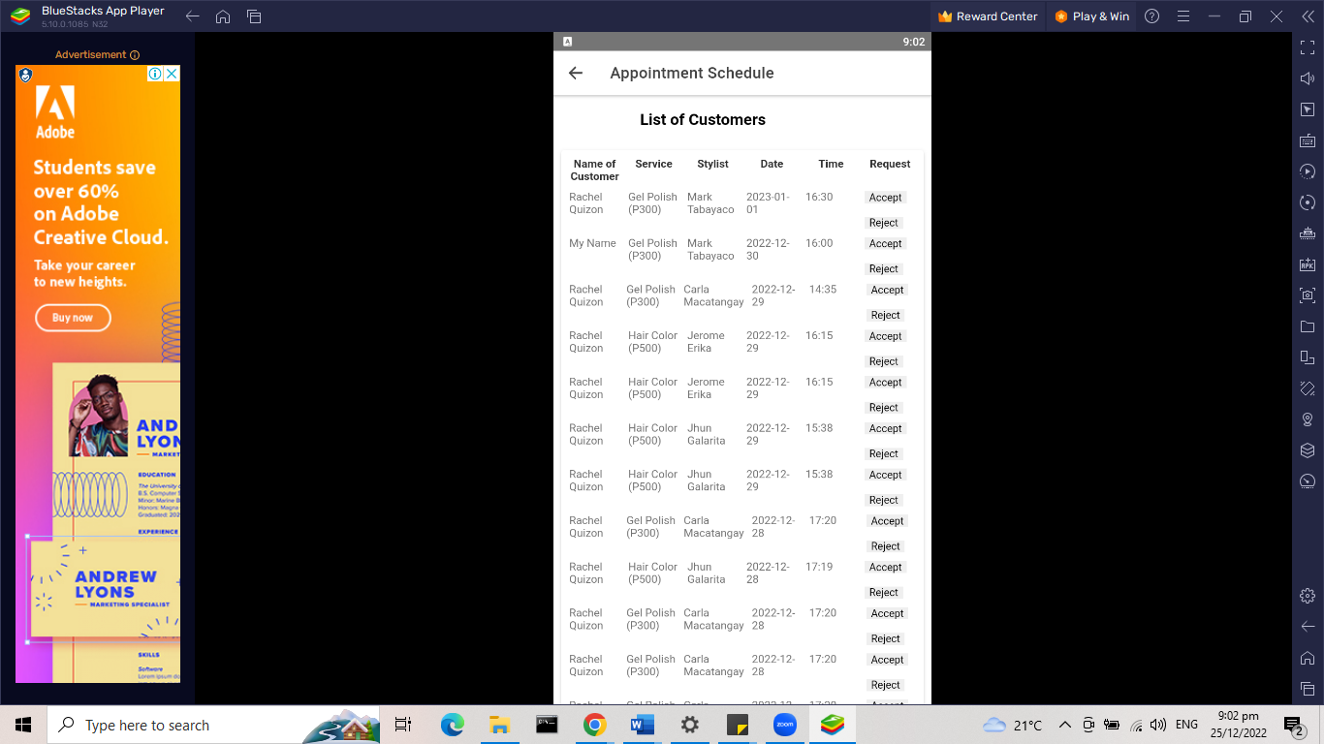

1. To help customers in finding the top rated salon with the use of analytics.

The developed android application used analytics to determine the top rated salons in Batangas City. So that the customers can see which of the salons in Batangas City has better customer service based on its ratings and positive feedbacks.

# Chapter V

# SUMMARY, CONCLUSIONS AND RECOMMENDATIONS

This chapter included the summary of findings found by the researchers in the study entitled **SalonBeau - An Android-Based Appointment System for Salons in Batangas City**. It also contained conclusions and recommendations to further improve the developed system.

## Summary

The researchers conducted a study and created the android-based application entitled: "SaloBeau - An Android-based Appointment System for Salons in Batangas City", With the use of a structured appointment booking system, customers now can book a slot for a certain salon. The following are the findings about the developed mobile application.

1. The android application provided an efficient way for the customer in terms of scheduling and booking of services in a salon.
2. The developed android application successfully incorporated the following features;

* Appointment confirmation via email.
* Salons review the appointment before confirmation.

1. The android application can show the top rated salons for the customers.

## Conclusions

This project concludes that the developed android-based application met the given objectives. The researchers developed a mobile application that would help customers to book their appointments. On the other hand, the business owners can register their business. The survey conducted by the researchers aim to achieve the following objectives:

* To provide basis for developing an android-based appointment system.
* To determine the number of customers who needed the application.
* To show the overall experience of the customer while testing the application.

According to the results of the survey conducted by the researchers, most of the respondents find it easy to use the application and the ratings/feedback feature is very useful in navigating the application.

## Recommendations

Developing a system was not easy to perform in such a way that it can be perfect. Therefore, the researchers recommend the following for further improvement of the “SaloBeau - An Android Based Appointment System for salons in Batangas City”.

1. Compatible with iOS devices

Based on our observation, majority of the registered salons are using android devices and the researchers used android platform because it is more user-friendly than iOS.

1. Pay through the system

This feature was not possible because there is no organization that will handle the android-application and it is impossible to have a secure system handling in-app payments.

1. Map function could be added

This feature was not added to the system since there are no objectives or goal in this project that a map is needed in booking appointments.

# BIBLIOGRAPHY

Abdelmagid, A., Gheith, M., & Eltawil, A. (2021). A comprehensive review of the truck

appointment scheduling models and directions for future research. Transport Reviews, 42(1), 102-126. doi: 10.1080/01441647.2021.1955034

Akshay, V., Kumar S., A., Alagappan, R., & Gnanavel, S. (2019). BOOKAZOR - an

Online Appointment Booking System. 2019 International Conference On Vision Towards Emerging Trends In Communication And Networking (Vitecon). doi: 10.1109/vitecon.2019.8899460

Alojado, R., Custodio, B., Lasala, K., & Marigomen, P. (2015). Designing an Ergonomic

Chair for Pedicurists and Manicurists in Quezon City, Philippines. Procedia Manufacturing, 3, 1812-1816. doi: 10.1016/j.promfg.2015.07.220

Ansary, T. (2018). An Android Based Online Plarlour Management System [Ebook].

Retrieved from http://hdl.handle.net/123456789/2672

Azab, A., & Morita, H. (2022). The block relocation problem with appointment

scheduling. European Journal Of Operational Research, 297(2), 680-694. doi: 10.1016/j.ejor.2021.06.007

Baradillo, V. ., Escobio, A., Feolino, A., Tica, D. ., Mangarin, J. ., & Dacuno, A. M. .

(2020). Feasibility Study on Establishment of BeautyFull Salon in #24 Shorthorn St., Project 8 Quezon City. Ascendens Asia Singapore – Bestlink College of the Philippines Journal of Multidisciplinary Research, 2(1). Retrieved from https://ojs.aaresearchindex.com/index.php/aasgbcpjmra/article/view/1303

Cabangunay, B., Villanueva, A., Gesmundo, N., Dazo, V., & Dacuno, MBA, A. M.

(2020). Feasibility Study on Establishment of Famdom Salon in Quirino Highway, Novaliches, Quezon City. Ascendens Asia Singapore – Bestlink College of the Philippines Journal of Multidisciplinary Research, 2(1). Retrieved from https://ojs.aaresearchindex.com/index.php/aasgbcpjmra/article/view/1359

Dharma Krisna Putra, K., Piarsa, I., & Sukarsa, I. (2020). Geographic Information System

for Booking Beauty Salon and Barber Shop with an Android-Based ECRM Approach. Scientific Journal Of Informatics, 7(1), 52-65. doi: 10.15294/sji.v7i1.22675

Dinio, C., Paragon, N., Pelena, G., Valida, A., L.Velasco, M., & Vizcarra, E. et al. (2018).

Automated Water Source Scheduling System with Flow Control System. 2018 IEEE 10Th International Conference On Humanoid, Nanotechnology, Information Technology,Communication And Control, Environment And Management (HNICEM). doi: 10.1109/hnicem.2018.8666253

Eslami, S., Mazaheri Habibi, M., Abadi, F., Tabesh, H., Vakili-Arki, H., & Abu-Hanna, A.

(2018). Evaluation of patient satisfaction of the status of appointment scheduling systems in outpatient clinics: Identifying patients' needs. Journal Of Advanced Pharmaceutical Technology &Amp; Research, 9(2), 51. doi: 10.4103/japtr.japtr_134_18

Ferreria, M. A., Semsem, N. E., Salgado, S. M., Sicabalo, S. G., & Dacuno, MBA, A.

M. M. (2019). A Feasibility Study on the Establishment of Aphrodite Home Salon

at Rolex Street, Brgy. Greater Fairview, Quezon City. Ascendens Asia Singapore – Bestlink College of the Philippines Journal of Multidisciplinary Research, 1(1). Retrieved from https://ojs.aaresearchindex.com/index.php/aasgbcpjmra/article/view/1613

Galasao, E., Picson, J., Balbarino, S., Ontolan, J., & Daguil, M. (2020). Proposed

Reservation Management System for Daisy Salon. Ascendens Asia Singapore – Bestlink College Of The Philippines Journal Of Multidisciplinary Research Abstracts, 2(1).

Gulshan, A., & Khan, A. (2021). Salon Management System. International Journal Of

Creative Research Thoughts (IJCRT), 9(5).

Habibi, M., Mohammadabadi, F., Tabesh, H., Vakili-Arki, H., Abu-Hanna, A., & Eslami,

S. (2019). Effect of an Online Appointment Scheduling System on Evaluation Metrics of Outpatient Scheduling System: a before-after MulticenterStudy. Journal Of Medical Systems, 43(8). doi: 10.1007/s10916-019-1383-5

Huda, M., Adwait, P., Kumar, A., & Jha, M. (2017). Scheduling Clients for Appointment

in Beauty Parlour.

Iliya Maisarah Sa’adon, & Mohd Yunus, M. A. (2021). Aplikasi Spa dan Salun. Applied

Information Technology And Computer Science, 2(2), 1298–1306. Retrieved from https://publisher.uthm.edu.my/periodicals/index.php/aitcs/article/view/2183

Lovedorial, P. ., Dejucos, R. ., De Leon, M. ., Retirado, G. D. ., & Jayoma, CHP, R. R.

(2020). Feasibility Study on Establishment of Sweet Aphrodite Salon and Spa in

Caltex Muzon SJDM, Bulacan. Ascendens Asia Singapore – Bestlink College of the Philippines Journal of Multidisciplinary Research, 2(1). Retrieved from https://ojs.aaresearchindex.com/index.php/aasgbcpjmra/article/view/1929

Mayor, J. (2021). EC Health Medical Clinic and Diagnostic Center Appointment System.

2021 IEEE 13Th International Conference On Humanoid, Nanotechnology, Information Technology, Communication And Control, Environment, And Management (HNICEM). doi: 10.1109/hnicem54116.20p21.9731815

Mendoza, S., Padpad, R., Vael, A., Alcazar, C., & Pula, R. (2019). A Web-Based

“InstaSked” Appointment Schedulingp System at Perpetual Help Medical Center Outpatient Department. World Congress On Engineering And Technology; Innovation And Its Sustainability 2018, 3-14. doi: 10.1007/978-3-030-20904-9_1

Mohd Soufi, S., Azmi, A., Musri, F., & Noho, N. (2020). “Salon Management

System'' Project Proposal - PDFCOFFEE.COM. Retrieved 19 June 2022, from https://pdfcoffee.com/salon-management-system-project-proposal-pdf-free.html

R.B, P., Suryawanshi, P., Kadtan, A., Dayalani, J., & Sonavane, T. (2021). Beauty Parlour

Management System. International Journal Of Scientific Research & Engineering Trends, 7(3).

Raj, A., M K, K., & V, K. (2021). Beauty Community: Android Application for Booking

Makeup and Mehendi Artist [Ebook]. Retrieved from http://localhost:8080/xmlui/handle/123456789/298

Ramos, P., Ocampo, J., Fornal, P., & Nayat Young, M. (2020). Impact of Implementing

77

Online Bus Seat Reservation on Provincial Bus Trips in the Philippines. 2020 The 6Th International Conference On Industrial And Business Engineering. doi: 10.1145/3429551.3429575

Salon Appointment System with SMS Notification - Free Capstone 2022. (2021).

Retrieved 19 June 2022, from https://www.inettutor.com/source-code/salon-appointment-system-with-sms/

Sarwindah, Marini, Hengki, & Febriyanti, S. (2020). A Development of Web-based

Customer Relationship Management (CRM) system for Beauty Clinic. 2020 8Th International Conference On Cyber And IT Service Management (CITSM). doi: 10.1109/citsm50537.2020.9268918

Selda, J., Mendoza, F., Balili, M., Famisara, R., Guerero, J., Puazo, J. G., Bingcang, I. N.,

Lopez, G., & Rellis, H. (2016). DEVELOPMENT OF SERVICE AND PRODUCT MANAGEMENT INFORMATION SYSTEM FOR SALON BUSINESS. Abstract Proceedings International Scholars Conference, 4(1), 93. https://doi.org/10.35974/isc.v4i1.1899

Srinivas, S., & Ravindran, A. (2018). Optimizing outpatient appointment system using

machine learning algorithms and scheduling rules: A prescriptive analytics framework. Expert Systems with Applications, 102, 245-261. doi: 10.1016/j.eswa.2018.02.022

Swastikasari, M., Sediyono, E., & Ardjo, A. (2017). Design of E-KOST: An

Android-based mobile application using location-based service (Study case:

WCU'S students). 2017 International Conference on Innovative And Creative Information Technology (Icitech). doi: 10.1109/innocit.2017.8319135

Vaishali, M., & V, M. (2017). Smart Hair Salon Management System. IARJSET, 4(2),

14-17. doi: 10.17148/iarjset/ncetete.2017.05

Vega, C., Gawron, P., Lebioda, J., Grouès, V., Matyjaszczyk, P., & Pauly, C. et al. (2022).

Smart Scheduling (SMASCH): multi-appointment scheduling system for longitudinal clinical research studies. JAMIA Open, 5(2). doi: 10.1093/jamiaopen/ooac038

Waubert de Puiseau, C., Meyes, R., & Meisen, T. (2022). On reliability of reinforcement

learning based production scheduling systems: a comparative survey. Journal Of Intelligent Manufacturing, 33(4), 911-927. doi: 10.1007/s10845-022-01915-2

Woodcock, E. (2022). Barriers to and Facilitators of Automated Patient Self-scheduling

for Health Care Organizations: Scoping Review. Journal Of Medical Internet Research, 24(1), e28323. doi: 10.2196/28323

Yandug, J., & Santos, C. (2020). Simulation Driven Appointment System Model for a

License Processing Office in the Philippines. Proceedings Of The International Conference On Industrial Engineering And Operations Management. Retrieved from http://www.ieomsociety.org/ieom2020/papers/489.pdf

Zhou, S., & Yue, Q. (2021). Sequencing and scheduling appointments for multi-stage

service systems with stochastic service durations and no-shows. International Journal Of Production Research, 60(5), 1500-1519. doi: 10.1080/00207543.2020.1862431

**APPENDIX: USABILITY SURVEY RESULT**

|  |  |  |  |  |  |
| --- | --- | --- | --- | --- | --- |
| **Questions** | **Response** | | | | |
|  | **SA** | **A** | **N** | **DA** | **SD** |
| 1. The customer finds it easy to use the application. | 73 | 24 | 2 | 0 | 1 |
| 1. The customer finds the rating/feedback useful for better choosing a salon. | 69 | 29 | 1 | 0 | 1 |
| 1. The customer can easily login in SaloBeau. | 64 | 32 | 3 | 0 | 1 |
| 1. I find SaloBeau to be more complicated. | 2 | 15 | 16 | 14 | 32 |
| 1. I find SaloBeau easy to book my appointment. | 75 | 20 | 4 | 0 | 1 |
| 1. I like the general functionality of SaloBeau. | 73 | 22 | 4 | 0 | 1 |

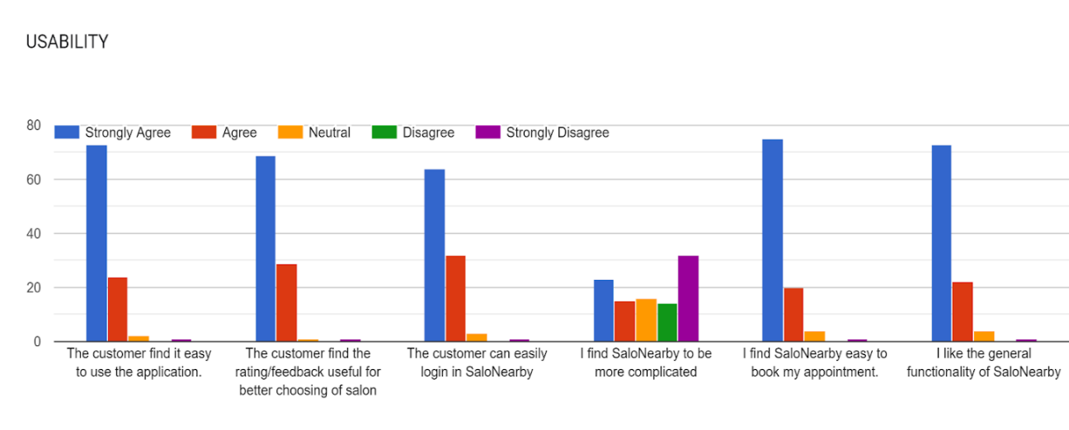

|  |  |  |  |  |  |
| --- | --- | --- | --- | --- | --- |
| **Questions** | **Response** | | | | |
|  | **SA** | **A** | **N** | **DA** | **SD** |
| 1. The information of the user is safe and secured. | 53 | 18 | 1 | 0 | 1 |
| 1. The user's personal data is being used inside the appointment system only. | 50 | 21 | 2 | 0 | 0 |

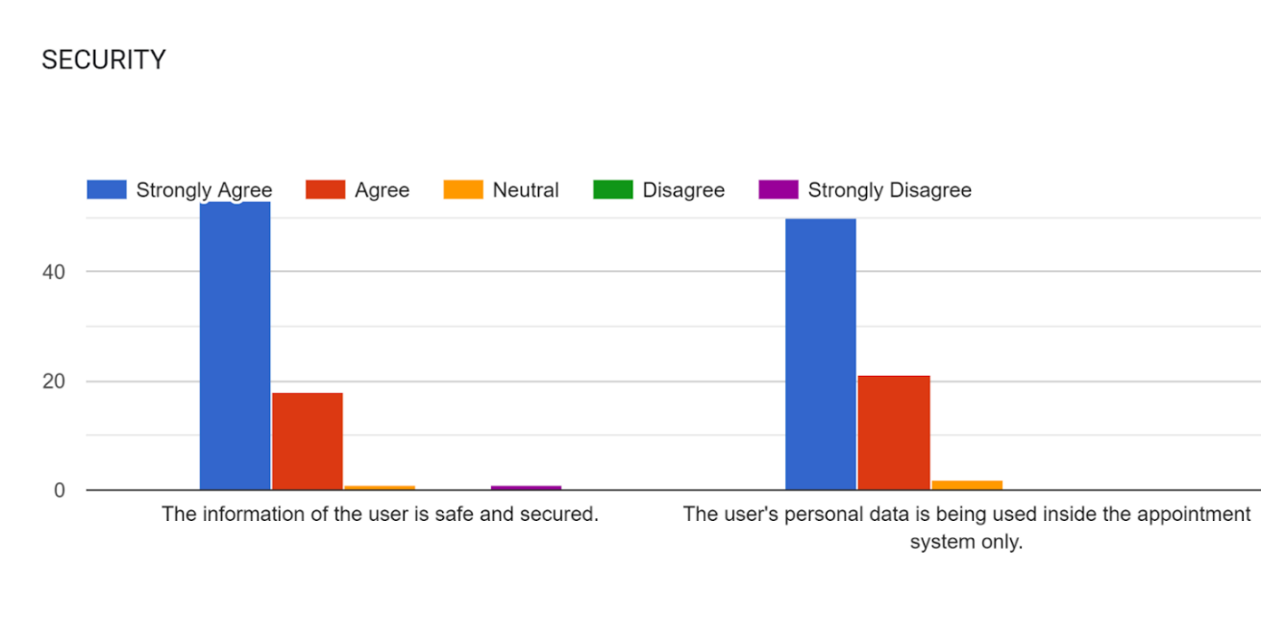

|  |  |  |  |  |  |
| --- | --- | --- | --- | --- | --- |
| **Questions** | **Response** | | | | |
|  | **SA** | **A** | **N** | **DA** | **SD** |
| 1. The system provides accurate output. | 56 | 16 | 1 | 0 | 0 |
| 1. The system is easy to understand and utilize. | 58 | 12 | 1 | 0 | 1 |

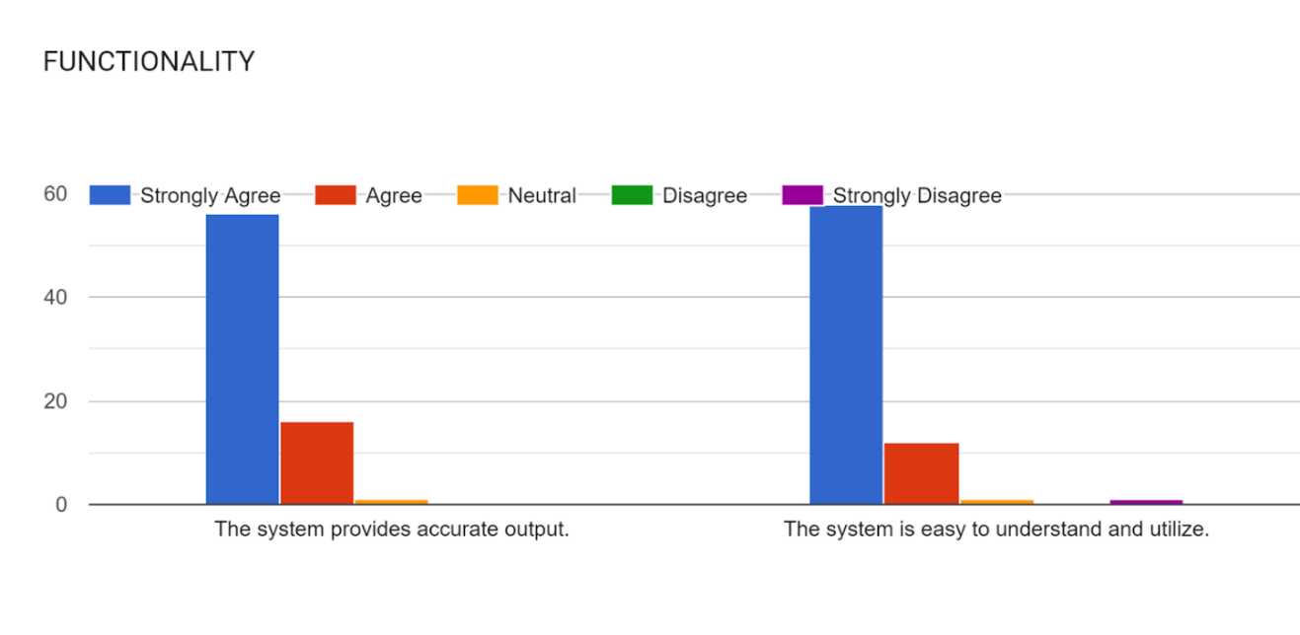

**APPENDIX: BUDGET COST MANAGEMENT PLAN**

**Payment for Panelist:**

**Chairman :** Php 300.00  × 2 = Php 600.00

**Members (2) :** Php 250.00  × 2 = Php 500.00

**Adviser :** Php 500.00  × 1 = Php 500.00

**Grammarian :** Php 1000.00  × 1 = Php 1000.00 *(for Capstone 2)*

**Hosting Application**

Google Play Store

**Internet Connection**

Php 300.00 per month x 3 members = Php 900.00

Php 1,200.00 x 6 months = Php 7,200.00

**Electricity**

Php 250.00 per month x 3 members = Php 750.00

Php 1000.00 x 6 months  Php 6,000.00

**APPENDIX: SOURCE CODE**

<ion-header>

<ion-toolbar>

<ion-buttons slot="start">

<ion-back-button></ion-back-button>

</ion-buttons>

<ion-title>Log In</ion-title>

</ion-toolbar>

</ion-header>

<ion-content>

<img src="assets/3.png" />

<div class="card-flex">

<ion-card class="shadow">

<ion-card-content>

<ion-item lines="full">

<ion-label position="floating">Email</ion-label>

<ion-input

[(ngModel)]="emailLogin"

name="emailLogin"

id="emailLogin"

class="float"

type="text"

placeholder="Email"

></ion-input>

</ion-item>

<ion-item lines="full">

<ion-label position="floating">Password</ion-label>

<ion-input

[type]="showPwd ? 'text' : 'password'"

passwordLogin="password"

name="password2"

id="password2"

[(ngModel)]="passwordLogin"

type="password"

placeholder="Password"

></ion-input>

<ion-icon

slot="end"

[name]="pwdIcon"

(click)="togglePwd()"

></ion-icon>

</ion-item>

</ion-card-content>

</ion-card>

</div>

<ion-button class="login-btn" color="#FFB5A7" type="submit" (click)="login()"

>Sign In</ion-button

>

<br />

<br />

<div class="signup">

<p>Doesn't have an account?</p>

<ion-button class="create" fill="clear" class="create" (click)="toSignUp('signup')">Sign up</ion-button>

</div>

<div>

<ion-button fill="clear" class="forgot" (click)="toSignUp('forgotpass')">Forgot Password?</ion-button></div>

<!-- <div *ngIf="(email.dirty || email.touched) && email.errors" class="errors">

<span *ngIf="email.errors?.required">Email is required</span>

<span *ngIf="email.errors?.email">Email is invalid</span>

</div>

<div

*ngIf="(password.dirty || password.touched) && password.errors"

class="errors"

>

<span *ngIf="password.errors?.required">Password is required</span>

<span *ngIf="password.errors?.minlength"

>Password needs to be 6 characters</span

>

</div> -->

</ion-content>

img {

padding-top: 15%;

}

.login-btn {

margin-top: 5%;

margin-left: 15%;

width: 70%;

height: 35px;

font-family: "poppins", sans-serif;

font-weight: 600;

background-color: #ffb5a7;

}

.email {

width: 90%;

height: auto;

font-family: "poppins", sans-serif;

}

.password {

width: 90%;

height: auto;

font-family: "poppins", sans-serif;

}

.shadow {

box-shadow: none;

}

.forgot {

position: relative;

left: 5px;

bottom: 60px;

font-family: "poppins", sans-serif;

}

.signup {

position: relative;

top: 5%;

left: 5%;

width: 70%;

height: 35px;

font-family: "poppins", sans-serif;

font-weight: 600;

}

.create {

position: relative;

top: 3%;

left: 3%;

width: 70%;

height: 35px;

font-family: "poppins", sans-serif;

font-weight: 600;

}

ion-icon{

vertical-align: center;

padding-top: 5%;

}

<ion-header>

<ion-toolbar>

<ion-buttons slot="start">

<ion-back-button></ion-back-button>

</ion-buttons>

<ion-title>Reset Your Password</ion-title>

</ion-toolbar>

</ion-header>

<div class = " container ion-text-center">

<img src = "assets/3.png">

</div>

<ion-content>

<form class="center">

<ion-item lines ="full" >

<ion-label position="floating">Type Your Email</ion-label>

<ion-input type="text" required></ion-input>

</ion-item>

<ion-row>

<ion-col>

<button (click)= 'updatePassword()' class="changepass" type="submit" >Submit</button>

</ion-col>

</ion-row>

</form>

</ion-content>

.changepass{

margin: auto;

top: 50%;

left: 16%;

width: 70%;

height: 35px;

border-radius: 10px;

font-family: 'poppins', sans-serif;

font-weight: 600;

background-color: #ffb5a7;

}

.center{

top: 15%;

left: 10%;

width: 80%;

font-family: 'poppins', sans-serif;

font-weight: 600;

position: absolute;

}

.img {

margin-top: 20%;

}

.shadow {

box-shadow: none;

}

<ion-header>

<ion-toolbar>

<ion-title>Adding Service</ion-title>

</ion-toolbar>

</ion-header>

<ion-content>

<ion-item class="length">

<ion-label class="text-stl2" position="floating">Name of Service</ion-label>

<ion-input

class="blank"

[(ngModel)]="category"

type="text"

placeholder=" "

></ion-input>

</ion-item>

<ion-item class="length">

<ion-label class="text-stl2" position="floating">Sub-category</ion-label>

<ion-input

class="blank"

[(ngModel)]="subCategory"

type="text"

placeholder=" "

></ion-input>

</ion-item>

<ion-item class="length">

<ion-label class="text-stl2" position="floating">Cost</ion-label>

<ion-input

class="blank"

[(ngModel)]="cost"

type="number"

placeholder=" "

></ion-input>

</ion-item>

<button class="submit" (click)="addServices()">Submit</button>

</ion-content>

.length{

font-family: 'poppins', sans-serif;

width: 250px;

}

.categ{

margin: auto;

top: 25px;

left: 65%;

width: 125px;

height: 40px;

border-radius: 10px;

font-family: 'poppins', sans-serif;

font-weight: 600;

position: absolute;

background-color: #F9DCC4;

}

.sub-categ{

margin: auto;

top: 85px;

left: 65%;

width: 125px;

height: 40px;

border-radius: 10px;

font-family: 'poppins', sans-serif;

font-weight: 600;

position: absolute;

background-color: #F9DCC4;

}

.submit{

margin: auto;

top: 30%;

left: 25px;

width: 85%;

height: 40px;

border-radius: 10px;

font-family: 'poppins', sans-serif;

font-weight: 600;

position: absolute;

background-color: #F9DCC4;

}

.submit:hover{

color: #f4978e;

}

<ion-header>

<ion-toolbar>

<ion-title>Appointment Schedule</ion-title>

</ion-toolbar>

</ion-header>

<ion-content>

<ion-label class="list-cust">List of Customers</ion-label>

<ion-card class="table-container">

<ion-grid [fixed]="true">

<ion-row class="font-title">

<ion-col>Name of Customer</ion-col>

<ion-col>Service</ion-col>

<ion-col>Date</ion-col>

<ion-col>Time</ion-col>

</ion-row>

<ion-row *ngFor="let appointment of appointments">

<ion-col>{{appointment?.name}}</ion-col>

<ion-col>{{appointment?.service}}</ion-col>

<ion-col>{{appointment?.date}}</ion-col>

<ion-col>{{appointment?.time}}</ion-col>

</ion-row>

</ion-grid>

</ion-card>

</ion-content>

.list-cust{

font-weight: 600;

font-size: 20px;

padding-top: 20px;

margin: auto;

position: absolute;

padding-left: 110px;

}

.table-container{

margin-top: 70px;

box-shadow: 5px;

}

.font-title{

font-weight: bold;

color: rgb(49, 49, 49);

font-size: 14px;

text-align: center;

}

<ion-header>

<ion-toolbar>

<ion-title> Salon Dashboard</ion-title>

<ion-button type="Button" expanded="block"[routerLink]="['/tabs/tab1']" ><ion-icon name="Home"></ion-icon></ion-button>

</ion-toolbar>

</ion-header>

<ion-content>

<button [routerLink]="['/apptsched']" class="appt-sched">

View Appointments

</button>

<button [routerLink]="['/addservice']" class="services">

Manage Services

</button>

<button [routerLink]="['/ratings']" class="ratings">Ratings/Feedbacks</button>

</ion-content>

<ion-button type="button" expand="block" (click)="logout()">Logout</ion-button>

.appt-sched{

margin: auto;

top: 25px;

left: 10px;

width: 93%;

height: 50px;

border-radius: 10px;

font-family: 'poppins', sans-serif;

font-size: 18px;

color: white;

font-weight: 600;

position: relative;

background-color: #f4978e;

}

.services{

margin: auto;

top: 85px;

left: 10px;

width: 93%;

height: 50px;

border-radius: 10px;

font-family: 'poppins', sans-serif;

font-size: 18px;

color: white;

font-weight: 600;

position: absolute;

background-color: #f4978e;

}

.ratings{

margin: auto;

top: 145px;

left: 10px;

width: 93%;

height: 50px;

border-radius: 10px;

font-family: 'poppins', sans-serif;

font-size: 18px;

color: white;

font-weight: 600;

position: absolute;

background-color: #f4978e;

}

<ion-header>

<ion-toolbar>

<ion-buttons slot="start">

<ion-back-button></ion-back-button>

</ion-buttons>

<ion-title>Log In</ion-title>

</ion-toolbar>

</ion-header>

<!-- Application Form -->

<ion-content>

<div>

<img src="assets/3.png" />

</div>

<div>

<ion-item class="item">

<ion-label class="text-stl2" position="floating">Salon Name</ion-label>

<ion-input

[(ngModel)]="salonName"

name="salonName"

class="float"

type="text"

placeholder=" "

></ion-input>

</ion-item>

<ion-item class="item">

<ion-label class="text-stl2" position="floating">Address</ion-label>

<ion-input

[(ngModel)]="salonLocation"

name="salonLocation"

class="float"

type="text"

placeholder=" "

></ion-input>

</ion-item>

<ion-item class="item">

<ion-label class="text-stl2" position="floating">Mobile Number</ion-label>

<ion-input

[(ngModel)]="contactNumber"

name="contactNumber"

class="float"

type="number"

placeholder=""

></ion-input>

</ion-item>

<ion-item class="item">

<ion-label class="text-stl2" position="floating">Email</ion-label>

<ion-input

[(ngModel)]="email"

name="email"

class="float"

type="email"

placeholder=""

></ion-input>

</ion-item>

<ion-item class="item">

<ion-label class="text-stl2" position="floating"

>Business Registration</ion-label

>

<ion-input

[(ngModel)]="businessRegistration"

name="businessRegistration"

class="float"

type="text"

placeholder=""

></ion-input>

</ion-item>

<ion-item class="item">

<ion-label class="text-stl2">Salon Logo (1 x 1 size only)</ion-label>

<input

#upload

type="file"

placeholder=""

(change)="fileChange($event)"

hidden

/>

<ion-button (click)="upload.click()">Upload Logo</ion-button>

</ion-item>

<br /><br />

<div float-right class="my-checkbox">

<ion-checkbox name="check"></ion-checkbox>

<ion-label class="text">I agree in all terms and conditions</ion-label>

</div>

<button class="submit" (click)="uploadFile($event)">

Start Your Journey!

</button>

</div>

</ion-content>

img {

padding-top: 20%;

}

.item{

font-family: 'poppins', sans-serif;

width: 90%;

font-size: 18px;

}

.float{

background-color: #F9DCC4;

}

.submit{

margin: auto;

top: 85%;

left: 25px;

width: 85%;

height: 35px;

border-radius: 20px;

font-family: 'poppins', sans-serif;

font-weight: 600;

background-color: #F9DCC4;

}

.submit:hover{

color: #f4978e;

}

.my-checkbox {

display: flex;

padding-left: 8%

}

.text{

padding-left: 10%;

}

<link rel="preconnect" href="https://fonts.googleapis.com" />

<link rel="preconnect" href="https://fonts.gstatic.com" crossorigin />

<link

href="https://fonts.googleapis.com/css2?family=Poppins&display=swap"

rel="stylesheet"

/>

<link href="https://rawgit.com/fraserxu/ionic-rating/master/ionic-rating.css" rel="stylesheet">

<script src="//code.ionicframework.com/nightly/js/ionic.bundle.js"></script>

<script src="https://rawgit.com/fraserxu/ionic-rating/master/ionic-rating.min.js"></script>

<ion-header>

<ion-toolbar>

<ion-buttons slot="start">

<ion-back-button

class="back-btn"

text=""

icon="arrow-back"

></ion-back-button>

</ion-buttons>

</ion-toolbar>

</ion-header>

<div class="container">

<p>{{salonData[0]?.salonName}}</p>

<ion-content>

<ion-slides [options]="option" class="ion-margin-top">

<ion-slide>

<ion-card id="img" button>

<img id="size" [src]="salonData[0]?.logoUrl" />

</ion-card>

</ion-slide>

</ion-slides>

<ion-card class="services">

<label>Services</label>

<!-- list of service-->

<ion-item>

<ion-list *ngFor="let salonService of servicesSalonData">

<ion-item

[routerLink]="['/user-appointment',salonData[0]?.id, salonService?.category]"

class="ion-button"

>

<ion-label> {{salonService.category}} </ion-label>

</ion-item>

</ion-list>

</ion-item>

<br /><br />

<div class="appointment" *ngIf="userDataArray[0]?.type!='salon'">

<ion-item

[routerLink]="['/user-appointment',salonData[0]?.id]"

class="ion-button"

>

<ion-label>Make Appointment</ion-label>

</ion-item>

</div>

<br />

<ion-label>Add Ratings and FeedBack</ion-label>

<ion-item ng-controller="MainCtrl"

class = "ion-button"

><br/>

<ion-content class="row, col, card, item item-divider, item item-text-wrap, list">Rating</ion-content>

<ion-list>

<ion-item>

<ion-select interface="action-sheet"

[(ngModel)]="rating"

name="rating"

Placeholder="rating">

<ion-select-option Value="1">1</ion-select-option>

<ion-select-option Value="2">2</ion-select-option>

<ion-select-option Value="3">3</ion-select-option>

<ion-select-option Value="4">4</ion-select-option>

<ion-select-option Value="5">5</ion-select-option>

</ion-select>

</ion-item>

</ion-list>

</ion-item>

<ion-item class="item">

<ion-label class="text-stl2" position="floating">

FeedBack

</ion-label>

<ion-input

[(ngModel)]="feedback"

name="feedback"

class="float"

type="text"

placeholder=""> <br/></ion-input>

</ion-item>

<button (click)="onSubmit()" class="submit" > Submit</button>

</ion-card>

</ion-content>

</div>

.container{

width:100%;

height: 100%;

font-family: 'Poppins', sans-serif;

}

p{

text-align: center;

padding: 15px;

font-size: 24px;

font-weight: bold;

}

ion-card-content{

text-align: left;

font-weight: bold;

font-size: 16px;

}

#card-1{

width:150px;

height: auto;

border-radius: 0;

border-width: 5px;

border-color: #FFB5A7;

box-shadow: none;

}

#card-1 img{

height:98px;

width: 200px;

}

#card-2{

width:150px;

height: auto;

border-radius: 0;

border: 5px;

border-color: #FFB5A7;

box-shadow: none;

}

#card-2 img{

height:131px;

width: 200px;

}

.services{

width: 100%;

height: 100%;

padding: 5%;

padding-bottom: 10%;

font-family: 'Poppins', sans-serif;

font-size: 18px;

font-weight: bold;

}

.ion-button{

width: 350px;

background-color: #FFB5A7;

}

.back-btn{

color: #000;

}

.rating-block {

display: inline-block;

}

.submit{

margin-top: 10%;

margin-left: 20%;

width: 85%;

height: 35px;

border-radius: 20px;

font-family: 'poppins', sans-serif;

font-weight: 600;

background-color: #F9DCC4;

}

<ion-header>

<ion-toolbar>

<ion-buttons slot="start">

<ion-back-button></ion-back-button>

</ion-buttons>

<ion-title> Sign Up</ion-title>

</ion-toolbar>

</ion-header>

<ion-content>

<!--icon-->

<div class="container ion-text-center">

<img src="assets/3.png" />

</div>

<!--sign up card-->

<div class="card-flex">

<ion-card>

<ion-card-content>

<form>

<ion-item lines="full">

<ion-label class="text-stl2" position="floating"

>First Name</ion-label

>

<ion-input

[(ngModel)]="firstName"

type="text"

placeholder="First Name"

required

name="firstName"

></ion-input>

</ion-item>

<ion-item lines="full">

<ion-label class="text-stl2" position="floating"

>Last Name</ion-label

>

<ion-input

[(ngModel)]="lastName"

type="text"

placeholder="Last Name"

required

name="lastName"

></ion-input>

</ion-item>

<ion-item lines="full">

<ion-label class="text-stl2" position="floating">Email</ion-label>

<ion-input

[(ngModel)]="email"

type="email"

placeholder="Enter Email"

required

name="email"

></ion-input>

</ion-item>

<ion-item lines="full">

<ion-label class="text-stl2" position="floating"

>Password</ion-label

>

<ion-input

[type]="showPwd ? 'text' : 'password'"

cPassword="password"

[(ngModel)]="password"

type="password"

placeholder="Enter Password"

required

name="password"

></ion-input>

<ion-icon

slot="end"

[name]="pwdIcon"

(click)="togglePwd()"

></ion-icon>

</ion-item>

<ion-item lines="full">

<ion-label class="text-stl2" position="floating"

>Confirm Password</ion-label

>

<ion-input

[type]="showPwd ? 'text' : 'password'"

cPassword="password"

[(ngModel)]="cPassword"

type="password"

placeholder="Confirm Password"

required

name="cPassword"

></ion-input>

<ion-icon

slot="end"

[name]="pwdIcon"

(click)="togglePwd()"

></ion-icon>

</ion-item>

<br />

<ion-button

class="text-stl2"

expand="block"

fill="solid"

color="medium"

type="submit"

(click)="onSubmit()"

>

Create Account

</ion-button>

</form>

</ion-card-content>

</ion-card>

</div>

<!--nav to login-->

<br />

<div class="ion-text-center text-stl2">

<ion-text>Already have an account?</ion-text>

</div>

<div class="ion-text-center text-stl">

<ion-text routerLink="../login">Sign in</ion-text>

</div>

</ion-content>

.container {

img {

height: 150px;

}

}

.card-flex{

margin-top: 5%;

padding-left: 5%;

padding-right: 5%;

}

.text-stl{

font-size: small;

font-weight: bold;

color: #F5C6AA;

}

.text-stl2{

font-size: small;

font-weight: normal;

color: #000;

}

.image{

top: 15%;

}

ion-icon{

vertical-align: center;

padding-top: 5%;

}

<ion-content>

<ion-slides [options]="option" class="ion-margin-top">

<ion-slide *ngFor="let salon of salonData">

<ion-card id="img" button>

<img id="size" style="max-width:100%; max-height:100%;" [src]="salon?.logoUrl" />

</ion-card>

</ion-slide>

</ion-slides>

<!-- List of Text Items -->

<ion-list>

<ion-card id="salon">

<ion-card-content> Top Rated Salon <ion-icon name="star"></ion-icon> </ion-card-content>

<ion-item

class="ion-activated"

*ngFor="let salon of salonData"

[routerLink]="['/saloninter/',salon.id]"

>

<!--{{ salon?.logoUrl}} Thumbnail-->

<img src="{{ salon?.logoUrl}}" alt="" height="60px" width="60px" >

<ion-label>

{{salon?.salonName}}

<br>

Rating:

{{getAverage(salon?.ratings)}}</ion-label

>

</ion-item>

</ion-card>

</ion-list>

</ion-content>

// SEARCH BEGINS

.search {

width: 350px;

margin: 20px auto;

background: #FCD5CE;

background: #F8EDEB;

border-radius: 10px;

border: 1px solid #fff;

input {

width: 150px;

padding: 10px 5px;

color: #000;

border: 0;

background: transparent;

border-radius: 3px 0 0 3px;

&:focus {

outline: 0;

background:transparent;

}

}

button {

position: relative;

float: right;

border: 0;

padding: 0;

cursor: pointer;

height: 40px;

width: 100px;

color: #000;

background: transparent;

border-radius: 0 3px 3px 0;

&:hover {

background: #fff;

}

&:active {

box-shadow: 0px 0px 12px 0px rgba(225, 225, 225, 1);

}

&:focus {

outline: 0;

}

}

}

// SEARCH ENDS

#size{

width: 420px;

height: 200px;

border-radius: 10px;

}

.ion-activated{

background-color: #FFB5A7;

margin: 10px;

font-weight: 600;

}

ion-card-content{

font-size: 20px;

font-weight: 600;

color: #544f4ec0;

}

<ion-content>

<ion-slides [options]="option" class="ion-margin-top">

<ion-slide *ngFor="let salon of salonData">

<ion-card id="img" button>

<img id="size" style="max-width:100%; max-height:100%;" [src]="salon?.logoUrl" />

</ion-card>

</ion-slide>

</ion-slides>

<!-- List of Text Items -->

<ion-list>

<ion-card id="salon">

<ion-card-content> Top Rated Salon <ion-icon name="star"></ion-icon> </ion-card-content>

<ion-item

class="ion-activated"

*ngFor="let salon of salonData"

[routerLink]="['/saloninter/',salon.id]"

>

<!--{{ salon?.logoUrl}} Thumbnail-->

<img src="{{ salon?.logoUrl}}" alt="" height="60px" width="60px" >

<ion-label>

{{salon?.salonName}}

<br>

Rating:

{{getAverage(salon?.ratings)}}</ion-label

>

</ion-item>

</ion-card>

</ion-list>

</ion-content>

// SEARCH BEGINS

.search {

width: 350px;

margin: 20px auto;

background: #FCD5CE;

background: #F8EDEB;

border-radius: 10px;

border: 1px solid #fff;

input {

width: 150px;

padding: 10px 5px;

color: #000;

border: 0;

background: transparent;

border-radius: 3px 0 0 3px;

&:focus {

outline: 0;

background:transparent;

}

}

button {

position: relative;

float: right;

border: 0;

padding: 0;

cursor: pointer;

height: 40px;

width: 100px;

color: #000;

background: transparent;

border-radius: 0 3px 3px 0;

&:hover {

background: #fff;

}

&:active {

box-shadow: 0px 0px 12px 0px rgba(225, 225, 225, 1);

}

&:focus {

outline: 0;

}

}

}

// SEARCH ENDS

#size{

width: 420px;

height: 200px;

border-radius: 10px;

}

.ion-activated{

background-color: #FFB5A7;

margin: 10px;

font-weight: 600;

}

ion-card-content{

font-size: 20px;

font-weight: 600;

color: #544f4ec0;

}

.salons{

box-shadow: none;

}

.salon-style{

text-align: left;

padding: 15px;

margin: 10px;

width: 100%;

font-size: 20px;

font-weight: 600;

background-color: #ffe7e365;

}

<link rel="preconnect" href="https://fonts.googleapis.com" />

<link rel="preconnect" href="https://fonts.gstatic.com" crossorigin />

<link

href="https://fonts.googleapis.com/css2?family=Poppins&display=swap"

rel="stylesheet"

/>

<ion-tabs>

<img src="assets/user.png" />

<label id="user">{{userData[0]?.firstName}} {{userData[0]?.lastName}}</label>

<div class="center">

<button

*ngIf="userData.length==0"

[routerLink]="['/customer-login']"

class="button"

>

Login

</button>

<button

*ngIf="userData.length==0"

[routerLink]="['/signup']"

class="button"

>

Sign Up

</button>

<button

*ngIf="userData.length==0||userData.length!=0"

[routerLink]="['/salonregis/',userData[0]?.uid]"

class="button"

>

Start your Salon's journey

</button>

<button

*ngIf="userData.length!=0 && userData[0].type=='salon'"

[routerLink]="['/dashboard']"

class="button"

>

Your Salon

</button>

<button *ngIf="userData.length!=0" (click)="logout()" class="button">

Logout

</button>

</div>

</ion-tabs>

.button{

width: 300px;

height: 40px;

margin: 10px;

border-radius: 20px;

font-family: 'poppins', sans-serif;

font-weight: 600;

font-size: 18px;

background-color: #f9dcc4c5;

}

.center {

margin: 0;

position: absolute;

top: 50%;

left: 50%;

transform: translate(-50%, -50%);

}

img{

width: 150px;

margin-top:10%;

left: 33%;

position: absolute;

}

#user{

left: 36%;

top: 30%;

font-family: "poppins", sans-serif;

font-size: 22px;

position: absolute;

}

<ion-header>

<ion-toolbar>

<ion-buttons slot="start">

<ion-back-button></ion-back-button>

</ion-buttons>

<ion-title>Appointment Information</ion-title>

</ion-toolbar>

</ion-header>

<ion-content>

<ion-card class="container">

<form>

<ion-input

name="name"

[(ngModel)]="name"

class="customer-info1"

type="text"

placeholder="Name"

></ion-input>

<ion-input

name="address"

[(ngModel)]="address"

class="customer-info2"

type="text"

placeholder="Address"

></ion-input>

<ion-input

name="contactNumber"

[(ngModel)]="contactNumber"

class="customer-info3"

type="text"

placeholder="Contact Number"

></ion-input>

<ion-select

name="services"

[(ngModel)]="services"

placeholder="Select services"

[value]="salonServiceParams"

>

<ion-select-option

*ngFor="let services of servicesList"

value="{{services?.category}} "

>

{{services?.category}}</ion-select-option

>

</ion-select>

<ion-input

name="date"

[(ngModel)]="date"

class="customer-info5"

type="date"

placeholder="Date"

>Date</ion-input

>

<ion-input

name="time"

[(ngModel)]="time"

class="customer-info6"

type="time"

placeholder="Time"

>Time

</ion-input>

</form>

<!-- For Looping, bind to a component -->

<!-- *ngFor="let services of servicesLists" -->

<!-- getting the value -->

<!-- {{services?.category}} -->

<!-- {{services?.subCategory}} -->

<!-- {{services?.cost}} -->

<button class="add-app" (click)="addAppointment()">Add Appointment</button>

</ion-card>

</ion-content>

.container{

box-shadow: none;

padding: 10px;

}

.customer-info1{

padding: 10px;

margin: 5px;

width: 98%;

font-size: 20px;

border-radius: 10px;

border-color: #f4978e;

}

.customer-info2 {

padding: 10px;

margin: 5px;

width: 98%;

font-size: 20px;

border-radius: 10px;

border-color: #f4978e;

}

.customer-info3 {

padding: 10px;

margin: 5px;

width: 98%;

font-size: 20px;

border-radius: 10px;

border-color: #f4978e;

}

.customer-info4 {

padding: 10px;

margin: 5px;

width: 98%;

font-size: 20px;

border-radius: 10px;

border-color: #f4978e;

}

.customer-info5 {

padding: 10px;

margin: 5px;

width: 50%;

font-size: 20px;

border-radius: 10px;

border-color: #f4978e;

}

.customer-info6 {

padding: 10px;

margin: 5px;

width: 43%;

font-size: 20px;

border-radius: 10px;

border-color: #f4978e;

}

.add-app{

width: 100%;

border-radius: 20px;

height: 40px;

background-color: #f4978e;

}

**APPENDIX: USER’S GUIDE**

This interface is the profile page in which the user should create an account before accessing the service.

1. Steps on creating an account:
2. Click ‘sign-up’ and fill-out the following fields needed.
3. Then click ‘create account’.
4. Lastly, login to your freshly created account and explore the application.

After creating an account, it was considered as a customer account but if you have a salon and you want to register it to the system, you can freely do that and make sure to register as a customer first.

   II. Steps to create a salon account:

1. If you already have a customer account, (as instructed in step I), click ‘start your salon’s journey’.
2. Fill-out the needed fields and upload a 1x1 logo.
3. Confirm the details and click ‘confirm’.
4. Your account has been created and you can post services that your salon offers.

Here is a step-by-step tutorial on how to login, in order to access the salon options and modify services.

III. Steps in managing your salon account:

1. You need to login to your account.
2. On ‘profile’, click ‘your salon’.
3. From there, you can view appointments, manage services and view the ratings/feedback of the customer.

After creating and registered your account as a Salon the mobile application show the dashboard for salon which has:

* Add Stylist
* Showed the available stylists of the salon.
* View Appointments
  + Showed the customer chosen date and the salon owners can either accept or reject the appointment depending on its availability.
* Manage services
  + Showed on how to add a Salon Services and how much it cost.
* View ratings
* Showed the ratings and feedback of the customer base on their experience and customer satisfaction.

**APPENDIX:** **CURRICULUM VITAE**

**Name :** John Gilbert R. Alcazar

**Address :** San Gregorio, Laurel, Batangas

**Birthdate :** July 08, 1999

**Birthplace :** Lemery, Batangas

**Religion :** Roman Catholic

**Father :** Cerilo Alcazar

**Mother :** Gregoria Rosales

**EDUCATIONAL ATTAINMENT**

**College :** Batangas State University -  Alangilan

Present

**Senior High :** Tanauan Institute, Inc.

2016 - 2018

**Junior High :** Payapa National High School

2012 - 2016

**Elementary :** San Gregorio Elementary School

2006 - 2012

**Name :** Jerevhel Banaag Lota

**Address :** Bibingkahan, Butong, Taal, Batangas

**Birthdate :** February 23, 2002

**Birthplace :** Lemery, Batangas

**Religion :** Roman Catholic

**Father :** Jeremiah A. Lota

**Mother :** Novelyn M. Banaag

**EDUCATIONAL ATTAINMENT**

**College :** Batangas State University - Alangilan

Present

**Senior High :** Taal Senior High School

2017 - 2019

**Junior High :** Taal National High School

2013 - 2017

**Elementary :** Butong Elementary School

2007 - 2013

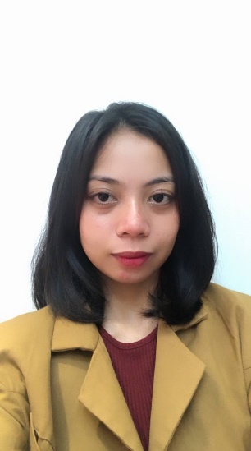

**Name :** Rachel Quizon

**Address :** San Jose, Lipa City

**Birthdate :** June 3, 2001

**Birthplace :** Batangas City

**Religion :** Roman Catholic

**Father :** Roberto Quizon

**Mother :** Lucia Quizon

**EDUCATIONAL ATTAINMENT**

**College :** Batangas State University - Alangilan

Present

**Senior High :** Canossa Academy

2017 - 2019

**Junior High :** Canossa Academy

2013 - 2017

**Elementary :** San Jose Elementary School

2007 - 2013