**DEVELOPMENT OF WEB-BASED INBOUND AND OUTBOUND DOCUMENT MANAGEMENT SYSTEM OF CITY COLLEGE OF TAGAYTAY**

**Mangubat, Carl Vincent M., Unabia, Ron Edward C.**



A Capstone Project Outline presented to the Faculty of the School of Computer Studies in partial fulfillment of their requirements for graduation with the degree of Bachelor of Science in Information Technology. Prepared under the supervision of Mr. Joel Mari Alcala.



**Chapter I**

**INTRODUCTION**

A Document Management System is a computer-based system that is used to manage the entire lifecycle of a document, such as uploading the document and transferring documents to the right persons at the right time through appropriate solutions and archiving the document when it is needed. Inbound and Outbound Document Management System is a web-based system that manages incoming and outgoing documents in one place. This includes uploading, downloading, searching, and storing inbound documents as well as distributing outbound documents. Additionally, it speeds up the workflow, improves accuracy, and provides around-the-clock access to documents from any part of the organization.

City College of Tagaytay (CCT) officially opened its doors to the public in 2003, providing affordable quality tertiary education, and offering different programs. The institution provides free education and focuses on the holistic development of the students that includes active involvement in the fields of academics, culture and arts, and sports. The tertiary education at City College of Tagaytay consists of nine (9) offices such as the Administration Office, Faculty Departments, Registrar, Accounting Office, Vice President for Academic Affairs (VPAA), Vice President for Administrative and Support Services (VPASS), College President, Management Information System (MIS), and Office of the Student Affairs and Services (OSAS). The main concern of the researchers to the institution is the manual handling of inbound and outbound documents.

Currently, the CCT Offices manually manage their inbound and outbound documents. At present, each office inside the institution handles correspondence such as communication letters, office memos, office orders, and other documents. Therefore, manually handling information can reduce productivity and cost time. For the inbound document process, when the office received excessive documents, the staff occasionally asks for assistance from others to organize and search the documents. They organize the documents based on the type of files, and after that, they will be put out in a folder to send to the College President. However, the outbound document process has been distributed personally. This made the Offices meet a problem in manually managing documents that will be received and sent.

Currently, the offices of the City College of Tagaytay manually manage a variety of documents. With that, each office is having a hard time managing the documents. There are some disadvantages encountered because the City College of Tagaytay depends on a traditional way of handling documents. First, the increase of paper-based documents. The place where hard copies are kept can take up additional room in the office. Secondly, the distribution of documents from office to office. Distributing paper-based documents takes time. Lastly, search issues. Finding a paper-based document will take time if there are a lot of stored documents.

Based on the facts stated above, researchers are motivated to develop a study entitled “Development of Web-based Inbound and Outbound Document Management System of City College of Tagaytay” that will manage the documents, centralized the data, minimize human errors, improve manual managing of documents and makes the document process more reliable and efficient.

# Objectives of the Study

The general objective of the study entitled “Development of Web-Based Inbound and Outbound Document Management System of City College of Tagaytay” is to automate the manual way of handling inbound and outbound documents of offices in City

College of Tagaytay.

Specifically, the study aimed to:

1. Identify all the procedures and requirements needed for the web-based inbound and outbound document management system of City College of Tagaytay through interviews;
2. Analyze the tools and requirements to be used for the development of the web-based system;
3. Design and develop a system entitled “Development of Web-Based Inbound and

Outbound Document Management System of City College of Tagaytay” that is capable of:

* 1. uploading inbound documents and scanned hardcopy documents;
  2. downloading uploaded documents;
  3. searching inbound and outbound documents;
  4. sending documents to all/specific offices;
  5. allowing the College President to approve selected documents before sending them to other Offices;
  6. allowing the System Administrator to provide a login form for the user account;
  7. allowing the System Administrator to archive documents; and
  8. view and print reports;

1. Test the performance of the proposed system through unit testing, integration testing, and performance testing;
2. Evaluate the system to determine if it complies with the ISO9126 standards; and
3. Deploy the system to the beneficiaries by providing a web-based system that can be accessed through a web browser using LAN with the user accounts that will be created by the System Administrator.

# Scope and Limitation of the Study

The study focuses on the Development of Web-Based Inbound and Outbound Document Management System at the City College of Tagaytay. This study will use PHP as its primary programming language. HTML and JavaScript will be used in the front end while MySQL will be in the back end. The study is purposely intended for four (4) users namely: System Administrator, Administrator, Offices, and College President.

**System Administrator**. The Management Information System (MIS) staff is responsible for creating user accounts, activating, and deactivating an account. The System Administrator also handles reports.

**Administrator**. The Administrator known as the Vice President for Academic Affairs (VPAA) and Vice President for Administrative and Support Services (VPASS) is responsible for managing inbound and outbound documents within the school. It will upload, download, store and search the inbound and send outbound documents inside the system.

**Office Head.** The office head inside the school offices is responsible for uploading, storing, searching, and downloading documents such as memos, letters, etc., as well as sending documents to other offices.

**College President.** Responsible for approving particular documents such as memorandums that must be sent to other offices.

The study consists of four (4) modules namely the Account Management Module, Inbound Document Management Module, Outbound Document Management Module, and Report Management Module.

The Account Management Module will be used to create and log in the system. Inbound Document Management Module will be used to manage the inbound documents in which the system allows the users to upload, search, download and store documents. Outbound Document Management Module will be used to manage outbound documents in the system, which allows the users to send documents from office to office. This module also includes archiving of documents. Lastly, the Report Management Module will be used to submit and print reports of the documents.

However, the system is limited only to inbound and outbound documents inside the City College of Tagaytay and its offices. Only documents that demand permission are given their approval by the College President. Therefore, not every document needs

to be approved. The system only supports several file types,

including .docx,.doc,.pptx,.ppt,.xlsx,.xls,.pdf,.odt, and .jpg.

# Significance of the Study

The study entitled “Development of Web-based Inbound and Outbound Document Management System of City College of Tagaytay” will help the City College of Tagaytay to improve the manual handling of inbound and outbound documents, it will be automatically recorded and stored inside the database. It will utilize their potential and maximize the use of Inbound and Outbound Document Management Systems. This study is beneficial to the following individuals, groups, and organizations.

**City College of Tagaytay (CCT)** is the main beneficiary of this study. This study will be beneficial to the user for providing a computerized system that will manage inbound and outbound documents inside the offices.

**System Administrator**. This study will help the MIS staff to easily manage the users' accounts that will be provided to users. It will also help in generating and printing reports.

**Administrator**. This study will help the VPAA and VPASS to provide an easy way of managing inbound and outbound documents within the school. It will help in uploading, downloading, searching, and storing the document in the offices. It will also help to send approved documents to other offices.

**Office Head**. This study will help to provide computerized management of all inbound and outbound documents. It will be easily managed by the Office Head, which is the one who will access the system for the use of each person inside the office.

**College President**. This study will provide a computerized system for approving specific documents for a faster way of distributing documents such as memorandums and letters.

**The Researchers**. This will be a tool that will direct and navigate them as they look for credible, reliable, and important variables that are known as essential information for deepening their comprehension of the subject. They will undoubtedly require this study as their main source for their upcoming studies.

**Future Researchers**. This study will also be beneficial to potential researchers. It will present information and development concerning the inbound and outbound document management system. As a result, the study will be accessible for further improvements.

# Theoretical Framework

The theoretical framework is a collection of interrelated concepts that will guide the proponents in developing the study.

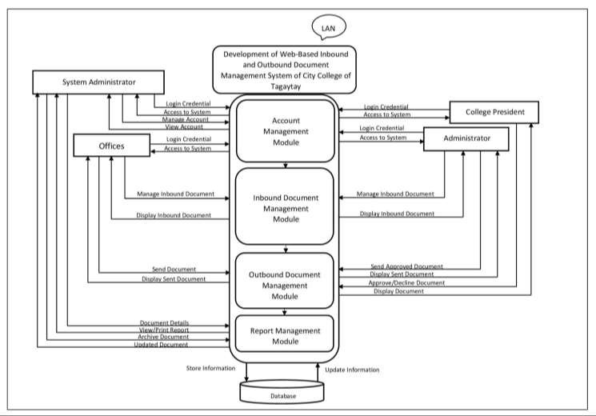

Figure 1. Theoretical Framework of Development of Web-Based Inbound and

Outbound Document Management System of City College of Tagaytay.

Figure 1 shows Theoretical Framework of Development of Web-based Inbound and Outbound Document Management System of City College of Tagaytay. The study consists of four (4) modules such as Account Management Module, Inbound Document

Management Module, Outbound Document Management Module, and Report Management Module.

**Account Management Module**. In this module, the System Administrator supports the system's security, which uses a username and password to protect from any unauthorized users. The System Administrator will create accounts, activate, and deactivate user accounts. Furthermore, in this module, the Administrator, College President, and Office Head will log in to access the system.

**Inbound Document Management Module**. This module is responsible for managing inbound documents. This module will allow the Administrator and Office Head to upload, store, search, and download inbound documents as well as scanned hardcopy documents. They will also manage to view the inbound documents.

**Outbound Document Management Module**. This module is responsible for managing outbound documents. This module will allow the Administrator and Office Head to send outbound documents whether they are intended for one office or all offices. This will also allow the Administrator to handle documents that require approval. Before sending them to the Administrator, certain documents will need to be approved by the College President. However, not all documents are required to request approval. The Administrator will send the approved documents to other offices. The users will also archive the documents if needed.

**Report Management Module**. This module is responsible for managing reports. This module will allow the System Administrator to generate and print the reports.

# Conceptual Model of the Study

Based on the foregoing concepts, theories, and finding of related literature, studies presented, and insight taken from them, a conceptual model is developed as shown below.

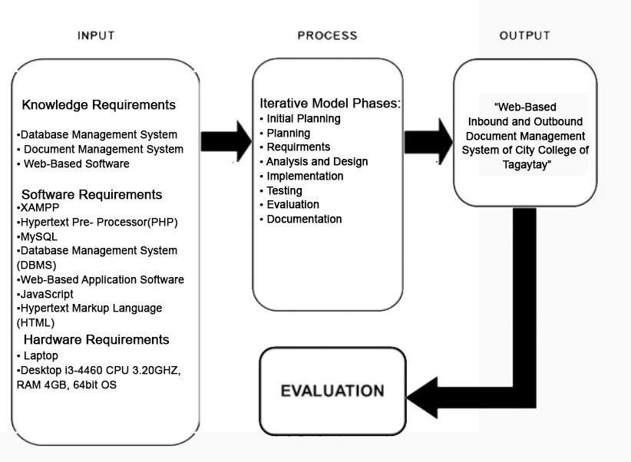

Figure 2. Conceptual Model of Web-based Inbound and Outbound Document Management System of City College of Tagaytay.

Figure 2. Development of Web-based Inbound and Outbound Document Management System of City College of Tagaytay. Conceptual processes for the development of the study which have four (4) stages such as Input, Process, Output, and Evaluation. These stages must be integrated with a common purpose to achieve the general objective of the study.

**Input Stage**. The input stage is composed of three (3) requirements which are knowledge requirement, software requirement, and hardware requirement. The knowledge requirement requires having a web-based software, document management system, and database management system. In software requirements, platforms are needed which are XAMPP that will test and verify the working of projects based on Apache, Perl, MySQL database, and PHP through the system of the host itself, Hypertext PreProcessor (PHP), MySQL, Database Management System (DBMS), Web-Based Application Software, JavaScript, and Hypertext Markup Language (HTML). For the hardware requirement, the system requires Desktop i3-4460 CPU 3.20GHZ, RAM 4GB, 64bit OS.

**Process Stage**. In this stage, the study used the iterative methodology as a guide in developing the system. The first phase is Initial Planning. The researchers will initialize and identify the problem of the City College of Tagaytay in their current manual process of the document management system. Second is the Planning phase. The researchers will create a project plan that would help manage the system. The third is the Requirements phase. The researchers will compile the requirements and analyze the data collected through interviews. The fourth stage, Analysis, and Design. The researchers will create a project design that would demonstrate the functionality of the system and help them understand the system requirements so they could see how the system should look. The fifth phase is Implementation. The researchers will now begin the coding step. The system is prepared for deployment following the phases of testing, evaluation, and system modification and improvement. Sixth is the Testing Phase. The next phase will go through a series of testing methods to discover and locate any bugs or issues that have emerged after this current build iteration has been created and implemented. The seventh stage, Analysis, and Design. The software will be assessed throughout this phase, along with the requirements as they are now being reviewed, altered, and additional requirements will be proposed. Lastly, in the Deployment Phase, the system will be delivered to the intended users to access the system.

**Output Stage**. In this stage, the output of this system is the “Development of Web-Based Inbound and Outbound Document Management System of City College of Tagaytay”.

**Evaluation Stage**. In this stage, the system will evaluate to determine if it complies with the ISO9126 standards, this stage ensures the project's quality in terms of its content, functionality, and effectiveness.

# Operational Definition of Terms

To better understand the study, the following terms are defined operationally.

**City College of Tagaytay (CCT)** - this was the school that will use to develop a web-based inbound and outbound document management system

**Document Management System** - a system used to receive, track, manage and store documents to reduce paper, time, and money in managing documents.

**Inbound Document** - refers to correspondence, reports, memorandums, issuances and personal letters from Executive Offices, Department Heads, and Intelligence Community that are sorted out and arranged according to its subject, content, and description.

**Login** - Need to provide a unique username and password for security purposes.

**Management Information System (MIS)** - The system administrator of the system, responsible for generating user accounts, and activating and deactivating accounts.

**Outbound Document** - these are the official reports/documents received within the institution that is immediately delivered to the person concerned.

**Password** - commonly used by authorized users to enter the system as a secret word or phrase, special letters, and numerals. The user's login and password must be kept private.

**User** - It includes the Management Information System (MIS), Vice President for Academic Affairs (VPAA), Vice President for Administrative and Support Services (VPASS), College President, Administration Office, Faculty Departments, Registrar, Accounting Office, and Office of the Student Affairs and Services (OSAS).

**Username** - the user personalized name or alias that must be kept private.

**Web-based** - run inside a web browser. These are applications that can be used or accessed through a network.

# CHAPTER II

# REVIEW OF RELATED LITERATURE AND STUDIES

This chapter presents the related literature and studies after the complete deep research done by the researchers. This also presents the combination of idea, theoretical and conceptual framework to totally understand the research to be done and lastly the definition of term for better comprehension of the study.

## Technical Background

**XAMPP.** Most popular PHP development Environment. Is a completely free, easy to install Apache distribution containing MariaDB, PHP, and pearl. The XAMPP opensource package has been set up to be incredibly easy to install and to use.

**PHP (Hypertext PreProcessor).** It is a server-side scripting language designed for web development but also used as a general-purpose programming language. Originally created by Ramus Lerdorf in 1994. PHP reference implementation is now produced by The PHP Development Team. PHP originally stood for Personal Home Page, but it now stands for the recursive acronym Hypertext PreProcessor.

**MySQL Database.** It is an open-source relational database management system based on Structured Query Language. It can be used in a wide range of applications; MySQL is most often associated with web-based applications and online publishing and is an important component of an open-source enterprise stack.

**Database Management Software or DBMS**. It is a software that is used to store, handle, and manage data in a database environment. It enables users to design a personalized database to suit their analytics and reporting needs (Naeem, 2022).

**Web-Based Application Software**. It is a software that is accessed via a network connection using HTTP rather than being stored in a device's memory. Web browsers are frequently used to run web-based applications. Web-based applications can alternatively be client-based, in which case only a tiny portion of the program is downloaded to the user's computer and all processing is carried out on an external server through the internet.

**JavaScript**. It is a programming language used by front-end web developers to add functionality and interactivity to a website. Examples of this include displaying popup or notification messages, responding to mouse clicks, producing animations, or validating data. It can also be used to modify a web page's content after it has been dynamically loaded. On the backend, it is also used to store and share data (Shokeen, 2021).

**Hypertext Markup Language or HTML**. It is a markup language for the web that defines the structure of web pages. It determines the structure of web pages. This structure alone is not enough to make a web page look good and interactive. So you'll use assisted technologies such as CSS and JavaScript to make your HTML beautiful and add interactivity, respectively (Kolade,2021).

**Related Studies**

**Foreign Studies**

## Investigation of document management systems in small size construction companies in Jordan

Cited by Ahmad H. et al. (2017), this study proves that adopting efficient management systems that can handle the varied information and documentation of project operations is essential for the successful management of construction projects and organizations. The system called document management system (DMS) is used to store, manage, coordinate, process, and/or retrieve documents, whether they are in electronic or paper-based format. This study looks at the electronic and paper-based

DMS that are currently in use in a sample of Jordanian small-scale contracting firms. Questionnaire surveys and interviews with contractors, contractors' representatives, and DMS practitioners in a variety of small contracting organizations were conducted to explore and analyze the elements, procedures, motives, and problems of the existing and intended DMS. The findings of this study can assist contracting businesses in improving their DMS and the effectiveness and performance of the procedures for managing construction projects.

Therefore, the researchers found out that this study has a relation to the

Development of Web-Based Inbound and Outbound Document Management System. These two (2) studies are related to managing documents with the use of Document Management System.

## The key factors in adopting an electronic records management system (ERMS) in the educational sector: a UTAUT-based framework

## 

Like almost all companies, higher education institutions must put in place information management systems that let them conduct everyday tasks with ease and simultaneously provide a variety of standardized and ad hoc reports. Institutions involved in higher professional education (HPE) encounter particular difficulties while putting in place computer-based information management systems. Systems for managing electronic records (ERMSs) assist in organizing the vast amounts of data required for preparation and informed decision-making. Organizations are still learning how to employ ERMS efficiently because they are a relatively recent feature. Unfortunately, some businesses still take their time implementing these technologies. (Muaadh M. et al., 2019)

## Document management system: A notion towards paperless office

As stated by Mahendra U. et al. (2017) in their study entitled Document Management System: A notion towards paperless offices, will eliminate the losses that the business suffers because of physical paper files and filing systems. Document Management System is very essential most especially in many offices. The study explains that managing documents will be more convenient with the help of a document management system. They can replace physical papers to paperless. It will be very helpful to the researcher's study for them to be able to manage the documents with the system and organize the flow of the researcher's study.

## A conceptual model for electronic document and records management system adoption in Malaysian public sector

As illustrated by Aziz et al. (2018), the study on Electronic Document and Record Management System will make changes in the Malaysian public sector. It urges the operations to shift from manual to automatic way of document and record management system. The study is related to the researcher's study in which it improves the manual way of handling documents and records to automatic way of managing documents.

## System development for document management system

In accordance with Fatin K. et al. (2018), the System development for document management system is a digitized way of managing the documents. The digitization system aids organizations in gathering crucial information. It plays a vital role especially in some sectors like offices to store important information or documents. Electronically digitized systems can store information in physical books, letters, pictures, etc. The study is the researcher's one of its main basis to develop the study. To handle the documents properly with the use of a digitized system.

## Document Management System in Ibnu Sina Middle School Administration

According to Nofri Yudi Arifin (2022), this study aims to create a management system that will help SMP Ibnu Sina Batam staff members store and gather online mail data for incoming and outgoing mail. It is important to develop a system because there isn't a document management system for storing correspondence. The object of this research is the admin and administrative staff of SMP Ibnu Sina, the modeling method used in the system is Unified Modeling Language (UML) while the system research development method uses Object Oriented Analysis Design (OOAD). The purpose of this research is to provide a solution in helping the Administration of SMP Ibnu Sina Batam in saving files online and numbering letters automatically and helping admins in doing their jobs so that they can complete their work properly and can store data safely. The data collection method used is by conducting interviews and collecting various sources, namely library research, observation. The conclusion in this study is that it is hoped that this system can be implemented by admins and other employees to facilitate performance.

## Concept of electronic document management system (EDMS) as an efficient tool for storing document

Based on the study of Rosa et al. (2019), In multiple formats for managing the use, storage and creation of documents that are made all through an association a framework of tools is considered as an electronic document management system (EDMS). Documents management is typically thought of as a centralized software system for managing and capturing both photographs and digital data of scanned documents. However, the software system of document management focuses on the optimization of structured and active documents and utilization of data, like emails and other defined formats, PDF files, PowerPoint, Word documents, and Excel spreadsheets, though ECM frameworks also oversee rich media formats and manage unstructured content. Both systems share many similarities with enterprise content management

(ECM) systems.

## About document management systems

As cited by Miranda Petronella Vlad and Loredana Mocean (2019). Nowadays, organizations are having trouble managing the numerous documents that are required. The Document Management System will allow the organizations to exchange information more efficiently. This will increase productivity and lower expenses. They are related to the researcher's study since it is used for strengthening the fact of making a study.

**Management of incoming and outgoing mails at the Ministry of Tourism Wildlife and Antiquities Kampala, Uganda**

As illustrated by Awor (2018), The study conducted at the Ministry of Tourism,

Wildlife, and Antiquities and focused on the management of incoming and outgoing mail with a view to examining the systems in use and the handling of mail to find out the types of records managed at the Ministry, identify how incoming and outgoing mails are managed at the Ministry, identify the challenges faced when managing incoming and outgoing records, and to suggest solutions for improved management of incoming and outgoing records. The study discovered different types of records managed at this study which included administrative records, personnel files, subject files, legal files. The relation of this study to researcher’s study is that the management of incoming and outgoing mail is manually done which is related to a lot of problems and the findings highlight the necessity for employment of computerized system to ensure better service delivery and improved records management system.

## Document Management System – A Way to Digital Transformation

As stated in the study of Jordan et al. (2022), one of the key activities of any company is the management of documents, which are created on a daily basis. Classic document management cannot follow the needs of the market for companies with a desire to be agile and modern. Therefore, companies need to offer employees a solution that allows them to carefully store and archive documentation, while at the same time giving them enough time to perform their main daily tasks. Electronic management of documents not only influences companies’ workflows, savings and adaptations to market needs but also influences their digital transformation. It is also necessary to consider the influences on the environment. The influence of the production and use of paper in daily business has burdened the environment a lot in the past and it is about time that this matter is addressed. Implementation of a document management system (DMS) is now almost a must-have for companies wanting to be competitive in the market and with a desire to digitalize its processes and is also surely a good step in the right direction for the environment.

The aim of this paper is to define the advantages and disadvantages of a DMS as part of companies’ digital transformation as well as to provide an overview of the process of implementation and to analyze future trends and predictions in this field. For better understanding, the authors also included some examples of the implementation of a

DMS in Slovenian companies.

**Local Studies**

## Document Management System for City College of Tagaytay

The study of Amaro et al. (2019) which entitled "Document Management System for City College of Tagaytay," which was submitted to the Faculty of Computer Studies, will assist the institution in appropriately organizing the papers. It will guarantee faculty members an easy-to-use task and a speedy process for storing and finding a certain report. On digital documentation, the system may be trusted and depended upon to organize into a high-tech filing, storing, updating, and retrieving files.

The researchers found a problem in the Document Management System in City College of Tagaytay. The Document Management System must be Web-Based and

capable of creating, editing, saving, printing, and submitting documents. The system will help the CCT faculties to submit their reports in time.

Therefore, the researchers found out that this study has a relation to the

Development of Web-Based Inbound and Outbound Document Management System.

These two (2) studies are related in that they use the same system for document creation, editing, saving, printing, and submission.

## Development of Web-Based Document Management System for Computer Studies

The study entitled "Document Management System" by Enriquez et al. (2017) of City College of Tagaytay was created to give department-specific forms for each instructor. It was presented to the school of computer studies. The system was created using PHP in accordance with World Wide Web standards for web development. Google Chrome, a desktop browser, can be used to browse the system. The study has the ability to view data and reports for each department's instructor and dean. This only demonstrates that the system satisfied the requirements based on the ISO 9126 evaluation.

## E-memo Archiving for City College of Tagaytay

Based on the study conducted by Daculla et al. (2017), the system has the ability to create, send, and delete memos as well as messages that are used to communicate with people. There are three (3) users namely the Administrator, the Vice President for Academic affairs Registrar and Dean, and the users. The Administrator has the ability to create, send, and delete memoranda that have been filed by the dean, registrar, and VPAA. Only the administrator has the authority to delete a user and, if necessary, reset the user's password.

## Development of Electronic Document Archive Management System (EDAMS): A Case Study of a University Registrar in the Philippines

The conventional approach to data storage has demonstrated how it affects document management in terms of security, retrieval, and oversight. Numerous pieces of study contend that this strategy would leave clients with low ratings of job satisfaction.

The Office of the Registrar at Leyte Normal University is no way out of this predicament. The university was hit by Haiyan, often known as Yolanda locally, the biggest typhoon ever recorded, in November 2013. The Registrar's archive and storage space was severely damaged, with the majority of the records being dispersed and deteriorating. With this experience, empirical research is needed to develop a workable solution. The result revealed various issues and coping strategies mentioned by the participants, from a limited storage area to difficulty in document retrieval and monitoring, and from the utilization of logbooks to misclassification of records. Finally, the results became the basis for developing the electronic document archive and management system (EDAMS)

(Caluza, 2017).

## Implementing Document Management System (DMS) Technology in Barangay Paligui, Apalit, Pampanga

According to a study conducted by Requinto et al. (2019), barangays are the smallest yet most crucial governmental units. Through its representatives, the government distributes its services. The quality of service, particularly in processing records and documents, is declining as a result of the growing population. An integrated "Document Management System" is suggested to address these issues following a detailed site assessment and series of surveys, with Barangay Paligui in Apalit, Pampanga chosen as the model. The DMS, an open-source system, was developed using the Kanban Agile Methodology and in-depth literature reviews. Its main goal is to provide a centralized document management system that can be accessed by any barangay officials using their office desktop computers and mobile phones.

## Project DOTS (DOCUMENT TRACKING SYSTEM): Its Effects in the Inter-offices in the Schools Division OF Parañaque City

Embralino (2019) claims that document management is now a widely recognized solution in all enterprises. This supposition has motivated researchers to focus on creating document management systems as part of the emergence of technology in the twenty-first century. The current research focuses on the creation of an online system called Document Tracking System (DoTS), which is used by the 12 inter-offices in Parañaque City's Schools Division (SDO – Parañaque City). The study's goal was to develop a tracking system for the SDO in Parañaque City to aid in the efficient management of papers between offices. The system's enablement goal is to provide a ticket that can be used to tag users and an online monitoring system that enables the tagged users to access the ticket for quicker compliance. It is recommended that DoTS could level up its usability down to the 42 public schools both from elementary and secondary levels under the jurisdiction of the SDO – Paranaque to make the document management system effective and efficient.

**Record Management System with 2D mapping for Royal Villas, Amadeo of A.P**

## Beltran Construction and Titling Services

Based on the study of Beltran and Rivera (2017) entitled Record Management

System with 2D mapping for Royal Villas, Amadeo of A.P Beltran Construction and Titling Services which developed to provide help to clients and servers as a tool in managing the records of the subdivision in an electronic manner. This study has the ability to view customers and a lot of information. There is just one (1) level of access, and that is the admin, who has the ability to create, edit, alter, and print any necessary reports.

## Development of Record Management System for Tagaytay Human Resource Office of Tagaytay City Hall

The study of Desengano et al. (2018), which entitled “Development of Record Management System for Tagaytay Human Resource Office of Tagaytay City Hall” was developed to provide a consolidated record of employees. The system may create different reports and add, view, amend, and filter employee information. They can filter the information they require through the Human Resource Management Office (HRMO).

## Record Management system for the Office of Senior Citizen in Tagaytay

Based on the developed study of Alanis et al. (2018) entitled “Record

Management system for the Office of Senior Citizen in Tagaytay”, which aims to help consolidate the records of every Senior Citizen in Tagaytay. On the Senior Citizens data kept by the Office of Senior Citizens Affairs, this will also include improvements and transformations to the organization's processes and handling of transactions and gathered data that contain important records of Senior Citizens. These records will be made as complete and up-to-date as possible as well as easily accessible for verification, monitoring, and reference purposes. The research is designed for two users, such as Staff and Administrator.

**CHAPTER III**

**METHODOLOGY**

This chapter presents the methods and materials that include the project design, operation, testing, and evaluation procedure.

## Project Design

The system entitled “Development of Web-Based Inbound and Outbound Document Management System of City College of Tagaytay” developed with the use of PHP for the user interface and MySQL as the database engine of the system. The study is intended on four (4) users: System Administrator, Administrator, Offices and College President.

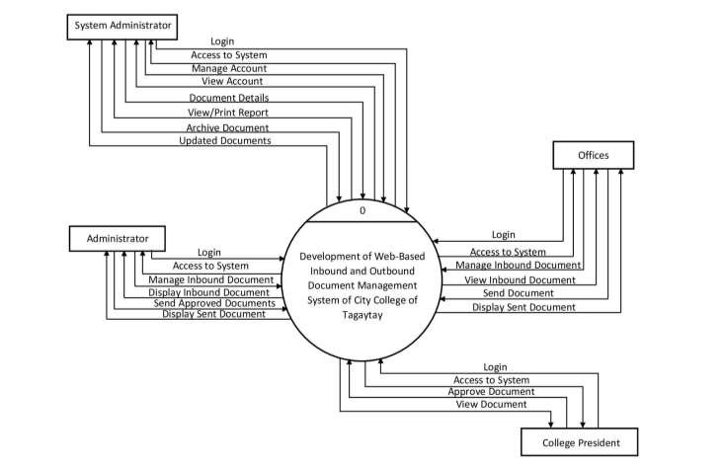

Figure 3. Context Diagram of Development of Web-Based Inbound and Outbound

Document Management System of City College of Tagaytay

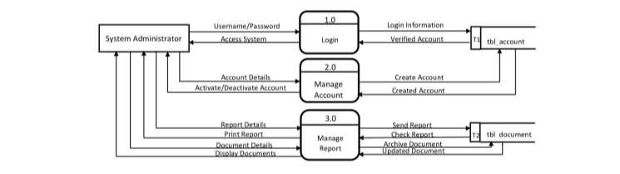Figure 3 illustrates the information between the system and external entities such as System Administrator, Administrator, College President, and Offices. The System Administrator will create and manage user accounts that will be used by Administrator, College President, and Offices. The Administrator and Offices will manage the inbound documents and in terms of hardcopy documents, it will be handled through uploading images of it. The Administrator will manage and view the inbound documents and send outbound documents to specific/all offices. The Offices will manage and view inbound documents and send outbound and approved documents to specific/all offices. The College President will approve specific documents that must be sent to other offices.

Figure 4. Data Flow Diagram of System Administrator

Figure 4 illustrates how the System Administrator manages the system. The System Administrator will login to the system, and the system will verify the account. On the account management, The System Administrator will create user accounts, as well as activate and deactivate it. The system will allow to view and print reports. The System Administrator will be the one to archive documents if it is not needed.

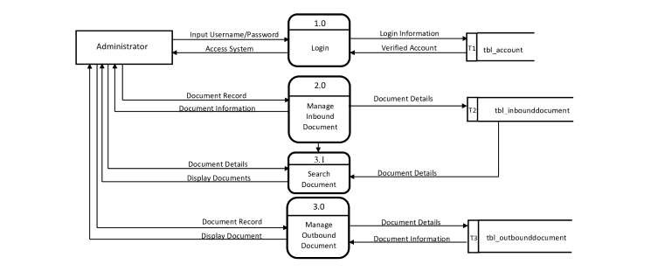

Figure 5. Data Flow Diagram of Administrator

Figure 5 illustrates how the Administrator manages the system. The Administrator will login to access the system, if the account is verified, the system will grant the authorization to access the system. On inbound document management, the Administrator will upload, store, and download inbound documents and scanned hardcopy documents. It will also search inbound documents. If the data inputted in the search button is in the database, it will appear on the display. On the outbound document management, the Administrator will input information that will be sent along with the documents and will be viewed if the documents have been sent. Additionally, selected documents that are approved by the College President will be also handled by the

Administrator.

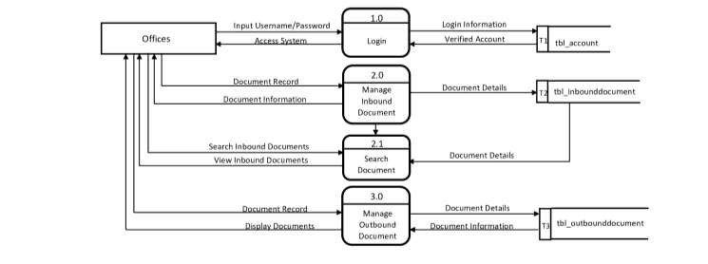

Figure 6. Data Flow Diagram of Offices

Figure 6 illustrates how the Offices manages the system. The Offices will login to access the system, if the account is verified, the system will grant the authorization to access the system. On inbound document management, the Office will upload, store, and download inbound documents and scanned hardcopy documents. It will also search inbound documents. If the data inputted in the search button is in the database, it will appear on the display. On the outbound document management, the Offices will input information that will be sent along with the documents and will be viewed if the documents have been sent.

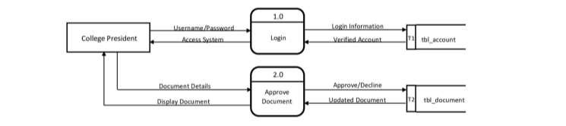

Figure 7. Data Flow Diagram of College President

Figure 7 illustrates how the College President uses the system. The College President will login to access the system, if the account is verified, the system will grant the authorization to access the system. The College President will approve certain documents. If the certain documents do not require for approval, it is not included in approving documents. The approved documents will be passed out on the Administrator. **Project Methodology**

The iterative development process model was the software methodology that will be used in designing the software, the functions, and the interface. This is an approach to software development that centers the idea of moving development cyclically rather than trying to do everything all at once. The following are the phases: Planning,

Requirement analysis, System design, Implementation, Testing and Evaluation and Deployment.

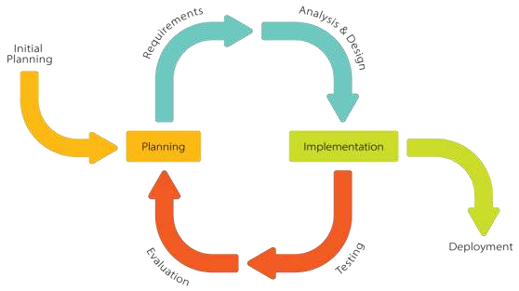

Figure 8. Iterative Methodology for the Development of Web-based Inbound and

Outbound Document Management System of City College of Tagaytay

Figure 8 shows the Iterative Methodology for the Development of Web-Based Inbound and Outbound Document Management System of City College of Tagaytay, which has eight (8) phases: Initial Planning, Planning, Requirements, Analysis and Design, Implementation, Testing, Evaluation, and Deployment.

## Initial Planning

The issue with the City College of Tagaytay's office's present manual document management procedure will be identified and examined by the researchers. The researchers will also construct an initial concept and idea for the system they would create to improve the current system at City College of Tagaytay.

## Planning

For the purpose of managing the present system management, the researchers prepared a project plan. The specified tasks and the deadline for completion presented some challenges as they gathered the data required by the system.

## Requirement

The researchers gathered and examined the requirements through interview in order to develop the software. Iteration should finally lead to a requirements phase that delivers a comprehensive and final specification of the requirement.

## Analysis and Design

The researchers conduct an interview with the Vice President for Academic Affairs (VPAA) and Administration Office to learn how they process the documents, letters, memos, and other correspondence that come into the City College of Tagaytay. The tasks that were finished in the requirement analysis provided a plan for the development of a web-based system that can be offered to the institution.

## Implementation

Prior to the start of each iteration, the researchers and user discuss the order of importance and the details of the system. After finalizing the system, the researchers could install or apply it, and it would be ready for testing and evaluation. Users' comments on the system's functionality and any inconsistencies were provided to the researcher.

## Testing

Every user who is involved in the study (Admin Staff, Faculty Departments, Registrar, VPAA, VPASS, College President, Library, Management Information System, and OSAS) is shown the system by the researchers during this phase. When the proponents have finished coding, testing is required to detect and resolve all problems and mistakes.

## Evaluation

Users' comments on the system's functionality and any inconsistencies were provided to the researcher. The purpose of this stage is to guarantee the project's quality in terms of its content, functionality, and effectiveness. They will also evaluate the system to ensure that all requirements are met.

## Deployment

The researchers could now deploy the system to the users after completing testing and evaluation. After checking and setting up the system, it will be ready to use by the System Administrator, Administrator, Office Head and College President.

**System and Testing Procedure**

## System Operation

**System Administrator**:

1. Input System Administrator’s Username and Password.
2. View User Accounts.
3. Add, activate, and deactivate the user accounts.
4. View and print reports and logs.
5. Archive Documents.

**Administrator**:

1. Input Administrator’s Username and Password.
2. Upload, download, and search inbound and scanned hardcopy documents.
3. Send outbound and approved documents to all/specific offices.
4. View display documents.

**Offices**:

1. Input Office’s Username and Password.
2. Upload, download, and search inbound scanned hardcopy documents.
3. Send outbound documents to all/specific offices.
4. View display documents

**College President**:

1. Input College President’s Username and Password.
2. Approve/Decline specific documents.

## Testing Procedure

**Unit Testing.** The researchers will conduct this on the individual units of source codes assigned areas to verify the functionality of a specific code section, usually at the function level. The main goal is to isolate each part of the program and show that individual parts are correct in terms of requirements and functionality.

**Integration Testing.** The researchers will test each combined parts of the application to determine if modules/units’ function accurately and check if they are coordinating with each other.

**Performance Testing.** The researchers will determine the process of speed,

responsiveness, and stability of a computer, software program, or device under a network**.**

## Evaluation Procedure

In the preliminary evaluation, the researchers will review all the necessary things/factors that will be needed in the completion of the system based on the system.

Results will be analyzed to determine if the desired output is met through the given input. For the final evaluation sheet given to the respondents. The comments, suggestions, and recommendations are used to improve and enhance the system. The study used the Evaluation Criteria for software.

Table 1 shows the numerical rating and its equivalent interpretation to scale the result of project evaluation.

Table 1. System Evaluation Sheet Numerical and Descriptive Scale

The gathered data computed by using Mean Range Formula to conclude if the developed system meets the Software Factors Standard for Acceptance. 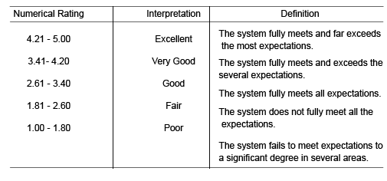

**References**

Ahmad, H., Bazlamit, I., Ayoush M. (2017, April 18). Investigation of document management systems in small size construction companies in Jordan. https://www.sciencedirect.com/science/article/pii/S1877705817312377.

Muaadh, M., Yusof, Z., Alotaibi, F., Mokhtar, U., Fauzi, F. (2019). The key factors in adopting an electronic records management system (ERMS) in the educational sector: a UTAUT-based framework.

https://ieeexplore.ieee.org/document/8666112.

Ugale, M., Patil, S., Musande, S. (2017). Document management system: A notion towards paperless office.

https://ieeexplore.ieee.org/document/8122176.

Aziz, A., Yusof, Z., Mokhtar, U., Jambariz, D. (2018). A conceptual model for electronic document and records management system adoption in Malaysian public sector. https://www.coursehero.com/file/77072858/ARTICLE-REVIEW-2pdf/

Kiplie, F., Yatin, S., Angutim, M., Hamid, N. (2018, October 19). System development

for document management system.

https://hrmars.com/index.php/IJARBSS/article/view/4652/System-Developmentfor-Document-Management-System.

Arifin, N. (2022). Document Management System in Ibnu Sina Middle School

Administration.

https://www.mand-ycmm.org/index.php/eatij/article/view/165/291.

Rosa, A., Pustokhina, I., Lydia, E., Shankar, K., Huda, M. (2019). Concept of electronic document management system (EDMS) as an efficient tool for storing document.

https://www.semanticscholar.org/paper/Concept-of-Electronic-Document-

Management-System-as-Rosa-

Pustokhina/35eff571181ef71b366464569643ed84ddfb0093.

Vlad, M., & Mocean, L. (2019). About document management systems. https://www.researchgate.net/publication/347635414_A_MODEL_OF_DATABA

SE_PLATFORM_FOR_E-COMMERCE_APPLICATIONS_IN_E-SOCIETY

Awor, F. (2018, July 1). Management of incoming and outgoing mails at the Ministry of

Tourism Wildlife and Antiquities Kampala, Uganda.

http://dissertations.mak.ac.ug/handle/20.500.12281/5929

Jordan, S., Zubokvsek, S., Klancnik, I. (2022), Document Management System – A Way to Digital Transformation.

https://ideas.repec.org/a/vrs/ngooec/v68y2022i2p43-54n6.html

Caluza, L. (2017). Development of Electronic Document Archive Management System

(EDAMS): A Case Study of a University Registrar in the Philippines.3.

https://www.semanticscholar.org/paper/Development-of-Electronic-Document

Archive-System-A-Caluza/2bcc2bbda654f523e07255a87f1f15b0e11b9d1e.

Requinto, A., Macapagal, R., Pineda, A., Cortez, C., Canlas, F., Natividad, R. (2019).

IMPLEMENTING DOCUMENT MANAGEMENT SYSTEM (DMS)

TECHNOLOGY IN BARANGAY PALIGUI, APALIT, PAMPANGA.

https://ejournals.ph/article.php?id=14074.

Emralino, J. (2019). PROJECT DOTS (DOCUMENT TRACKING SYSTEM): ITS

EFFECTS IN THE INTER-OFFICES IN THE SCHOOLS DIVISION OF

PARAÑAQUE CITY.

https://ejournals.ph/article.php?id=14080