**(STUDENT FORM)**

**Indicate in direction (Input N/A if not applicable example in Shiftee from)**

**Or put *required or for those not important put *optional**

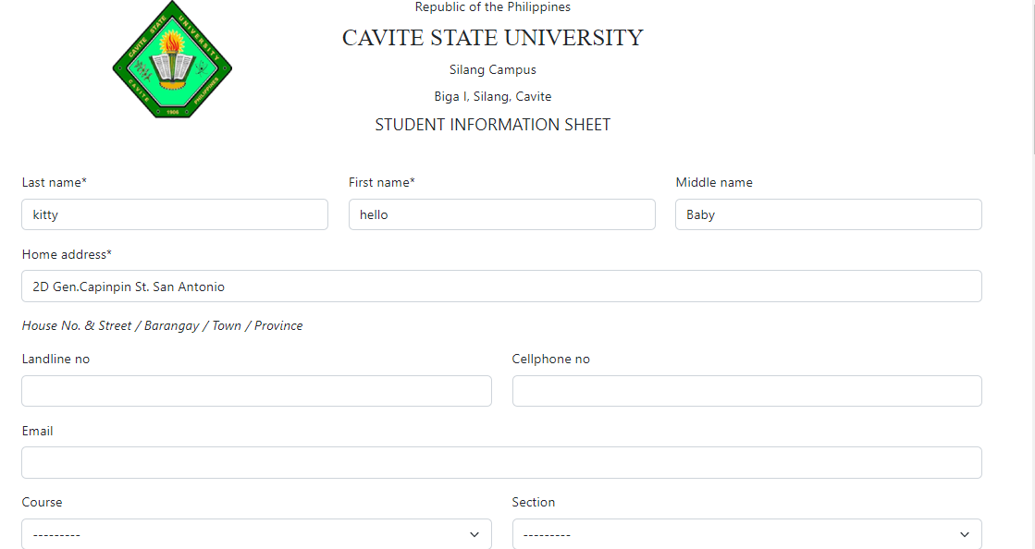

**(STUDENT FORM)**

**Put yy/mm/dd** inside the box and changed \***Birthday** to **\*Birthdate**



**(STUDENT FORM)**

**Change to (High School/Senior High School)**



Need to see name of school **CAVITE STATE UNIVERSITY OF SILANG CAMPUS** in this main page

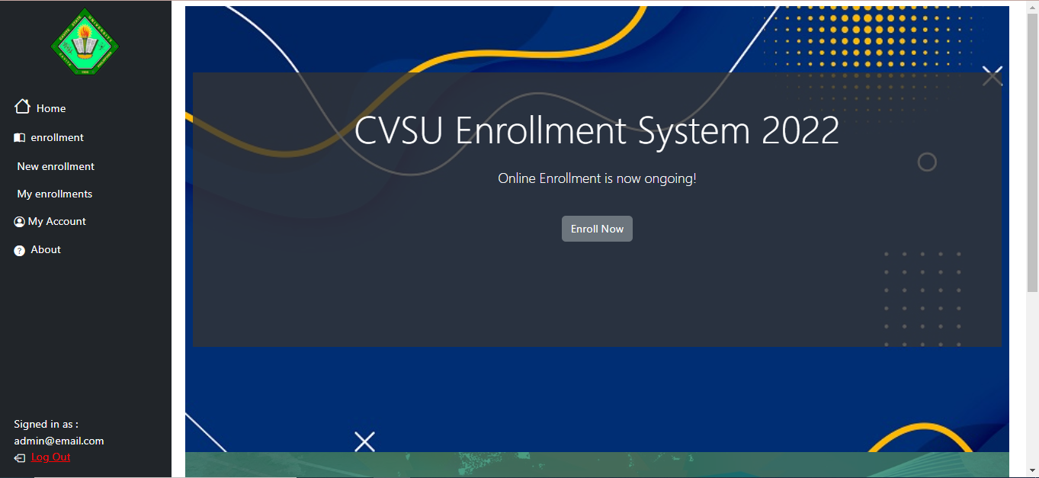

Change or replace the background



**(STUDENT FORM)**

Increase weight of the outline/line between Address and Parent/Guardian and other line

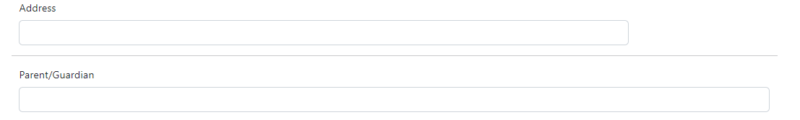

Same year validation of school_year

Irregular registration status in profile page

Phone number error on submit

Profile picture upload

Sticky nav header in admin