GRAMMATICA SYSTEM DESIGN
Subsystem Dataflow Diagrams (Gane & Sarson Style)

Figure 1: Dataflow Diagram for User Login and Registration
Overview: How users create an account, verify their email with a code, and safely log in.
How the Data Flows (Simple Steps):
- User enters email and password or chooses Google Sign-In.
- System checks if the account is locked (locks for 15-60 mins after 3 failed attempts).
- If new user: System sends a 6-digit verification code to the user's email.
- User enters the code; system validates it and activates the account in Users Database.
- System logs user in and loads their personalized dashboard.
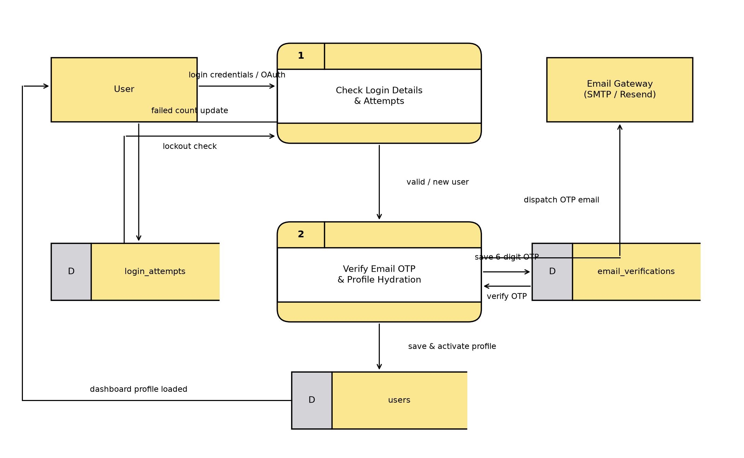
Figure 1: Dataflow Diagram for User Login and Registration

Figure 2: Dataflow Diagram for Teacher and Validator Verification
Overview: How educators submit their credentials and how Admins approve or reject them.
How the Data Flows (Simple Steps):
- Teacher uploads their resume (CV), PRC License, teaching video, and syllabus.
- System saves files in Cloud Storage and marks status as 'Pending Review'.
- Super Admin inspects credentials and decides to Approve or Reject.
- If Approved: User role is changed to 'Educator' or 'Validator'.
- If Rejected: User gets a notification explaining the reason and can re-apply after 7 days.
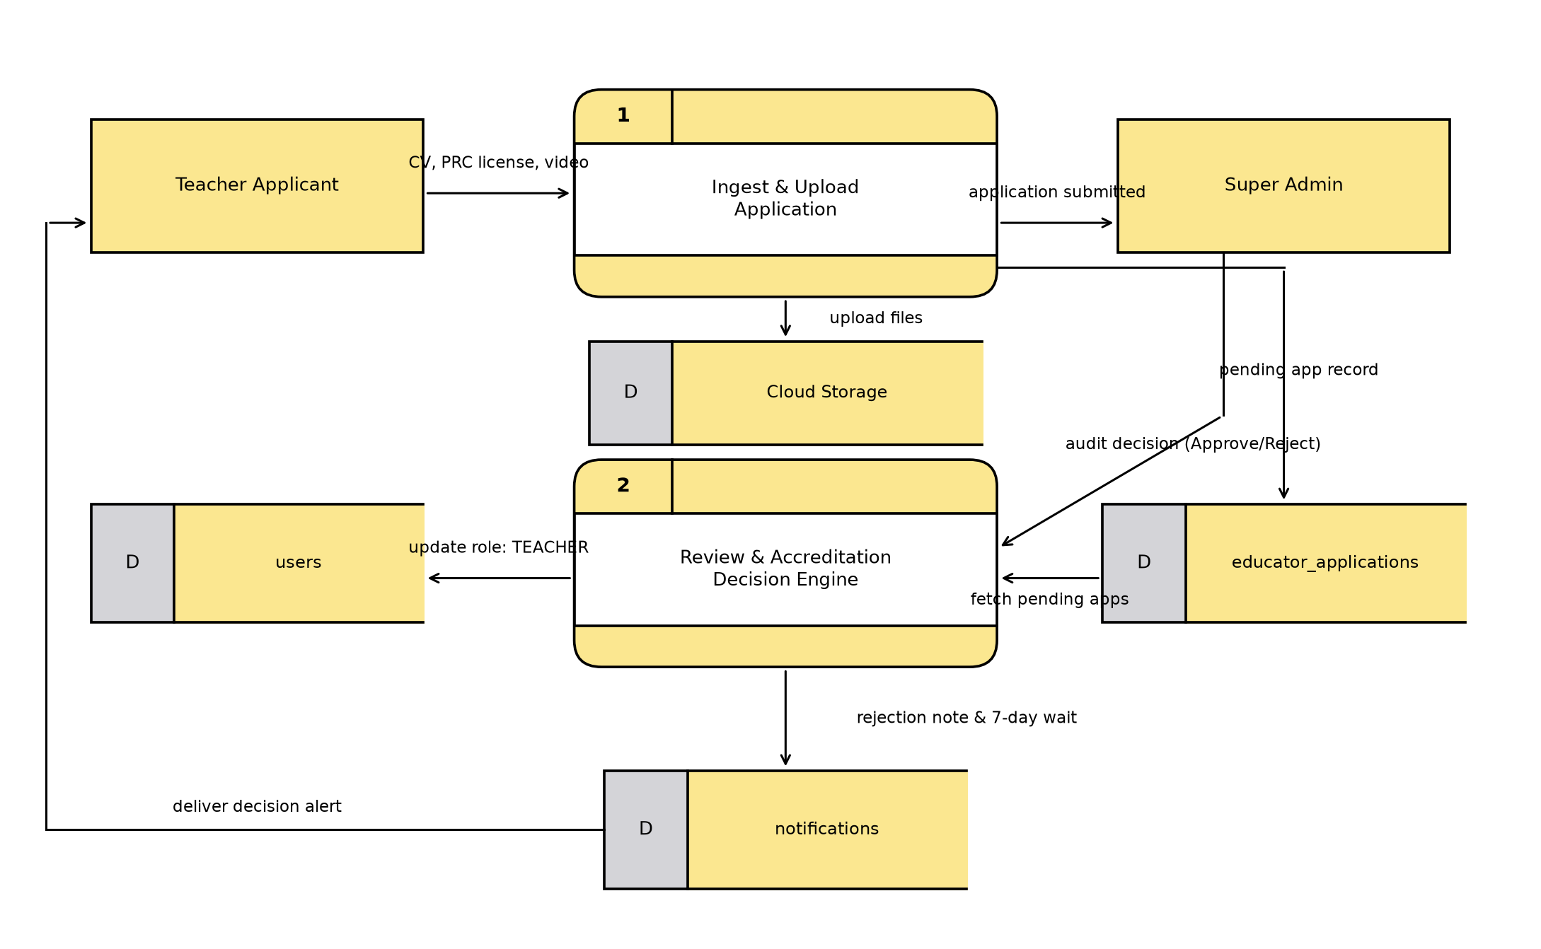
Figure 2: Dataflow Diagram for Teacher and Validator Verification

Figure 3: Dataflow Diagram for Creating Lessons with AI
Overview: How teachers upload study materials to generate interactive lessons using Google AI.
How the Data Flows (Simple Steps):
- Teacher uploads notes, PDF books, web links, or audio recordings.
- System checks teacher's daily AI limit (e.g., up to 200 generations per day).
- System passes the notes to Google Gemini AI to generate a complete lesson.
- AI returns clean formatted text with headings, tables, and bullet points.
- Teacher reviews, edits, and publishes the lesson for students.
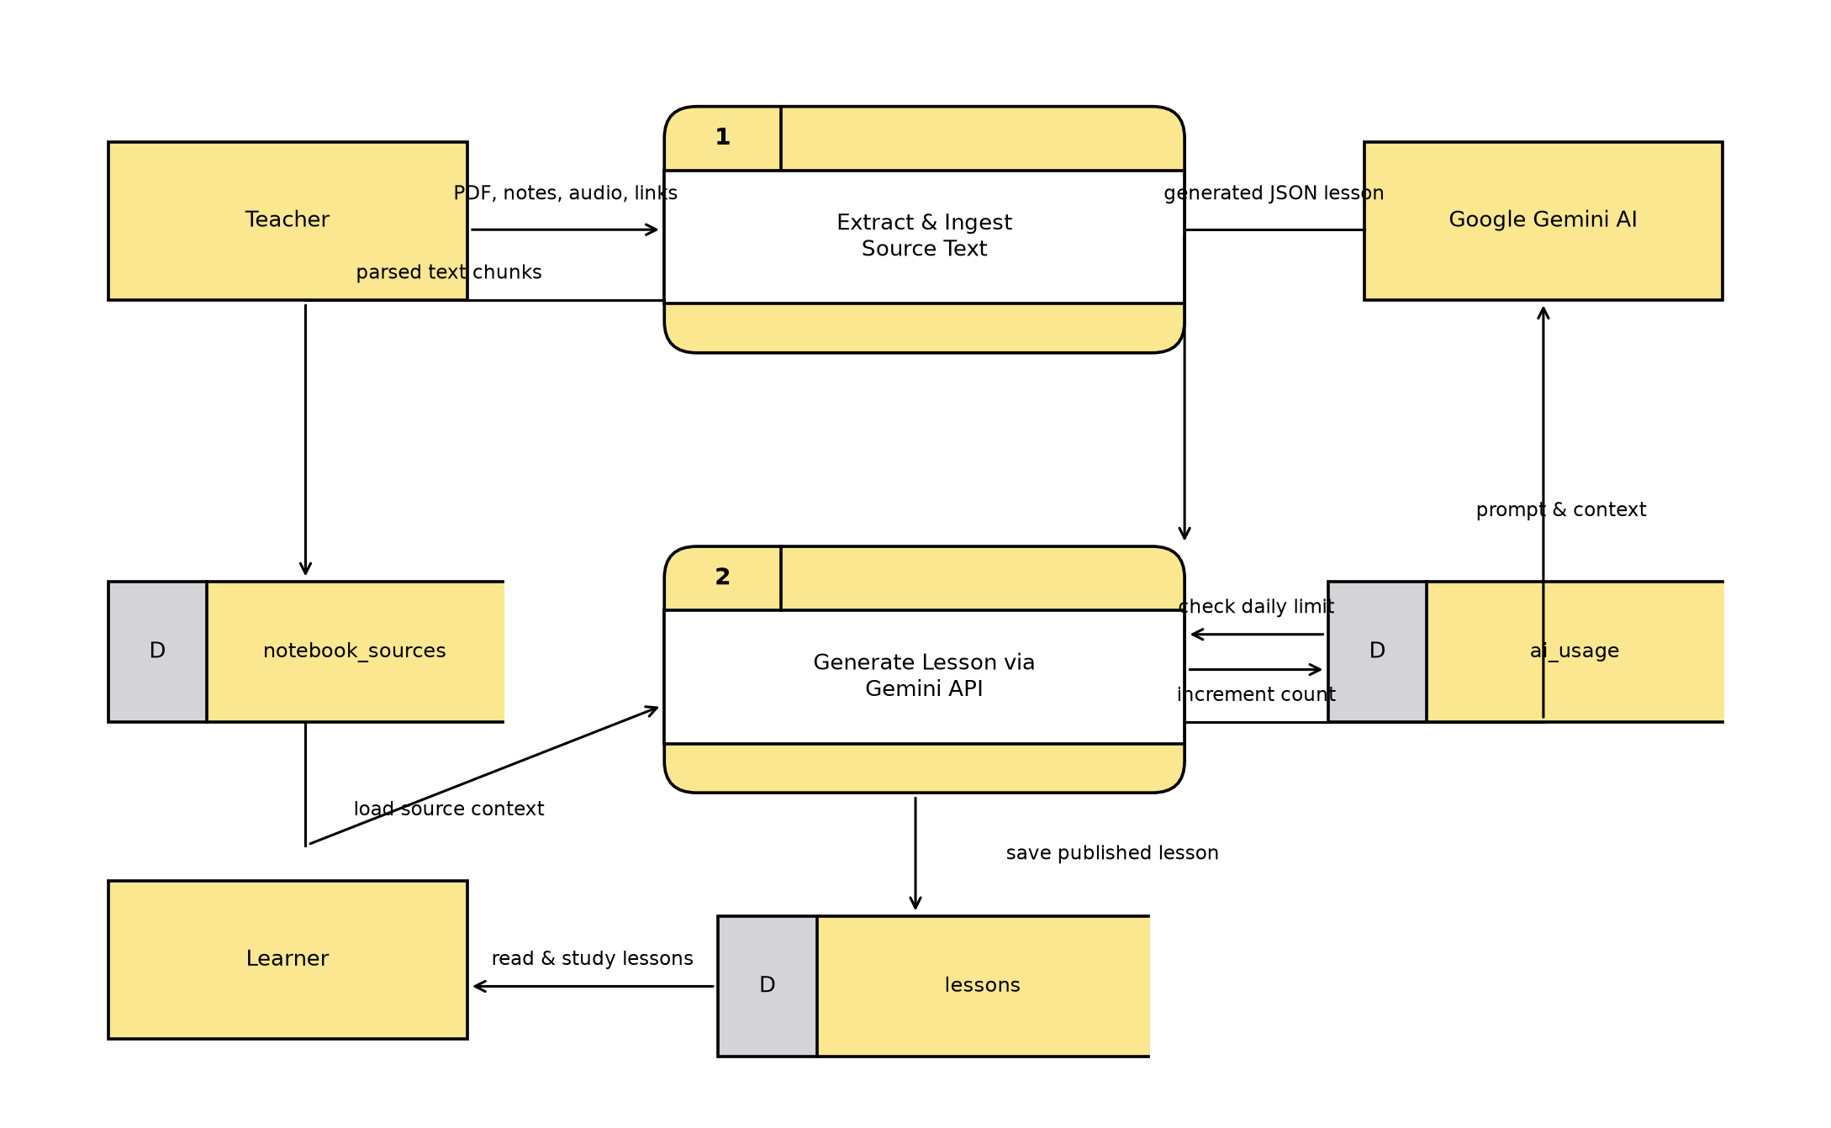
Figure 3: Dataflow Diagram for Creating Lessons with AI

Figure 4: Dataflow Diagram for Taking Quizzes and Checking Scores
Overview: How learners take quizzes, get instant scoring, and unlock lesson progress.
How the Data Flows (Simple Steps):
- Learner opens a quiz (system checks if required lesson is already read).
- Learner answers questions (Multiple Choice, Fill in Blanks).
- System compares learner's answers against the answer key.
- System computes score, timer duration, and attempt count.
- Score is saved in Quiz Scores, and the lesson is marked as passed.
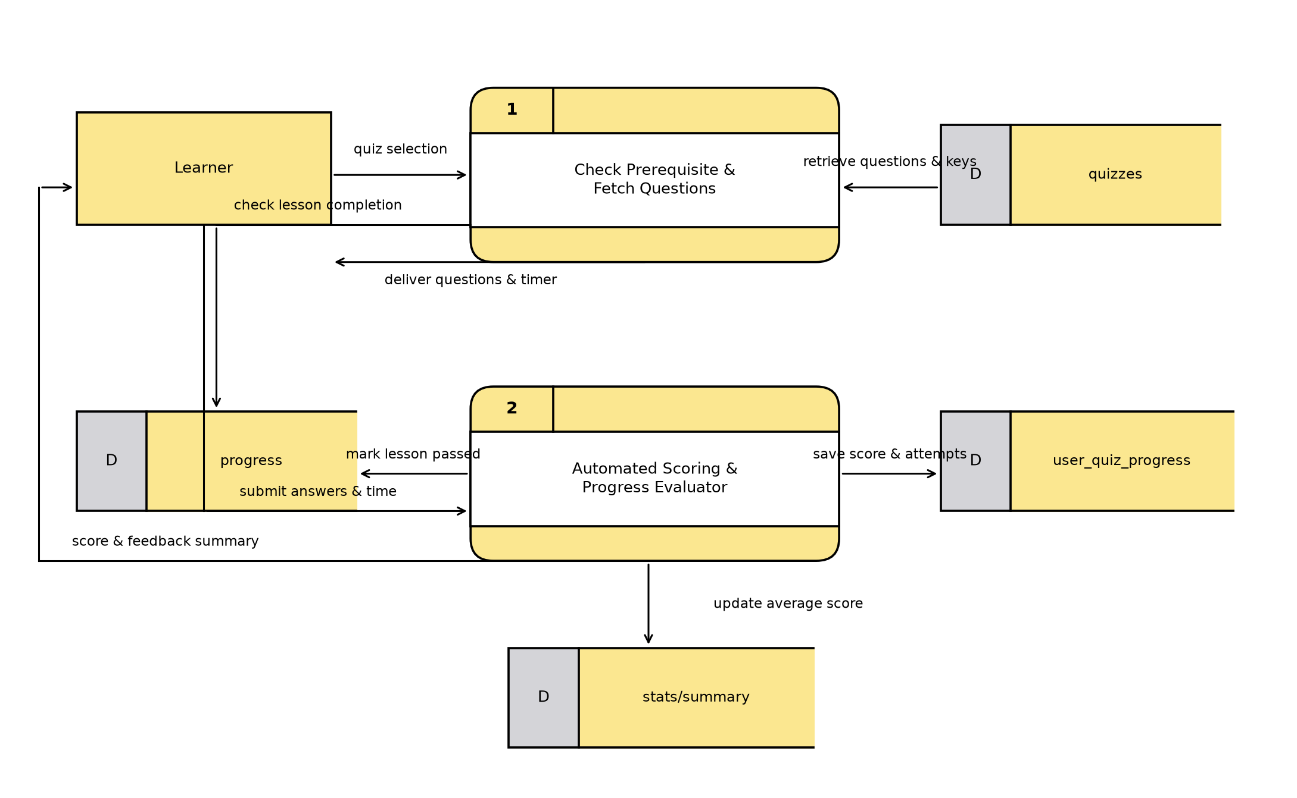
Figure 4: Dataflow Diagram for Taking Quizzes and Checking Scores

Figure 5: Dataflow Diagram for Speech and Spelling Bee Practice
Overview: How the system listens to learner pronunciation and checks voice spelling bee challenges.
How the Data Flows (Simple Steps):
- System selects vocabulary word and plays audio pronunciation.
- Spelling Bee: Learner types the word -> System checks spelling.
- Pronunciation: Learner speaks into mic -> Vosk Speech Engine listens and converts to text.
- System grades pronunciation accuracy and timer speed.
- Correct words increase user's spelling count and study streak.
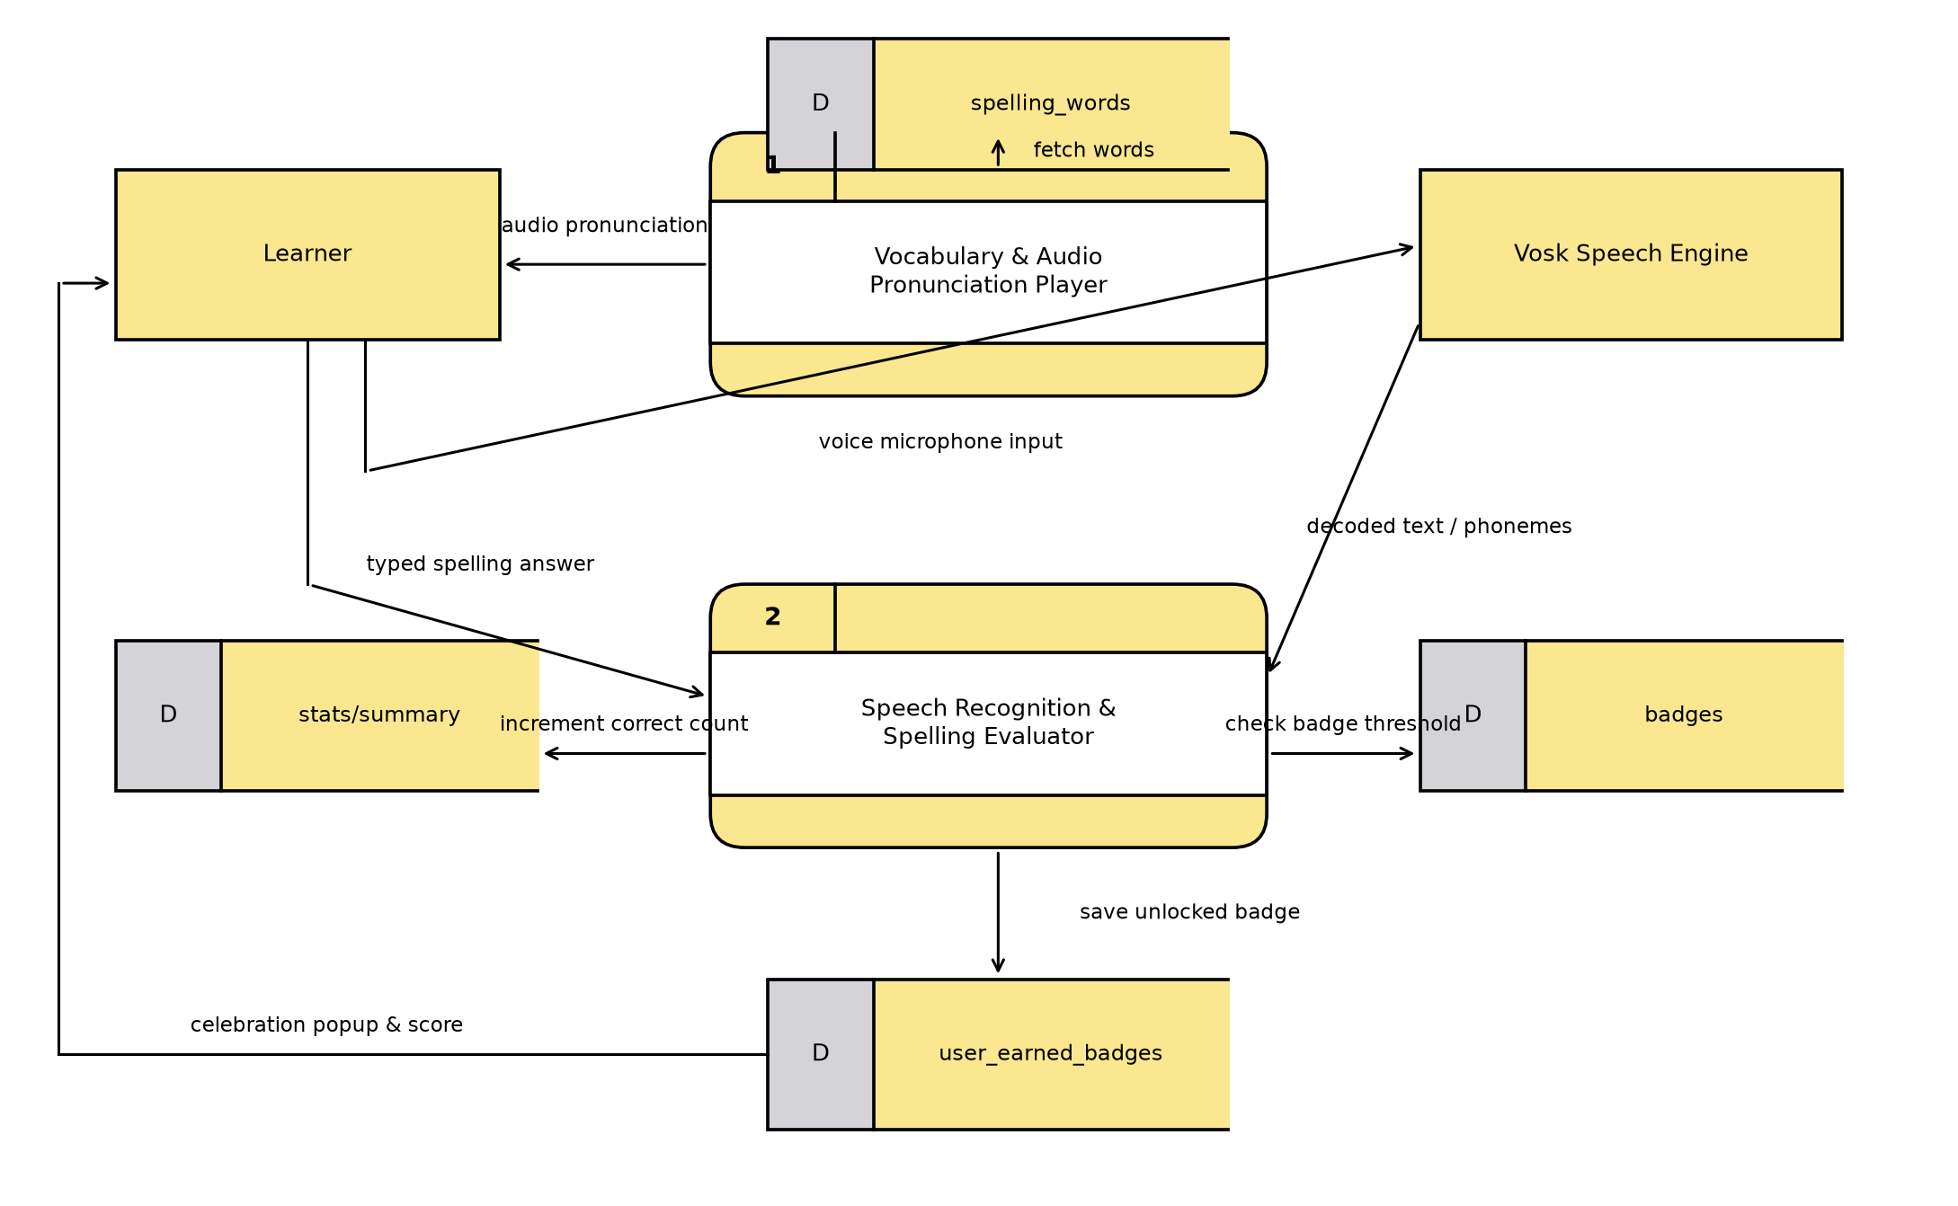
Figure 5: Dataflow Diagram for Speech and Spelling Bee Practice

Figure 6: Dataflow Diagram for Flashcards and Memory Review
Overview: How flashcards are scheduled using spaced repetition so students remember words long-term.
How the Data Flows (Simple Steps):
- System creates flashcards (Front = Term, Back = Definition & Example).
- Learner opens review deck; system shows only cards due today.
- Learner flips card and rates how easy/hard it was (0 to 5).
- System schedules next review: easy cards return in 4 days; hard cards return tomorrow.
- Cards mastered and review session time are saved in user stats.
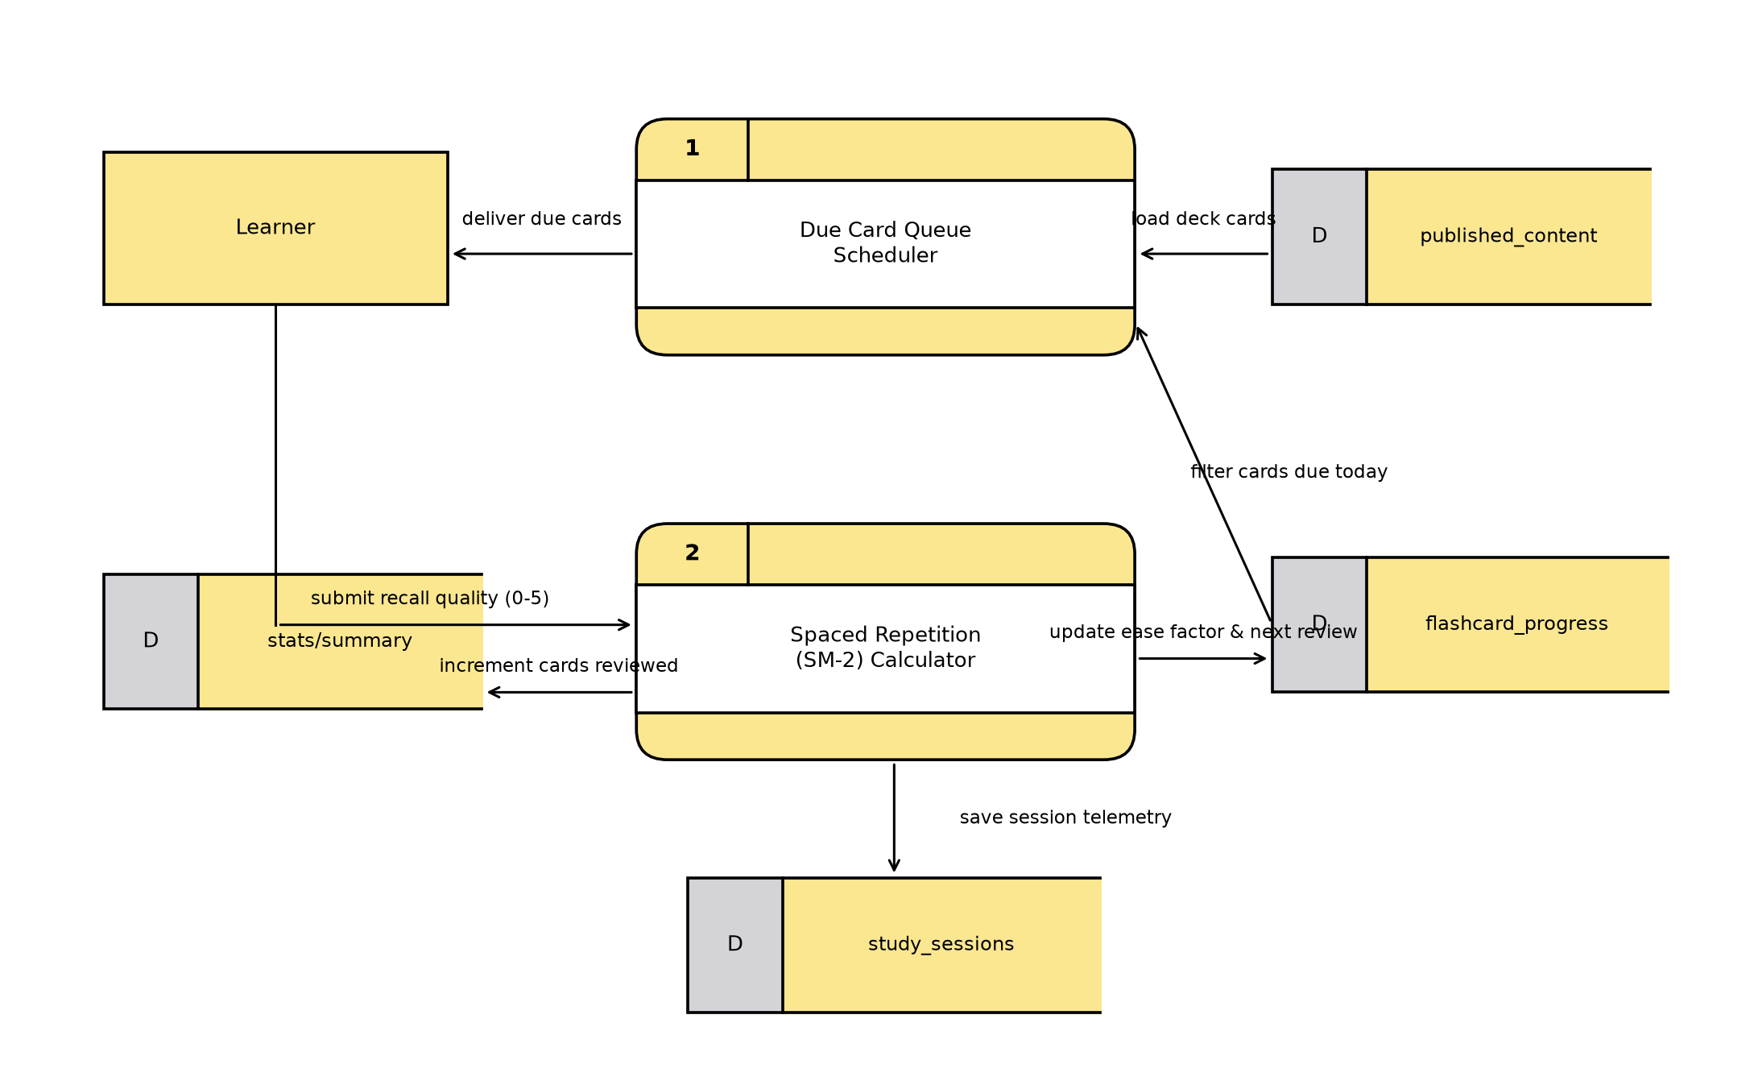
Figure 6: Dataflow Diagram for Flashcards and Memory Review

Figure 7: Dataflow Diagram for Subscriptions and Payments
Overview: How learners pay for teacher subscriptions using GCash, Maya, or Card safely.
How the Data Flows (Simple Steps):
- Learner selects teacher subscription (Basic or Premium).
- System generates a payment link / QR code through PayMongo.
- Learner pays via GCash, Maya, or Bank Card.
- PayMongo confirms payment; system creates a tamper-proof receipt.
- System activates subscription and unlocks the teacher's exclusive modules.
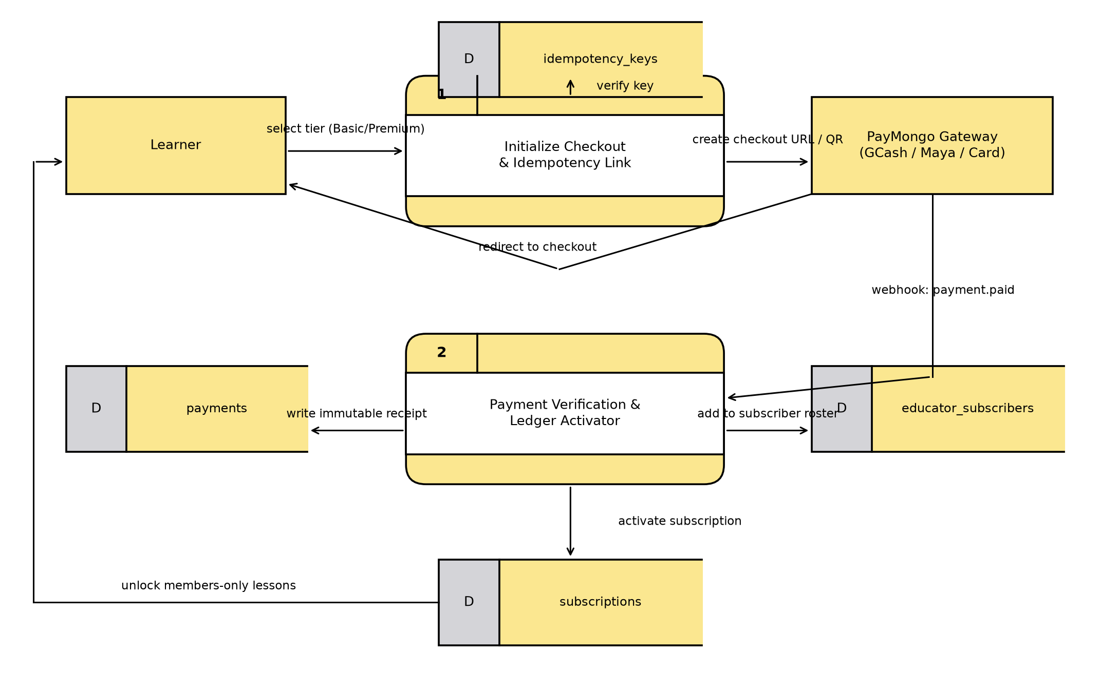
Figure 7: Dataflow Diagram for Subscriptions and Payments

Figure 8: Dataflow Diagram for 1-on-1 Mentoring and Video Calls
Overview: How students book live 90-minute mentoring sessions and connect via real-time video call.
How the Data Flows (Simple Steps):
- Teacher sets available 90-minute time slots on their calendar.
- Learner selects and reserves an open time slot.
- System locks the slot instantly so no double-booking can happen.
- At session time, both click 'Join Call' to enter the live video room.
- Both talk on video and use the live in-call text chat to share notes.
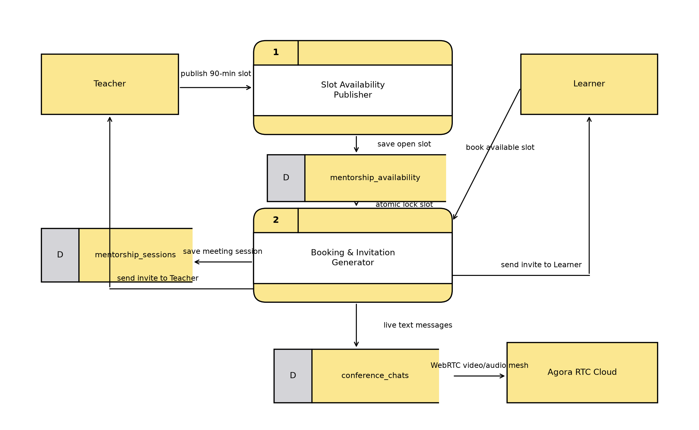
Figure 8: Dataflow Diagram for 1-on-1 Mentoring and Video Calls

Figure 9: Dataflow Diagram for Badges, Streaks, and Achievements
Overview: How daily practice builds study streaks and automatically awards achievement badges.
How the Data Flows (Simple Steps):
- Learner completes a learning activity (lesson, quiz, spelling, or flashcards).
- System checks the date: If learned today, study streak count increases by +1 day.
- System updates total counts (lessons completed, perfect scores).
- System checks badge requirements (e.g., 5 perfect quizzes = Silver Badge).
- If reached, badge unlocks with a celebration popup and is saved in user profile.
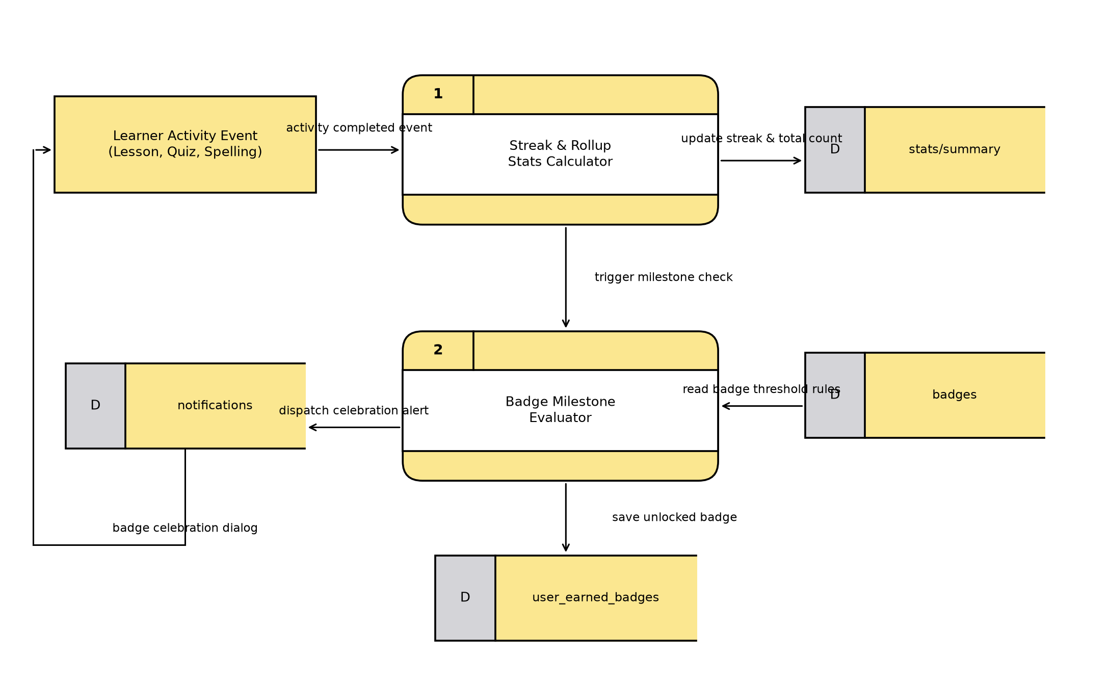
Figure 9: Dataflow Diagram for Badges, Streaks, and Achievements

Figure 10: Dataflow Diagram for User Feedback and Help Support
Overview: How users send feedback or report bugs, saving immediately to database and alerting admins by email.
How the Data Flows (Simple Steps):
- User taps the Feedback button anywhere in the app.
- User picks a category (Bug, Suggestion, Content), rates 1-5 stars, and writes a message.
- System saves the ticket immediately in the Feedback Database.
- System automatically emails the support team (grammatica.support@gmail.com) via Resend API.
- User receives an instant confirmation on screen.
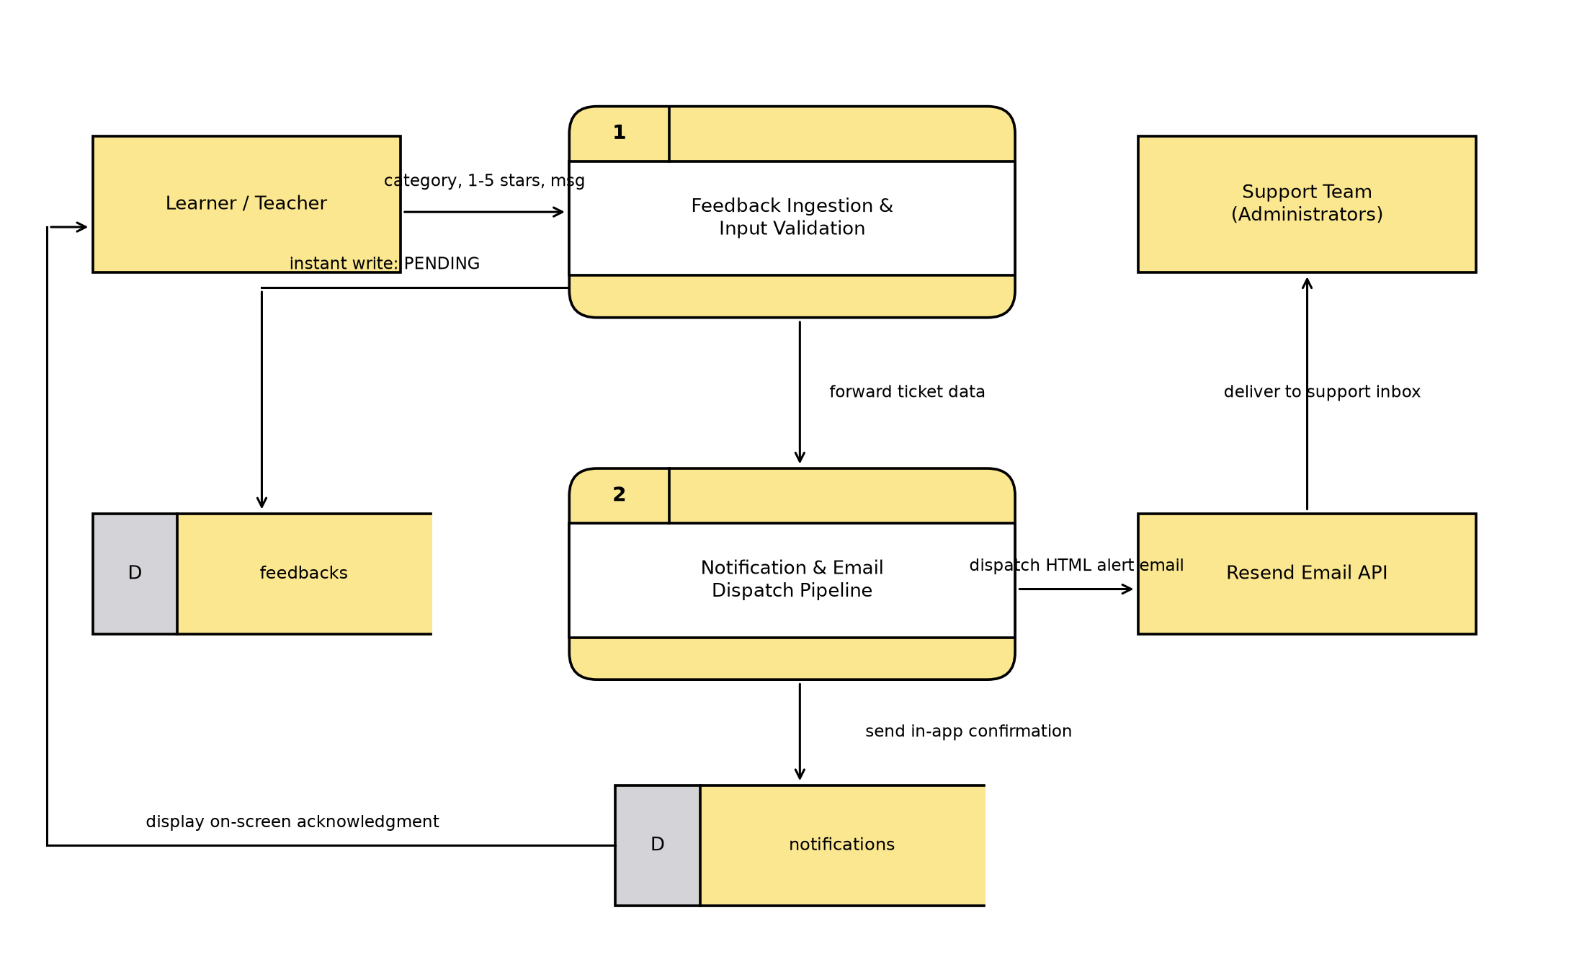
Figure 10: Dataflow Diagram for User Feedback and Help Support

