1. Taking into account missing & noisy data or potential outliers.

First, I removed the train rows where the person dies according to discharge disposition id, since it's obvious that this people will not readmit and these are outliers. We could hard code this in the prediction later.

For admission_type_id, discharge_disposition_id, and admission_source_id, I had to manually change them to factors instead of int.

For race, I assumed the question marks are the same as "other" .
For payer_code and medical_specialty, I changed the questions marks to unknown.

2. Go beyond what is given in the dataset to improve your classification error.

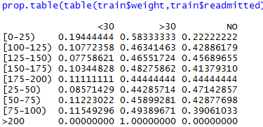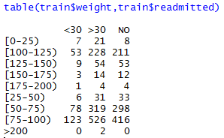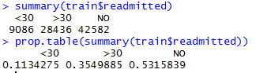

At first, I decided to just remove the weight column instead of cleaning it up. Too much information on the table is unknown, and logically, weight shouldn't contribute to re-admittance much without knowing height and fitness level.
The 0-25 row on the prop table has a higher re-admittance compared to other classifications which are approximately equal, but age should be enough to be used for the prediction. Curiously enough, people with their weight noted has a high re-admittance for >30 days compared to others, so I decided to make a column (weight_known) which tells if the weight is known or not.

For Diagnosis 1, 2 , and 3, I decided to create additional columns for them. The diabetic_diagnosis1 column checks if diag_1 has a number from [249,251) since diabetes ICD-9 Code is 249 for secondary and 250 for primary (diag_1 has no secondary diabetes). For diabetic_diagnosis2, it checks whether diag_2 or diag_3 has [249,250) for "secondary" or [250,251) for primary. The tables below show that these columns has little use in prediction. So I didn't include it in the prediction. Another way to classify data in these columns is to divide it into groups according to ICD-9 (i.e. 1-139, 140-239, E,V, etc). However, I don't think this will work since The classification shouldn't affect the likelihood of readmittance.
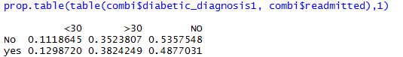
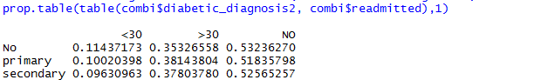
3. Attempts to prevent over-fitting.

I grouped together classifications from admission_type_id, discharge_disposition_id, and admission_source_id that are similar. For example, null, not available and not mapped are group together for admission_type_id.

I used random forest algorithm for my prediction. I removed medical_specialty as a factor since it has too many categories (which might be possible to fix by grouping them).
To check for overfitting, I divided the training set to another training set and a test set, and check its confusion matrix score. The first score I got is 54.517%, which could be improved. I then tried mtry=4 and the score rose to 54.85%.

I combined most of the medications except metformin and insulin. If any of the drugs are Up, other_drugs will be up, else if any of the drugs is down, other_drugs will be down, else check for steady, else no. The medication columns are then removed except for insulin and metformin. This increased accuracy of confusion matrix by 0.5%.

4. What features/patterns leads to a certain classification based on
your model.
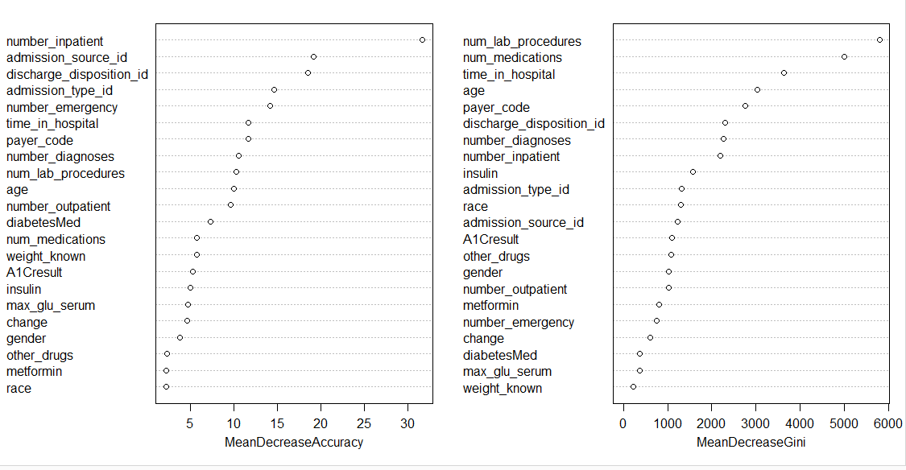
From the VarImpPlot above, the important columns in the prediction include number_inpatient, admission_source_id, discharge_disposition_id, admission_type_id, number_emergency, time_in_hospital, age, and payer_code.
Some major patterns:
- Increased number_inpatient, number_diagnosis, number_medications, number_lab_procedures, number_outpatient leads to readmittance
- admission type 1 and 5 leads to readmittance
- admission_source 1,2,3,7,9,10 leads to readmittance

5. Choice of model and techniques to improve your model performance
- Model: Random Forest
- Grouping and simplifying of similar data to prevent over-fitting
- Removing columns
- Removing outliers and manually reinserting to test

Possible further improvements:
Grouping or feature engineering on diagnosis and medical_specialty

