Box Maker
User manual
Parametric box generator with live 3D preview
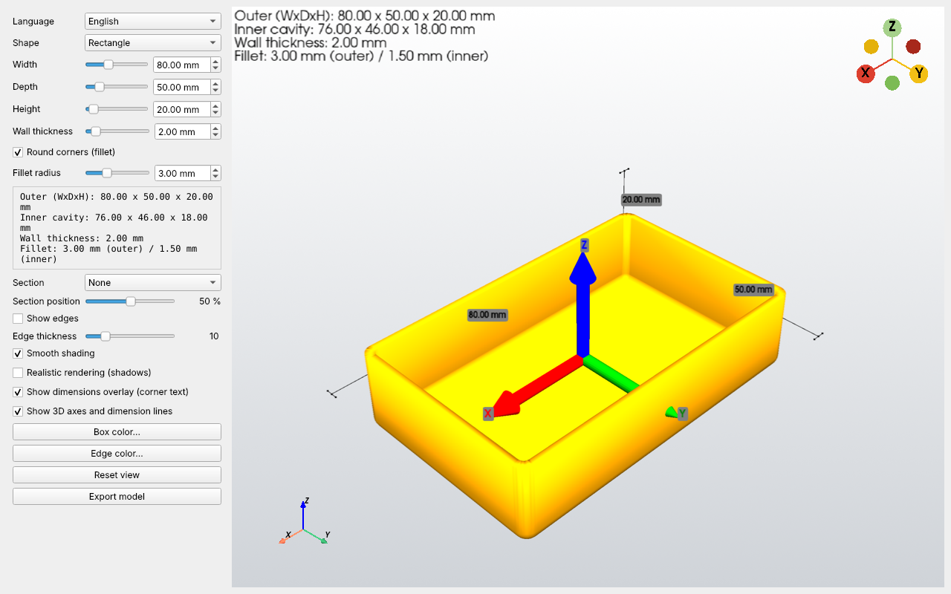
Version 1.0 — November 2026

1. Introduction
Box Maker is a small offline program that generates parametric boxes with a live 3D preview. It is made for people who 3D-print: you set the size, the wall thickness and the shape, see the result immediately and export a model ready to slice (STL) or ready to edit in a CAD program (STEP).
- Box shapes: rectangle, circle, ellipse, regular polygon, slot, a contour imported from an SVG file, or text set in any TrueType/OpenType font.
- Hollow boxes with an internal cavity computed from the wall thickness, or closed solid prisms.
- Rounded corners (fillet) with automatic, safe limits.
- Cut-away preview along any axis to inspect the cavity.
- Export to STL (mesh for printing) and STEP (exact CAD geometry).
- Interface in English, Italiano, Español and Français, switchable at any time.

2. Requirements and start
- Windows 10 (or later), 64-bit. The program works offline and needs no installation.
- A graphics card/driver that supports OpenGL 3.2 (any recent PC; virtual machines need 3D acceleration enabled).
- Portable version: double-click BoxMaker.exe. The very first launch unpacks the program (about 1 GB) into %LOCALAPPDATA%\BoxMaker; this takes a while. The following launches are much faster.
- From source code (developers): Python 3.11 or newer with build123d, PySide6, pyvista and pyvistaqt installed, then python main.py.
Note. If the program does not start, open the log file %LOCALAPPDATA%\BoxMaker\boxmaker.log: it records every start-up error.

3. The main window
The window has a control panel on the left and the 3D view on the right. Every change in the panel updates the model.
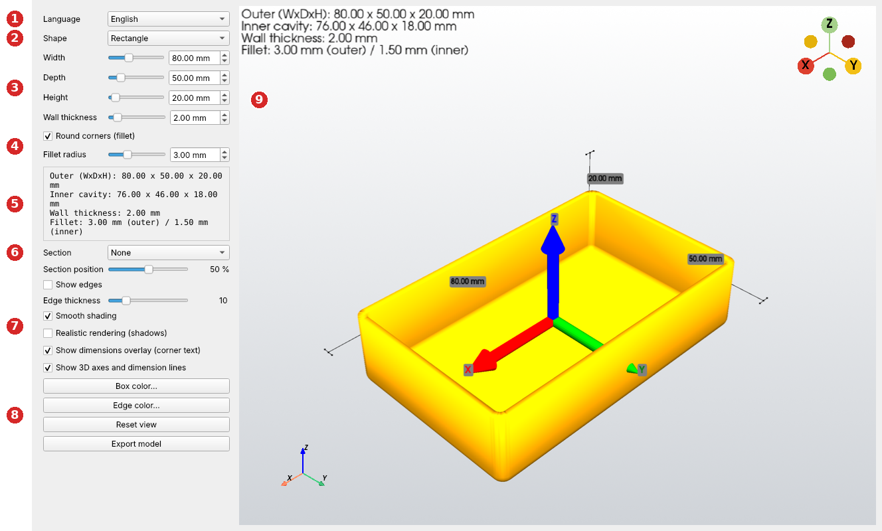
Figure 1. The main window. The numbers are explained below.
No. | Area | What it does
1 | Language | Switches the language of the interface immediately, without restarting.
2 | Shape | Chooses the shape of the box (chapter 5). Shape-specific controls appear below it.
3 | Dimensions | Width, Depth, Height and Wall thickness: drag the slider or type a value in the box next to it (0.01 mm resolution).
4 | Round corners (fillet) | Rounds the corners and sets the radius (chapter 6).
5 | Summary | Outer size, inner cavity size, wall thickness and the fillet really applied.
6 | Section | Cut-away preview (chapter 7).
7 | Appearance | Edges, shading, realistic rendering, overlays (chapter 8).
8 | Buttons | Colors, Reset view and Export model (chapter 9).
9 | 3D view | Drag with the left mouse button to rotate, use the wheel to zoom, drag with the middle button (or Shift + left button) to pan.

4. Dimensions and wall thickness
Control | Range | Meaning
Width | 20 – 200 mm | Size along the X axis.
Depth | 20 – 200 mm | Size along the Y axis (not used by circle, polygon, SVG and text shapes).
Height | 10 – 200 mm | Size along the Z axis.
Wall thickness | 0 – 20 mm | Thickness of walls and floor. The box is open at the top.

The cavity is the outline of the box shrunk by the wall thickness, and its floor is one wall thickness above the bottom. If the wall thickness is 0, or so large that no cavity fits, the box is a closed solid and the summary shows "No cavity (wall = 0 or too thick)".
Note. A typed value is applied when you press Enter or leave the field, not at every digit. Sliders follow the mouse live (see chapter 10).

5. Shapes
The box is the extrusion of a flat outline. Choose the outline in the Shape list.
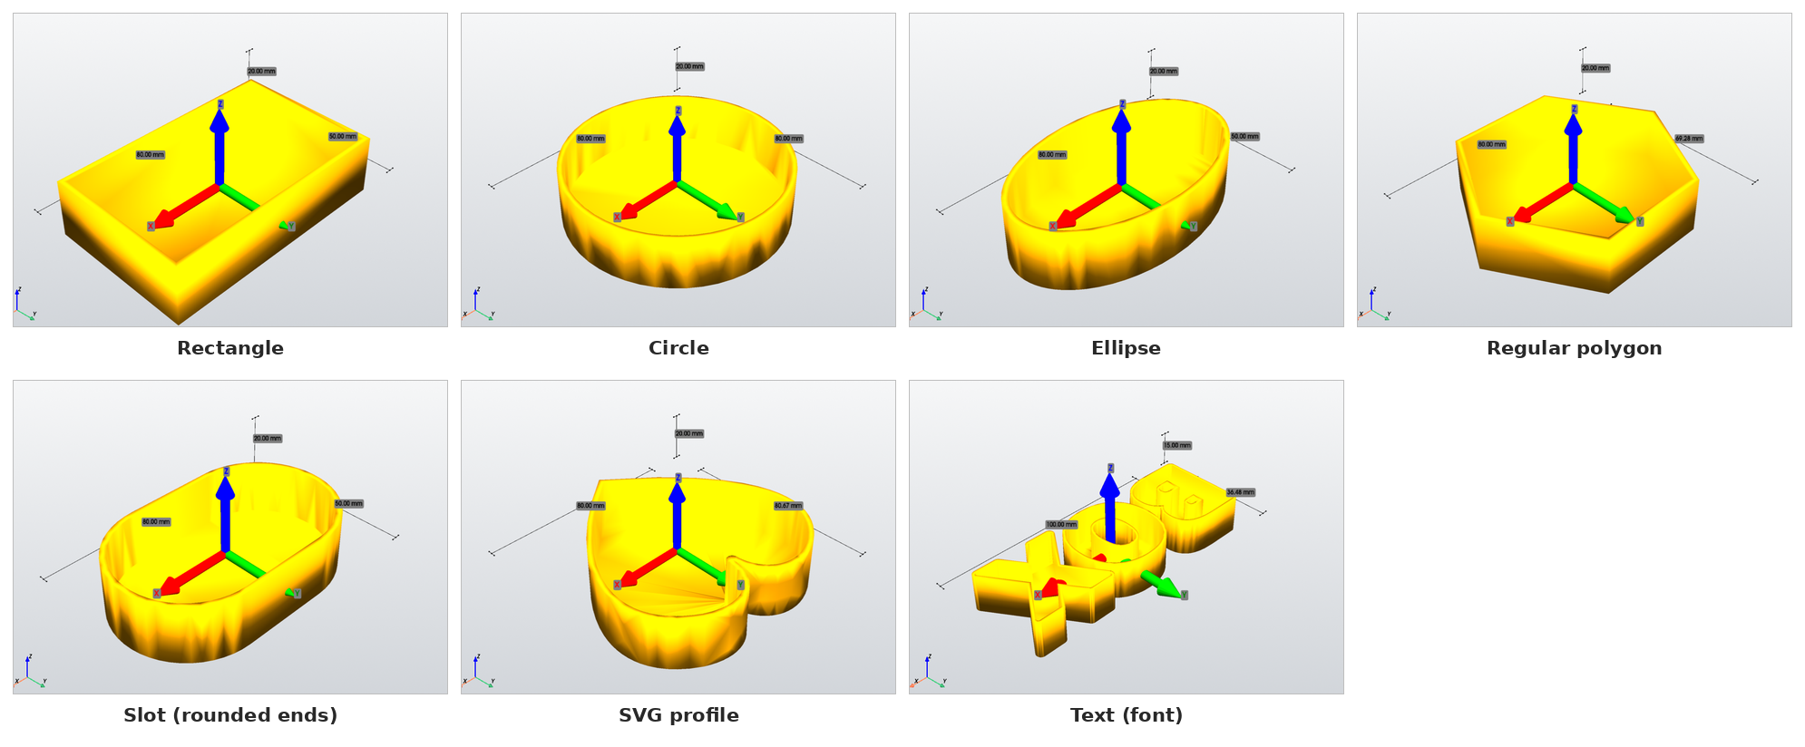
Figure 2. Available shapes: rectangle, circle, ellipse, regular polygon, slot, SVG profile and text.

5.1 Basic shapes
Shape | Controls | Notes
Rectangle | Width, Depth
Circle | Diameter | The depth is ignored.
Ellipse | Width, Depth | Full axes of the ellipse.
Regular polygon | Diameter, Sides (3 – 64) | The diameter is the circumscribed circle; the summary shows the real outer size.
Slot (rounded ends) | Width, Depth | A rectangle with fully rounded ends.

5.2 SVG profile
Choose SVG profile to build the box from a drawing. The program asks for the file; you can load another one at any time with Import SVG….
- The largest closed shape in the file is the contour of the box.
- Other closed shapes inside the contour become holes through the box.
- Open paths and closed shapes outside the contour are ignored. The panel reports how many holes were used and how many shapes were ignored.
- Width sets the width of the drawing in millimetres; the depth follows the proportions of the drawing.
- If the file has no closed shape, an error message explains it and the previous shape is kept.
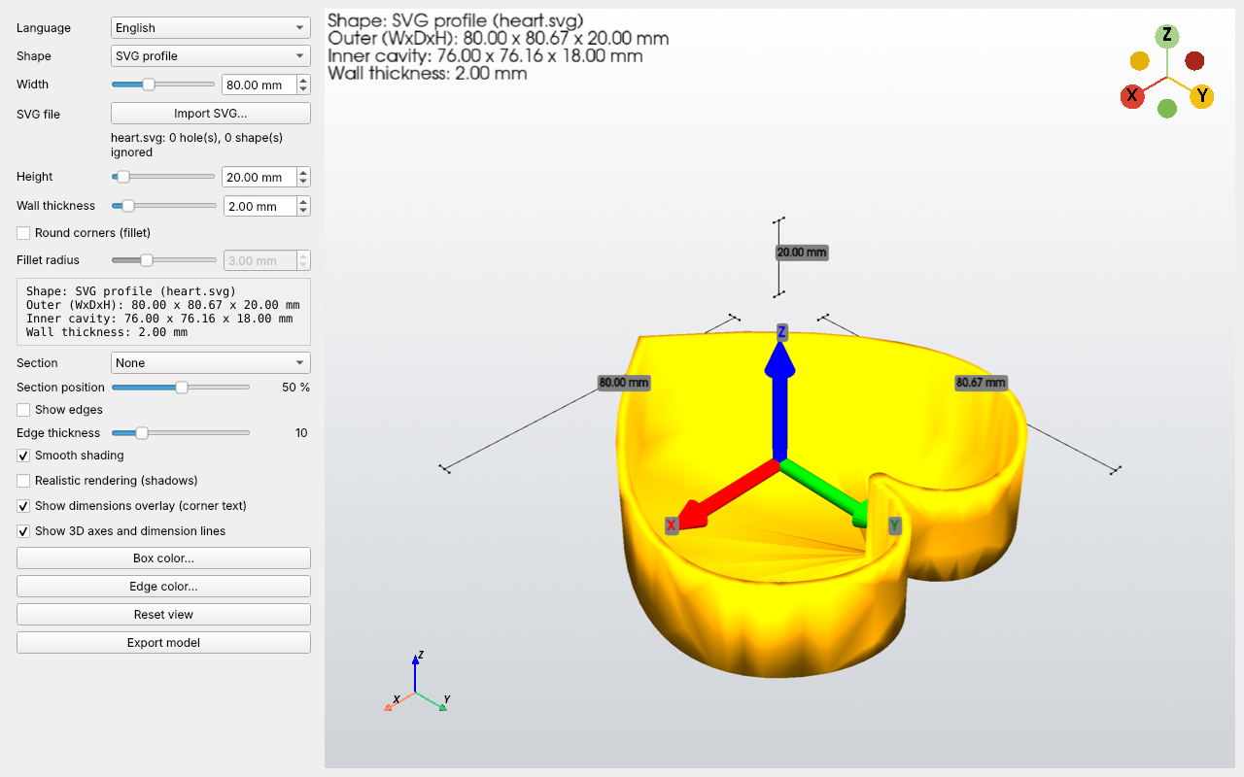
Figure 3. A box made from an SVG drawing (a heart).

5.3 Text (font)
Choose Text (font) to make a box shaped like a word or a logo.
- Type the text in the Text field (up to 60 characters). The holes of letters such as A, B or O are real holes.
- Pick a font in the Font (type to search) list: it contains the fonts installed in Windows, and typing part of a name filters the list. The first entry is the system font.
- To use a font that is not installed, press Other font file… and select a .ttf, .otf or .ttc file.
- Set Width for the overall width of the text.
- Set Letter growth to thicken the letters. Letters that touch or overlap fuse into one piece.
Without growth each letter is a separate box; the summary shows "Separate pieces: N". Letters whose strokes are thinner than two wall thicknesses have no cavity and stay solid. Choose bold fonts for better results.
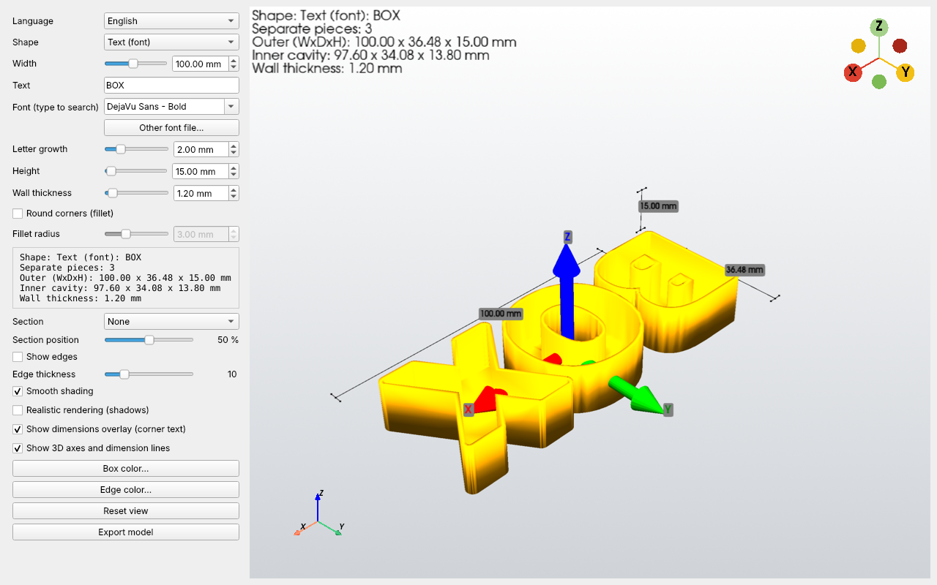
Figure 4. A box made from the text "BOX" with a letter growth of 2 mm.

6. Rounded corners (fillet)
Enable Round corners (fillet) and set Fillet radius. The radius you set is the outer radius.
- The inner radius follows it: outer radius minus wall thickness, but never less than half of the outer radius, so the inner corners are always rounded too.
- Rounded are the vertical corners and the edges of the base, outside and inside. The rim of the open box stays sharp, so a lid can rest on it.
- With wall thickness 0 the box is a closed prism and all edges, top included, are rounded.
- The radius is limited automatically to a safe value. If the CAD kernel cannot build it (typical with SVG or text outlines), the program tries smaller radii and the summary shows the radius really applied.
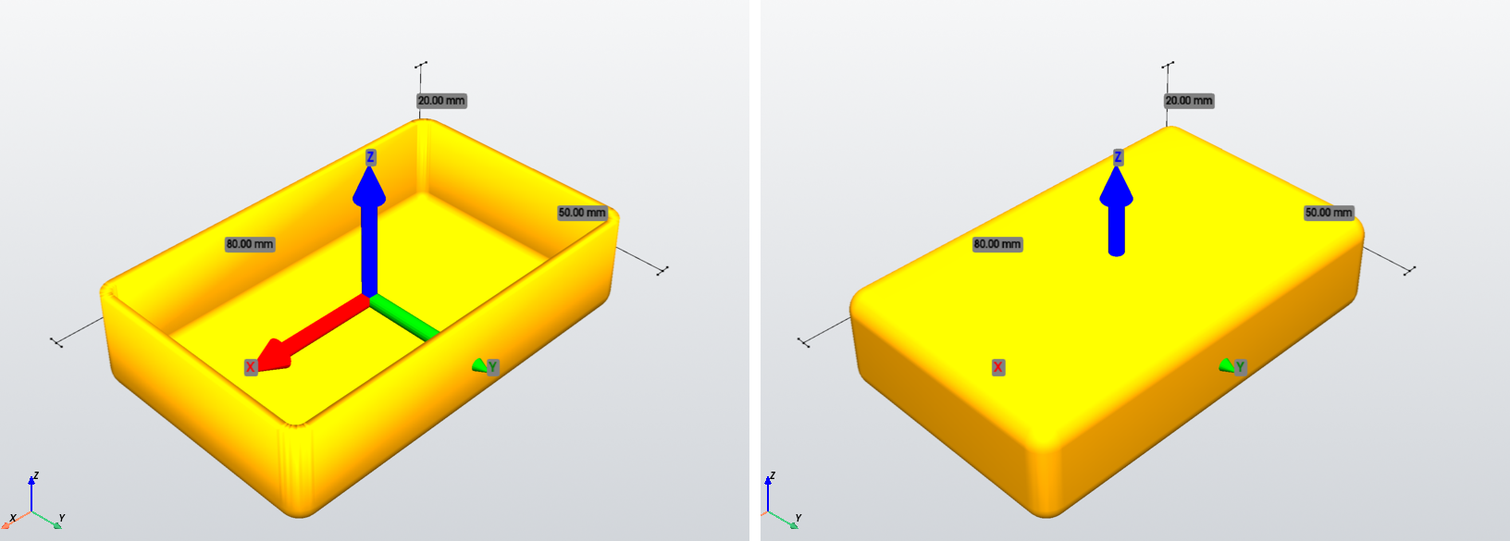
Figure 5. Left: hollow box with fillet. Right: closed prism (wall thickness 0), all edges rounded.
Note. Fillets on text outlines are the least reliable case: with thin or intricate fonts expect small radii, or none.

7. Section (cut-away)
Choose an axis (X, Y or Z) in Section and move Section position to cut the model open and inspect the cavity. At 0 % the whole model is cut away.
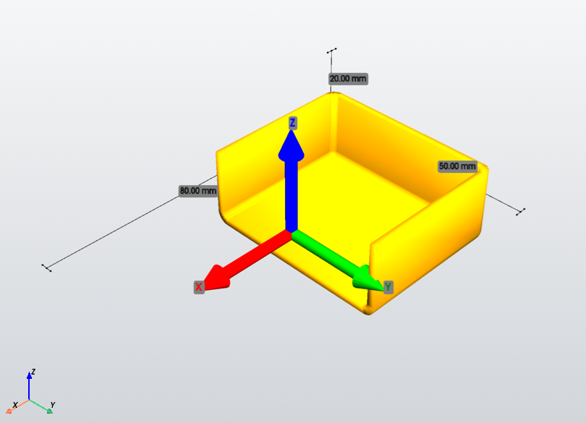
Figure 6. Section along the X axis at 50 %.
Note. The section is only a preview: the exported model is always complete.

8. Appearance of the 3D view
Option | Effect
Show edges | Draws the edges of the model; Edge thickness sets their width.
Smooth shading | Smooth shading of curved surfaces.
Realistic rendering (shadows) | Shadows and anti-aliasing. It needs a capable graphics card and falls back to normal rendering if it is not supported. Turn it off if the program feels slow.
Show dimensions overlay (corner text) | Writes the measures in the top-left corner of the view.
Show 3D axes and dimension lines | Shows the 3D axes and technical-drawing dimension lines.
Box color…, Edge color… | Choose the color of the box and of the edges.
Reset view | Restores the default camera.

9. Exporting the model
Press Export model. In the "Save model" window choose the file type.
Format | What it is | When to use it
STL | A triangle mesh. | To slice and print as it is.
STEP | Exact CAD geometry (surfaces, edges, vertices). | To keep modifying the box in FreeCAD, Fusion 360, SolidWorks and similar: add holes, bosses, slots, labels. Fillets stay exact.

The extension is added automatically. The exported file never includes the section preview.

10. Speed and responsiveness
- While you drag a slider the preview follows live as long as updates are quick. With a heavy model (text, SVG, fillets) it updates when you release the slider.
- The mouse cursor shows a wait symbol while the model is being rebuilt.
- The 3D preview is deliberately coarser than the exported STL: curved surfaces look smooth, but the exported file is more precise.
- Complex outlines (text, SVG) with fillets can take several seconds per update. If you only need the shape, switch the fillet off while you adjust the sizes and turn it on at the end.

11. Language and saved session
Choose the language in the Language list. When you close the program it saves the window position and all the values: dimensions, shape, SVG file, text, font, fillet, colors and options. They are restored at the next start.

12. Messages and troubleshooting
Message or symptom | Meaning | What to do
No cavity (wall = 0 or too thick) | Wall thickness is 0 or too large for this shape. | Reduce the wall thickness if you want a hollow box.
Fillet not applied, or only partially (requested X mm). Try a smaller radius. | The CAD kernel could not build any fillet. | Use a smaller radius or switch the fillet off.
Requested fillet … -> applied … | The radius was reduced to a safe or buildable value. | No action needed; the applied value is what you get.
No closed shape found. Draw the contour as a closed path, rectangle, circle or polygon. | The SVG contains only open lines. | Close the paths in your drawing program, or convert strokes to paths.
The letter growth is too large for this width. | The letter growth is too large for the chosen width. | Increase the width or reduce the growth.
This file is not a usable font. | The chosen file is not a usable font. | Select a .ttf, .otf or .ttc font file.
The font list is empty | No fonts were found in the Windows font folders. | Use Other font file….
The program does not start | Start-up error (graphics driver, missing component). | Read %LOCALAPPDATA%\BoxMaker\boxmaker.log. In a virtual machine enable 3D acceleration.
Updates are slow | Heavy model or realistic rendering. | Turn Realistic rendering (shadows) off, reduce the fillet, work without fillet and enable it at the end.

Appendix A. Building the executable (developers)
- Install Python 3.13 (64-bit) and the packages build123d, PySide6, pyvista, pyvistaqt and nuitka.
- Put compile.bat, the icon 3d.ico and the project files in the same folder and run compile.bat.
- Two options at the top of the script: ONEFILE=1 builds a single BoxMaker.exe, ONEFILE=0 builds a folder; CONSOLE=force shows a console with Python errors while debugging.
- The first build takes a long time (Nuitka compiles the whole program and its libraries). The result is in nuitka_build.
- When you rebuild the single-file version, raise --product-version or delete %LOCALAPPDATA%\BoxMaker\<version>, otherwise the old unpacked files may be reused.
Box Maker is distributed under the GNU General Public License v3.0. It is built with build123d (OpenCascade), PySide6 (Qt), PyVista/VTK and Nuitka.

