Task 3. 1: Connect with openssl s_client

:~$ openssl s_client -connect google.com:443 -showcerts
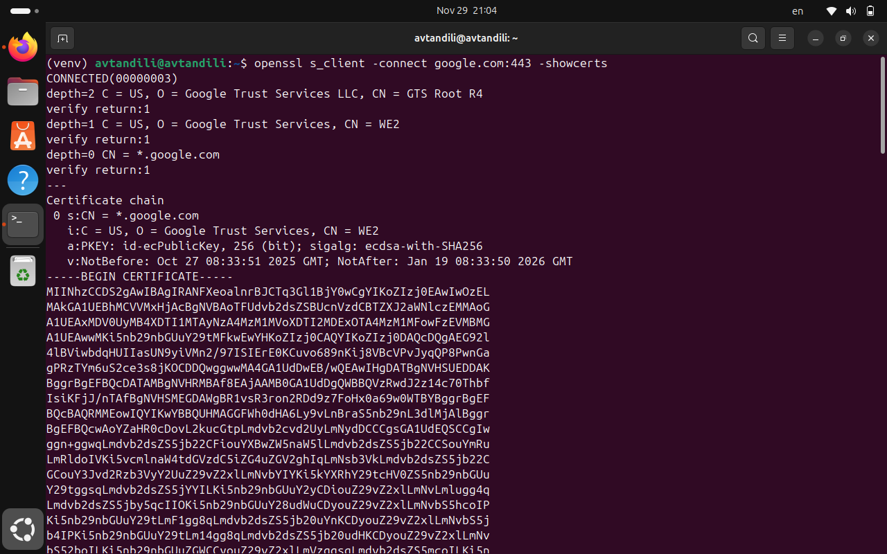

🔹 task 2: Extract and Document
2.1 Certificate chain (Root → Intermediate → Leaf)

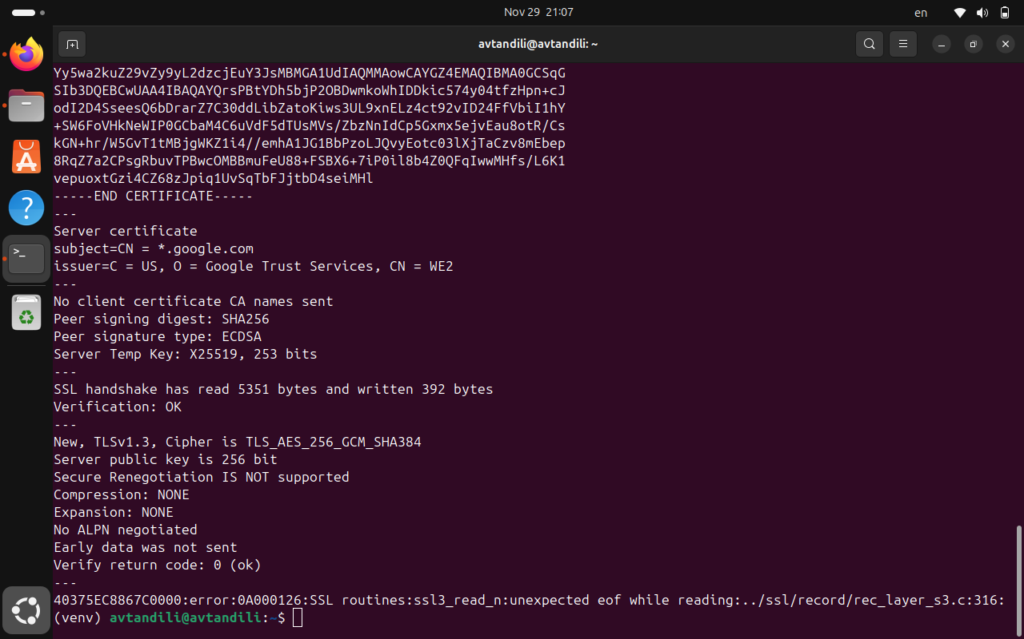

2.2 Cipher suite used

2.3 TLS version

3. Capture a TLS handshake using Wireshark and highlight:

3.1 Client Hello
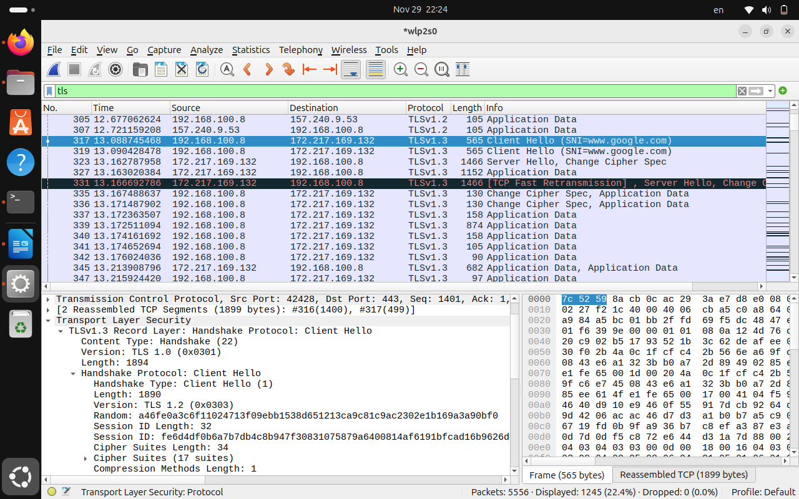

3.2 Server Certificate

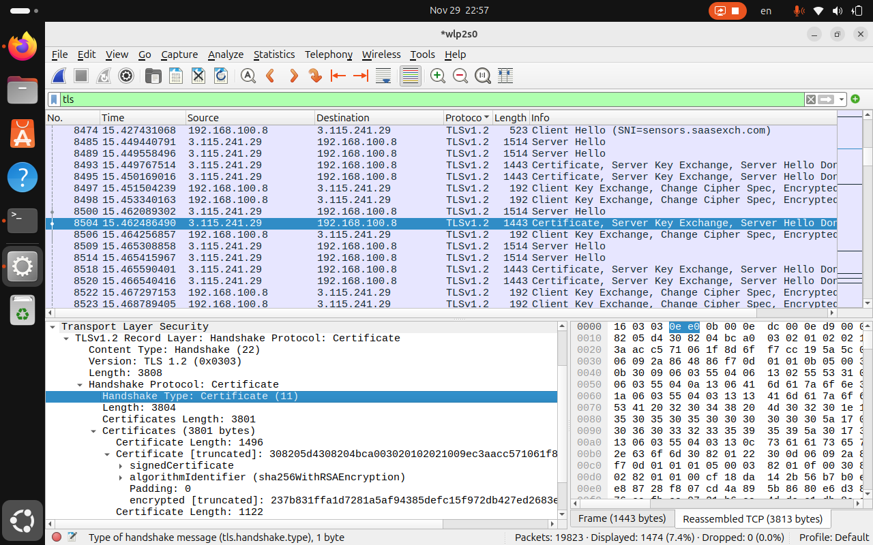

3.3 Key Exchange

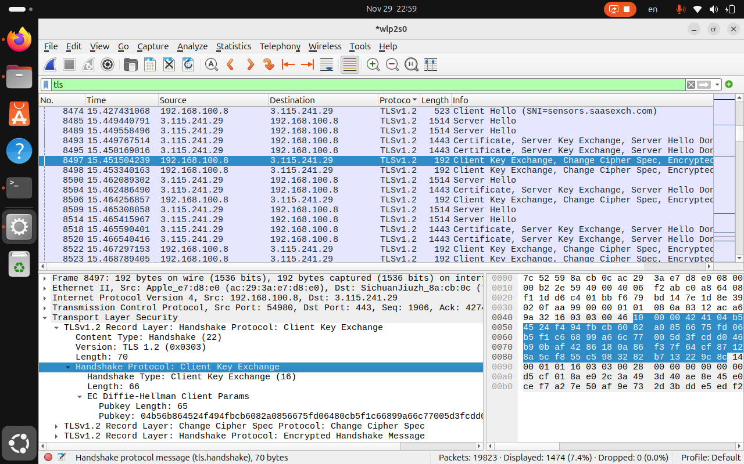

Taks 3.4
Briefly describe how TLS provides confidentiality and integrity

Confidentiality
- Encryption of data: TLS uses symmetric encryption (e.g., AES, ChaCha20) once the handshake establishes a shared session key.
- Key exchange: The handshake (often via Diffie-Hellman or Elliptic Curve Diffie-Hellman) securely generates a shared secret, ensuring that even if someone intercepts traffic, they cannot derive the encryption key.
- Result: Sensitive information such as passwords, financial data, or personal messages remains private between client and server

Integrity
- Message authentication codes (MACs): TLS attaches a cryptographic hash (e.g., HMAC with SHA-256) to each message.
- Tamper detection: If any bit of the data is altered in transit, the MAC verification fails, and the connection is dropped.
- Result: Guarantees that the data received is exactly what was sent, protecting against modification or injection attacks

Summary
- Confidentiality: Achieved through encryption of the communication channel.
- Integrity: Achieved through cryptographic hashing and MACs to prevent undetected changes. Together, these mechanisms make TLS the backbone of secure web communication, ensuring privacy and trustworthiness of data exchanged online.

