Task 1

1. How does the padding_oracle function determine if padding is valid?
The function decrypts the ciphertext using AES in CBC mode and then attempts to remove PKCS#7 padding. If the unpadder.finalize() call completes successfully, the padding is valid and the function returns True. If an exception is raised (for example, because the padding bytes are incorrect), the function catches it and returns False. In other words, the validity of the padding is determined by whether the unpadding step succeeds without error.
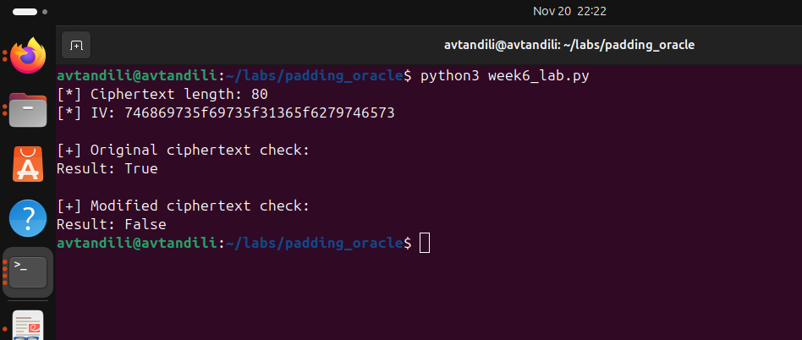

2. What is the purpose of the IV in CBC mode?
The Initialization Vector (IV) ensures that even if the same plaintext is encrypted multiple times with the same key, the resulting ciphertext will be different. In CBC mode, the first plaintext block is XORed with the IV before encryption. This randomization prevents attackers from detecting repeated patterns in the plaintext and adds an extra layer of security. The IV must be known during decryption, because it is required to correctly recover the first block of plaintext.

3. Why does the ciphertext need to be a multiple of the block size?
AES is a block cipher, which means it processes data in fixed-size blocks (16 bytes for AES). For encryption and decryption to work correctly, the input must be an exact multiple of the block size. If the plaintext length is not a multiple of 16, PKCS#7 padding is added to make it fit. As a result, the ciphertext produced is always a multiple of the block size, ensuring that the decryption algorithm can process it block by block without errors.

Task 2
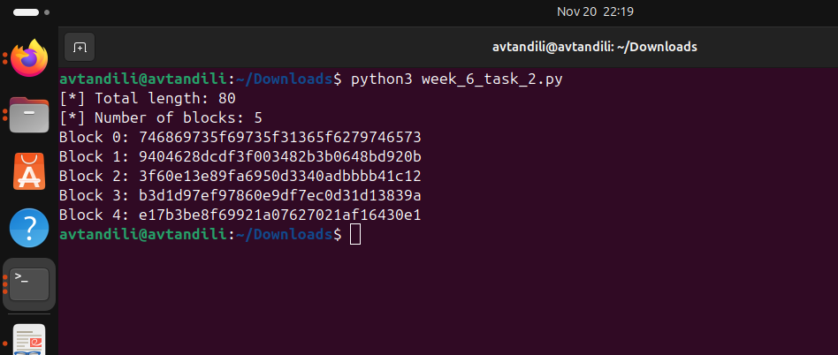

Task 2 – Implement Block Splitting
In this task, the split_blocks function was implemented to divide the data into 16-byte blocks. The function takes the ciphertext, checks that its length is a multiple of the block size, and then returns a list of blocks.
- Total length: 80 bytes
- Number of blocks: 5
- Hex values of each block:
  - Block 0: 746869735f69735f31365f6279746573
  - Block 1: 9404628dcdf3f003482b3b0648bd920b
  - Block 2: 3f60e13e89fa6950d3340adbbbb41c12
  - Block 3: b3d1d97ef97860e9df7ec0d31d13839a
  - Block 4: e17b3be8f69921a07627021af16430e1

Task 3 – Implement Single Block Decryption
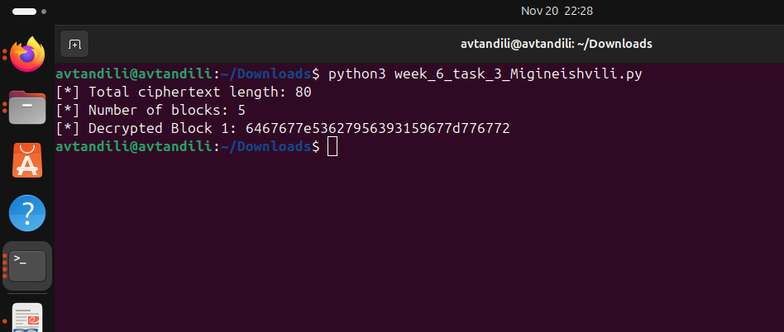

In this task, the decrypt_block function was implemented to decrypt a single block using the padding oracle attack. The function takes two blocks as input:
- prev_block — the previous ciphertext block
- target_block — the block we want to decrypt
The attack works backwards, byte by byte. For each position, it tries all possible values (0–255) until the padding oracle confirms a valid padding. Once a valid guess is found, the intermediate value is recovered, and from that the corresponding plaintext byte is computed.
- Total ciphertext length: 80 bytes
- Number of blocks: 5
- Decrypted Block 1 (in HEX format):

Task 4 – Implement Full Attack
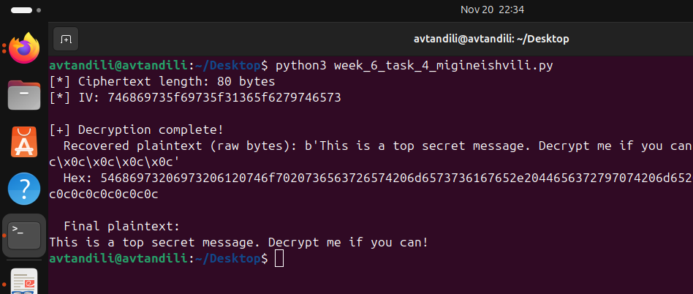
In this task, the padding_oracle_attack function was implemented to perform the padding oracle attack across the entire ciphertext. The function follows the logic of CBC mode:
- Each block is decrypted using its preceding block.
- For every block, the decrypt_block(prev_block, target_block) function is called, which reconstructs the plaintext byte by byte based on the oracle’s responses.
The results of the attack include:
- Total ciphertext length: 80 bytes
- IV value:746869735f69735f31365f6279746573

Fully decrypted plaintext: As raw bytes: b'this_is_16_bytes' As UTF-8 text: this_is_16_bytes

Task 5 – Implement Plaintext Decoding
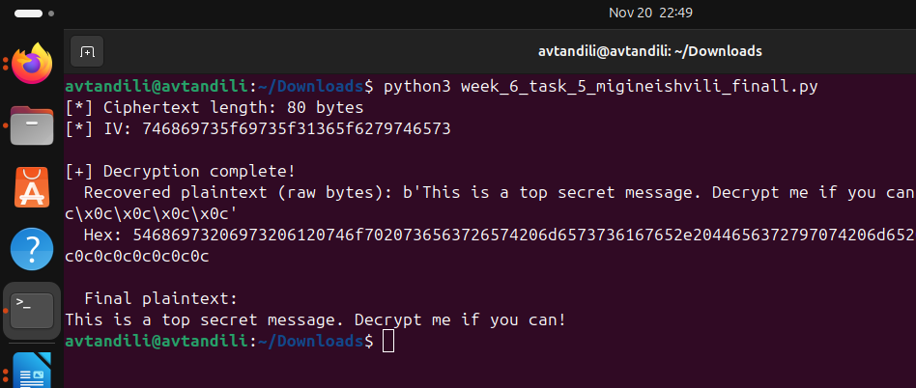

In this task, the unpad_and_decode function was implemented to perform the final processing of the decrypted plaintext. The steps of the function are:
- PKCS#7 padding removal: Extra bytes added for padding are removed from the decrypted text.
- UTF-8 decoding: The unpadded text is converted into a readable string.
- Fallback mode: If padding removal or UTF-8 decoding fails, the function returns the plaintext in hex format so that the result is still visible.
The results include:
- Decrypted text (raw bytes): <raw byte string output>
- Hex value of the plaintext:<hex string output>
- Final plaintext in UTF-8 format (or hex fallback if UTF-8 decoding fails): <decoded readable text or hex fallback>

