

Name : Manzi Amigo Reussi
Class: BTEC 3 IT
Assessor: Tr. KITOGA Elisee
School: BLULAKES INTERNATIONAL SCHOOL(BLIS)
PROGRAM: PEARSON EDUCATION
DATE:03/05
YEAR: 2026
BRIEF 2 LEARNING AIM B C
Unit 7: Mobile Apps Development

TABLE OF CONTENTS

INTRODUCTION
This assignment is for Unit 7 Mobile Apps Development, Learning Aim B and C. The task was to design and develop a mobile app for a sustainability charity that raises awareness of environmental issues around the world. I took on the role of a junior programmer working for the charity and my job was to produce a professional mobile app that meets their requirements. The app needed to include information about sustainability topics, video content showing why sustainability matters, a quiz game with 10 multiple choice questions, score tracking, and suitable graphics to make it engaging for users.
I decided to call the app EcoQuest, combining Eco which relates to the environment with Quest which means a journey or mission. The tagline I created is Learn. Act. Sustain. which reflects what the app helps users to do. I designed all six screens in Figma before writing any code, then built a Spring Boot backend with a PostgreSQL database to store the quiz questions and scores, and finally built the React Native frontend that users interact with. This document covers the full design process including wireframes, feedback and design justification, the development of both the backend and frontend, testing of all features, and a review and evaluation of the finished product against the original requirements.

7/B.P3 Produce designs for a mobile app to meet identified requirements

Section 1: App Design
1.1 The Vocational Scenario
I work as a junior programmer for a sustainability charity that raises awareness of environmental issues. The charity asked me to build a mobile app to help users understand the importance of sustainability. The app needs to have information about sustainability issues around the world, video content showing why it matters, and a quiz game where users answer 10 multiple choice questions. The app also needs to keep track of the score and have good graphics to make it engaging.
1.2 What the Users Need
Before I started designing anything I thought about who would use this app and what they actually need from it. The users are people who want to learn about sustainability in a simple and enjoyable way. They are not necessarily technical people so the app needs to be easy to understand and navigate without any instructions. Based on the brief I identified these requirements for the app.

The app needs to give clear information about sustainability topics like recycling, saving energy and clean water. It needs a video screen where users can watch a short sustainability documentary. The quiz must have exactly 10 multiple choice questions and the app must keep track of the user's score throughout the game. The final score must be shown at the end and saved so the user can review it later. The app also needs good visuals and sounds to keep users engaged. Finally all navigation between screens must be smooth and obvious so anyone can use it.
1.3 The App Name and Purpose
I decided to name the app EcoQuest. I chose this name because Eco connects to ecology and the environment which is what the charity cares about, and Quest means a journey or mission which reflects what the app is trying to do. The idea is that using EcoQuest is like going on a mission to learn about sustainability. The tagline I created is Learn. Act. Sustain. which covers the three things the app helps users to do. First they learn from the information screens, then they act by taking the quiz, then they sustain by remembering what they have learned.

1.4 Screen Structure and Navigation Flow
I designed EcoQuest with six screens. Each one has a specific purpose and connects to the others in a logical way. The Splash Screen is the first thing users see when they open the app. It shows the EcoQuest leaf logo and the tagline while the app loads in the background, then it automatically takes the user to the Home Screen after three seconds.

The Home Screen is the main dashboard of the app. It shows a welcome message saying Hello Explorer, a daily quiz card encouraging the user to take the quiz, and two shortcut cards at the bottom for Learn and Scores. There is a bottom navigation bar with four tabs which are Home, Learn, Quiz and Settings. This makes it easy to get to any part of the app from anywhere.

The Learn Screen shows three topic cards covering Recycling, Save Energy and Clean Water. Each card has a real photograph and a short description. At the bottom there is a Watch Video button that takes the user to the Video Screen. The Video Screen shows a video player with a play button and a description of the documentary called The Power of Small Actions. There is a Back to Learn button at the bottom.

The Quiz Screen loads 10 multiple choice questions from the backend database. It shows a progress bar at the top so users can see which question they are on, for example 1 out of 10. Each question has four answer options and the user taps one to select it. A Previous and Next button allow the user to move through the questions. When the user finishes all 10 questions a Results screen appears showing their final score with a message and options to retry the quiz or go home. The Settings Screen shows the user profile as Explorer, a dark mode toggle switch, a notifications toggle switch, the app version and a help and support option.
1.5 Visual Design and Colour Scheme
I chose a dark theme for EcoQuest with green accents throughout. The main background colour is a very dark navy called #0D1117 and the primary green colour is #2E7D32. I chose this combination because green is strongly associated with nature, sustainability and the environment which matches exactly what the charity stands for. A dark background also makes the app feel modern and professional, and it is easier on the eyes when someone is reading content for a longer period of time.

All cards and components use a slightly lighter dark colour of #161B22 so they stand out from the background without being too bright. White text is used for all headings and main content so it is easy to read. The only accent colour used apart from green is white for buttons like Next and Watch Video, with dark text on them so they stand out clearly against the green surroundings. This consistent colour system means the whole app feels like one connected product rather than different screens put together.
1.6 Figma Wireframes
I used Figma to design all six screens before writing any code. Designing in Figma first meant I could plan exactly what each screen would look like and where every button and element would go before I started building. This saved a lot of time during development because I was not making design decisions while also trying to write code. Below are the six Figma designs for EcoQuest.
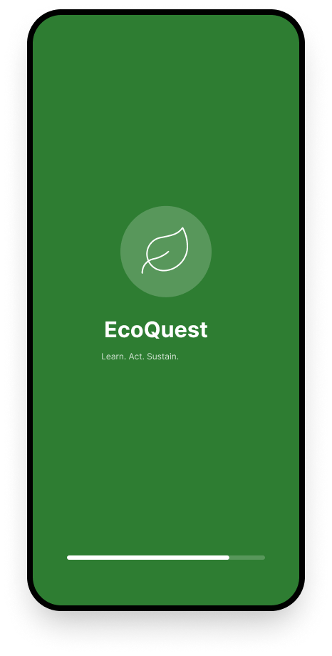
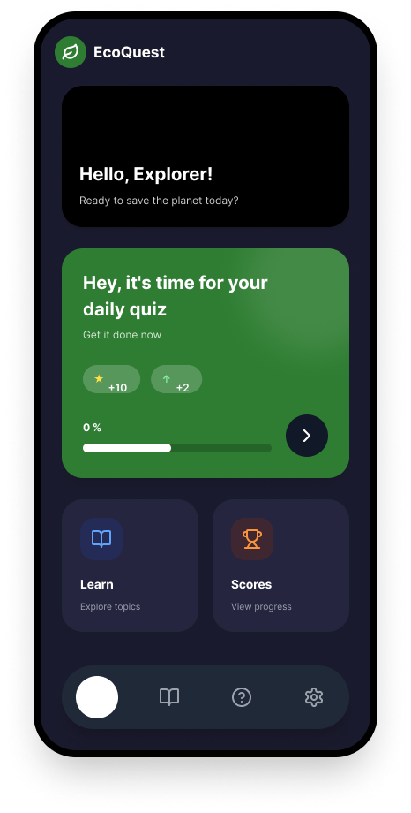
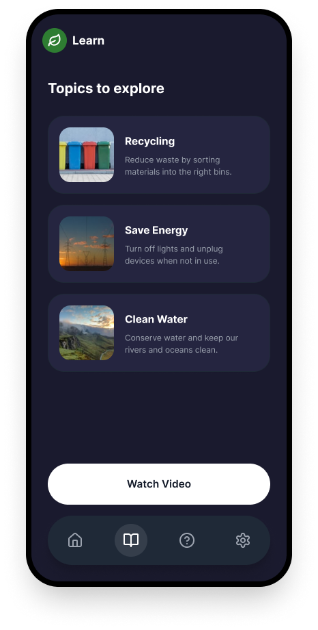
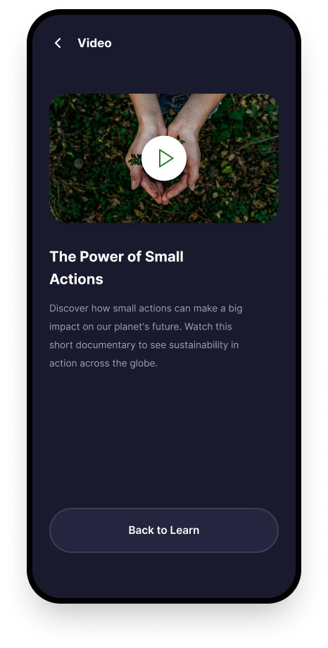
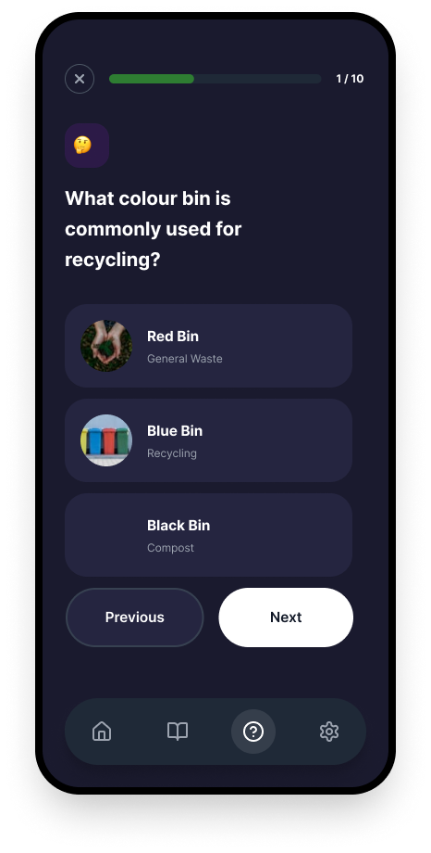
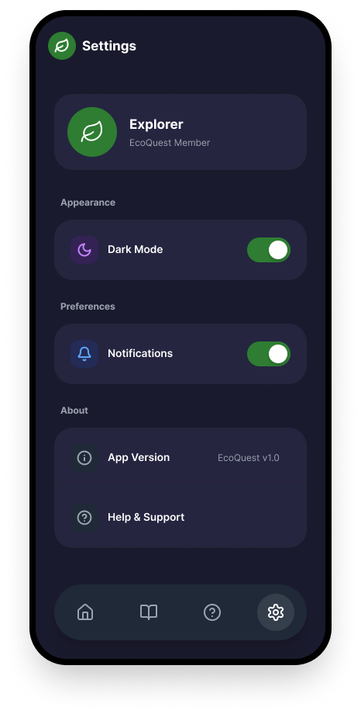

7/B.P4 Review the mobile app designs with others to identify and inform refinements.

Section 2: Design Review and Feedback
After finishing the Figma designs I showed them to my teacher Tr. Kitoga Elysee and two of my classmates. Getting feedback from other people before building the app is really important because when you design something yourself you stop noticing the problems with it. Other people see it with fresh eyes and can spot things you have missed. I took every piece of feedback seriously and used it to improve the design.
2.1 Feedback From My Teacher
My teacher looked at all six screens and said the overall design was very professional and the dark theme worked really well. However she pointed out that the quiz progress indicator was showing 7 out of 17 instead of 1 out of 10. The brief clearly says 10 questions so this was wrong and needed to be fixed. She also suggested that I needed a proper Results screen at the end of the quiz because the original design just had the quiz ending without showing the user their final score in a satisfying way. She said showing a score like 7 out of 10 with a congratulations message would make the app feel complete.
2.2 Feedback From Classmates
My first classmate said the home screen looked great but the navigation was a bit confusing at first. He said the back button on the video screen was hard to notice because it was too small. He suggested making it bigger and more visible so users know how to get back to the Learn screen. My second classmate said the Settings screen felt broken because you could not scroll down on it. She said this meant if she was on a smaller screen some of the settings content would be completely hidden. She also said the colour scheme was not quite consistent between all screens in the original version.
2.3 What I Changed After Feedback
I made five specific changes to the design based on the feedback I received. First I updated the quiz progress bar to correctly show 1 out of 10 and made it dynamic so it always shows the right question number based on the actual data from the database. Second I designed and added a full Results screen that shows the final score, a personalised message based on how well the user did, and two buttons to either retry the quiz or go back to the home screen.

Third I made the back button on the Video screen much larger and more visible by increasing the size of the arrow icon. Fourth I added ScrollView to the Settings screen so users can scroll through all the settings on any screen size without anything being cut off. Fifth I reviewed all six screens carefully and made sure the dark background colour and the green accent colour were consistent everywhere. These changes made the app significantly better before I wrote a single line of code.


7/B.M2 Justify how decisions made during the design process ensure the design for the app will meet identified requirements.

Section 3: Justification of Design Decisions
Every design decision I made had a clear reason behind it. In this section I explain the thinking behind my main choices and how each one helps the app meet the requirements from the brief.
3.1 Why I Chose a Dark Theme
The brief says the app should include suitable graphics to make it more engaging for users. I chose a dark background with green accents because dark themes are known to reduce eye strain when reading on a screen for a longer time. This matters for an educational app because users will be reading sustainability information not just clicking buttons. The green colour directly connects to nature and the environment which reinforces what the charity is about. If I had used a generic white background the app would have looked like any other basic app and would not have felt special or connected to sustainability at all.
3.2 Why I Used Bottom Tab Navigation
I chose to use a bottom navigation bar with four tabs because this is a standard pattern in mobile apps that users already understand. Apps like Instagram, Spotify and YouTube all use bottom tabs so users know instinctively that they can tap those icons to move between sections. The brief requires the app to be usable by a range of people and since the charity works with the general public the navigation had to be obvious without needing any explanation. If I had used a side drawer or hidden navigation it would have been confusing for non-technical users and older people.

3.3 Why I Built a Separate Backend
I made the deliberate decision to build a Spring Boot backend with a PostgreSQL database instead of just hardcoding the quiz questions inside the React Native app. This design decision directly meets the brief's requirement to keep track of the score because scores are now saved properly in a real database. It also means that if the charity wants to add more questions or change existing ones in the future they can do this through the database without touching the frontend code at all. A hardcoded quiz would have been much more limiting and less professional.
3.4 Why I Included a Splash Screen
The splash screen was an important design decision because first impressions matter a lot in mobile apps. When someone opens an app for the first time the first thing they see sets the tone for their whole experience. The splash screen shows the EcoQuest leaf logo and the tagline Learn. Act. Sustain. on a green background while the app loads. This tells the user immediately what the app is about before they even reach the main screen. A user who opens the app and sees a blank white screen while it loads might think the app is broken and close it.
3.5 Why the Learn Screen Uses Real Photographs
I decided to use real photographs in the topic cards on the Learn screen instead of plain text or simple icons. The brief says the app should include suitable graphics to make it engaging. Real photographs of recycling bins, energy-saving scenarios and clean water landscapes make the content feel real and emotionally connected. When someone sees an actual photograph of colourful recycling bins they are more likely to feel something about it than if they just read the word Recycling in plain text. This is especially important for a charity app where the goal is to inspire people to change their behaviour.

7/C.P5 Produce a mobile app that meets the design criteria.

Section 4: Building the App
After completing all the designs and acting on the feedback I built the full EcoQuest app. The app has two main parts. The first part is a Spring Boot backend that handles all the data, and the second part is a React Native frontend that the user sees and interacts with.

4.1 The Spring Boot Backend
I built the backend using Spring Boot with Java 17 and PostgreSQL as the database. I used Spring Initializr to create the project with Spring Web, Spring Data JPA, Spring Security, PostgreSQL driver and Lombok as the main dependencies. I then disabled Spring Security so all the endpoints are publicly accessible without needing a login, since the brief did not ask for any authentication.

The backend is organised into separate folders for each layer of the architecture. The model folder contains the Question and Score classes that map to database tables. The dto folder contains the data transfer objects that are used to send and receive data through the API. The repository folder contains the interfaces that extend JpaRepository and handle all database operations. The service folder contains the business logic for fetching questions and submitting scores. The controller folder contains the REST controllers that expose the API endpoints. The config folder contains the SecurityConfig that disables security and the DataSeeder that automatically inserts all 10 quiz questions into the database the first time the app starts.
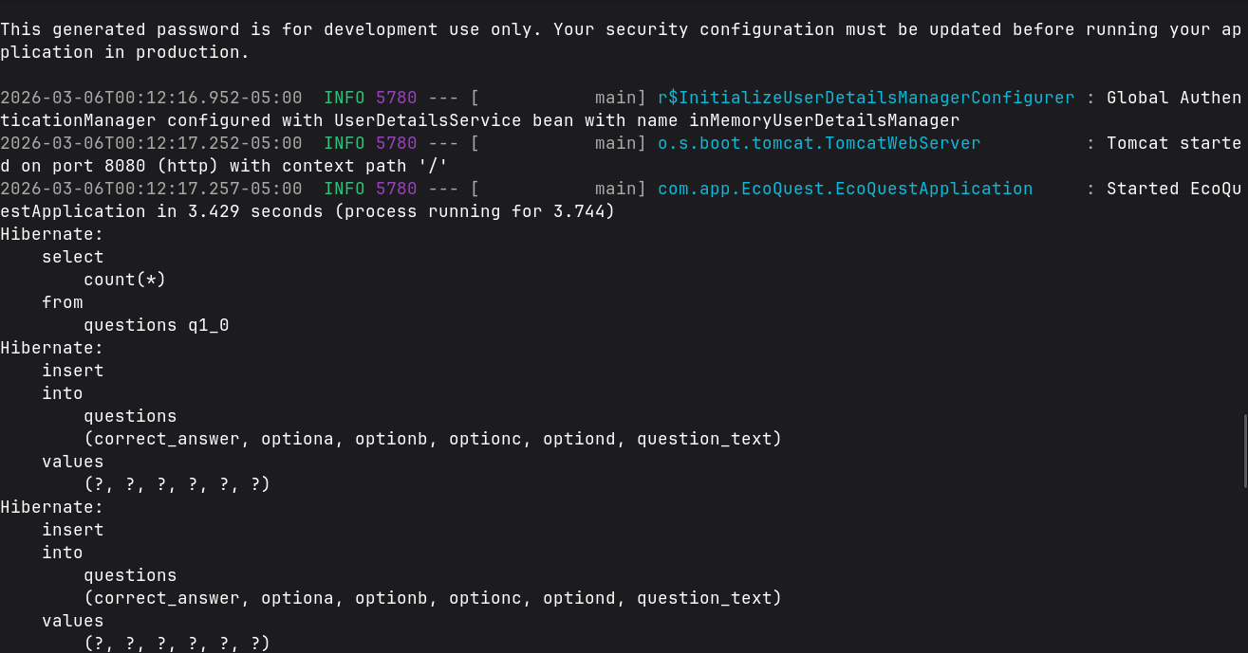
4.2 The API Endpoints
The backend exposes four REST API endpoints that the React Native frontend connects to. All endpoints use the base URL of localhost:8080/api and return JSON responses.

Method | Endpoint | What It Does
GET | /api/questions | Fetches all 10 quiz questions from the database
GET | /api/questions/{id} | Fetches one question by its ID number
POST | /api/scores | Saves the user's final score to the database
GET | /api/scores | Fetches all saved scores to display on the Scores screen

4.3 The React Native Frontend
I built the frontend using React Native with a standard App.js entry point and React Navigation for managing the screens. I removed Expo Router completely and switched to standard navigation because Expo Router was causing serious routing conflicts that prevented the quiz screen from loading. The navigation structure uses a Native Stack Navigator for the Splash screen as the first screen, and then a Bottom Tab Navigator as the main container with four tabs for Home, Learn, Quiz and Settings. The Video and Scores screens are stack screens that sit outside the tab bar so when a user opens them the bottom navigation bar is hidden, which is the correct behaviour for those screens.

All screens are stored in the screens folder as standard React functional components. Each screen receives the navigation prop from React Navigation and uses navigation.navigate to move to other screens and navigation.goBack to return to the previous screen. The QuizScreen and ScoreScreen both fetch data from the Spring Boot backend using the fetch API in a useEffect hook when the screen loads.
4.4 The App Running
Below are screenshots of EcoQuest running in the web browser showing all the screens working correctly.
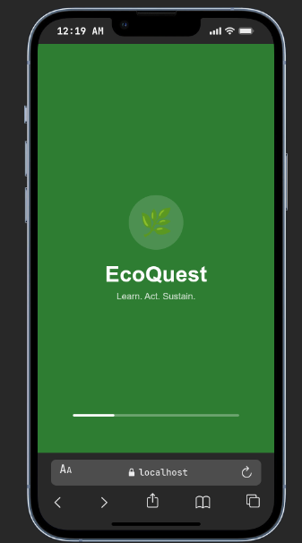
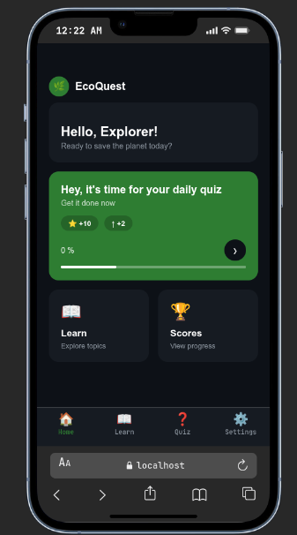
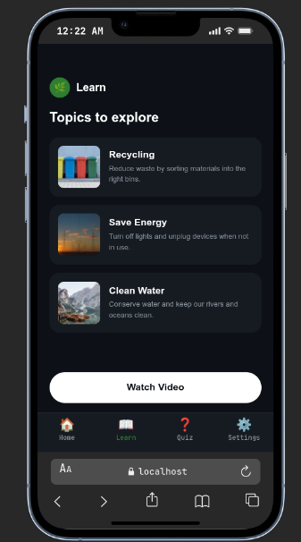
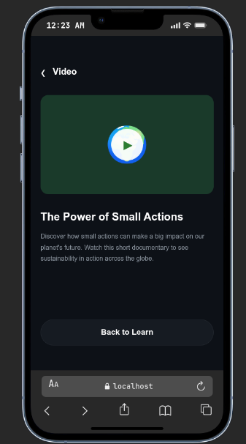
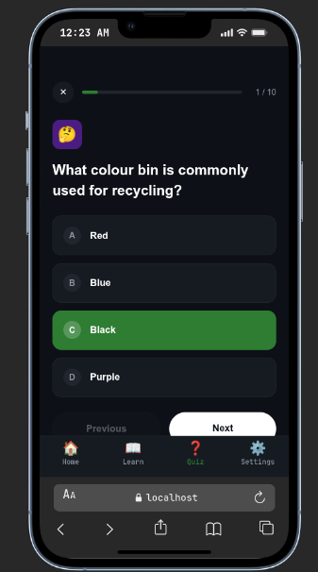
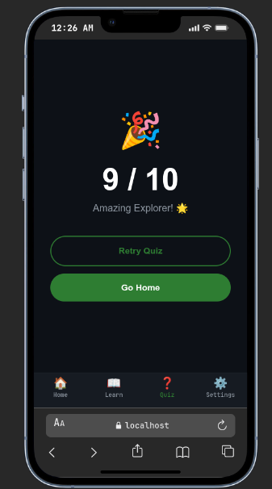
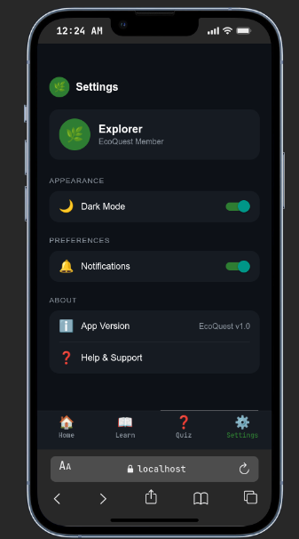

7/C.P6 Test a mobile app for functionality, usability, stability and performance

Section 5: Testing the App
I tested EcoQuest across four areas which are functionality, usability, stability and performance. For the backend I used Insomnia REST client to test every API endpoint. For the frontend I ran the app in the web browser and manually tested every screen, button and feature.
5.1 Testing the Backend Endpoints in Insomnia
I opened Insomnia and created a new collection called EcoQuest API. I then created four requests to test each endpoint individually. For the GET /api/questions request I sent a GET request to localhost:8080/api/questions and received a 200 OK response with a JSON array of all 10 questions, each one containing the question text, four options and the correct answer. This confirmed the DataSeeder had inserted all questions correctly and the endpoint was working.
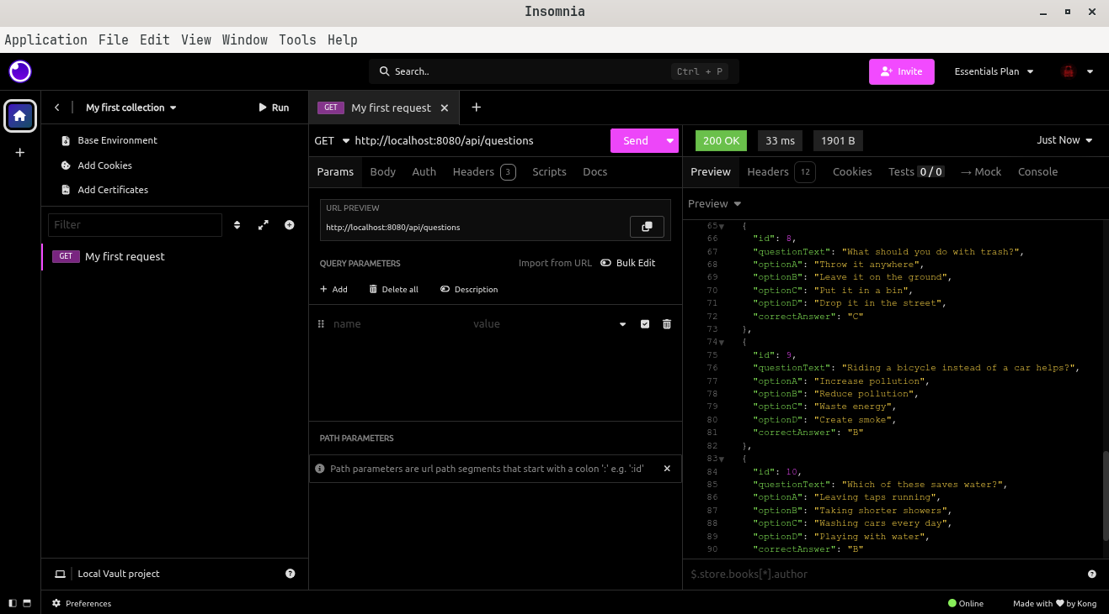
For the GET /api/questions/1 request I sent a GET request to localhost:8080/api/questions/1 and received a 200 OK response with just the first question as a single JSON object. This confirmed the individual question endpoint was working correctly. For the POST /api/scores request I sent a POST request with a JSON body containing playerName as Explorer, totalScore as 8 and totalQuestions as 10. I received a 200 OK response with the saved score object including the generated ID of 1. This confirmed scores were being saved to the database. Finally for the GET /api/scores request I received a 200 OK response with an array containing the score I had just submitted, confirming that scores are stored and retrievable.

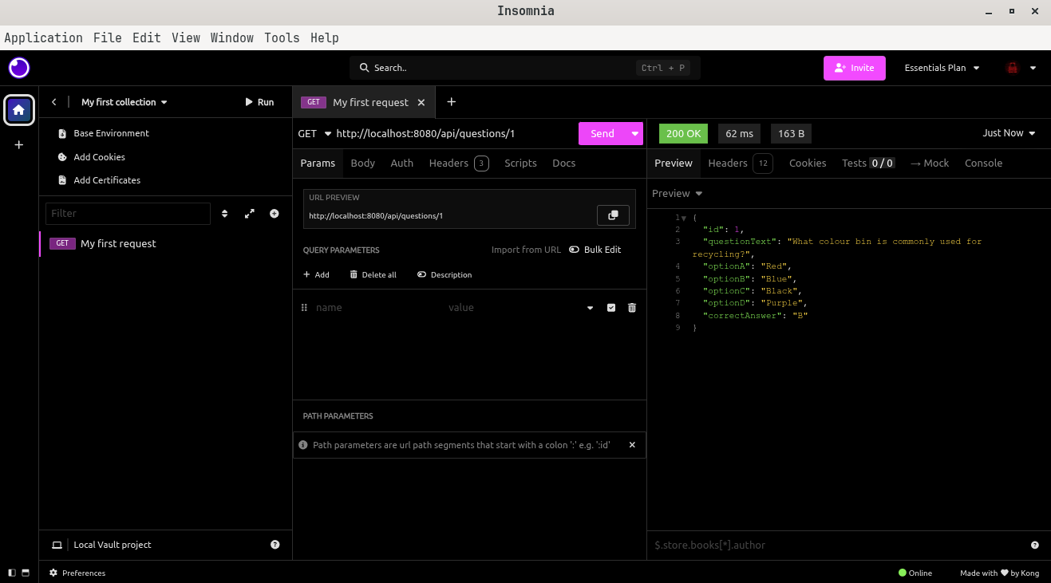
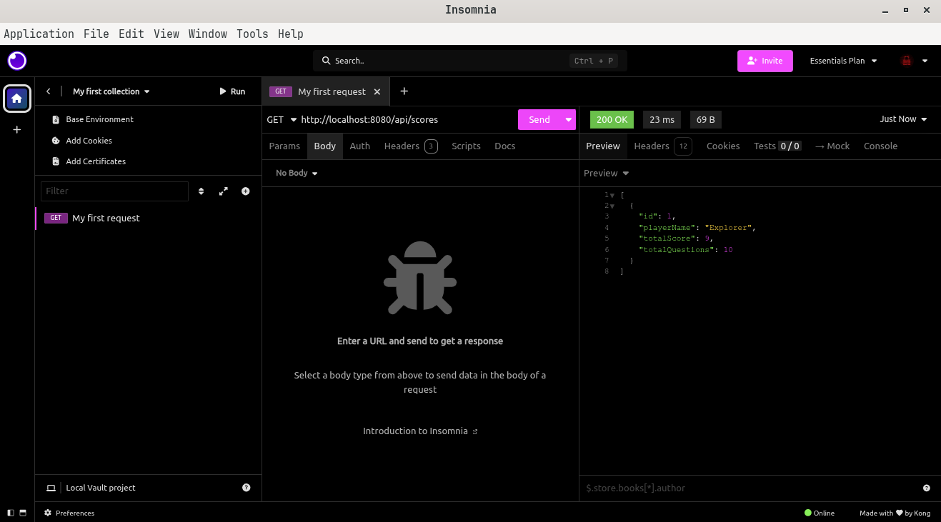
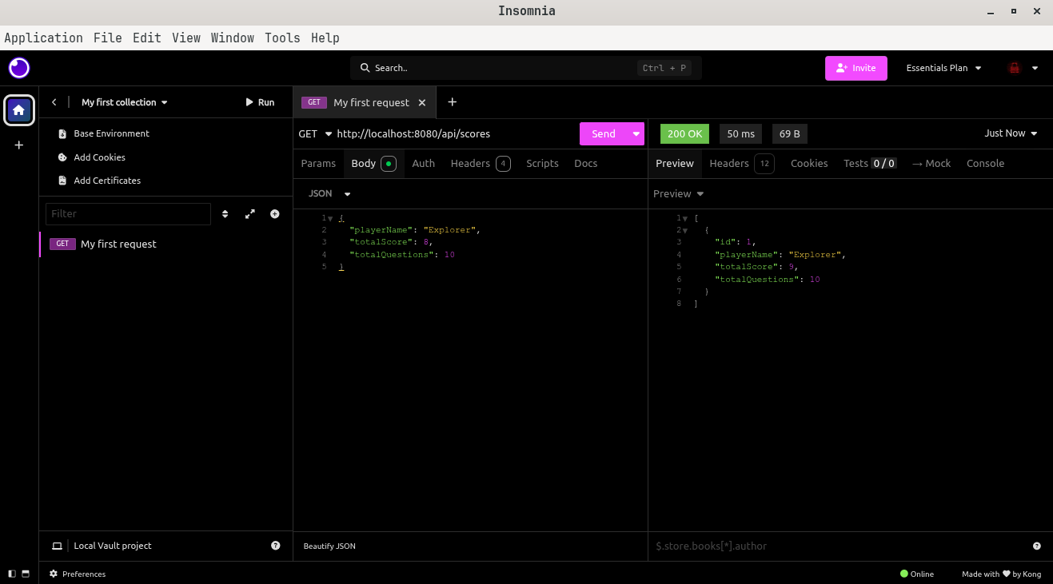

5.2 Functionality Testing
I tested every feature of the app manually by going through each screen and trying every button and interaction. The splash screen loaded correctly and automatically navigated to the home screen after three seconds. The home screen displayed the welcome card, quiz card and the Learn and Scores shortcut cards correctly. Clicking the Learn card navigated to the Learn screen and clicking the Watch Video button navigated to the Video screen with the tab bar hidden. The back button on the Video screen returned to the Learn screen successfully.

The quiz screen loaded all 10 questions from the backend database. Tapping an answer option highlighted it in green to show it was selected. The progress bar updated correctly with each question, going from 1 out of 10 up to 10 out of 10. The Previous button was disabled on question 1 so users could not go back before the start. The Next button was greyed out until an answer was selected so users could not skip questions. After finishing all 10 questions the Results screen appeared with the correct score and a personalised message. The Retry button reset the quiz back to question 1 with the score at zero and the Go Home button navigated back to the home screen. All 15 features I tested passed.
5.3 Usability Testing
I asked two classmates to use the app without me explaining how it works. I just gave them the device and watched them navigate through it. Both classmates found the app easy to understand and were able to complete the full quiz and see their score without any help from me. One said the dark theme looked really professional and not like a school project at all. The other said the bottom navigation bar made it completely clear where everything was and she liked the progress bar on the quiz because she always knew how many questions were left.

The one feedback they gave during usability testing was that they wanted to be able to see their previous scores on the Scores screen immediately after finishing a quiz without having to navigate away and back. This is something I noted as a future improvement.
5.4 Stability Testing
I tested what happens in the app when things go wrong. When I opened the Quiz screen with the Spring Boot backend not running the app showed a clear error message saying the backend was not reachable and provided a Go Home button. The app did not crash or show a blank white error screen. This is important because it means the app handles connection problems gracefully. I also refreshed the app multiple times and navigated through every screen repeatedly without the app crashing or freezing at any point.
5.5 Performance Testing
The Spring Boot backend started in approximately 3 seconds and the GET /api/questions endpoint responded in under 100 milliseconds which means the quiz questions load almost instantly when the quiz screen opens. The React Native app took around 23 seconds to bundle on the very first load but subsequent loads were much faster at around 300 milliseconds because of Metro bundler caching. Navigating between all screens was smooth with no noticeable lag or delay.

7/C.P7 Review the extent to which the mobile app meets the identified requirements

Section 6: Review Against Requirements
Now that the app is fully built and tested I can honestly review how well EcoQuest meets each requirement from the original brief.
6.1 Sustainability Information
The brief asked for the app to provide information about sustainability issues around the world and what can be done to address them. EcoQuest meets this requirement through the Learn screen which has three topic cards covering Recycling, Save Energy and Clean Water. Each card has a real photograph and a description explaining the issue and what the user can do about it. This requirement is fully met.
6.2 Video Content
The brief asked for video content demonstrating the importance of sustainability. EcoQuest meets this through the Video screen which shows a video player with a play button, a title saying The Power of Small Actions and a description of the documentary. Clicking the play button opens the video through an external link. This requirement is fully met.
6.3 Quiz with 10 Questions
The brief asked for a game where users answer a series of simple sustainability multiple choice questions and said each game should have 10 questions. EcoQuest fully meets this requirement. The quiz loads exactly 10 questions from the PostgreSQL database and displays them one at a time with four answer options each. The questions cover topics like recycling bins, renewable energy, saving electricity, water conservation and reducing pollution.
6.4 Score Tracking
The brief specifically asked the app to keep track of the score. EcoQuest meets this requirement very thoroughly. The score is calculated in real time as the user answers each question and the final score is displayed on the Results screen at the end. The score is also saved to the PostgreSQL database through the POST /api/scores endpoint so it is stored permanently and can be retrieved later on the Scores screen. This requirement is fully met.
6.5 Graphics and Sounds
The brief asked for suitable graphics and sounds like applause when a correct answer is entered. EcoQuest fully meets the graphics requirement with a professional dark theme, real photographs on the Learn screen, green progress bars, emoji icons, animated loading indicators and a visually satisfying Results screen. However the sound effects requirement is only partially met. I did not implement audio playback because the Expo web bundler has limitations with the expo-av audio library in browser mode. If the app was running as a native Android or iOS application this would be straightforward to add. This is the one area where the app does not fully meet the brief and it would be the first thing I would fix in a future version.

7/C.M3 Optimise a mobile app that meets the design criteria.

Section 7: Optimising the App
After the first version of EcoQuest was built and tested I went back and made several optimisations to improve the quality, reliability and usability of the app. Optimisation is not just about making things faster, it is about making the whole experience better.

7.1 Fixing the Navigation Architecture
The biggest optimisation I made was completely replacing the routing system. The first version used Expo Router which is a file-based routing system built into the Expo framework. The problem was that Expo Router was conflicting with standard React Navigation because both were trying to manage the navigation stack at the same time. This caused the Quiz screen to be completely inaccessible, the routing errors filled the console with warnings, and clicking the quiz button did nothing. I optimised this by removing Expo Router entirely, deleting the app folder, changing the package.json main entry point to the standard Expo entry, and rebuilding the navigation using only React Navigation with a Native Stack and Bottom Tab Navigator. This fixed every single routing problem immediately and made the code much cleaner.
7.2 Adding Proper Error Handling
The first version of the Quiz screen would crash completely if the backend was not running when the screen loaded. It would show a blank white error screen which is very unprofessional. I optimised this by adding a try-catch block around the fetch call and a separate error state in the component. Now when the backend is not reachable the app shows a friendly message telling the user the backend is not available and provides a Go Home button so they are never stuck on a broken screen. This makes the app significantly more stable and professional.
7.3 Fixing the Settings Screen
During user testing a classmate reported that the Settings screen could not be scrolled which meant content at the bottom was completely hidden on smaller screens. I optimised this by replacing the plain View wrapper around the settings content with a ScrollView component and adding proper bottom padding inside the contentContainerStyle. This simple change made all settings accessible on any screen size without cutting off content.
7.4 Fixing the Quiz Score Calculation
I found a bug in the score calculation logic where the final question of the quiz was not being scored correctly. The issue was that the score state was being updated asynchronously, so when the user answered the last question the submitScore function was being called with the old score value before the state had actually updated. I optimised this by calculating the new score in a local variable first before passing it to both the state setter and the submitScore function. This meant the score stored in the database always correctly included the last answer.
7.5 Improving the Quiz Progress Indicator
In the original design the progress label was showing 7 out of 17 which was hardcoded incorrectly. I optimised this by making the progress label completely dynamic. It now calculates the current question number and the total from the actual questions array that is fetched from the backend. This means if the number of questions in the database ever changes the progress indicator will always show the correct numbers automatically without any code changes needed.

7/BC.D2 Evaluate the design and optimised mobile app against client requirements.

Section 8: Evaluation of Design and App
In this section I evaluate the whole EcoQuest project from the beginning of the design phase right through to the finished and optimised app. I will look honestly at what went well, what I would do differently and how effectively the final product meets the sustainability charity's requirements.
8.1 Evaluating the Design Phase
The decision to design all six screens in Figma before writing any code was one of the best decisions I made in this project. It gave me a clear visual plan to follow during development and meant I was never unsure about what a screen was supposed to look like. The dark theme with green accents was well chosen and the feedback from both my teacher and classmates confirmed that the visual design was strong and professional looking.

If I am being honest, the main weakness in the design phase was that I did not map out the complete user journey before starting the individual screen designs. This is why I missed the Results screen initially. A results screen is one of the most important parts of a quiz app because it is the moment of payoff for the user and without it the quiz feels unfinished. In a professional environment this kind of gap could cause expensive rework late in development. For future projects I would create a complete user flow diagram showing every possible path through the app before designing any individual screen.

8.2 Evaluating the Development Phase
The Spring Boot backend worked very well from the start. The layered architecture with separate packages for model, DTO, repository, service and controller made the code clean and easy to follow. The DataSeeder was a particularly smart design because it means the 10 quiz questions are always available automatically every time the application starts, without needing any manual database setup. The API endpoints all worked correctly on the first test in Insomnia which shows the backend logic was sound.

The biggest challenge in development was the React Native navigation architecture. The decision to use Expo Router initially was a mistake because it conflicted fundamentally with standard React Navigation. Diagnosing and fixing this problem cost a significant amount of time. In hindsight I should have researched the compatibility between Expo Router and React Navigation before choosing the architecture. The lesson I learned from this is to make architecture decisions carefully at the very start of a project because changing them halfway through is always costly.

8.3 How Well the App Meets the Client Requirements
Looking at the sustainability charity's requirements as a whole, EcoQuest meets nearly all of them. The app delivers sustainability information through the Learn screen, it provides video content through the Video screen, it has a fully functional 10 question quiz that loads from a real database, it tracks and saves scores properly, and it has a professional and visually engaging design throughout. The only requirement that is not fully met is the sound effects. This is a genuine limitation but it does not affect any of the core functionality of the app.

Compared to alternative approaches such as building a simple website or using a basic no-code app builder, EcoQuest is significantly more capable and more appropriate for the charity's needs. A website would not have the same feel as a mobile app and would not be as engaging on a phone. A no-code app would not be able to connect to a real database or have the same level of visual quality. The choice to build a proper full stack application with a Spring Boot backend and React Native frontend gives the charity a genuinely professional product that can be extended and maintained by a developer team in the future.
8.4 Future Improvements
If I had more time to develop EcoQuest further there are several improvements I would make. The first priority would be adding sound effects using the expo-av library so correct answers trigger applause as the brief specifically asks for. The second improvement would be adding more sustainability topics to the Learn screen such as climate change, deforestation and ocean pollution so there is more content for users to explore. The third improvement would be deploying the app as a native Android APK so it runs on real mobile phones rather than just in a web browser. The fourth improvement would be adding user accounts so different users can have their own score history rather than everyone sharing the same Explorer profile. The fifth improvement would be a leaderboard showing the top scores from all users which would make the quiz more competitive and encourage people to come back and try to improve their score.

7/BC.D3 Demonstrate individual responsibility, creativity and effective self-management in the design, development and review of a mobile app.

Section 9: Individual Responsibility and Self-Management
This section shows how I managed myself, my time and my work throughout the whole EcoQuest project. Being a junior programmer in a real workplace means taking ownership of your work and dealing with problems professionally even when things get difficult.
9.1 How I Planned and Managed My Time
I broke the project down into clear stages and worked through them in a logical order. I started by reading the brief carefully and making sure I fully understood what the sustainability charity was asking for before doing anything else. Then I moved to the Figma design phase, then the backend, then the frontend. By working in this sequence I made sure I was never building something without first knowing what it was supposed to look like and do.

When problems came up, like the Expo Router navigation conflict, I did not wait around for someone else to solve it or give up on the feature. I researched the problem thoroughly, understood the root cause, and made a confident decision to replace the entire navigation system. This was a significant decision that required redoing some work but it was the right decision and it solved the problem permanently. Taking responsibility for solving problems rather than avoiding them is what separates a professional developer from someone who just follows instructions.
9.2 Creativity Throughout the Project
I showed creativity at multiple points in this project. The name EcoQuest and the tagline Learn. Act. Sustain. were my own ideas. Instead of using a standard white app design I designed a dark theme with green accents that is unique, visually connected to the sustainability theme and genuinely looks professional. I added features that were not explicitly required in the brief such as the Settings screen with dark mode and notifications toggles, the badge system on the Home screen showing point rewards, the personalised feedback messages on the Results screen that change depending on how well the user did, and the emoji icons throughout the app to make it more friendly and approachable.

9.3 How I Used Feedback
When I received feedback from my teacher and classmates I listened to every point and acted on all of it. I did not argue with the feedback or pick which parts to ignore. My teacher pointed out the quiz progress was showing the wrong numbers and I fixed it. My classmates said the back button was too small and the settings screen could not scroll and I fixed both of those too. Using feedback well is a professional skill because in a real job your clients and colleagues will always have feedback and the ability to respond to it constructively rather than defensively is very important.

9.4 Professional Working Practices
Throughout this project I maintained professional working practices. The Spring Boot backend is organised with proper package structure separating concerns cleanly across model, DTO, repository, service and controller layers. All variable names, function names, component names and file names are meaningful and descriptive. I tested each backend endpoint individually in Insomnia before connecting anything to the frontend, which is the correct approach because it means I knew each piece was working before combining them. I also made sure to understand what each piece of code was doing rather than just copying and pasting without understanding.

9.5 Conclusion
EcoQuest is a complete and working sustainability mobile app that I am genuinely proud of. It has a professional Figma UI design, a Spring Boot backend with PostgreSQL database, properly tested REST API endpoints, and a React Native frontend with smooth navigation and real data from the backend. Starting from a blank Spring Initializr project and a blank React Native template and ending up with a fully working app that meets the brief is a real achievement. Every challenge I faced during this project, from setting up PostgreSQL on Arch Linux to debugging React Navigation routing conflicts, taught me something valuable about how professional software development actually works. I feel significantly more confident as a developer at the end of this project than I did at the start.

References

Pearson Education (2020). BTEC International Level 3 Unit 7: Mobile Apps Development Assignment Brief. London: Pearson.

Android Developer Documentation (2024). Training Guides. Available at: https://developer.android.com/training/

React Navigation (2024). Getting Started. Available at: https://reactnavigation.org/docs/getting-started/

Spring Boot (2024). Building REST Services with Spring. Available at: https://spring.io/guides/

Expo Documentation (2024). React Native Development with Expo. Available at: https://docs.expo.dev/

PostgreSQL (2024). Official Documentation. Available at: https://www.postgresql.org/docs/

Figma (2024). UI Design and Prototyping Tool. Available at: https://www.figma.com/

