ZEPTRIX CRM
FIELD GUIDE
A modern operating playbook for sales teams
Build pipeline discipline, protect every follow-up, keep customer context together, and forecast with confidence.
01 ACT  Never lose the next action | 02 KNOW  Keep customer context close | 03 FOCUS  Forecast what matters

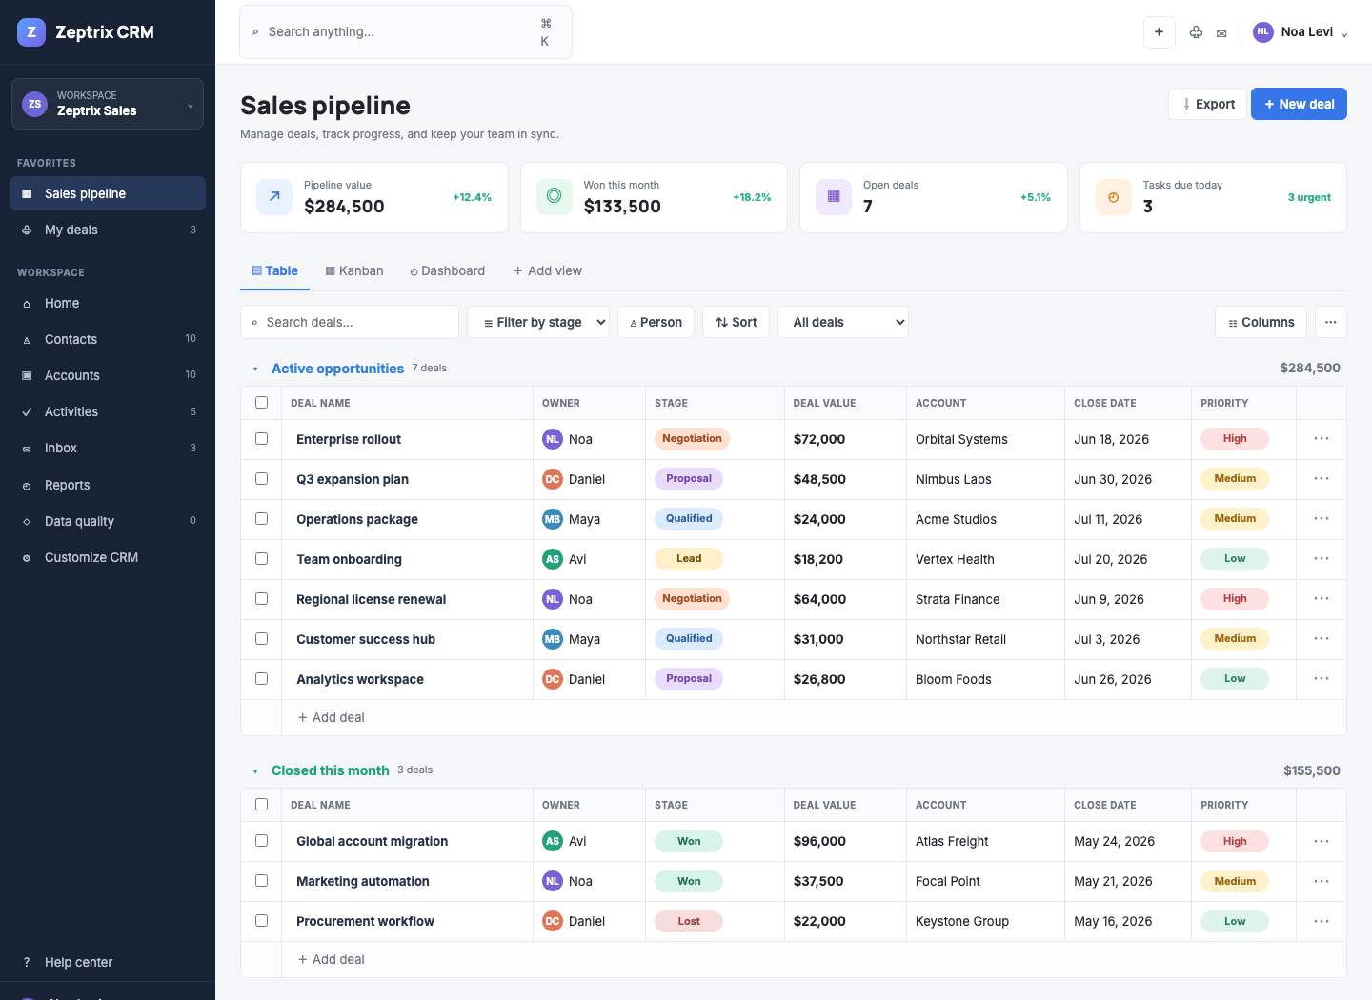
Zeptrix CRM pipeline workspace
LIVE WORKSPACE zeptrix.io/your-new-crm/
VERSION 1.1 / MAY 2026

START HERE

Use the CRM like a sales operating system
  - A short guide designed around the actions your team performs every day.
HOW THIS GUIDE IS DIFFERENT
The strongest CRM onboarding guides from monday CRM, HubSpot, Pipedrive, Zoho, Freshsales, Dynamics 365, Close, Copper, Insightly, and Zendesk Sell teach a repeatable operating flow first. This guide follows that model: decide what needs attention, take the next action, update the record, and review the forecast.

Your guide at a glance
SECTION | USE IT WHEN | OUTCOME
01 First 10 minutes | You are opening Zeptrix CRM for the first time. | Start working without a long setup session.
02 Daily sales motion | You need a repeatable representative routine. | Move from tasks to deals with clear priorities.
03 Pipeline control | You create, update, or move opportunities. | Keep stages and close dates credible.
04 Follow-up discipline | You schedule calls, meetings, emails, and reminders. | Prevent quiet deals from slipping away.
05 Customer context | You need the latest interaction before contacting a buyer. | Enter every conversation prepared.
06 Data quality | You import records or review duplicates. | Keep pipeline reports trustworthy.
07 Forecasting | You manage team performance and expected revenue. | Focus attention where intervention matters.
08 Workspace setup | You tune views, fields, and probabilities. | Fit the CRM to your sales method.

The operating rule
NO IDLE DEALS
Every meaningful active opportunity should have one accountable owner, one realistic close date, one accurate stage, and one visible next action.

Open the live CRM https://zeptrix.io/your-new-crm/

01 / FIRST 10 MINUTES

Start with signal, not setup
  - Use this five-step path to become productive immediately.
1 | Open Sales pipeline. Scan active opportunities in Table view.
2 | Choose a saved view. Use Closing soon, High priority, or My open deals to narrow attention.
3 | Open one important deal. Review its stage, value, close date, notes, communication, and tasks.
4 | Create the next action. Add a follow-up, call, email, or meeting with an owner and due date.
5 | Check Reports. Review weighted forecast, win rate, and closing-soon opportunities.


Table view: a compact operating view for owner, stage, value, account, close date, and priority.
YOU ARE READY WHEN
You can identify the most important deal, explain its current state, and see the next action without leaving the workspace.

02 / DAILY SALES MOTION

Run a disciplined sales day
  - The CRM should reduce decisions about where to start, not create more administration.

Representative rhythm
08:30 TRIAGE  Open Activities. Complete or reschedule overdue work. | 09:00 FOCUS  Use My open deals and Closing soon to choose priority conversations.
ALL DAY CAPTURE  Log meaningful communication and update stages when buyer reality changes. | 16:30 CLOSE LOOP  Finish completed tasks and create the next action for active deals.

Manager rhythm
MON PIPELINE  Review high-priority and closing-soon opportunities. | MIDWEEK COACH  Check stalled work, task hygiene, and realistic close dates.
FRI FORECAST  Review weighted pipeline, win rate, and owner performance. | MONTHLY CLEAN  Resolve duplicates and tune stage confidence only with evidence.

BEST PRACTICE
Keep the operating routine simple. Contacts, stage, close date, next action, and communication context should stay current before adding more fields or automation.

03 / PIPELINE CONTROL

Keep opportunity truth visible
  - The pipeline is both the team workboard and the foundation for a credible forecast.

Create a deal
1 | Select + New deal. Use the pipeline header or the Add deal row inside a group.
2 | Capture the commercial basics. Enter account, contact, owner, stage, value, close date, priority, and notes.
3 | Save the opportunity. The deal appears immediately in the pipeline and browser-local workspace.

Move a deal forward
A | Use Table view for detail. Open the deal, select Edit deal, update the stage, and save.
B | Use Kanban for speed. Drag a deal card into the stage that matches the customer buying state.

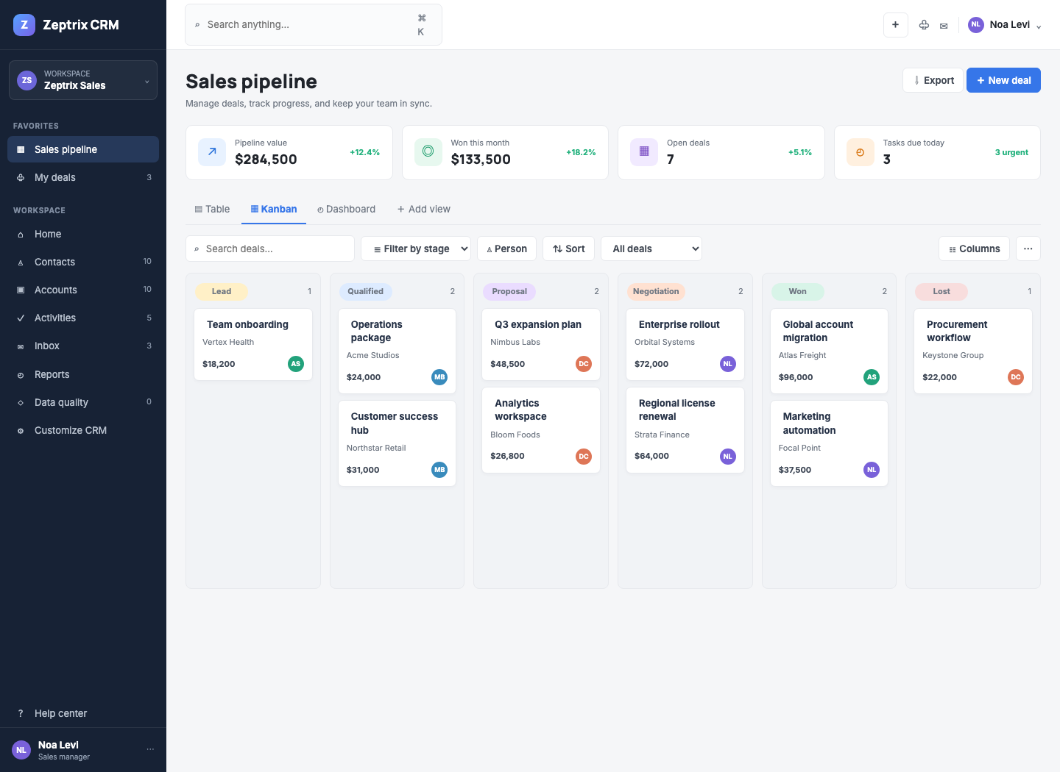
Kanban view: move opportunities through Lead, Qualified, Proposal, Negotiation, Won, and Lost.
AUTOMATION BUILT IN
When a deal enters Proposal from another stage, Zeptrix CRM automatically creates a medium-priority Follow up on proposal task due in three days.

04 / FOLLOW-UP DISCIPLINE

Protect the next action
  - Activities turn a pipeline record into an executable sales plan.

Create an activity
1 | Start from Activities or a deal. Select + New activity, or open the deal drawer and select + Add task.
2 | Name the action clearly. Choose Follow-up, Call, Email, or Meeting; set owner, due date, and priority.
3 | Close the loop. Use the circular control to complete a task or reopen it when needed.

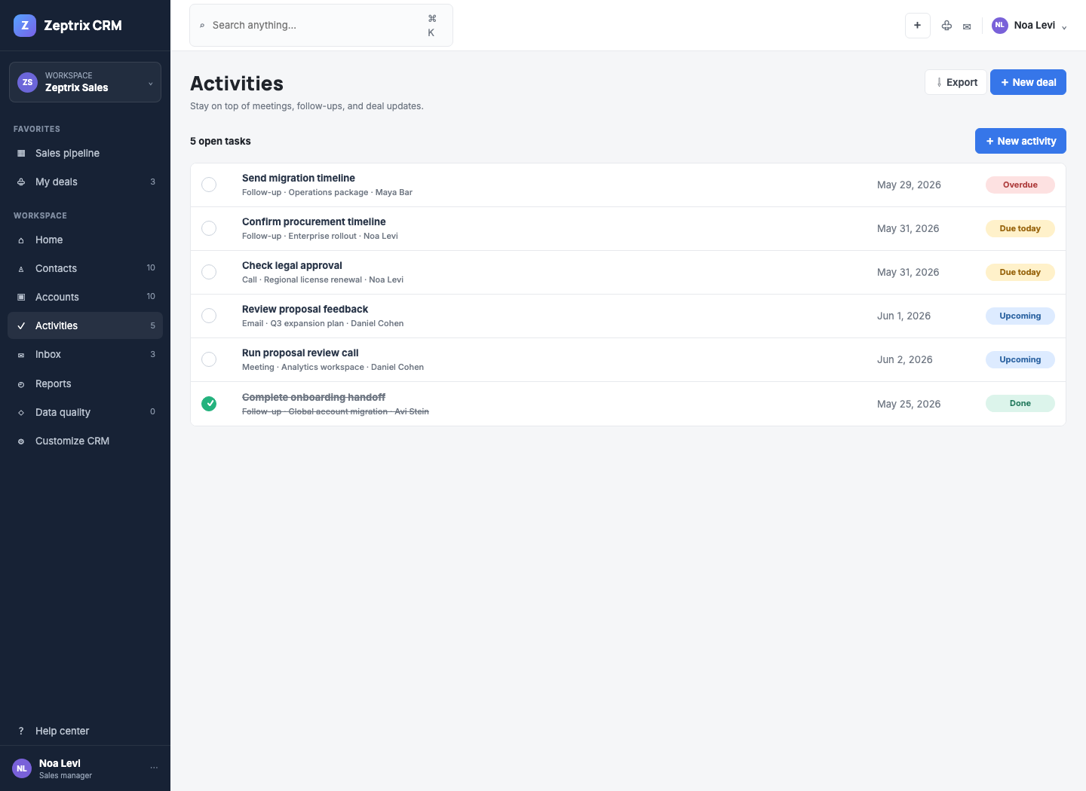
Activities workspace: overdue, due-today, upcoming, and completed work in one queue.

Status language
STATUS | MEANING | EXPECTED ACTION
Overdue | Open task with a due date before today. | Resolve immediately or choose a realistic new date.
Due today | Open activity due today. | Include it in the current work plan.
Upcoming | Open task due later. | Keep scheduled and monitor.
Done | Completed work retained for context. | No action unless the task must be reopened.

05 / CUSTOMER CONTEXT

Enter every conversation prepared
  - Keep communication close to the opportunity so the whole team can act with context.

Log an interaction
1 | Open Inbox or the deal drawer. Select + Log email from the communication area.
2 | Attach it to the correct deal. Choose inbound or outbound, add the subject, and record the message.
3 | Use context before action. Review recent interactions before calling, emailing, or changing a stage.

01 ONE TIMELINE  See communication alongside notes, tasks, and deal state. | 02 FAST HANDOFF  Give the next owner enough context to continue the conversation. | 03 LESS SEARCHING  Reduce time lost across inboxes, notes, and spreadsheets.

CURRENT DEMONSTRATION SCOPE
The browser-based workspace records interactions locally. Production Gmail or Outlook synchronization requires backend OAuth integration.

06 / DATA QUALITY

Protect the numbers you manage
  - Clean records make reports credible and customer context complete.
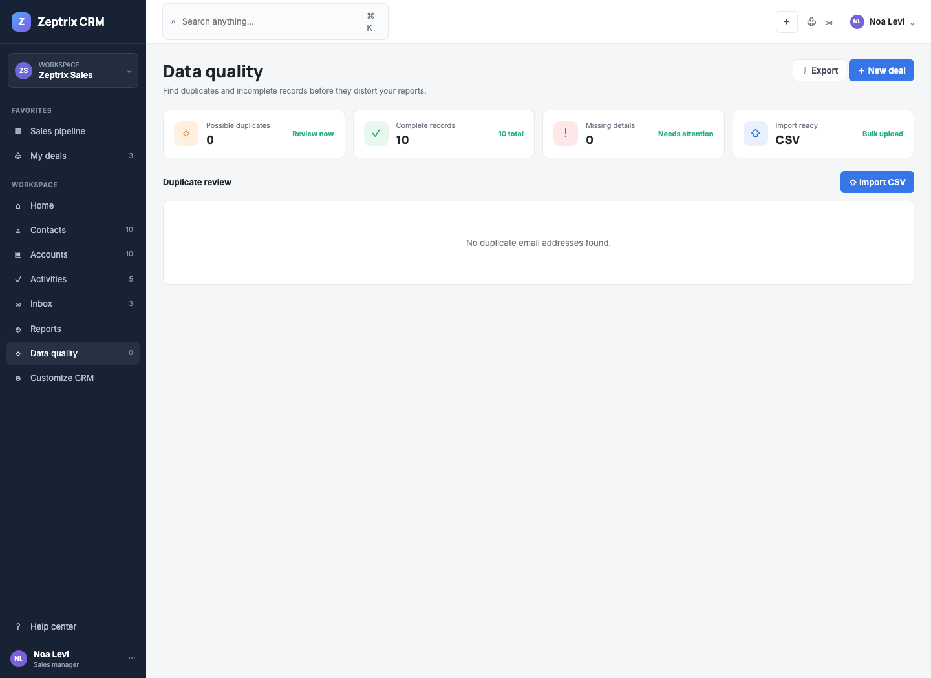
Data quality workspace: review duplicates, record completeness, and CSV import readiness.

Import records
1 | Open Data quality. Select Import CSV.
2 | Paste one deal per line. Use the required field order shown below.
3 | Review after import. Check the pipeline and resolve any new duplicate warnings.

CSV FIELD ORDER
name, account, contact, email, owner, stage, value, close, priority
Website redesign, Acme, Jane Doe, jane@acme.com, Noa Levi, Lead, 18000, 2026-07-15, Medium

Merge duplicates
1 | Review Possible duplicates. Compare records grouped under the same email address.
2 | Select Merge records. Retain one record when the entries represent the same person.
3 | Keep the history. Linked tasks and communication move to the retained record automatically.

IMPORTER NOTE
The current demonstration expects simple comma-separated rows. Fields containing commas are not yet supported.

07 / FORECASTING

Forecast with evidence
  - Use deal value, stage confidence, and closing dates to decide where management attention changes outcomes.
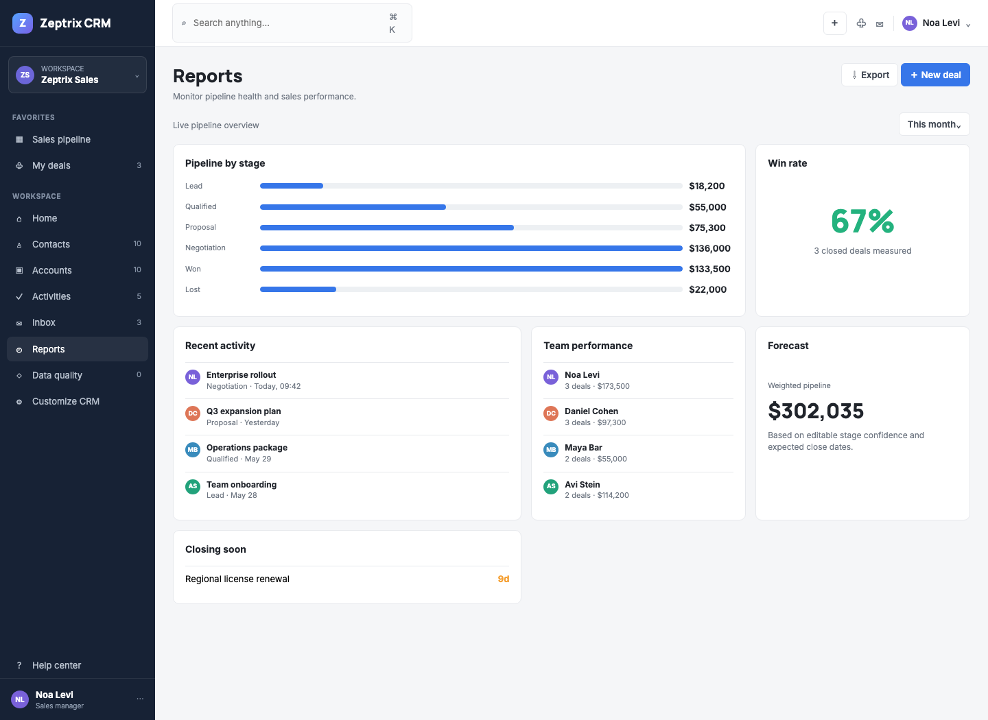
Reports workspace: pipeline by stage, calculated win rate, recent activity, team performance, forecast, and closing-soon deals.

How weighted forecast works
Each opportunity contributes its deal value multiplied by the confidence assigned to its current stage. Adjust the confidence model in Customize CRM only when your team has evidence that the default assumptions need to change.
STAGE | DEFAULT CONFIDENCE | MANAGEMENT INTERPRETATION
Lead | 10% | Interest exists; validate fit and timing.
Qualified | 30% | Need and qualification are established.
Proposal | 55% | Commercial proposal has been shared.
Negotiation | 80% | Terms, procurement, or legal review are active.
Won | 100% | Revenue is confirmed.
Lost | 0% | Opportunity no longer contributes.

Manager questions to ask
- Which closing-soon deal has no visible next action?
- Which negotiation has an optimistic close date but no recent communication?
- Where is pipeline value accumulating without stage movement?
- Which owner needs coaching on task hygiene or deal qualification?

08 / WORKSPACE SETUP

Adapt the CRM without adding clutter
  - Start with an opinionated workspace. Add configuration only when it improves a real workflow.

Useful controls
CONTROL | WHERE TO FIND IT | USE IT FOR
Visible columns | Pipeline toolbar → Columns | Keep Table view focused on the fields needed for the current review.
Saved views | Pipeline toolbar | Switch quickly between All deals, Closing soon, High priority, and My open deals.
Custom fields | Sidebar → Customize CRM | Capture team-specific concepts such as Industry or Lead source.
Stage confidence | Sidebar → Customize CRM | Tune weighted forecast assumptions.
Reset demo data | Sidebar → Customize CRM | Restore the original browser-local workspace.

PRODUCT NOTE
Custom field definitions are retained in workspace settings. Editing values per deal is the next production extension point.

Data ownership
This interactive CRM demonstration stores records in browser localStorage. Changes remain available in that browser until storage is cleared or Reset demo data is selected.

QUICK REFERENCE

Keep the operating standard visible
  - A compact checklist for daily use and team onboarding.

The five-record check
01 OWNER  One person is accountable. | 02 STAGE  Buyer reality is reflected accurately. | 03 CLOSE DATE  Timing is realistic, not aspirational.
04 NEXT ACTION  At least one visible follow-up exists. | 05 CONTEXT  Recent communication is captured.

Common actions
I WANT TO… | GO TO… | THEN…
Create a deal | Sales pipeline | Select + New deal.
Move a deal visually | Sales pipeline → Kanban | Drag the card into the correct stage.
Add a reminder | Activities or deal drawer | Select + New activity or + Add task.
Log customer email | Inbox or deal drawer | Select + Log email.
Import opportunities | Data quality | Select Import CSV.
Resolve duplicates | Data quality | Select Merge records.
Review expected revenue | Reports | Check weighted pipeline and Closing soon.
Export the pipeline | Sales pipeline | Select Export.

Links
Interactive workspace https://zeptrix.io/your-new-crm/
Product overview https://zeptrix.io/your-new-crm.html
FINAL REMINDER
A CRM earns trust when it helps the team act. Keep the workflow current, keep the next action visible, and let reports reflect the work that is actually happening.

