# Plan

|  |  |  |  |  |
| --- | --- | --- | --- | --- |
| # | Description | Source | Duration | Output |
| 1 | Read angular js documentation and review examples | <https://docs.angularjs.org/guide> | 5 days | AngularJS Basics understanding. |
| 2 | Read about nested routing in Angular JS via UI.Router | <http://angular-ui.github.io/ui-router/site/#/api/ui.router> | 1 day | Nested Routing Basics understanding. |
| 3 | Read about restangular | <https://github.com/mgonto/restangular> | 1 day | Rest via Angular Basics understanding. |
| 4 | Read about dependency injection in JavaScript | <http://addyosmani.com/writing-modular-js/> | 2 days | Dependency injection understanding in JavaScript. Ability to compare it with AngularJS approach. |
| 5 | Read About Structuring Angular Application | <https://scotch.io/tutorials/angularjs-best-practices-directory-structure> | 1 day | Understanding of scaling AngularJS applications. |
| **6** | **Create application that has one “Test” module, with one each test entity (controller, service, etc.) in scope of defined structure.** | | | |
| 6 | Read about Gulp | <https://scotch.io/tutorials/automate-your-tasks-easily-with-gulp-js> | 1 day |  |
| **7** | **Add gulp tasks to already created project to concatenate js, run simple server, build SCSS and inject dependencies.** | | | |
| 8 | Read about browserify | <http://www.sitepoint.com/getting-started-browserify/>; <https://lincolnloop.com/blog/untangle-your-javascript-browserify/> | 1 day |  |
| 9 | Read about angular and browserify | <https://blog.codecentric.de/en/2014/08/angularjs-browserify/> | 0.5 days |  |
| **10** | **Refactor project’s dependencies to browserify. Update gulp tasks for browserify integration.** | | | |
| 11 | Read about bower | <http://bower.io/> | 0.5 days |  |
| **12** | **Add bower to product; Use all 3rd parties via bower; Update gulp tasks for bower integration.** | | | |
| **13** | **Implement each of three defined tasks in scope of learned technologies and approaches.** | | | |

Tasks:

1. Angular - Purchases manager task;
2. Angular - Scheduler task;
3. Angular - TODO lists task

# Angular - Purchases manager task

## Requirements   I'm a person who wants to control my business. I want to manage my purchases.    I need simple tool that support me in planning my business purchases.

**Functional requirements**

* I want to be able to create/delete purchase for each day of week:
  + Add by clicking 'Add Purchase'
  + Remove by clicking corresponding 'x' button
* I want to be able to edit purchases by clicking on the corresponding row in table
* Validation rules:
  + All fields are required
  + Price value should be higher than $5

**Technical requirements**

* It should be WEB application
* For the client side must be used: HTML5, CSS3, Bootstrap, JavaScript: AngularJS, UI.Router, Restangular, browserify);
* It should have client side validation in base of Angular JS;
* It should look like on screens (see attached files);
* It should use bower as package manager;
* It should use Gulp as build tool.

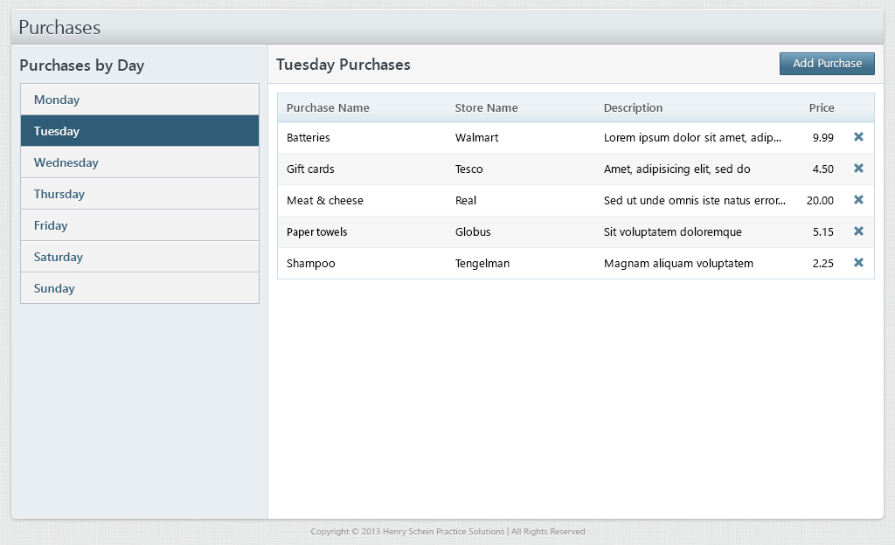

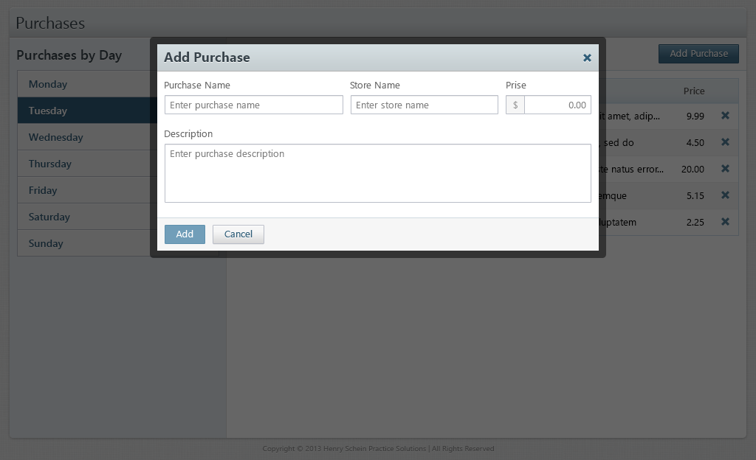

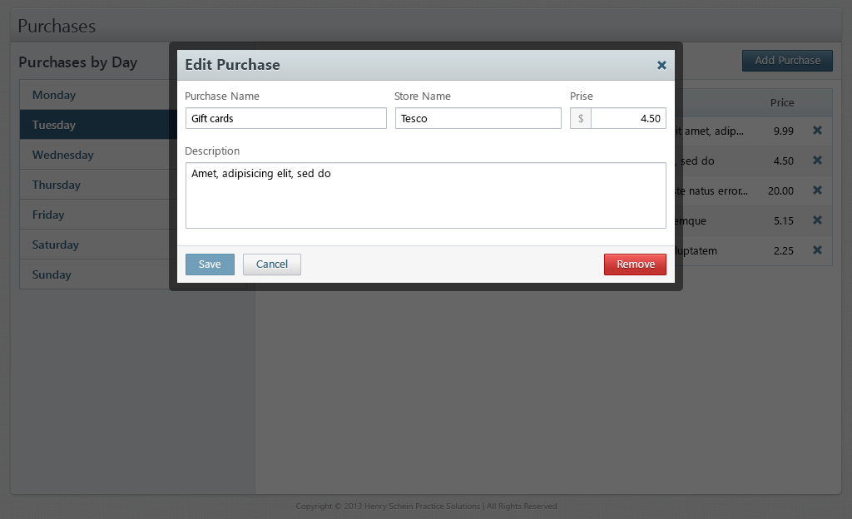

|  |
| --- |
|  |
|  |

**Additional functionality**  
● It should work like one page WEB application and should use AJAX technology, load  
and submit data without reloading a page. Use Restangular and Express for this functionality.  
● It should have unit tests for all functionality.

# Angular - Scheduler task

## Requirements   I'm a person who passionate about own productivity and punctuality. I want to schedule my tasks and see them in calendar. I need simple tool that support me in controlling my task-flow.

**Functional requirements**

* I want to be able to schedule tasks to my calendar by double-clicking corresponding day/time cell
* I want to be able to delete tasks from my calendar by double-clicking corresponding tasks and clicking delete button
* I want to be able to edit my tasks by double clicking on the corresponding task

**Technical requirements**

* It should be WEB application
* For the client side must be used: HTML5, CSS3, Bootstrap, JavaScript: AngularJS, UI.Router, Restangular, browserify);
* It should have client side validation in base of Angular JS;
* It should look like on screens (see attached files);
* It should use bower as package manager;
* It should use Gulp as build tool.
* Validation rules:
  + All fields are required
  + Duration value should be more than 30 minutes

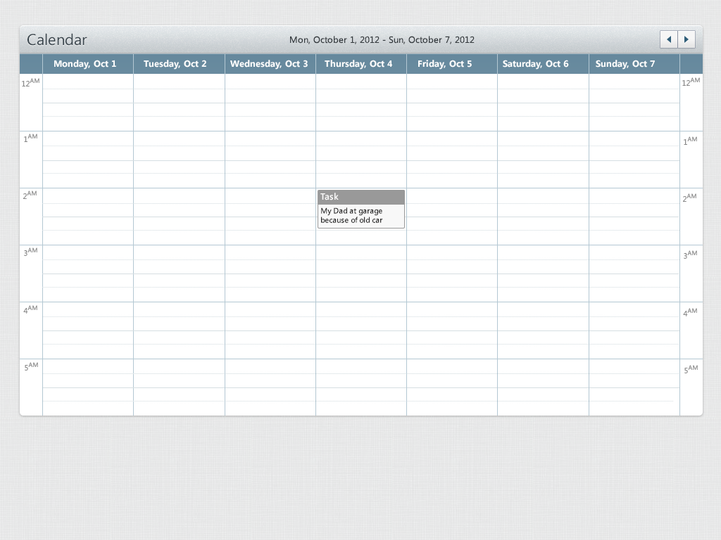

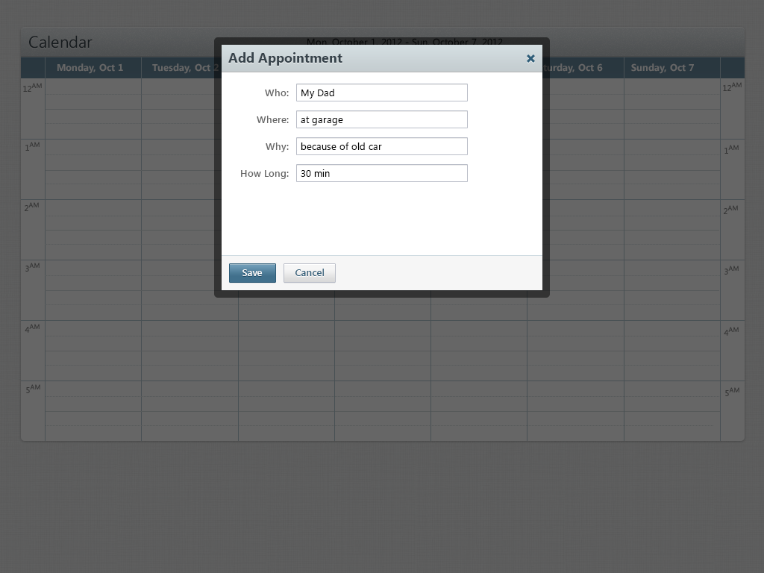

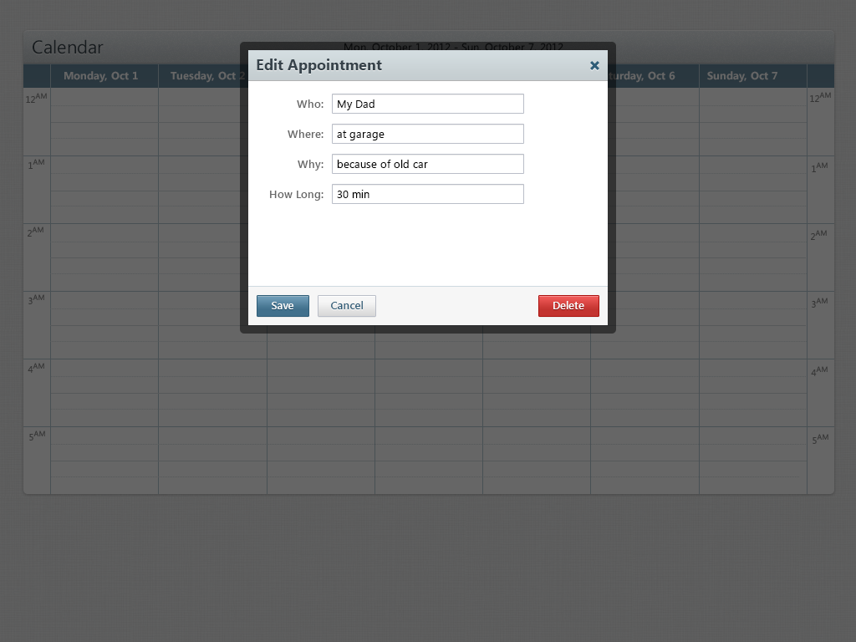

**Additional functionality**  
● It should work like one page WEB application and should use AJAX technology, load  
and submit data without reloading a page. Use Restangular and Express for this functionality.  
● It should have unit tests for all functionality.

# Requiremens

## ****Task manager****   I'm a person who passionate about own productivity. I want to manage my tasks and separate them by the subject more effectively. I need simple tool that support me in controlling my task-flow.

**Functional requirements**

* I want to be able to create/delete task lists
* I want to be able to add tasks to my task list
* I want to be able to edit/delete tasks
* I want to be able to choose deadline for my task. It should be shown as date/time stamp before task
* I want to be able to mark a task as 'done'
* Validation rules:
  + The name fields are required for both task and list

**Technical requirements**

* It should be WEB application
* For the client side must be used: HTML5, CSS3, Bootstrap, JavaScript: AngularJS, UI.Router, Restangular, browserify);
* It should have client side validation in base of Angular JS;
* It should look like on screens (see attached file);
* It should use bower as package manager;
* It should use Gulp as build tool.

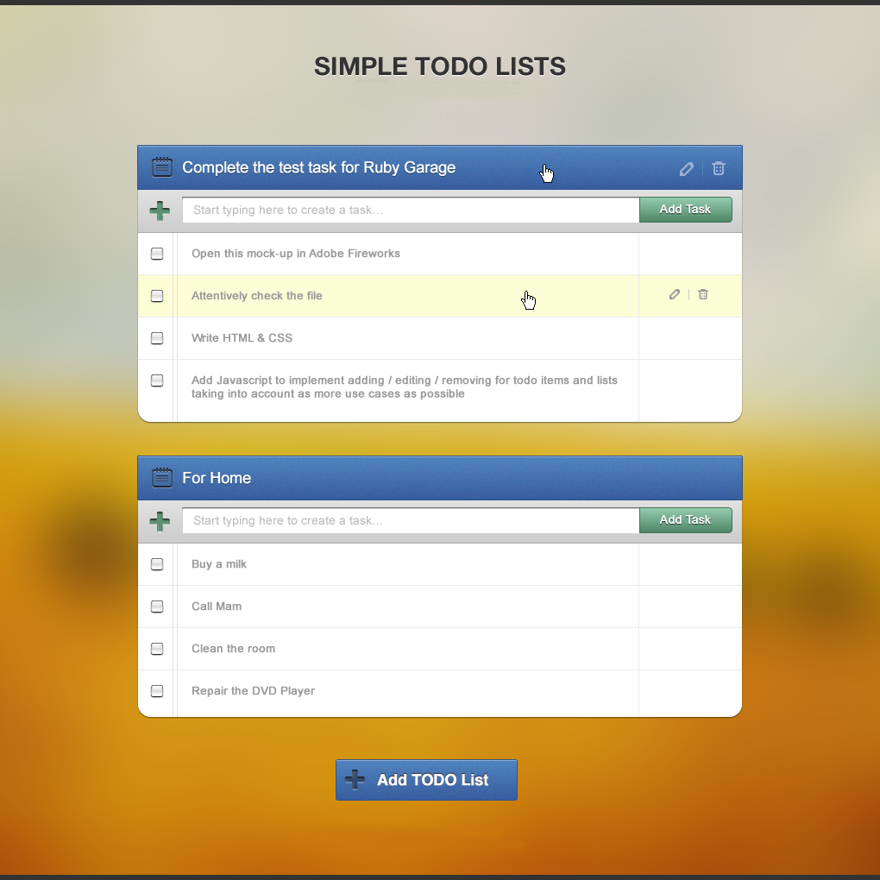

**Additional functionality**  
● It should work like one page WEB application and should use AJAX technology, load  
and submit data without reloading a page. Use Restangular and Express for this functionality.  
● It should have unit tests for all functionality.