**Credit Card Fraud Detection**

**Wireframe Document**

Table of Contents

1. **Home Page**
2. **Prediction Page**

# Home Page

Homepage consists of a single page having different user input sections and the submit button that will either lead the user to prediction page or error page. I have designed my home page in such a way that users can insert their inputs according to their transaction details. The user will be entering only those details that are required for prediction.There are 21 input sections in the homepage where the user will have to enter the correct entries as per their transaction detail.

Here is the sample of my home page:

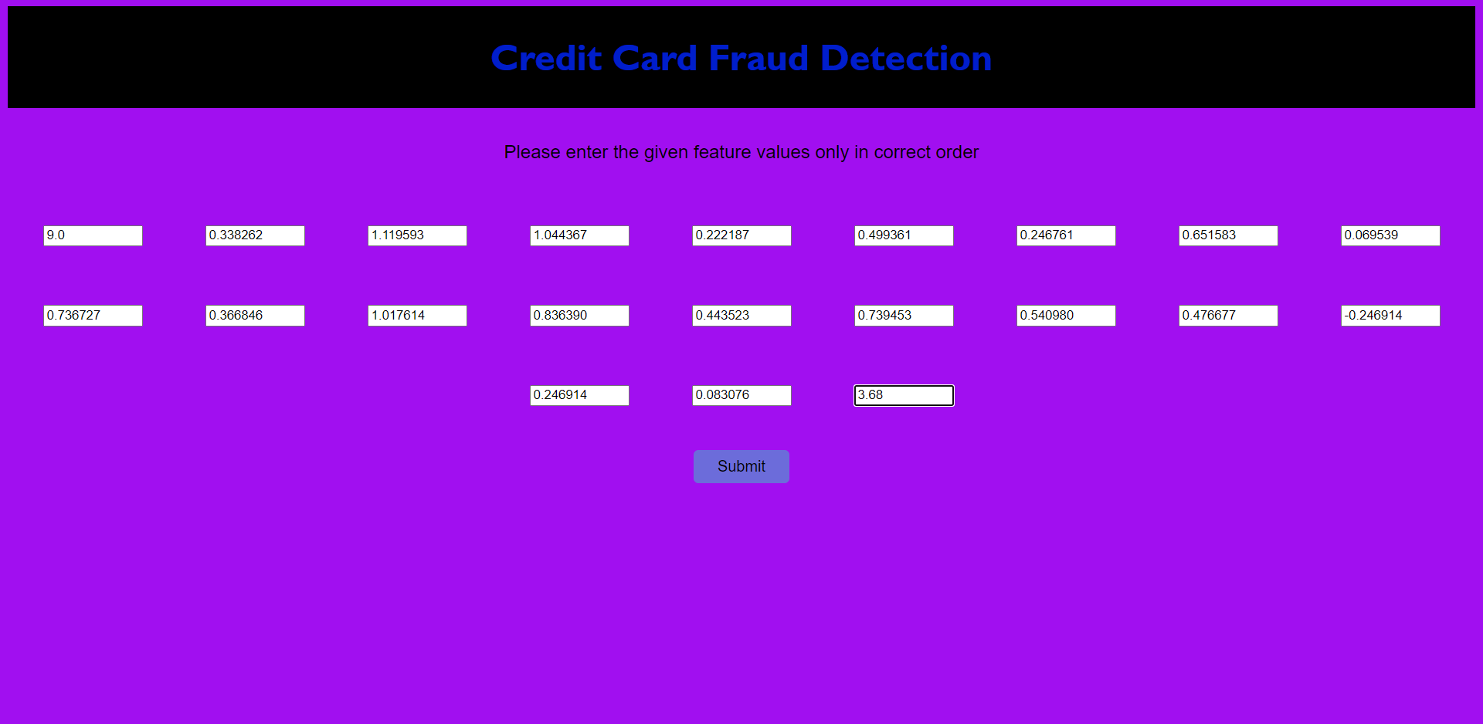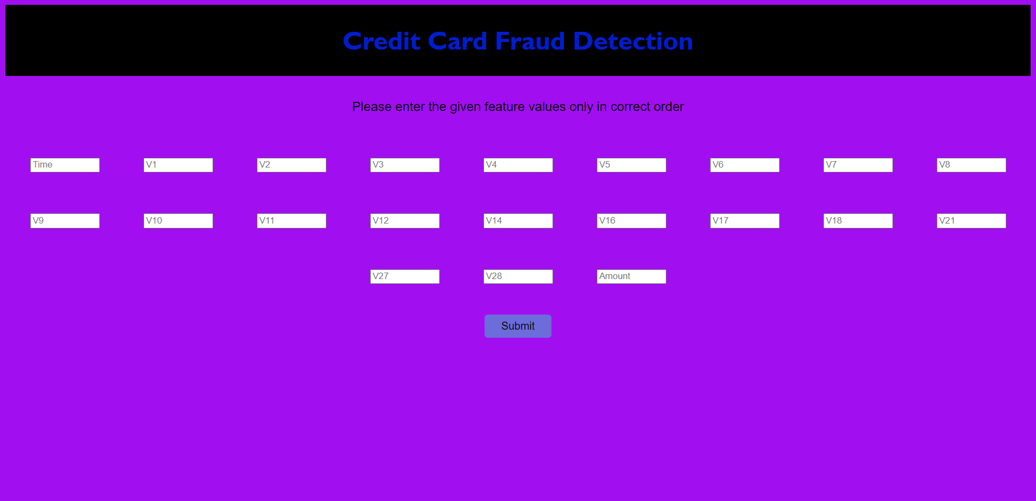

# Prediction Page

The prediction page of my web app consists of the result of the entered transaction details.This page will show Predicted Result to the user based on the user information.

Here is the sample prediction page if the transaction is not a fraud transaction.

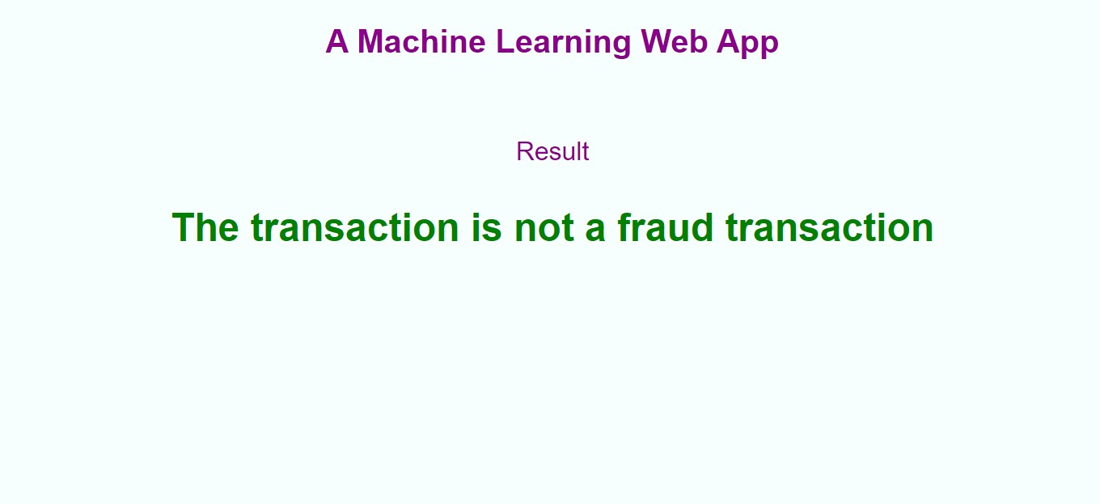

Here is the sample prediction page if the transaction is a fraud transaction

