LAB REPORT
Lab Title | Interactive Input and Selections | Lab No. | 2
Student Name | LiRongyao | Student ID | 2024103975
Date | 2025/3/10
Lab description/objectives:
1. Demonstrate understanding of interactive input handling, selection statement (if-else, switch) and logical operators in C programming.
2. Implement percentage-to-grade conversion and conditional message printing based on character input as defined in the lab tasks/requirements.
3. Analyze input validation, handling of invalid entries, and proper use of conditional logic to ensure program robustness.
Source code:
Task 1:
#include <stdio.h>
int main(){
double i;
int temp = scanf("%lf", &i);
if (!temp){
printf("Invalid Value");
return 0;
}
if (i<60){
printf("Your grade is F.");
}else if (i<70){
printf("Your grade is D.");
}else if (i<80){
printf("Your grade is C.");
}else if (i<90){
printf("Your grade is B.");
}else if (i<=100){
printf("Your grade is A.");
}else {
printf("Invalid value.");
}
return 0;
}
Task 2:
#include <stdio.h>
#include <ctype.h>
int main(){
char score;
scanf("%c", &score);
score = toupper(score);
switch (score)
{
case 'A':
case 'B':
printf("Excellent!");
break;
case 'C':
case 'D':
printf("Good");
break;
case 'E':
case 'F':
printf("Need Improvement");
break;
case 'O':
printf("Outstanding!");
break;
case 'U':
printf("Undefined grade");
break;
default:
printf("Invalid grade");
break;
}
return 0;
}
Program output:
Task 1:
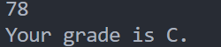
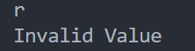
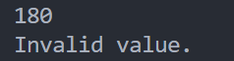
Task 2:
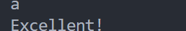
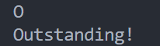
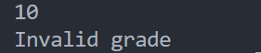
Analysis:
- Validate Range of Inputs
- The range of task 1 is 0-100. If we input the number out the range or input other character, the input is invalid.
- The range of task 2 is those letters in either uppercase or lowercase. If we input others then the input is invalid.
- Optimize
- In task 1 we choose the right scope to decrease the number of judgements.
- In task 2 we do not use “break” in some cases and use the function to transfer the lowercase letter to uppercase letter to get our wanted result.
- Manage Edge Cases:
- In task 1, we check the return value of the function “scanf()” to ensure the right input. Then we eliminate those invalid cases.
- In task 2, we set default case as the invalid input to ensure the right input.
Conclusion：
- When doing the interactive input, we need to ensure the right format of the input and cope with the input in advance.
- When doing selection, we need to set the appropriate scope and optimize the cases so that we can get the right output more accurately and rapidly.

