LAB REPORT
Lab Title | Loops | Lab No. | 03
Student Name | Li Rongyao | Student ID | 2024103975
Date | 2025/3/17
Lab description/objectives:
- Demonstrate understanding of key C programming concepts including for loop, while loop, arithmetic operations, conditional statements, basic input/output, and data types.
- Implement two specific functionalities/algorithms:
  - Calculate the factorial of a given number using a for loop.
  - Find the sum of all digits of a given integer using a while loop.
- Analyze critical aspects.
Source code:
Task 1:
#include <stdio.h>
int main(){
int n;
int ans = 1;
printf("Enter a positive integer.\n");
scanf("%d", &n);
for (int i = 1; i <= n; i ++){
ans *= i;
}
printf("The product from 1 to %d is %d.\n", n, ans);
return 0;
}
Task 2:
#include <stdio.h>
int main(){
int n;
int sum = 0;
printf("Enter a positive number.\n");
scanf("%d", &n);
int temp = n;
while (temp != 0){
sum += temp % 10;
temp /= 10;
}
printf("The sum of the digits of %d is %d.\n", n, sum);
return 0;
}
Program output:
Task 1:
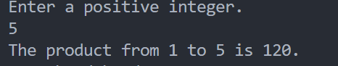
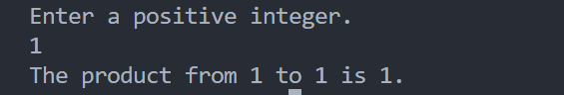
Task 2:
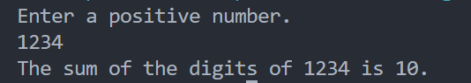
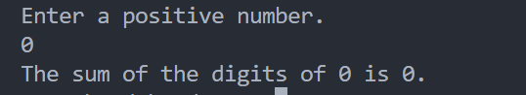
Analysis:
- The For Loops to Calculate the Factorial
- Ensure the terminal condition and the corresponding expression as test condition in the for loop. In this task is to multiple from 1 to n so the terminal condition is i = n. And the corresponding test condition is i <= n.
- Fulfill the loop body by setting the initial value of product is 1 and then multiple the integers one by one.
- The While Loops to Find the Sum
- Ensure the method to find the answer. We need to split the digits one by one by taking remainders and then modify the integer by division.
- Find the corresponding test condition and loop body. The loop will halt as the digit has completely split thus the test condition is the integer not equals to 0. Then we need to get the sum first by add the digit with the before sum and then modify the integer by dividing 10.
Conclusion：
For the loops, we need to ensure the terminal condition or test condition first after setting the method to solve the problem. Then we need to use appropriate operations in the loop body to fulfill the goal.

