LAB REPORT
Lab Title | Pointers and Recursion | Lab No. | 05
Student Name | Li Rongyao | Student ID | 2024103975
Date | 2025/3/31
Lab description/objectives:
1. Demonstrate understanding of pointers and recursion in C programming.
2. Implement the functionality of extracting phone-number components from a combined integer and calculating Tribonacci numbers as defined in the lab tasks/requirements.
3. Analyze the critical aspects.
Source code:
Task I:
#include <stdio.h>
void phoneDecompose(int number, int* areaCode, int* exchangeCode, int* lineNumber){
int temp1 = 1e7;
int temp2 = 1e4;
*areaCode = number / temp1;
number %= temp1;
*exchangeCode = number / temp2;
*lineNumber = number % temp2;
}
int main(){
int num;
int areaCode, exchangeCode, lineNumber;
printf("Please entre the phone number.\n");
scanf("%d", &num);
phoneDecompose(num, &areaCode, &exchangeCode, &lineNumber);
printf("The areacode is %d, the exchangecode is %d, the linenumber is %d.\n", areaCode, exchangeCode, lineNumber);
return 0;
}
Task II:
#include <stdio.h>
int Tribonacci(int n){
if (n <= 0){
printf("Incorrect value.\n");
return -1;
}
if (n == 1){
return 0;
}else if (n == 2 || n == 3){
return 1;
}
return Tribonacci(n - 1) + Tribonacci(n - 2) + Tribonacci(n - 3);
}
int main(){
int n;
printf("Please enter the number.\n");
scanf("%d", &n);
if (n > 0)
printf("The value of the term is %d.", Tribonacci(n));
else
Tribonacci(n);
return 0;
}
Program output:
Task I:
Task II:
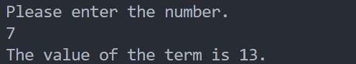
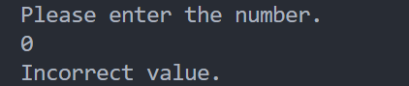
Analysis:
- Phone Number Decomposition Function
- To modify the value of three variables in the function, we need to use the pointer to set the address of the variables in the main function rather than just rely on the return value.
- Correspondingly, we need to pass the reference about the three variables when calling the function rather than just pass the value to ensure the correct implementation.
- Since we just pass the value of the number, the modification in the function does not affect the value in the main function.
- Tribonacci Sequence
- We first specify the initial case about the recursion for Tribonacci. There the initial case is when n equals to 1,2 and 3.
- Then we need to ensure the formula of recursion and make it as the return value to finish the recursion.
- Note to check the validity of the number n.
Conclusion：
When we need to change the value more than one variable in the function or we want to store the status in the return value and do other incidents in the function body, we need to use the pointers, that is, we need to pass by reference rather than pass by value.
For recursion, we need to specify the initial case. Then we need to find the relationship between the function with itself to ensure the formula. Meanwhile note the recursion does not exceed the limitation of stack.

