LAB REPORT
Lab Title | Strings | Lab No. | 08
Student Name | Li Rongyao | Student ID | 2024103975
Date | 2025/4/21
Lab description/objectives:
1. Demonstrate understanding of strings in C programming.
2. Implement the functionality of counting characters/searching a substring as defined in the lab tasks/requirements.
3. Analyze critical aspects.
Source code:
Task I:
#include <stdio.h>
#define size 100
char countingstr(char* str, int* max){
char tmp = str[0];
char ret = tmp;
int i = 1;
*max = 1;
int tmpmax = *max;
while (str[i] != '\0'){
if (str[i] == tmp){
tmpmax++;
if (tmpmax > *max)
{
*max = tmpmax;
ret = tmp;
}
}else{
tmp = str[i];
tmpmax = 1;
}
i++;
}
return ret;
}
int main() {
int max = 1;
char str[size];
printf("Please enter a string.\n");
gets(str);
char maxchar = countingstr(str, &max);
printf("The maximum number is %d, the character is %c", max, maxchar);
return 0;
}
Task II:
#include <stdio.h>
#define size 100
int subsearch(char* str, char* substr){
int ret = -1;
int i = 0, j = 0, k = 0;
for (i = 0; str[i] != '\0'; i++)
{
if (str[i]==substr[j]){
if (j == 0)
k = i;
j++;
if (substr[j] == '\0'){
ret = k;
break;
}
continue;
}
j = 0;
}
return ret;
}
int main(){
char str[size], substr[size];
printf("Please enter the main string.\n");
gets(str);
printf("Please enter the substring you want to find.\n");
gets(substr);
int pos = subsearch(str, substr);
if (pos != -1){
printf("The substring starts at index %d.\n", pos);
}else{
printf("Not found.\n");
}
return 0;
}
Program output:
Task I:
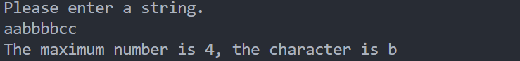
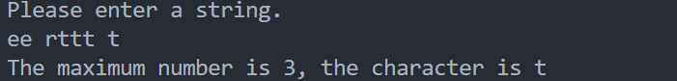
Task II:
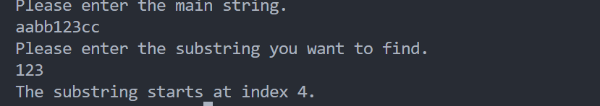
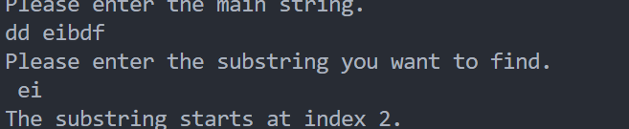
Analysis:
- Counting Consecutive Repeating Characters
- When writing the function, we need to not only give the information of the maximum but also give the character. So we need to use pointers to modify the max as the maximum and use return value as the character.
- We need to renew the maximum and corresponding character until ending the string.
- Let the variable maxchar receive the return value of the function.
- The input should use gets() so that the string can receive the space.
- Substring Searching
- We need to respectively store the position in both main string and substring. So we choose i,j to record their position and use k to store the starts of substing in main strings.
- If the next character is not the corresponding element in substring, we need to clear the situation and restart the find again so we need let j be zero again.
Conclusion：
For the strings, the input and output should choose the appropriate function, such as printf(), scanf() and gets(), puts(). And the terminal element in a string is ‘\0’, which can be used as the terminal condition of loop.

