LAB REPORT
Lab Title | Structures and Unions for Animal Information | Lab No. | 11
Student Name | Li Rongyao | Student ID | 2024103975
Date | 2025/5/12
Lab description/objectives:
1. Demonstrate understanding of structures and unions in C programming.
2. Implement functionality of creating a structure array of animals as defined in the lab tasks/requirements.
3. Analyze critical aspects.

Source code:
#include <stdio.h>
#define L 4
struct Animal
{
char name[20];
int animalID;
char animalCategory;
union Attribute
{
int lifespan;
float flightSpeed;
} attribute;
} animal[L];
int inputanimal(int i, int* mnum, int* bnum);
void outputanimal(int i);
int main()
{
int n;
int tmp;
int mnum = 0, bnum = 0;
printf("Please enter the number of animals.\n");
if ((tmp = scanf("%d", &n)) < 1 || n > L)
{
printf("Error input.\n");
return 1;
}
for (int i = 0; i < n; )
{
if (inputanimal(i, &mnum, &bnum)){
i++;
};
}
if ((n >= 2) && (mnum == 0 || bnum == 0)){
printf("Please enter at least one mammal and one bird.\n");
return 1;
}
for (int i = 0; i < n; i++){
outputanimal(i);
}
return 0;
}
int inputanimal(int i, int* mnum, int* bnum){
printf("Please enter the name of animal %d.\n", i);
scanf("%19s", animal[i].name);
printf("Please enter the ID of animal %d.\n", i);
scanf("%d", &animal[i].animalID);
printf("Please enter the category of animal %d.\n", i);
scanf(" %c", &animal[i].animalCategory);
if (animal[i].animalCategory != 'M' && animal[i].animalCategory != 'B'){
printf("Error input.\n");
return 0;
}
if (animal[i].animalCategory == 'M')
{
printf("Please enter the lifespan of animal %d.\n", i);
scanf("%d", &animal[i].attribute.lifespan);
(*mnum)++;
return 1;
}
else if (animal[i].animalCategory == 'B')
{
printf("Please enter the flight speed of animal %d.\n", i);
scanf("%f", &animal[i].attribute.flightSpeed);
(*bnum)++;
return 1;
}
}
void outputanimal(int i){
printf("The name of animal %d is %s.\n", i, animal[i].name);
printf("The ID of animal %d is %d.\n", i, animal[i].animalID);
printf("The category of animal %d is %c.\n", i, animal[i].animalCategory);
if (animal[i].animalCategory == 'M'){
printf("The lifespan of animal %d is %d.\n", i, animal[i].attribute.lifespan);
}else{
printf("The flight speed of animal %d is %.2f km/h.\n", i, animal[i].attribute.flightSpeed);
}
}
Program output:
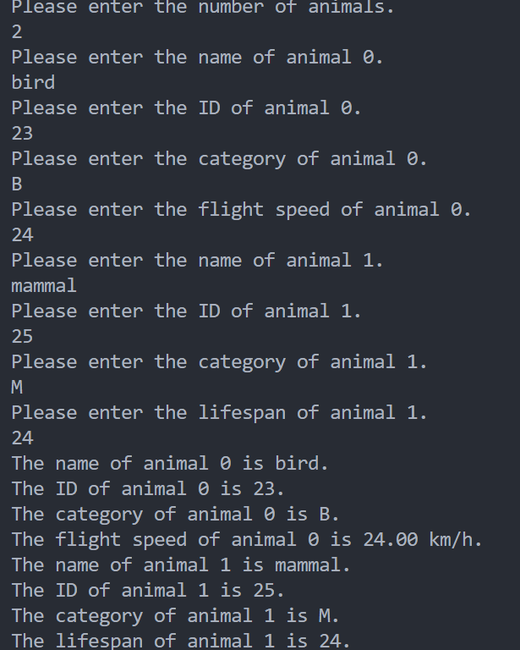
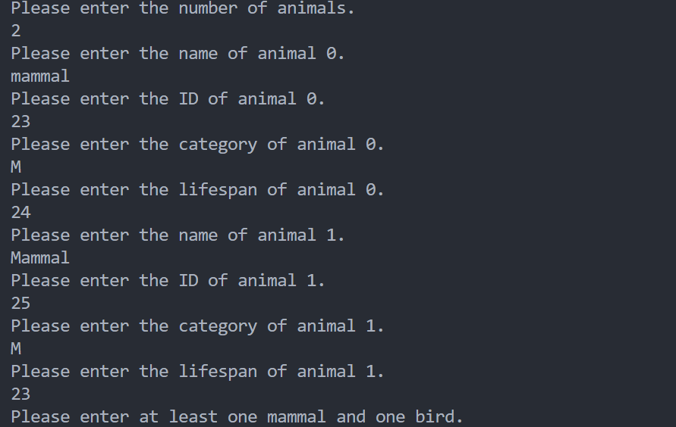
Analysis:
- Key Challenges & Solutions
- Separate the procedures of input and output into functions.
- Understand the relationship among variables, unions and structures.
- Initialize a structure variable when creating a structure.
- Result Validation
- Confirm the category are right.
- Ensure it has at least one mammal and one bird when more than two animals.
- Improvement Suggestions
- Can confirm the more validation of the name, ID, lifespan and category.
- The format of the output can be optimized.
Conclusion：
The structure can combine different individual variables together and the memory is the sum of them while the union is similar to the structure but they use the same memory. And we need to know how to use the members in structures or unions including using pointers.

