LAB REPORT
Lab Title | Bitwise Operation with Command-Line Argument | Lab No. | 13
Student Name | Li Rongyao | Student ID | 2024103975
Date | 2025/5/26
Lab description/objectives:
1. Demonstrate understanding of the bitwise operation and the usage of command line.
2. Implement the bitwise operation with command-line argument as defined in the lab tasks/requirements.
3. Analyze the error handling and the validity of argument.
Source code:
#include <stdio.h>
#include <string.h>
void And(int num1, int num2);
void Or(int num1, int num2);
void Xor(int num1, int num2);
int main(int argc, char* argv[]){
if (argc != 4){
printf("Invalid argument count.\n");
return 1;
}
int num1, num2;
if (!sscanf(argv[1], "%d", &num1) || !sscanf(argv[3], "%d", &num2)){
printf("Invalid integer input. Please provide valid integers.\n");
return 1;
}
if (strcmp(argv[2], "and") && strcmp(argv[2], "or") && strcmp(argv[2], "xor")){
printf("Invalid bitwise operation. Valid operations are 'and', 'or', 'xor'.\n");
return 1;
}
if (!strcmp(argv[2], "and"))
{
And(num1, num2);
}
else if (!strcmp(argv[2], "or"))
{
Or(num1, num2);
}
else if (!strcmp(argv[2], "xor"))
{
Xor(num1, num2);
}
return 0;
}
void And(int num1, int num2){
printf("%d ANDed with %d is %d.\n", num1, num2, num1 & num2);
}
void Or(int num1, int num2){
printf("%d ORed with %d is %d.\n", num1, num2, num1 | num2);
}
void Xor(int num1, int num2){
printf("%d XORed with %d is %d.\n", num1, num2, num1 ^ num2);
}
Program output:
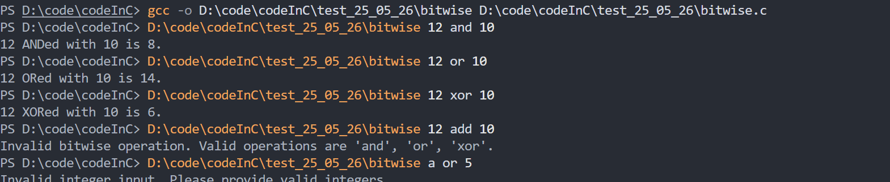
Analysis:
- Key Challenges & Solutions
- Understand the usage of command line and the bitwise operator.
- Use the function sscanf() to perform the transformation from the type char to int in the buffer.
- Result Validation
- Check whether the count of arguments input by command line is valid by the variable argc.
- Use the function sscanf() and strcmp() to respectively chech the validity of the integers and the operation.
- Improvement Suggestions
- May create a function to replace the function sscanf() since I forgot it at the beginning but it is not necessary.
- Optimize the input of command line to repeat the input if error.
Conclusion：
In this experiment, we need to learn about the operations of bitwise and their corresponding operators. And we also need to master the usage of command line to input and corresponding format of the main() function.

