LAB REPORT
Lab Title | Inheritance and Polymorphism | Lab No. | 14
Student Name | Li Rongyao | Student ID | 2024103975
Date | 2025/6/9
Lab description/objectives:
1. Demonstrate understanding of Inheritance and Polymorphism in C++ programming.
2. Implement a practical class hierarchy as defined in the lab tasks/requirements.
3. Analyze the usage of inheritance and polymorphism and how it works.
Source code:
Inheritance:
#include <iostream>
using namespace std;
class Person{
public:
string name;
int age;
void introduce(){
cout << "My name is " << name << "and I'm " << age << " years old." << endl;
}
};
class Student : public Person{
public:
int studentID;
void study()
{
cout << "I'm studying hard." << endl;
}
};
class Teacher : public Person{
public:
string subject;
void teach()
{
cout << "I'm teaching " << subject << "." << endl;
}
};
int main(){
Student st1;
st1.age = 18, st1.name = "Li", st1.studentID = 2024103975;
Teacher tch1;
tch1.age = 40, tch1.name = "Zhao", tch1.subject = "Maths";
st1.introduce(), st1.study();
tch1.introduce(), tch1.teach();
return 0;
}
Polymorphism:
#include <iostream>
using namespace std;
class Person{
public:
string name;
int age;
void introduce()
{
cout << "My name is " << name << "and I'm " << age << " years old." << endl;
}
virtual void work() = 0;
};
class Student : public Person{
public:
int studentID;
void study()
{
cout << "I'm studying hard." << endl;
}
virtual void work() override{
cout << "I'm a student and I'm working on my studies." << endl;
}
};
class Teacher : public Person{
public:
string subject;
void teach()
{
cout << "I'm teaching " << subject << "." << endl;
}
virtual void work() override{
cout << "I'm a teacher and I'm working on teaching." << endl;
}
};
int main(){
Person *p1 = new Student();
Person *p2 = new Teacher();
p1->work(), p2->work();
delete p1, delete p2;
return 0;
}
Program output:
Inheritance:
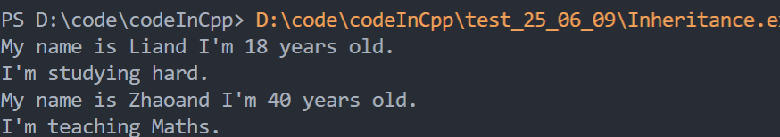
Polymorphism:
Analysis:
- Key Challenges & Solutions
- Understand the syntax of inheritance and polymorphism and their corresponding practices.
- Understand the base class and subclass in inheritance and virtual function and dynamic binding in polymorphism.
- Result Validation
- Note the access in the different class.
- Use the base class pointer to point to the object of subclass and then invoke the function in the subclass.
- Note free the corresponding memory of the pointer.
- Improvement Suggestions
- The access in the class can be modified to ensure the security.
Conclusion：
For inheritance, we need to understand that it aims at improving the percentage of reuse and constructing the relationship among classes. For polymorphism, we need to understand that it aims at unifying the connector to the subclasses in the base class and making the invocation more valid.

