JNU International School
《Data Structure》Lab Report

Score ：

Project ： | Data Structure
Name ： | 李荣耀
Student No： | 2024103975
Semester ： | First Semester of Sophomore
Date ： | 2025/12/2

Experiment1：Strange Lift Problem
Section 1: Introduction
The "Strange Lift" problem focuses on finding the minimum number of button presses required to move from a starting floor to a target floor in a special lift system. Each floor is equipped with a number, and the lift has only two operations: "UP" and "DOWN" by specific number. The lift cannot exceed the building’s floor range (1 to N) or go below the 1st floor.
This problem is modeled as an unweighted directed graph where each floor represents a vertex, and edges represent possible button presses. The solution requires finding the shortest path in terms of edge count, making Breadth-First Search (BFS) the optimal algorithm choice.
Here I use the graphviz as the tools to generate visualized graph. Corresponding codes are in Section 5.
Section 2: Algorithms Specification
  - Description of Data Structures
Graph ADT:
The graph is implemented by adjacent matrix with dynamic expansion capability. Here the type of vertices is integer. It is only indices of actual data. And the type of adjacent matrix elements is double. The specific structures and corresponding operations are in Section 5.
#define VEX_TYPE int
#define ADJ_TYPE double

#define GRAPH_INF 100000000
#define MAXSIZE 50

// ADT of Graph
typedef VEX_TYPE VexType;
typedef ADJ_TYPE AdjType;

typedef enum
{
UG,
DG,
WUG,
WDG
} GraphKind;

typedef struct Graph
{
GraphKind type;
VexType *vex; // store the vertices
int vexnum;
int arcnum; // the number of vertices, edges
int vexcapacity; // the capacity of vextices
AdjType **adj; // the adjacent matrix
} Graph;
Queue ADT:
It is linked-list implementation for efficient enqueue/dequeue. Here the Ldata is integer type to store vertices indices. Specific structures and operations are in Section 5.
// ADT of Queue
typedef VexType Ldata;

typedef struct Lnode
{
Ldata data;
struct Lnode *next;
} Lnode;

typedef struct Qnode
{
Lnode *front;
Lnode *rear;
} Qnode;
typedef Qnode *Queue;

  - Integrity of Algorithm Logic
    - Graph Construction
  - Read input, including total floors, start floor, target floor and specific value for each floor.
  - Initialize the directed graph. Calculate the result of UP and Down for each floor. If valid then set it into graph.
    - BFS Impementation
  - Enqueue the start floor and mark it as visited.
  - Set initial shortest distance as zero. (dist[start] = 0)
  - Dequeue a floor, traverse all its adjacent floors. For unvisited floors, enqueue them and mark it as visited. Then update their shortest distance as dist[current] + 1.
  - Repeat the former steps until the target floor is dequeued or the queue is empty. Return shortest distance. (-1 for unreachable floor).
Section 3: Test results
Test Case 1: Example in Project
Input:

5 1 5
3 3 1 2 5 0

Expected Output: 3 (1->4->2->5 to get the path)
Actual Output: 3
Graph Visualization:
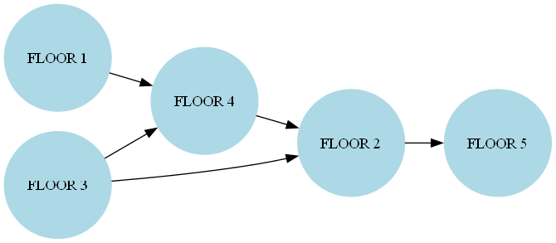

Test Case 2: No Path
Input:

3 1 2
2 2 2 0

Expected Output: -1(No path from floor 1 to floor 2)
Actual Output: -1
Graph Visualization:
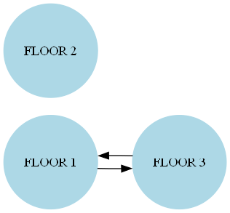

Test Case 3: More Movements
Input:

7 2 5
3 2 1 3 2 1 1 0

Expected Output: 4 (2->4->2->3->5)
Actual Output: 4
Graph Visualization:
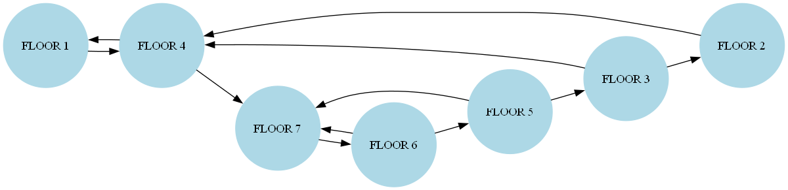

Test Case 4: Start equals End
Input:

5 3 3
1 2 3 4 5 0

Expected Output: 0
Actual Output: 0
Graph Visualization:
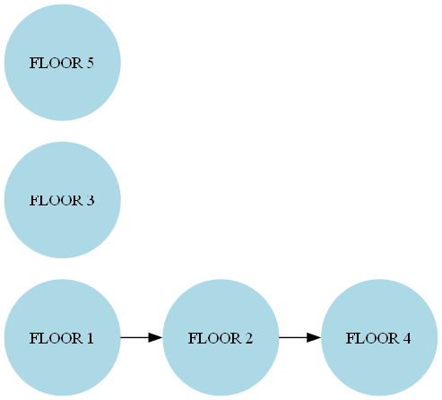

Test Case 5: Direct Arrival
Input:

10 1 10
9 1 1 1 1 1 1 1 1 1 0

Expected Output: 1 (1->10)
Actual Output: 1
Graph Visualization:
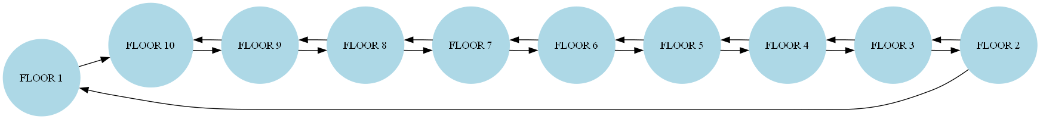

Test Case 6: Upper Bound
Input:

200 1 200
1 1 1 … 1 (200 x 1) 0

Expected Output: 199(1->2->3->…->200)
Actual Output: 199
The graph size is too small thus omit it.

Test Case 7: One Floor
Input:

1 1 1
1 0

Expected Output: 0
Actual Output: 0
Graph Visualization:
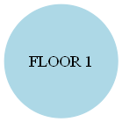

Section 4: Analysis and Comments
  - Analysis
    - Time Complexity
- BFS: O(V^2)
Each vertex processed once, but adjacent matrix requires scanning all V columns per vertex.
- Graph Construction: O(V)
Each vertex are single pass to create graph.
    - Space Complexity
- Adjacent Matrix: O(V^2)
Suitable for dense graph storage.
- BFS Queue: O(V)
Each vertex are traversed once.
  - Comments
    - Advantages:
- More efficient insertion for edges with O(1) complexity.
- Simplifies implementation for dense graphs.
- The design of abstract index layer can reduce the coupling between the graph and this problem. Improve the reusability of Graph ADT and robust of the problem.
- Dynamic expansion prevents overflow of the capacity.
    - Questions:
- Memory inefficient for sparse graphs. For example, 200 floors need 40000 matrix cells but only 400 for use.
- The design of abstract index layer causes extra storage for vertices. And it reduces the efficiency of Locate vertex.
- The coupling degree between the queue and graph is large, making the queue only use for graph.
    - Optimization Direction:
- Vertex Lookup Optimization:
Use hash table for O(1) Locate vertex in this problem.
- Sparse Graph Handling:
Implement adjacent list for O(V+E) space and time for sparse graph.
Section 5: Source code (in C language)
Graph.h:
#ifndef __GRAPH_ADT__
#define __GRAPH_ADT__

#define VEX_TYPE int
#define ADJ_TYPE double

#include <stdbool.h>
#define GRAPH_INF 100000000
#define MAXSIZE 50

// ADT of Graph
typedef VEX_TYPE VexType;
typedef ADJ_TYPE AdjType;

typedef enum
{
UG,
DG,
WUG,
WDG
} GraphKind;

typedef struct Graph
{
GraphKind type;
VexType *vex; // store the vertices
int vexnum;
int arcnum; // the number of vertices, edges
int vexcapacity; // the capacity of vextices
AdjType **adj; // the adjacent matrix
} Graph;

// ADT of Queue
typedef VexType Ldata;

Graph *CreateGraph(GraphKind Gtype);
void InitializeGraph(Graph *g, int n);
Graph *InsertVertex(Graph *g, VexType v);
Graph *InsertEdge(Graph *g, VexType v1, VexType v2, double weight);
Graph *DeleteVertex(Graph *g, VexType v);
Graph *DeleteEdge(Graph *g, VexType v1, VexType v2);
bool IsEmpty(Graph *g);
Graph *ExpandGraph(Graph *g);
int LocateVertex(Graph *g, VexType v);
Graph *DestroyGraph(Graph *g);

#endif
Graph.c:
#include <stdio.h>
#include <stdlib.h>
#include <stdbool.h>
#include "Graph.h"

// Create empty graph
Graph *CreateGraph(GraphKind Gtype)
{
// Create pointer to emtpy graph
Graph *g = (Graph *)malloc(sizeof(struct Graph));

if (!g)
{
printf("Failed to create graph.\n");
return NULL;
}

g->type = Gtype;
g->vexnum = g->arcnum = 0;
g->vexcapacity = MAXSIZE;
g->vex = (VexType *)malloc(g->vexcapacity * sizeof(VexType));

if (!g->vex)
{
printf("Failed to create graph.\n");
free(g);
return NULL;
}

g->adj = (AdjType **)malloc(g->vexcapacity * sizeof(AdjType *));
if (!g->adj)
{
printf("Failed to create graph.\n");
free(g->vex);
free(g);
return NULL;
}

for (int i = 0; i < g->vexcapacity; i++)
{
g->adj[i] = (AdjType *)malloc(g->vexcapacity * sizeof(AdjType));
if (!g->adj[i])
{
for (int j = 0; j < i; j++)
{
free(g->adj[j]);
}
free(g->adj);
free(g->vex);
free(g);
return NULL;
}
}

return g;
}

// receive the input and initialize the graph
void InitializeGraph(Graph *g, int n)
{
// handle the error situation
if (!g)
{
printf("The graph has not been created.\n");
return;
}

while (n > g->vexcapacity)
{
g = ExpandGraph(g);
if (!g)
{
return;
}
}

// initialize the graph
g->vexnum = n;
int vex_num = g->vexnum;
if (g->type == DG || g->type == UG)
{
for (int i = 0; i < vex_num; i++)
{
for (int j = 0; j <= i; j++)
{
g->adj[i][j] = g->adj[j][i] = 0;
}
}
}
else
{
for (int i = 0; i < vex_num; i++)
{
for (int j = 0; j <= i; j++)
{
g->adj[i][j] = g->adj[j][i] = GRAPH_INF;
}
}
}
}

// expand the graph
Graph *ExpandGraph(Graph *g)
{
if (!g)
return NULL;

int old_capacity = g->vexcapacity;
int new_capacity = old_capacity + MAXSIZE;

// expand the array of vertices
VexType *new_vex = (VexType *)realloc(g->vex, new_capacity * sizeof(VexType));
if (!new_vex)
{
printf("Failed to expand vertex array.\n");
return NULL;
}
g->vex = new_vex;

// expand adjacent matrix
AdjType **new_adj = (AdjType **)realloc(g->adj, new_capacity * sizeof(AdjType *));
if (!new_adj)
{
printf("Failed to expand adjacency matrix pointer array.\n");
return NULL;
}
g->adj = new_adj;

// handle old rows
for (int i = 0; i < old_capacity; i++)
{
AdjType *new_row = (AdjType *)realloc(g->adj[i], new_capacity * sizeof(AdjType));
if (!new_row)
{
printf("Failed to expand row %d.\n", i);
return NULL;
}
g->adj[i] = new_row;

}

// handle new rows
for (int i = old_capacity; i < new_capacity; i++)
{
g->adj[i] = (AdjType *)malloc(new_capacity * sizeof(AdjType));
if (!g->adj[i])
{
printf("Failed to allocate new row %d.\n", i);
// free previous old rows
for (int j = old_capacity; j < i; j++)
free(g->adj[j]);
return NULL;
}

}

g->vexcapacity = new_capacity;
printf("The graph has been expanded. (New Capacity: %d)\n", g->vexcapacity);
return g;
}

// locate the vertex in the graph
int LocateVertex(Graph *g, VexType v)
{
if (!g)
{
return -1;
}

for (int i = 0; i < g->vexnum; i++)
{
if (g->vex[i] == v)
{
return i;
}
}
return -1;
}

// Insert a new vertex without incident edge
Graph *InsertVertex(Graph *g, VexType v)
{
// Cope with the error situation
if (!g)
{
printf("The graph has not been created.\n");
return NULL;
}

int j = LocateVertex(g, v);
if (j != -1)
{
printf("The vertex has been in the graph.\n");
return g;
}

if (g->vexnum == g->vexcapacity)
{
g = ExpandGraph(g);
if (!g)
{
return NULL;
}
}

// initialize the row and column in the matrix
int i = g->vexnum;
g->vex[g->vexnum++] = v;
if (g->type == DG || g->type == UG)
{
for (int j = 0; j <= i; j++)
{
g->adj[i][j] = g->adj[j][i] = 0;
}
}
else
{
for (int j = 0; j <= i; j++)
{
g->adj[i][j] = g->adj[j][i] = GRAPH_INF;
}
}
return g;
}

// Insert a new edge between v1 and v2
Graph *InsertEdge(Graph *g, VexType v1, VexType v2, double weight)
{
// handle the error situation
if (!g)
{
printf("The graph has not been created.\n");
return NULL;
}

if (IsEmpty(g))
{
printf("The graph is empty.\n");
return NULL;
}

// find the position of the vertices in the array
int i = LocateVertex(g, v1);
int j = LocateVertex(g, v2);

// handle error situation
if (i == -1 || j == -1)
{
printf("The vertex is not in the graph.\n");
return g;
}

bool is_exist = false;
if (g->type == UG || g->type == DG)
{
is_exist = (g->adj[i][j] - 1 < 1e-9);
}
else
{
is_exist = (g->adj[i][j] - GRAPH_INF > 1e-9);
}
if (is_exist)
{
printf("The edge has been in the graph");
return g;
}

// set the corresponding position as 1
if (g->type == UG)
{
g->adj[i][j] = g->adj[j][i] = 1;
}
else if (g->type == DG)
{
g->adj[i][j] = 1;
}
else if (g->type == WUG)
{
g->adj[i][j] = g->adj[j][i] = weight;
}
else
{
g->adj[i][j] = weight;
}

g->arcnum++;
return g;
}

// return TRUE if it is empty and FALSE if not
bool IsEmpty(Graph *g)
{
return (g->vexnum == 0) ? true : false;
}

// delete the vertex v and all incident edges to v
Graph *DeleteVertex(Graph *g, VexType v)
{
// handle the error situation
if (!g)
{
printf("The graph has not been created.\n");
return NULL;
}

if (IsEmpty(g))
{
printf("The graph is empty.\n");
return NULL;
}

// find the location to be deleted
int i = LocateVertex(g, v);
if (i == -1)
{
printf("The vertex is not in the graph.\n");
return g;
}

// move the last element and corresponding matrix to the location
g->vex[i] = g->vex[g->vexnum - 1];
for (int j = 0; j < g->vexnum; j++)
{
if (g->type == WUG || g->type == WDG){
if (g->adj[i][j] - GRAPH_INF > 1e-9){
g->arcnum--;
}

}else{
if (g->adj[i][j] - 1 < 1e-9){
g->arcnum--;
}
}
g->adj[i][j] = g->adj[i][g->vexnum - 1];
g->adj[j][i] = g->adj[g->vexnum - 1][i];
}

g->vexnum--;

return g;
}

// delete the edge with the vertices v1 and v2
Graph *DeleteEdge(Graph *g, VexType v1, VexType v2)
{
// handle error situation
if (!g)
{
printf("The graph has not been created.\n");
return NULL;
}

if (IsEmpty(g))
{
printf("The graph is empty.\n");
return NULL;
}

// locate the two vertices in the graph
int i = LocateVertex(g, v1);
int j = LocateVertex(g, v2);

if (i == -1 || j == -1)
{
printf("The vertex is not in the graph.\n");
return g;
}

if (g->adj[i][j] - 0 < 1e-9)
{
printf("The edge is not in the graph.\n");
return g;
}

// delete the edge
if (g->type == DG)
{
g->adj[i][j] = 0;
}
else if (g->type == UG)
{
g->adj[i][j] = g->adj[j][i] = 0;
}
else if (g->type == WDG){
g->adj[i][j] = GRAPH_INF;
}else{
g->adj[i][j] = g->adj[j][i] = GRAPH_INF;
}

g->arcnum--;

return g;
}

// destroy the graph
Graph *DestroyGraph(Graph *g)
{
if (!g)
{
return NULL;
}

// free each row of adjacent matrix
if (g->adj)
{
for (int i = 0; i < g->vexcapacity; i++)
{
if (g->adj[i])
{
free(g->adj[i]);
}
}
free(g->adj);
}

// free the array of vertices
if (g->vex)
{
free(g->vex);
}

// free the struct of graph
free(g);

return NULL;
}
Queue.h:
#ifndef __QUEUE_ADT__
#define __QUEUE_ADT__

#include <stdbool.h>
#include "Graph.h"

// ADT of Queue
typedef VexType Ldata;

typedef struct Lnode
{
Ldata data;
struct Lnode *next;
} Lnode;

typedef struct Qnode
{
Lnode *front;
Lnode *rear;
} Qnode;
typedef Qnode *Queue;

Queue CreateQueue();
bool IsEmptyQueue(Queue q);
void Enqueue(Queue q, Ldata item);
Ldata Dequeue(Queue q);
Queue DestroyQueue(Queue q);

#endif
Queue.c:
#include "Queue.h"
#include <stdio.h>
#include <stdlib.h>

#define ERRORDEQUEUE -1

// Create a empty queue
Queue CreateQueue()
{
Queue q = (Queue)malloc(sizeof(struct Qnode));
if (!q)
{
printf("Failed to create queue.\n");
return NULL;
}

q->front = q->rear = NULL;

return q;
}

// return true if queue is empty and return false if not
bool IsEmptyQueue(Queue q)
{
if (!q)
{
return 1;
}
if (q->rear == NULL)
{
return 1;
}
return 0;
}

// enqueue
void Enqueue(Queue q, Ldata item)
{
if (!q)
{
printf("The queue has not been created.\n");
return;
}

Lnode *newnode = (Lnode *)malloc(sizeof(Lnode));
if (!newnode)
{
printf("Failed to enqueue.\n");
return;
}
newnode->data = item;
newnode->next = NULL;

if (IsEmptyQueue(q))
{
q->front = q->rear = newnode;
}
else
{
q->rear->next = newnode;
q->rear = newnode;
}
return;
}

// dequeue
Ldata Dequeue(Queue q)
{
if (!q)
{
printf("The queue has not been created.\n");
return ERRORDEQUEUE;
}
if (IsEmptyQueue(q))
{
printf("The queue is empty.\n");
return ERRORDEQUEUE;
}

Lnode *tmpnode = q->front;
Ldata retdata = tmpnode->data;

if (q->rear == q->front)
{
q->rear = q->front = NULL;
}
else
{
q->front = q->front->next;
}
free(tmpnode);

return retdata;
}

// Destroy the queue
Queue DestroyQueue(Queue q)
{
if (!q)
{
return NULL;
}

while (q->front)
{
Lnode *tmpnode = q->front;
q->front = tmpnode->next;
free(tmpnode);
}

free(q);
return NULL;
}
Strange_Lift.c:
#include <stdio.h>
#include <stdlib.h>
#include <stdbool.h>
#include <math.h>
#include "Graph.h" /* int for VexType as index*/
#include "Queue.h"

void Initialize_Input(Graph *g, int *k);
int Strange_Lift(Graph *g, int a, int b);
void Lift_Graph_to_dot(Graph *g, const char *dot_filename);

int main(int argc, char *argv[])
{
int a, b, n;
scanf("%d %d %d", &n, &a, &b);

int *k = (int *)malloc(n * sizeof(int));
if (!k)
{
printf("Failed to allocate memory for k.\n");
return 1;
}

for (int i = 0; i < n; i++)
{
scanf("%d", &k[i]);
}

Graph *g = CreateGraph(DG);
InitializeGraph(g, n);
Initialize_Input(g, k);
int ans = Strange_Lift(g, a, b);
printf("%d\n", ans);

const char *dot_filename = (argc > 1) ? (argv[1]) : ("Lift_Graph.dot");
Lift_Graph_to_dot(g, dot_filename);

free(k);
DestroyGraph(g);
return 0;
}

// initialize the input into the graph
void Initialize_Input(Graph *g, int *k)
{
int n = g->vexnum;
int i = 0;
int upend, downend;

while (i < n)
{
// the end of UP and DOWN
upend = k[i] + i;
downend = i - k[i];

// check whether the end is legal
if (upend < n)
{
g->adj[i][upend] = 1;
g->arcnum++;
}
if (downend >= 0)
{
g->adj[i][downend] = 1;
g->arcnum++;
}
i++;
}

// store index for vex array
for (int j = 0; j < n; j++)
{
g->vex[j] = j;
}
}

// return the least times to press the button
int Strange_Lift(Graph *g, int a, int b)
{
// handle error situation
if (!g)
{
printf("The graph has not been created.\n");
return -1;
}

if (IsEmpty(g))
{
printf("The graph is empty.\n");
return -1;
}

if (a == b)
{
printf("The start and the end are the same.\n");
return 0;
}

// settle the start and end
int start = a - 1;
int end = b - 1;
int vex_num = g->vexnum;

if (start < 0 || start >= vex_num || end < 0 || end >= vex_num)
{
printf("Invalid start and end floor.\n");
return -1;
}

// create array to store the situation fo visit
int *Isvisited = (int *)calloc(vex_num, sizeof(int));
if (!Isvisited)
{
printf("Failed to create an array storing the situation of visit.\n");
return -1;
}

// create array to store the shortest distance from start to i
int *dist = (int *)calloc(vex_num, sizeof(int));
if (!dist)
{
printf("Failed to create an array storing the distance.\n");
free(Isvisited);
return -1;
}

int ret = -1;
int is_found = 0;

// enqueue the start node
Queue q = CreateQueue();
Enqueue(q, g->vex[start]);
Isvisited[start] = 1;
dist[start] = 0;

Ldata curr;
int pos;

// BFS and renew the shortest distance for each node until the end node
while (!IsEmptyQueue(q))
{
curr = Dequeue(q);
pos = LocateVertex(g, curr);

if (pos == end)
{
is_found = 1;
ret = dist[pos];
break;
}

for (int i = 0; i < vex_num; i++)
{
if (Isvisited[i] == 0 && g->adj[pos][i] == 1)
{
Enqueue(q, g->vex[i]);
Isvisited[i] = 1;
dist[i] = dist[pos] + 1;
}
}
}

DestroyQueue(q);
free(Isvisited);
free(dist);

if (is_found)
{
return ret;
}
else
{
printf("No path from floor %d to %d.\n", a, b);
return -1;
}
}

// Output DOT file of graph
void Lift_Graph_to_dot(Graph *g, const char *dot_filename)
{
if (!g)
{
printf("The graph has not been created.\n");
return;
}

if (IsEmpty(g))
{
printf("The graph is empty.\n");
return;
}

// open DOT file
FILE *fp = fopen(dot_filename, "w");
if (!fp)
{
printf("Failed to create DOT file.\n");
return;
}

// write the head of DOT
fprintf(fp, "digraph Lift_Graph{\n");
fprintf(fp, " rankdir = LR;\n");
fprintf(fp, " node [shape = circle, style = filled, color = lightblue]; // style of vertices\n");
fprintf(fp, " edge [color = black]; // style of edges\n");

int vex_num = g->vexnum;

// write all vertices
for (int i = 0; i < vex_num; i++)
{
fprintf(fp, " %d [label = \"FLOOR %d\"];\n", i, i + 1);
}

fprintf(fp, "\n");

// write all edges
for (int i = 0; i < vex_num; i++)
{
for (int j = 0; j < vex_num; j++)
{
if (fabs(g->adj[i][j] - 0) > 1e-9)
{
fprintf(fp, " %d -> %d;\n", i, j);
}
}
}

fprintf(fp, "\n");

// write the tail of DOT
fprintf(fp, "}\n");
fclose(fp);
}

Experiment2：Subway Problem
Section 1: Introduction
The "Subway" problem focuses on finding the minimum time required to travel from home to school using a combination of walking and subway rides.
This problem is modeled as an weighted undirected graph where each edge weight represent travel time. Dijkstra’s Algorithm is selected since all edge weights are non-negative.
Additionally, the problem requires handling vertex merging, that is, stations with the same coordinates.
Here I still use the graphviz as the tools to generate visualized graph. Corresponding codes are in Section 5.
Section 2: Algorithms Specification
  - Description of Data Structures
Graph ADT:
The graph ADT is reused. It is implemented by adjacent matrix with dynamic expansion capability. Here the type of vertices is integer. It is only indices of actual data. And the type of adjacent matrix elements is double. The specific structures and corresponding operations are in Section 5.
#define VEX_TYPE int
#define ADJ_TYPE double

#define GRAPH_INF 100000000
#define MAXSIZE 50

// ADT of Graph
typedef VEX_TYPE VexType;
typedef ADJ_TYPE AdjType;

typedef enum
{
UG,
DG,
WUG,
WDG
} GraphKind;

typedef struct Graph
{
GraphKind type;
VexType *vex; // store the vertices
int vexnum;
int arcnum; // the number of vertices, edges
int vexcapacity; // the capacity of vextices
AdjType **adj; // the adjacent matrix
} Graph;
Coordinate Management System:
The coordinate array stores unique data of actual coordinates. And the counter of coordinates stores the count of unique coordinates. The stop array stores the index of stops in actual coordinate array. It is also the abstract index layer to store in the graph. And the counter of coordinates stores the number of stops including transfers.
typedef struct Coordinate
{
double x;
double y;
} Coordinate;

#define MAX_VERTICES 300

static Coordinate coord_data[MAX_VERTICES]; // store actual data of coordinates
static int coord_cnt = 0; // the number of coordinates
static int stops[MAX_VERTICES]; // store corresponding index of actual coordinates
static int stop_cnt = 0; // the number of stops
When handling transfer station, there is no new actual coordinate. The insert vertex function will only insert corresponding index in stops array and not create new vertex in coordinate array.
  - Integrity of Algorithm Logic
    - Graph Construction
  - Read input, including home and coordinates, subway line stations terminated by -1 -1 and end flag.
  - Merging vertices by reuse the existing actual coordinate for transfer stops.
  - Connect all walking edges among home, school and all stations.
  - Connect all walking edges among stops in different lines.
  - Connect all subway edges among adjacent stations on same line.
    - Dijkstra’s Algorithm Impementation
  - Initialize dist[home_idx] equals to zero and all other dist values to their corresponding weight in Graph.
  - Repeatedly selected the unvisited vertex with the smallest dist value, mark it as visited, and update all adjacent edges.
  - Terminate when the school vertex is selected or all vertices are processed.
Section 3: Test results
Test Case 1: Example in Project
Input:

0 0 10000 1000
0 200 5000 200 7000 200 -1 -1
2000 600 5000 600 10000 600 -1 -1
end

Expected Output:
21 (home->line1(0,200)->line1(5000,200)->line2(5000,600)->line2(10000,600)->school)
Actual Output: 21
Graph Visualization:
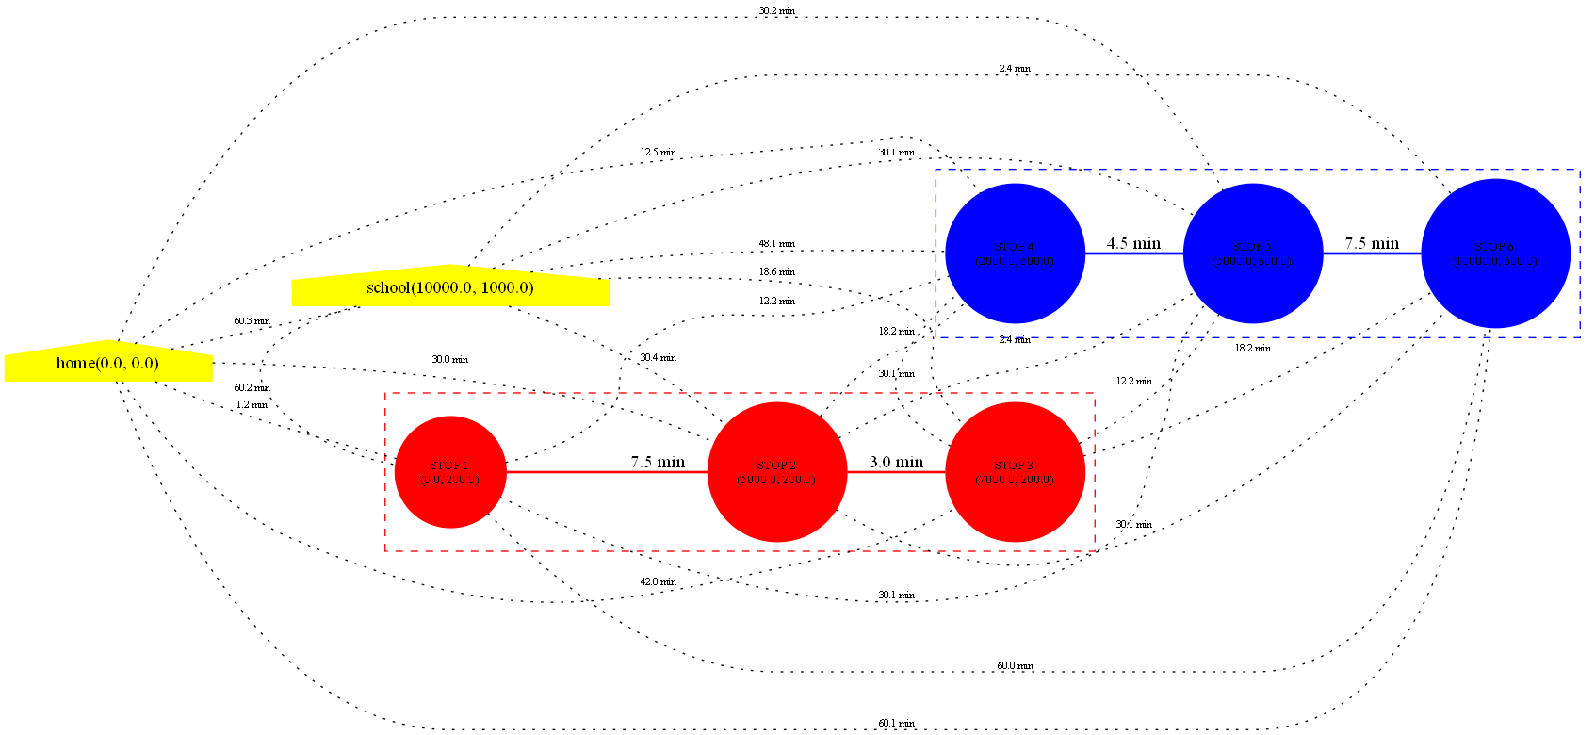

Test Case 2: No Stops
Input:

0 0 200 0
-1 -1
end

Expected Output: 1(directly walking)
Actual Output: 1
Graph Visualization:

Test Case 3: Start Equals End
Input:

100 100 100 100
-1 -1
end

Expected Output: 0
Actual Output: 0
Graph Visualization:

Test Case 4: Transfer
Input:

0 0 10000 0
0 0
5000 0
-1 -1
5000 0
-1 -1
5000 0
10000 0
-1 -1
end

Expected Output:
15(home->line1(0,0)->line1(5000,0)->line3(5000,0)->line3(10000,0)->school)
Actual Output: 15
Graph Visualization:
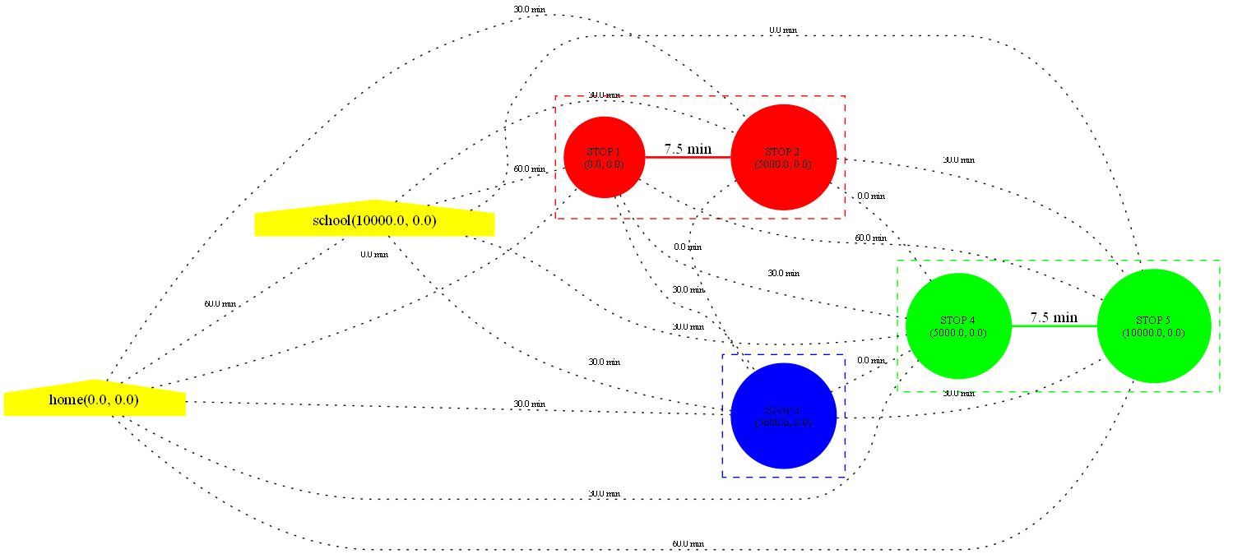

Test Case 5: Not Linear Lines
Input:

0 0 10000 10000
0 0
0 5000
0 10000
-1 -1
0 10000
5000 10000
10000 10000
-1 -1
end

Expected Output: 30 (home->L subway->school)
Actual Output: 30
Graph Visualization:
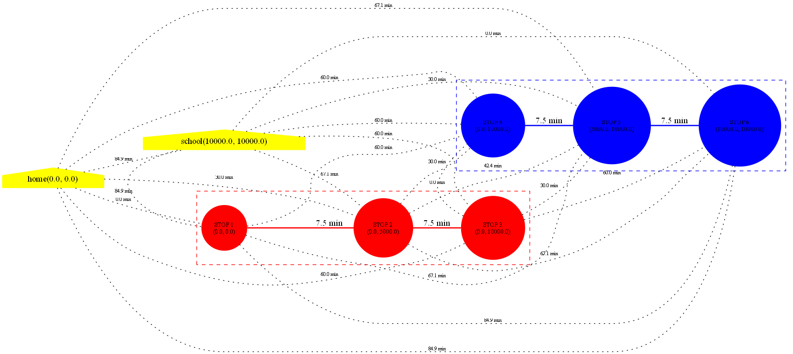

Test Case 6: Upper Bound
Input:

0 0 100000 0
0 0
500 0
1000 0
…
100000 0
-1 -1
end

Expected Output: 150(The distance between each two stops is 500 meters and total 200 stops)
Actual Output: 150
The graph size is too small thus omit it.

Test Case 7: Complex Network
Input:

0 0 10000 0
0 2000
5000 2000
10000 2000
-1 -1
5000 0
5000 2000
5000 4000
-1 -1
0 0
3333 3333
6666 6666
10000 10000
-1 -1
end

Expected Output: 39
Actual Output: 39
Graph Visualization:
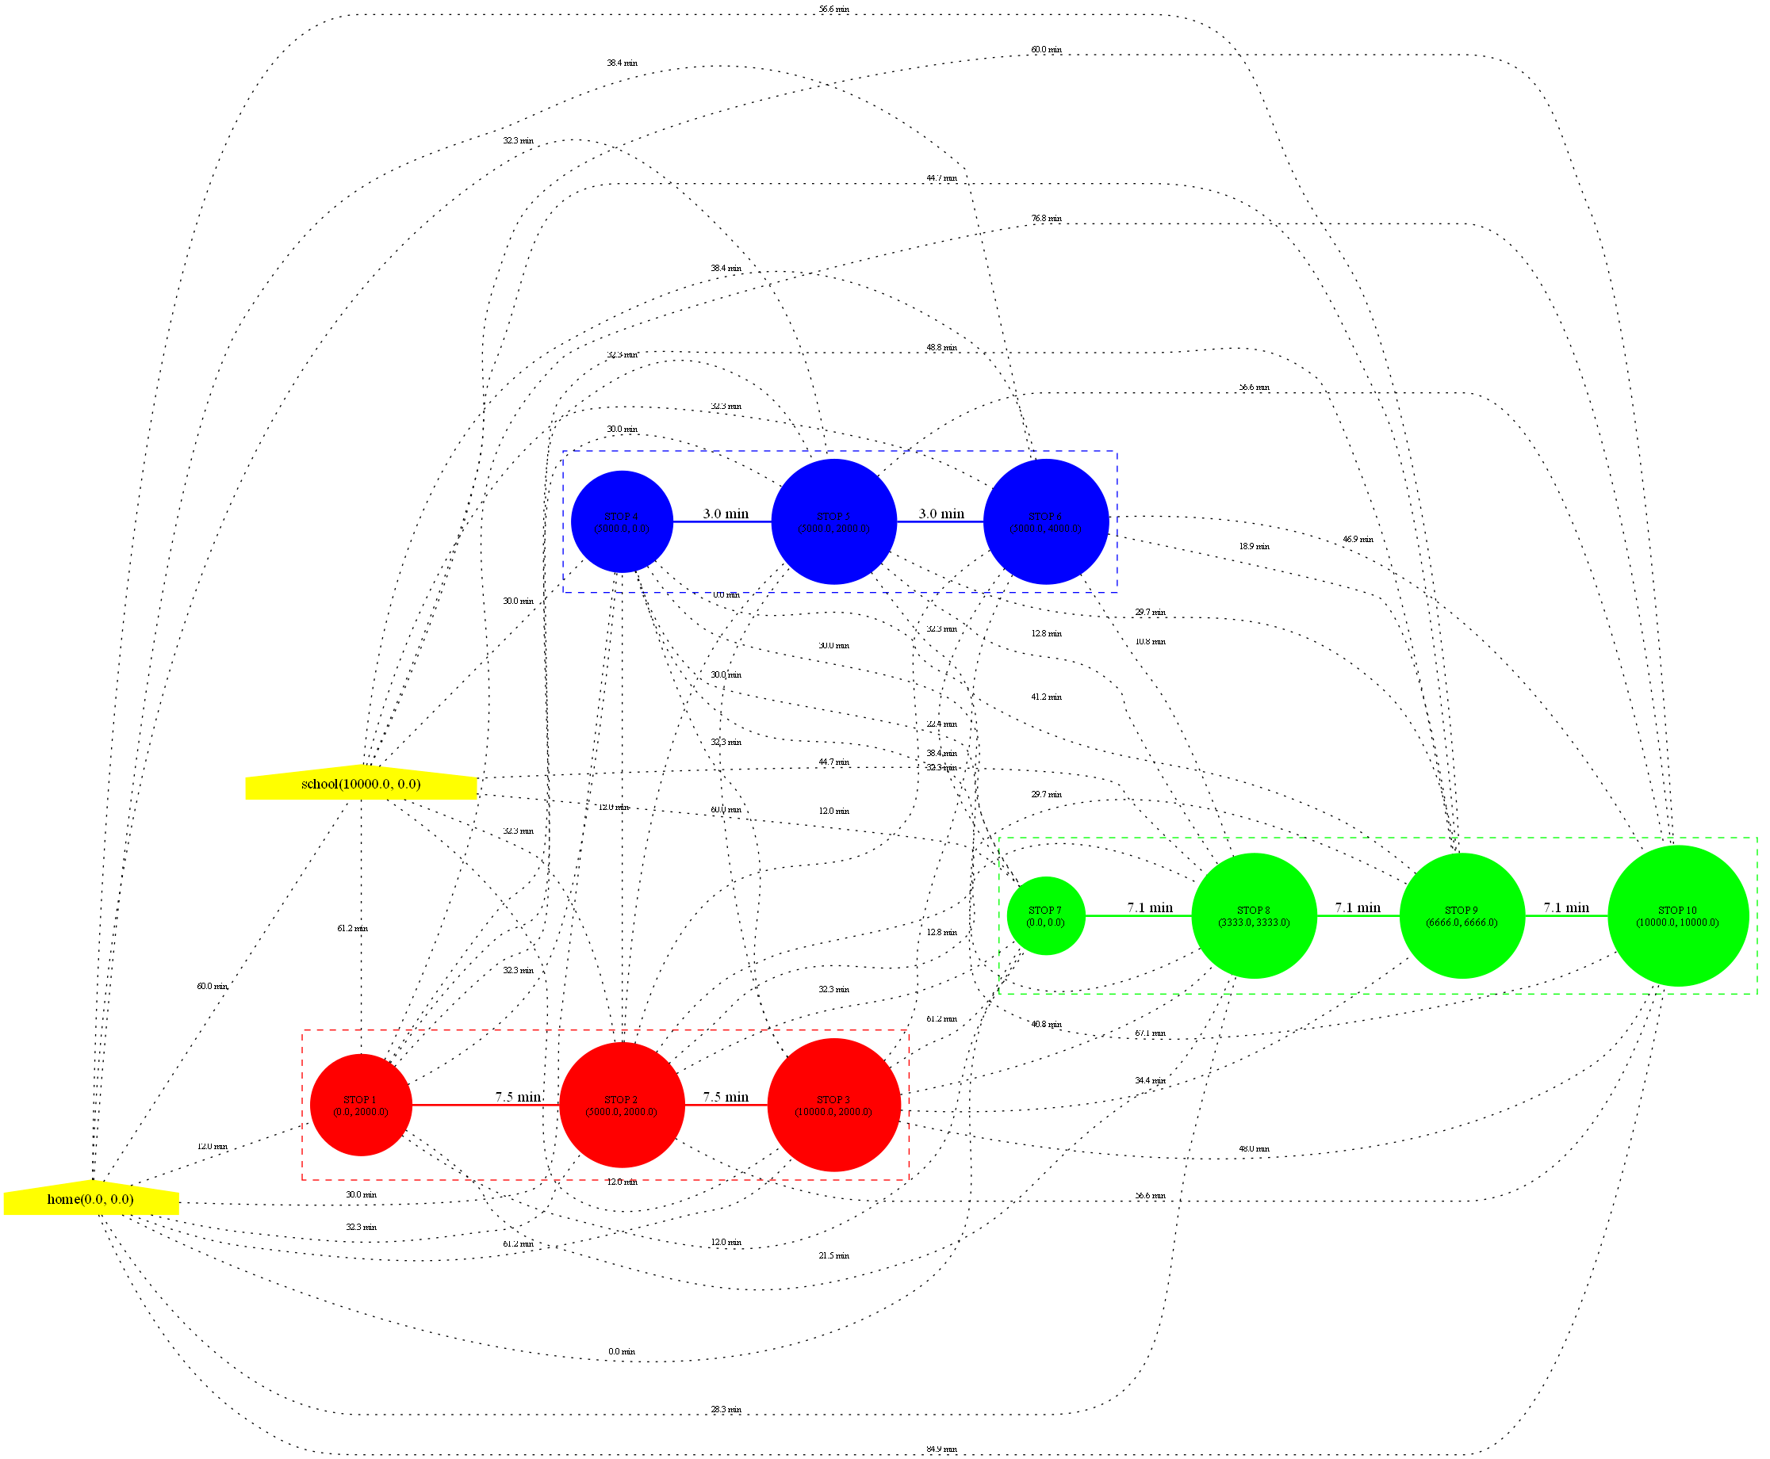

Section 4: Analysis and Comments
  - Analysis
    - Time Complexity
- Dijkstra Algorithm: O(V^2)
The algorithm iterates V times and process V edges per iteration.
- Graph Construction: O(V^2)
Triple nested loop for inter-line walking edges (worst case).
    - Space Complexity
- Adjacent Matrix: O(V^2)
- Dijkstra Structures: O(V)
  - Comments
    - Advantages:
- The merge stops eliminates redundant vertices, make the logic of management more clear.
- The design of abstract index layer can reduce the coupling between the graph and this problem. Improve the reusability of Graph ADT and robust of the problem.
- Dynamic expansion prevents overflow of the capacity.
    - Questions:
- Same question as experiment 1. Memory inefficient for sparse graphs.
- There exist too much walking edges that are not useful for the problem.
    - Optimization Direction:
- Priority Queue Optimization:
Use min-heap to replace the linear search for the minimum dist, reducing the time complexity to O(VlogV + E).
- Graph Generation Optimization:
Filter the walking edges that takes too long times to reduce the complexity of generating graph.
Section 5: Source code (in C language)
The Graph ADT is the same as Experiment 1.
Subway_Problem.c:
#include <stdio.h>
#include <stdlib.h>
#include <stdbool.h>
#include <math.h>

typedef struct Coordinate
{
double x;
double y;
} Coordinate;

#include "Graph.h"
/* int for VexType as index, double for AdjType as weight*/

#define MAX_VERTICES 300

static Coordinate coord_data[MAX_VERTICES]; // store actual data of coordinates
static int coord_cnt = 0; // the number of coordinates
static int stops[MAX_VERTICES]; // store corresponding index of actual coordinates
static int stop_cnt = 0; // the number of stops

int Stops_LocateVertex(Coordinate coord);
int Stops_InsertVertex(Graph *g, Coordinate coord);
void Initialize_Line(Graph *g, int *lines_start, int line_num);
void Stops_InsertEdge(Graph *g, int idx1, int idx2, double weight);
double Distance(Coordinate v1, Coordinate v2);
double Walking_Time(double dist);
double Subway_Time(double dist);
double Subway_Problem(int home_idx, int school_idx, Graph *g);
void Subway_Graph_to_dot(Graph *g, const char *dot_filename, int *lines_start, int line_num);

int main(int argc, char *argv[])
{
double x, y;
Coordinate home, school;
int lines_start[300]; // store start stops' index of each line
int line_idx = 0; // iterator of lines_start
Graph *g = CreateGraph(WUG);
if (!g)
{
printf("Failed to create the graph.\n");
return 1;
}

// receive the vertice home and school
if (scanf("%lf %lf", &x, &y) != 2)
{
printf("Invalid home coordinate.\n");
return 1;
}

home.x = x, home.y = y;
Stops_InsertVertex(g, home);

if (scanf("%lf %lf", &x, &y) != 2)
{
printf("Invalid school coordinate.\n");
return 1;
}

school.x = x, school.y = y;
Stops_InsertVertex(g, school);

// insert edge between school and home by walking
int home_idx = 0, school_idx = 1;
double dist = Distance(home, school);
double t = Walking_Time(dist) * 60; // transfer to minute
Stops_InsertEdge(g, home_idx, school_idx, t);

int Is_Start = 1;

// receive the lines
while (scanf("%lf %lf", &x, &y) == 2)
{
if (x == -1 && y == -1)
{
Is_Start = 1;
continue;
}

Coordinate stop = {x, y};

if (Is_Start)
{
Is_Start = 0;
lines_start[line_idx++] = stop_cnt;
}

Stops_InsertVertex(g, stop);
}

// to calculate the number of stops of the last line
lines_start[line_idx] = stop_cnt;

// initialize the line
Initialize_Line(g, lines_start, line_idx);

// output the DOT file of the graph
const char *dot_filename = (argc > 1) ? argv[1] : "Subway_Graph.dot";
Subway_Graph_to_dot(g, dot_filename, lines_start, line_idx);

int ans = (int)round(Subway_Problem(home_idx, school_idx, g));

if (ans < 0)
{
DestroyGraph(g);
return 1;
}

printf("%d\n", ans);
DestroyGraph(g);
return 0;
}

// return the distance between two vertices (m)
double Distance(Coordinate v1, Coordinate v2)
{
double dx = v1.x - v2.x;
double dy = v1.y - v2.y;
return sqrt(dx * dx + dy * dy);
}

// return the time of walking dist (h)
double Walking_Time(double dist)
{
double walking_speed = 10 * 1000;
return dist / walking_speed;
}

// return the time of subway the dist (h)
double Subway_Time(double dist)
{
double subway_speed = 40 * 1000;
return dist / subway_speed;
}

// Get the index of stop in coord_data
int Stops_LocateVertex(Coordinate coord)
{
for (int i = 0; i < coord_cnt; i++){
double dist = Distance(coord_data[i], coord);
if (dist < 1e-3)
{
return i;
}
}

return -1;
}

// Insert the stop index in the graph and return its position in coord
int Stops_InsertVertex(Graph *g, Coordinate coord)
{
// transfer stop, return index
int v = Stops_LocateVertex(coord);
if (v != -1)
{
stops[stop_cnt] = v;
InsertVertex(g, stop_cnt);
stop_cnt++;
return v;
}

// insert the coord into coord_data
if (coord_cnt >= MAX_VERTICES){
printf("Too many coordinates.\n");
return -1;
}

coord_data[coord_cnt].x = coord.x;
coord_data[coord_cnt].y = coord.y;
stops[stop_cnt] = coord_cnt++;

// insert the corresponding index into graph
InsertVertex(g, stop_cnt);
if (!g){
return -1;
}

stop_cnt++;

return coord_cnt;
}

// Insert edge by index in the graph
void Stops_InsertEdge(Graph *g, int idx1, int idx2, double weight)
{
if (idx1 == -1 || idx2 == -1){
printf("The coordinate is not in the graph.\n");
return;
}

InsertEdge(g, idx1, idx2, weight);
if (!g){
return;
}
}

// initialize the line into graph
void Initialize_Line(Graph *g, int *lines_start, int line_num)
{
// handle the error situation
if (!g)
{
printf("The graph has not been created.\n");
return;
}

int home_idx = 0, school_idx = 1;

// connect all stops to home and school by walking
for (int i = 2; i < stop_cnt; i++)
{
Coordinate home = coord_data[home_idx], curr = coord_data[stops[i]], school = coord_data[school_idx];
double dist_to_home = Distance(home, curr);
double dist_to_school = Distance(curr, school);

double time_to_home = Walking_Time(dist_to_home) * 60;
double time_to_school = Walking_Time(dist_to_school) * 60;

Stops_InsertEdge(g, home_idx, i, time_to_home);
Stops_InsertEdge(g, school_idx, i, time_to_school);
}

// connect all stops on different lines by walking
for (int i = 2; i < stop_cnt; i++)
{
for (int j = i + 1; j < stop_cnt; j++)
{
// check whether is on the same line
bool same_line = false;
for (int k = 0; k < line_num; k++)
{
if (i >= lines_start[k] && i < lines_start[k + 1] &&
j >= lines_start[k] && j < lines_start[k + 1])
{
same_line = true;
break;
}
}

if (!same_line)
{
Coordinate coord1 = coord_data[stops[i]], coord2 = coord_data[stops[j]];
// for different line with same stops, not renew the edge
double dist = Distance(coord1, coord2);
double time = Walking_Time(dist) * 60; // transfer to minute

Stops_InsertEdge(g, i, j, time);
}
}
}

// connect all stops on the same line by subway
for (int j = 0; j < line_num; j++)
{
int start_idx = lines_start[j];
int end_idx = lines_start[j + 1];

for (int i = start_idx; i < end_idx - 1; i++)
{
Coordinate coord1 = coord_data[stops[i]], coord2 = coord_data[stops[i + 1]];
double dist = Distance(coord1, coord2);
double time = Subway_Time(dist) * 60; // transfer to minute

Stops_InsertEdge(g, i, i + 1, time);
}
}

return;
}

// solve the problem and return the shortest time from home to school
double Subway_Problem(int home_idx, int school_idx, Graph *g)
{
// handle the error situation
if (!g)
{
printf("The graph has not been created.\n");
return -1;
}

double tmp_dist = Distance(coord_data[stops[home_idx]], coord_data[stops[school_idx]]);
if (tmp_dist < 1e-3)
{
printf("The position of home and the school are the same.\n");
return 0;
}

int vex_num = g->vexnum;

if (home_idx < 0 || home_idx >= vex_num ||
school_idx < 0 || school_idx >= vex_num)
{
printf("Invalid home_idx/school_idx index (out of range).\n");
return -1;
}

// create an array to store shortest distance from the home to the point
double *dist = (double *)calloc(vex_num, sizeof(double));
if (!dist)
{
printf("Failed to create an array to store shortest distance.\n");
return -1;
}

// create an array to store the situation of visit
int *Isvisited = (int *)calloc(vex_num, sizeof(int));
if (!Isvisited)
{
printf("Failed to create an array to store the situation of visit.\n");
free(dist);
return -1;
}

// initialize the dist
int min_dist_idx;
double min_dist;

for (int i = 0; i < vex_num; i++)
{
dist[i] = g->adj[home_idx][i];
}

dist[home_idx] = 0;
Isvisited[home_idx] = 1;

while (1)
{
// find the minimum in dist
min_dist = GRAPH_INF;
min_dist_idx = -1;

for (int j = 0; j < vex_num; j++)
{
if (!Isvisited[j] && min_dist > dist[j])
{
min_dist = dist[j];
min_dist_idx = j;
}
}

// break if traverse all vertices
if (min_dist_idx == -1)
{
break;
}

Isvisited[min_dist_idx] = 1;

// break if find the shortest path to school
if (min_dist_idx == school_idx)
{
break;
}

// Dijkstra algorithm to renew the dist
for (int j = 0; j < vex_num; j++)
{
if (!Isvisited[j] && g->adj[min_dist_idx][j] != GRAPH_INF && min_dist + g->adj[min_dist_idx][j] < dist[j])
{
dist[j] = min_dist + g->adj[min_dist_idx][j];
}
}
}

// judge whether find the position of school
double ret = -1;
if (min_dist_idx == school_idx)
{
ret = dist[school_idx];
}
else
{
printf("No path from home to school.\n");
}

free(Isvisited);
free(dist);

return ret;
}

// Output DOT file of graph
void Subway_Graph_to_dot(Graph *g, const char *dot_filename, int *lines_start, int line_num)
{
if (!g){
printf("The graph has not been created.\n");
return;
}

if (IsEmpty(g)){
printf("The graph is empty.\n");
return;
}

// open DOT file
FILE *fp = fopen(dot_filename, "w");
if (!fp){
printf("Failed to create DOT file.\n");
return;
}

// write the head of DOT
fprintf(fp, "graph Subway_Graph{\n");
fprintf(fp, " rankdir = LR;\n");
fprintf(fp, " node [shape = circle, style = filled, color = lightblue]; // style of vertices\n");
fprintf(fp, " edge [color = black]; // style of edges\n");

fprintf(fp, " 0 [label = \"home(%.1f, %.1f)\", shape = house, color = yellow];\n", coord_data[stops[0]].x, coord_data[stops[0]].y);
fprintf(fp, " 1 [label = \"school(%.1f, %.1f)\", shape = house, color = yellow];\n", coord_data[stops[1]].x, coord_data[stops[1]].y);

// create subgraph for each line
const char *colors[] = {"red", "blue", "green", "purple", "orange"};

for (int i = 0; i < line_num; i++)
{
int start = lines_start[i];
int end = lines_start[i + 1];

const char *color = colors[i % 5];

// create subgraph head
fprintf(fp, " subgraph cluster_line%d {\n", i);
fprintf(fp, " style = dashed;\n");
fprintf(fp, " color = %s;\n", color);
fprintf(fp, " lable = \"Line %d\";\n", i + 1);

// write stops in a line
for (int j = start; j < end; j++)
{
fprintf(fp, " %d [label = \"STOP %d\\n(%.1f, %.1f)\", color = %s, fontsize = 10];\n", j, j - 1, coord_data[stops[j]].x, coord_data[stops[j]].y, color);
}

// highlight edges in a line
for (int j = start; j < end - 1; j++){
fprintf(fp, " %d -- %d [color = %s, penwidth = 2, weight = 100, label = \"%.1f min\"];\n", j, j + 1, color, g->adj[j][j + 1]); // high weight to ensure straight line
}

fprintf(fp, " }\n");
}

fprintf(fp, "\n");

// create walking edges
int vex_num = g->vexnum;
for (int i = 0; i < vex_num; i++){
for (int j = i + 1; j < vex_num; j++){
if (fabs(g->adj[i][j] - GRAPH_INF) > 1e-9){
bool adjacent_in_line = false;
for (int k = 0; k < line_num; k++){
int start = lines_start[k];
int end = lines_start[k + 1];

if (i >= start && i < end
&& j >= start && j < end && j == i + 1){
adjacent_in_line = true;
break;
}
}

if (!adjacent_in_line){
fprintf(fp, " %d -- %d[style = dotted, color = black, weight = 1, len = 2.0, label = \"%.1f min\", fontsize = 8];\n", i, j, g->adj[i][j]);
}
}
}
}

fprintf(fp, "\n");

// write the tail of DOT
fprintf(fp, "}\n");
fclose(fp);
}

