JNU International School
《Data Structure》Lab Report

Score ：

Project ： | Data Structure
Name ： | 李荣耀
Student No： | 2024103975
Semester ： | First Semester of Sophomore
Date ： | 2025/12/16

Experiment：Sorting
Section 1: Introduction
  - Problem to Solve
This experiment aims to deepen understanding of different sorting algorithms. The specific tasks include:
- Implement four classic sorting algorithms, including Bubble Sort, Binary Insertion Sort, Quick Sort and Merge Sort.
- Read input data from input.txt file(containing at least 1000 randomly generated integers) and output sorted data to output.txt file.
- Measure the actual running time of each algorithm to verify their theoretical time complexity.
- Analyze the performance differences between algorithms.
  - Background Knowledge
Sorting is one of the most fundamental and widely used operations in computer science, accounting for a significant proportion of CPU cycles in practical applications.
- Bubble Sort and Insertion Sort:
Basic comparison-based sorting, while binary insertion sort optimizes the search step of direct insertion sort, reducing comparison times.
- Quick Sort and Merge Sort:
More efficient comparison-based sorting, relying on divide-and-conquer algorithms.
Section 2: Algorithms Specification
  - Description of Data Structures
    - Bubble Sort
Input integer array. In-place sorting, no extra place.
    - Binary Insertion Sort
Input integer array. In-place sorting, no extra place.
    - Quick Sort
Input integer array. In-place sorting, recursion stack space O(logn).
    - Merge Sort
Input integer array and auxiliary array O(n).
  - Integrity of Algorithm Logic
    - Bubble Sort
Iteratively compare adjacent elements and swap them if they are in wrong order.
  - Traverse the array from end to the start.
  - Compare adjacent elements and swap if the left is larger than the right, setting flag as true to mark swap.
  - Break the loop if flag is false.
    - Binary Insertion Sort
Retain the shift elements logic of direct insertion sort but use binary search to find the insertion position of target elements.
  - Iterate through the array and taking the end-1-th element as the target to insert.
  - Use binary search to find the insertion position.
  - Shift elements from the insertion position to end one position to the right and insert the target element at left.
    - Quick Sort (Tail Recursion Optimization + Hoare Partition + Three-Number Median + Insertion Sort optimization)
Divide the array using a pivot, place elements smaller than the pivot on the left and larger elements on the right, then recursively sort the subarrays.
  - If the array size is less than 50, switch to Binary Insertion Sort.
  - Select the pivot via three-number median and hide it at the right end.
  - Use Hoare partition (double pointer) to partition the array into left (smaller than pivot) and right (larger than pivot) parts.
  - Recursively process the smaller subarray and update the loop range to process the larger subarray iteratively.
    - Merge Sort
Split the array into two halves, recursively sort each half, then merge the two sorted halves into a single sorted array.
  - If the array size is less than or equal to 1, return.
  - Split the array into two halves at the midpoint.
  - Recursively sort the left and right halves.
  - Merge the two halves into the auxiliary array then copy the result back to the original array.
Section 3: Test results

  - Test Environment
- OS: Windows 11 (64-bit)
- Compiler: GCC with -O3 optimization
- CPU: Intel Core i5-12400f (4.4Ghz)
- Measurement: Microsecond-resolution timing via gettimeofday().
  - Performance
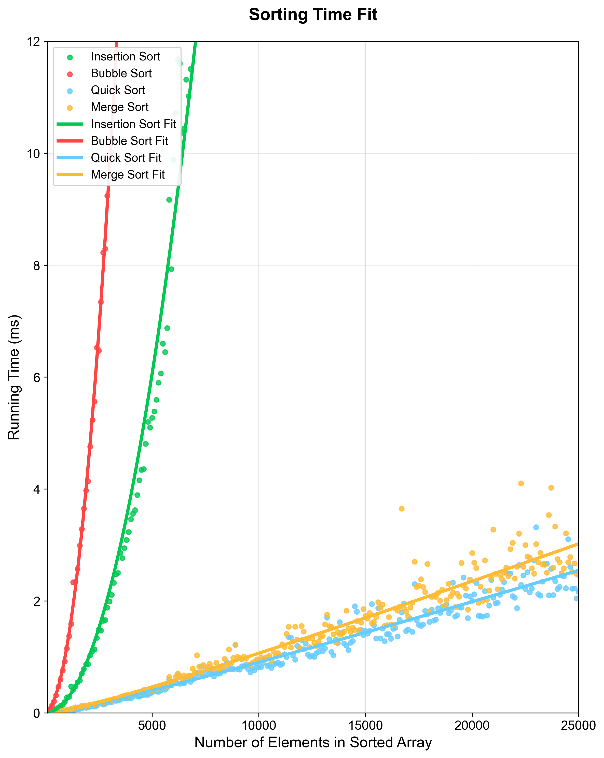
The code regarding generating csv file and visualization are in Section 5.
- Small-Scale Test (n = 1000)
Expected: Insertion Sort approximately equals to Quick Sort due to cut off threshold.
Actual Results:
  - Bubble Sort: 1.148280ms
  - Insertion Sort: 0.277760ms
  - Quick Sort: 0.02036ms
  - Merge Sort: 0.055610ms
All O(nlogn) algorithms perform similarly, while Quick Sort is much quick than Insertion Sort. Insertion Sort has apparently improvement than Bubble Sort which is also O(n ^ 2) algorithm due to binary search.
- Medium-Scale Test (n = 5000)
Expected: O(nlogn) algorithms shows apparent advantage.
Actual Results:
  - Bubble Sort: 27.209760ms
  - Insertion Sort: 5.270760ms
  - Quick Sort: 0.365100ms
  - Merge Sort: 0.408540ms
Insertion sort still competitive than bubble sort.
- Large-Scale Test (n = 20000)
Expected: Quick Sort and Merge Sort should dominate.
Actual Results:
  - Bubble Sort: 755.133900ms
  - Insertion Sort: 99.617400ms
  - Quick Sort: 2.006600ms
  - Merge Sort: 2.857700ms
Quick Sort maintains lead and insertion sort shows apparent O(n ^ 2) degradation.
Section 4: Analysis and Comments
  - Analysis
    - Time Complexity
Algorithm | Best Time Complexity | Average Time Complexity | Worst Time Complexity
Bubble Sort | O(n) | O(n^2) | O(n^2)
Binary Insertion Sort | O(nlogn) | O(n^2) | O(n^2)
Quick Sort | O(nlogn) | O(nlogn) | O(n^2)
Merge Sort | O(nlogn) | O(nlogn) | O(nlogn)
- Bubble Sort: The O(n ^ 2) complexity is evident in the timing results. Time increases quadratically with array size.
- Binary Insertion Sort: Although the average and worst complexity is still O(n ^ 2), binary search reduces the comparison overhead, making it much faster than Bubble Sort.
- Quick Sort: The fastest among all algorithm due to O(nlogn) complexity and low constant overhead. Optimizations like three-number median avoid worst-case scenarios.
- Merge Sort: Stable O(nlogn) complexity but slower than Quick Sort due to extra auxiliary array copy operations.
    - Space Complexity
- Bubble Sort/ Binary Insertion Sort: O(1)
In-place sorting, no extra space except temporary variables.
- Quick Sort: O(logn)
Recursion stack depth, optimized by tail recursion to avoid O(n) worst case.
- Merge Sort: O(n)
Fixed auxiliary array and no repeated allocation.
  - Comments
    - Questions:
- The version of Hoare partition on PPT has incorrect. Pointers should first movement and then compare.
- The precision of testing time on project are not sufficient. Here I use more accurate time test function.
    - Advantages:
- Quick Sort:
Use three-number median to avoid the worst case and improve the efficiency. Use tail recursion to avoid the worst recursion O(n) complexity. Use Insertion Sort when scale is small to improve cache locality.
- The precision of testing time on project are not sufficient. Here I use more accurate time test function.
    - Optimization Direction:
- Quick Sort:
Use “median-of-medians” to select the pivot for guaranteed O(nlogn) worst-case complexity .
- Merge Sort:
For large arrays, parallelize Merge Sort’s recursive steps to process by multi-threading.
- Binary Sort:
Add a gap to reduce the number of element shifts, like Shell Sort. Further improve efficiency for medium-sized arrays.
Section 5: Source code
Sorting.c:
#include <stdio.h>
#include <stdlib.h>
#include <string.h> // use memcpy
#include <time.h> // measure the performance of functions
#include <sys/time.h> // for more accurate time test

typedef void (*Sort_Func)(int *, int); // define function pointer type

void Bubble_Sort(int a[], int size);
void Insertion_Sort(int a[], int size);
void Merge_Sort(int a[], int size);
void Quick_Sort(int a[], int size);
int Generate_Input_File();
void Generate_Output_File();
void Run_Performance_Test();

// auxiliary functions
double Time_Test(int a[], int size, Sort_Func sort);
void Swap(int *a, int *b);
int Median(int *a, int left, int right);
void Auxi_Msort(int a[], int size, int *tmparr);
void Generate_Random_Array(int a[], int size);
int Repeat_Times(int size, Sort_Func sort);
double get_time_us();

int main(int argc, char *argv[]){
srand(time(0));
int size = Generate_Input_File();
Generate_Output_File(size);
Run_Performance_Test();
return 0;
}

// swap two int value
void Swap(int *a, int *b){
int tmp = *a;
*a = *b;
*b = tmp;
}

// find median of three number
int Median(int *a, int left, int right)
{
// ensure safe for small array
if (right - left + 1 <= 1)
return 0;

// order the three number
int mid = ((right - left) >> 1) + left;
if (a[left] > a[mid]){
Swap(&a[left], &a[mid]);
}
if (a[left] > a[right]){
Swap(&a[left], &a[right]);
}
if (a[mid] > a[right]){
Swap(&a[mid], &a[right]);
}

/*hide pivot to right rather than right - 1 to make the code
more readable and standard*/
Swap(&a[mid], &a[right]);

return a[right];
}

// bubble sort
void Bubble_Sort(int a[], int size)
{
for (int i = size - 1; i > 0; i--){
int flag = 0;
for (int j = 0; j < i; j++){
if (a[j] > a[j + 1]){
Swap(&a[j], &a[j + 1]);
flag = 1;
}
}
// break if no swaps
if (!flag)
break;
}
}

// binary insertion sort
void Insertion_Sort(int a[], int size)
{
for (int end = 0; end < size - 1; end++)
{
// binary search to find insertion position
int left = 0, right = end;
int tmp = a[end + 1];
while (left <= right){
int mid = ((right - left) >> 1) + left;
// strictly larger to ensure stable
if (a[mid] > tmp){
right = mid - 1;
}else {
left = mid + 1;
}
}

// move
for (int i = end; i >= left; i--){
a[i + 1] = a[i];
}
a[left] = tmp;
}
}

// quick sort: tail recursion optimization and Hoare partition
void Quick_Sort(int a[], int size)
{
// Insertion sort when size is small
const int min_lim = 50;

int left = 0, right = size - 1;

while (size > min_lim){
int pivot = Median(a, left, right);

int i = left - 1, j = right;

while (1){
// find the element greater than pivot by left iterator
// first decrease or increase to avoid iterator stopping movement
while (a[++i] < pivot)
;
// find the element smaller than pivot by right iterator
while (a[--j] > pivot)
;
// swap the two elements if the iterators are legal
if (i < j)
{
Swap(&a[i], &a[j]);
}
else
break;
}

// swap the pivot and the left iterator
Swap(&a[i], &a[right]);

// recursion for small partition and loop for larger partition
if (i - left > right - i){
Quick_Sort(a + i + 1, right - i);
right = i - 1;
size = right - left + 1;
}else{
Quick_Sort(a + left, i - left);
left = i + 1;
size = right - left + 1;
}
}

Insertion_Sort(a + left, size);
}

// merge sort
void Merge_Sort(int a[], int size)
{
if (size <= 1)
return;

int *tmparr = (int *)malloc(size * (sizeof(int)));
if (!tmparr){
printf("No memory to create extra array.\n");
return;
}

Auxi_Msort(a, size, tmparr);

free(tmparr);
}

// auxiliary function to decrease the space complexity
void Auxi_Msort(int a[], int size, int *tmparr)
{
if (size <= 1){
return;
}

int mid = size / 2;
// merge sort the left half array
Auxi_Msort(a, mid, tmparr);
// merge sort the right half array
Auxi_Msort(a + mid, size - mid, tmparr);

int left = 0, right = mid;
int i = 0;

// merge the left and right half array to tmparr
while (left < mid && right < size){
if (a[left] <= a[right]){
tmparr[i++] = a[left++];
}else {
tmparr[i++] = a[right++];
}
}

while (left < mid){
tmparr[i++] = a[left++];
}
while (right < size){
tmparr[i++] = a[right++];
}

// copy the tmparr to original array
for (i = 0; i < size; i++){
a[i] = tmparr[i];
}
}

// more accurate time (us)
double get_time_us()
{
struct timeval tv;
gettimeofday(&tv, NULL);
return tv.tv_sec * 1000000.0 + tv.tv_usec;
}

// test the performance of a function
double Time_Test(int a[], int size, Sort_Func sort)
{
double start, stop;
double duration = 0.0;
int rep = Repeat_Times(size, sort);

// create test array
int *test = (int *)malloc(size * sizeof(int));
if (!test){
printf("Failed to create array to test.\n");
exit(1);
}

for (int i = 0; i < rep; i++)
{
memcpy(test, a, size * sizeof(int));
start = get_time_us();
sort(test, size);
stop = get_time_us();
duration += stop - start;
}

return (duration / rep) / 1000; // ms
}

// generate random array
void Generate_Random_Array(int a[], int size)
{
for (int i = 0; i < size; i++){
// avoid the limitation of RAND_MAX
a[i] = (rand() << 15 | rand()) % 100000 + 1;
}
}

// return different repeat times for different scale
int Repeat_Times(int size, Sort_Func sort)
{
if (sort == Bubble_Sort || sort == Insertion_Sort)
{
if (size <= 1000)
return 100;
if (size <= 5000)
return 50;
if (size <= 10000)
return 20;
return 10;
}

if (sort == Quick_Sort || sort == Merge_Sort)
{
if (size <= 2000)
return 100;
if (size <= 10000)
return 50;
if (size <= 20000)
return 20;
return 10;
}
return 1;
}

// generate input file and return its size
int Generate_Input_File()
{
FILE *fp = fopen("input.txt", "w");
if (!fp){
printf("Failed to generate input file.\n");
exit(1);
}

int size;
printf("Please enter the scale of input array. (at least 1000).\n");
scanf("%d", &size);
size = (size < 1000) ? 1000 : size;

int *arr = (int *)malloc(size * sizeof(int));
if (!arr){
printf("Failed to create array.\n");
fclose(fp);
exit(1);
}

Generate_Random_Array(arr, size);

for (int i = 0; i < size; i++){
fprintf(fp, "%d ", arr[i]);
if ((i + 1) % 10 == 0){
fprintf(fp, "\n");
}
}

free(arr);
fclose(fp);
return size;
}

// generate output file
void Generate_Output_File(int size)
{
FILE *fp1 = fopen("output.txt", "w");
FILE *fp2 = fopen("input.txt", "r");
if (!fp1){
printf("Failed to generate output file.\n");
exit(1);
}
if (!fp2){
printf("Failed to open input file.\n");
fclose(fp1);
exit(1);
}

const char *names[] = {"Bubble Sort", "Insertion Sort", "Quick Sort", "Merge Sort"};
Sort_Func sorts[] = {Bubble_Sort, Insertion_Sort, Quick_Sort, Merge_Sort};
const int sorts_size = sizeof(sorts) / sizeof(sorts[0]);

// create the array to receive the input
int *arr = (int *)malloc(size * sizeof(int));
if (!arr){
printf("Fail to create the array to test.\n");
fclose(fp1);
fclose(fp2);
exit(1);
}

for (int i = 0; i < size; i++){
fscanf(fp2, "%d", &arr[i]);
}

fprintf(fp1, "Test Results: (Input Size = %d)\n", size);
fprintf(fp1, "================================================\n");
for (int i = 0; i < sorts_size; i++){
double total_duration = Time_Test(arr, size, sorts[i]);

fprintf(fp1, "%s : Time: %.6f ms\n", names[i], total_duration);

// sort oringin array
sorts[i](arr, size);
for (int k = 0; k < size; k++)
{
fprintf(fp1, "%d ", arr[k]);
if ((k + 1) % 10 == 0)
{
fprintf(fp1, "\n");
}
}

fprintf(fp1, "\n================================================\n");
}

fclose(fp1);
fclose(fp2);
free(arr);
}

// generate performance.csv
void Run_Performance_Test()
{
FILE *fp = fopen("Performance_of_Sorting.csv", "w");
if (!fp){
printf("Failed to create performance test file.\n");
exit(1);
}

fprintf(fp, "Size, BubbleSort, InsertionSort, QuickSort, MergeSort\n");

int max_size = 25000, gap = 100;
for (int size = 100; size <= max_size; size += gap){
printf("Testing size: %d\n", size);

// int rep = Repeat_Times(size);
Sort_Func sorts[] = {Bubble_Sort, Insertion_Sort, Quick_Sort, Merge_Sort};
const int sorts_size = sizeof(sorts) / sizeof(sorts[0]);
double *avg_time = (double *)calloc(sorts_size, sizeof(double));
if (!avg_time){
printf("Failed to create array to store average time.\n");
fclose(fp);
exit(1);
}

int *arr = (int *)malloc(size * sizeof(int));
if (!arr)
{
printf("Failed to create array to test.\n");
fclose(fp);
free(avg_time);
exit(1);
}

for (int i = 0; i < sorts_size; i++)
{
Generate_Random_Array(arr, size);
avg_time[i] = Time_Test(arr, size, sorts[i]);
}

fprintf(fp, "%d, %.6f, %.6f, %.6f, %.6f\n", size, avg_time[0], avg_time[1], avg_time[2], avg_time[3]);

fflush(fp);
free(avg_time);
free(arr);
}

fclose(fp);
}
Visualize.py
import pandas as pd
import numpy as np
import matplotlib.pyplot as plt
from scipy.optimize import curve_fit
import warnings
warnings.filterwarnings('ignore')

# ---------------------- read data and filter appropriate points ----------------------
csv_path = "Performance_of_Sorting.csv"
df = pd.read_csv(csv_path)
df.columns = df.columns.str.strip()

def filter_data(col_name):
return df[(df["Size"] >= 100) & (df[col_name] <= 12)][["Size", col_name]]

df_bubble = filter_data("BubbleSort")
df_insert = filter_data("InsertionSort")
df_quick = filter_data("QuickSort")
df_merge = filter_data("MergeSort")

x_bubble, y_bubble = df_bubble["Size"].values, df_bubble["BubbleSort"].values
x_insert, y_insert = df_insert["Size"].values, df_insert["InsertionSort"].values
x_quick, y_quick = df_quick["Size"].values, df_quick["QuickSort"].values
x_merge, y_merge = df_merge["Size"].values, df_merge["MergeSort"].values

# ---------------------- define fitting curve ----------------------
def func_n2_origin(n, a):
# appropriate for insertion sorting
return a * n**2

def func_n2_normal(n, a, b, c):
return a * n**2 + b * n + c

def func_nlogn_local(n, a, b):
return a * n * np.log2(n) + b

# ---------------------- fitting curve ----------------------
popt_insert, _ = curve_fit(
func_n2_origin, x_insert, y_insert,
p0=[1e-8],
maxfev=30000
)

popt_bubble, _ = curve_fit(
func_n2_normal, x_bubble, y_bubble,
p0=[1e-8, 1e-4, 0.1],
maxfev=20000
)

popt_quick, _ = curve_fit(func_nlogn_local, x_quick, y_quick, p0=[1e-6, 0.1], maxfev=20000)
popt_merge, _ = curve_fit(func_nlogn_local, x_merge, y_merge, p0=[1e-6, 0.1], maxfev=20000)

# ---------------------- generate fitting curve ----------------------
x_fit = np.linspace(0, 25000, 2000)

y_insert_fit = func_n2_origin(x_fit, *popt_insert)
mask_insert = y_insert_fit <= 12
x_insert_fit_show = x_fit[mask_insert]
y_insert_fit_show = y_insert_fit[mask_insert]

y_bubble_fit = func_n2_normal(x_fit, *popt_bubble)
mask_bubble = y_bubble_fit <= 12
x_bubble_fit_show = x_fit[mask_bubble]
y_bubble_fit_show = y_bubble_fit[mask_bubble]

y_quick_fit = func_nlogn_local(x_fit, *popt_quick)
y_merge_fit = func_nlogn_local(x_fit, *popt_merge)
mask_nlogn = y_quick_fit <= 12
x_quick_fit_show = x_fit[mask_nlogn]
y_quick_fit_show = y_quick_fit[mask_nlogn]
x_merge_fit_show = x_fit[mask_nlogn]
y_merge_fit_show = y_merge_fit[mask_nlogn]

# ---------------------- visualization ----------------------
plt.rcParams['font.sans-serif'] = ['Arial']
plt.figure(figsize=(8, 10))

plt.scatter(x_insert, y_insert, s=20, c='#00C851', alpha=0.8, label='Insertion Sort', marker='o')
plt.scatter(x_bubble, y_bubble, s=20, c='#FF4444', alpha=0.8, label='Bubble Sort', marker='o')
plt.scatter(x_quick, y_quick, s=20, c='#66CCFF', alpha=0.8, label='Quick Sort', marker='o')
plt.scatter(x_merge, y_merge, s=20, c='#FFBB33', alpha=0.8, label='Merge Sort', marker='o')

plt.plot(x_insert_fit_show, y_insert_fit_show, c='#00C851', linewidth=3, linestyle='-', label=f'Insertion Sort Fit')
plt.plot(x_bubble_fit_show, y_bubble_fit_show, c='#FF4444', linewidth=3, linestyle='-', label=f'Bubble Sort Fit')
plt.plot(x_quick_fit_show, y_quick_fit_show, c='#66CCFF', linewidth=3, linestyle='-', label=f'Quick Sort Fit')
plt.plot(x_merge_fit_show, y_merge_fit_show, c='#FFBB33', linewidth=3, linestyle='-', label=f'Merge Sort Fit')

plt.xlim(100, 25000)
plt.ylim(0, 12)

plt.xlabel('Number of Elements in Sorted Array', fontsize=14)
plt.ylabel('Running Time (ms)', fontsize=14)
plt.title('Sorting Time Fit', fontsize=16, fontweight='bold', pad=20)
plt.legend(loc='upper left', fontsize=11, framealpha=0.9)
plt.grid(True, alpha=0.4, linestyle='-', linewidth=0.5)
plt.xticks(fontsize=12)
plt.yticks(fontsize=12)

plt.tight_layout()
plt.savefig('sorting_fit.png', dpi=300, bbox_inches='tight')
plt.show()

