WarmUp Prog. Exercise for SE (April 1)
Solve the following 4 problems by programming. Test all your programs in your own environment. Put all your code with input data and output data in separate sub-folders for each problem, zip them in a package like 2345AdamSmith-WarmUpProg.zip and send it to c.max@yeah.net with an email subject like: SE-2345AdamSmith: WarmUp Prog. Exercise. before (including) April 11.

P1 Dragon curves. Write a program to get an integer N from command-line arguments and print the instructions for drawing the dragon curve of order N. The instructions are strings of F, L, and R characters, where F means “draw line while moving 1 unit forward,” L means “turn left,” and R means “turn right.” A dragon curve of order n is formed when you fold a strip of paper in half n times, then unfold to right angles. The key to solving this problem is to note that a curve of order n is a curve of order n-1 followed by an L followed by a curve of order n-1 traversed in reverse order, and then to figure out a similar description for the reverse curve.
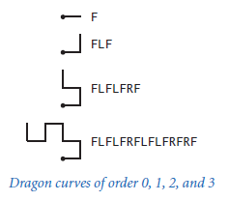

(Tips: You may search “Dragon curves” or “龙形曲线” online for help.
For example: https://www.cnblogs.com/WhyEngine/p/4013245.html )
P2 Write a program to output the following digit diamond in the console.
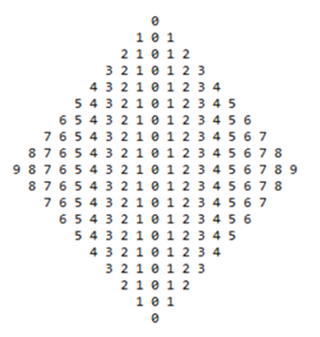
P3 Write 2 overloading static methods to construct a String that compose a diamond:
public static String diamond ();
public static String diamond (int n, char… color);
System.out.print( diamond() ) will output as left below:
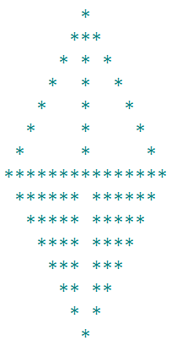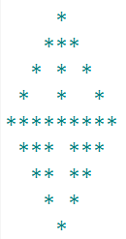
System.out.print( diamond( 5 ) ) will output as right above.

System.out.print( diamond( 7, ’$’ ) ) will output as left below:


System.out.print( diamond( 6, ’@’, ’.’ ) ) will output as right above.
(Tips: in diamond(int n, char… color) declaration, where declared a variable-length argument (varargs) color that works like a char[] in the method body and may have a color without any entry, i.e., color.length may be 0 and color = {} .
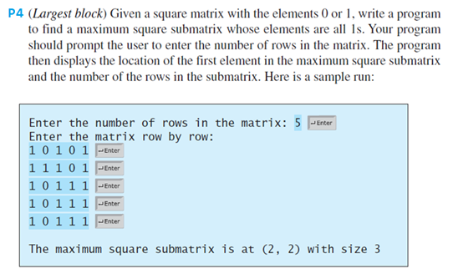
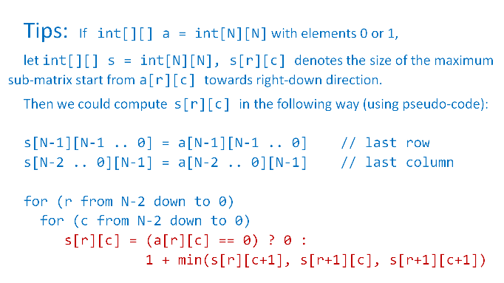
The Output may be changed to the following example.
