1. What are the characteristics of an algorithm?
Answer:
An algorithm is a sequence of steps which is used to solve a category of problems. Characteristics are given by:
- Unambiguous: every step is deterministic;
- Mechanical: machine can “understand”;
- Finite: can be implemented in limited steps;
- Input/output: to state the problem size and the result.

2. Solve the following recurrence relations and give a θ bound for each of them.
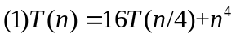
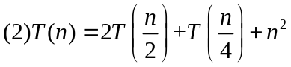
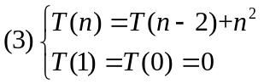

Answer:
(1) Using the master theorem:
a=16, b=4, d=4, log₄16 < 4，so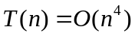
(2) Using the recursive tree method:
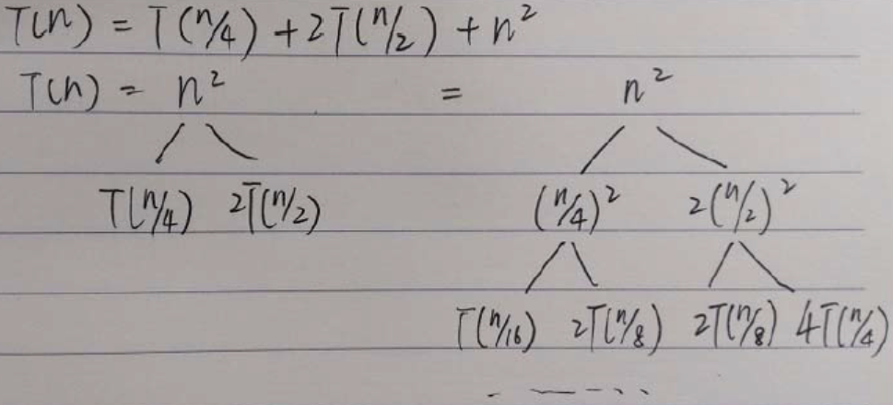
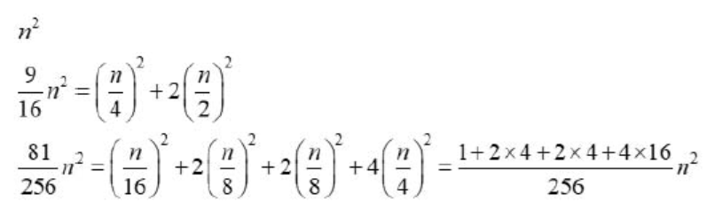
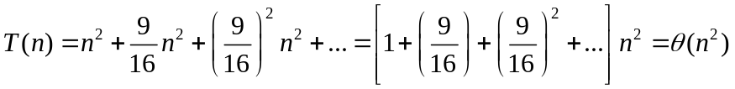
(3) Using the iterative method:
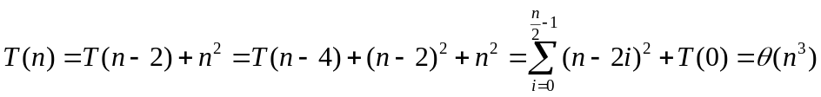

3. Sort the following functions in increasing order of asymptotic (big-O) complexity and explain why:
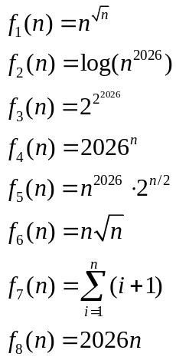

Answer:
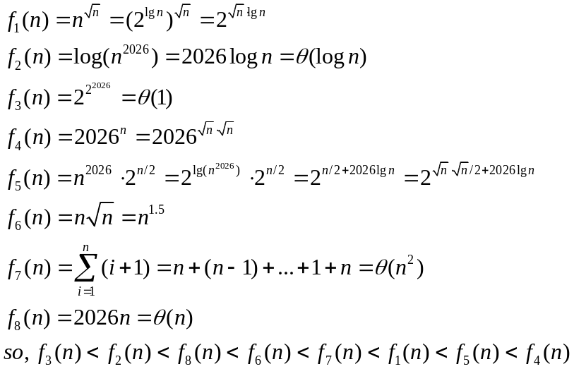

4. Integer Partition. We need to find the number of ways to partition a positive integer N into a sum of positive integers, where the order doesn't matter and we don't count permutations as different (non-repetitive splitting schemes). Give a divide-and-conquer algorithm with the time complexity O(N²) to do this.
For example, N = 5 has seven splitting schemes:
- 5=5
- 5=4+1
- 5=3+2
- 5=3+1+1
- 5=2+2+1
- 5=2+1+1+1
- 5=1+1+1+1+1
Answer:
The key insight is to use a recursive approach where we consider partitions with constraints on the maximum part size.
Let P(n, m) be the number of ways to partition integer n using parts of size at most m.
Base cases:
- P(0, m) = 0 (one way to partition 0: use no parts)
- P(n, 0) = 0 for n > 0 (can't partition positive number with max part 0)
- P(n, m) = P(n, n) for m > n (max part can't exceed n)
Recursive case:
- P(n, m) = P(n, m-1) + P(n-m, m)
  - P(n, m-1): partitions that don't use part of size m
  - P(n-m, m): partitions that use at least one part of size m
The answer we want is P(N, N).

Algorithm Implementation:
q(n, m) {
if q(n, m) in memo: return memo[n, m];
else:
// Base cases
if (n < 1 || m < 1) return 0; // Invalid input
if (n == 1 || m == 1) return 1; // Only one way to partition

// Recursive cases
if (n < m) {
// If max part 'm' is greater than 'n', it's equivalent to q(n, n)
return q(n, n);
}
if (n == m) {
// Partitions are those without 'm' plus the partition {n} itself
return q(n, m - 1) + 1;
}

// The main divide-and-conquer step:
// q(n, m) = (partitions without m) + (partitions with at least one m)
q(n, m) = q(n, m - 1) + q(n - m, m);
memo[n, m] = q(n, m);
return q(n, m);
}

Time Complexity Analysis
- We have a 2D memoization table of size (N+1) × (N+1)
- Each state P(n, m) is computed at most once
- Each computation takes O(1) time (just two recursive calls that are memoized)
- Total number of states: O(N²)
- Therefore, time complexity: O(N²)
Space Complexity
- O(N²) for the memoization table
- O(N) for recursion depth in the worst case

