Exercise 1: Cloud Storage Cost Optimization (0/1 Knapsack Variant)
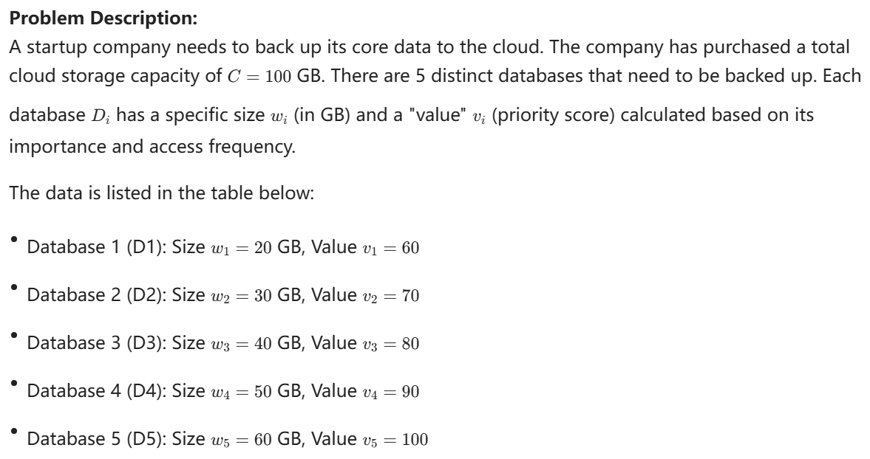
Questions:
- Please formally define this Dynamic Programming problem. Clearly identify:
  - Subproblem Definition
  - Recurrence Relation
  - Base Cases
- Solve the problem using a Dynamic Programming algorithm (described in Pseudocode) to maximize the total value of the backed-up databases without exceeding the 100 GB capacity. Provide the maximum total value and list the specific databases selected.
- Analyze the time and space complexity of the algorithm.

Answer:
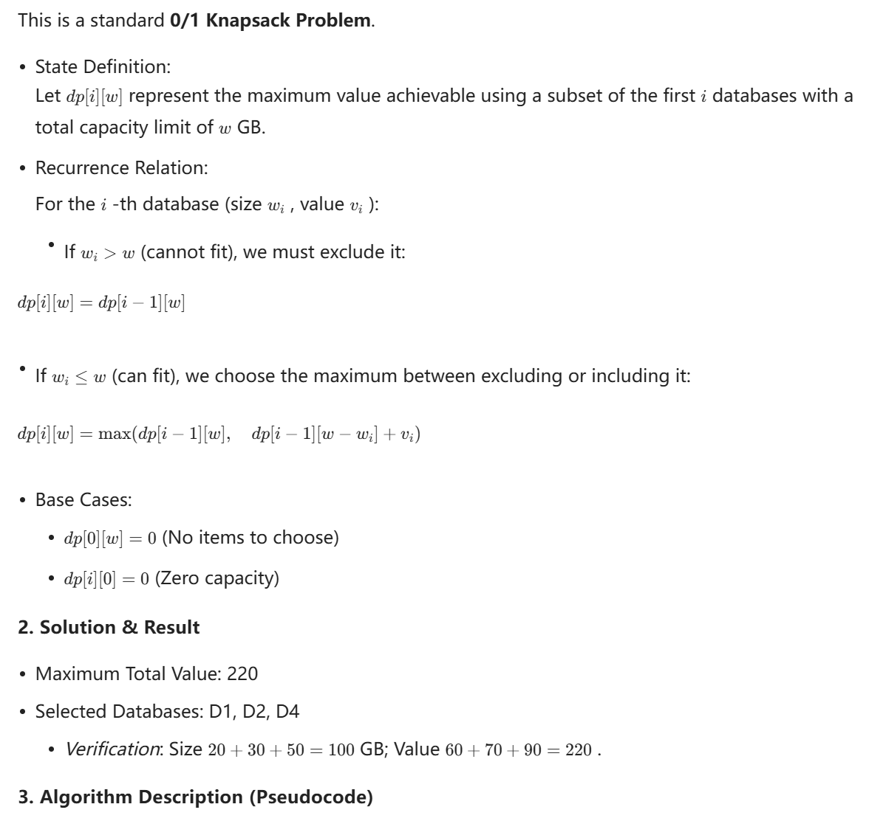
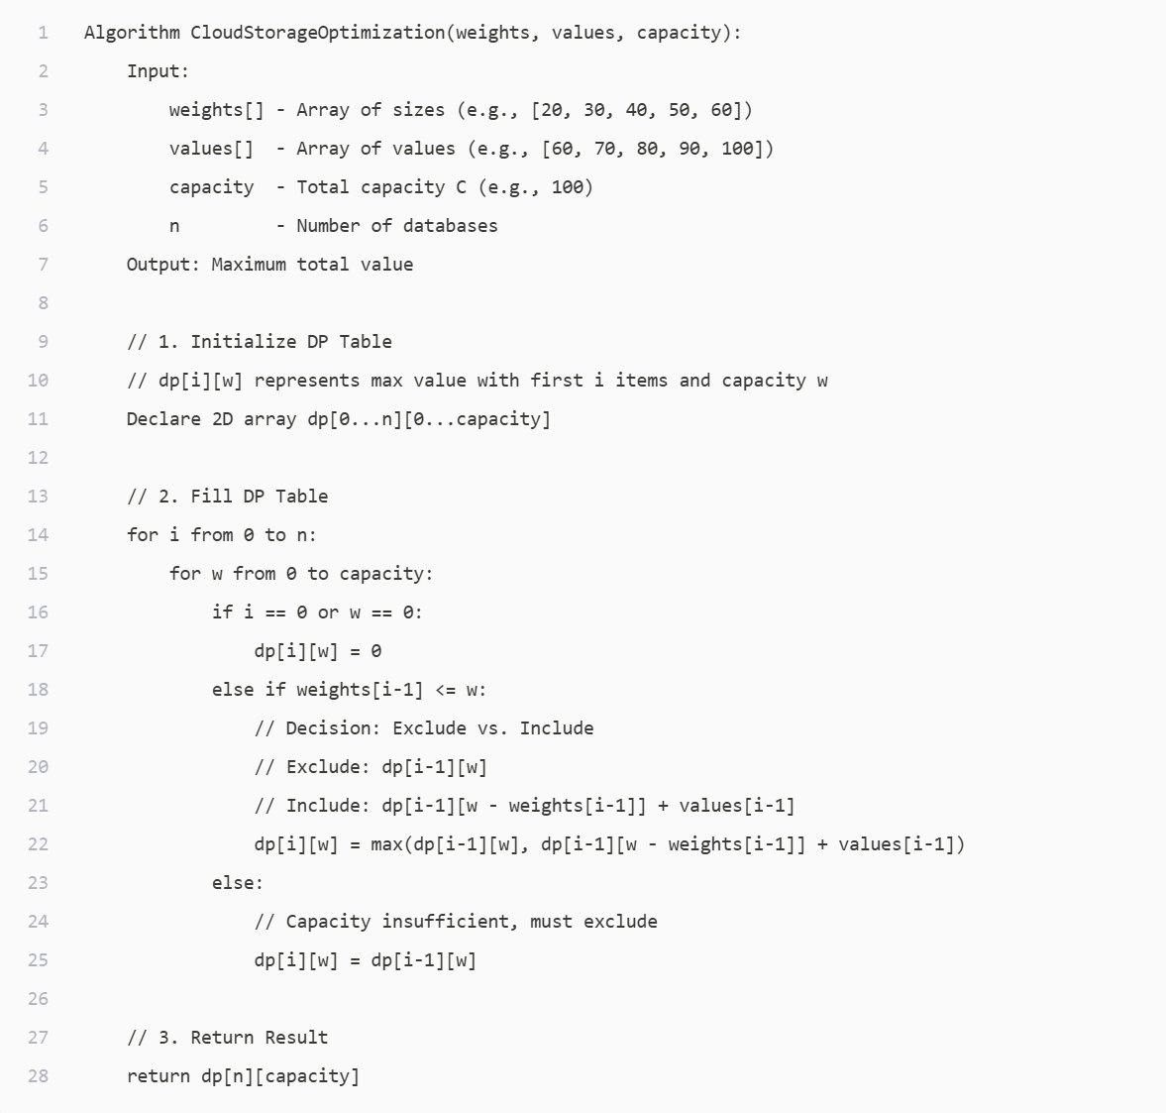
[i]

Exercise 2: Path Planning in Smart Warehousing (Grid Path Optimization)
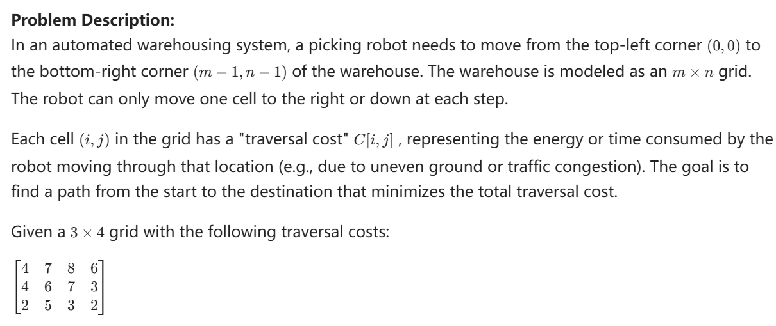

Questions:
- Define the dynamic programming subproblem dp[i, j], representing the minimum cost to reach position (i, j) from the start (0,0). Write down the recurrence relation.
- Use the dynamic programming algorithm to calculate and fill the entire dp table.
- What is the minimum total cost for the robot to move from (0,0) to (2,3)?
- By backtracking through the dp table, identify the specific path (sequence of coordinates) that achieves this minimum cost.

Answer:
