Exercise 1: Assign Cookies (Greedy Yields Optimal Solution)
Problem Description:
Assume you are an awesome parent and want to give your children some cookies. Each child i has a greed factor g[i], which is the minimum size of a cookie that will make the child content; and each cookie j has a size s[j]. If s[j] >= g[i], we can assign cookie j to child i, and the child will be content. Your goal is to maximize the number of content children and output this maximum number. Designing a greedy algorithm for doing this and discuss whether your algorithm can find an optimal solution.
Algorithm Description:
- Sort: Sort the children's greed factors g and the cookies' sizes s in ascending order.
- Initialize Pointers: Set two pointers, child and cookie, both starting at index 0, to traverse the children and cookies respectively.
- Two-Pointer Traversal:
  - In the loop, check if the current cookie's size is greater than or equal to the current child's greed factor (s[cookie] >= g[child]).
  - If true: The current cookie can satisfy the current child. Move the child pointer forward (the child is satisfied) and move the cookie pointer forward (the cookie is consumed).
  - If false: The current cookie is too small to satisfy even the least greedy child. This cookie is useless. Move only the cookie pointer forward to try a larger cookie, while keeping the child pointer stationary.
- Return Result: When either array is fully traversed (all children are satisfied or all cookies are used), the loop ends. The value of the child pointer represents the total number of satisfied children. Return this value.
Python Solution:
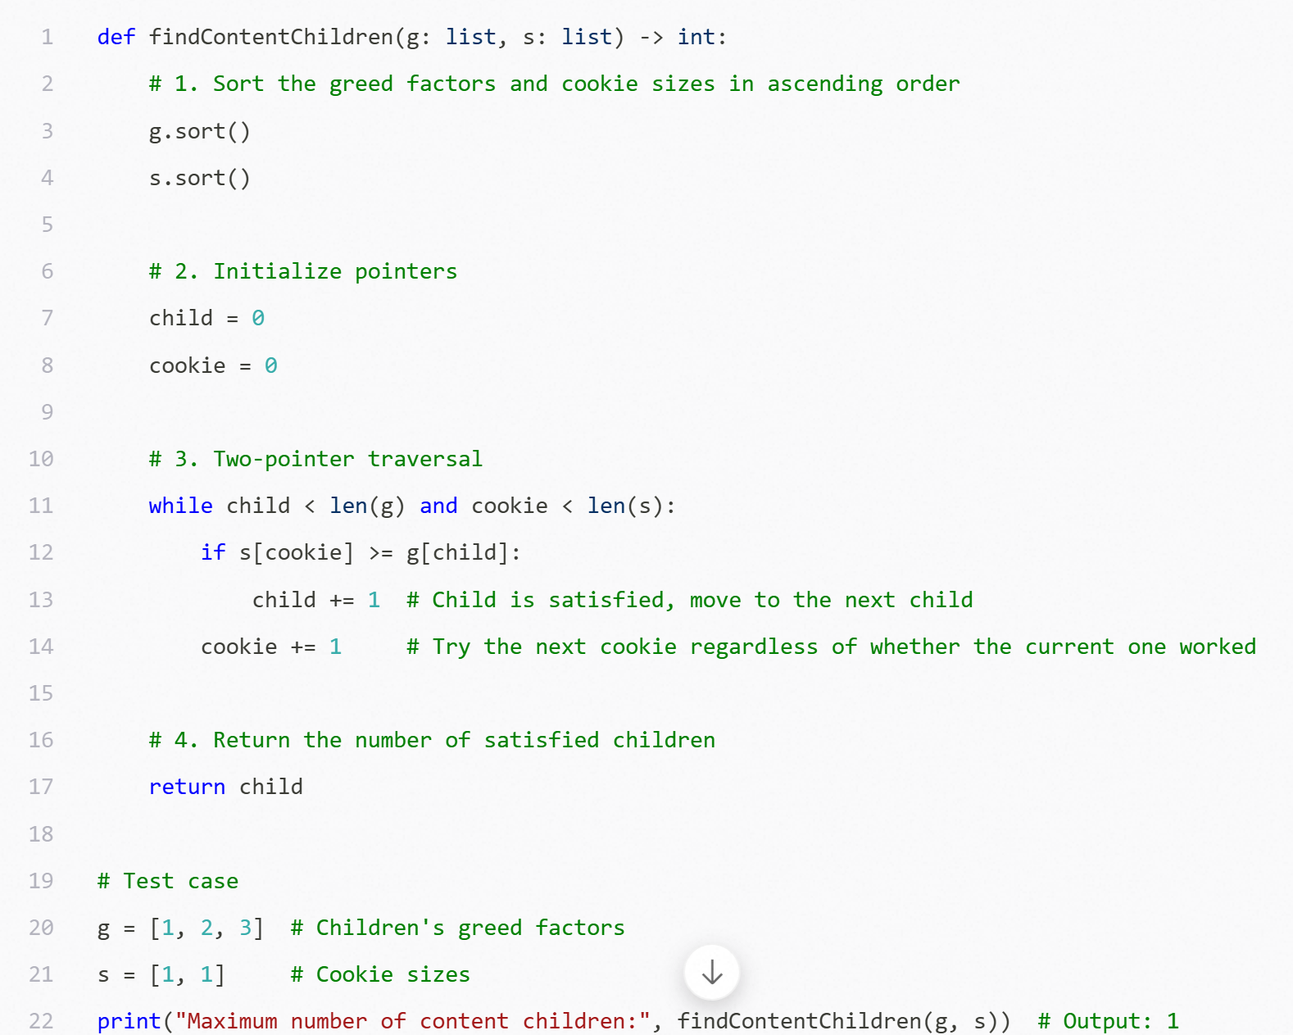

Exercise 2: Coin Change (Greedy Fails to Find Optimal Solution)
Problem Description:
Suppose you have coins with denominations [1, 3, 4] and need to make change for 6 units. The goal is to use the minimum number of coins. What is the minimum number of coins required? Designing a greedy algorithm for answering this question and discuss whether your algorithm can find an optimal solution.
Algorithm Description:
- Sort: Sort the coin denominations coins in descending order (largest to smallest).
- Initialize Variables: Set a counter count to track the number of coins used, starting at 0. Keep track of the remaining amount.
- Greedy Selection & Iteration:
  - Iterate through the sorted coins, starting from the largest denomination.
  - For the current coin, as long as its value is less than or equal to the remaining amount (amount >= coin), do the following:
    - Subtract the coin's value from the remaining amount (amount -= coin).
    - Increment the coin counter by 1 (count += 1).
  - When the current coin can no longer be used, proceed to the next smaller denomination and repeat until the remaining amount becomes 0.
- Return Result: Once the amount is made up, return the count.
Python Solution:
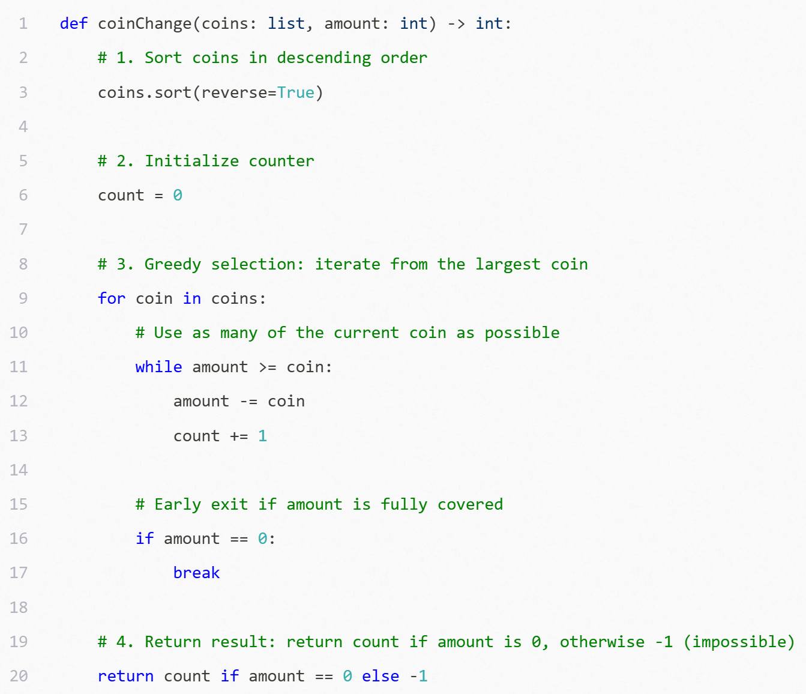
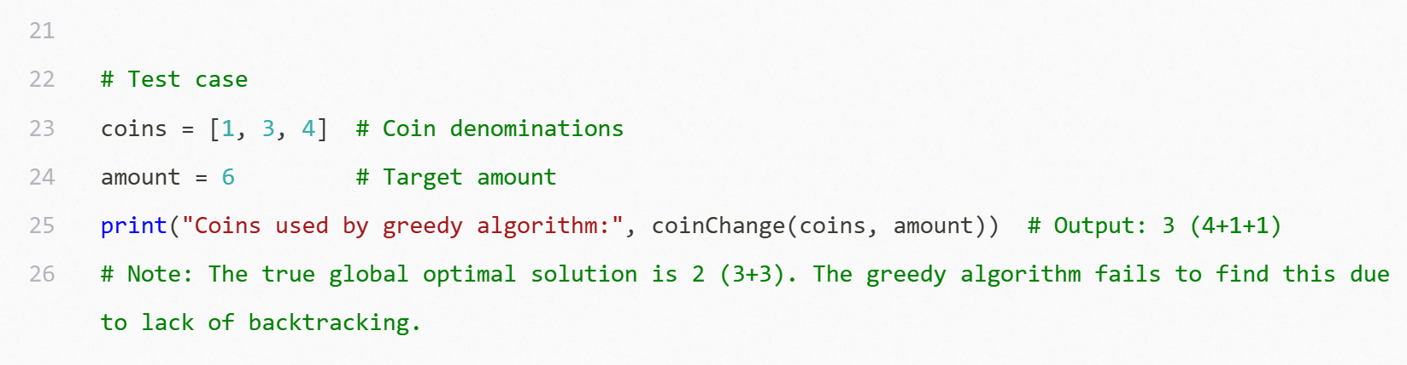

Exercise 3: Sequence Alignment in Bioinformatics (Longest Common Subsequence)
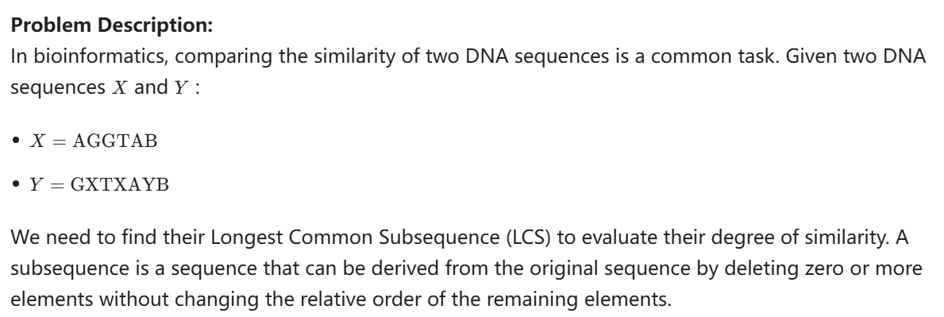

Questions:
- Define the dynamic programming subproblem c[i, j] and write down its recurrence relation.
- Construct and fill the dynamic programming table (2D array) to demonstrate the calculation process.
- Based on the filled table, backtrack to write down the Longest Common Subsequence of X and Y.

Answer:
