Operating Systems 2026 Spring
Lab 01 李荣耀 2024103975
Goals:
Learn to work with Linux system calls related to process creation and control by fork() and wait().
Contents:
- fork()
In this lab, we start experimenting with a few Unix system calls. The first one, we will look at is fork, which is used by a process to spawn an identical copy of itself. When the fork system call is executed, a new process is created which consists of a copy of the address space of the parent.
The fork call:
- Returns a value of type pid_t (essentially, an integer), and
- Does not take any input parameters, what is indicated by the formal parameter void.
- The return code for fork is 0 for the child process and the process identifier of child is returned to the parent process.
- On success, both processes continue execution at the instruction after the fork call.
- On failure, -1 is returned to the parent process.
- wait()
When a process creates a child process, sometimes it becomes necessary that the parent process should execute only after the child has finished. wait() system call does exactly this. It makes the parent process wait for child process to finish and then the parent continues its working from the statement after the wait().
To be exact wait makes the parent wait for the child to change state. The state change can be: the child terminated; the child was stopped by a signal; or the child was resumed by a signal.
wait() system call takes only one parameter which stores the status information of the process. Pass NULL as the value if you do not want to know the exit status of the child process and are simply concerned with making the parent wait for the child. On success, wait returns the PID of the terminated child process while on failure it returns -1.
Tasks
Task 1:
Write a C program to create 4 processes where first process is the parent of the second one and the second process is the parent of the third one and the third process is the parent of the fourth one. Your program should be capable of:
- checking if the processes is forked with success,
- printing the pid and parent pid of each process,
- printing the parent pid of the first process.
Task 2:
Write a C program to create a fan of processes. That is, process 1 is the parent of processes 2, 3, 4, 5, 6.
Ideas and Code Structures
Task 1:
- First print the process identifier of the first process.
- Create four processes whose structure is the chain structure.
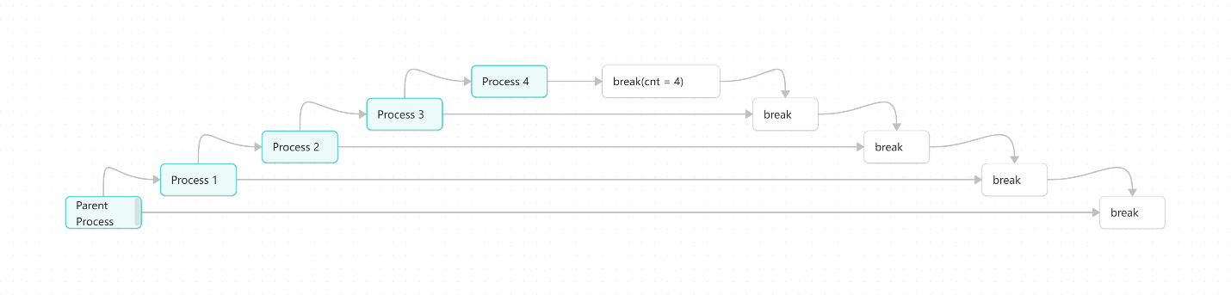
- Print PID and PPID for each process.
The code is:
#include<stdio.h>
#include<unistd.h>
#include<sys/types.h>
#include<sys/wait.h>
#include<stdlib.h>

int main(){
int cnt = 0;
printf("Parent here. PID: %d\n", getpid());
while (cnt < 4){
pid_t pid = fork();
if (pid < 0){
printf("Fork failed.\n");
exit(1);
}else if (pid == 0){
// child process
// print child process and increment cnt
printf("Child here. PID: %d, PPID: %d\n", getpid(), getppid());
cnt++;
}else{
// parent process
// wait for child to finish to ensure the order of processes
wait(NULL);
break;
}
}
}
- Print the PID of the first process.
- Each iteration forks a child process and breaks the parent process until create four processes.
- Check whether failed to fork.
- Print PID and PPID for each process.
Task 2:
- Create four processes which are all parallel to the parent process.
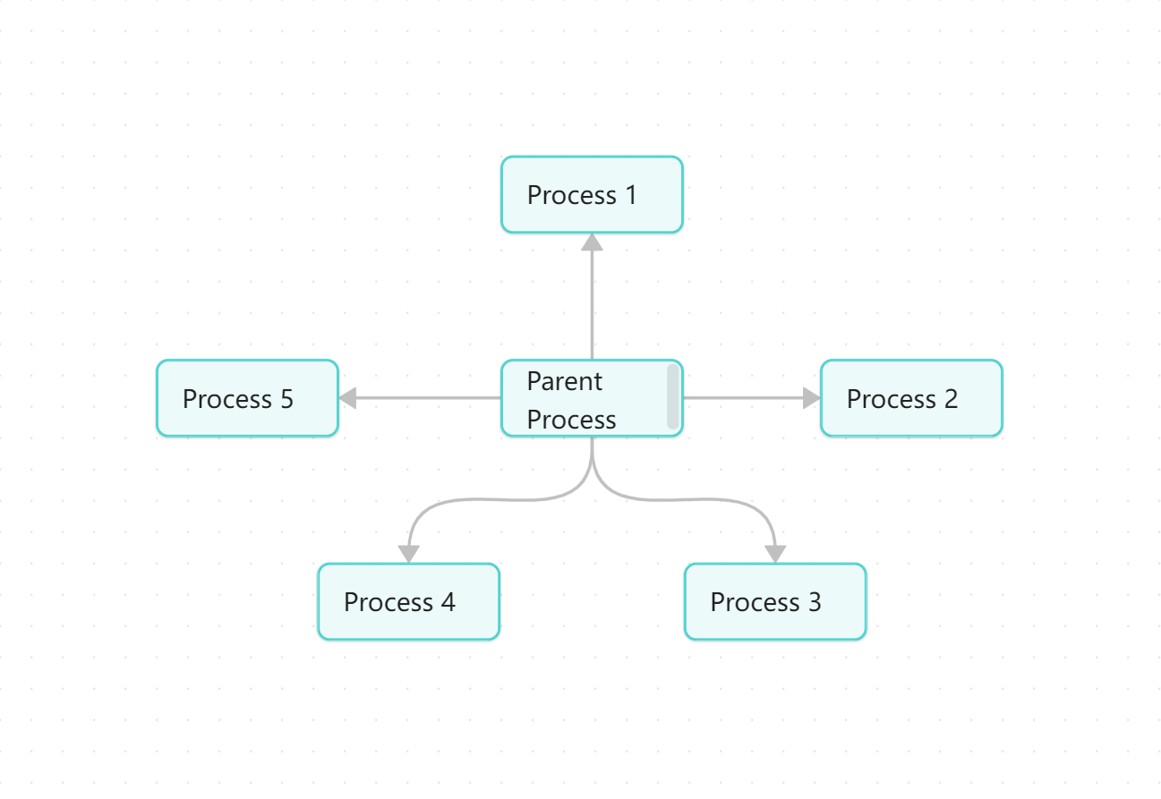
- Print PID and PPID for each process.
The code is:
#include<stdio.h>
#include<unistd.h>
#include<sys/types.h>
#include<sys/wait.h>
#include<stdlib.h>

int main(){
int cnt = 0;
while (cnt < 5){
pid_t pid = fork();
if (pid == 0){
// create child process, exit immediately after printing
printf("Child here. PID: %d, PPID: %d\n", getpid(), getppid());
exit(0);
}else if (pid > 0){
// parent process, wait for child to finish
wait(NULL);
}else{
printf("Fork failed.\n");
exit(1);
}
cnt++;
}
}
- Each iteration forks a child process and exit immediately after printing until create five processes.
- Check whether failed to fork.
- For parent process, wait for child to finish.
Execution Results
Task 1:
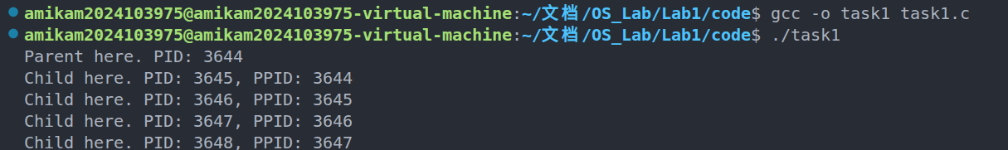
Task 2:
